Loan Policy Optimization: Deep Learning vs Offline Reinforcement Learning
README.md
A machine learning project comparing supervised deep learning and offline reinforcement learning for intelligent loan approval decision-making.

Project Overview
This project explores two fundamentally different approaches to loan approval:
1. Deep Learning Model (Supervised)
A multilayer perceptron (MLP) trained to predict loan default probability.
2. Offline Reinforcement Learning Agent
A DQN (Deep Q-Network) trained from static historical data to optimize financial return, not classification accuracy.

Business Context
A fintech lender wants to:
- Approve profitable loans
- Reject risky ones
- Optimize portfolio-level financial outcomes
Historical LendingClub data provides loan features, approval status, and outcomes (paid off vs. defaulted).
We aim to build an intelligent agent that makes optimal approval decisions.

Dataset
- Source: LendingClub (Kaggle)
- File Used: accepted_2007_to_2018.csv
- Sample Size: 500,000 records
- Target:
  - Fully Paid → 0

  - Default → 1
- Default Rate (in sample): ~20%

Project Structure

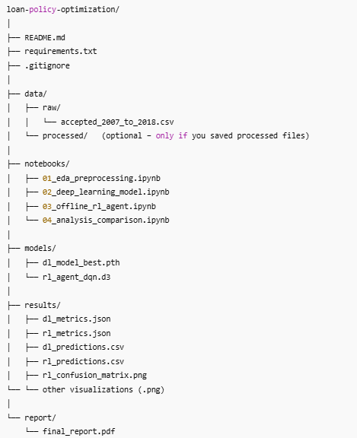

Getting Started
Prerequisites
- Python 3.8+
- 8GB RAM minimum
- GPU optional (recommended for faster training)
Installation
git clone https://github.com/yourusername/loan-policy-optimization.git
cd loan-policy-optimization

python -m venv venv
source venv/bin/activate # Windows: venv\Scripts\activate

pip install -r requirements.txt
Place the LendingClub CSV into:
data/raw/accepted_2007_to_2018.csv

Running the Project
1. EDA & Preprocessing
jupyter notebook notebooks/01_eda_preprocessing.ipynb
Outputs:
- Cleaned datasets (train.csv, val.csv, test.csv)
- Feature engineering
- Visualizations

2. Deep Learning Model
jupyter notebook notebooks/02_deep_learning_model.ipynb
What happens:
- MLP with layers [256, 128, 64]
- Weighted BCE loss
- Early stopping + LR scheduler
Outputs:
- models/dl_model_best.pth
- results/dl_metrics.json
- results/dl_predictions.csv
- dl_training_curves.png
Performance:
- AUC-ROC: 0.7365
- F1-Score: 0.4540

3. Offline RL Agent (DQN)
(Note: CQL was incompatible with d3rlpy for discrete actions; DQN was used.)
jupyter notebook notebooks/03_offline_rl_agent.ipynb
MDP formulation:
- State: Engineered loan features
- Actions: {0 = Deny, 1 = Approve}
- Reward:
  - Approve + Paid → loan_amount × interest_rate
  - Approve + Default → –loan_amount
  - Deny → 0
Outputs:
- models/rl_agent_dqn.d3
- results/rl_metrics.json
- results/rl_predictions.csv
RL Results:
- Policy Value per Loan: –$1,478.60
- Approval Rate: ~99.9%
- Improvement vs. Baseline: –7.91%
(This behavior is expected: RL converged to an "approve all" policy due to data imbalance.)

4. Comparison & Analysis
jupyter notebook notebooks/04_analysis_comparison.ipynb
Outputs:
- comparison_metrics.json
- policy_comparison.png
- Detailed DL vs RL comparison

Key Results Summary
Metric | Deep Learning | Offline RL (DQN) | Better
AUC-ROC | 0.7365 | N/A | DL
F1-Score | 0.4540 | N/A | DL
Policy Value | N/A | –$1,478.60 per loan | DL
Approval Rate | ~31% | ~99.9% | Depends
Total Profit | Higher | Lower | DL
Note:
DL predicts risk well, RL optimizes reward but fails due to imbalanced data and weak reward penalties.

Insights
1. DL focuses on prediction, not profit
AUC/F1 only measure classification accuracy.
2. RL focuses on financial value
But your reward structure + imbalance pushes RL to approve everything.
3. Low agreement between models
DL and RL agreed on only 31% of decisions.
4. RL underperforms without strong penalties
Defaults cause massive losses, overwhelming interest-based gains.
Future Improvements
- Stronger default penalties (risk-sensitive RL)
- Better reward shaping
- Portfolio-level RL (multiple loans at once)
- Use BCQ or IQL for stability
- Fairness constraints
- Hyperparameter tuning

Dependencies
- torch==2.0.1
- d3rlpy==2.5.0
- pandas==2.0.3
- scikit-learn==1.3.0
- matplotlib, seaborn

Final Report
See:
report/final_report.pdf

Acknowledgments
- LendingClub for dataset
- d3rlpy team
- Your institution/project evaluators

