System Requirements Statement (SRS) –

Tours And Travels

1. Introduction 3

2. Functional Requirements 4

2.1 Traveler Module 5

2.2 TOUR mODULE 9

2.3 admin Module 12

2.4 UseCaseDiagram..................................................................................................................................13

1. **Introduction**

This document explains the system requirements and scope for developing Tours and Travels.

Tour and Travels could divide the three main parts Tourist part, Tour Manager part, Administrator part.

1. **Functional Requirements**

The Account part of Tours and Travels has three modules which are divided 13 processes described as below.

|  |  |  |
| --- | --- | --- |
| **No** | **BRS requirement ID** | **Description** |
| **2.1** | **Tourist Module** | |
| **2.1.1** | **F1** | **Account Registration Process** |
| **2.1.2** | **F2** | **Login Process** |
| **2.1.3** | **F3** | **Forgot Password Process** |
| **2.1.4** | **F4** | **Change Password Process** |
| **2.1.5** | **F5** | **Update Profile** |
| **2.1.6** | **F6** | **Search Package** |
| **2.1.7** | **F7** | **Book Tour** |
| **2.1.8** | **F8** | **Cancel Booking** |
| **2.1.9** | **F9** | **Feedback and Rating** |
| **2.2** | **Tour Manager Module** | |
| **2.2.1** | **F10** | **Login Process** |
| **2.2.2** | **F11** | **Forgot Password Process** |
| **2.2.3** | **F12** | **Change Password Process** |
| **2.2.4** | **F13** | **Update Account Process** |
| **2.2.5** | **F14** | **Add package** |
| **2.2.6** | **F15** | **Modify Package** |
| **2.2.7** | **F16** | **Remove Package** |
| **2.2.8** | **F17** | **Manage Package** |
| **2.3 Admin Module** | | |
| **2.3.1** | **F18** | **Login Process** |
| **2.3.4** | **F29** | **Approve Package** |
| **2.3.5** | **F20** | **Modify Package** |
| **2.3.6** | **F21** | **Manage Account** |
| **2.3.7** | **F22** | **Manage Transaction** |

* 1. **Tourist Module**
* Tourist are the user of system who plans the tour and travel.
* They are able to view and search the packages.
  + 1. **Account Registration Process**
* Tours and Travels compels to login before booking a tour. So, tours and travels should provide the function which makes tourist creates new account.
* When tourist creates new account, the function demands following information described as below.

1. User ID
2. Password
3. First Name
4. Last Name
5. E-mail address
6. Address
7. Phone No
   * All informations are mandatory.
8. User ID

* The User ID should be unique. If the User ID corresponds with not case-sensitive to other which is previously registered, the User ID should not be registered as an account.

1. Password

* The Password has a constraints which makes the Password consists of more than or equal 8 and less than or equal 16 characteristics including characters described as below.
* Numeric figure (at least one)
* Capital alphabet (A-Z)(at least one)
* Small alphabet (a-z)(at least one)
* Special character (#, $, %, &, etc.) (at least one)
* The Password is masked by dummy characters. The re-entering Password is demanded.

1. First name

* First name has the constraints which contain max size of 15 characters.

1. Last name

* First name has the constraints which contain max size of 15 characters.

1. Email Address

* Email address should be valid

1. Address

* Address has the constraints which contain max size of 200 characters.

1. Phone no

* Phone number has the constraints which contain exactly 10 digit.
  + 1. **Login Process**
* The user authentication demands User ID and Password. The User ID and the Password should be checked as below.
  + The User ID and the Password should be existed and correct.
* If The User ID and the Password are not equal to what the user has registered, the user authentication cannot be provided.
* The “Home Page” provides the some items described as below.

1. A trigger to logout
2. A trigger to profile
3. A trigger to Search Tour package
4. A trigger to wishlist
   * 1. **Forgot Password Process**

* When system user lost their Password, the recovery method should be provided by Tours and Travels.

The recovery method is described as below.

* + First, system user enters their User ID for Tours and Travels.
  + Next, Tours and Travels demands email id, which has been registered since when the Account was created.
  + Tourist get the new password by E-mail.
  + The new password is automatically generated by Tours and Travels.
* Of course, the new password should consist of more than or equal 8 and less than or equal 16 characteristics.
* As a consequence, The Tourist can re-login using the new password.
  + Then, the tourist had better change the new password manually.
    1. **Change Password Process**
* When Tourist wants to change their Password, the measure should be provided by Tours and Travels.
* Therefore, Tours and Travels should provide the function which is available after the Tourist logs in
* The function demands the current password and the new password.
  + The new password should consist of more than or equal 8 and less than or equal 16 characteristics including at least a numeric figure, a capital alphabet, a small alphabet, and a special character.
  + The current password and the new password are masked by using dummy characters.
  + The new password is demanded to enter twice to avoid a typing error.
* Only when the current password is correct, Tourist could change their Password.
  + 1. **Update Account Process**
* Tours and Travels should provide the function which makes the account updated for Tourist.
* The information Tourist could update is described below.

1. Login information
2. User information

* The Login information

The updatable items as described below.

1. User Id
2. Password
   * All items are mandatory, but updating is optional.

* The User information

The updatable items as described below

1. First Name
2. Last Name
3. Phone No
4. E-mail address
5. address
   * All items are mandatory, but updating is optional.
     1. **Search Package**

* Search conditions are described as below.

1. Date
2. Location
   * 1. **Book Tour**

* After selecting package, all details will get displayed.
* According to date and location customization feature is available.
* At time of booking and adding to wish list tourist login is required.
  + 1. **Cancel Booking**
* Tourist can cancel the booking on certain criteria
  + 1. **Feedback and Rating**
* Tourist can give feedback and rating after the completion of tour.
  1. **Tour Manager Module**
     1. **Login Process**
* Tours and Travels always compels manager authentication before using itself.
* The user authentication demands User ID and Password. The User ID and the Password should be checked as below.
  + The User ID and the Password should be existed and correct.
* If The User ID and the Password are not equal to what the user has registered, the user authentication cannot be provided.
* The “Home Page” provides the some items described as below.

1. A trigger to logout
2. A trigger to profile
3. A trigger to add the package
4. A trigger to remove the package
5. A trigger to modify the package
6. A trigger to search packages
7. A trigger to view tourists details by searching
   * 1. **Forgot Password Process**

* When system user lost their Password, the recovery method should be provided by Tours and Travels.

The recovery method is described as below.

* + First, system user enters their User ID for Tours and Travels.
  + Next, Tours and Travels demands email id, which has been registered since when the Account was created.
  + Tourist get the new password by E-mail.
  + The new password is automatically generated by Tours and Travels.
* Of course, the new password should consist of more than or equal 8 and less than or equal 16 characteristics.
* As a consequence, The Tourist can re-login using the new password.
  + Then, the tourist had better change the new password manually.
* Tours and Travels always compels Tour Manager authentication before using itself.
* The user authentication demands User ID and Password. The User ID and the Password should be checked as below.
  + The User ID and the Password should be existed and correct.
* If the User ID and the Password are not equal to what the user has registered, the user authentication cannot be provided.
* The “Home Page” provides the some items described as below.

1. A trigger to logout
2. A trigger to profile
3. A trigger to add the package
4. A trigger to remove the package
5. A trigger to modify the package
6. A trigger to search packages
7. A trigger to view tourists details by searching
   * 1. **Change Password Process**

* When Tourist wants to change their Password, the measure should be provided by Tours and Travels.
* Therefore, Tours and Travels should provide the function which is available after the Tourist logs in.
* The function demands the current password and the new password.
  + The new password should consist of more than or equal 8 and less than or equal 16 characteristics including at least a numeric figure, a capital alphabet, a small alphabet, and a special character.
  + The current password and the new password are masked by using dummy characters.
  + The new password is demanded to enter twice to avoid a typing error.
* Only when the current password is correct, Tourist could change their Password.
  + 1. **Update Account Process**
* Tours and Travels should provide the function which makes the account updated for Tour Manager.
* The following information can be updated by the Tour Manager .

1. Login information
2. User information
   * All items are mandatory, but updating is optional.

* The Login information

The updatable items as described below.

1. Password

* The User information

The updatable items as described below.

1. First Name
2. Last Name
3. Phone No
4. E-mail address
5. Address
   * 1. **Add Package**

Tours and Travels Provides a feature by using which Tour Manager can add new packages .

* Name of Package
* Location
* Date
* Duration
* Capacity
* Last date of booking
* Description
  + 1. **Modify Package**

Tours and Travels Provides a feature by using which Tour Manager can add modify packages .

* + Date
  + Duration
  + Tourist capacity
    1. **Remove Package**
* Tours and Travels provide feature which is used by Tour Manager to remove package if required.
  + 1. **Manage Package**
* Tour Manager can manage the package if tourist capacity is full.
  1. **Admin Module**
     1. **Login Process**
* The admin authentication demands User ID and Password. The User ID and the Password should be checked as below.
  + The UserID and the Password should be existed and correct.
* The “Home Page” provides the some items described as below.

1. A trigger to logout
2. A trigger to profile
3. A trigger to Search Tour package
4. A trigger to modify tour package
5. A trigger to Approve Package
6. A trigger to manage Tour Manager profile
7. A trigger to manage transaction
   * 1. **Approve Package**

* Tours and Travels provides a feature when Tour Manager add a new package request will receive to admin portal for approval.
  + 1. **Modify Package**

Tours and Travels Provides a feature by using which Admin can add modify packages .

* + Date
  + Duration
  + Tourist capacity
    1. **Manage Account**
* Tours and Travels Provides a feature by using which Admin can add and modify Tour Manager details
  + 1. **Manage Transaction**
* Admin can manage all the transactions made by customers.
  1. **Use Case Diagram**
     1. **Admin :**

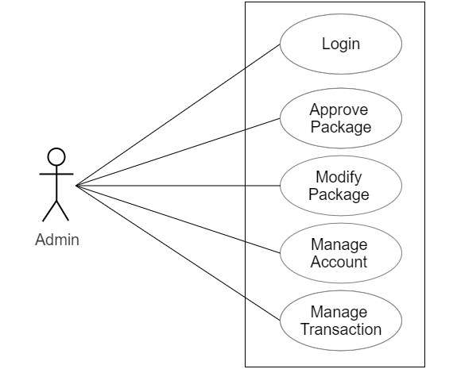

*Fig. Use case diagram for admin*

1. In Admin use case diagram Admin is the Actor.
2. Admin can handle following use cases:
3. Login
4. Approve Package
5. Modify Package
6. Manage Account
   * 1. **Tourist :**

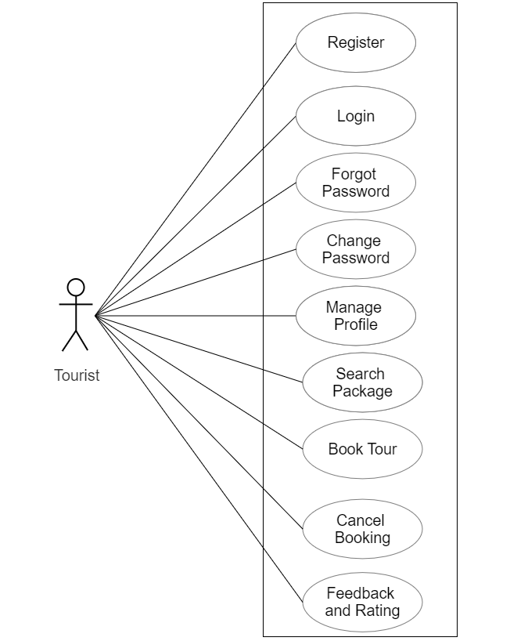

*Fig. Use case diagram for Tourist*

1. In Tourist use case diagram Tourist is the Actor.
2. Tourist can handle following use cases:
3. Register
4. Login
5. Forgot Password
6. Change Password
7. Update Profile
8. Search Package
9. Book Tour
10. Cancel Booking
11. Feedback and Rating
    * 1. **Tour Manager :**

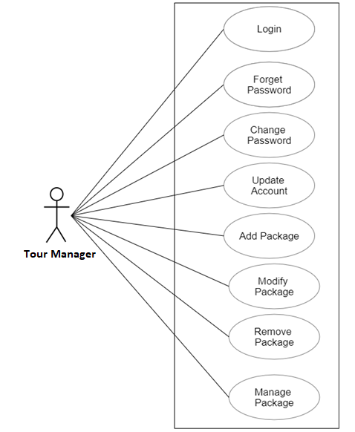

*Fig. Use case diagram for Tour Manager*

1. In Tour Manager use case diagram Tour Manager is the Actor**.**
2. Tour Manager can handle following use cases:
3. Login
4. Forgot Password
5. Update Account
6. Create Account
7. Add Package
8. Modify Package
9. Remove Package
10. Manage Package
11. Change Password