**Mini Project Report on**



**ONLINE TRAVELLING SYSTEM**



**Submitted in partial fulfilment of the requirement for the award of the degree of**

**BACHELOR OF TECHNOLOGY**

**IN**

**COMPUTER SCIENCE & ENGINEERING**

**Submitted by:**

**Student Name: AKANKSHA UNIYAL** **University Roll No: 2021064**

***Under the Mentorship of***

**Mentor Name: DR. RISHI KUMAR**

**Designation: Assistant Professor**



**Department of Computer Science and Engineering**

**Graphic Era (Deemed to be University)**

**Dehradun, Uttarakhand**

**January-2024**



**CANDIDATE’S DECLARATION**

I hereby certify that the work which is being presented in the project report entitled **“Online Travelling System”** in partial fulfillment of the requirements for the award of the Degree of Bachelor of Technology in Computer Science and Engineeringof the Graphic Era (Deemed to be University), Dehradun shall be carried out by the under the mentorship of **Dr. Rishi Kumar, Assistant Professor**, Department of Computer Science and Engineering, Graphic Era (Deemed to be University), Dehradun.

Akanksha Uniyal 2021064

Name University Roll no1

**Table of Contents**

|  |  |  |
| --- | --- | --- |
| **Chapter No.** | **Description** | **Page No.** |
| Chapter 1 | Introduction | **1** |
| Chapter 2 | Literature Survey | **4** |
| Chapter 3 | Methodology | **6** |
| Chapter 4 | Result and Discussion | **12** |
| Chapter 5 | Conclusion and Future | **13** |
|  | Work References |  |

**Chapter 1**

**Introduction**

* 1. **Introduction**

The advent of online platforms has revolutionized the travel industry, offering travelers unprecedented convenience and accessibility in planning and managing their journeys. As the demand for seamless travel experiences continues to grow, the development of robust Online Traveling Systems becomes imperative. Moreover, the paradigm shift towards digitization has significantly impacted the travel industry and gave them an upper-hand when it comes to online-booking services. This report delves into the development of a comprehensive Online Traveling System crafted using Java Swings and powered by MySQL as the database. It aims at creating an advanced and user-centric Online Traveling System with a primary focus on enhancing user experience, empowering travelers to seamlessly book train, cab, and bus tickets, redefining the ease and efficiency of their journeys on a single platform.

* 1. **Scope of Project**

The scope of this project is centered around the development of an advanced Online Transport Booking System, with a primary focus on facilitating the seamless booking of train, bus, and cab tickets. Drawing inspiration from the successful implementation of a similar system at Politeknik Kota Kuala Terengganu (PKKT) by Badariah (2007), our goal is to extend the advantages of this online booking system to all its users.

The evolving landscape of business has significantly transformed service delivery in both the private and public sectors. Creating a parallel with our project, IRCTC, a Mini Ratna under the Indian government and a subsidiary of the Indian Railway, stands as a testament to this shift. Booking a staggering 1.5 to 1.6 million tickets daily, IRCTC has emerged as a key player in the online travel domain, embodying the tagline "Lifeline of the nation." This underscores the pressing need for our Online Traveling System, which aims to streamline and enhance the booking experience for trains, cabs, and buses, aligning with the dynamic expectations of today's travelers.

**1.2.1 Online Reservation System for Multiple Modes of Transfer:**

* Implementing a versatile system that allows users to make online reservations for train, bus, and cab services.
* Ensuring the adaptability of the system to accommodate various modes of transportation, thereby providing users with a one-stop platform for all their travel needs.

**1.2.2 Elimination of Counter Queues:**

* Addressing the challenges faced by customers when queuing at counters by providing an online alternative for making reservations.
* Enhancing customer experience by eliminating the need for physical presence at counters, allowing users to book tickets conveniently from their homes or offices.

**1.2.3 Graphic User Interface (GUI) Interaction:**

* Implementing an easy-to-use Graphic User Interface (GUI) that enhances user experience and promotes accessibility.
* Ensuring that the interface is visually appealing and straightforward, promoting user engagement and interaction with the system.

**1.2.4 Easy Sign-In and Detail Entry:**

* Users will be greeted with an intuitive and straightforward sign-in interface, minimizing the steps required to access the system.
* The detail entry process will be designed for efficiency and user-friendliness, allowing users to input their information effortlessly.

Thus, this project's scope extends to creating a feature-rich Online Traveling System that leverages the capabilities of Java Swings for an intuitive and visually appealing user interface. By integrating MySQL as the database, we ensure robust data management, contributing to the reliability and scalability of the system. Providing the users, a one-stop solution for their travel needs, helps them experience a modern, efficient, and user-friendly alternative to traditional counter-based reservations.

* 1. **Present Developments**

In the ever-evolving landscape of online travel solutions, our project is positioned at the forefront of present developments, encapsulating the latest trends and technologies in the travel industry. With the increasing reliance on digital platforms for travel planning and bookings, our Online Traveling System addresses contemporary needs by integrating real-time updates, secure payment options, and a responsive user interface. The project aligns with the current trajectory where consumers demand seamless and efficient solutions, allowing them to book train, cab, and bus tickets effortlessly. Leveraging Java Swings and MySQL as the technological backbone, our system not only reflects the industry's present reliance on robust frameworks but also anticipates future scalability and adaptability requirements. The emphasis on user-centric design, transparent information presentation, and easy sign-in processes underscores our commitment to meeting the evolving expectations of modern travelers. Moreover, by drawing inspiration from successful models like IRCTC, KTMB etc we acknowledge and incorporate the global shift towards digitalized travel services. In essence, the present developments within our project are not only shaped by the current needs of users but also anticipate and prepare for the future trajectory of the online travel industry. Through these strategic considerations, our Online Traveling System endeavors to set new standards in convenience, security, and user satisfaction.

**Chapter 2**

**Literature Survey**

The literature survey conducted for this research is instrumental in shaping the foundation of our project on the Online Traveling System, shedding light on key aspects of user experience (UX) and security in online ticket reservation systems. Emphasizing the pivotal role of mobile applications in the tourism sector, studies by Buell, Campbell, & Frei (2010) highlight the increasing prevalence of mobile-friendly solutions. Approximately 50% of existing tourism recommender systems are tailored for mobile devices, reflecting the industry's increasing reliance on digital platforms. Four primary mobile travel application categories, including "Online Booking," "Information Resource," "Location-Based Services," and "Trip Journals," have been identified, each catering to specific aspects of the traveler's journey (Smirnov et al., 2014). As our project focuses on the development of an Online Traveling System using Java Swings and MySQL, we recognize the importance of aligning with contemporary trends, ensuring that travelers can seamlessly book train, cab, and bus tickets from the convenience of their chosen platforms.

The survey delves into established principles of UX design, drawing from previous research that underscores the significance of user-friendly interfaces, clear information presentation, and personalized recommendations in online ticket reservation systems. Survey results advocate for the integration of these elements to enhance UX, providing insights into UX design concepts and best practices. Additionally, cross-device compatibility, mobile accessibility, and responsive design are acknowledged as crucial factors in improving user experiences across various platforms. As our project aims to streamline the booking process for travelers, insights from these studies provide a robust foundation for enhancing the overall user experience. Moreover, the survey's exploration of security measures aligns closely with our project's commitment to safeguarding user data through secure authentication mechanisms, encryption techniques, and fraud prevention strategies.

Addressing the integration of emerging technologies, the literature survey identifies the potential impact of Artificial Intelligence (AI), Machine Learning (ML), and blockchain on online ticket reservation systems. Studies on AI and ML algorithms for personalized ticket recommendations, dynamic pricing models, and demand forecasting are reviewed, shedding light on both the benefits and challenges associated with their integration. As we develop our Online Traveling System using Java Swings and MySQL, these insights inform our consideration of advanced technologies to improve ticket availability, pricing strategies, and overall system transparency.

Case studies and examples presented in numerous surveys, showcase successful online ticket reservation systems, offering valuable lessons for our project. By examining how innovative technologies, security measures, and UX design principles are applied in various contexts, we gain inspiration for implementing effective strategies in our system. This synthesis of best practices guides us in creating a user-centric, secure, and technologically advanced platform for booking train, cab, and bus tickets.

In essence, the existing models serve as a crucial guide for our project, providing a comprehensive understanding of the dynamics in online ticket reservation systems. By aligning our practices with established principles, integrating advanced technologies, and learning from successful implementations, we embark on developing the Online Traveling System by synthesizing the established principles and insights from emerging technologies to ensure our project is a trailblazer in the domain, promising users a secure, seamless, and technologically advanced journey in the realm of online travel solutions.

**Chapter 3**

**Methodology**

**3.1 Software Specification**

• Operating system: Microsoft windows 10.

• Integrated Development Environment: Apache Netbeans IDE 19

• MySQL Workbench 8.0 CE

• Programming language: JAVA

**3.2 Hardware Specification**

• System type: 64-bit Operating System, x64-bassed processor.

• Installed memory (RAM):8.00 GB (7.43 GB Usable)

• Total size of Hard disk: 1 TB

**3.3 Design**

The project initiation begins with a MAIN WINDOW, serving as the starting point for user interaction. From this MAIN WINDOW, users can access the LOGIN FRAME. Within the LOGIN FRAME, three distinct options are presented:

**SIGN IN:** Users opting for this choice are directed to a dedicated "SIGN IN FRAME." In this frame, they are prompted to input their sign-in details such as username, password, and security question. Once the input is provided, users can navigate back to the LOGIN FRAME.

**LOG IN:** This option facilitates users in entering their username and password to successfully log into the system. Upon successful login, users are directed to the LOADING FRAME.

**FORGOT PASSWORD:** Users selecting this option are guided to the "FORGET PASSWORD FRAME." Here, they can initiate the process of retrieving their password from the database. Upon successful completion, users are redirected back to the LOGIN FRAME.

Upon successful login, the system transitions to the LOADING FRAME, which serves as an intermediate step leading users to the DASHBOARD. The DASHBOARD acts as a central hub offering multiple options for users to choose from as shown in Fig. 3.3.1

**ADD PERSONAL DETAILS:** Users can navigate to this frame to input and store their personal information.

**UPDATE PERSONAL DETAILS:** This option allows users to modify and update their existing personal details.

**VIEW DETAILS:** Users can access this feature to view their stored personal information.

**DELETE PERSONAL DETAILS:** Users have the ability to delete stored personal details using this option.

**ENTER DEPARTURE DETAILS:** This feature enables users to input information related to their departure.

**CANCEL BOOKING:** Users can utilize this option to cancel any existing bookings.

**ABOUT ME:** This section provides users with information or details related to their own profile.

Refer to Fig. 3.3.2 and Fig 3.3.3 for the Flowchart depicting the workflow of other frames.

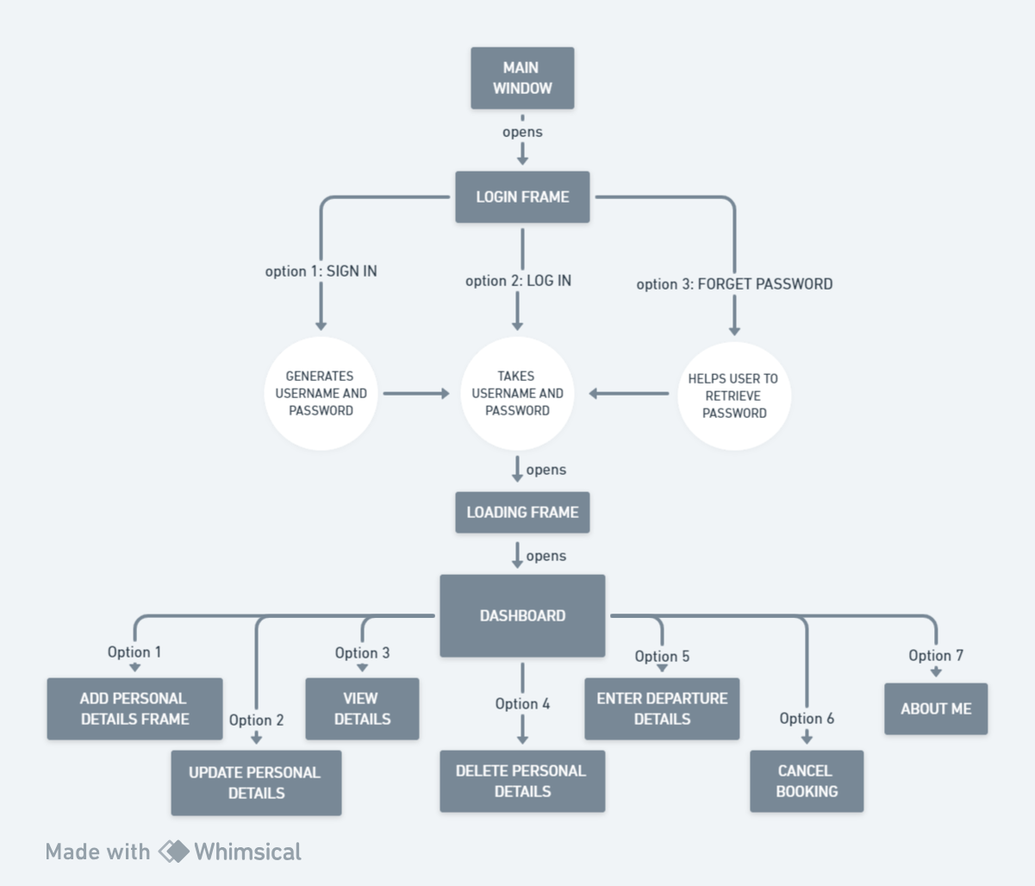

Fig. 3.3.1 Basic Flow of Program till Dashboard

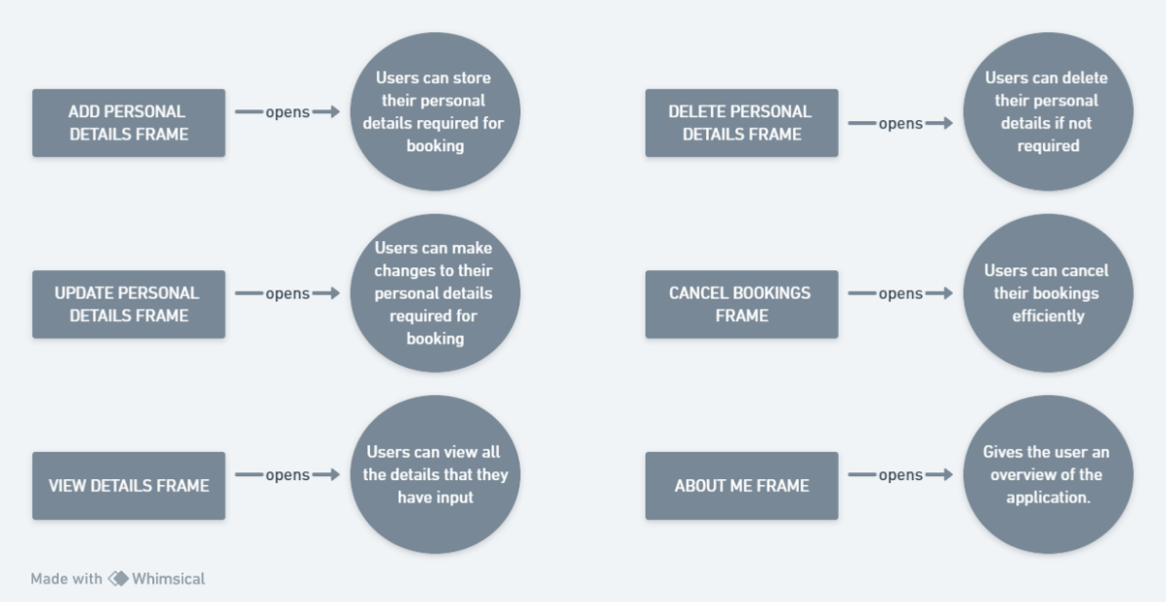

Fig. 3.3.2 Other Frames in Dashboard

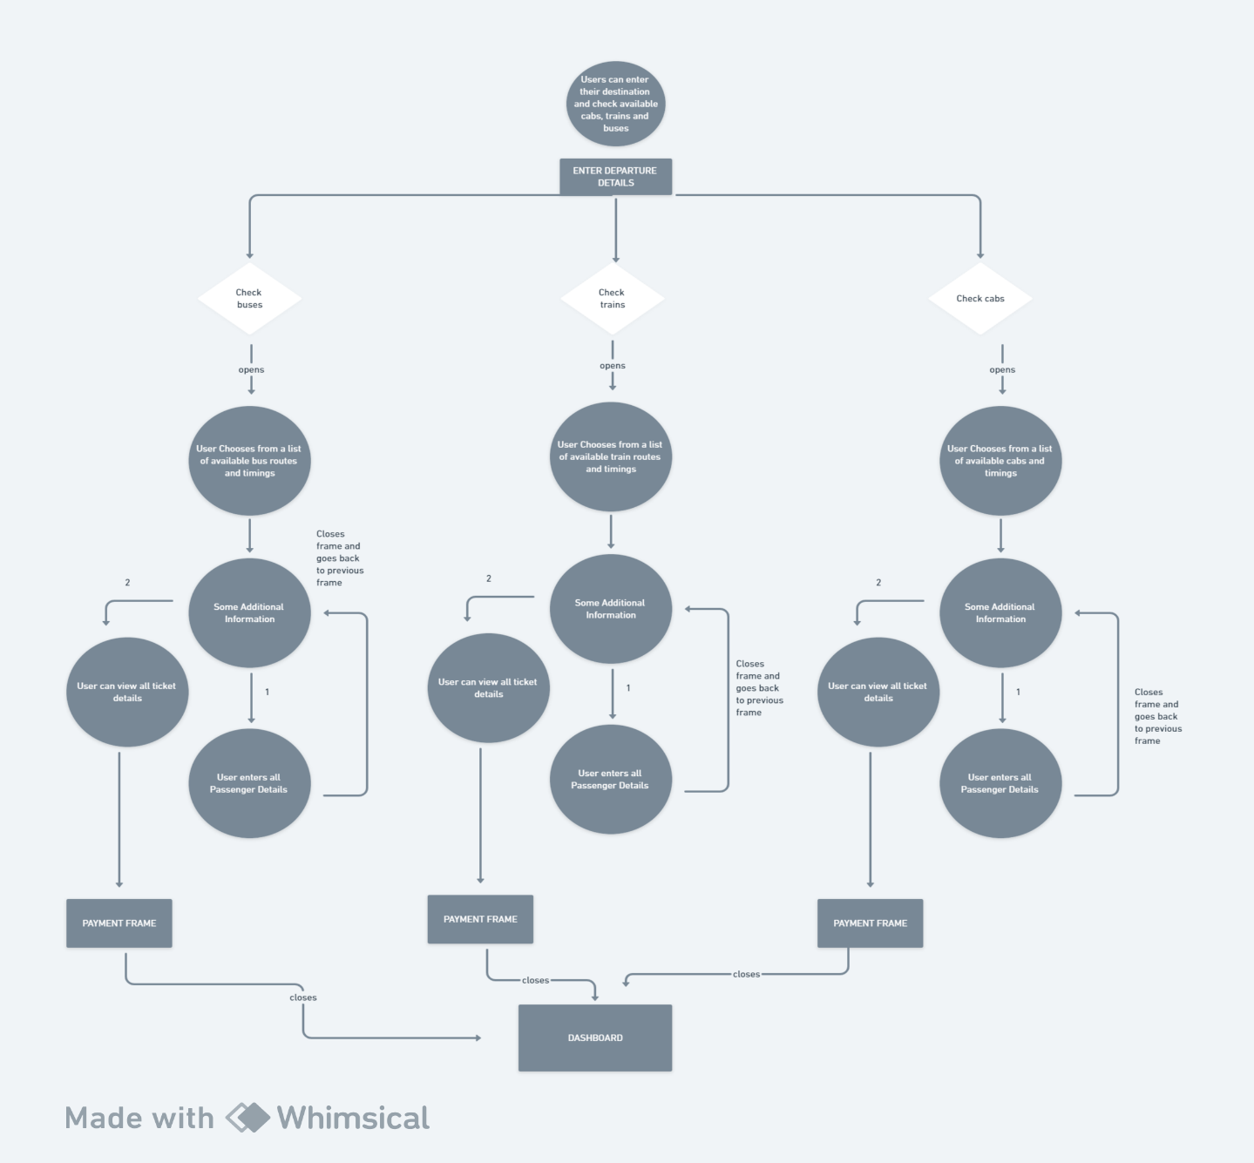

Fig. 3.3.3 Frames for Booking Bus, Train and Cab Tickets

**3.4 Database Implementation**

For the database backbone of the Online Traveling System, MySQL has been chosen as the primary relational database management system. Renowned for its open-source nature and compatibility with Java applications, MySQL offers a robust solution for storing and retrieving data efficiently. The system leverages MySQL's relational structure, allowing the creation of interconnected tables for user credentials, personal details, travel bookings, and departure information. This relational approach ensures data integrity, minimizes redundancy, and facilitates seamless integration with the Java Swings framework.

MySQL's security features, including robust authentication and access controls, are harnessed to safeguard sensitive user information. Passwords are securely hashed and stored, adhering to industry standards. The SQL capabilities of MySQL are utilized to execute optimized queries, enhancing the performance and responsiveness of the Online Traveling System. In essence, the selection of MySQL as the database system aligns with the project's goal of providing a secure, structured, and efficient platform for users to manage their travel-related activities.

**3.4 Java and Java Swings Integration**

In the development framework of the Online Traveling System, Java serves as the core programming language, offering versatility and cross-platform compatibility. Java's object-oriented paradigm provides a structured foundation for building scalable and modular components within the application. This choice aligns with the project's aim to create a robust, platform-independent system capable of delivering a seamless user experience.

Java Swings, a user interface toolkit for Java applications, plays a pivotal role in shaping the graphical user interface (GUI) of the Online Traveling System. With its rich set of components and a flexible architecture, Java Swings empowers the creation of an intuitive and aesthetically pleasing user interface. The integration of Java Swings ensures a responsive and interactive user experience, allowing for the implementation of features such as easy navigation, data input forms, and dynamic content display. The combination of Java and Java Swings contributes to the development of a user-friendly and visually appealing online travel management system.

**3.5 JDBC for Database Connectivity**

To seamlessly link the graphical user interface (GUI) with the MySQL database in the Online Traveling System, Java Database Connectivity (JDBC) is employed. A dedicated “Conn” class manages this connection, handling tasks such as establishing connections, executing queries, and managing data transactions. Through JDBC, the system dynamically interacts with the MySQL database, ensuring real-time data retrieval and updates. This integration establishes a robust link, fostering a responsive and reliable platform for users to efficiently manage their travel bookings.

**3.6 SQL Commands**

**1) TABLE 3.6.1: DDL – Data Definition Language**

|  |  |
| --- | --- |
| **Commands** | **Description** |
| CREATE | Creates a new table. |
| ALTER | Modifies an existing database object, such as tables. |
| DROP | Deletes the table, a view or other objects of the table. |

**2)TABLE 3.6.2: DML – Data Manipulation Language**

|  |  |
| --- | --- |
| **Commands** | **Description** |
| SELECT | Retrieves certain records from one or more tables. |
| INSERT | Creates a record. |
| UPDATE | Modifies the record. |
| DELETE | Deletes records. |

**3)TABLE 1.2.3: DCL – Data Control Language**

|  |  |
| --- | --- |
| **Commands** | **Description** |
| GRANT | Gives a privilege to the user. |
| REVOKE | Takes back privileges granted from user. |

**Chapter 4**

**Result and Discussion**

**4.1 Testing**

|  |  |  |  |  |  |  |
| --- | --- | --- | --- | --- | --- | --- |
| **Test cases**  **No.** | **Test case** | **Input Data** | **Steps to execute the test case** | **Expected Result** | **Actual Result** | **Pass/Fail** |
| **1** | Login Screen | Wrong username or password | After entering the data click  on the login button | A proper message indicating the error should appear and the user should be redirected to login screen. | A message  was displayed saying Invalid username or password | Pass |
| **2** | Insertion | If any field was entered, say passenger details | After entering the data click  on the enter button | A proper message should appear and the user should be redirected to customer screen. | A message  was displayed saying all passenger details entered | Pass |
| **3** | Deletion | If a field was to be deleted | After clicking  on the delete button | A proper message should appear and the user should be redirected to customer screen. | A message  was displayed saying All details deleted successfully | Pass |
| **4** | Update | If any field needs to be changed | After entering the data click  on the update button | A proper message should appear and the user should be redirected to update customer screen. | A message  was displayed saying All details updated successfully | Pass |

**Chapter 5**

**Conclusion and Future Work**

**5.1 Conclusion**

The successful implementation of the Online Traveling System, leveraging technologies such as Java, Java Swings, MySQL, and JDBC, underscores its capability to provide users with a seamless and user-friendly platform for managing their travel activities. The integration of Java ensures cross-platform compatibility and a scalable architecture, while Java Swings contributes to an intuitive and visually appealing graphical user interface. The choice of MySQL as the relational database management system enhances data integrity and security, facilitated through JDBC for efficient connectivity.

The project's success lies in the synergy of these technologies, creating a robust system that caters to the diverse needs of users seeking to book train, bus, and cab tickets. The incorporation of MySQL ensures a secure and organized storage of user data, while Java Swings enhances the overall user experience with a responsive and aesthetically pleasing interface.

**5.2 Future Scope**

Looking ahead, the Online Traveling System can be expanded to incorporate additional features, such as real-time travel updates, personalized recommendations, and integration with external services for a comprehensive travel experience. Implementation of advanced security measures and exploring cloud-based solutions can further enhance the system's reliability and accessibility. Additionally, mobile application development can be pursued to meet the evolving preferences of users who prefer on-the-go access. Continuous updates and enhancements will ensure that the Online Traveling System remains at the forefront of technology, providing an efficient and enjoyable travel management experience for users.

**5.3 References**

We have taken references from many resources like YouTube and many websites.

Websites:

* <https://www.w3schools.com>
* <https://www.javatpoint.com>
* <https://www.codecademy.com>
* <https://www.stackoverflow.com>

YouTube video links:

1. <https://youtu.be/5vzCjvUwMXg>
2. <https://youtu.be/dwVj_g3TpZ4>