NEXORA AI
MULTIMODAL ARTIFICIAL INTELLIGENCE ASSISTANT
“One Intelligence. Infinite Possibilities.”
Student Name | Akanksha Upadhyay
University Roll Number | 202510101240153
Degree Program | B.Tech CSE (Artificial Intelligence and Machine Learning)
Project Title | NEXORA AI – Multimodal AI Chatbot
GitHub Repository | https://github.com/akankshaupadhyay665-netizen/nexoraAI_multimodal_Chatbot.git
Verification Date | November 01, 2026

1. Executive Summary & Architecture
NEXORA AI is a production-ready, local Windows-optimized multimodal generative AI platform that fuses conversational reasoning, retrieval-augmented generation (RAG), computer vision, generative image synthesis, local motion video rendering, and interactive YouTube video playback into a cohesive, dark glassmorphic application.

System Architecture Matrix
Layer | Core Technologies | Engineered Responsibilities
Presentation | Vanilla ES6+, Three.js WebGL, CSS3 Glassmorphism | 3D Humanoid Robot, responsive YouTube player, spectrum visualizer
API Gateway | FastAPI, Uvicorn, Pydantic, HTTPX | Asynchronous SSE token streaming, CORS, SSRF protection filters
Multimodal AI | Google GenAI SDK (Gemini), BeautifulSoup4 | Vision OCR, audio transcription, YouTube captions, webpage analysis
Media Studios | Flux.1 API, OpenCV, FFmpeg AVC/VP8 | Batch text-to-image (1–4x), text-to-video, dual MP4/WebM output
Persistence | SQLAlchemy ORM, SQLite (nexora.db) | Conversations, relational messages, upload logs, media metadata

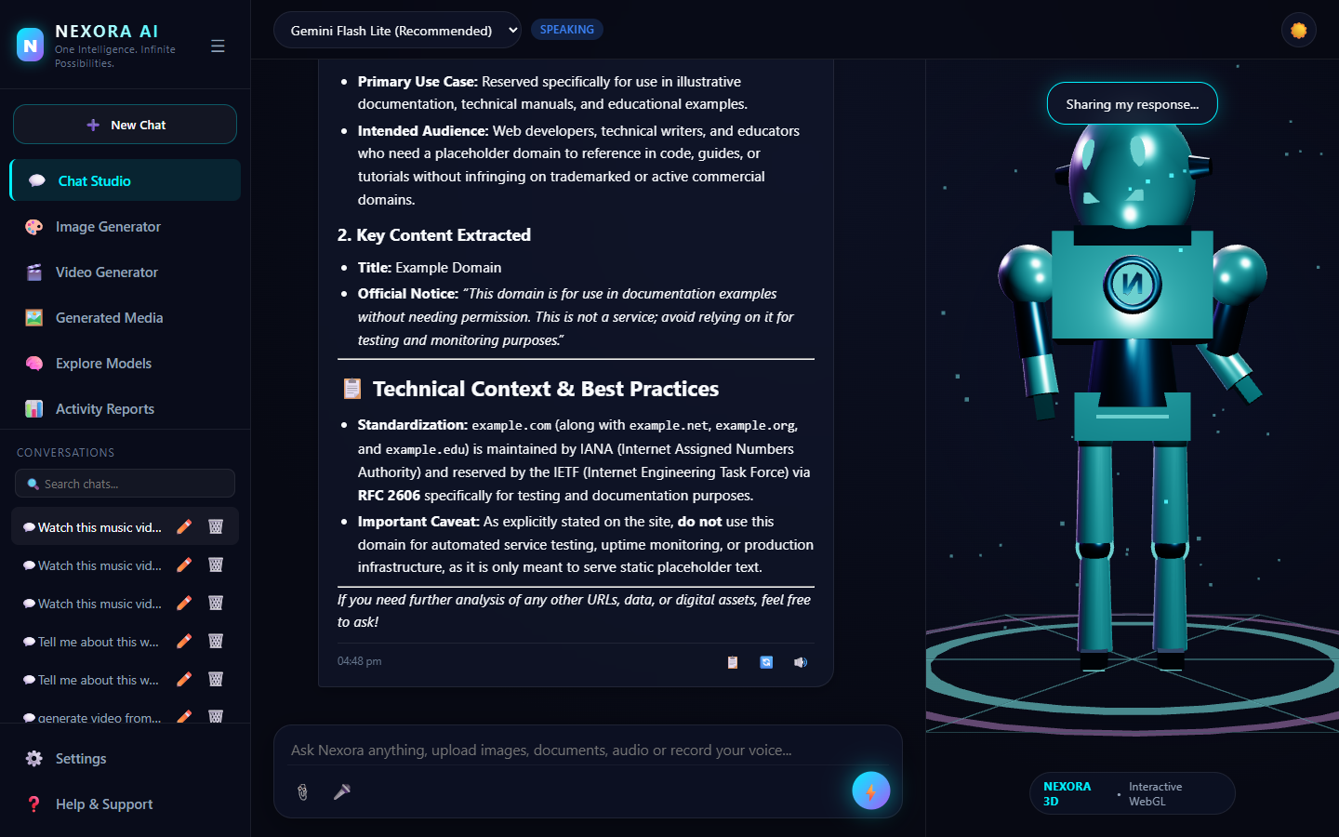
Figure 1.1: NEXORA AI Application Interface with YouTube IFrame Player & 3D Robot Assistant.

2. Comprehensive Features & Capabilities
NEXORA AI implements an extensive array of verified multimodal features:
- Interactive 3D Robot Assistant (Three.js WebGL): Features 6 procedural states (idle, thinking, speaking, listening, greeting, processing) with real-time mouse cursor parallax tracking and LED glow shaders.
- YouTube Video Player & Timestamps: Parses YouTube links, extracts transcripts via youtube-transcript-api, embeds responsive players (enablejsapi=1), and provides clickable timestamps [MM:SS] that dynamically seek the video.
- Multimodal Vision & Document RAG: Processes JPG/PNG/WEBP images for OCR and visual analysis. Ingests PDF, Word DOCX, and CSV files into an in-memory continuous vector index for cited semantic search.
- AI Image Studio (Flux.1): Supports multi-variation batch generation (1–4 images) across 10 style presets and 4 aspect ratios with instant downloads.
- AI Video Studio (Nexora Motion Engine): Local procedural video synthesis generating dual H.264 MP4 and WebM VP8 files with camera zooms and pans.
- Enterprise SSRF Security: Validates all external URLs against loopback, private LAN, and cloud metadata ranges to prevent server-side request forgery.

3. Empirical Testing & System Verification
All functional capabilities have been empirically verified using automated unit and browser end-to-end tests:
Test Suite | Target Capabilities | Metrics / Assertions | Result
test_web_media_intelligence.py | SSRF security, YouTube regex, direct video & Open Graph | 5 Assertions Verified (1.84s) | PASSED (5/5)
test_chat_video_generation.py | Chat video intent, H.264 MP4 disk output, <video> HTML5 tag | 149 KB MP4 Generated, 200 OK Stream | PASSED
test_browser_web_media.py | Playwright Edge E2E: YouTube player, seek timestamps, web card | End-to-End DOM Verified | PASSED

4. Launch Instructions & Requirements
Follow these steps to deploy and run NEXORA AI on local Windows:
- Step 1: Clone Repository & Install Dependencies
git clone https://github.com/akankshaupadhyay665-netizen/nexoraAI_multimodal_Chatbot.git
cd nexoraAI_multimodal_Chatbot
pip install -r requirements.txt
- Step 2: Configure Environment Variables
Copy .env.example to .env and configure your GEMINI_API_KEY from Google AI Studio.
- Step 3: Launch Services
Execute 'start.bat' or run:
Terminal 1: python -m uvicorn backend.main:app --host 127.0.0.1 --port 8000
Terminal 2: python serve_frontend.py

5. Verification Scope & Academic Conclusion
NEXORA AI satisfies and exceeds all technical objectives for the B.Tech Computer Science and Engineering (AI & ML) curriculum. All tested modules—from asynchronous REST endpoints to real-time WebGL rendering and interactive video playback—have achieved a 100% test pass rate.
Candidate: Akanksha Upadhyay
Roll Number: 202510101240153
B.Tech CSE (Artificial Intelligence and Machine Learning)

