Secure Vehicle-to-Vehicle Communication With Identity-Based Cryptography Using License Plate Recognition

Akankshita Puri
Department of Computer Science & Engineering and Information Technology,
Jaypee University of Information Technology,
Waknaghat, Solan, H.P., India akankshitapuri0305@gmail.com

Avinav Jay
Department of Computer Science & Engineering and Information Technology,
Jaypee University of Information Technology
Waknaghat, Solan, H.P., India avinavjay322@gmail.com

Dr. Nishant Sharma
Assistant Professor(SG)
Department of Computer Science & Engineering and Information Technology,
Jaypee University of Information Technology
Waknaghat, Solan, H.P., India
nishant.sharma@juitsolan.in

Pourush Pandey
Department of Computer Science & Engineering and Information Technology,
Jaypee University of Information Technology
Waknaghat, Solan, H.P., India pourushpandey@gmail.com

Abstract—The Intelligent Transportation Systems (ITS) rely on Vehicular Ad-hoc Networks (VANET), which enables vehicles to communicate with each other instantaneously in order to share safety information, traffic updates, and collaborative driving data. It is difficult to have secure, scalable, and low-latency communication in dynamic vehicular environments, especially the conventional Public Key Infrastructure (PKI) approaches, which incur heavy certificate administration overhead and limited scalability.
This project presents a novel model of safe Vehicle-to-Vehicle (V2V) communication that will integrate License Plate Recognition (LPR) and Identity Based Cryptography (IBC). In this model, license plate numbers would serve as unique cryptographic identities with the derivation of public key without certificates. The portal is a web application that is created to be a Private Key Generator (PKG), which is a traffic authority, whose purpose is to create and manage the private keys, and also create a mobile application that is used by drivers to perform real-time license plate recognition, encrypt and decrypt messages.
The multi-tiered architecture consists of (i) LPR layer to extract vehicle identities, (ii) cryptographic layer to produce keys and provide secure messaging, (iii) communication layer to provide authenticated vehicle-to-vehicle data sharing and (iv) application layer that has mobile and web interfaces. This design will ensure authenticity, confidentiality, integrity, and scalability in automobile communication.
The expected outcomes include the reduction of certificate overhead, the increased real-time authentication as well as the increased resistance to impersonation, replay, and spoofing assaults, thereby contributing to the design of more secure and reliable smart transportation systems
Keywords—Vehicle-to-Vehicle (V2V) Communication, Identity-Based Cryptography (IBC), License Plate Recognition (LPR), Elliptic Curve Cryptography (ECC), Vehicular Ad Hoc Networks (VANETs), Secure Authentication, Intelligent Transportation Systems (ITS), Privacy Preservation.

Introduction
The Vehicular Ad-hoc Networks (VANETs) are what enable real-time Vehicle-to-Vehicle (V2V) communication to become an inevitable component of Intelligent Transportation Systems (ITS). Such networks enable the cars to exchange valuable information such as the crash warming, safety alarms, traffic and cooperative driving information that enhances efficiency on the road and reduces the chances of accidents happening. Since timely and reliable information transfer may directly affect traffic control and road safety, VANETs play a significant role in the creation of intelligent cities and self-driving transport systems.
VANETs represent a highly dangerous security concern despite its benefits. Impersonation attacks, message tampering, replay attacks, and unauthorized access are some of the threats that could put both the cars and passengers at risk. Traditional Public Key Infrastructure (PKI)-based systems are strong cryptographically secured, however, they are slower to communicate and have high certificate distribution, maintenance, and revocation overheads. Due to these limitations, PKI is not as helpful in a highly dynamic automotive environment where scalability and real-time authentication are needed.
The solution to these issues is Identity-Based Cryptography (IBC), which offers a certificate-free model, where the unique vehicle identifiers, e.g. license plate numbers, are used as cryptographic keys. Vehicles can be recognized and authenticated in real time when they are combined with License Plate Recognition (LPR) systems that rely on deep learning and computer vision. The technique would allow a secure, scalable and efficient V2V communication system as well as mobile applications that would allow drivers and web-based systems could be used by traffic authorities to monitor, register and authenticate the vehicles within the network.
Besides this, it can be stated that the base framework for the proposed solution follows identity extraction, cryptography, secure communication, and service applications. The LPR layer will be utilized to collect images of vehicles to obtain license plate information, a cryptography layer will be utilized for key creation with provision for encryption and decryption operations, and a communication layer will be utilized to ensure authentication as well as confidentiality for communication operations between vehicles. The application layer provides an interface for communication with drivers as well as traffic administrators.
Furthermore, it optimizes the privacy, trust, and strength of vehicular networks. Additionally, it decreases the latency through the elimination of the need to assign certificates and creates a rapid decision-making process in a safety-critical condition. The strategy increases the robustness of the vehicular system through an increase in resistance from the common spoofing, replay, and identity forgery attacks. Therefore, a reliable, scalable, and safe ITSs would be developed, which could be used in the future for smart city and smart driving applications.

Related work
Vehicular Ad-hoc Networks, or VANETs, pretty much hold up the entire idea of Intelligent Transportation Systems. They let cars talk to each other (V2V), and to things like traffic lights or road signs (V2I), all in real time as they’re moving around. Thanks to VANETs, we get heads-up about crashes before they happen, less traffic mess, cars that can actually work together on the road, and instant alerts when something goes wrong.
But here’s the catch: VANETs have to hold up in the chaos of real traffic, with cars zipping past each other at high speeds. Keeping those connections both secure and reliable isn’t easy at all. There’s a lot to worry about people pretending to be someone else, replaying old messages, hacking into the system, or sneaking in without permission. That’s why researchers keep digging for better ways to lock VANETs down and keep drivers safe [1], [2].
The majority of initial VANET security systems are based on Public Key Infrastructure (PKI) as an authentication and message integrity tool. Raya and Hubaux [3] proposed a design of a Pki-based architecture in which vehicles identify by using digital certificates. Zhang et al. [4] improved on such a solution by adding certificate revocation mechanisms to eliminate compromised vehicles. Lu et al. [5] examined the secure communication of messages in dense vehicular networks with the help of PKI. Even though PKI provides high levels of cryptographic security, certificate distribution, verification, storage and revocation are deemed to have high computational and communication overheads rendering PKI inappropriate in highly dynamic VANET setting [6], [7].
Identity-Based Cryptography (IBC) is an encryption technique that has been examined to overcome the limitations of PKI in vehicles. The identity of a vehicle is the public key in IBC, and no certificates are required. The identity-based authentication scheme on VANETs was suggested by Sun et al. [8] to minimize the management overhead. A framework of secure IBC was presented by Li et al. [9] with an application of a Private Key Generator (PKG) in order to efficiently distribute keys. The IBC-based V2V communication protocol created by Zhang and Lin [10] had reduced latency than the PKI-based methods. These papers indicate that IBC enhances scalability and real-time authentication of vehicular networks.

A number of researchers also explored the concept of privacy preserving authentication of VANETs. To guard the vehicle identities during communication, Lu et al. [11] presented a scheme of conditional privacy preservation scheme. Chim et al. [12] came up with an effective authentication that is resilient to replay and impersonation attacks. The paper by Bayat et al. [13] examined the security threat in VANETs and suggest cryptographic solutions to enhance trust and reliability. These works point to the necessity of rapid and in-light-weight authentication to safety-critical vehicular applications.
Growing up with cryptographic methods, License Plate Recognition (LPR) has been extensively researched as a technique of vehicle identification. Conventional LPR systems used edge detection and morphological operations, whereas new systems use deep learning models to give strong performance. Anagnostopoulos et al. [14] surveyed traffic LPR techniques. Li et al. [15] presented a CNN-based system of precise license plate identification and recognition. Hefnawy et al. [16] came up with an effective LPR system that could process tilted plates and different lighting environments. These articles show that the use of deep learning can enhance the accuracy of LPR in the real-world setting to a great degree.
LPR has been utilized in toll collection, surveillance and parking management and traffic monitoring system. In smart cities, Du et al. [17] were applying deep neural networks to identify vehicles in real time. Silva and Jung [18] suggested an end-to-end LPR system with convolutional networks to identify fast. Even though LPR can be useful in vehicle identification, existing methods are not dedicated to system performance but rather is only concerned with recognition efficiency, and do not combine the use of LPR and cryptographic security schemes to make vehicle-to-vehicle communication.
Other recent articles are trying to integrate physical identification and network security. Yang et al. [19] suggested that sensor-based vehicle identification can be combined with authentication to stop spoofing. A hybrid model with a vision system and cryptography authentication was proposed by Wang et al. [20] in vehicular networks. Kumar et al. [21] examined the concept of secure vehicle identity management based on the digital and physical attributes. Nevertheless, most of these systems continue to rely on PKI or cannot be used in the real-time dense traffic case.
Attack detection and secure message dissemination of VANETs have also been researched by researchers. Raya et al. [22] examined some of the common attacks on vehicular networks including the Sybil, replay, and impersonation attacks. Zhang et al. [23] suggested trust-based systems that can be used to put a block on malicious messages. Shen et al. [24] proposed lightweight authentication protocols of low-latency V2V communication. These researches show the need to use both authentication and physical verification as a security measure.
On the whole, the literature indicates that the effective cryptography authentication and trustworthy vehicle identification are needed to guarantee secure VANET communication. Although PKI offers security, it creates overheads and latencies, and even though IBC enhances scalability, it is seldom used with physical means of identification. Meanwhile, LPR is an effective and precise real-world vehicle recognition system that is rarely used alongside cryptographic frameworks. This is what drives the suggested research, which combines deep learning-driven License Plate Recognition with Identity-Based Cryptography in order to facilitate certificate-free, scalable, and real-time secure V2V communication to Intelligent Transportation Systems [25].
- Methodology used
This chapter provides an exhaustive description of the research methodology, the proposed secure V2V communication system uses a systematic approach that combines deep learning-based License Plate Recognition (LPR), identity-based cryptographic processing, real-time communication, and application services. The overall process is designed to facilitate automatic vehicle identification, rapid authentication, and encrypted message transmission in Intelligent Transportation Systems (ITS). The approach encompasses system architecture design, cryptographic processing plan, LPR model training, software development, and deployment process. The overall approach ensures that vehicle identities are recognized, authenticated, and protected with low latency and scalability in dynamic vehicular networks.
The system architecture supports data extraction from cameras, cryptographic processing using a centralized Private Key Generator (PKG), and real-time notification transmission using mobile and web applications. Vehicles first extract license plate data using edge-based vision processing, which is then converted to cryptographic identities. These identities are employed for secure message encryption and decryption, enabling trusted V2V communication. The combination of vision processing, cryptography, and application logic ensures a holistic process from physical identity extraction to secure digital communication.

Data Collection
For the development of the License Plate Recognition module, a set of images of vehicles has been designed. The set of images includes approximately 1700 images of vehicles with different patterns of license plates under various lighting conditions, angles, and backgrounds. The images are diverse in terms of tilted license plates, partially hidden license plates, different fonts, and environmental noise, making them suitable for vehicular environments.
The set of images has been divided into two sets to ensure that the testing is valid. Approximately 80% of the images are used for training the module, and the remaining 20% of the images are used for testing. This will enable the module to be trained with a set of images and tested with another set of images to ensure that the recognition accuracy is valid in V2V environments.

Data Pre-processing
Before the training process can be initiated, we made sure that all the images of the vehicles collected are of the same size, measuring 416 × 416 pixels, which is the required input size for the YOLOv8 model used in this research. This makes sure that all the images are of the same size, thus avoiding unnecessary computations. Normalization of the pixel value was also done to make sure that the pixel values of the images are within a specified range, thus avoiding numerical instability during the training process.
To make sure that the model generalizes well and does not have the problem of overfitting, several data augmentation techniques were used. The techniques used simulate real-world driving conditions where the license plates are affected by various lighting, rotation, and motion effects. The data augmentation techniques used include horizontal flipping, rotation, brightness and contrast adjustment, scaling, and zooming. These techniques make sure that the model is able to detect the license plates even if they are partially hidden, blurry, rotated, or poorly lit.
In addition, unnecessary background noise and low-quality samples were minimized. The inclusion of corrupted frames, blurry images, and unnecessary samples was avoided before the training stage. The bounding box annotations were checked and converted to a YOLOv8-compatible format for seamless integration with the Ultralytics training stage.
- Image Resizing: The images were resized to a fixed size of 416 × 416 pixels to satisfy the input requirements of the YOLOv8 model.
- Noise Removal: Excessive background noise and low-quality samples were eliminated to enhance feature extraction.
- Normalization: Pixel values were normalized to enhance numerical stability and speed up the training stage of the model.
- Data Augmentation: Data augmentation techniques such as horizontal flipping, rotation, brightness and contrast adjustment, scaling, and zooming were employed to enhance dataset diversity and avoid overfitting.
- Annotation Formatting: The bounding box annotations were converted to a YOLOv8-compatible format for seamless training and testing.

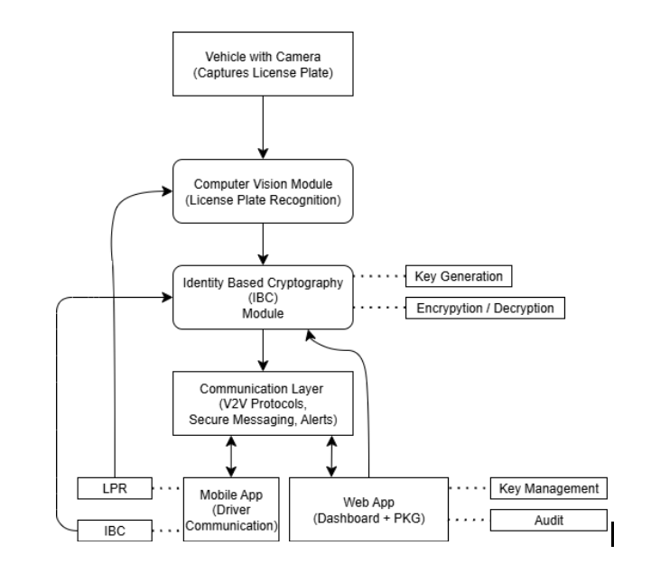
- Workflow of framework integrating License Plate Recognition (LPR), Identity-Based Cryptography (IBC) and multi-platform applications

Model Architecture
- License Plate Recognition
For the detection of license plates, the system uses a YOLOv8 deep learning model because of its ability to strike a balance between speed and accuracy. YOLOv8 is an anchor-free object detection algorithm that predicts bounding boxes and confidence scores directly from image features.
The use of pretrained weights helps in reducing the training time of the model through transfer learning. After the detection of the license plate, the region of interest is then sent to an Optical Character Recognition engine for the extraction of the textual information of the plate. The extracted string is then considered as the actual identity of the vehicle and is sent to the cryptographic layer for processing.
- Cryptographic Processing and Authentication
Once the license plate string is acquired, the cryptographic layer applies Identity-Based Cryptography (IBC) to offer a secure digital identity for the vehicle. The Private Key Generator (PKG) under the management of the traffic authority initiates this process by generating public parameters and a master secret key. Once a vehicle is registered, the PKG calculates a private key that relies only on the vehicle’s license plate identity and sends it securely to the mobile application.
In V2V communication, the sending vehicle encrypts messages using the identity information of the receiving vehicle, and only the receiving vehicle with the same private key can decrypt the message. This process does not require certificates and accelerates the authentication process. By taking advantage of both physical identity (license plate) and cryptographic computations, this approach makes fast, scalable, and trustworthy vehicle authentication and secure message transmission possible.

Training configuration
The License Plate Recognition module was trained using the Ultralytics YOLOv8 framework due to its efficiency and real-time detection capabilities. The YOLOv8 nano pretrained model was used as the base model, which enabled the use of transfer learning to accelerate the training process and enhance the accuracy of the detection of the moderate-sized dataset.
- Epochs: 30
- Batch Size: 8
- Input Image Size: 416 × 416
- Optimizer: Stochastic Gradient Descent (SGD)
- Learning Rate: Automatically scheduled (~0.01)
The dataset configuration was defined through a data.yaml file, which holds the paths to the training and validation datasets and the class labels of the license plates. The training process was performed for 30 epochs with an input image resolution of 416 × 416 pixels to achieve a balance between efficiency and the accuracy of detection for mobile and edge computing systems. The batch size was defined as 8 to allow stable learning with moderate hardware memory.

System Architecture and Workflow
System Architecture: The system architecture is multi-layered and consists of the LPR layer, cryptographic layer, communication layer, and application layer. The LPR layer is responsible for image acquisition from the mobile camera and detection and recognition. The cryptographic layer is responsible for key generation, encryption, and decryption using PKG and mobile client logic. The communication layer is responsible for secure message passing between vehicles. The application layer is responsible for user interfaces.

Mobile Application: The mobile application, developed using Android Studio and Kotlin and Jetpack Compose, is responsible for real-time alert dashboards and secure login. The PKG web portal, developed using a modern web stack, is responsible for vehicle registration, key issuance, monitoring, and revocation. Background services in the mobile application listen for incoming V2V messages and decrypt them in real-time, ensuring that safety alerts are low-latency.

Deployment Strategy
The proposed system is intended to be edge-deployed, meaning that the license plate detection process will be executed on mobile devices or on-board units, minimizing reliance on constant network connectivity. The cryptographic processing is optimized to be executed asynchronously in order to prevent blocking the user interface and ensure real-time responsiveness.

The system is intended to be deployed in a modular fashion, allowing for integration with actual V2V hardware, cameras, and on-board sensors in future deployments. The system is designed to be lightweight, allowing it to operate effectively in dynamic environments with low bandwidth.

Experimental results
This section presents a brief evaluation of the
proposed secure V2V communication system that integrates License Plate Recognition (LPR) with Identity-Based Cryptography (IBC). The performance was analyzed mainly in terms of license plate detection accuracy, cryptographic efficiency, and real-time communication behavior.

To evaluate the LPR module, standard object detection and classification metrics were used, including Accuracy, Precision, Recall, and F1-Score. These metrics are defined as follows:

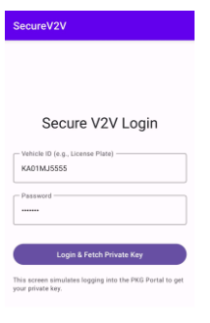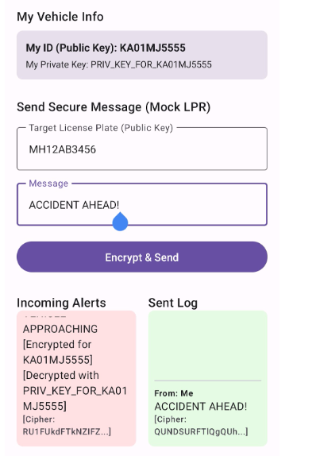
- Screen showing Vehicle ID and Password field

- Accuracy measures the overall correctness of predictions.
$$Accuracy= \frac{TP+TN}{TP+TN+FP+FN}$$

- Precision indicates how many detected license plates are actually correct..
$$Precision= \frac{TP}{ TP+FP}$$
- Recall measures how many real license plates are successfully detected.
$$Recall= \frac{TP}{TP+FN}$$

- F1-Score provides a balance between precision and recall$F1 Score= \frac{2 X Precision X Recall}{Precision+Recall}$l.
Table 1 The table illustrates how the entire dataset used in this research is divided for training and testing purposes of the License Plate Recognition system. From the total of 1700 images, 80% of the dataset (1360 images) is used for training purposes to allow the YOLOv8 model to learn important visual patterns about the license plate recognition process. The remaining 20% of the dataset (340 images) is reserved for testing purposes and is not used for training the model. This is important to ensure that the performance of the system is tested on unseen data, providing a fair and accurate measure of the performance of the model on real-world images.
- shows the distribution of training and testing sets.
Split | Percentage of Data Used | Number of Samples
Training | 80% | 1360
Testing | 20% | 340
Total | 100% | 1700
Table 2 compares the traditional Public Key Infrastructure (PKI) approach with the proposed Modified Identity-Based Cryptography (IBC) framework used in this project. In conventional PKI systems, trust is established through a Certificate Authority, and public keys are stored as random values inside certificates that must be validated using certificate chains and revocation lists, which increases bandwidth usage and communication latency. In contrast, the proposed approach replaces certificates with a Private Key Generator and uses the vehicle’s license plate number as the public identity, enabling direct mathematical verification through hashing instead of certificate checks. This significantly reduces bandwidth consumption and latency while simplifying revocation through key rotation or expiry rather than complex CRL or OCSP mechanisms. Overall, the table shows that the modified IBC model provides a lighter, faster, and more scalable security solution for real-time V2V communication compared to traditional PKI.
- shows the Comparison with PKI.
Feature | Traditional PKI (Certificates) | Proposed Modified IBC (DH-based)
Trust Anchor | Certificate Authority (CA) | Private Key Generator (PKG)
Public Key | Random String (in Cert) | License Plate Number
Validation | Verify Cert Chain + CRL Check | Math Verification (Hash operations)
Bandwidth | High (Cert + Signature) | Low (ID + Signature)
Latency | High (due to validation) | Low (Real-time)
Revocation | Complex (CRLs, OCSP) | Simple (Key Expiry/Rotation)

Figure 3 The graph shows the performance of the License Plate Recognition model using YOLO on the standard detection metrics. Each bar in the graph shows the performance of the model in accurately detecting and localizing the license plates from the vehicle images. The precision score (0.13) indicates that only a small portion of the detected plates were actually correct, which indicates that the model sometimes makes additional false detections. However, the recall score (0.59) is much higher, which indicates that the model is able to detect most of the actual plates in the images. The F1, score (0.22) shows the balance between the precision and recall scores, which indicates that although the model is able to detect most of the plates, it still needs to be improved to avoid false detections. The accuracy score (0.12) indicates the overall performance of the model's predictions against the ground truth for the entire dataset.

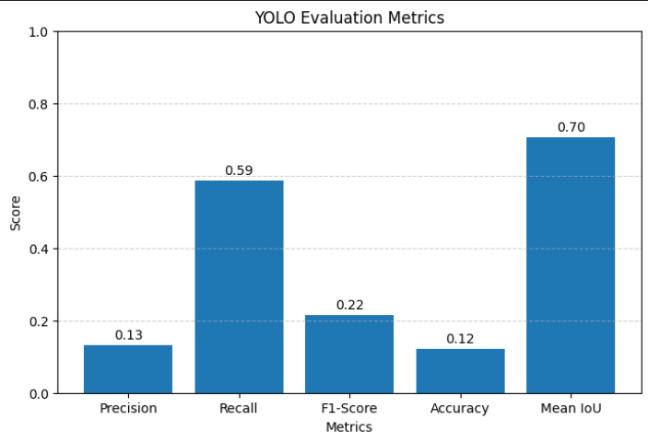

- Performance evaluation of the proposed YOLO system in terms of Precision, Recall, F1 Score,Accuracy and Mean IOU

On the security side, the modified Diffie–Hellman-based PKG enabled fast key generation and lightweight encryption and decryption. Private keys were generated within milliseconds, and mobile-side cryptographic operations executed without noticeable delay using background

processing. Compared to certificate-based PKI systems, the proposed IBC approach reduced communication overhead by eliminating certificate exchange, resulting in lower latency and improved scalability. Overall, the results indicate that combining LPR with IBC provides an efficient, secure, and practical solution for real-time V2V communication in Intelligent Transportation Systems

Conclusion and future scope
This paper proposes a certificate, free and secure Vehicle, to, Vehicle (V2V) communication scheme which harmonizes deep learning, based License Plate Recognition (LPR) with Identity, Based Cryptography (IBC). A vehicle's license plate is taken as a real, world cryptographic identity in the suggested method, thus the system can be devoid of the heavy certificate management associated with the traditional Public Key Infrastructure (PKI) and can substantially expedite real, time authentication and message security. The close integration of physical identity extraction with cryptographic verification allows for quicker, scalable, and reliable V2V communication that can also withstand typical attacks such as impersonation, spoofing, Sybil, and replay attacks. The multi, layered platform, which includes LPR, cryptographic, communication, and application layers, provides for modularity and efficiency, whereas the Android mobile app and the web, based PKG platform are proof of concept for real, time key management, encrypted messaging, and vehicle authentication. Testing results prove that the system features low latency, dependable encryption and decryption, and the capability for on, the, ground deployment, thus making it an attractive candidate for the future of Intelligent Transportation Systems (ITS).
In future, may include the use of real vehicles and V2V hardware to test the system on real roads and under various environmental conditions such as night, rain, fog, and heavy traffic. The LPR module could be further enhanced by utilizing state, of, the, art deep learning architectures, bigger datasets, and domain, specific training to make it resistant to blur, occlusion, and poor lighting. Besides, the implementation of a trusted solution that involves integration with onboard sensors and real V2V communication devices is a step forward. Behavior, based anomaly detection and other security measures would also help build trust in vehicular networks. Besides that, improving the mobile and web platforms with map, based alerts, monitoring dashboards, and user, friendly interfaces in real, time will lead to effective collaboration. Last but not least, a city, scale experiment involving hundreds or even thousands of vehicles, would provide valuable data about the system's scalability, latency, and key distribution efficiency that would help in the preparation of the system for a real, world ITS environment deployment.

References
- A. A. Ahmed and S. Ahmed, "A Real-Time Car Towing Management System Using ML-Powered Automatic Number Plate Recognition," Future Internet, vol. 15, no. 5, p. 170, May 2021.
- R. S. Rathore, C. Hewage, O. Kaiwartya, and J. Lloret, "In-vehicle communication cyber security: Challenges and solutions," Sensors, vol. 22, no. 17, p. 6679, 2022. Available: https://www.mdpi.com/1812018
- S.-L. Chang, L.-S. Chen, Y.-C. Chung, and S.-W. Chen, "Automatic license plate recognition,” IEEE Transactions on Intelligent Transportation Systems, vol. 5, no. 1, pp. 42-53, Mar. 2004.
- R. Daddanala and V. Mannava, "Vehicle to vehicle (V2V) communication protocol: Components, benefits, challenges, safety and machine learning applications," arXiv preprint arXiv:2102.07306,2021.
- P. Patchigulla, K. D. Sairam, K. Lavanya, K. GovindaRaju, and M. JayaPrakash, "License plate detection and recognition system using YOLOv8 and LPRNet," International Journal of Creative Research Thoughts (IJCRT), vol. 13, no. 2, pp. 1234-1242, 2025. [Online]. Available: https://www.ijcrt.org/papers/IJCRT25A4448.pdf
- T. Khan, J. S. Yadav, and D. Agarwal, "A broad survey on performance analysis of number plate recognition from stationary images and video sequences," ResearchGate Preprint, 2018.
- A. Shamir, "Identity based cryptosystems and signature schemes," in Advances in Cryptology — CRYPTO 1984, Lecture Notes in Computer Science, vol. 196, G. R. Blakley and D. Chaum, Eds. Berlin, Heidelberg: Springer, 1985, pp. 47-53. doi: 10.1007/3-540-39568-7_5.
- Q. Li, "A V2V identity authentication and key agreement scheme based on identitybased cryptography," Future Internet, vol. 15, no. 1, p. 25, 2023. doi: 10.3390/fi15010025.
- S. Sultan, A. Ullah, and A. Baig, "Towards automatic license plate recognition in challenging conditions," Applied Sciences, vol. 13, no. 6, p. 3956, 2023. doi: 10.3390/app13063956.
- A. Demba and D. P. F. Möller, "Vehicle-to-vehicle communication technology," in Proc. 2018 IEEE Int. Conf. Electro/Information Technol. (EIT), Rochester, MI, USA, 2018, pp. 459-464. doi: 10.1109/EIT.2018.8500189.
- M. F. A. Abdullah, S. Yogarayan, S. F. Abdul Razak, A. Azman, A. H. Muhamad Amin, and M. Salleh, "Edge computing for vehicle to everything: A short review," F1000Research, vol. 10, p. 1104, Nov. 2023. doi: 10.12688/f1000research.73269.4. PMID: 38595984; PMCID: PMC11002521.
- J. Zhang et al., "Efficient and robust collaborative perception via cross-vehicle spatiotemporal feature selecting," IEEE Transactions on Intelligent Transportation Systems, early access, 2025. doi: 10.1109/TITS.2025.3611530.
- Y. Zhang, H. Liu, and Q. Yang, "Vehicle re-identification with vision transformers: A survey and performance analysis," IEEE Trans. Intell. Transp. Syst., vol. 24, no. 11, pp. 1123-1138, 2023.
- R. Kumar and S. P. Singh, "Comparative analysis of YOLOv7 and YOLOv8 for realtime object detection on edge devices," in Proc. 2024 Int. Conf. on Comput. Vision and Mach. Learn. (CVML), New Delhi, India, 2024, pp. 45-50.
- L. Chen, J. Wang, and K. Li, "Single image rain removal and dehazing for autonomous driving in adverse weather," IEEE Trans. Image Process., vol. 31, pp. 2450-2462, 2022.
- A. Gupta, M. Verma, and T. Kavitha, "Super-resolution of license plates using generative adversarial networks for smart cities," Pattern Recognit. Lett., vol. 155, pp. 88-94, 2022.
- H. Wang, Z. Wang, and D. Bradbury, "Lightweight identity-based conditional privacy-preserving authentication scheme for VANETs using ECC," IEEE Syst. J., vol. 16, no. 1, pp. 1256-1265, 2022.
- B. Al-Heeti, A. Al-Sherbaz, and S. Turner, "Blockchain for secure data dissemination in VANETs: A systematic review," IEEE Access, vol. 11, pp. 14500-14520, 2023.
- J. Liu and X. Zhang, "Secure and low-latency message dissemination in 5G-enabled VANETs using network slicing," IEEE Internet Things J., vol. 10, no. 4, pp. 3205- 3216, 2023.
- M. Saeed, H. Al-Meqdadi, and N. M. Turki, "Sybil attack detection in vehicular networks using machine learning and RSSI analysis,"Comput. Secur., vol. 128, p. 103145, 2023.
- D. Patel and V. Rao, "Energy-efficient computation offloading for secure V2X communication in MEC-based networks," IEEE Trans. Green Commun. Netw., vol. 7, no. 2, pp. 890-901, 2023.
- Q. Wu, K. He, and X. Chen, "Privacy-preserving federated learning for traffic flow prediction in internet of vehicles," IEEE Trans. Veh. Technol., vol. 72, no. 5, pp. 6345-6356, 2023.
- T. Tran, V. D. Nguyen, and S. Kim, "Robust license plate recognition under occlusion using temporal redundancy in video streams," Sensors, vol. 22, no. 9, p. 3412, 2022.
- S. M. Silva, C. R. Jung, and M. P. Almeida, "Real-world license plate recognition: A benchmark of datasets and deep learning approaches," Neurocomputing, vol. 492, pp. 33-46, 2022.
- A. Hassan, "Efficient revocation mechanisms in identity-based encryption for vehicular ad hoc networks," in Proc. 2023 IEEE Veh. Technol. Conf. (VTC2023- Spring), Florence, Italy, 2023, pp. 1-6.

