Mukaila Akeem Oladimeji
220404094

IRO Issues Reporting Outlet
Reporting issues concerning AAUA students and indigenes (Akungba, Iwaro, Etioro, Ayegunle indigenes)

Prepared for: Dr. O. O. Ajayi

1. Introduction

1.1 Purpose
This Software Requirements Specification (SRS) describes the functional and non-functional requirements of the Issues Reporting Outlet (IRO), a web-based system that allows AAUA students and indigenes of the surrounding communities to report and track issues affecting them. It is intended to guide the design, development, and evaluation of the IRO prototype.

1.2 Scope
IRO allows registered and anonymous users to submit issue reports describing problems in their community (security, infrastructure, harassment, health, land/housing, etc.), and allows an IRO Officer to review, categorise, update the status of, and export these reports. The prototype is a client-side web application (HTML, CSS, and JavaScript) that stores data as JSON in the browser's local storage, simulating a lightweight reporting database without requiring a backend server.

1.3 Definitions and Abbreviations
- IRO — Issues Reporting Outlet
- SRS — Software Requirements Specification
- Reporter — a student or indigene who submits an issue report
- IRO Officer — an administrator who reviews and manages submitted reports
- JSON — JavaScript Object Notation, the format used to store report data

2. Overall Description

2.1 Product Perspective
IRO is a standalone, self-contained web application. It does not depend on external servers or third-party APIs; all data persists locally in the user's browser via the localStorage API in JSON form. This design keeps the prototype simple while still demonstrating a realistic reporting workflow.

2.2 User Classes and Characteristics
User Class | Description | Primary Interaction
Reporter | AAUA student or community indigene | Submit issue reports; no login required
IRO Officer | Staff managing community issues | View, filter, update status of, and export reports

2.3 Operating Environment
- Runs in any modern web browser (Chrome, Edge, Firefox) on desktop or mobile.
- No installation or server required — files can be opened directly or hosted on GitHub Pages.
- Built with plain HTML5, CSS3, and vanilla JavaScript (ES6) — no external frameworks.

2.4 Design and Implementation Constraints
- Data storage is client-side only (localStorage as JSON); it is not shared across devices.
- Submission deadline and scope required a minimal, low-complexity interface as instructed.
- The questionnaire to the community is administered separately via Google Forms.

3. Functional Requirements
ID | Requirement
FR-1 | The system shall allow a Reporter to submit an issue report containing name (optional), reporter type, community, category, title, description, and urgency level.
FR-2 | The system shall validate that all required fields are completed before accepting a report.
FR-3 | The system shall assign a unique ID and timestamp to every submitted report.
FR-4 | The system shall persist all submitted reports as JSON in the browser's local storage.
FR-5 | The system shall display a dashboard listing all submitted reports with key details.
FR-6 | The system shall allow the IRO Officer to filter reports by status and by community.
FR-7 | The system shall allow the IRO Officer to update the status of a report (Open, In Progress, Resolved).
FR-8 | The system shall display summary statistics (total, open, in progress, resolved).
FR-9 | The system shall allow reports to be exported as a downloadable JSON file.
FR-10 | The system shall allow all stored reports to be cleared after confirmation.

4. Non-Functional Requirements
Attribute | Requirement
Usability | The interface shall be simple and understandable to first-time users without training.
Performance | Report submission and dashboard updates shall reflect instantly (client-side, no network latency).
Portability | The system shall run on any modern browser without installation.
Maintainability | Code shall be organised into separate HTML, CSS, and JS files for readability and easy modification.
Availability | Since it is a static client-side app, it is available offline once loaded.
Security/Privacy | Reporters may submit anonymously; text input is sanitised before display to prevent script injection.

5. System Interactions Between Major Components
The IRO prototype is composed of three cooperating components:
- Presentation Layer (index.html + style.css) — renders the report form and the dashboard, and captures user input.
- Application Logic (script.js) — validates form input, generates report objects, filters/sorts data, and handles status updates and export.
- Storage Layer (browser localStorage, JSON format) — persists the array of issue-report objects between sessions under the key 'iro_issues'.
Interaction flow: when a Reporter submits the form, script.js reads and validates the field values, builds a JSON object, appends it to the existing array retrieved from localStorage, and re-saves the array as a JSON string. When the IRO Officer opens the dashboard tab, script.js reads the same JSON array from localStorage, applies the selected filters, and renders the report cards and summary statistics. Status changes and the 'Export JSON' / 'Clear All' actions all read from and write back to this same JSON store, keeping a single source of truth for the whole application.

6. Use-Case Diagram
The diagram below shows how the two actors — Reporter and IRO Officer — interact with the major use cases of the system.
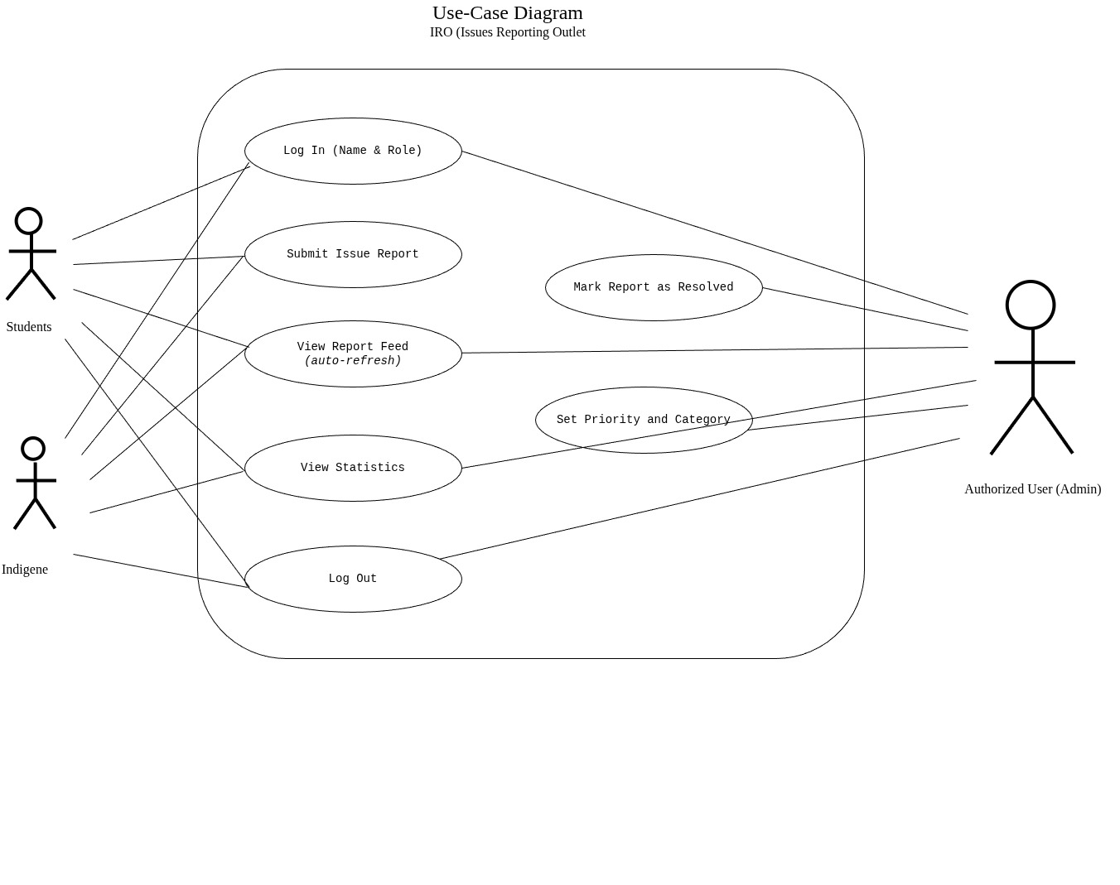
Figure 1: Use-Case Diagram for IRO

7. Ishikawa (Fishbone) Diagram — Problem Analysis
Before designing the solution, a cause-and-effect analysis was carried out to understand why community issues typically go unreported or unresolved. Five cause categories were identified: People, Process, Policy/Management, Technology, Communication, and Environment.

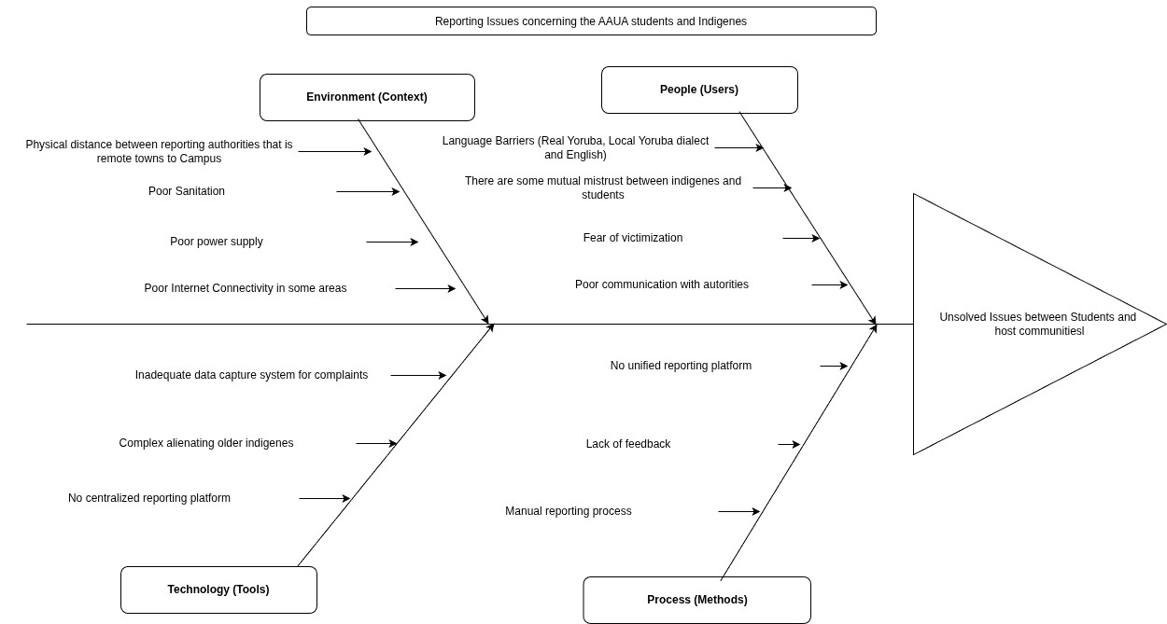
Figure 2: Ishikawa Diagram — Root causes of unreported/unresolved community issues

8. Appendix A — Community Questionnaire (Google Form)
A short questionnaire was designed and distributed to students and indigenes via Google Forms to capture first-hand issue data and validate the categories used in this system. The form captures:
- Respondent type (Student / Indigene) and community of residence
- Whether the respondent has experienced or witnessed a community issue
- The category and description of the issue
- How urgent/severe the respondent considers the issue
- Whether the respondent would use a digital platform to report such issues
(Insert your live Google Form link here, e.g. https://forms.gle/xxxxxxx, and attach a screenshot of the form and its responses summary.)

9. Appendix B — Repository
Source code, this SRS, the use-case diagram, and the Ishikawa diagram are stored in a public GitHub repository. (Insert your GitHub repository link here.)

