**CE 88 Final** **Project**

**Year 2025: Transportation-Energy Nexus in CA**

**Due Friday April 29th (for 5 bonus points)**

**Can be submitted by May 6th with no late penalty**

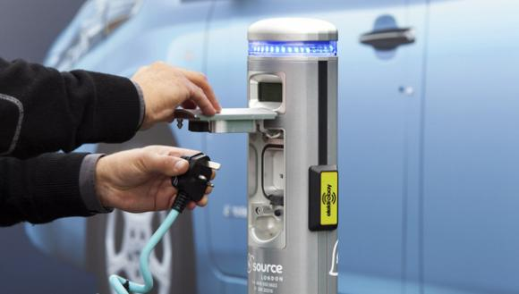In this project you will explore several data sources and develop scenarios of preferred development of renewable energy generation and electricity demand management in California. The main factor you should account for is a rapid growth of the number of Plug-in Electric Vehicles (PEVs) owned and used in California. Charging habits of the PEV owners may result in the demand pattern that is difficult to meet with renewable energy sources, and accurate planning must be carried out to ensure stable operation of the grid while minimizing its reliance on non-renewable sources (producing greenhouse gases, GHG) and hydroelectricity (destructively changing river basin ecosystems).

**The data.** We will work with the data from March 2016 in CA, following the analysis we did in the Minilabs.

The datasets on the current hourly demand as well as production of solar and wind energy (in MWh) in CA was explored in Minilabs 9 and 10. We have observed that diurnal patterns of renewables and growing demand in evening hours create multiple risks, both in terms of the over-generation of energy in day hours as well as the need for the fast ramp-up in the evening hours. Minilab 10 and 11 also explored demand patterns resulting from the charging behaviors of PEV owners. We have observed that a certain proportion of the PEVs are charged in daytime hours, while a majority of PEVs are charged in the evening.

**The Problem.** Multiple ambitious goals were defined by the Governor’s Office for post-2025, under overall goals of GHG emissions reduction. For simplicity, we will summarize the goals as:

> 50% of energy produced from renewable sources,

> 2.5M zero emission vehicles (PEVs).

It means that the production of renewables will need to be scaled up (by a factor of $β_{1}$ and $β_{2}$ for solar and wind). Demand from PEVs will grow, and residential energy consumption will hopefully decline (by a factor of $α_{0}$) due to advances in energy-efficient technology. We can also apply *demand management* strategies to nudge PEV owners change their charging habits and increase the share of PEVs charged at day vs evening hours ( $α_{1}^{1}$ and $α_{1}^{2}$). Then, the goal of reducing GHG and balancing the grid can be posed as an optimization problem of minimizing the squared difference between the renewable energy supplied and the total demand, using a combination of historically observed data and a forecast of demand for 2025:

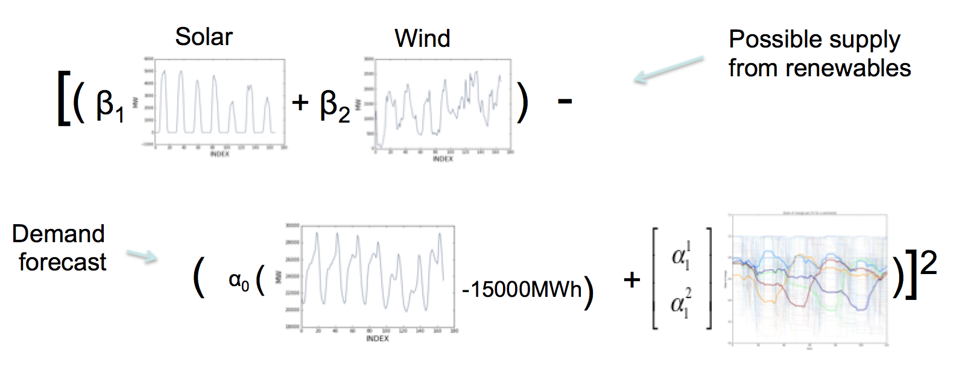

As the demand load never drops below a certain level, and renewable sources are inherently intermittent, assume that there is a constant supply of 15000MWh per hour from non-renewables that one can not avoid using to match this load.

**Your task.**Come up with a proposal for year 2025 that minimize the squared difference between renewable supply and total demand. The proposal should include values for the coefficients $β_{1}$ and $β_{2}$, the amount by which solar and wind energy production, respectively, are scaled, $α_{0}$, the amount by which you expect residential consumption to decline, and $α_{1}^{1}$ and $α_{1}^{2}$, the daytime and evening EV charging demand.

In your proposal you can make some assumptions about future supply and demand, and can fix the corresponding coefficients according to your proposed action plan and/or forecasts, for example:

* if one assumes that domestic energy use will be reduced by 25%, we can fix $α_{0}=0.75$,
* if one proposes to triple production of solar energy, we can fix $β_{1}$ =3,
* if one proposes to oblige PEV owners to charge vehicles at day hours 50% of the time, we can fix $α_{1}^{1}$ =0.5,
* etc.

The rest of the coefficients can be obtained by solving the minimization problem using the *minimize* function of the data8 toolbox (see Lecture 21 examples of Multiple Regression, <https://data-8.appspot.com/sp16/unit?unit=5&lesson=23>).

Any solution that results from an optimization problem must be analysed for its feasibility[1]. Some coefficients might correspond to a situation that would not be possible to implement in reality, and a different scenario should be sought.

Your submission should include a PDF report describing the solution you have found, with reasoning and justification. Enclose the ipynb with an implementation of the methods you used to find and evaluate your scenario.

You are strongly encouraged to discuss the project with classmates and instructors, but your final submition must be individual work.

Let’s build a sustainable future for California!

Good luck!

1. In essence, we are facing an optimization problem with constraints: some coefficients can not be negative, and depending on your data representation and your proposed scenario, you may need to consider $α_{1}^{1}+ α_{1}^{2}=1$ as another constraint.