CE88 Homework 1

Out: 1/26/2016

Due 2/3/2016

10 points

1. Your Background – please tell us the following (1 point):
   1. Your Name
   2. Your intended major
   3. Are you are currently enrolled in C8, the Foundations of data science course? Did you take C8 in the fall?
   4. Describe your prior coding experience – what programming languages have you used? How competent do you feel? (No prior experience is required for this course. We want to see what the range is so we can keep it interesting for all)
2. In a few sentences tell us why you are interested in smart cities (1 point):

**Questions 3-4** are related to the minilab we worked on in class on 1/26. If you have not done so already, please go to <https://data8.berkeley.edu/hub/interact?repo=smart-cities-connector&path=demos> and complete the mini-lab 1 before trying to answer the following questions.

1. In mini-lab 1 we noticed that strangely low traffic counts were caused by the “Black Lives Matter” protest on MLK day that stopped traffic heading westward on the Bay Bridge. While in this case the low traffic flow was caused by a protest, in general low traffic counts can be caused by many things including vehicle collisions, broken sensors, construction, or a protest. Explain how you could use sensor data to distinguish between a collision, a broken sensor, a protest, and construction? (4 points)

(**Hint** – we gave you traffic counts from one sensor. There are hundreds of sensors in the bay area. Below is a map of the sensors near the bay bridge. Could you make use of data from multiple sensors to distinguish between event types? Think about how data from a collision would look different from data from a broken sensor)

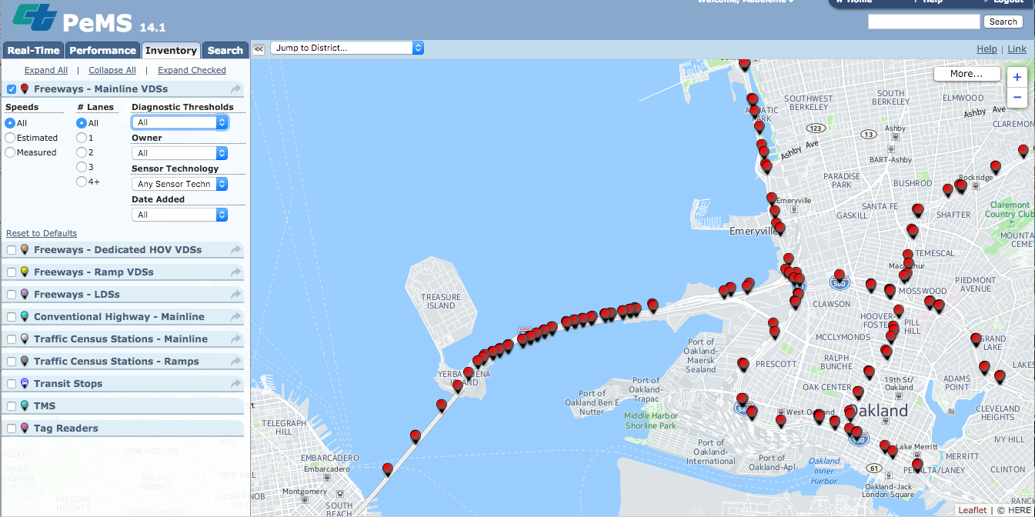

1. In this lab we noticed the cyclical nature of traffic flows. In this exercise we ask you to forecast what you think the per hour traffic counts will be going west-bound on the bay bridge on Wednesday February 3rd.
   1. Create a **graphical** representation of the expected traffic counts per hour for Wednesday February 3rd. (4 points)
   2. **(Extra credit)** Provide numbers for the expected traffic count per hour for each hour from 1 am to midnight on Wednesday February 3rd and explain the process you used to come up with these numbers (2 points extra credit)