**CE 88 Midterm**: **Bike Sharing**

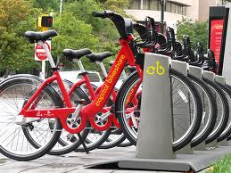In this midterm you will explore the data and build a forecast for the total number of hourly bike rentals in the Capital Bikeshare, a bike sharing network of Washington, D.C.

**The data.** The dataset (**bikeshare_2011.csv**) provided to you is hourly bike rental data of 2011. The following variables are available:

* index: record index, from the beginning of the year (1 to 8760)
* date: date
* season: season (winter, spring, summer, fall)
* year: year (0: 2011, 1: 2012)
* month: month (1 to 12)
* hour: hour (0 to 23)
* holiday: if a day is a holiday or not (if a day is a regular weekend, it is still 0)
* weekday: day of the week (0 - Sunday to 6 - Saturday)
* workingday: if day is neither weekend nor holiday is 1, otherwise is 0.
* weather: general weather conditions

1: Clear, Few clouds, Partly cloudy, Partly cloudy

2: Mist + Cloudy, Mist + Broken clouds, Mist + Few clouds, Mist

3: Light Snow, Light Rain + Thunderstorm, Light Rain + Scattered clouds

4: Heavy Rain + Ice Pallets + Thunderstorm + Mist, Snow + Fog, Apocalypse

* temp: normalized temperature, from values in Celsius. The values are derived via (t-t_min)/(t_max-t_min), t_min=-8, t_max=+39
* feels_like: normalized chill-factor adjusted temperature, from original values in Celsius. The values are derived via (t-t_min)/(t_max-t_min), t_min=-16, t_max=+50
* hum: normalized humidity. The values are divided to 100 (max).
* windspeed: normalized wind speed. The values are divided to 67 (max).

Finally, the dependent variables:

* casual: count of casual users
* registered: count of registered users
* count: total count of bikes rented, casual + registered

**The Problem.** You will be asked to provide a forecast of the number of hourly bike rentals for a number of days in 2012. The exact days (along with all the variables) will be released to you in 1 week. You will then have 3 days to submit your forecast. Meanwhile, use this time to explore the data and prepare your forecasting tools. Bikeshare_Midterm.ipynb provides some basic functions to help you get started.

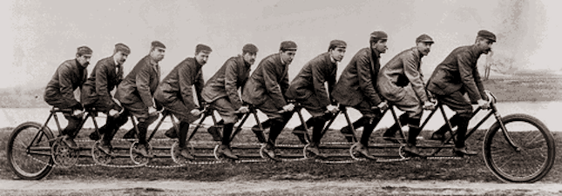

Good luck!