EEG-Based Schizophrenia Detection

Submitted by:
Shrey Rawat-102303669
Abhishek Kansal-102303808

BE Third Year CSE/COE

Submitted to:
Dr. Anjula Mehto
Assistant Professor



Computer Science and Engineering Department Thapar Institute of Engineering and Technology, Patiala

November 2025

TABLE OF CONTENTS

S. No | Topic | Page No.
1 | Introduction or Project Overview | 3
2 | Problem Statement | 4
3 | Overview of the Dataset used | 5
4 | Project workflow | 6
5 | Results | 7
6 | Conclusion | 9

Introduction or Project Overview
Electroencephalography (EEG) is a widely used, non-invasive method for recording brain activity and has become an important tool in studying mental disorders such as schizophrenia. Schizophrenia often shows abnormal patterns in specific EEG frequency bands, especially the alpha rhythm, making EEG a promising biomarker for early and objective detection. Since traditional diagnosis mainly relies on clinical observation, there is a growing need for automated systems that can analyze EEG signals and assist clinicians in identifying the disorder more accurately.sss
This project focuses on designing an EEG-based Schizophrenia Detection System using a hybrid feature fusion approach. Instead of relying only on handcrafted features or only on deep learning, the system combines both to achieve better performance and reliability. The raw EEG signals are first filtered to isolate the alpha band (7.5–15 Hz), which is strongly linked to cognitive functioning and is known to show disruptions in schizophrenia. The filtered signal is then divided into 3-second segments to capture meaningful temporal patterns.
A CNN-BiGRU deep learning model is used to extract spatial and temporal features from each EEG segment. In parallel, handcrafted features—including statistical measures, Hjorth parameters, and band-power features—are computed for all 16 channels. These two sets of features are merged to form a rich, 304-dimensional representation of the EEG signal.
An XGBoost classifier is trained on the fused features, achieving high accuracy in distinguishing healthy individuals from schizophrenia patients. To ensure transparency, the model is analyzed with SHAP explainability, which highlights the most influential features contributing to the prediction.
Overall, this project presents an efficient, interpretable, and data-driven approach to schizophrenia detection, combining signal processing, deep neural networks, and explainable AI techniques to support clinical decision-making.

Problem Statement
Schizophrenia is a complex neuropsychiatric disorder that affects perception, cognition, and behavior. Accurate diagnosis is often challenging because it relies heavily on clinical interviews, subjective evaluation, and behavioral observations. These methods can lead to delayed or inconsistent detection, making early intervention difficult.
Electroencephalography (EEG) provides an objective way to study brain abnormalities associated with schizophrenia, particularly through disruptions in specific frequency bands such as the alpha rhythm. However, raw EEG data is high-dimensional, noisy, and difficult to interpret manually. Therefore, there is a need for an automated system that can efficiently extract meaningful patterns from EEG signals and classify subjects with high accuracy.
The problem addressed in this project is to develop a robust, hybrid machine learning model that can:
- Preprocess EEG signals and extract both deep and handcrafted features,
- Identify discriminative patterns related to schizophrenia,
- Classify EEG segments as either healthy or schizophrenic, and
- Provide interpretable insights into the model’s decision-making.
This system aims to offer a reliable, data-driven approach to assist clinicians in the early and objective detection of schizophrenia.

Overview of the Dataset used
The dataset used in this project is the publicly available EEG Schizophrenia Dataset from Kaggle. It contains multichannel EEG recordings collected from two groups of subjects: healthy individuals (control group) and patients clinically diagnosed with schizophrenia. This makes the dataset suitable for supervised binary classification tasks where the model learns to distinguish between normal and schizophrenic brain activity.
Each EEG recording consists of signals captured from 16 scalp electrodes, following standard EEG acquisition protocols. The signals are sampled at a frequency of 128 Hz, which provides adequate temporal resolution for analyzing brainwave patterns while keeping the data size manageable. The dataset files store raw EEG values in a tabular format, where all channel data is arranged sequentially. During preprocessing, each file is reshaped into a matrix of shape (time samples × 16 channels) to restore the original multichannel signal structure.
To enable meaningful analysis, the EEG recordings are divided into fixed-length 3-second epochs, allowing the model to learn patterns from small, consistent segments. Before segmentation, an alpha-band band-pass filter (7.5–15 Hz) is applied. This frequency band is particularly important because abnormalities in the alpha rhythm have been widely reported in schizophrenia research. Filtering helps remove irrelevant noise and enhances the discriminative patterns present in the EEG.
The dataset provides a balanced mix of healthy and schizophrenia samples, enabling effective training and evaluation of machine learning models. Since the data is raw and unprocessed, it allows complete flexibility in applying custom preprocessing steps such as normalization, filtering, and feature extraction. Overall, this dataset serves as an excellent benchmark for developing an automated, data-driven system for schizophrenia detection using EEG signals.

Project Workflow
This project follows a structured workflow to process EEG signals and develop a hybrid machine learning model for schizophrenia detection:
- Data Loading:
Raw EEG files (.eea) containing 16-channel recordings are loaded and reshaped into a time-series format suitable for analysis.
- Preprocessing:
Signals are filtered using a 7.5–15 Hz alpha-band Butterworth filter to remove noise and focus on clinically relevant frequencies. The filtered EEG is then divided into 3-second epochs.
- Normalization:
Each epoch is standardized using z-score normalization to ensure consistent scaling across all samples.
- Deep Feature Extraction:
A CNN-BiGRU model is applied to each epoch to learn spatial and temporal EEG patterns, producing 128 deep features.
- Handcrafted Feature Extraction:
Statistical features, Hjorth parameters, and band-power features (delta, theta, alpha, beta) are extracted from all 16 channels, generating 176 handcrafted features.
- Feature Fusion:
Deep and handcrafted features are combined to form a 304-dimensional fused feature vector representing each EEG segment.
- Classification:
An XGBoost classifier is trained on the fused features to distinguish between healthy and schizophrenic subjects. Performance is evaluated using accuracy, confusion matrix, and classification reports.
- Explainability:
SHAP values and saliency maps are used to identify the most influential features and time segments contributing to the model’s predictions, ensuring interpretability and reliability.

Results

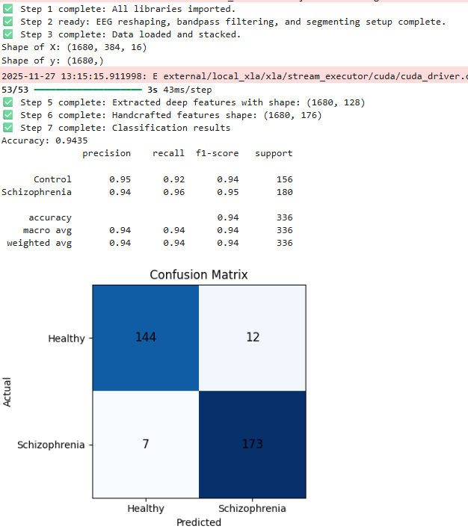

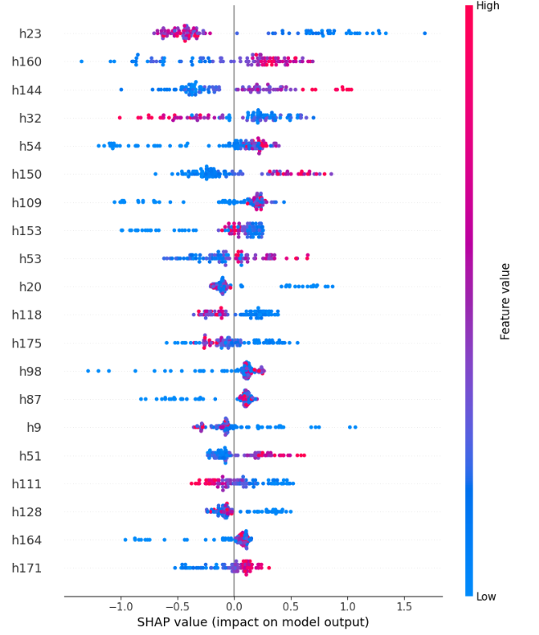

Conclusion

This project presents an effective approach for detecting schizophrenia using EEG signals by combining deep learning and handcrafted feature extraction methods. By applying alpha-band filtering, segmenting the EEG into consistent time windows, and extracting both data-driven and domain-specific features, the system captures important patterns associated with schizophrenia. The fusion of CNN-BiGRU deep features and handcrafted statistical, Hjorth, and band-power features results in a rich representation that significantly improves classification performance.
The XGBoost classifier demonstrates strong accuracy in distinguishing healthy subjects from schizophrenia patients, showing that the hybrid feature fusion strategy is successful. The use of SHAP values and saliency maps enhances the interpretability of the model, making the results more understandable and reliable for potential medical use. Overall, this work highlights the value of combining machine learning, signal processing, and explainable AI techniques to create a reliable, data-driven tool for supporting early and objective schizophrenia detection.

