**IMU: Inertial Measurement Unit**

Consisting three sensors

1. Accelerometer
2. Gyroscope
3. Magneto meter

Accelerometer: <https://www.youtube.com/watch?v=T_iXLNkkjFo&ab_channel=PracticalNinjas>

Gyroscope:

<https://www.youtube.com/watch?v=ti4HEgd4Fgo&ab_channel=PracticalNinjas>

Magneto Meter:

<https://www.youtube.com/watch?v=_ZiLwoClRGQ&ab_channel=PracticalNinjas>

MEMS: Micro Electro Mechanical System

We all have heard about accelerometer, gyroscopes and magnetometers built into our smartphones. Using these sensors, smartphone processors understand the orientation of the phone in 3d space and takes actions accordingly. Let’s take some of our time to understand how these actually work.

**Accelerometer:**

First lets start by understanding the basic physics of acceleration measurement using a spring and mass system. As seen in diagram, a body of mass m is attached to a wall by a spring having spring coefficient k.

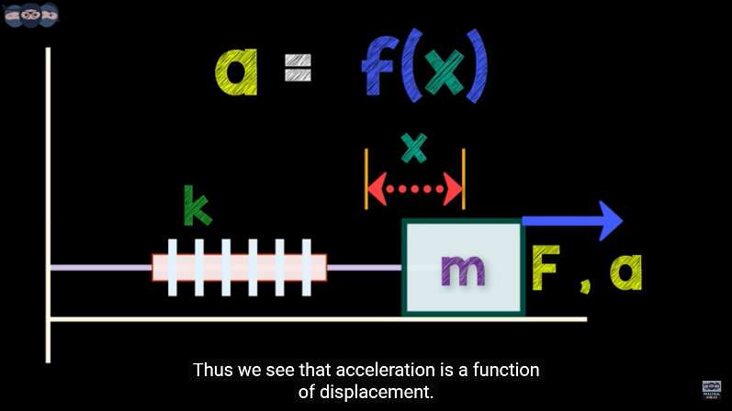

When force F is applied to mass m, it is displaced in the direction of the force by amount x with acceleration a. Using newtons law, and writing the force conserving equation,

we get F = ma = Fs (force due to spring tension).

The force due to spring is written as kx, where x is the displacement of the body from initial rest position. Equating the forces, we get ma=kx.

Thus, we see that acceleration is a function

of displacement.

i.e. a=f(x).

If we are able to measure displacement somehow,

we can calculate the acceleration on the body.

There are different methods to measure displacement ‘x’.

The methods use resistive techniques,

capacitive techniques or inductive techniques.

Let’s have a look at capacitive technique.

We know from basic physics that C=epsilon*A/d,

where d is the displacement between the two plates forming the capacitance. By varying the distance ‘d’ between the plates we can change the capacitance ‘C’. Capacitance can be easily measured electronically by using a signal conditioning circuit. So now to achieve this capacitance change, lets look at the modified spring mass diagram. Here we can see two plates of capacitor. One is the movable plate attached to the mass m. Other is fixed at the initial position. When body accelerates due to force f, it causes change in the displacement ‘x’ which is dependent on the acceleration ‘a’ of the body. Due to ‘x’, the capacitance C across the fixed and movable plates change. By measuring this C, we can calculate the value of ‘x’ which helps us to infer the value of ‘a’. This is the principle of measuring acceleration. However, one cannot employ such big spring mass systems inside accelerometer IC’s.

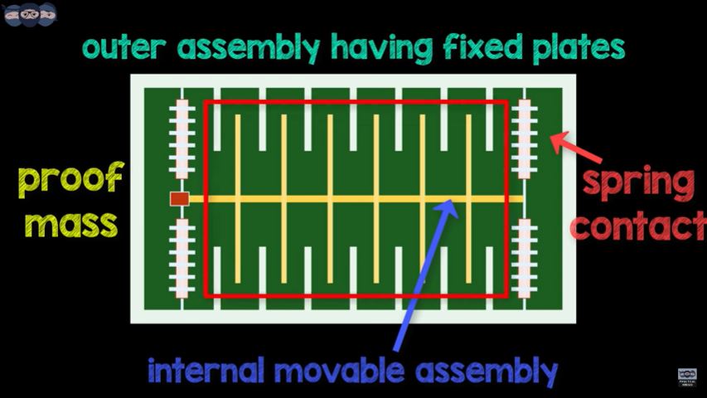

This is where MEMS come into play. MEMS stands for micro electro mechanical systems. These systems contain both mechanical and electronic components, but are fabricated at the scale of micrometer.

These MEMS are employed inside accelerometer IC which helps keep it size small. Looking at the diagram, we can see a series of fixed plate on the outer assembly. Then there is an internal movable assembly having a small mass and connected to outer assembly using spring contacts. The movable assembly also has plates which form a capacitor with plates of outer fixed assembly. As the system moves due to acceleration, the internal assembly moves and due to displacement, the value of different capacitors change.

By measuring these changes in capacitance, we can infer the acceleration acting on the body.

Having such multiple MEMS systems in different planes i.e. X, Y, Z the accelerometer gives the readings of acceleration in different directions as seen by the body.

**Gyroscope:**

The gyroscope is one of the sensor found inside an IMU (Inertial measurement unit). We find lot of appliances having motion control

built into them. To give a few examples, many of us play games on our smartphones. By tilting or rotating the phone, a certain character can be controlled. Similarly, the controller of nintendo wii works using motion control technology. This is made possible only because of the use of sensors which measure acceleration, rotation and sometimes magnetic field acting on the body.

The part about acceleration measurement is already covered.

Now, we will visualize, how the rotation on a particular axis is measured using a gyroscope. Before starting with the construction of gyroscope, let us first understand basic physics principles that allow us to measure rotation. The coriolis force or coriolis effect helps one measure rotation or angular velocity. Once we understand this principle, we can calculate the angular velocity by measuring the coriolis force.

The technique of measurement of force or acceleration is already covered in the accelerometer part. The same principle using capacitance would be used to measure coriolis force however with some minor changes. The gyroscope uses a two mass system which keep moving in opposite direction continuously having same magnitude of velocity. When this whole system experiences angular rotation, both the masses experience Coriolis force. However, they have opposite directions as per the right hand rule. One can visualise it easily from the animation.

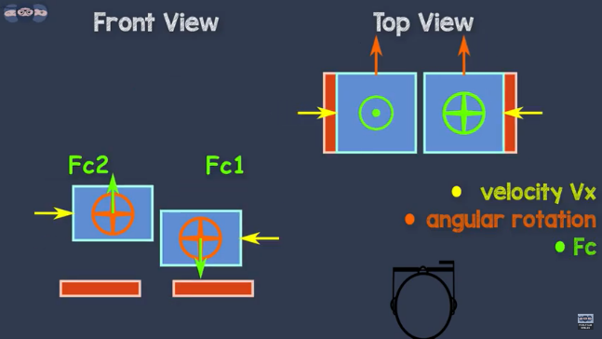 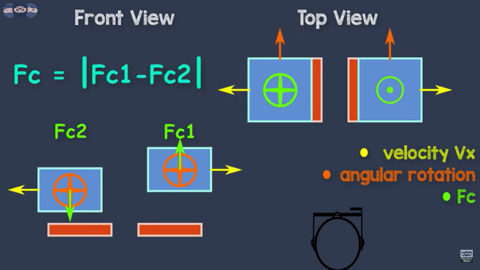

The final value is taken by finding the difference of measured acceleration of the coriolis force. As the acceleration is a vector quantity, and both the accelerations are in opposite directions, they get added up when subtracted. As a result any other unwanted forces acting on the system can be easily neglected and they do not affect the measurement. As seen in the animation, we can see two blocks of mass ‘m’ moving continuously in opposite directions. When they experience angular rotation, Coriolis force acts on these blocks and they move in upward or downward direction. As a result the capacitance across the plate changes as the distance d changes. By measuring delta ‘d’, we can calculate the magnitude of Coriolis force and thereby calculate the angular rotation from the relationship discusses previously. This whole assembly is built as MEMS of the scale of micrometer. This makes it possible to manufacture small IC’s for gyroscopes. Having such systems placed in all the three axis helps to find the angular velocity in X, Y and Z direction.

**Magnetometer:**

The accelerometer and gyroscope found inside an IMU are already covered.

Now, we would learn about the magnetometer. The magnetometer is used to detect the magnetic fields present near the body or object. By studying the magnetic fields, we can find the north direction and thus understand our orientation and location. Many of the smartphones are equipped with a magnetometer to detect the directions. The smartphone is an electronic device and communicates with its sensors using electrical quantities like voltages or currents. So, it is required that the magnetometer output the value of the magnetic field in terms of voltage or current.

This can be achieved using the principle of 'HALL' effect. According to hall effect, if a current carrying conductor is placed in the magnetic field, a voltage is generated across the conductor which is perpendicular to both the current and magnetic field. Let us understand how the voltage is generated. Consider a thin sheet of metal connected to a current source. As seen in the animation, we can see the electrons moving across the thin metal sheet. The electrons are distributed evenly across the sheet. Now when this metal sheet is subjected to the magnetic field, the density of electrons in the metal sheet changes. As seen in the video, we observe that electrons get distributed unevenly.

Due to this distribution, voltage gets generated across the metal sheet and is perpendicular to both the magnetic field and current as seen here.

Now let us understand how and why the electron density changes when magnetic field is applied. A moving electric charge experiences a force when it is present in magnetic field. The magnitude of this force is dependent on the magnetic field, charge and the speed. The direction of this force is perpendicular to both the magnetic field and the velocity of the charged particle. In the case of current, the charge particles are the electrons and they have a specific velocity. When subjected to a magnetic field, they experience a force perpendicular to their velocity and magnetic field, thus deviating from their path.

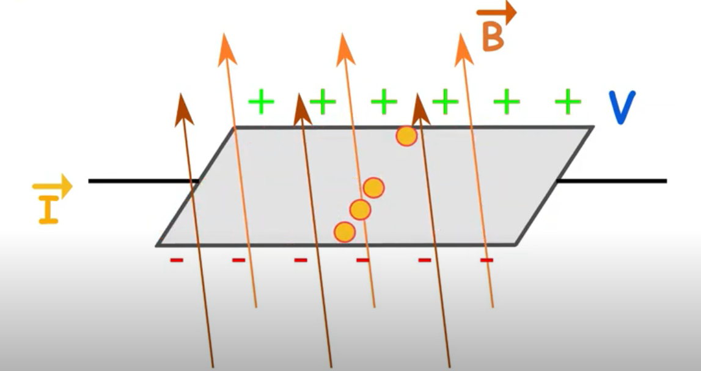

Due to this, as observed earlier, electron density will change, giving rise to potential difference across the metal sheet. By changing the amount of magnetic field or changing its direction leads to change in the force Vector. As the value of force changes, the potential difference also changes, thus giving us the value and direction of magnetic field. Now, if the current is kept constant and the magnetic field is increased, more electrons get disturbed, thus increasing the voltage. This principle is called as HALL effect. Using this principle, we can measure magnetic field using HALL effect sensors. HALL effect sensors employ the technique described in the video and give the output as a voltage which is proportional to the magnetic field.