SQL Analysis of Customer Churn Data
.

Business Questions and SQL Queries
The following queries answer key business questions about churn behaviour using GROUP BY, aggregate functions, and conditional logic.

Q1: What is the churn rate by contract type?
This query calculates the total number of customers, the number churned, and the churn rate percentage for each contract type.
SELECT contract,
COUNT(*) AS total_customers,
SUM(churn) AS churned,
ROUND(100.0 * SUM(churn) / COUNT(*), 2) AS churn_rate_pct
FROM customer_churn
GROUP BY contract
ORDER BY churn_rate_pct DESC;
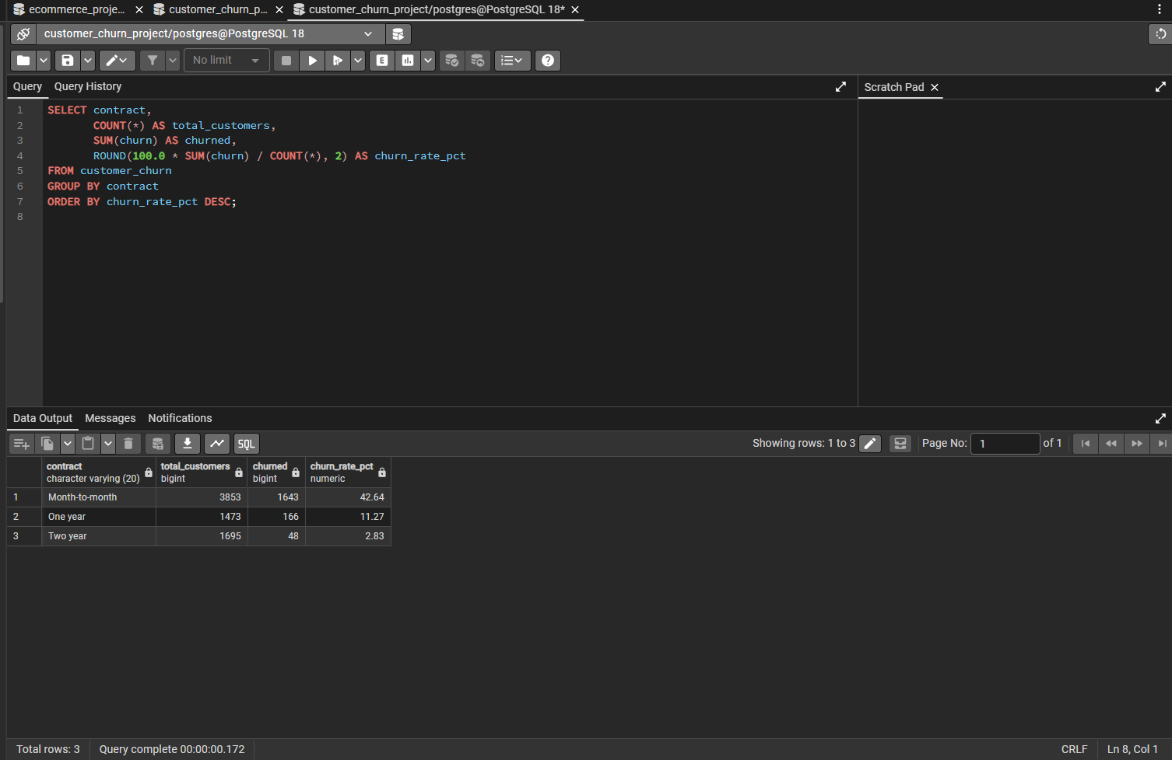

Q2: How does churn vary across tenure groups (0-12, 13-24, 25+ months)?
Customers are grouped into tenure buckets using a CASE statement, and the churn rate is calculated for each group.
SELECT
CASE
WHEN tenure <= 12 THEN '0-12 months'
WHEN tenure <= 24 THEN '13-24 months'
ELSE '25+ months'
END AS tenure_group,
ROUND(100.0 * SUM(churn) / COUNT(*), 2) AS churn_rate_pct
FROM customer_churn
GROUP BY tenure_group
ORDER BY churn_rate_pct DESC;
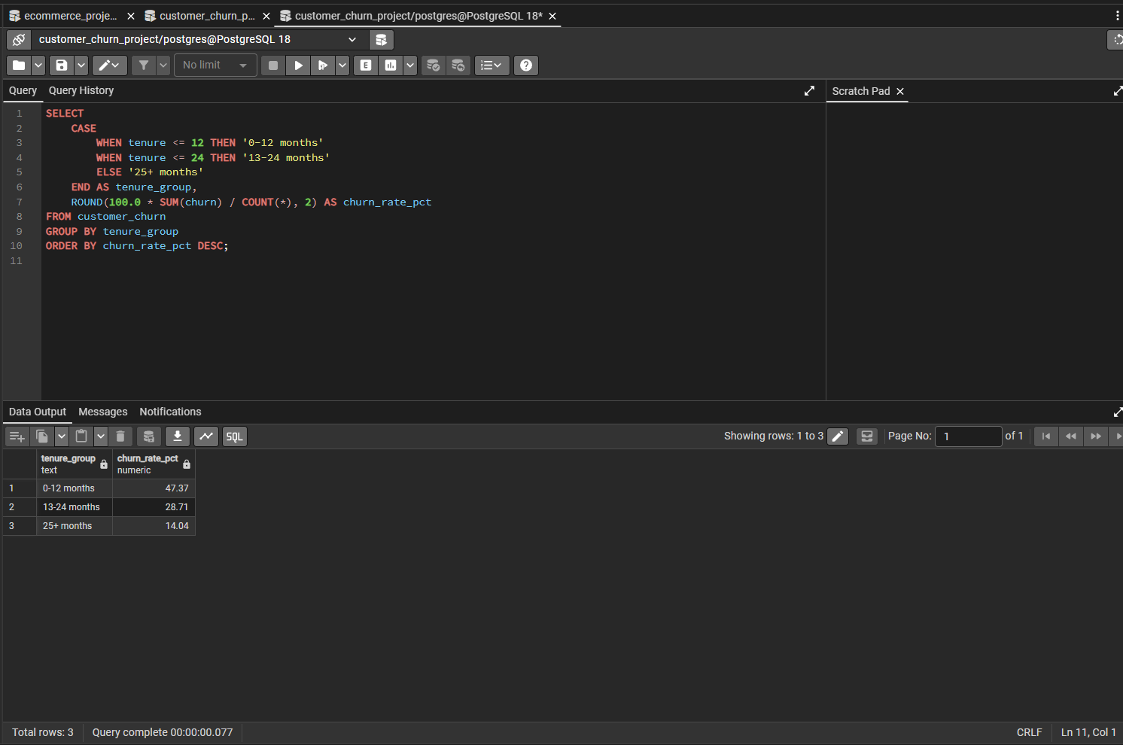

Q3: Which contract types have high-paying customers ($70+) still churning? (GROUP BY + HAVING)
This query filters for churned customers with monthly charges above $70, groups them by contract type, and uses HAVING to only show groups with more than 5 such customers.
SELECT contract, AVG(monthly_charges) AS avg_charges, COUNT(*) AS churned_customers
FROM customer_churn
WHERE churn = 1 AND monthly_charges > 70
GROUP BY contract
HAVING COUNT(*) > 5
ORDER BY churned_customers DESC;
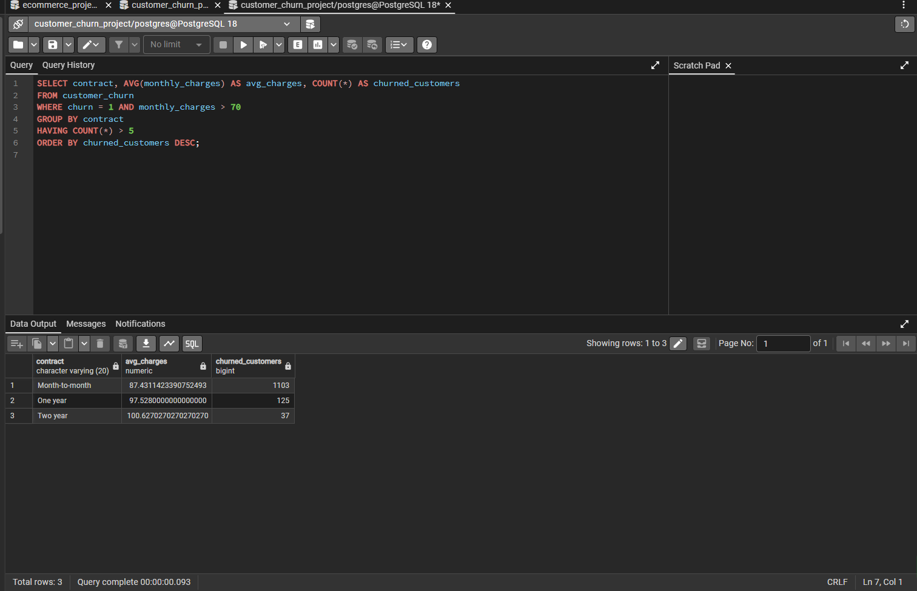

Q4: What is the average monthly charge and tenure for churned vs. retained customers?
This query compares average monthly charges and average tenure between customers who churned (churn = 1) and those who stayed (churn = 0).
SELECT churn, AVG(monthly_charges) AS avg_monthly_charges, AVG(tenure) AS avg_tenure
FROM customer_churn
GROUP BY churn;
