Business Questions and SQL Queries
Section 5.3

Q1
What are the top 10 products by revenue?
SQL Query
SELECT description, SUM(total_price) AS total_revenue
FROM retail_sales
GROUP BY description
ORDER BY total_revenue DESC
LIMIT 10;
Explanation
This query groups all sales records by product description, calculates the total revenue generated by each product, sorts them from highest to lowest revenue, and returns only the top 10 results.

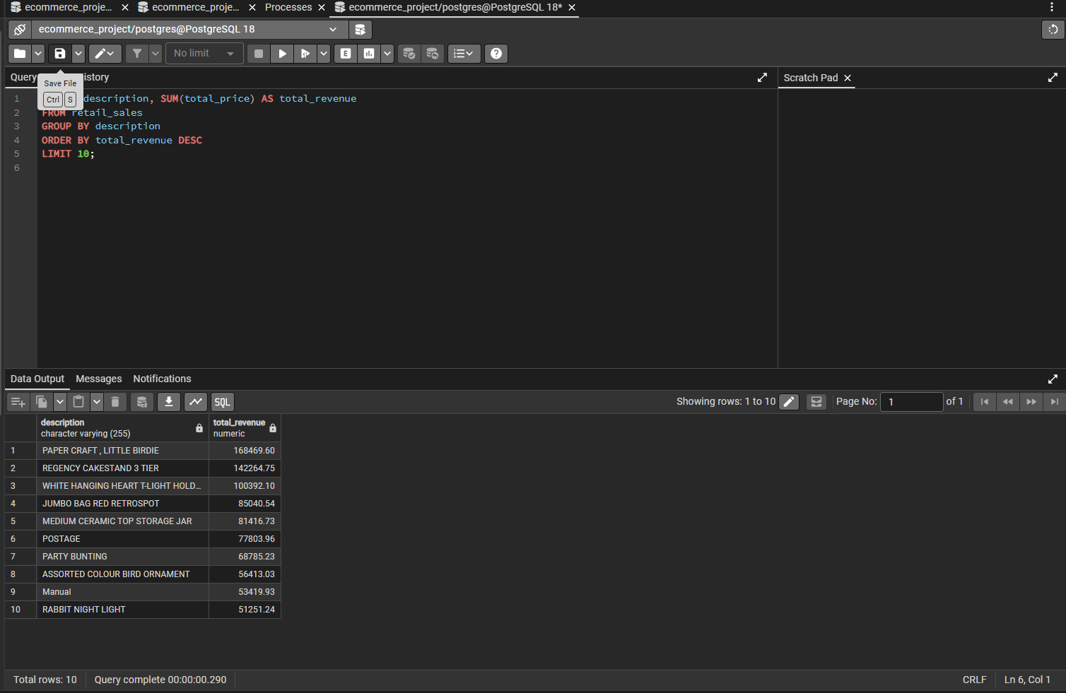

Q2
What does the month-wise sales trend look like?
SQL Query
SELECT DATE_TRUNC('month', invoice_date) AS month, SUM(total_price) AS monthly_revenue
FROM retail_sales
GROUP BY month
ORDER BY month;
Explanation
This query truncates each invoice date down to the month level, groups all transactions by that month, and sums up the total revenue for each month. The result is sorted chronologically to show the sales trend over time.

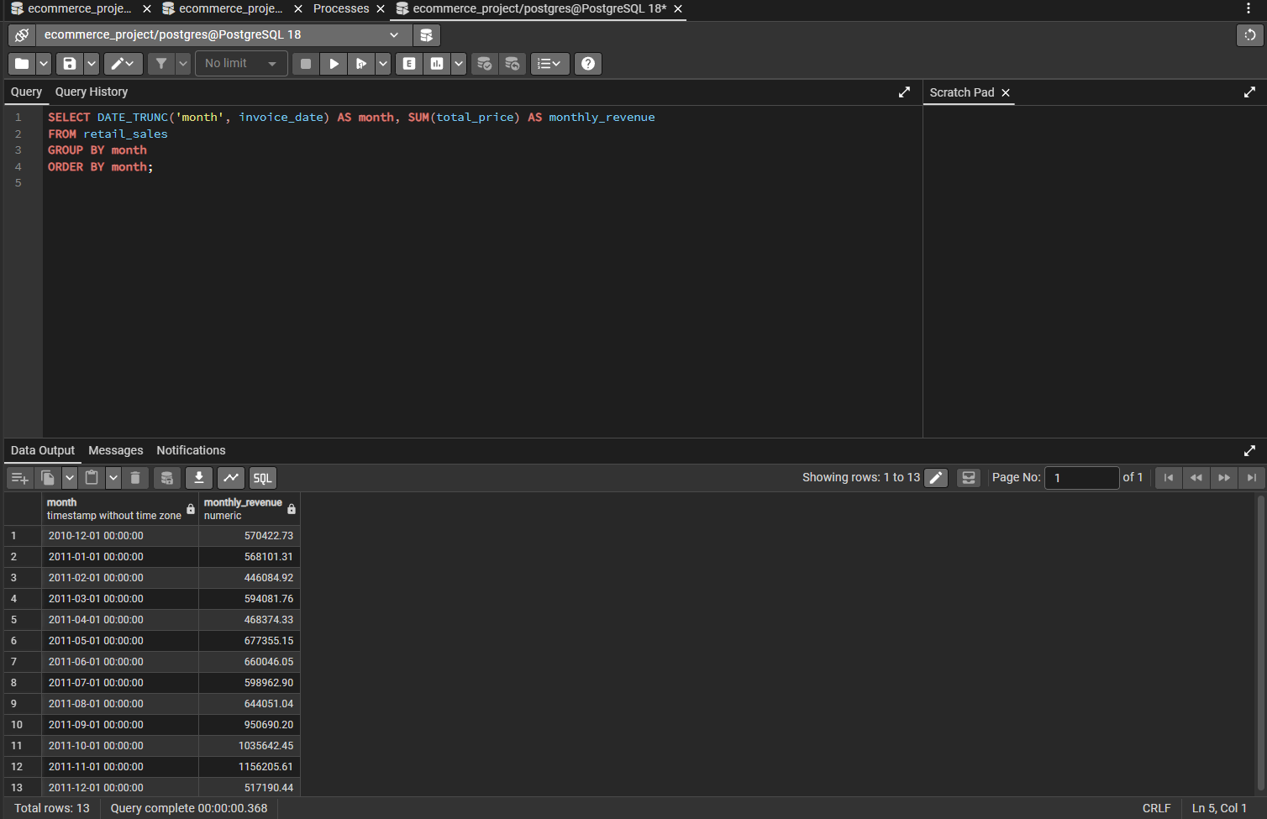

Q3
Which country generates the most revenue?
SQL Query
SELECT country, SUM(total_price) AS revenue
FROM retail_sales
GROUP BY country
ORDER BY revenue DESC;
Explanation
This query groups all sales by country, calculates total revenue per country, and sorts the results in descending order, so the highest-revenue country appears first.

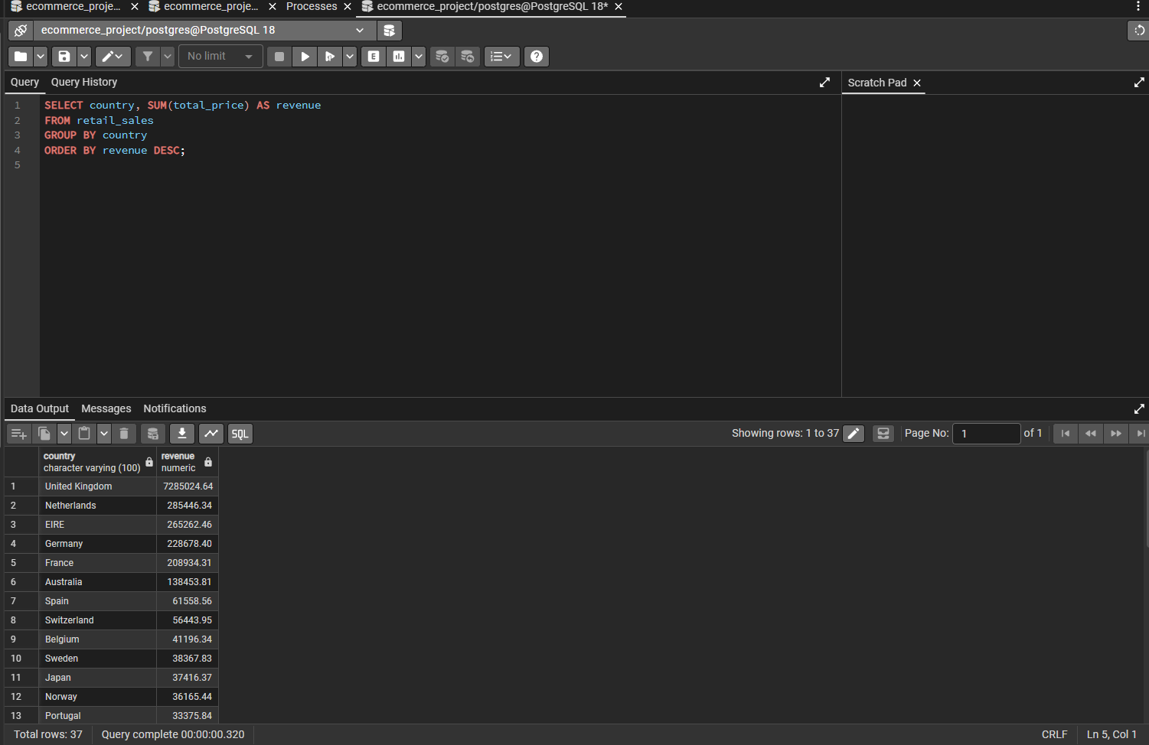

Q4
Which customers have spent more than $10,000? (GROUP BY + HAVING)
SQL Query
SELECT customer_id, SUM(total_price) AS total_spent
FROM retail_sales
GROUP BY customer_id
HAVING SUM(total_price) > 10000
ORDER BY total_spent DESC;
Explanation
This query groups all transactions by customer, calculates each customer's total spending, and then filters using HAVING (since the filter applies to an aggregated value) to keep only customers whose total spend exceeds $10,000. Results are sorted from highest to lowest spender.

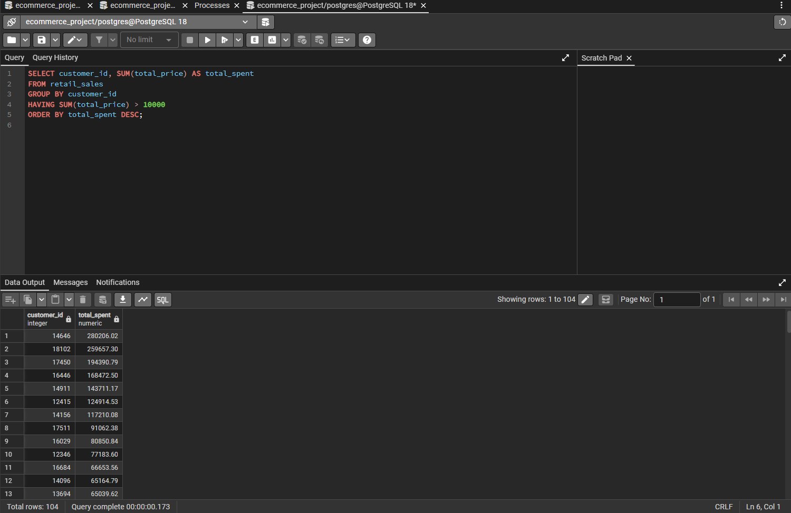

Q5
What is the average order value?
SQL Query
SELECT AVG(invoice_total) AS avg_order_value
FROM (
SELECT invoice_no, SUM(total_price) AS invoice_total
FROM retail_sales
GROUP BY invoice_no
) AS order_totals;
Explanation
This query uses a subquery to first calculate the total value of each individual invoice (order), by grouping line items by invoice number and summing their prices. The outer query then takes the average of all those invoice totals, giving the average order value across the entire dataset.

