**DevOps Test**

**Q1 - SCENARIO**

A car rental company called FastCarz has a .net Web Application and Web API which are recently migrated from on-premise system to Azure cloud using Azure Web App Service

and Web API Service.

The on-premises system had 3 environments Dev, QA and Prod.

The code repository was maintained in TFS and moved to Azure GIT now. The TFS has daily builds which triggers every night which build the solution and copy the build package to drop folder.

deployments were done to the respective environment manually. The customer is planning to setup Azure DevOps Pipeline service for below requirements:

1) The build should trigger as soon as anyone in the dev team checks in code to master branch.

Answer-: Enable Continuous Integration (Under Pipeline ->Triggers)

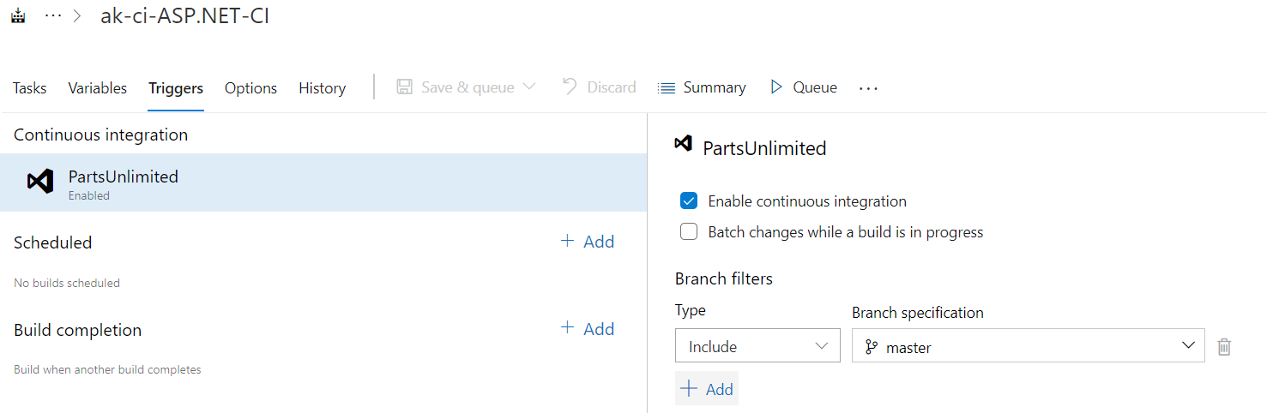

2) There will be test projects which will create and maintained in the solution along the Web and API. The trigger should build all the 3 projects - Web, API and test.

The build should not be successful if any test fails.

Answer-: VS Test Task ,Check the below option

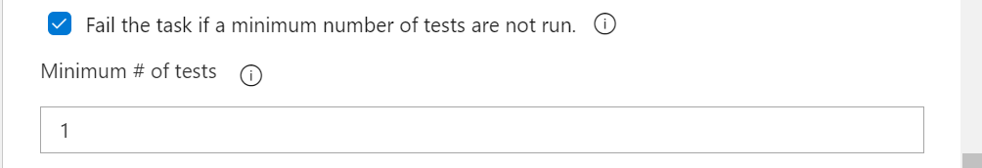

3) The deployment of code and artifacts should be automated to Dev environment.

Answer-:

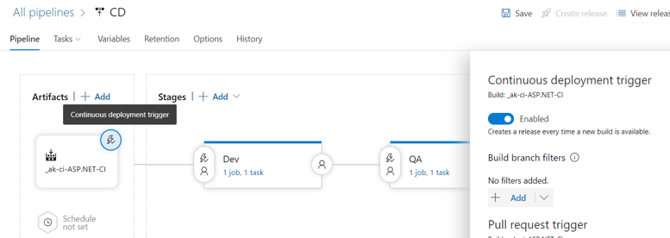

4) Upon successful deployment to the Dev environment, deployment should be easily promoted to QA and Prod through automated process.

Answer-:

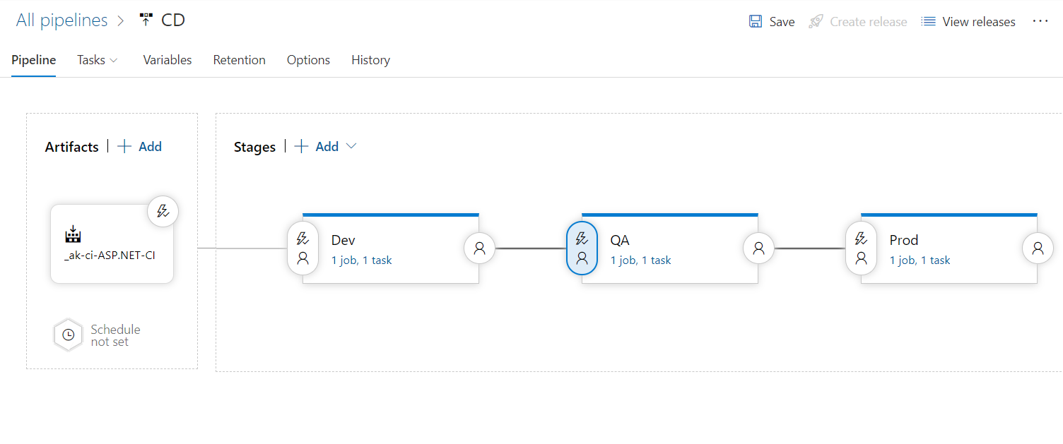

5) The deployments to QA and Prod should be enabled with Approvals from approvers only.

Answer-:

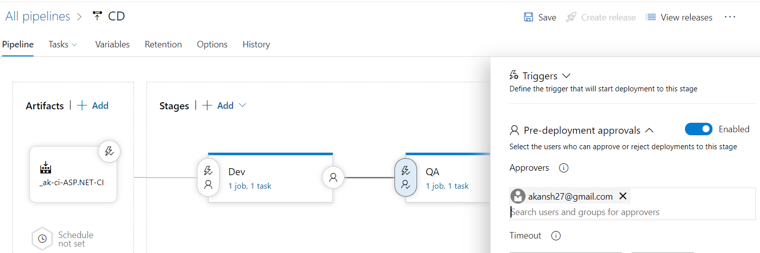

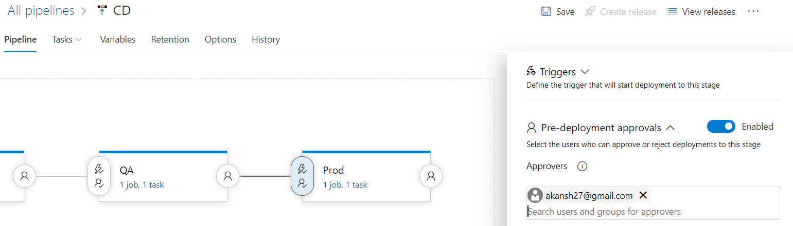

Explain how each of the above the requirements will be met using Azure DevOps configuration.

Explain the steps with configuration details.

**Q2 - SCENARIO**

Macro Life, a healthcare company has recently setup the entire Network and Infrastructure on Azure.

The infrastructure has different components such as Virtual N/W, Subnets, NIC, IPs, NSG etc.

The IT team currently has developed PowerShell scripts to deploy each component where all the properties of each resource is set using PowerShell commands.

The business has realized that the PowerShell scripts are growing over period of time and difficult to handover when new admin onboards in the IT.

The IT team has now decided to move to Terraform based deployment of all resources to Azure.

All the passwords are stored in a Azure Service known as key Vault. The deployments needs to be automated using Azure DevOps using IaC(Infrastructure as Code).

1) What are different artifacts you need to create - name of the artifacts and its purpose

Answer-: Terraform template Artifacts

2) List the tools you will to create and store the Terraform templates.

Answer-: Visual studio code/VS , Azure Repo git , Azure DevOps CI &CD Pipelines.

3) Explain the process and steps to create automated deployment pipeline.

Answer-: Setup Azure git repo, Write your terraform code & push to Azure git repo, require permission for pipeline like Service connection, Set CD Triggers , Define different stages, Integrate Key Vault & define Variables.

4) Create a sample Terraform template you will use to deploy Below services:

Vnet

2 Subnet

NSG to open port 80 and 443

1 Window VM in each subnet

1 Storage account

Answer-: Please find the Answer in Git Repo.

5) Explain how will you access the password stored in Key Vault and use it as Admin Password in the VM Terraform template.

Answer-: Using data block to refer Key vault secret (Used in Above VM template)