# **Real-Time Object Detection, Tracking, and Missing/New Object Detection**

## **Objective**

The goal of this project was to develop a real-time video analytics system capable of:

* **Detecting Missing Objects**: Identifying when a previously detected object leaves the frame.
* **Detecting New Objects**: Identifying when a new object appears in the video feed.

The system emphasizes real-time performance and high accuracy in detection.

## **System Overview**

The system uses:

* **YOLOv8** for object detection.
* **DeepSORT** for object tracking.
* **Custom monitoring** to detect missing and new objects across frames.

### **Key Features:**

* **Object Detection**: YOLOv8 detects objects with bounding boxes and confidence scores.
* **Object Tracking**: DeepSORT assigns unique IDs to objects and tracks them across frames.
* **Object Monitoring**: Tracks missing or new objects by comparing object IDs between frames.
* **Real-Time Performance**: Optimized to maintain high FPS (~30 FPS).

## **FPS Achieved**

The system achieves an average FPS of **10 FPS** during real-time testing, ensuring smooth performance.

## **Hardware Configuration**

* **CPU**: AMD Ryzen 5 5500U with Radeon Graphics (8 cores, 2.10 GHz)
* **GPU**: NVIDIA GeForce GTX 1660 Ti (Dedicated)
* **RAM**: 8 GB DDR4
* **Storage**: SSD 477 GB

This configuration ensures smooth object detection and tracking.

## **Techniques and Optimizations**

1. **YOLOv8**: Chosen for its speed and accuracy, with confidence thresholding to reduce false positives.
2. **DeepSORT**: Tracks objects across frames using appearance features and Kalman filtering.
3. **Real-Time Optimization**: Lightweight YOLOv8 model for faster inference, skipping video writing during testing to avoid FPS drops.
4. **Object Monitoring**: Tracks missing and new objects by comparing object IDs between frames.

## **Screenshots / Sample Output**

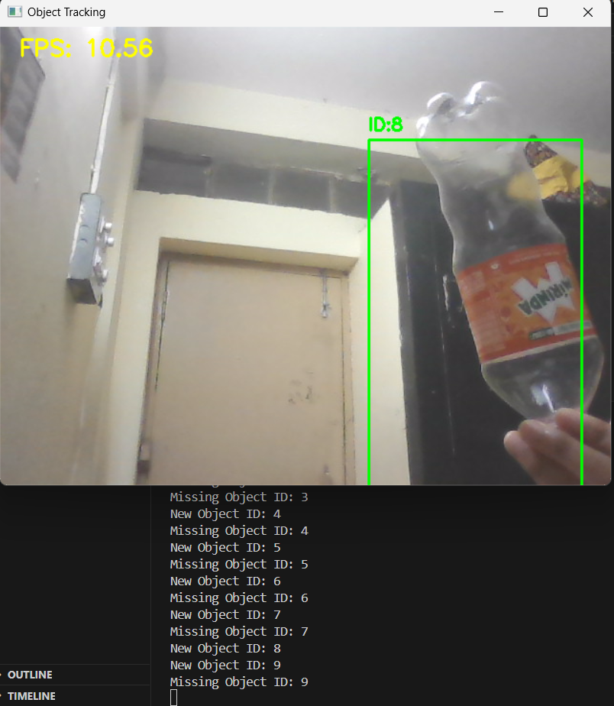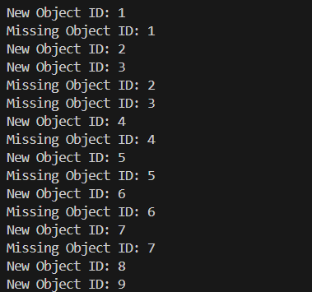

## **Output Video**

The system generates a real-time video showing:

* Object detection with bounding boxes.
* Tracking with unique IDs.
* Alerts for missing and new objects.

The video is available in the repository under **Object_Tracking.mp4.**