PROJECT REPORT
STUDENT ACADEMIC PERFORMANCE ANALYSIS
A Predictive Analytics Study Using IBM SPSS Statistics
and Microsoft Excel
SUBMITTED BY
AKANKSHA BIND
ROLL NO.: UU250500016
in partial fulfilment of the academic project requirements
of
MASTER OF BUSINESS ADMINISTRATION
IN

SESSION 2026–2027
UNDER THE GUIDANCE OF
MR. Ferhan Ahmed
IBM Trainer
Rawatpur, Prayagraj
Uttar Pradesh – 211012

DECLARATION
I hereby declare that the project report entitled “Student Academic Performance Analysis: A Predictive
Analytics Study Using IBM SPSS Statistics and Microsoft Excel” has been prepared for academic learning
purposes. The report explains a structured process for preparing data, exploring patterns, building a prediction
model, interpreting results, and presenting findings.
I understand that the example dataset included with this draft is synthetic and does not represent actual
students. Any final submission should use data collected with appropriate permission, protect student privacy,
and report only analyses that have genuinely been performed.
Student Name: Akanksha Bind
Roll Number: UU250500016
Signature: __________________________
Date: ______________________________

ACKNOWLEDGEMENT
I express my sincere gratitude to my faculty guide and university for providing the opportunity to prepare this
project on student academic performance analysis. This project helped me understand how data analytics can
support educational planning and evidence-based decisions.
I also acknowledge the learning resources and software documentation that explain Microsoft Excel, IBM
SPSS Statistics, descriptive statistics, correlation, and regression analysis. These tools make it easier to
organize student-level information, identify patterns, and communicate findings in a systematic manner.
The project is a learning draft. The illustrative data and sample results are clearly labelled; they must be
replaced or validated using the actual dataset and software output before the report is treated as an empirical
study.

ABSTRACT
Student academic performance is influenced by several factors, including study habits, attendance, prior
achievement, sleep, and assignment completion. This project presents a predictive analytics workflow to
examine how selected academic and behavioural indicators may relate to a student's final score. Microsoft
Excel is used for data entry, validation, initial summaries, charts, and file preparation. IBM SPSS Statistics is
used as the main statistical environment for descriptive analysis, correlation, and linear regression.
The report demonstrates the workflow with a synthetic dataset of 100 student records. The outcome variable is
final score out of 100. Predictor variables include study hours per day, attendance percentage, previous
semester score, sleep hours per day, and assignment completion percentage. An illustrative regression model is
evaluated using a held-out test sample. Because the dataset is synthetic, the numerical outputs are examples for
learning rather than evidence about a real student population.
The report discusses objectives, research questions, data definitions, ethics, data preparation, Excel procedures,
SPSS procedures, model interpretation, limitations, recommendations, and future improvements. The central
conclusion is methodological: a transparent, validated model can help educators identify patterns and plan
support, but predictions should never replace professional judgement or be used to label students unfairly.

TABLE OF CONTENTS
1. 1. Title and Project Overview
2. 2. Introduction
3. 3. Problem Statement
4. 4. Data Discussion
5. 5. Methods, Tools and Technologies Used
6. 6. Workflow
7. 7. Procedure
8. 8. Results / Predictive Model
9. 9. Insights and Observations
10. 10. Recommendations / Suggestions
11. 11. Limitations and Ethical Considerations
12. 12. Conclusion
13. 13. References
14. Appendix A: Data Dictionary
15. Appendix B: Excel Instructions
16. Appendix C: IBM SPSS Instructions
17. Appendix D: Sample Dataset Preview

1. TITLE AND PROJECT OVERVIEW
Project title
Student Academic Performance Analysis: A Predictive Analytics Study Using IBM SPSS Statistics and
Microsoft Excel
Project type
Predictive analytics project with descriptive and inferential statistical analysis.
Project focus
The project demonstrates how selected academic and routine indicators can be organized and examined to
estimate final academic scores. It focuses on an understandable, reproducible workflow rather than a
complicated black-box model.
Software
•
Microsoft Excel: data entry, cleaning checks, formulas, pivot tables, charts, and workbook documentation.
•
IBM SPSS Statistics: variable setup, descriptive statistics, correlation, linear regression, residual
diagnostics, and output export.
•
Microsoft Word: report writing and presentation of tables, figures, and conclusions.
Expected academic contribution
The project builds practical skills in defining variables, handling data responsibly, selecting an appropriate
analysis, interpreting statistical output, and communicating limitations.

2. INTRODUCTION
2.1 Background
Educational institutions collect information about attendance, assessments, assignments, study routines, and
academic progress. When analysed carefully, these records can reveal patterns that are difficult to identify by
looking at individual marks alone. For example, regular attendance and consistent assignment completion may
coincide with stronger performance, while a decline in earlier scores may signal a need for timely support.
2.2 Meaning of predictive analytics
Predictive analytics uses historical observations and statistical or machine-learning methods to estimate an
outcome for new cases. In this project, the outcome is a student's final score. A linear regression model
estimates the expected score from a set of predictor variables. Its output is an estimate, not a guarantee of an
individual student's future result.
2.3 Why this topic matters
•
It encourages evidence-based academic support rather than assumptions.
•
It demonstrates a practical application of Excel and IBM SPSS Statistics.
•
It helps students learn data preparation, visualisation, statistical interpretation, and report writing.
•
It can support early conversations with students when used carefully and fairly.
2.4 Scope
The report focuses on a small set of measurable indicators and a continuous outcome score. It does not attempt
to diagnose personal circumstances, determine intelligence, or make high-stakes decisions about students.
Real-world use would require a representative dataset, institutional approval, privacy safeguards, and
validation across student groups and semesters.

2. INTRODUCTION — CONCEPTUAL FRAMEWORK
2.5 Conceptual model
The conceptual model assumes that final academic score may be associated with study hours, attendance,
previous semester score, sleep duration, and assignment completion. These variables are selected because they
are understandable and can be measured consistently. Their association does not prove that changing one
variable will automatically cause a particular change in marks.
Role
Variable
Measurement
Outcome (dependent)
Final_Score
Score out of 100
Predictor
Study_Hours_Per_Day
Average hours per day
Predictor
Attendance_Percent
Percentage, 0–100
Predictor
Previous_Semester_Score
Score out of 100
Predictor
Sleep_Hours_Per_Day
Average hours per day
Predictor
Assignment_Completion_Percent
Percentage, 0–100
2.6 Key terms
•
Dependent variable: the outcome the model is intended to estimate.
•
Independent variable/predictor: an input used to estimate the outcome.
•
Correlation: a measure of the direction and strength of a linear association between two variables.
•
Regression coefficient: the estimated change in the outcome associated with a one-unit change in a
predictor, holding the other included predictors constant.
•
Residual: the difference between an observed score and the model's predicted score.
•
Overfitting: when a model captures peculiarities of training data and performs poorly on new data.

3. PROBLEM STATEMENT
3.1 Problem definition
Academic performance is commonly reviewed through final marks, but marks alone may not explain the
patterns behind performance. Institutions may need a structured way to examine several indicators together.
The problem addressed by this project is how to organise a student dataset and use statistical tools to explore
whether selected indicators can help estimate final scores.
3.2 Research questions
18. How are final scores distributed in the demonstration dataset?
19. What relationships appear between final scores and study hours, attendance, previous score, sleep, andassignment completion?
20. Can a linear regression model estimate final scores with reasonable error on a held-out sample?
21. How can Excel and IBM SPSS Statistics support a reproducible analysis?
22. What limitations and safeguards are needed before using this approach in an educational setting?
3.3 Objectives
•
Prepare a well-documented dataset with consistent variable definitions.
•
Summarise the data using descriptive statistics and visualisations.
•
Examine associations between the outcome and selected predictors.
•
Demonstrate a multiple linear regression model and evaluate its test-sample error.
•
Explain the analysis steps in Excel and IBM SPSS Statistics.
•
Provide practical, ethical recommendations for responsible use.
3.4 Hypotheses for demonstration
H1: Study hours are positively associated with final score in the demonstration dataset.
H2: Attendance percentage is positively associated with final score in the demonstration dataset.
H3: Previous semester score is positively associated with final score in the demonstration dataset.
These are working hypotheses for analysis, not established facts about all students. Statistical significance and
effect sizes must be assessed using real data.

3. PROBLEM STATEMENT — SIGNIFICANCE AND BOUNDARIES
3.5 Significance
The project is useful as a learning exercise because it connects an everyday educational question with a
repeatable data workflow. It shows how raw rows can be converted into summaries, relationships, a model,
and recommendations. It also demonstrates that good analysis requires careful definitions and transparent
reporting, not only software output.
3.6 Delimitations
•
Only five predictors are included in the example model.
•
The outcome is a numerical final score out of 100.
•
The report demonstrates linear regression, not a production-ready student-risk system.
•
The dataset is synthetic and does not support conclusions about a real college.
•
The project does not use names, phone numbers, addresses, or other direct identifiers.
3.7 Intended users
Potential users of a carefully validated version include students, academic mentors, faculty members, and
institutional researchers. Any operational use should be governed by institutional policy and should provide
students with context and opportunities to correct inaccurate data.

4. DATA DISCUSSION
4.1 Data source and status
For this draft, a synthetic dataset of 100 records was generated to demonstrate the software workflow. The
values are artificial and were not collected from students. The dataset is supplied as an Excel workbook with a
Student_Data sheet and a Codebook sheet. For an empirical submission, replace the synthetic records with
approved data and update every table, chart, and result in this report.
4.2 Unit of analysis
One row represents one student record. Student_ID is a non-identifying code used to distinguish rows. The
project avoids including student names in the analysis file.
4.3 Variables and measurement levels
Variable
Measurement level
Expected role
Valid range / format
Student_ID
Nominal identifier
Record key
S001, S002, ...
Study_Hours_Per_Day
Scale
Predictor
0–24 hours; example
range 0.5–8
Attendance_Percent
Scale
Predictor
0–100
Previous_Semester_Score
Scale
Predictor
0–100
Sleep_Hours_Per_Day
Scale
Predictor
0–24 hours; example
range 4–9
Assignment_Completion_Percent Scale
Predictor
0–100
Final_Score
Scale
Outcome
0–100
Performance_Category
Ordinal
Descriptive grouping
Needs Support,
Average, Good,
Excellent
4.4 Data quality checks
•
Check for blank cells and duplicate Student_ID values.
•
Check that percentages and scores are between 0 and 100.
•
Check that hour variables are within plausible limits.
•
Confirm that variable names contain no confusing spaces or punctuation.
•
Document how missing values and impossible values are handled.
•
Keep a clean original copy before making changes.

4. DATA DISCUSSION — DATA PREPARATION
4.5 Data cleaning plan
Data cleaning should be performed before any model is estimated. In Excel, use filters, conditional formatting,
COUNTBLANK, COUNTIF, and data validation to identify unusual entries. In SPSS, use Frequencies,
Descriptives, and Data View to inspect ranges and missingness. Corrections should be based on source
records, not guesses.
4.6 Missing values
If a real dataset contains missing values, first determine why they are missing. Do not automatically replace all
missing values with zero. Depending on the number and pattern of missing values, a researcher may exclude
records, use an appropriate imputation method, or report a limitation. The selected rule must be recorded
before analysis.
4.7 Outliers
An outlier is an observation unusually far from the rest of the data. It may be a data-entry error or a genuine
student result. Inspect the source before changing it. Boxplots, scatterplots, standardised residuals, and
casewise diagnostics can help identify observations that deserve review.
4.8 Privacy and access
Use the minimum information needed. Remove names and direct identifiers, store the data in a secure location,
limit access to authorised people, and follow the institution's approval and consent requirements. A model
should not be used to stigmatise students or make consequential decisions without human review.

5. METHODS, TOOLS AND TECHNOLOGIES USED
5.1 Research design
The project uses a quantitative, cross-sectional demonstration design. It combines descriptive statistics,
correlation analysis, and multiple linear regression. In a real study, the sampling method, time period, source
of records, consent process, and inclusion criteria should be specified.
5.2 Microsoft Excel
•
Enter or import records in a rectangular table with one variable per column.
•
Use filters and data validation to identify invalid values.
•
Use AVERAGE, MEDIAN, MIN, MAX, STDEV.S, COUNT, and COUNTIF for summaries.
•
Use PivotTables to summarise performance categories.
•
Create scatterplots and bar charts to communicate patterns.
•
Save the cleaned data as .xlsx and, if required, export a copy as .csv for SPSS.
5.3 IBM SPSS Statistics
•
Define variable names, labels, types, decimals, and measurement levels in Variable View.
•
Use Frequencies and Descriptives to review distributions.
•
Use Bivariate Correlations to examine linear associations.
•
Use Linear Regression to estimate a model with several predictors.
•
Review Model Summary, ANOVA, Coefficients, residual plots, and casewise diagnostics.
•
Export tables and charts to Word, Excel, or PDF for reporting.
5.4 Why use both tools?
Excel is convenient for data entry, quick checks, formula-based summaries, and flexible charts. SPSS provides
a dedicated statistical interface with documented procedures and standard regression output. Using both tools
makes it possible to cross-check totals and create a clear audit trail. Software does not replace careful design or
sound interpretation.

5. METHODS — STATISTICAL PLAN
5.5 Descriptive analysis
Calculate sample size, mean, median, standard deviation, minimum, and maximum for each scale variable. For
Performance_Category, calculate frequency and percentage. Descriptive statistics summarise the observed
dataset; they do not establish causal relationships.
5.6 Correlation analysis
Pearson's correlation coefficient ranges from -1 to +1 and describes the direction and strength of a linear
association. Check scatterplots for nonlinearity and influential points. Correlation does not prove causation,
and a correlation between two variables can be affected by other variables.
5.7 Multiple linear regression
The proposed model is:
Final Score = β₀ + β₁(Study Hours) + β₂(Attendance) + β₃(Previous Score) + β₄(Sleep) + β₅(Assignment
Completion) + ε
Here, β₀ is the intercept, β₁ to β₅ are regression coefficients, and ε represents factors not captured by the model.
Coefficients are conditional associations and should not be described as causal effects without an appropriate
research design.
5.8 Model evaluation
•
R-squared: proportion of outcome variation explained in the evaluated sample.
•
Mean Absolute Error (MAE): average absolute difference between observed and predicted scores.
•
Root Mean Squared Error (RMSE): gives more weight to larger prediction errors.
•
Hold-out testing: evaluates performance on records not used to fit the model.
•
Residual checks: assess whether the model assumptions are reasonably met.
5.9 Assumptions
Linear regression assumes an approximately linear relationship, independent errors, reasonably constant
residual variance, no severe multicollinearity, and residual behaviour suitable for the intended inference.
Diagnostics should be reviewed rather than assuming the model is valid because the software produced a table.

6. WORKFLOW
6.1 End-to-end workflow
23. Define the question, outcome variable, and predictors.
24. Obtain approval and identify an appropriate data source.
25. Create a codebook and collect or import records.
26. Clean and validate the data in Excel.
27. Save a protected original and a cleaned analysis copy.
28. Import the file into IBM SPSS Statistics.
29. Define variable properties and missing-value rules.
30. Run descriptive statistics and inspect charts.
31. Run correlations and interpret them cautiously.
32. Split data into training and test samples for predictive evaluation.
33. Fit the regression model and inspect assumptions.
34. Compare predicted and observed scores on test records.
35. Export genuine output tables and charts.
36. Write findings, limitations, recommendations, and references.
37. Check that every reported number matches the final analysis output.
6.2 Workflow quality gates
Stage
Quality check
Evidence to retain
Data intake
Permission and source
documented
Data source note / approval
Cleaning
Ranges, duplicates, missing
values reviewed
Cleaning log
Exploration
Summary values cross-checked
Excel summary and SPSS output
Modelling
Predictors and outcome defined in
advance
Model specification
Evaluation
Test data not used to fit model
Train/test procedure
Reporting
All values trace to output
Tables, charts, syntax, workbook
6.3 Reproducibility
Keep the source workbook, cleaned workbook, SPSS .sav file, optional SPSS syntax (.sps), output viewer file
(.spv), and final report in clearly named folders. Record software version, date of analysis, any recoding, and
all decisions that could change the results.

7. PROCEDURE — MICROSOFT EXCEL
7.1 Prepare the workbook
38. Open Student_Academic_Performance_Dataset_Excel_SPSS.xlsx.
39. Review the Student_Data sheet and confirm the first row contains variable names.
40. Confirm that each row represents one student and there are no merged cells in the data area.
41. Use Data > Filter to inspect unusual values and blanks.
42. Use conditional formatting to highlight scores below 0 or above 100.
43. Check duplicate IDs with Conditional Formatting or COUNTIF.
44. Save a separate cleaned copy before editing real data.
7.2 Useful Excel formulas
Purpose
Example formula (adjust
column/range)
Interpretation
Count records
=COUNTA(A2:A101)
Counts populated IDs
Mean final score
=AVERAGE(G2:G101)
Arithmetic average
Median final score
=MEDIAN(G2:G101)
Middle score
Standard deviation
=STDEV.S(G2:G101)
Sample variability
Minimum
=MIN(G2:G101)
Lowest score
Maximum
=MAX(G2:G101)
Highest score
Count excellent category
=COUNTIF(H2:H101,"Excellent") Records in a category
7.3 Create charts
Select Study_Hours_Per_Day and Final_Score and choose Insert > Scatter. Add a clear chart title and axis
labels. To show category counts, create a PivotTable or use COUNTIF and insert a column chart. Avoid 3-D
charts and do not use a truncated axis in a way that exaggerates differences.
7.4 Export for SPSS
Save the workbook as .xlsx. If the installation or workflow requires CSV, use Save As > CSV UTF-8. Confirm
that the first row contains variable names and that decimal values use a consistent decimal separator. CSV
does not preserve formatting or multiple worksheets, so retain the original workbook.

7. PROCEDURE — IBM SPSS STATISTICS
7.5 Import Excel data
45. Open IBM SPSS Statistics.
46. Choose File > Open > Data and select the Excel workbook.
47. Select the Student_Data worksheet and tick the option to read variable names from the first row.
48. Check that numeric variables were imported as numeric rather than string.
49. In Variable View, set labels, decimals, and measurement levels.
50. Save the dataset as an SPSS .sav file.
7.6 Define variables
Use Student_ID as a nominal identifier. Set the scale variables to Numeric and Measure = Scale. Set
Performance_Category to Ordinal and define value labels if it is stored as numeric codes. Add variable labels
that explain the units. Do not include the identifier as a predictor in the regression.
7.7 Descriptive statistics
51. Choose Analyze > Descriptive Statistics > Descriptives.
52. Move the five predictors and Final_Score into the Variables box.
53. Select mean, standard deviation, minimum, and maximum.
54. Run the procedure and compare key totals with Excel.
55. Use Analyze > Descriptive Statistics > Frequencies for Performance_Category.
7.8 Correlation
Choose Analyze > Correlate > Bivariate. Move the scale variables into the analysis box, select Pearson, and
use a two-tailed significance test when appropriate. Inspect the scatterplots as well. Report the coefficient,
sample size, and p-value where relevant, but do not equate statistical significance with practical importance.

7. PROCEDURE — SPSS REGRESSION
7.9 Run linear regression
56. Choose Analyze > Regression > Linear.
57. Place Final_Score in the Dependent box.
58. Place Study_Hours_Per_Day, Attendance_Percent, Previous_Semester_Score, Sleep_Hours_Per_Day, and
Assignment_Completion_Percent in Independent(s).
59. Under Statistics, request estimates, model fit, confidence intervals, and collinearity diagnostics.
60. Under Plots, request a standardised residual plot against standardised predicted values and a normal
probability plot.
61. Under Save, optionally save predicted values and residuals for diagnostic review.
62. Run the model and inspect Model Summary, ANOVA, Coefficients, and diagnostic plots.
7.10 Train/test evaluation in SPSS
A simple split can be created using a reproducible random assignment variable, then fitting the model only on
training records and evaluating predicted values on test records. The split procedure must be documented.
Avoid using test records to choose predictors or repeatedly tune the model. For larger datasets, cross-
validation can provide a more stable estimate.
7.11 Export output
In the SPSS Output Viewer, select the required table or chart and use File > Export. Choose Word, Excel, or
PDF. Copy only tables that are relevant to the research questions, preserve their labels, and ensure the reported
values match the output. Save the .spv file so the analysis can be checked later.

8. RESULTS / PREDICTIVE MODEL
8.1 Important interpretation note
All values on this results page are generated from the synthetic 100-record example included with the
workbook. They demonstrate how results can be reported. They are not findings about actual students and
must be replaced by results from the approved dataset and genuine SPSS/Excel analysis.
Variable
N
Mean
Std. Dev.
Min
Max
Study_Hours_Per_Day
100
3.75
1.31
0.7
6.8
Attendance_Percent
100
79.50
11.79
47.5
100.0
Previous_Semester_Score
100
62.29
14.10
28.2
90.3
Sleep_Hours_Per_Day
100
6.80
0.91
4.0
8.8
Assignment_Completion_Percent 100
75.95
12.43
39.4
100.0
Final_Score
100
74.30
9.02
49.5
100.0
8.2 Performance category distribution
Category
Count
Percentage
Needs Support
0
0.0%
Average
7
7.0%
Good
40
40.0%
Excellent
53
53.0%
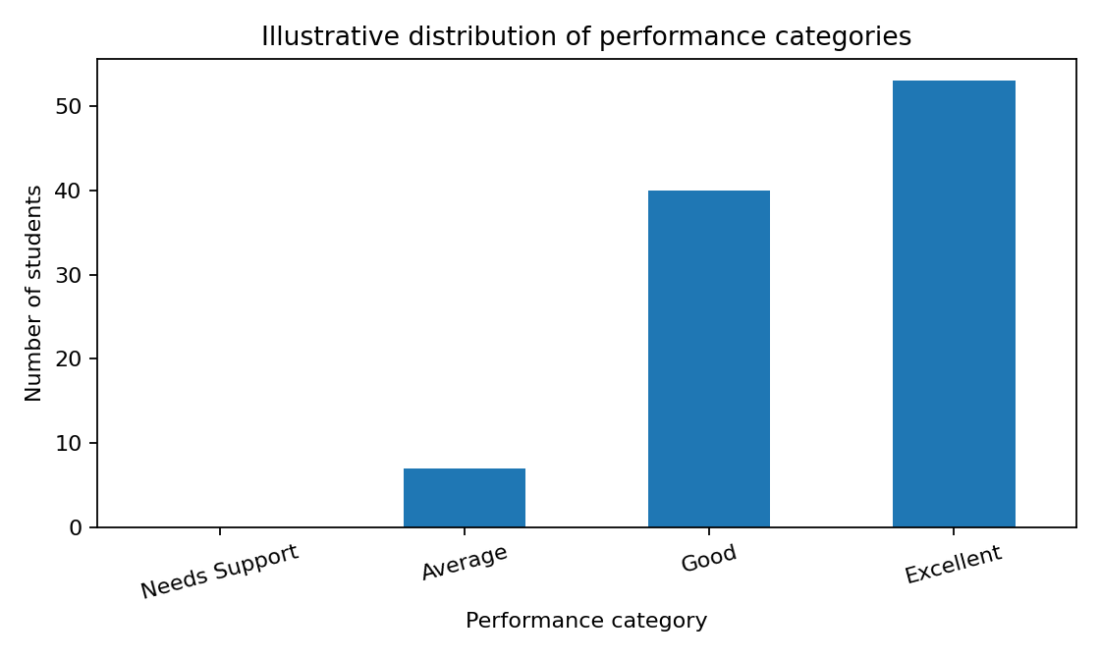
Figure 1. Performance category distribution in the synthetic demonstration dataset.

8. RESULTS — CORRELATION AND MODEL
8.3 Correlation with final score
Predictor
Correlation with Final_Score
Direction
Previous_Semester_Score
0.414
Positive
Study_Hours_Per_Day
0.405
Positive
Attendance_Percent
0.256
Positive
Assignment_Completion_Percent
0.129
Positive
Sleep_Hours_Per_Day
0.026
Positive
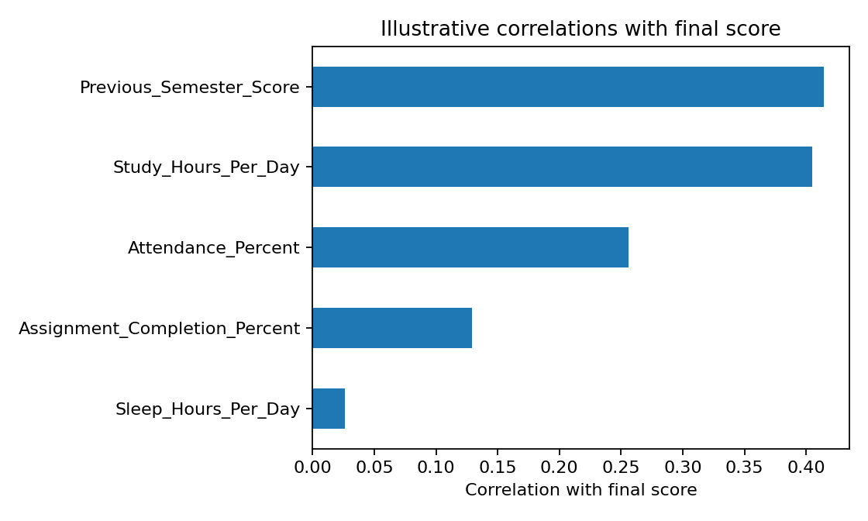
Figure 2. Correlations with final score for the synthetic example. Correlations describe pairwise association
and are not causal estimates.
8.4 Illustrative test-set regression performance
Metric
Illustrative value
Meaning
Number of records
100 total; 75 training; 25 test
A fixed 75/25 train-test split was
used
R-squared (test)
0.556
Fraction of test-sample variation
explained
MAE (test)
3.97 points
Average absolute prediction error
RMSE (test)
4.63 points
Penalises larger errors more
heavily
These metrics can change when the data or random split changes. They should be interpreted against a simple
baseline and the score scale. A model with a reasonable average error can still make large errors for individual
students.

8. RESULTS — MODEL INTERPRETATION
8.5 Regression coefficients
Term
Coefficient (illustrative)
Interpretation
Intercept
-0.040
Expected baseline when all
predictors equal zero; may not be
substantively meaningful
Study_Hours_Per_Day
3.232
Estimated score difference for a
one-unit increase, holding other
predictors constant
Attendance_Percent
0.197
Estimated score difference for a
one-unit increase, holding other
predictors constant
Previous_Semester_Score
0.301
Estimated score difference for a
one-unit increase, holding other
predictors constant
Sleep_Hours_Per_Day
2.206
Estimated score difference for a
one-unit increase, holding other
predictors constant
Assignment_Completion_Percent
0.170
Estimated score difference for a
one-unit increase, holding other
predictors constant
8.6 Example interpretation
A positive coefficient means the model estimates a higher final score as that predictor increases, after
accounting for the other included predictors. The size of a coefficient depends on its units: a one percentage-
point increase in attendance is not comparable to one additional study hour. The coefficients shown here are
calculated from synthetic data and must not be presented as evidence of real-world effects.

8.7 Predicted versus observed scores
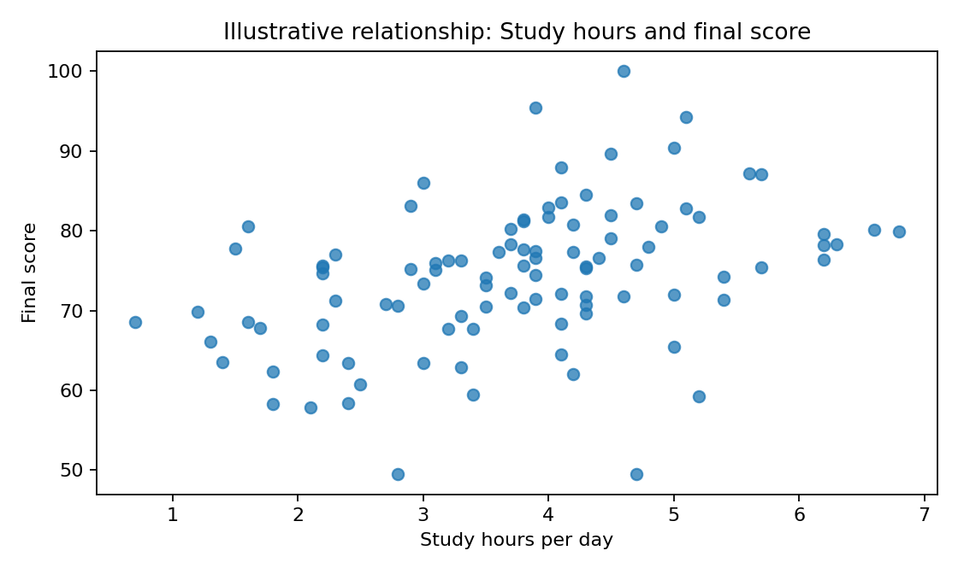
Figure 3. Scatterplot of study hours and final score in the synthetic dataset. The plot is exploratory; the fitted
regression uses all five predictors.
8.8 Reporting template for real SPSS output
“A multiple linear regression was conducted to estimate final score from [list predictors]. The model explained
[R² × 100]% of the variation in the test sample (R² = [value]). The test MAE was [value] points and RMSE
was [value] points. The coefficients and diagnostics were reviewed before drawing conclusions. These
findings describe the analysed sample and should not be interpreted as causal effects.”

9. INSIGHTS AND OBSERVATIONS
9.1 How to interpret the demonstration
The synthetic dataset was generated with a formula that includes several academic indicators plus random
variation. Therefore, some positive associations are expected by design. The demonstration is useful for
learning the software workflow, but it cannot validate a hypothesis about real students.
9.2 Observation framework
•
Distribution: review whether scores cluster around the middle or include many very low or high values.
•
Association: compare the direction and magnitude of each correlation rather than relying only on p-values.
•
Unique contribution: examine regression coefficients after accounting for the other predictors.
•
Prediction quality: compare test error with a simple baseline such as predicting the training-set mean.
•
Diagnostics: look for curved patterns, unequal residual spread, influential cases, and multicollinearity.
•
Practical value: consider whether the prediction error is small enough to support the intended low-risk use.
9.3 Statistical versus practical significance
A small association may become statistically significant in a large dataset while still being too small to matter
practically. Conversely, a potentially meaningful pattern may be uncertain in a small sample. Report effect
sizes, confidence intervals where available, sample size, and limitations alongside significance tests.
9.4 Avoid overinterpretation
Do not conclude that more sleep or more study hours automatically causes higher marks based only on
observational data. Personal circumstances, course difficulty, teaching methods, prior preparation, and many
other factors may affect outcomes. Results should be framed as associations and estimates.

9. INSIGHTS — QUALITY AND VALIDATION
9.5 Compare against a baseline
A useful predictive model should be compared with a simple baseline. For a continuous score, one baseline is
to predict the mean final score observed in the training data for every test record. If the regression model does
not improve on that baseline, it may not add useful predictive value.
9.6 Generalisability
A model developed using one cohort may not perform equally well for another programme, institution,
semester, or assessment format. Before wider use, test the model on a later cohort and examine performance
across relevant groups. Check that the model does not systematically underpredict or overpredict for particular
groups.
9.7 Data leakage
Data leakage occurs when information that would not genuinely be available at prediction time is used to train
or evaluate the model. For example, using final exam components to predict the final score before the exam
would produce misleadingly strong results. All predictor variables must be available at the intended time of
use.
9.8 Evidence checklist
•
Are the data source and time period documented?
•
Are variables measured consistently?
•
Was the test set kept separate from model fitting?
•
Are model assumptions and residuals reviewed?
•
Are the limitations explained clearly?
•
Can another person reproduce the results from the workbook and SPSS file?

10. RECOMMENDATIONS / SUGGESTIONS
10.1 Recommendations for students
•
Review study routines and create a realistic weekly study plan.
•
Monitor attendance and assignment deadlines consistently.
•
Use previous assessment feedback to identify topics that need revision.
•
Seek support early when academic progress changes.
•
Maintain healthy routines; avoid treating a statistical model as a judgement of ability.
10.2 Recommendations for faculty
•
Use analytics as an early-support signal, not as a disciplinary or grading mechanism.
•
Validate source data before drawing conclusions.
•
Discuss results with students and consider contextual information.
•
Use transparent criteria for any intervention and allow corrections to inaccurate records.
•
Review the model periodically and discontinue it if it is inaccurate or unfair.
10.3 Recommendations for analysts
•
Use an approved, sufficiently representative dataset.
•
Predefine the outcome, predictors, and evaluation strategy.
•
Report test error and compare with a baseline.
•
Retain syntax, output files, and a cleaning log.
•
Avoid causal claims unless the study design supports them.

10. RECOMMENDATIONS — IMPLEMENTATION PLAN
Phase
Action
Responsible role
Evidence of completion
1. Planning
Define purpose, target
users, and safeguards
Faculty / project lead
Written project protocol
2. Data approval
Obtain permission and
remove identifiers
Institution / data
custodian
Approval and privacy
plan
3. Data preparation
Clean records and
document rules in Excel
Analyst / student
Cleaning log and
codebook
4. Statistical analysis
Analyst
SPSS syntax and output
Run descriptives,
correlations, regression
in SPSS
5. Validation
Evaluate held-out error
and group performance
Analyst / reviewer
Validation summary
6. Review
Interpret findings with
domain experts
Faculty / mentors
Review notes
7. Responsible use
Institution
Monitoring and appeal
process
Use results only for
supportive low-risk
actions
10.4 Suggested timeline
Week
Activity
Deliverable
Week 1
Topic definition and literature
review
Objectives and references
Week 2
Data dictionary and permissions
Approved data plan
Week 3
Excel entry and cleaning
Cleaned workbook
Week 4
SPSS descriptive and correlation
analysis
Tables and charts
Week 5
Regression and diagnostics
Model output
Week 6
Interpretation and report writing
Draft report
Week 7
Review, corrections, final
formatting
Final submission package
10.5 Expected benefits
The main expected benefit is a repeatable analytical process that helps learners connect data preparation with
statistical reasoning. If applied to real approved data, it may support more timely academic conversations,
provided that model quality, privacy, and fairness are monitored.

11. LIMITATIONS AND ETHICAL CONSIDERATIONS
11.1 Limitations of this draft
•
The dataset is synthetic and does not represent an actual student population.
•
The model's apparent performance is not evidence of performance on real institutional data.
•
The predictor list is limited and omits contextual factors such as course difficulty, assessment design, and
access to learning resources.
•
The demonstration uses one random train-test split; results can vary across splits.
•
Linear regression may not capture nonlinear relationships or interactions.
•
No formal institutional approval or student consent is implied by this example.
11.2 Ethical principles
Student data is sensitive in context even when direct identifiers are removed. Data should be collected for a
defined purpose, accessed only by authorised people, retained only as needed, and reported in aggregate where
possible. Predictions must not be used to label students as failures or to restrict educational opportunities.
11.3 Fairness and accountability
Before operational use, assess whether the model has different error rates across relevant groups, where such
evaluation is lawful and appropriate. Explain the model's limitations, keep human review in the loop, and
provide a way to challenge inaccurate data. Do not use protected or irrelevant personal attributes as predictors.
11.4 Responsible interpretation
A prediction is uncertain and conditional on the data and model. A lower predicted score should be treated as a
possible prompt for supportive conversation, not a definitive statement about a student's capability or future.

12. CONCLUSION
This project presents a structured predictive analytics workflow for student academic performance using
Microsoft Excel and IBM SPSS Statistics. It covers the full process from defining a research question and
preparing a codebook to validating data, summarising variables, examining correlations, fitting a multiple
linear regression model, evaluating test-sample errors, and reporting limitations.
Excel supports data preparation, formulas, checks, and charts, while SPSS supports descriptive and inferential
statistical procedures. Using both tools can improve clarity and reproducibility when the steps are documented
and results are cross-checked.
The demonstration uses a synthetic dataset of 100 records, so its numerical outputs are illustrative only. The
project must not claim that the results describe real students. For a valid empirical study, the synthetic data
should be replaced with approved records, the analysis should be rerun, and every table, chart, coefficient, and
metric should be updated from the genuine output.
In conclusion, predictive analytics can support evidence-informed academic assistance when used carefully.
Reliable decisions require quality data, suitable methods, transparent evaluation, privacy protection, and
human judgement.

13. REFERENCES
63. IBM. (n.d.). IBM SPSS Statistics documentation. IBM Documentation.
https://www.ibm.com/docs/en/spss-statistics
64. Microsoft. (n.d.). Excel help and learning. Microsoft Support. https://support.microsoft.com/excel
65. James, G., Witten, D., Hastie, T., Tibshirani, R., & Taylor, J. (2023). An Introduction to Statistical
Learning (2nd ed.). Springer. https://www.statlearning.com/
66. Field, A. (2018). Discovering Statistics Using IBM SPSS Statistics (5th ed.). SAGE Publications.
67. Montgomery, D. C., Peck, E. A., & Vining, G. G. (2021). Introduction to Linear Regression Analysis (6th
ed.). Wiley.
68. OECD. (2021). Recommendation of the Council on Artificial Intelligence. https://oecd.ai/en/ai-principles
Note: Verify the editions and access dates required by your faculty's citation style. Add any sources actually
consulted during the final analysis.

APPENDIX A: DATA DICTIONARY
Variable
Definition
Type
Role
Validation rule
Student_ID
Anonymous
record code
String
Identifier
Unique and
nonblank
Study_Hours_Per_Day
Average daily
study duration
Numeric
Predictor
0–24
Attendance_Percent
Attendance
percentage
Numeric
Predictor
0–100
Previous_Semester_Score
Previous
semester score
Numeric
Predictor
0–100
Sleep_Hours_Per_Day
Average daily
sleep duration
Numeric
Predictor
0–24
Assignment_Completion_Percent
Numeric
Predictor
0–100
Completed
assignments
percentage
Final_Score
Final score out
of 100
Numeric
Outcome
0–100
Performance_Category
Grouped score
band
Ordinal
Descriptive
variable
Needs Support
<40; Average
40–59.9; Good
60–74.9;
Excellent ≥75
Category coding suggestion
Code
Label
1
Needs Support
2
Average
3
Good
4
Excellent
If categories are recoded numerically in SPSS, retain value labels and do not treat the category code as a
continuous score without justification.

APPENDIX B: EXCEL WORKSHEET GUIDE
Recommended workbook structure
•
Student_Data: one row per student and one column per variable.
•
Codebook: variable definitions, types, units, and allowed ranges.
•
Summary: descriptive statistics and category counts.
•
Charts: scatterplot and category bar chart.
•
Cleaning_Log: issue found, action taken, date, and reason.
Suggested checks
Check
Example approach
Reason
Missing values
COUNTBLANK on each key
column
Find incomplete records
Out-of-range score
Conditional formatting for <0 or
>100
Flag invalid scores
Duplicate ID
COUNTIF(ID range, current
ID)>1
Find duplicate records
Category totals
Sum category counts and compare
with N
Check consistency
Independent cross-check
Compare Excel mean with SPSS
mean
Catch import or formula errors
Example Excel summary formulas
Assuming Final_Score is in column G and records occupy rows 2–101: =AVERAGE(G2:G101),
=MEDIAN(G2:G101), =STDEV.S(G2:G101), =MIN(G2:G101), and =MAX(G2:G101). Adjust ranges if the
number of records changes.

APPENDIX C: IBM SPSS SYNTAX EXAMPLE
The syntax below is a starting point. Variable names must match the imported dataset exactly. Run the
commands only after confirming that the data has been imported and the variable types are correct.
* Descriptive statistics.
DESCRIPTIVES VARIABLES=Study_Hours_Per_Day Attendance_Percent
Previous_Semester_Score Sleep_Hours_Per_Day
Assignment_Completion_Percent Final_Score
/STATISTICS=MEAN STDDEV MIN MAX.
* Pearson correlations.
CORRELATIONS
/VARIABLES=Study_Hours_Per_Day Attendance_Percent
Previous_Semester_Score Sleep_Hours_Per_Day
Assignment_Completion_Percent Final_Score
/PRINT=TWOTAIL SIG
/MISSING=PAIRWISE.
* Multiple linear regression.
REGRESSION
/DEPENDENT Final_Score
/METHOD=ENTER Study_Hours_Per_Day Attendance_Percent
Previous_Semester_Score Sleep_Hours_Per_Day
Assignment_Completion_Percent
/STATISTICS COEFF OUTS R ANOVA COLLIN TOL
/RESIDUALS DURBIN HISTOGRAM(ZRESID) NORMPROB(ZRESID)
/SCATTERPLOT=(*ZPRED,*ZRESID).
How to use syntax
69. Open the imported .sav file in SPSS.
70. Choose File > New > Syntax.
71. Paste the commands and verify variable names.
72. Select the relevant commands and click Run.
73. Review the output and diagnostics; save the syntax and output files.
This example runs regression on the full dataset. For predictive evaluation, use a documented training/test split
and evaluate predictions only on records held out from model fitting.

APPENDIX D: SAMPLE DATASET PREVIEW
Stude
nt_ID
Study_Hou
rs_Per_Day
Performanc
e_Category
Attendan
ce_Percen
t
Previous_Se
mester_Scor
e
Sleep_Hou
rs_Per_Da
y
Assignment_Co
mpletion_Percen
t
Final
_Scor
e
S001
5.7
61.5
46.4
5.4
64.6
75.4
Excellent
S002
3.3
47.5
83.7
6.0
82.4
76.3
Excellent
S003
2.4
72.4
55.5
5.9
53.2
58.4
Average
S004
4.3
68.9
47.2
7.1
82.4
69.6
Good
S005
3.5
83.4
67.5
7.3
88.3
74.1
Good
S006
4.5
75.4
33.1
7.8
81.2
79.1
Excellent
S007
3.0
81.1
81.3
5.9
100.0
86.0
Excellent
S008
5.2
52.1
69.9
6.5
57.0
59.3
Average
S009
4.1
87.3
63.7
7.1
67.0
83.5
Excellent
S010
4.4
90.1
69.6
6.7
69.9
76.6
Excellent
S011
3.8
75.4
55.3
7.0
79.9
70.4
Good
S012
5.4
80.2
76.4
6.5
68.4
74.2
Good
The attached Excel workbook contains all 100 synthetic example records. Student IDs are artificial. Do not
submit these example records as if they were collected from actual students.
Checklist before final submission
•
Fill in guide/faculty name, programme/course, university, and academic session.
•
Replace synthetic data with approved actual data if empirical results are required.
•
Rerun all analyses in Excel and IBM SPSS Statistics.
•
Replace every illustrative table, coefficient, metric, and chart with genuine output.
•
Check page numbering, university formatting rules, citations, and spelling.
•
Keep the workbook, SPSS .sav, .sps syntax, and .spv output as supporting evidence.

