1. **Add a maven dependency and its related repository URL.**

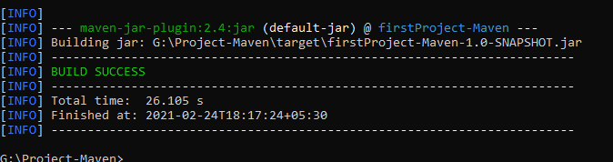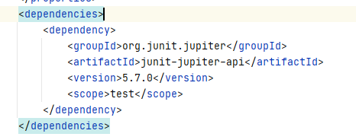

1. **Add a new repository in the pom.xml and use its dependencies.**

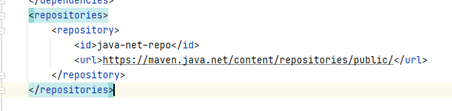

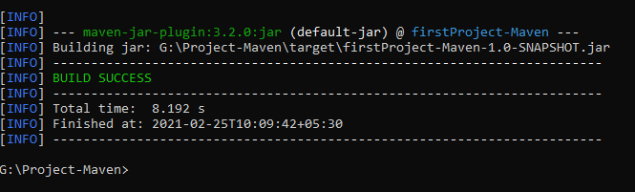

1. **Using JAR plugin, make changes in the pom.xml to make the jar executable. Using java -jar JAR_NAME, the output should be printed as "Hello World"**

**Steps:**

Compile java file-**mvn compile**

Compile test file-**mvn test-compile**

Creating jar and installing to local repository-**mvn install**

Executing jar- java -**jar G:\Project-Maven\target\firstProject-Maven-1.0-SNAPSHOT.jar**

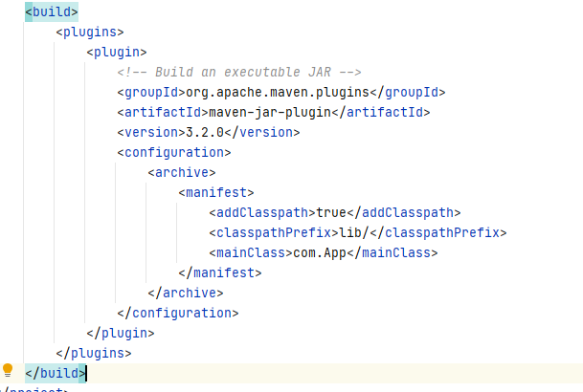

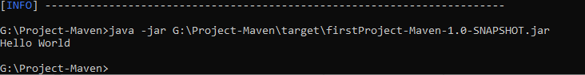

1. **Differentiate between the different dependency scopes: compile, runtime, test, provided using different dependencies being defined in your pom.xml.**

**Compile:-** This scope indicates that dependency is available in classpath of project. It is default scope.

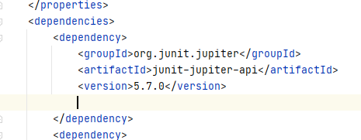

**Test:**- This scope indicates that the dependency is only available for the test compilation and execution phases. 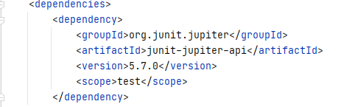

**Runtime:**- This scope indicates that dependency is not required for compilation, but is required during execution.

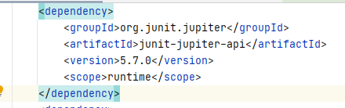

**Provided:**- This scope indicates that dependency is to be provided by JDK or web-Server/Container at runtime.

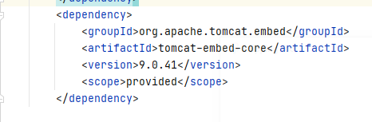

1. **Create a multi-module project. Run package command at the top level to make jar of every module.**

**Parent Project-**Project2-Maven

**Modules-**business,data

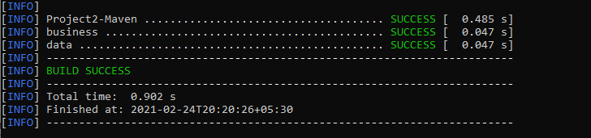

**Business module jar-**

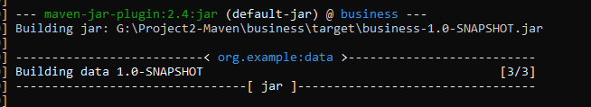

**Data-module jar-**

