ZOMATO  
Data Warehousing and Analysis

**Project Description:**

**Zomato** is an Indian restaurant aggregator and food delivery start up founded by Deepinder Goyal in 2008. Zomato provides information, menus and user-reviews of restaurants, and also has food delivery options from partner restaurants in select cities. As of 2019, the service is available in 24 countries and in more than 10,000 cities.

Zomato has acquired 12 startups globally. In July 2014, Zomato made its first acquisition by buying Menu-mania for an undisclosed sum. While in September 2018, Zomato acquired Bengaluru-based food e-marketplace TongueStun Food for about $18 million in a cash and stock deal. On 21st January, 2020, Zomato acquired its rival Uber Eats' business in India in an all stock deal.

**The main aim of this Data warehousing project is to analyse the following subjects:  
1) Sales Analysis  
2) Complaint Analysis  
3) Feedback Analysis  
4) Delivery Analysis  
5) Review Analysis**

**Subjects and Research Questions:**

1. **Sales Analysis**
   1. **Total sales cost according to the customer.**
   2. **Gender of which city has higher or lower sales cost?**
   3. **In which city which gender has most or least sales?**
   4. **Which city consumes which food item?**
   5. **Which type of food is consumed in what quantity?**
   6. **What is the total sales count per city?**
   7. **How much quantity is consumed in each city?**
   8. **Which age group consumes how much food?**
   9. **What is the percentage discount given by every restraunts?**
   10. **How much quantity of each cuisine is consumed?**
2. **Complaint Analysis**
   1. **Number of complaints solved and unsolved.**
   2. **How much complaints are solved in each city?**
   3. **How much complaints are solved according to the food type?**
   4. **How much complaints are filed per delivery boy?**
   5. **How much complaints are solved or unsolved according to cuisine?**
   6. **Which food item has how much complaints?**
   7. **Number of complaints per restaurant.**
   8. **Number of complaints solved or unsolved per customer?**
   9. **Number of complaints per city.**
   10. **Number of complaints location wise.**
3. **Delivery Analysis**
   1. **Delivery charge per customer according to review.**
   2. **How much rating is given by customers?**
   3. **How much is the delivery charge ,according to vehicles?**
   4. **Number of vehicles per city.**
   5. **How much orders are made by each gender?**
   6. **Delivery count for customers per gender.**
   7. **What is the delivery charge per city?**
   8. **How much are the ratings given according to delivery charge?**
4. **Feedback Analysis**
   1. **Number of feedbacks given per customer.**
   2. **Total count of feedbacks per gender.**
   3. **Total count of feedbacks of each age group and gender.**
   4. **City wise satisfaction count based on ratings.**
   5. **Gender wise satisfaction count based on ratings.**
   6. **Satisfaction count according to detailed feedback given by users.**
   7. **City wise total count of feedback given by each age group.**
   8. **Cuisine wise total count of detailed feedback given by users.**
   9. **Rectaurant wise feedback count given by users that whether they are satisfied or not.**
5. **Review Analysis** 
   1. **Total count of ratings given per city.**
   2. **Total count of reviews given in different levels per city.**
   3. **Total count of review per gender.**
   4. **Total rating and review count given by each age.**
   5. **Total rating and review count per food item.**
   6. **Total count of ratings given to each food item by customers.**
   7. **City waise total reviews given by customer.**
   8. **Category wise total reviews given by customers.**

**Dimension Modelling:**

**Dimension Tables**

1. **Customers 2. Discount**

|  |
| --- |
| **Zomato_Customers_dataset** |
| **Customer_ID Customer_Name Age**  **Gender**  **City** |

|  |
| --- |
| **Zomato_Discount** |
| **Discount_ID Name**  **Percentage_Discount**  **Vaidity** |

1. **Food 4. Restaurant**

|  |
| --- |
| **Food_items_dataset** |
| **Food_ID Name Actual_Cost Sales_Cost Category** |

|  |
| --- |
| **Restaurant_dataset** |
| **Restraunt_ID Name Location Ratings Category** |

|  |
| --- |
| **Feedback** |
| **FeedbackID**  **UserFeedback**  **SatisfiedOrNot** |

**5. Feedback 6. Review**

|  |
| --- |
| **Review** |
| **ReviewID CustomerReview** |

**7.Complaint 8.DeliveryEmp**

|  |
| --- |
| **DeliveryEmp** |
| **empID**  **Name**  **VehicleOwn** |

|  |
| --- |
| **Complaint** |
| **ComplaintID**  **Date**  **Complain**  **Category** |

**Fact Tables**

**1.Fact Sales 2. Fact Review**

|  |
| --- |
| **Fact_Sales** |
| **TransactionID SalesInvoiceNumber RestaurantId**  **ID**  **FoodID**  **DiscountID**  **Quantity**  **SalesTotalCost**  **FoodActualCost**  **Deviation** |

|  |
| --- |
| **Fact_Review** |
| **ReviewID ID**  **FoodID**  **ReviewID**  **Rating** |

**3. Fact Feedback 4. Fact Complaint**

|  |
| --- |
| **Fact_Feedback** |
| **FeedbackNumber ID RestaurantID FeedbackID Rating** |

|  |
| --- |
| **Fact_Complaint** |
| **ComplaintNotice ComplaintID EmpID FoodID RestaurantID**  **ID**  **Resolved** |

**5.Fact Delivery**

|  |
| --- |
| **Fact_Delivery** |
| **DeliveryNumber**  **ID**  **EmpID**  **DeliveryCharge**  **DeliveryRating**  **DeliveryReview** |

**Datawarehouse Schema:**

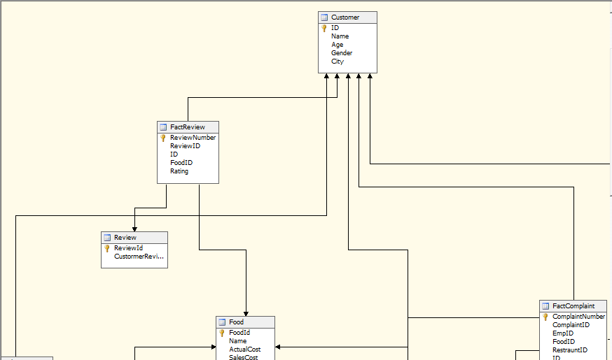

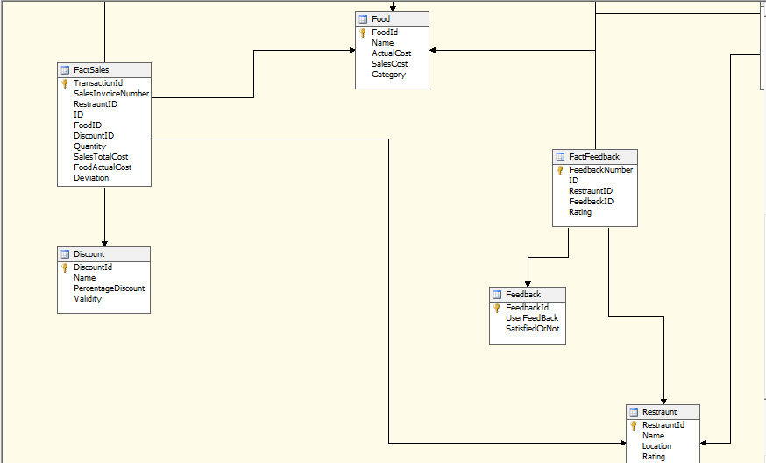

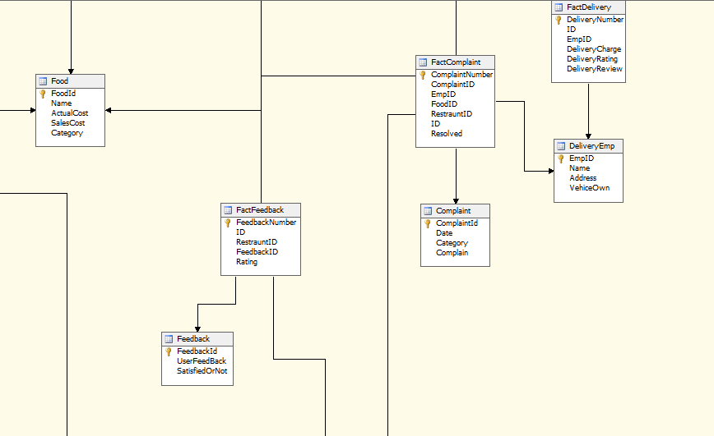

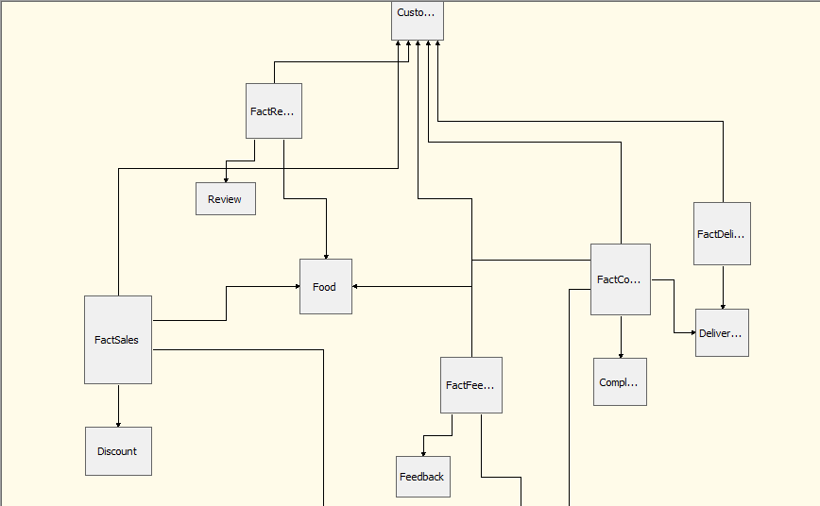

**BIDS Analysis Steps(Inventory Analysis):**

**STEPS:**

1. Created new data source

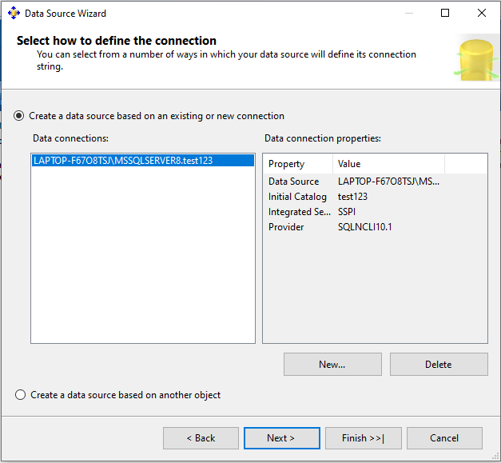

1. Created new data source view

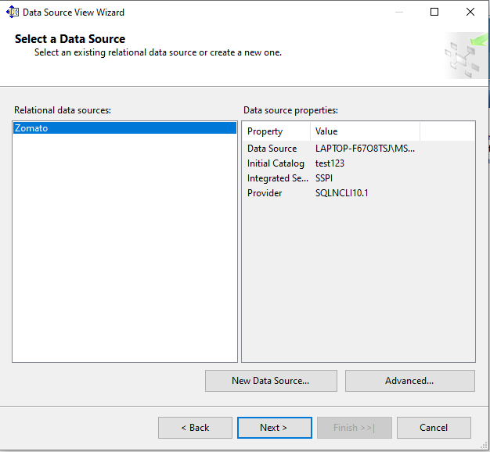

1. Created new cube

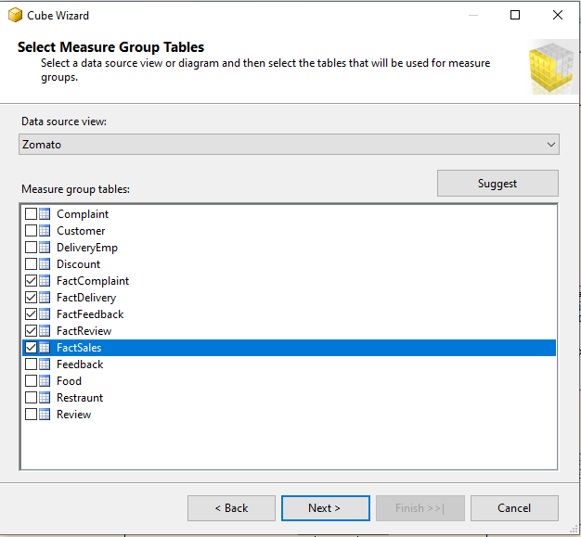

1. Created new Dimension

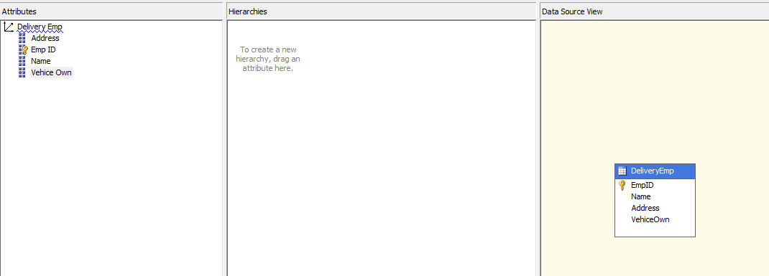

1. Deployed and Processed

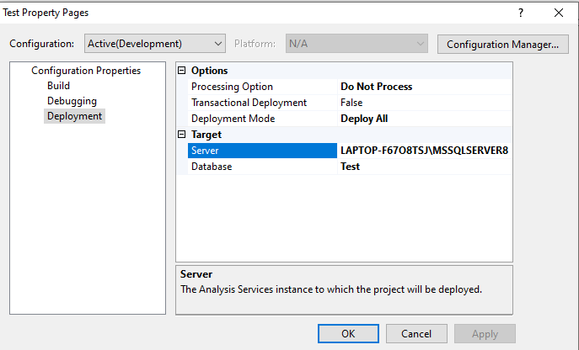

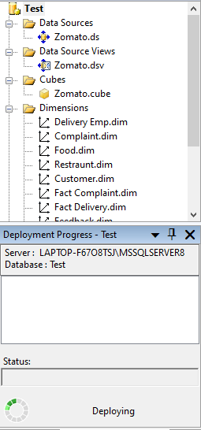

1. Browsed the cube and performed the analysis according to research questions.

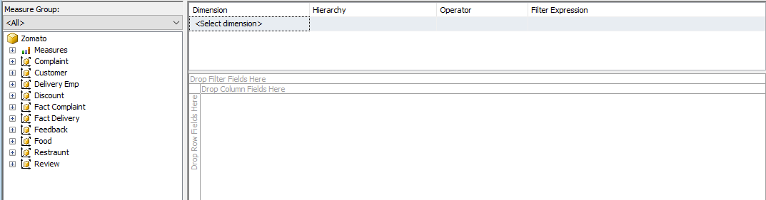

**Analysis Results:**

**Sales Analysis**

1. Total Sales cost according to the gender

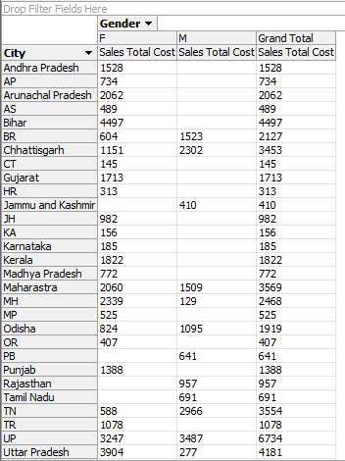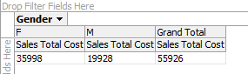

1. Gender of which city has higher or lower sales cost

.

1. In which city which gender has most or least sales?



1. Which City consumes which food item?

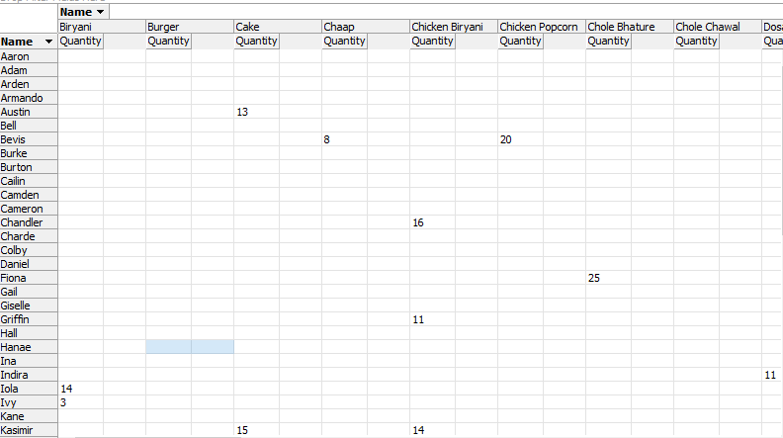

1. Which type of food is consumed in what quantity?

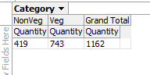

1. What is the total sales count per city?

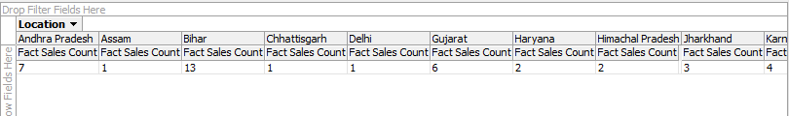

1. How much quantity is consumed in each city?

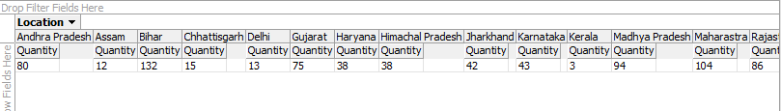

1. Which age group consumes how much food?

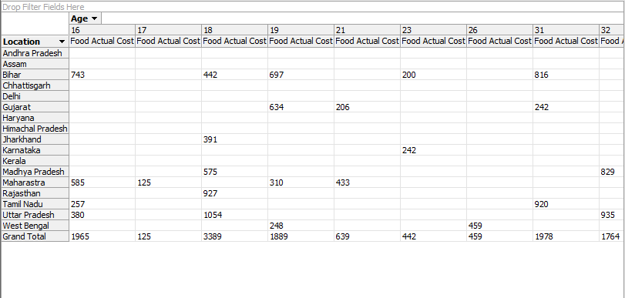

1. What is the percentage discount given by restaurants?

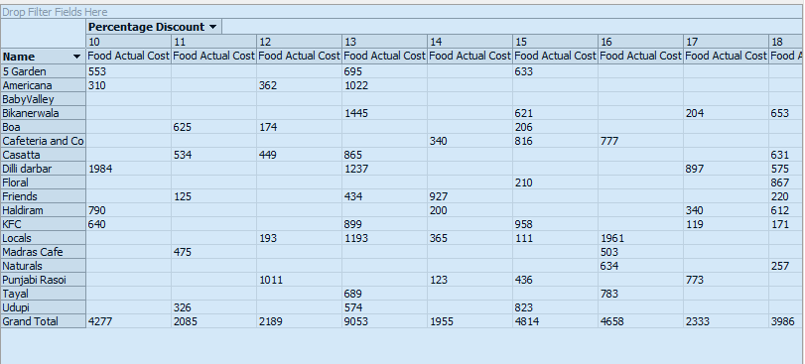

1. How much quantity of each cuisine is consumed?

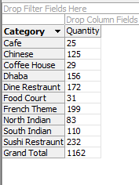

**Complaint Analysis**

1. Number of Complaints solved and unsolved?

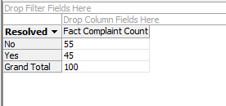

1. How much complaint are solved in each city?

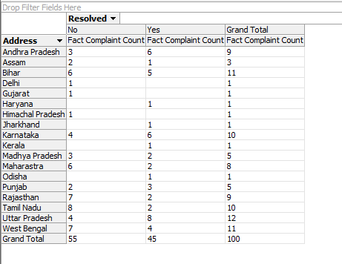

1. How much complaints are solved according to the food type?

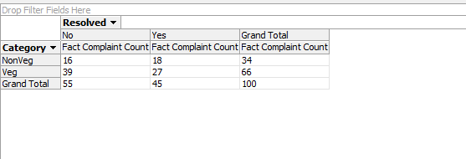

1. How much complains are filed per delivery boy?

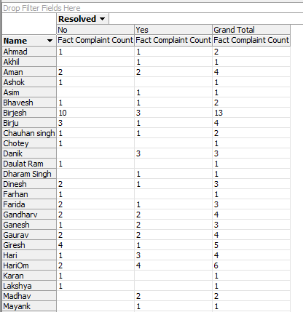

1. How much complaints are solved or unsolved according to cuisine?

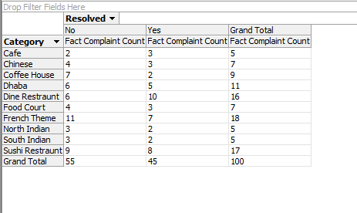

1. Which food item has how much complaint?

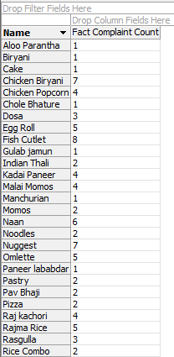

1. Number of complaints per restaurant.

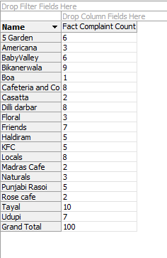

1. Number of complains solved or unsolved per customer?

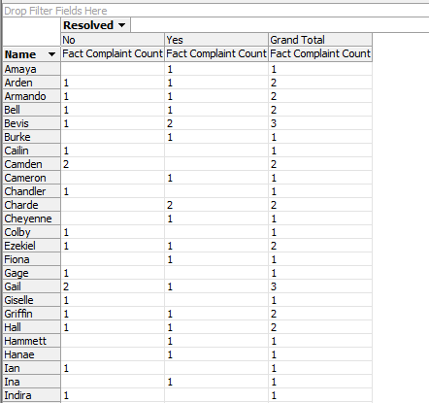

1. Number of complaints per city

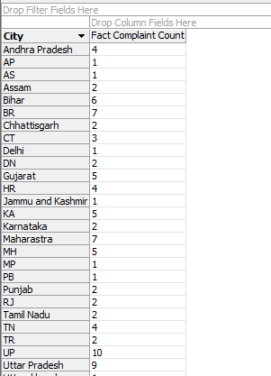

1. Number of complaints location wise.

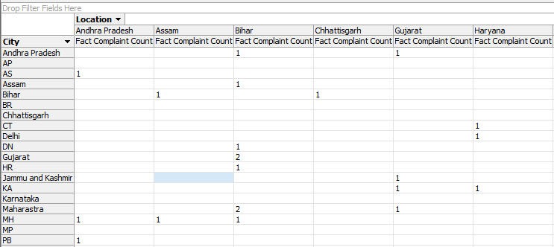

**Delivery Analysis**

1. Delivery charge per customer acording to review.

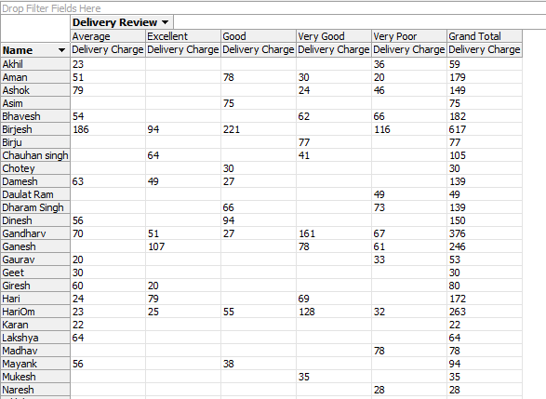

1. How much rating is given by customers.

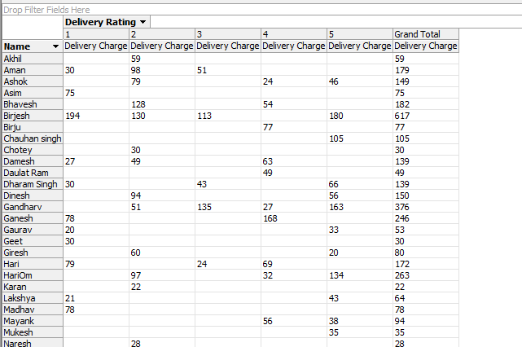

1. How much delivery charge is, according to vehicles.

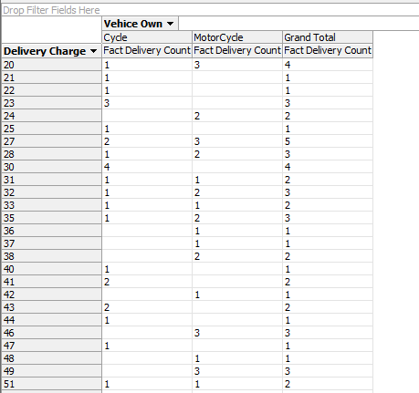

1. Number of vehicles per city.

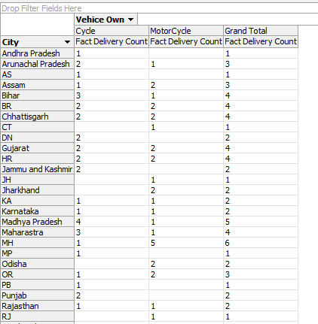

1. How much orders are made by each gender?

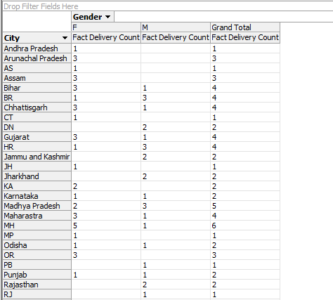

1. Delivery count for customers per gender.

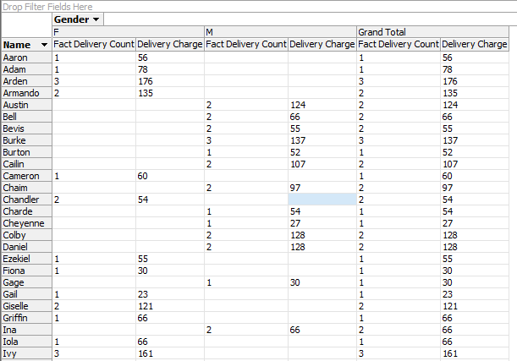

1. What is the delivery charge per city?

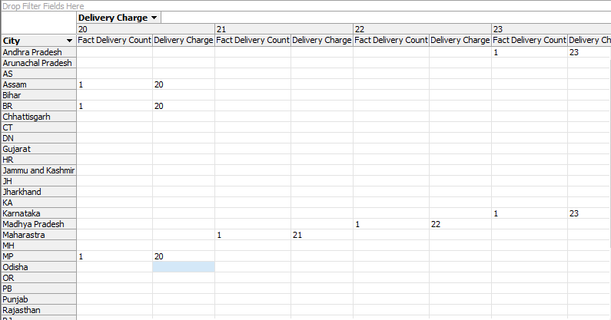

1. How much are the ratings given according to delivery charge?

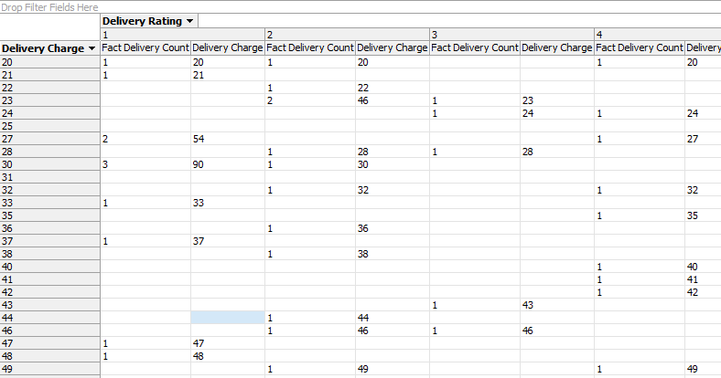

**Feedback Analysis:**

1. Number of feedbacks given per customer.

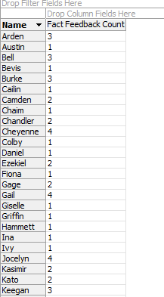

1. Total Count of feedbacks per gender.

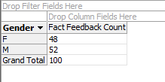

1. Total count of feedbacks of each age group and gender

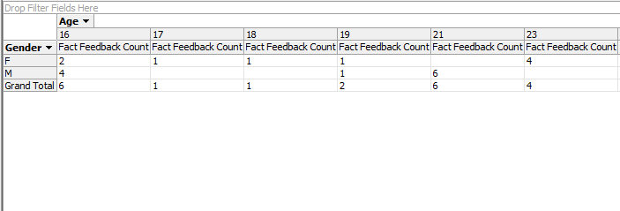

1. City wise satisfaction count based on ratings.

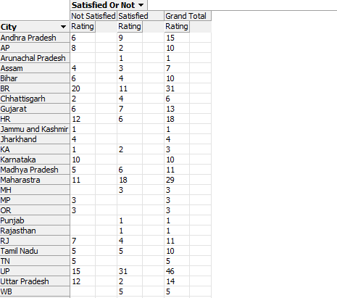

1. Gender wise satisfaction count based on ratings.

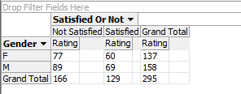

1. Satisfaction count according to detailed feedback given by users.

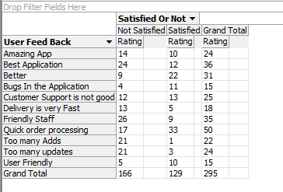

1. City wise total count of feedback given by each age group.

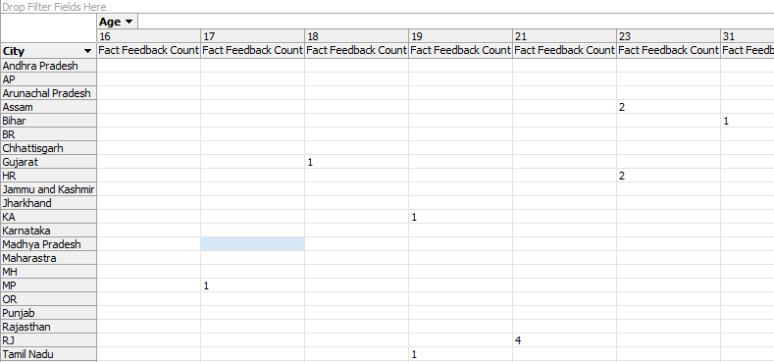

1. Cuisine wise total count of detailed feedback given by users .

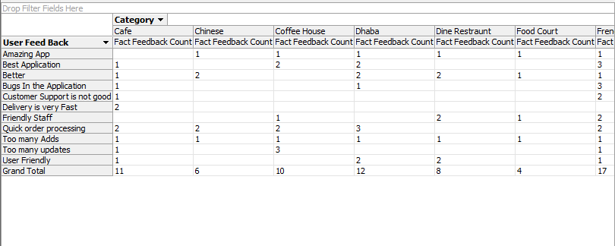

1. Restaurant wise feedback count given by users that whether they are satisfied or not.

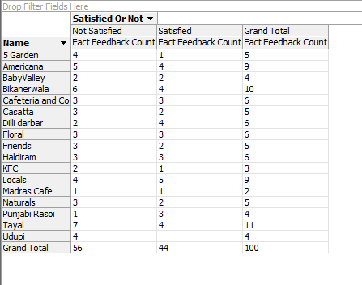

**Review Analysis:**

1. Total count of ratings given per city.

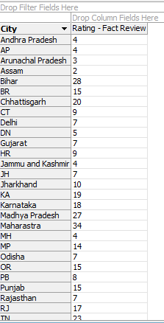

1. Total count of reviews given in different levels per city.

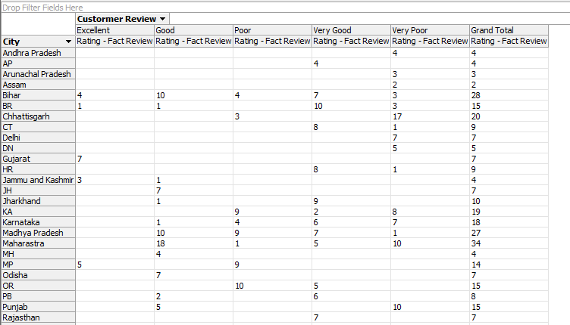

1. Total count of review per gender.

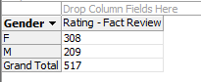

1. Total rating and review count given by each age.

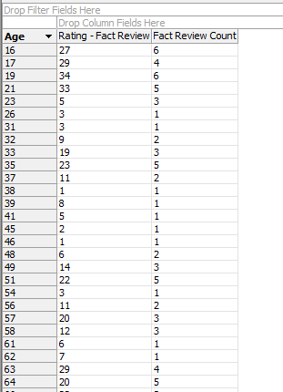

1. Total rating and review count per food item.

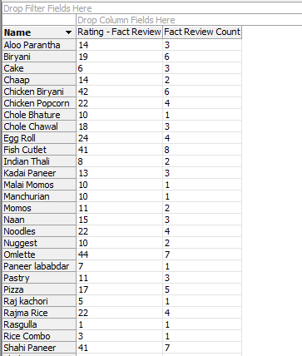

1. Total count of ratings given to each food item by customers.

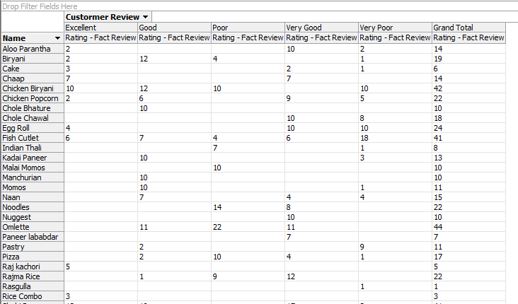

1. City wise total reviews given by customer.

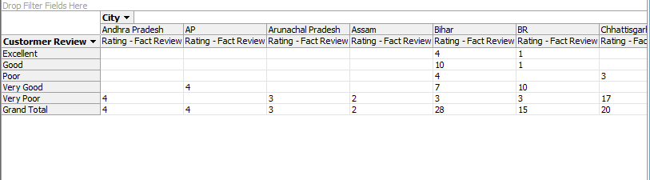

1. Category wise total reviews given by customers.

