**Vendor Performance Data Analysis Report**

**Exploratory Data Analysis Insights**

Summary Statistics

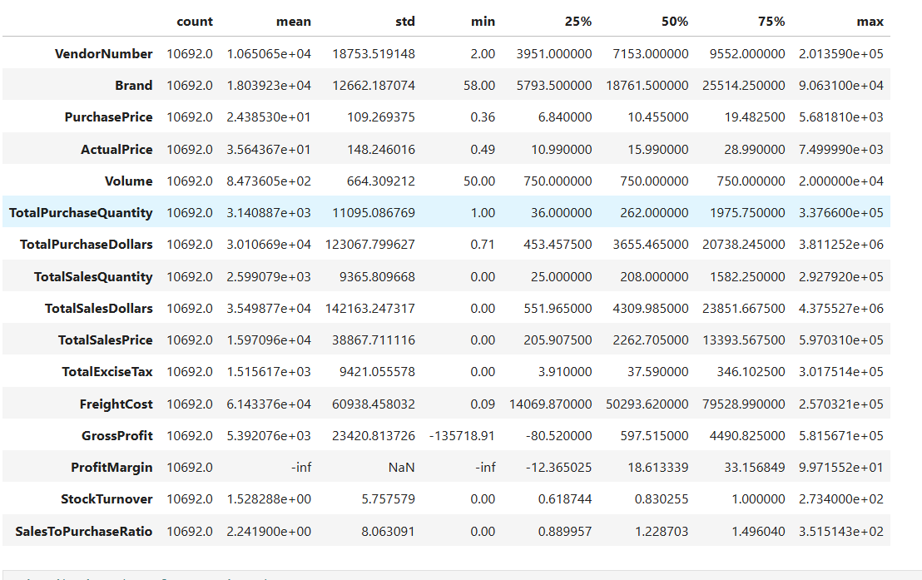

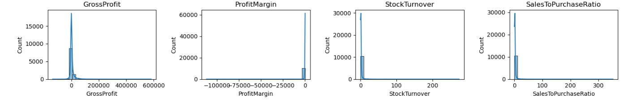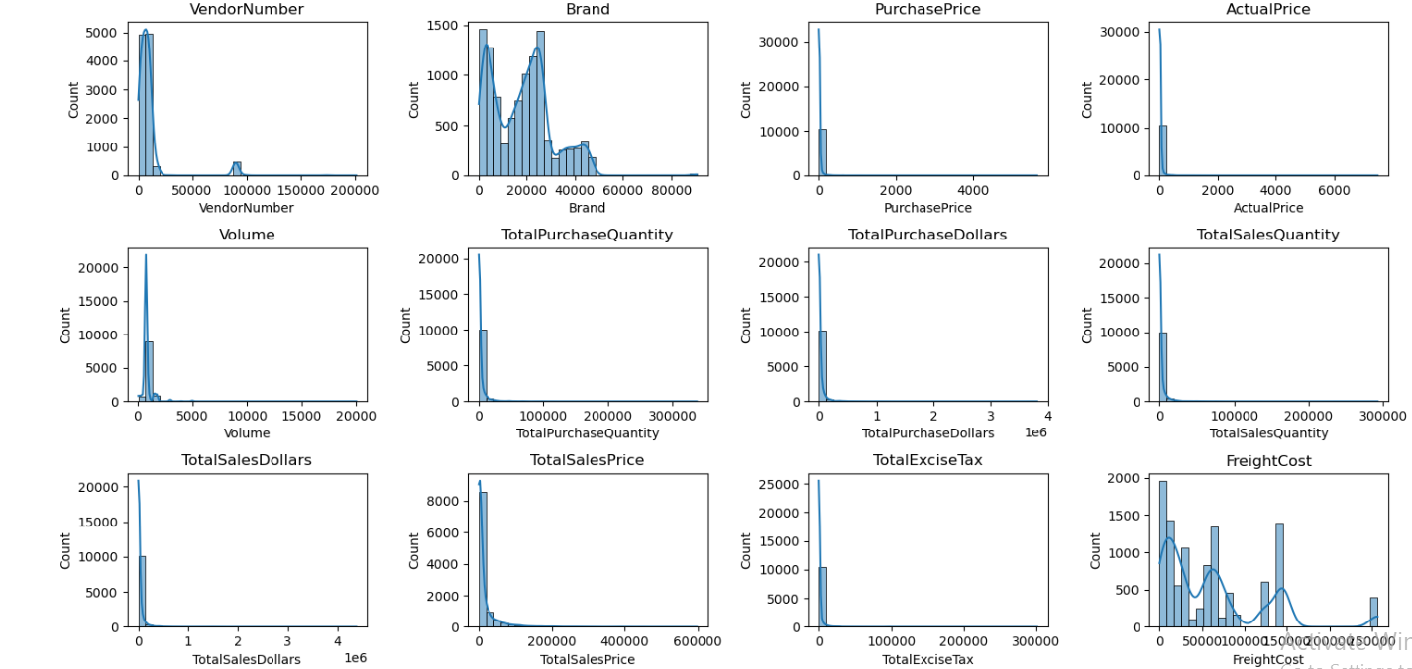

***Negative and Zero Values***

* **Gross profit**: Minimum value is -52,002.78, including losses. Some products or transactions may be selling at loss due to high costs or selling at discounts lower than the purchase price
* **Profit Margin:** Has a minimum purchase of -infinity , which suggests cases where revenue is zero or even lower than costs.
* **Total sales quantity & Sales Dollars:** Minimum value are 0 , meaning some products were purchased but never sold. These could be slow-moving or absolute stock

***Outliers indicated by high standard derivations***

* **Purchase & Actual Prices** : The max values (5,681.810 & 7,499.99) are significantly higher than the mean (24.39 & 35.64), indicating potentially premium products.
* **Freight Cost** : Huge Variations, from 0.09 to 257,032.07) suggests logistics inefficiencies or bulk shipments.
* **Stock Turnover :** Ranges from 0 to 274.5, implying some products sell extremely fast while others remain in stock indefinitely . Value are than 1 indicates that sold quantity for tat product is higher than purchased quantity due to either sales are being fulfilled from older stock.

Data Filtering

To enhance the reliability of the insights, we removed inconsistent data points where:

* Gross Profit <= 0(To exclude transactions leading to losses).
* Profit Margin <= 0 (to ensure analysis focuses on profitable transactions)
* Total Sales Quantity = 0(to eliminate inventory that was never sold)

**Correlations Insights**

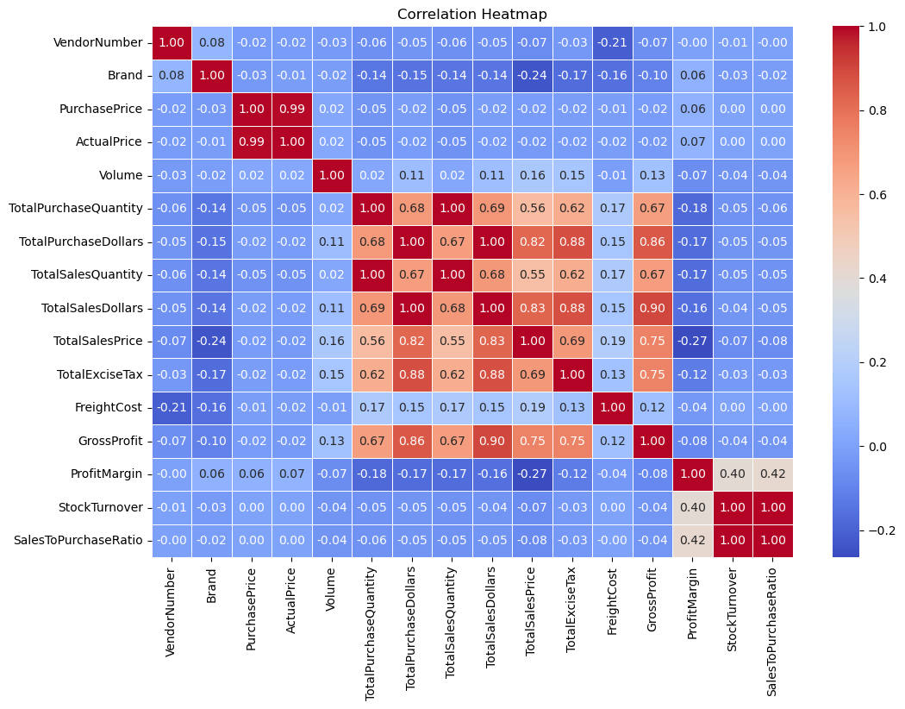

**Correlation Insights**

* PurchasePrice has weak correlations with TotalSalesDollars(-0.012) and GrowthProfit(-0.016), suggesting that the price variations do not significantly impact sales revenue or profit
* Strong Correlation between total purchase quantity and total sales quantity(0.999) , confirming efficient inventory turnover.
* Negative correction between profit margin & total sales price (-0.179) suggests that as sales price increases , Margins decreases , possibly due to competitive pricing pressures.
* StockTurnover has weak negative correlation with both GrossProfit(-0.038) and ProfitMargin (-0.0555) , indicating that faster turnover does not necessarily results in higher profitablity

**Research Questions & Key Findings**

1. Brands for Promotional or Pricing Adjustments

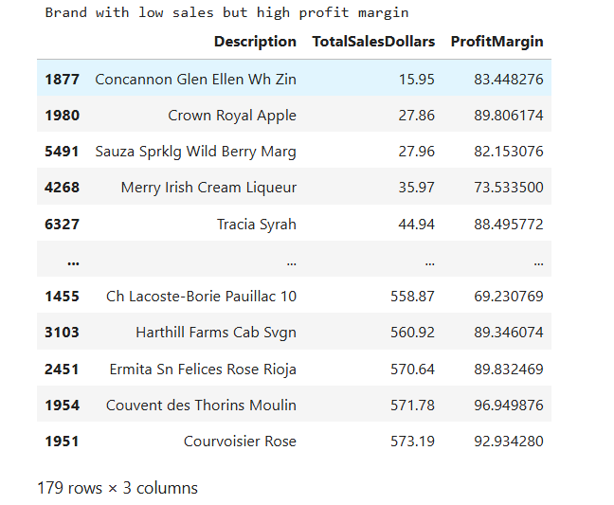

179 brands exhibit lower sales but higher profit margins, which could benefit from targeted marketing, promotions, or price optimizations to increase volume without compromising profitability.

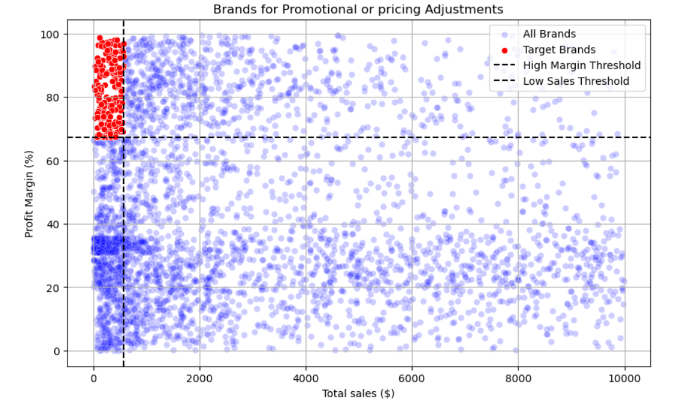

2. Top Vendors by sales & Purchase contributions

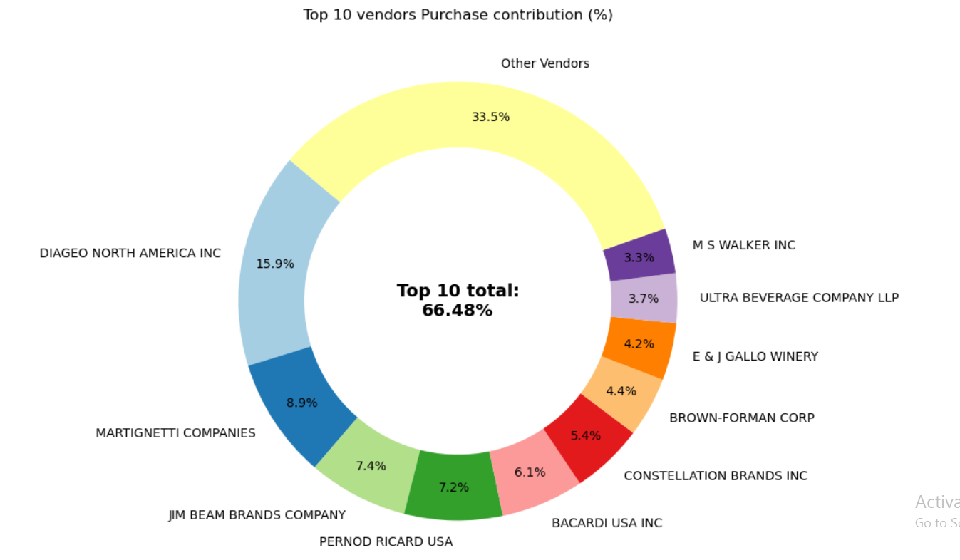

The Top 10 Vendors contribute 66.48% of total purchases, while the remaining vendors contribute only 35.5%. This over-reliance on a few vendors may introduce risks such as supply chain disruptions, indicating a need for diversification.

3. Impact of bulk purchasing on Cost Savings

Vendors buying in large quantities receives a 72% lower unit cost($10.78 per unit Vs. higher unit costs in smaller order)

Bulk Pricing strategies encourage large orders, increasing total sales while maintaining profitability.

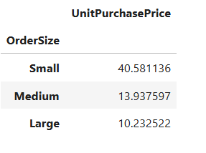

4. Identifying Vendors with Low Inventory Turnover

Total Unsold Inventory Capital : $2.71M

Slow-moving inventory increases storage costs, reduces cash flow efficiency, and affects overall profitability.

Identifying vendors with low inventory turnover enables better stock management, minimizing financial strain.

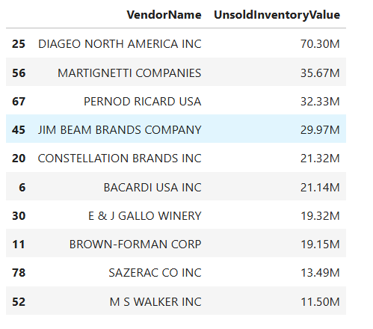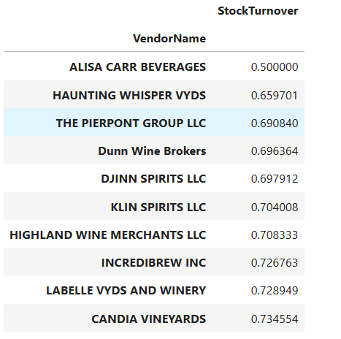

5. Profit Margin Comparison: High vs. Low-Performing Vendors

Top Vendors’ Profit Margin(95% CI): (18.87%, 23.36%), Mean: 21.11

Low Vendors’ Profit Margin(95% CI): (39.92%, 45.08%), Mean: 42.50

Low-Performing vendors maintain higher margins but struggle with sales volumes, indicating potential pricing inefficiencies or market reach issues.

Actionable Insights:

* Top- Performing Vendors: Optimize profitability by adjusting pricing, reducing operational costa, or offering bundled promotions.
* Low -Performing Vendors: Improve marketing efforts, optimize pricings strategies, and enhance distribution networks.

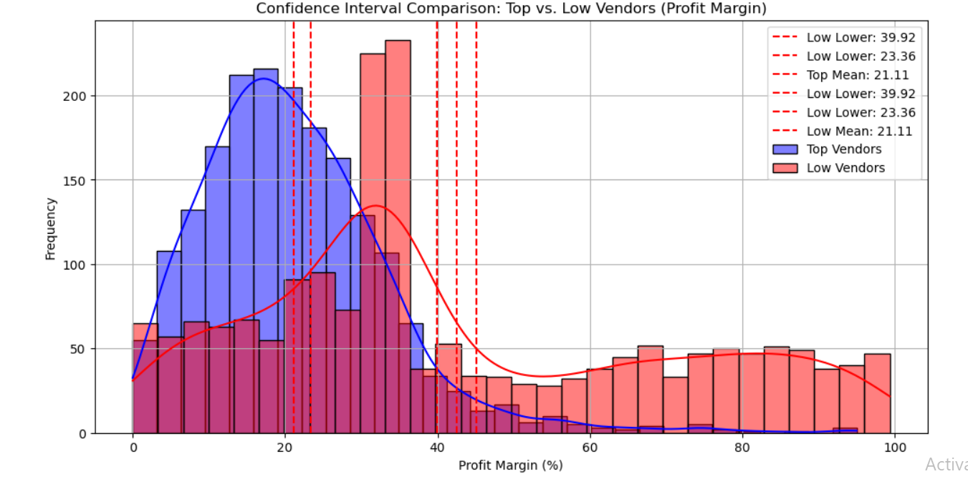6. Statistical Validation of Profit Margin Difference

Hypothetical Testing:

H1 (Null Hypothesis): There is no significant difference in the mean profit margins of top-performing and low-performing vendors

H2 (Alternative Hypothesis): A significant difference exists in profit margins between the two vendor groups.

**Result:** The null Hypothesis is rejected, confirming that the two groups operate under distinctly different profitability models.

Implications : High- Margin vendors may benefit from better pricing strategies, while top-selling vendors could focus on cost efficiency.

**Final Recommendation**

* Re-evaluate pricing for low-sales, high-margin brands to boost sales volume without sacrificing profitability.
* Diversify vendor partnerships to reduce dependency on a few suppliers and mitigate supply chain risk.
* Leverage bulk purchasing advantages to maintain competitive pricing while optimizing inventory managements.
* Optimize slow-moving inventory by adjusting purchase quantities, launching clearance sales, or revising storage strategies.
* Enhance marketing and distributions strategies for low-performing vendors to drive higher sales volumes compromising profit margins.
* By implementing these recommendations , the company can achieve sustainable profitability, mitigate risks, and enhance overall operational efficiency.