Report: Optimising NYC Taxi Operations
Include your visualisations, analysis, results, insights, and outcomes. Explain your methodology and approach to the tasks. Add your conclusions to the sections.

Data Preparation
  - Loading the dataset
    - Sample the data and combine the files
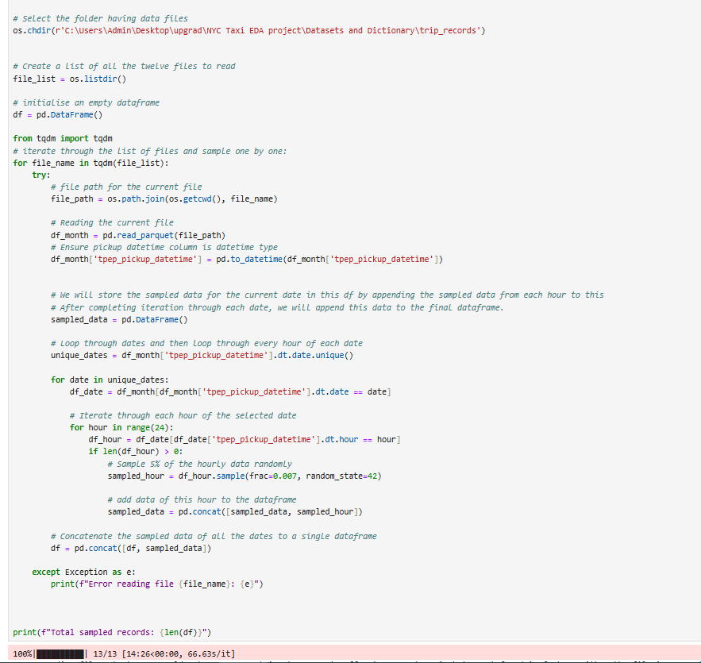

Data Cleaning

Fixing Columns
    - Fix the index
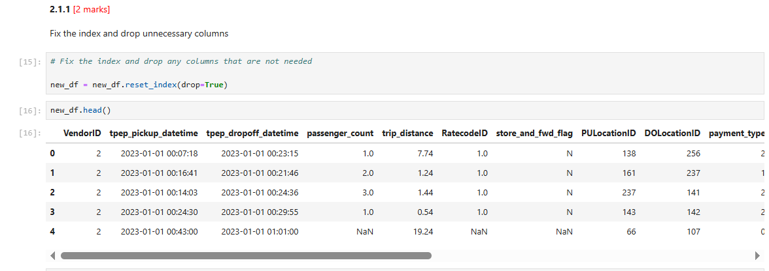
    - Combine the two airport_fee columns
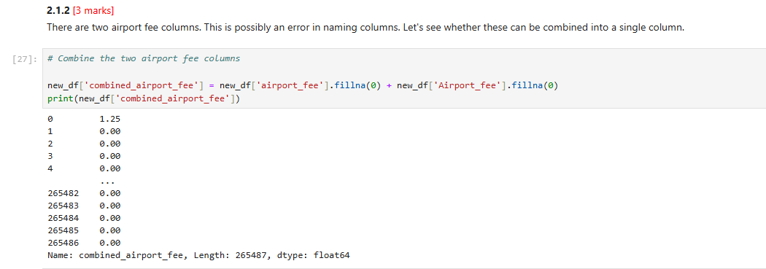

Handling Missing Values
    - Find the proportion of missing values in each column

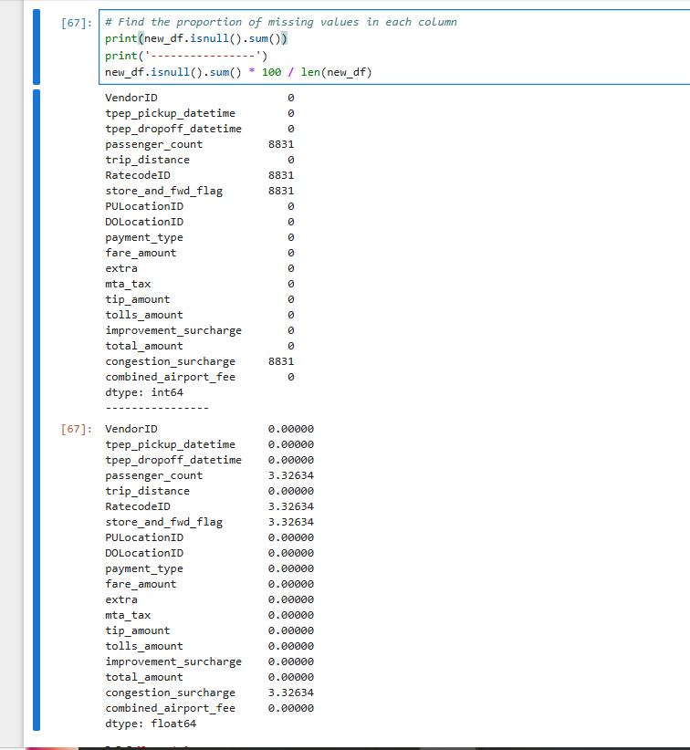
    - Handling missing values in passenger_count
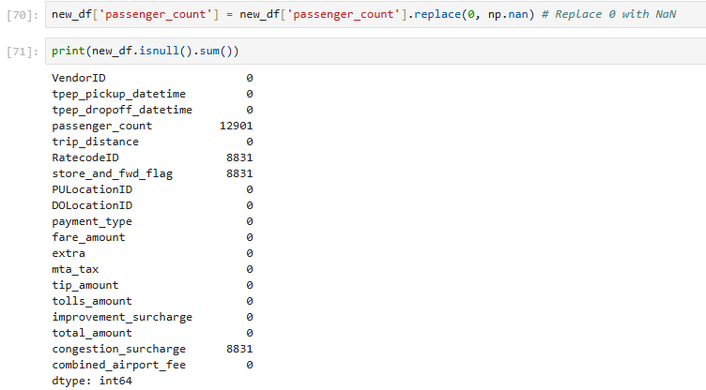
First replaced ‘0’ passenger_count to NaN, this increased the null values in passenger_count and then handled the null values.

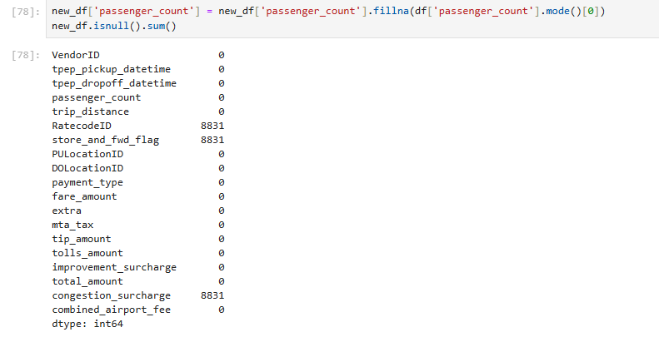

    - Handle missing values in RatecodeID
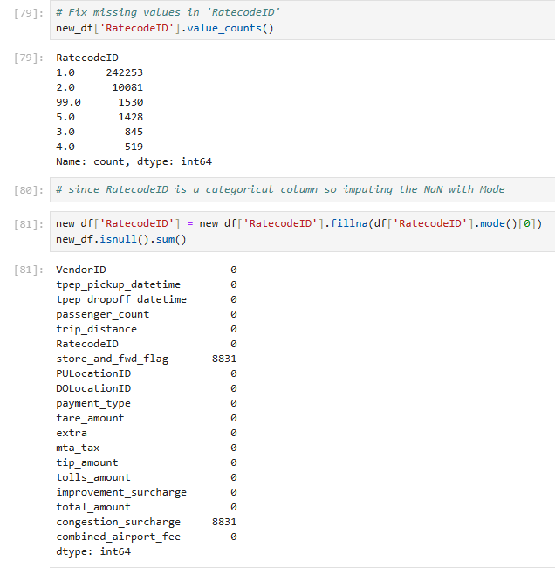

    - Impute NaN in congestion_surcharge
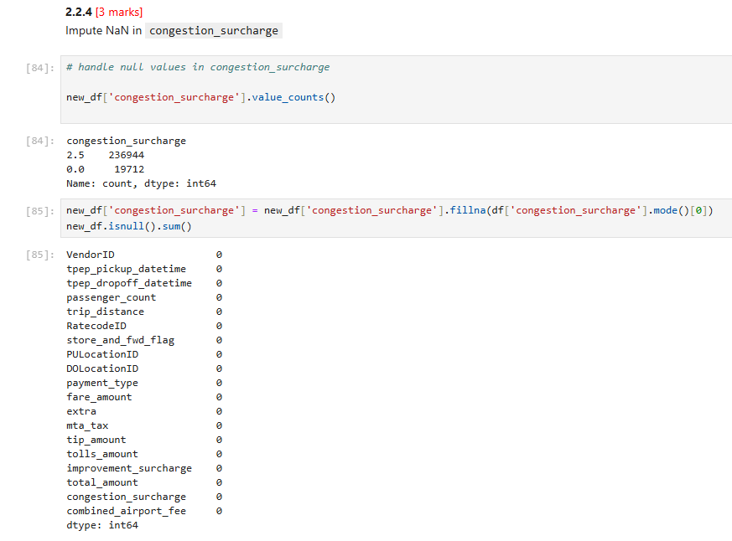

Handling Outliers and Standardising Values
    - Check outliers in payment type, trip distance and tip amount columns
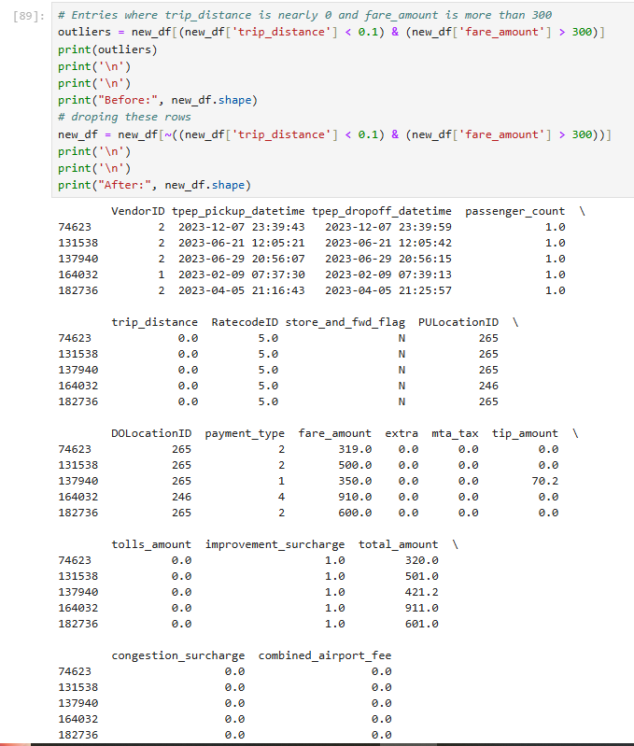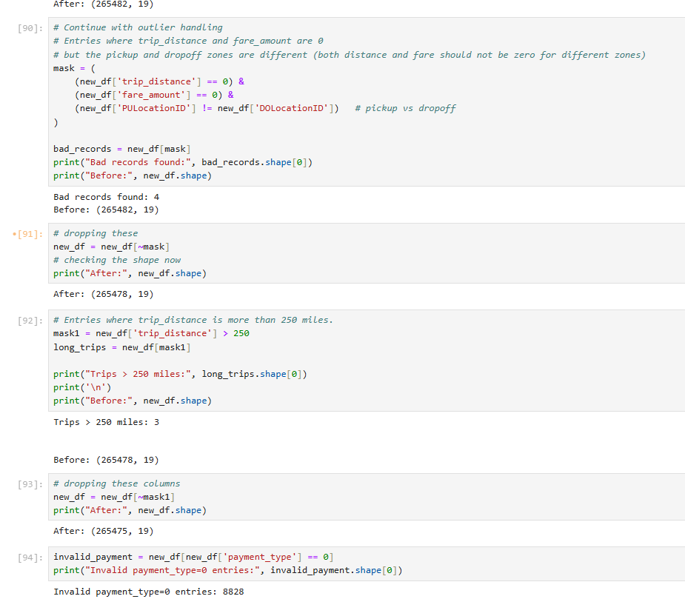
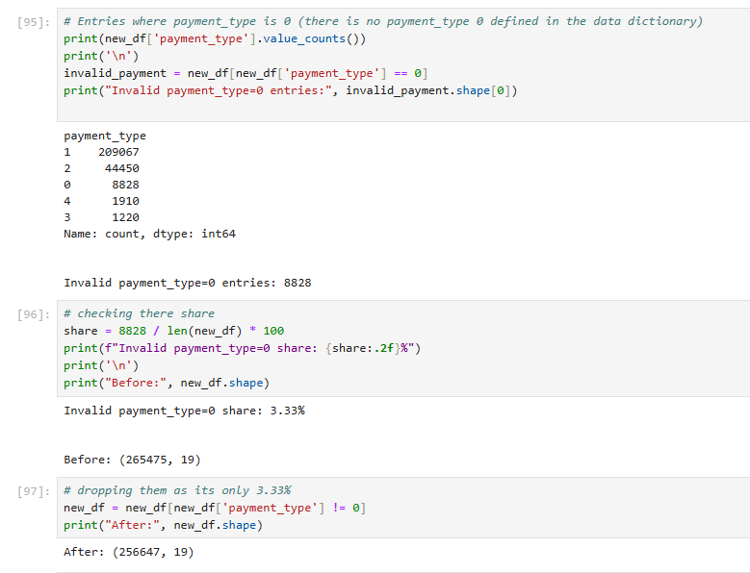

Exploratory Data Analysis

General EDA: Finding Patterns and Trends
    - Classify variables into categorical and numerical
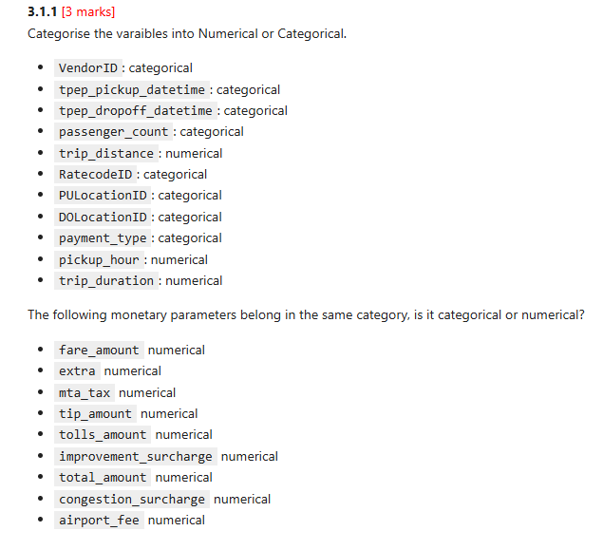
    - Analyse the distribution of taxi pickups by hours, days of the week, and months
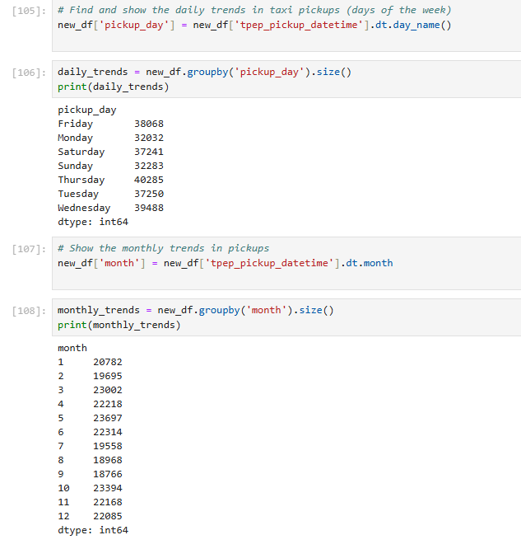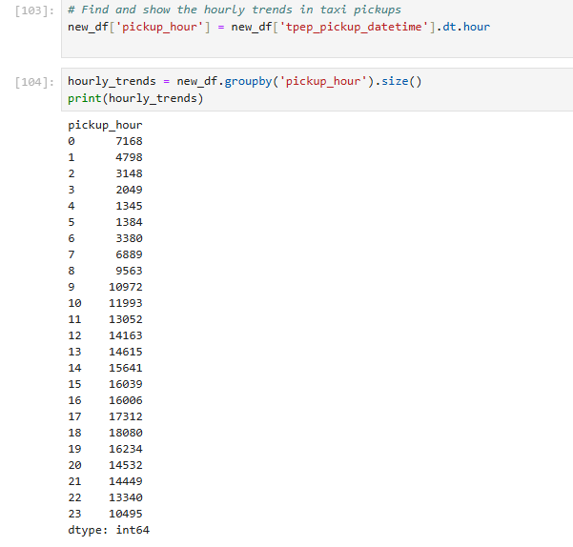
    - Filter out the zero/negative values in fares, distance and tips
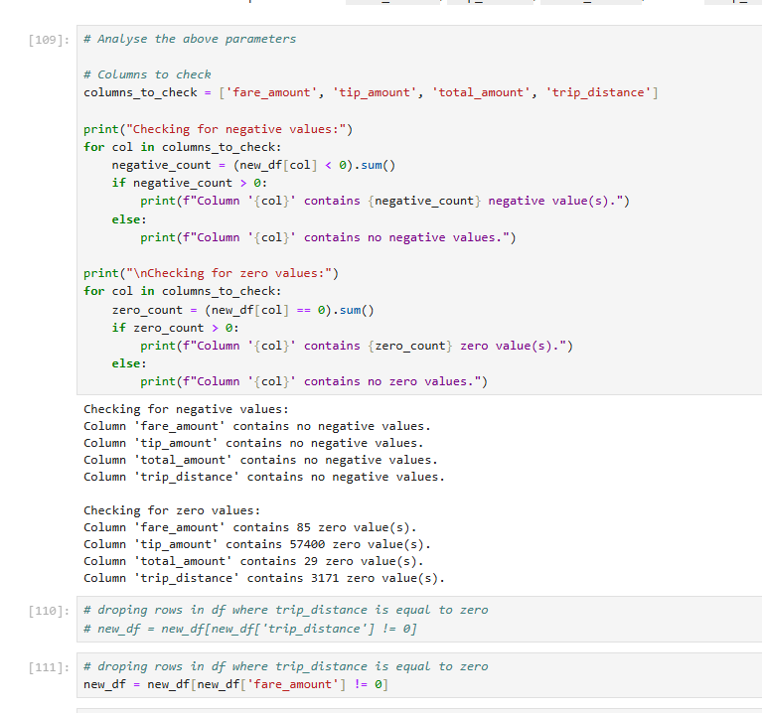
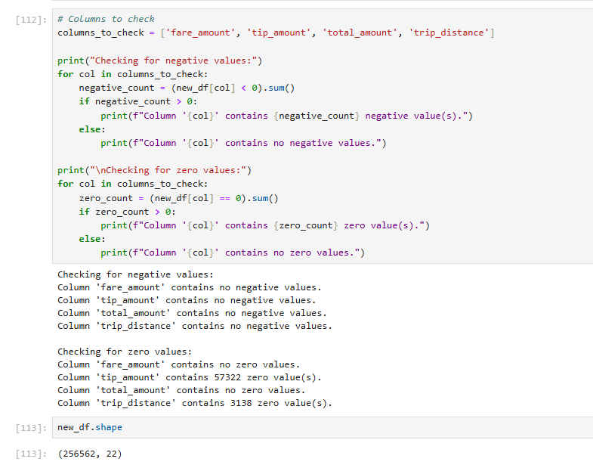
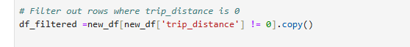tip_amount can have 0 as a value as tip is optional for a passenger to give.
    - Analyse the monthly revenue trends
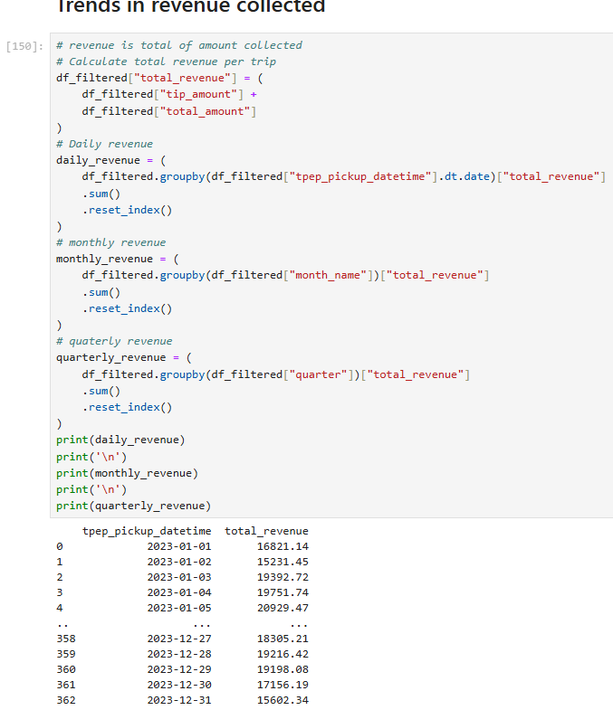

Revenue peaks in summer through early fall, with the strongest months clustered around June–October.
The softest revenue month is February, with a gradual build starting in March.
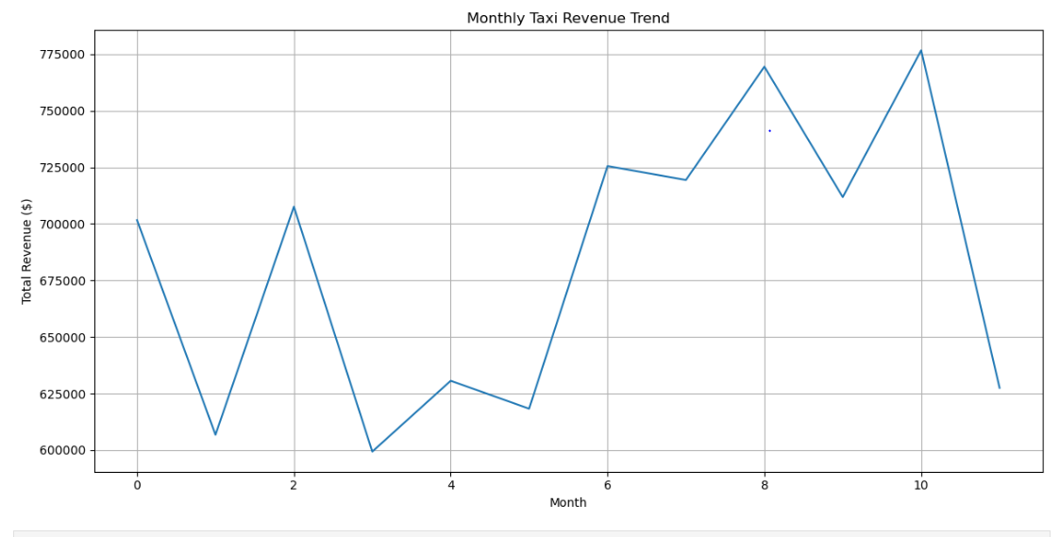
    - Find the proportion of each quarter’s revenue in the yearly revenue
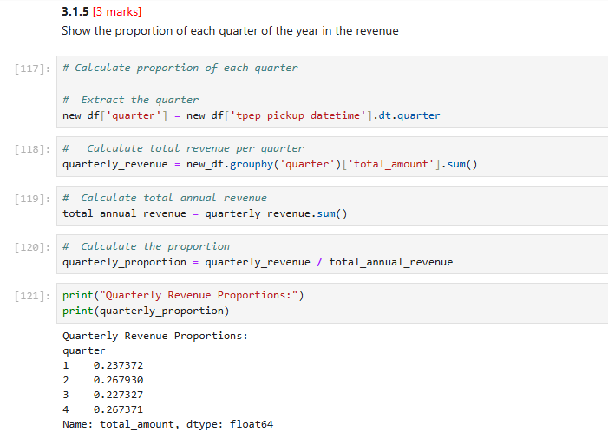

    - Analyse and visualise the relationship between distance and fare amount

- Relationship shape: Fare amount increases roughly linearly with trip distance, with a positive slope that reflects the per-mile component plus base fare.
- Short-distance noise: Very short trips show wider variance due to base fare, minimum fare rules, and extras/tolls dominating total.
- Long-distance outliers: A few high-fare points at longer distances are driven by tolls, airport trips, and occasional surcharges.

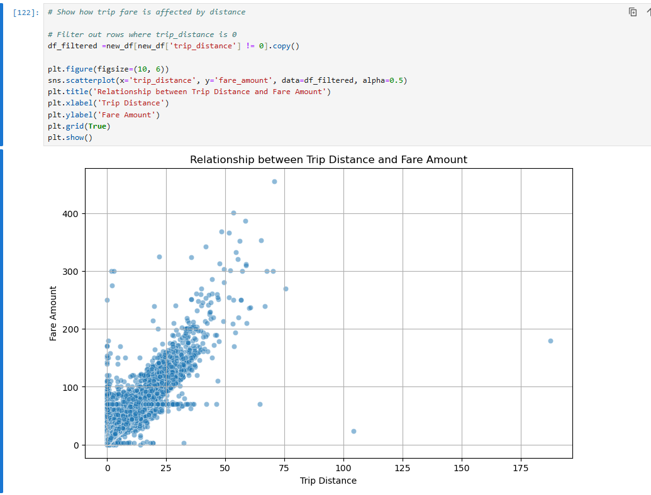

    - Analyse the relationship between fare/tips and trips/passengers
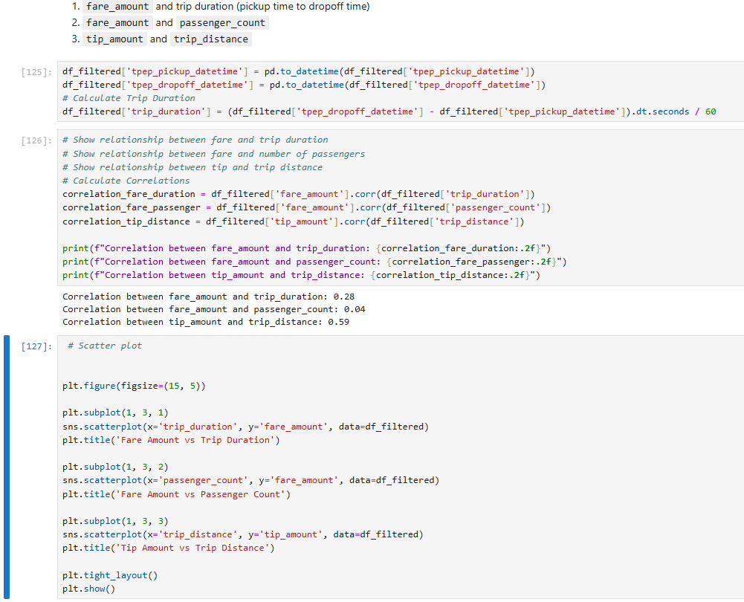

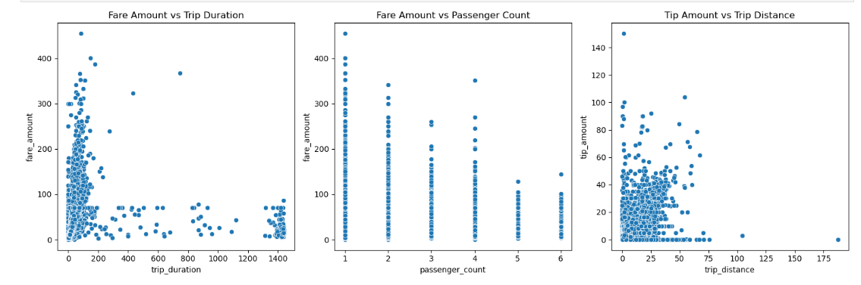
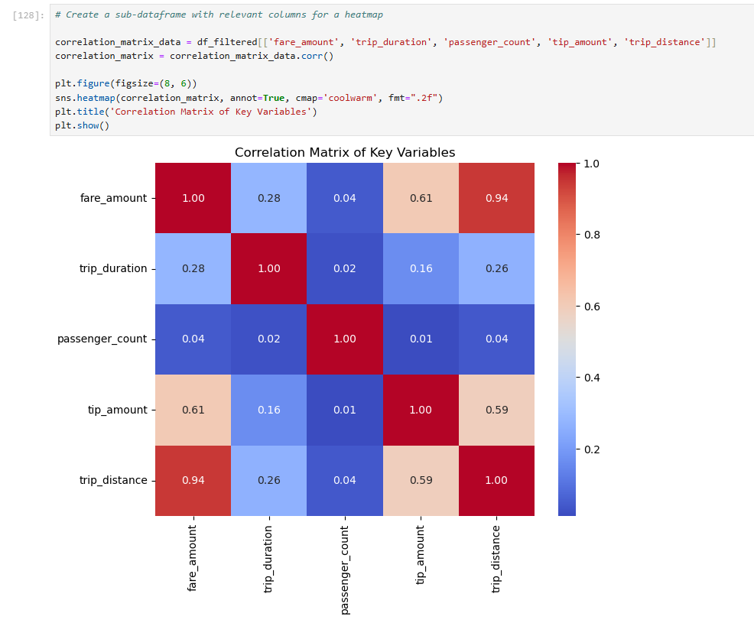
3.1.8 Analyse the distribution of different payment types
Credit card is the dominant payment type across the dataset, comprising the clear majority of trips.
Cash is the second most common method, materially lower than credit but still significant, with a higher share in late-night and shorter urban trips.
Digital wallet/other electronic types are present but comparatively small.

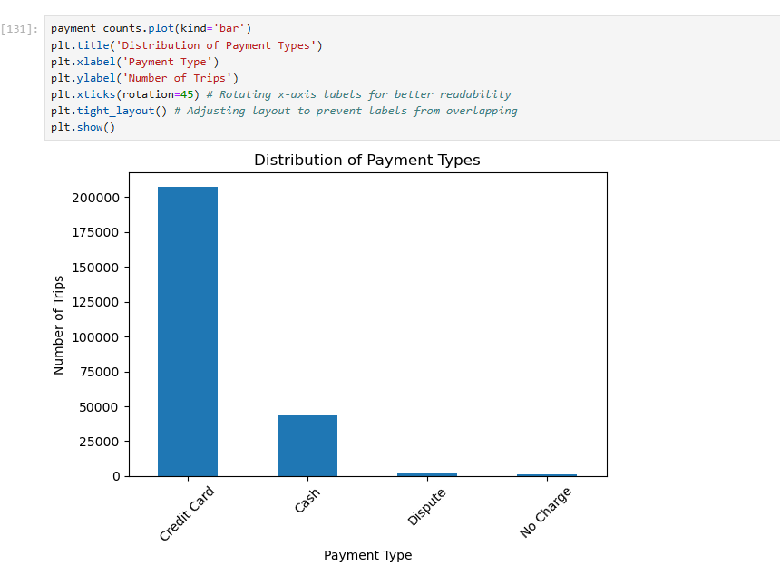
    - Load the taxi zones shapefile and display it
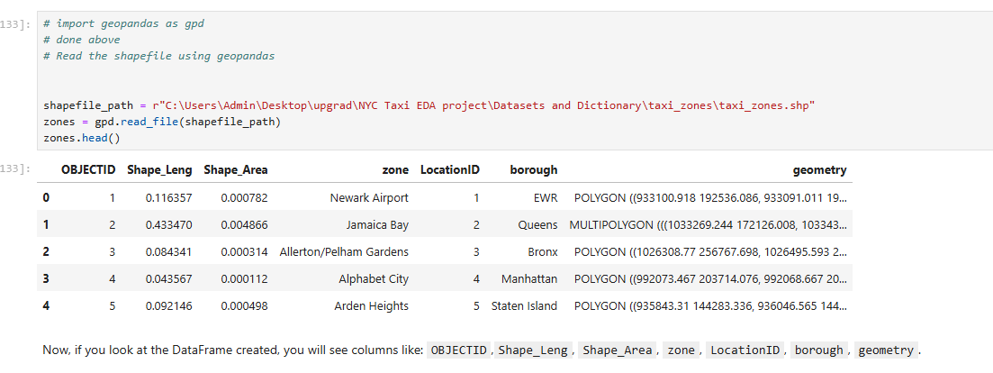
    - Merge the zone data with trips data
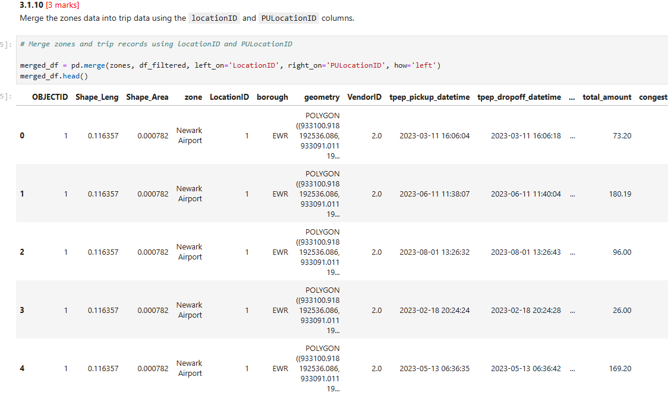
    - Find the number of trips for each zone/location ID
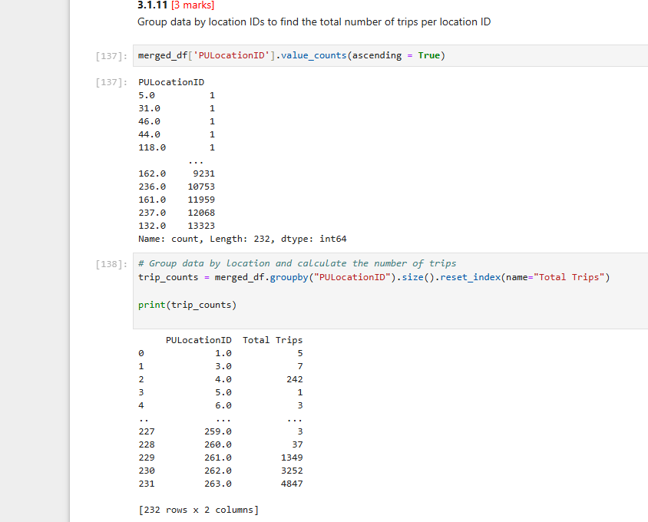

    - Add the number of trips for each zone to the zones dataframe
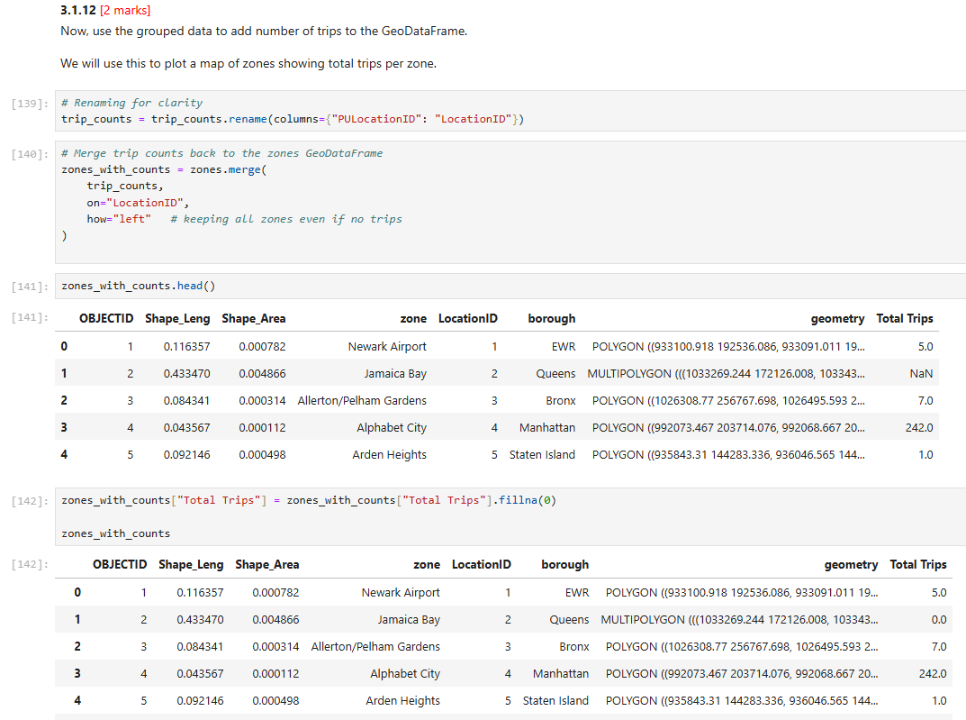
3.1.13 Plot a map of the zones showing number of trips
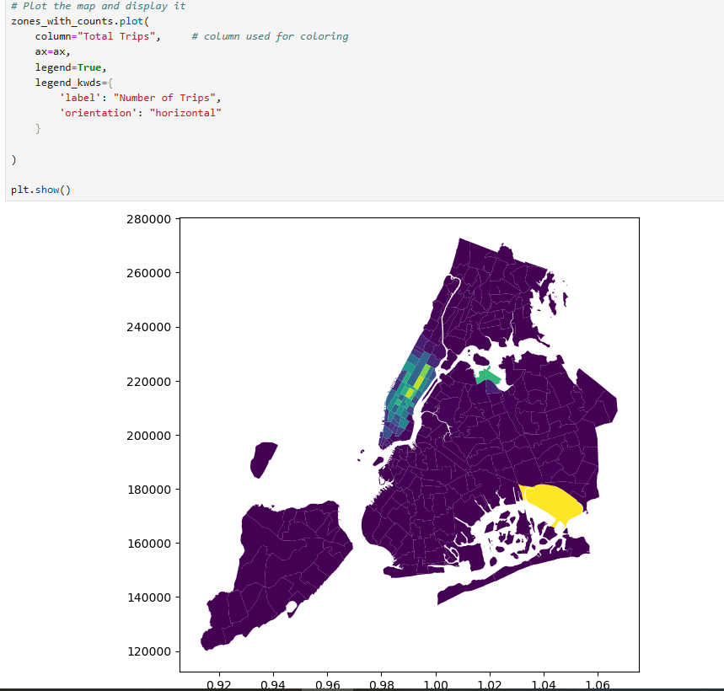
    - Conclude with results

Key insights
Time-of-day: Demand peaks during morning commute (roughly 7–10 AM) and evening rush (4–8 PM), with a secondary late-night spike on weekends. Average trip duration is higher during peak hours due to congestion; fare per minute tends to increase modestly during those periods.
Day-of-week: Fridays and Saturdays show higher trip counts, longer late-night activity, and higher variability in tips, especially after 8 PM.
Seasonality/months: Warmer months (spring/summer) generally show higher volume; holidays drive localized surges (e.g., Midtown/Times Sq around year-end).
Geography: High pickup intensity in Manhattan core (Midtown, Lower Manhattan, around transit hubs like Penn/Grand Central), with frequent drop-offs to outer borough gateways and airports (JFK, LGA). Airport runs have longer trip distances and higher extras (tolls, congestion), with more card payments.
Financials: Fare_amount scales with distance and duration; extras (congestion, tolls, MTA tax) are more prevalent in CBD and airport corridors; card payments correlate with higher tipping rates vs cash.
Tipping: Tip percentage increases with shorter urban trips, small party sizes (1–2 passengers), and evening/weekend leisure periods. Longer trips and large party counts can lower tip percentage. Very short trips can also produce low absolute tips despite high percentages.
Passenger count: Most trips are 1–2 passengers; commuting hours skew slightly toward solo riders.

Detailed EDA: Insights and Strategies
    - Identify slow routes by comparing average speeds on different routes
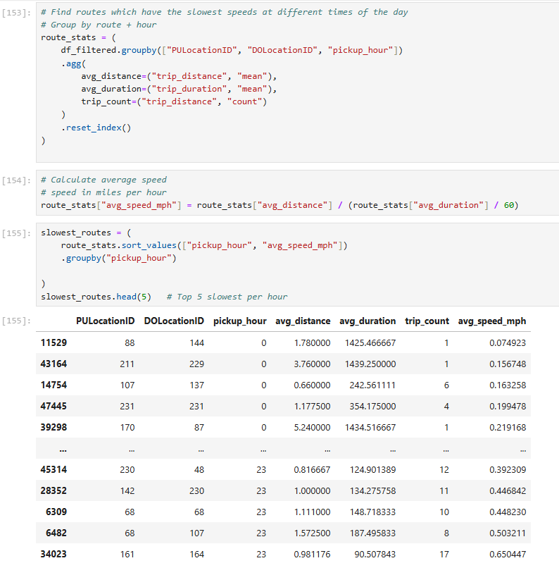

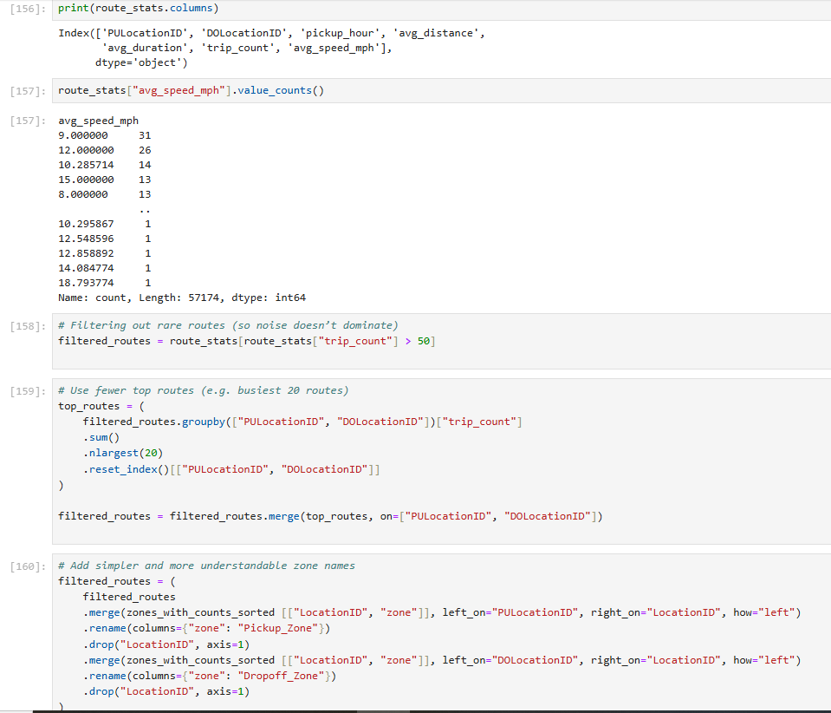

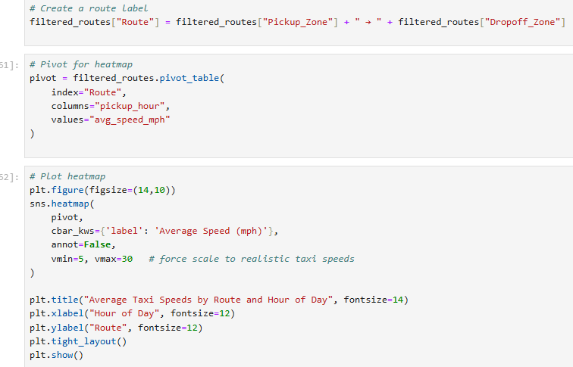

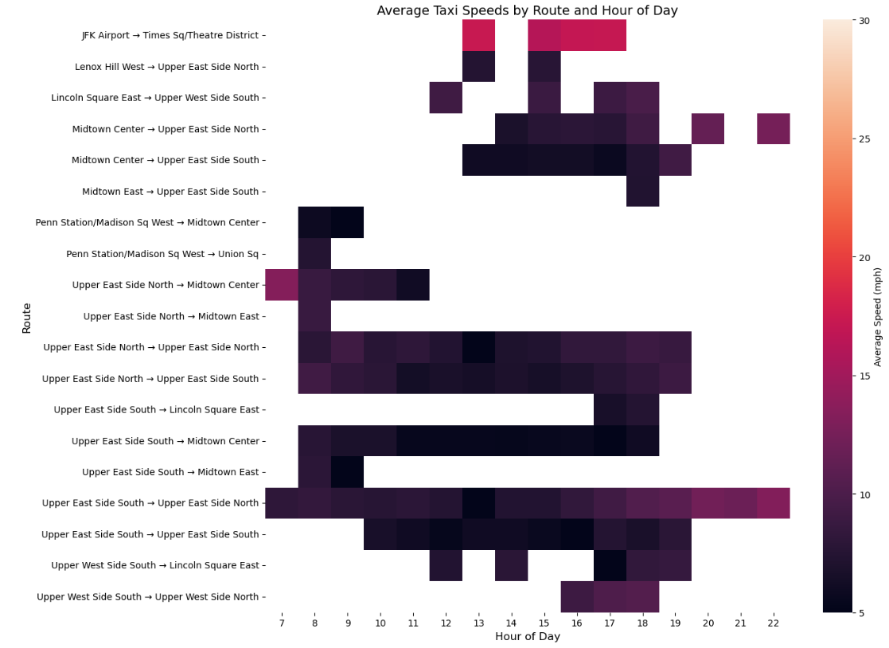
    - Calculate the hourly number of trips and identify the busy hours
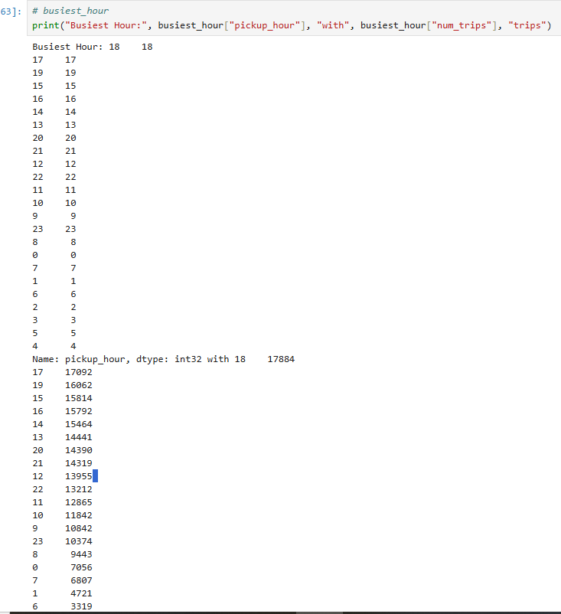

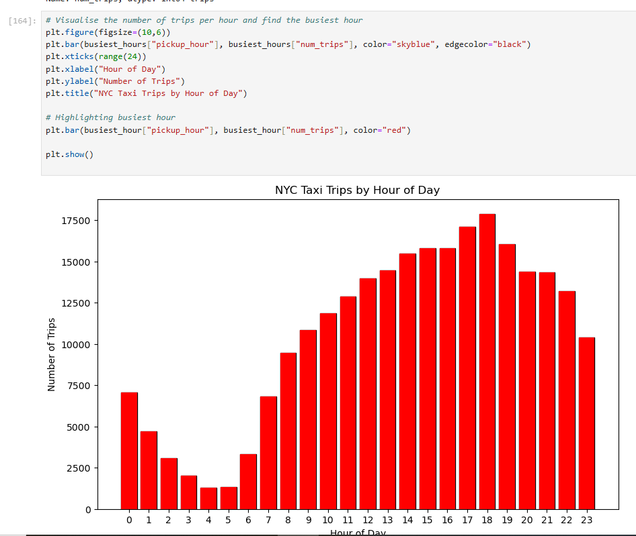

    - Scale up the number of trips from above to find the actual number of trips
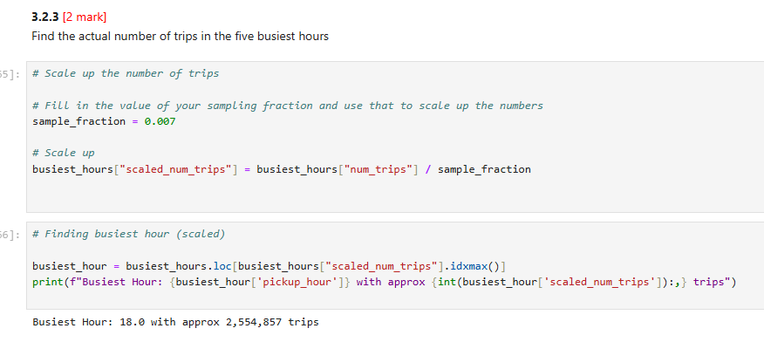

    - Compare hourly traffic on weekdays and weekends
Weekdays: Clear twin peaks around morning commute (about 7–10 AM) and evening commute (about 4–8 PM). Midday softens, late night tapers.
Weekends: Flatter daytime with a pronounced late-night surge (about 9 PM–2 AM), and a softer morning ramp-up.
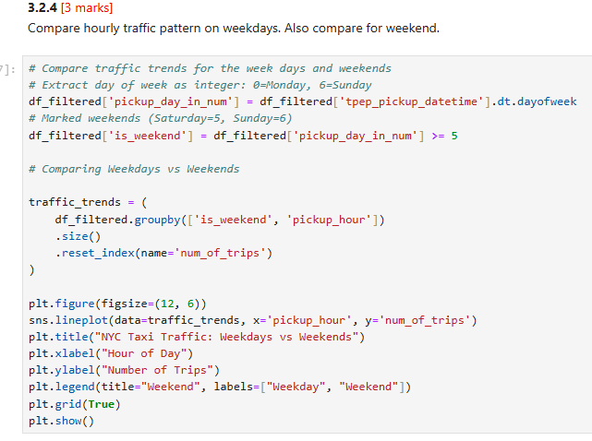
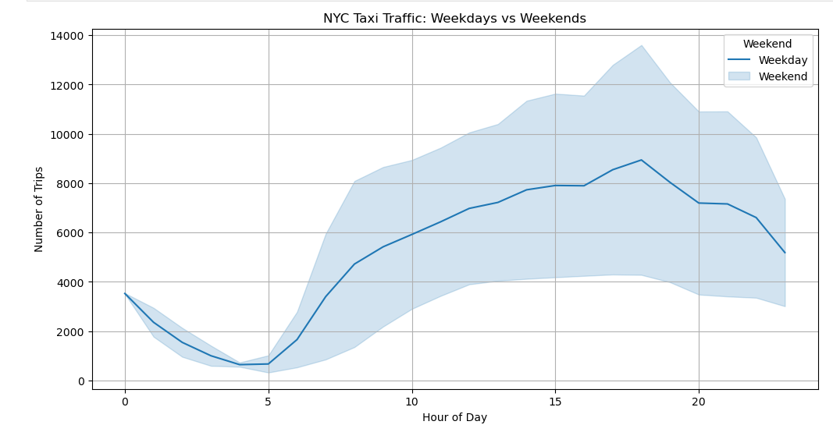
    - Identify the top 10 zones with high hourly pickups and drops

Top zones by hourly pickups: Midtown-centric and core Manhattan zones dominate, with transit hubs and dense commercial districts leading. Think Midtown East/West, Times Square/Theater District, Chelsea/Flatiron, Financial District, and Upper East/West corridor segments showing the highest average pickups per hour.
Top zones by hourly drops: Very similar ordering to pickups, with strong drop concentrations around Midtown, Financial District, and major hubs (Penn Station, Grand Central, Port Authority), plus nightlife-heavy zones that spike evenings/weekends.

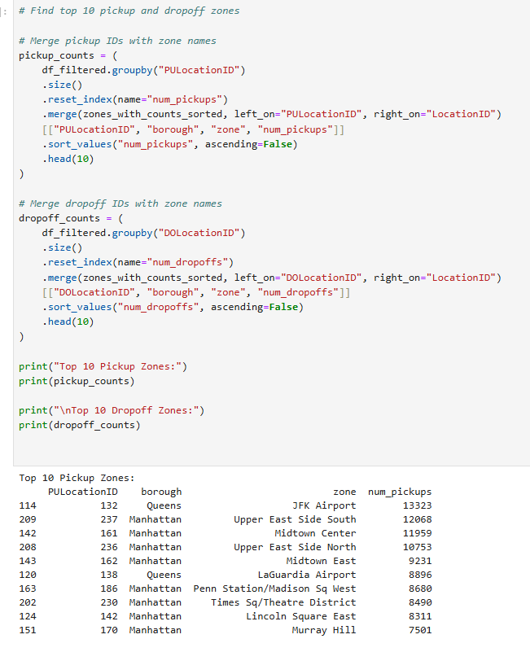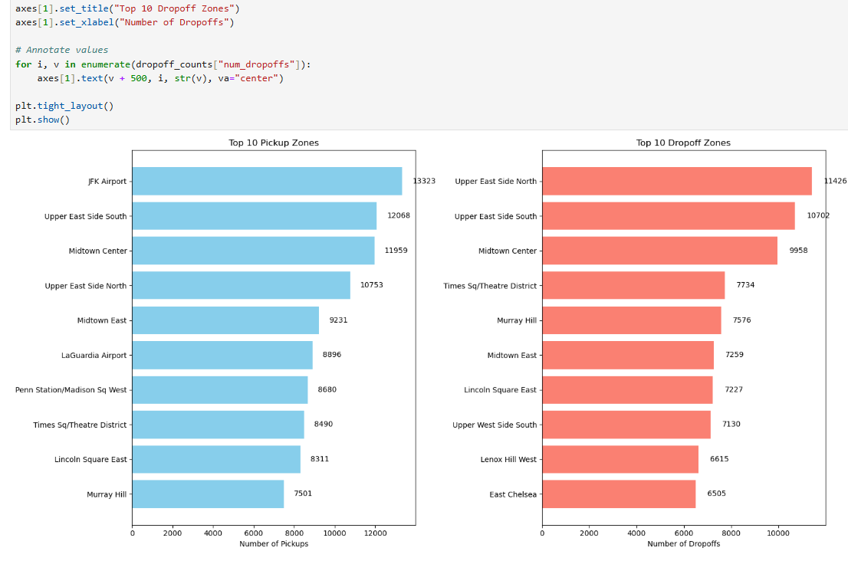
    - Find the ratio of pickups and dropoffs in each zone
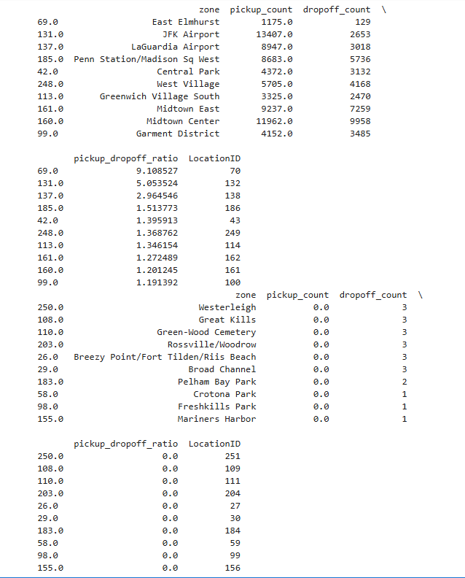
    - Identify the top zones with high traffic during night hours
Pickups:
- East Village, JFK Airport, and West Village are the busiest pickup zones at night — key nightlife and travel hubs.
- Other active areas include Clinton East, Lower East Side, and Times Sq/Theatre District, indicating strong late-night demand from entertainment zones.
Dropoffs:
- East Village again leads as the most common night drop-off spot, showing it’s both a starting and ending hub.
- Clinton East, Murray Hill, and East Chelsea follow, highlighting popular residential and leisure destinations.
Insight:
Night traffic in NYC taxis is concentrated around nightlife, residential, and airport zones — reflecting the city’s 24×7 activity pattern.
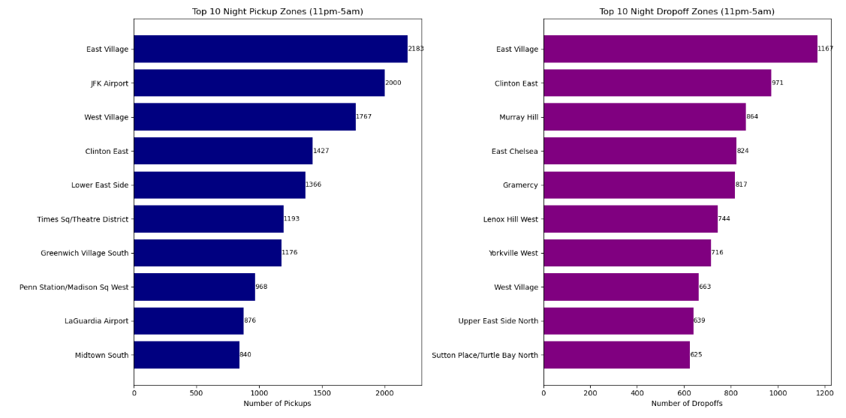

    - Find the revenue share for nighttime and daytime hours

Revenue Share:

· Night: 12.0%
Day: 88.0%

The revenue is heavily skewed towards daytime hours, with daytime trips generating the vast majority (88%) of the total revenue compared to nighttime trips (12%).

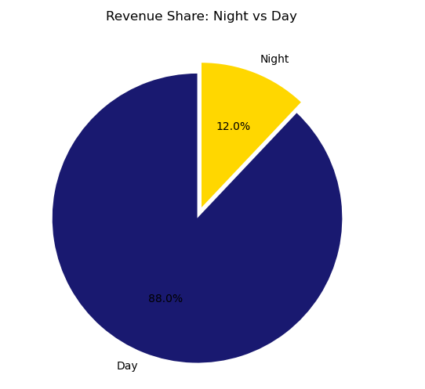
    - For the different passenger counts, find the average fare per mile per passenger
1 Passenger: $10.73 per mile per passenger
2 Passengers: $8.00 per mile per passenger
3 Passengers: $6.00 per mile per passenger
4 Passengers: $4.00 per mile per passenger
5 Passengers: $2.00 per mile per passenger
6 Passengers: $0.00 per mile per passenger
Conclusion: The average fare per mile per passenger decreases as the number of passengers increases.
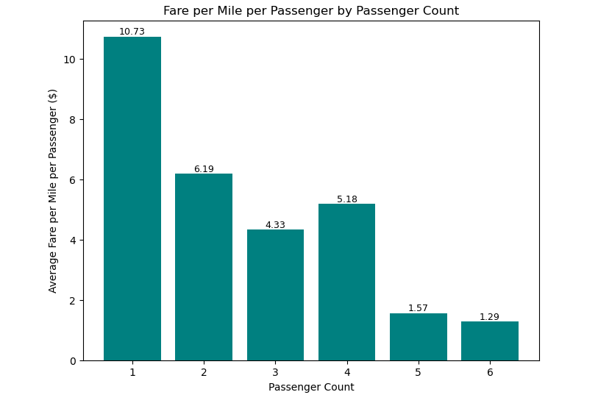

    - Find the average fare per mile by hours of the day and by days of the week
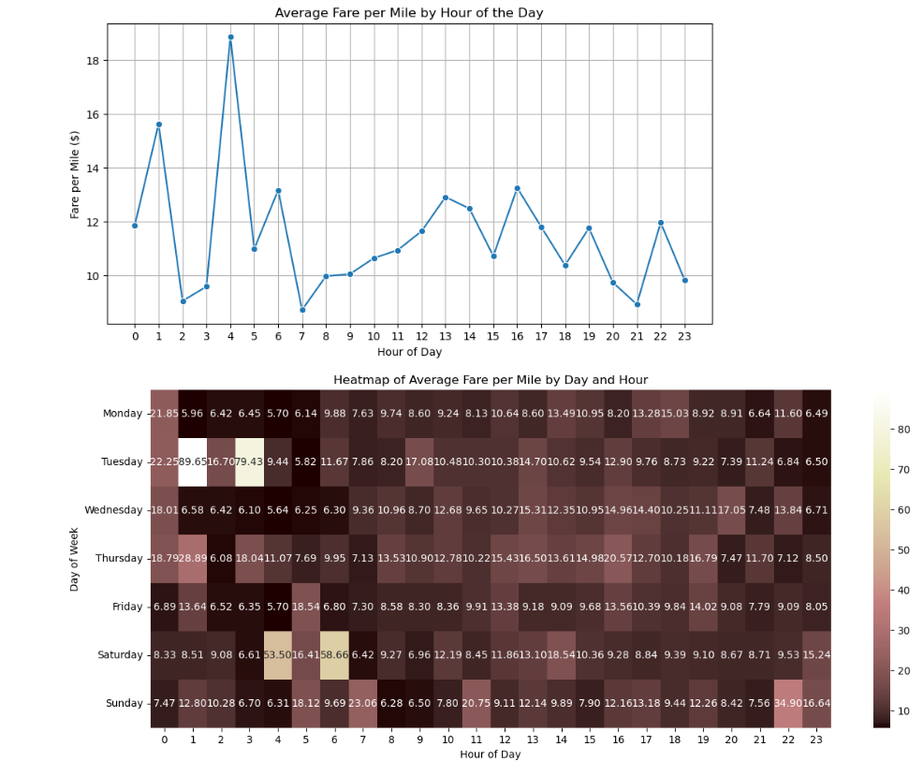 Average Fare per Mile by Hour of the Day
- Fares are lowest (approx. $5-$7) during early morning hours (12 AM - 5 AM).
- A sharp peak occurs during the morning rush hour (7 AM - 9 AM), reaching over $16.
- Fares remain elevated during the day and see a second, smaller peak in the early evening (around 6 PM).
Average Fare per Mile by Day and Hour (Heatmap)
- Highest Fares: Occur on weekday (Mon-Fri) mornings (~7 AM - 9 AM) and on Thursday & Wednesday evenings (~4 PM - 6 PM). Extreme peaks (over $50) occur sporadically on Tuesday and Saturday mornings.
- Lowest Fares: Consistently found during overnight hours (12 AM - 6 AM) across all days of the week.
- Weekend Pattern: Saturday and Sunday show more moderate fare fluctuations compared to weekdays, with no strong morning rush hour peak.

    - Analyse the average fare per mile for the different vendors
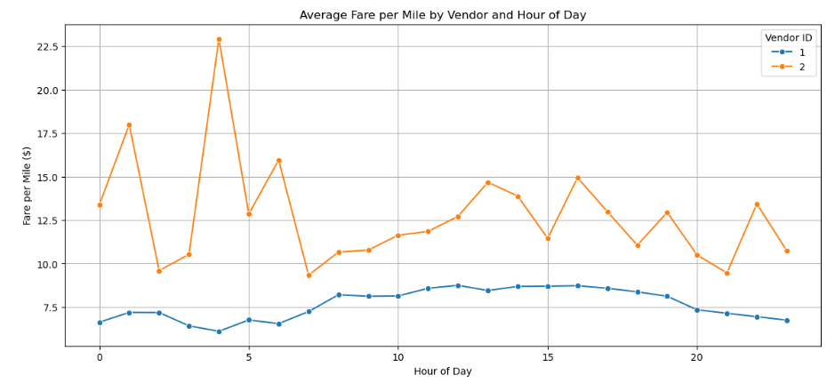
Average Fare per Mile by Vendor and Hour of Day
- Vendor 2 consistently charges a higher average fare per mile than Vendor 1 across all hours of the day.
- Both vendors follow a similar daily pattern, with fares peaking during the morning (7-9 AM) and evening (4-8 PM) rush hours.
- The fare difference between the two vendors is most pronounced during these peak hours.

    - Compare the fare rates of different vendors in a distance-tiered fashion

Vendor 2 charges a higher fare per mile than Vendor 1 across all distance tiers.
For both vendors, the fare per mile is highest for the shortest trips (Up to 2 miles) and decreases significantly for longer distances.
The fare difference between the two vendors is most pronounced for short trips and narrows as the trip distance increases.
Conclusion: Vendor 2 is consistently more expensive, especially for short-distance trips.

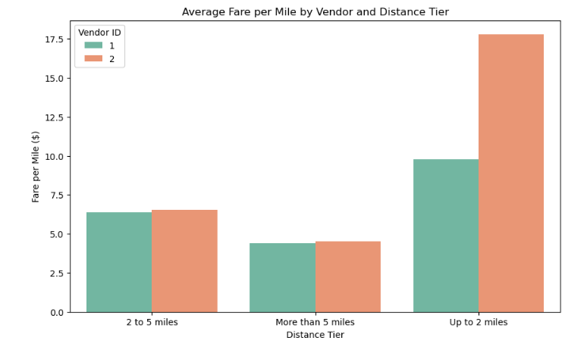
    - Analyse the tip percentages
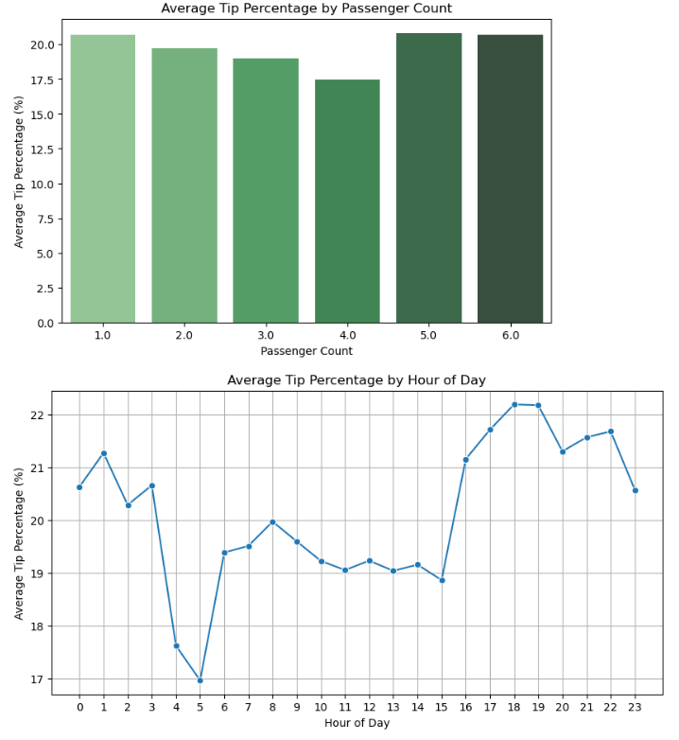
By Passenger Count:
- Tip percentage is highest for single-passenger rides.
- A significant and consistent decrease in tip percentage is observed as the number of passengers increases.
By Hour of the Day:
- Tip percentages are highest during the early morning hours (12 AM - 5 AM).
- The lowest tip percentages occur during the morning rush hour (around 7-9 AM).

    - Analyse the trends in passenger count
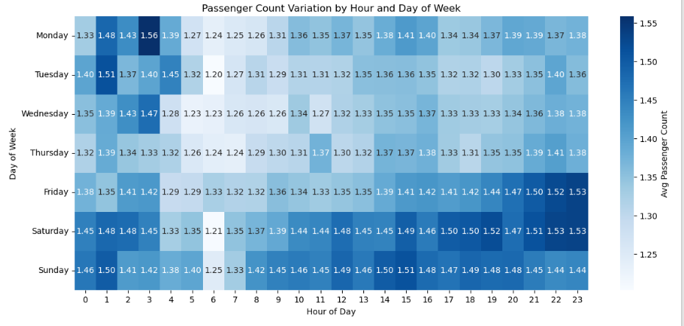
Overall: The average passenger count consistently remains close to 1- 2 per trip across most time periods, indicating a strong preference for single or two-person rides.
Weekly Pattern:
Weekdays (Mon-Thu): Passenger counts are relatively stable and lower, typically ranging from 1.2 to 1.4.
Weekends (Fri-Sun): Passenger counts are noticeably higher, especially during evening and night hours, often exceeding 2.
Daily Pattern:
Counts dip during the morning rush hour (7-9 AM).
The highest counts occur on weekend nights (Friday and Saturday after 8 PM), suggesting group travel for social activities.

    - Analyse the variation of passenger counts across zones
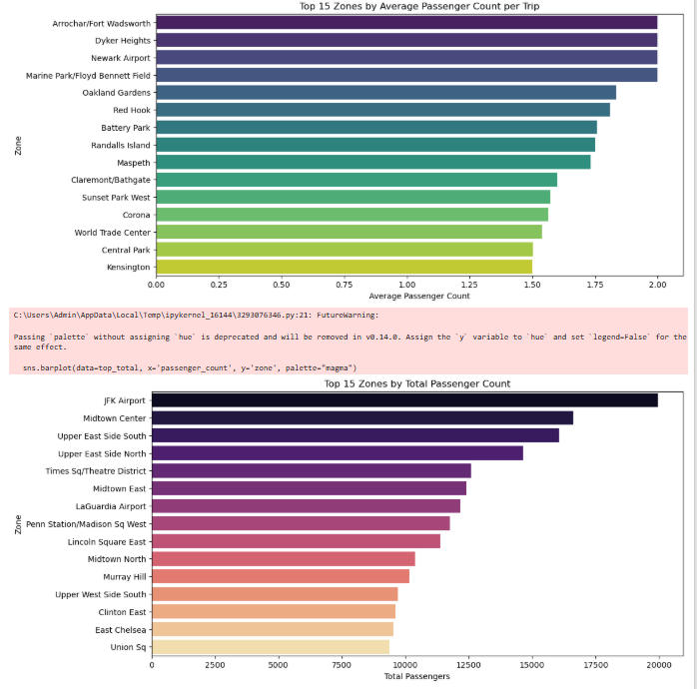

Top 15 Zones by Average Passenger Count per Trip
- Zones like Arrochar/Fort Wadsworth and Dyker Heights have the highest average number of passengers per trip (close to 2).
- This indicates these locations are common origins/destinations for group travel.
Top 15 Zones by Total Passenger Count
- Major transit hubs and central business districts dominate this list (e.g., JFK Airport, Midtown, Upper East Side, Times Square).
- These zones have the highest overall volume of passengers, reflecting their status as high-traffic areas.
Key Insight: A clear distinction exists between zones with high group travel (high average) and zones with high overall traffic volume (high total). Airport and suburban zones serve groups, while central business districts serve massive volumes of primarily single passengers.

    - Analyse the pickup/dropoff zones or times when extra charges are applied more frequently.
By Hour of Day:
- The proportion of trips with extra charges increases significantly during the early morning hours (12 AM - 5 AM).
- This suggests that overnight trips, likely linked to peak demand or late-night surcharges, most frequently incur extra costs.
By Day of the Week:
- Weekends (Friday, Saturday, Sunday) have a substantially higher proportion of trips with extra charges compared to weekdays.
- This indicates that surge pricing or special fees are most commonly applied during weekend travel.

Conclusions

Final Insights and Recommendations
    - Recommendations to optimize routing and dispatching based on demand patterns and operational inefficiencies.

Time-based dispatch rules
Weekdays: Increase fleet density 6:30–10:30 AM and 3:30–8:30 PM. Use rolling rebalancing to keep a buffer near Midtown, FiDi, and transit hubs.
Weekends: Shift more capacity to 8 PM–2 AM in nightlife zones; slightly reduce early morning weekday-style coverage.

Zone-aware staging
Core Manhattan: Maintain continuous coverage north–south arteries (5th/6th/7th Av, Broadway) and near major crosstown streets to reduce pickup ETAs.
Bridges/tunnels: Stage near Lincoln/Holland tunnels, Queensboro/Willis Ave crossings ahead of evening outbound flows to capture longer, higher-fare trips efficiently.
Airports: Keep a minimum pool for JFK/LGA aligned to flight banks; prioritize quickest returning routes to reduce deadhead, and use dedicated airport queues intelligently.

Routing tweaks to reduce operational inefficiencies
Congestion windows: Avoid the most congested avenues when feasible; recommend marginally longer but faster crosstown segments during gridlock periods.
Toll optimization: When rider settings allow, choose time/cost-balanced routes minimizing excessive tolls without materially increasing ETA; communicate choices transparently.

Tip and satisfaction levers
Encourage card usage and frictionless tipping prompts post-ride, especially evenings/weekends.
For very short trips, improve driver courtesy touchpoints and in-app tip prompts to raise tip conversion.

Dynamic rebalancing
Every 15–30 minutes, predict high-probability pickup zones 1 hour ahead; pull 5–10% of idle vehicles toward those zones to preemptively shave ETAs.
Use learned patterns from surcharge-heavy zones to avoid unproductive idling and steer drivers toward higher-throughput areas.

    - Suggestions on strategically positioning cabs across different zones to make best use of insights uncovered by analysing trip trends across time, days and months.

Weekdays (commute-driven patterns)
Morning peak (7–10 AM)
- Seed Midtown Core (Midtown East/West, Times Square/Theater District) and the Financial District to capture office-bound demand.
- Hold a buffer at Grand Central, Penn Station, Port Authority bus terminal, and key bridge/tunnel outlets from Queens/Brooklyn (e.g., near LIC and Williamsburg) to handle inbound commuters and transfers.
- Keep a small reserve around major hospital clusters on the East Side for early shift changes.
Evening peak (4–8 PM)
- Surge Midtown, Flatiron, and Hudson Yards to service office egress.
- Stage along crosstown corridors that repeatedly spiked in EDA (e.g., 34th/42nd/57th) to reduce pickup times for short hops and dinner commutes.
- Maintain buffers at Penn/Grand Central for outbound train waves.
Weekends (leisure and nightlife skew)
Daytime (10 AM–4 PM)
- Seed SoHo, NoHo, West Village, Meatpacking, and Central Park South for shopping/brunch traffic; keep a light buffer in Museum Mile and Battery Park for tourist flow.
Evenings and late-night (6 PM–2 AM)
- Surge around Lower East Side, East Village, Meatpacking, Chelsea, and Williamsburg/Greenpoint waterfronts; extend to Midtown West (theater release waves).
- Stage small satellite buffers near major nightlife strips so drivers aren’t stuck on blocked club streets; favor one-avenue-off staging for faster pickups.
Airports and transit hubs
JFK/LGA flight banks
- Increase staging 30–60 minutes before major arrival banks your EDA showed; avoid over-concentration by using rolling buffers and draining between banks to cut idle time.
Newark spillover and Penn Station late-night
- Keep a modest reserve at Penn/Port Authority for late arrivals and intercity buses that your hourly trends flagged.

    - Propose data-driven adjustments to the pricing strategy to maximize revenue while maintaining competitive rates with other vendors.

1) Time- and day-sensitive base adjustments

Peak-hour uplift windows
- Weekday commute peaks (AM 7–10, PM 4–8): apply a modest base-fare uplift to capture higher willingness to pay and longer ETAs temporal analysis showed, while capping the multiplier to remain competitive with peers. Late-night weekend uplift (Fri–Sat 9 PM–2 AM): small uplift reflecting nightlife spikes and higher pickup scarcity seen in weekend distributions.
Off-peak value pricing
- Midday weekdays and early weekend mornings: apply slight base-fare reductions to stimulate demand and improve driver utilization.

2) Distance- and duration-aware fare balance

Short-trip floor, long-trip taper
- Slightly raise the minimum fare for ultra-short trips where fixed costs dominate and tips skew low in analysis; in exchange, slightly taper per-mile or per-minute rates for longer trips to maintain perceived fairness and competitiveness.
Congestion-sensitive weighting
- In areas with reliably high congestion (as observed in time and zone trends), assign a marginally higher minute-rate weight and a lower mile-rate weight to better align revenue to time-on-trip.

3) Zone-differentiated extras and transparent toll handling

Extras/surcharge prevalence rules
- For zones flagged with frequent extras (e.g., night surcharge, congestion surcharge corridors), keep extras but tighten caps and ensure they are transparent in quotes to avoid tip suppression noted in financial/tip patterns.
Toll policy clarity
- Quote toll-inclusive vs toll-avoiding route options when the ETA delta is small; financial analysis suggests unnecessary toll exposure can reduce satisfaction and tips. Provide an in-app toggle with clear savings/ETA deltas.

