Hdfc Bank

Create a Bank table

CREATE TABLE Bank(Branch_id int(20) NOT NULL , Branch_name varchar(50), branch_city varchar(50));

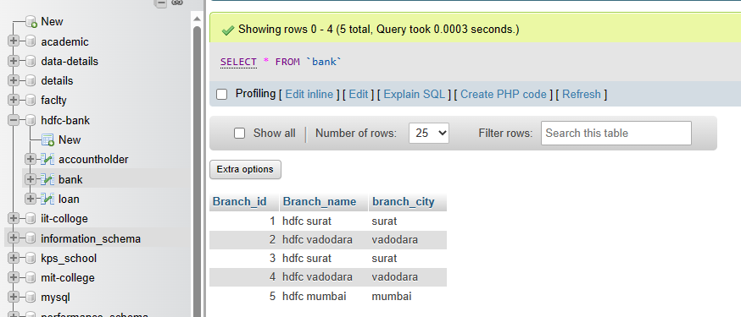

Create a Loan table

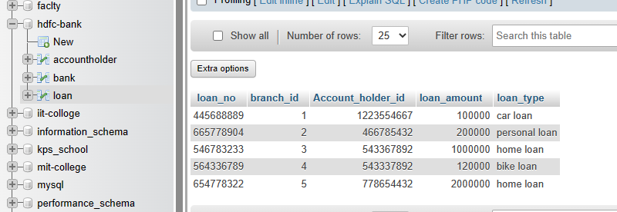

Create a table named Account holder

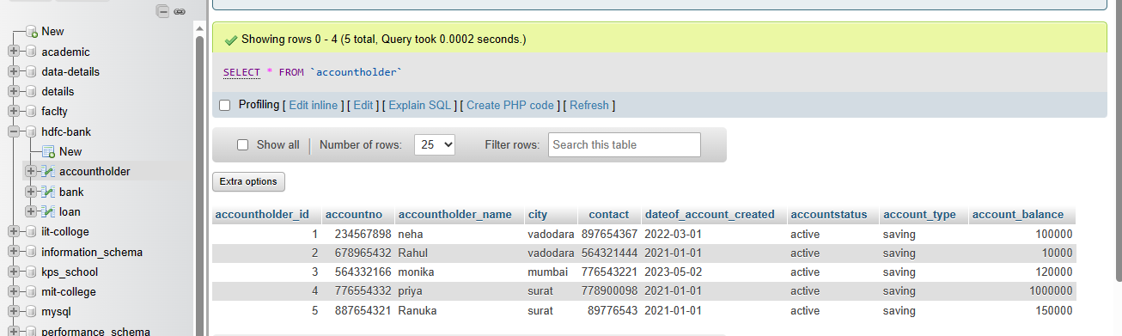

for this you have to make a transaction in sql which can transfer fund from account A to B

UPDATE `accountholder` SET account_balance = 90000 WHERE accountholder_id = 1 ;

UPDATE `accountholder` SET account_balance = 20000 WHERE accountholder_id = 2 ;

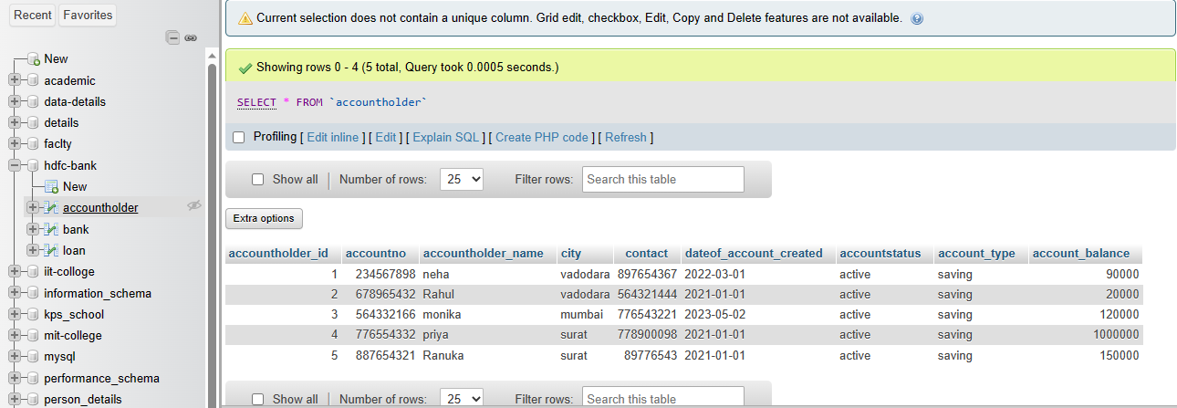

Also fetch the details of the account holder who are related from the same city

SELECT * FROM accountholder WHERE city = 'surat';

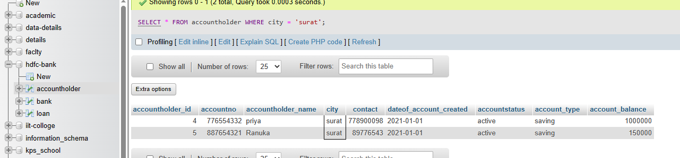

Write a query to fetch account number and account holder name, whose accounts were created after 15th of any month

SELECT accountno, accountholder_name FROM accountholder WHERE date(dateof_account_created) > 15;

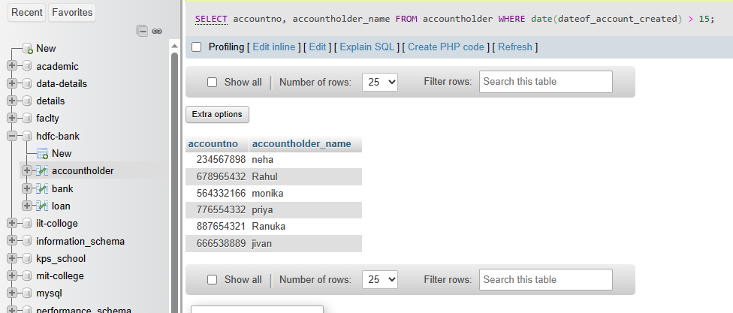

Write a query to display the city name and count the branches in that city. Give the count of branches an alias name of Count_Branch.

SELECT branch_city AS city, COUNT(*) AS Count_branch FROM bank GROUP BY branch_city;

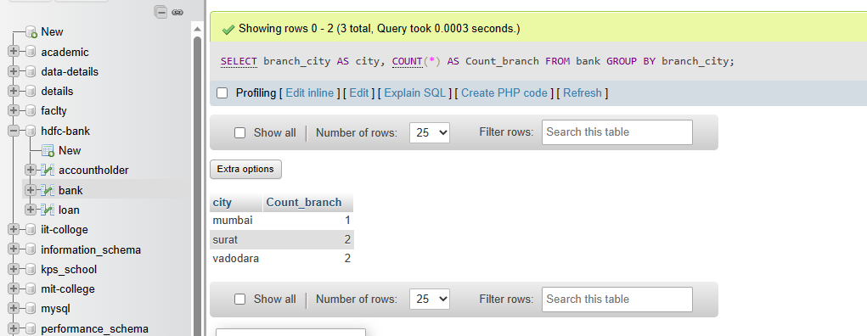

Write a query to display the account holder’s id, account holder’s name, branch id, and loan amount for people who have taken loans.

SELECT AH.accountholder_id, AH.accountholder_name, L.branch_id, L.loan_amount FROM accountholder AH JOIN loan L ON AH.accountholder_id = L.branch_id;

