Table of Contents

Table of Contents i
List of Figures ii
1.0. Introduction 1
1.1. Purpose 1
1.2. Scope of Project 1
1.3. Glossary 2
1.4. References 2
1.5. Overview of Document 2
2.0. Overall Description 4
2.1 System Environment 4
2.2 Functional Requirements Specification 5
2.2.1 Reader Use Case 5
Use case: Search Article 5
2.2.2 Author Use Case 6
Use case: Submit Article 6
2.2.3 Reviewer Use Case 7
Use case: Submit Review 7
2.2.4 Editor Use Cases 8
Use case: Update Author 8
Use case: Update Reviewer 9
Use case: Update Article 9
Use case: Receive Article 10
Use case: Assign Reviewer 11
Use case: Receive Review 11
Use case: Check Status 12
Use case: Send Response 12
Use case: Send Copyright 13
Use case: Remove Article 14
Use case: Publish Article 14
2.3 User Characteristics 15
2.4 Non-Functional Requirements 15
3.0. Requirements Specification 17
3.1 External Interface Requirements 17
3.2 Functional Requirements 17
3.2.1 Search Article 17
3.2.2 Communicate 18
3.2.3 Add Author 18
3.2.4 Add Reviewer 19
3.2.5 Update Person 19
3.2.6 Update Article Status 20
3.2.7 Enter Communication 20
3.2.8 Assign Reviewer 21
3.2.9 Check Status 21
3.2.10 Send Communication 22
3.2.11 Publish Article 22
3.2.12 Remove Article 23
3.3 Detailed Non-Functional Requirements 23
3.3.1 Logical Structure of the Data 23
3.3.2 Security 25
Index 26

List of Figures

Figure 1 - System Environment 4
Figure 2 - Article Submission Process 6
Figure 3 - Editor Use Cases 8
Figure 4 - Logical Structure of the Article Manager Data 23

1.0. Introduction

1.1. Purpose
The purpose of this document is to present a detailed description of “ Track my child ” application. It will explain the purpose and features of the system, the interfaces of the system, what the system will do, the constraints under which it must operate and how the system will react to external stimuli. This document is intended for both the stakeholders and the developers of the system.

1.2. Scope of Project
This software system is intended for parents with their child(ren) going to school(s), as well as schools interested in keeping a track of their students.
More specifically, this system is to be designed to facilitate safe travel of children to and from their schools. It will let registered schools keep a track of students travelling via their school buses as well parents keep a track of the journey of their child(ren).

1.3. Glossary
Term | Definition
Parent | Gaurdian of any student.
Conductor | Conductor of an school bus.
Driver | Driver of an school bus.
Bus | Vehicle to pick students.
Student | A child studying at any school. (Specifically, a child who has taken bus service of an school which is registered to this project.)
School Admin | A person associated to school, able to modify data related to parent, conductor, student, driver and bus.
Main Admin | A person associated to the people who are hosting this project and providing the services to various schools.
Data Flow Diagram | a graphical representation of the "flow" of data through the entire project, modelling its process aspects.
Use Case Diagram | a representation of a user's interaction with the system that shows the relationship between the user and the different use cases in which the user is involved.

1.4. References
IEEE. IEEE Std 830-1998 IEEE Recommended Practice for Software Requirements Specifications. IEEE Computer Society, 1998.

1.5. Overview of Document
The next chapter, the Overall Description section, of this document gives an overview of the functionality of the product. It describes the informal requirements and is used to establish a context for the technical requirements specification in the next chapter.
The third chapter, Requirements Specification section, of this document is written primarily for the developers and describes in technical terms the details of the functionality of the product.
Both sections of the document describe the same software product in its entirety, but are intended for different audiences and thus use different language.

2.0. Overall description

2.1 Data Flow diagam

Figure 1 – Data flow diagram

The Web Publishing System has four active actors and one cooperating system.
The Author, Reader, or Reviewer accesses the Online Journal through the Internet. Any Author or Reviewer communication with the system is through email. The Editor accesses the entire system directly. There is a link to the (existing) Historical Society.
<< The division of the Web Publishing System into two component parts, the Online Journal and the Article Manager, is an example of using domain classes to make an explanation clearer. >>

2.3 User Characteristics
The Reader is expected to be Internet literate and be able to use a search engine. The main screen of the Online Journal Website will have the search function and a link to “Author/Reviewer Information.”
The Author and Reviewer are expected to be Internet literate and to be able to use email with attachments.
The Editor is expected to be Windows literate and to be able to use button, pull-down menus, and similar tools.
The detailed look of these pages is discussed in section 3.2 below.

2.4 Non-Functional Requirements
The Online Journal will be on a server with high speed Internet capability. The physical machine to be used will be determined by the Historical Society. The software developed here assumes the use of a tool such as Tomcat for connection between the Web pages and the database. The speed of the Reader’s connection will depend on the hardware used rather than characteristics of this system.
The Article Manager will run on the editor’s PC and will contain an Access database. Access is already installed on this computer and is a Windows operating system.

3.0. Requirements Specification

3.1 External Interface Requirements
The only link to an external system is the link to the Historical Society (HS) Database to verify the membership of a Reviewer. The Editor believes that a society member is much more likely to be an effective reviewer and has imposed a membership requirement for a Reviewer. The HS Database fields of interest to the Web Publishing Systems are member’s name, membership (ID) number, and email address (an optional field for the HS Database).
The Assign Reviewer use case sends the Reviewer ID to the HS Database and a Boolean is returned denoting membership status. The Update Reviewer use case requests a list of member names, membership numbers and (optional) email addresses when adding a new Reviewer. It returns a Boolean for membership status when updating a Reviewer.

3.2 Functional Requirements Specification
This section outlines the use cases for each of the active actors separately. There are 3 main actors i.e parent,school admin
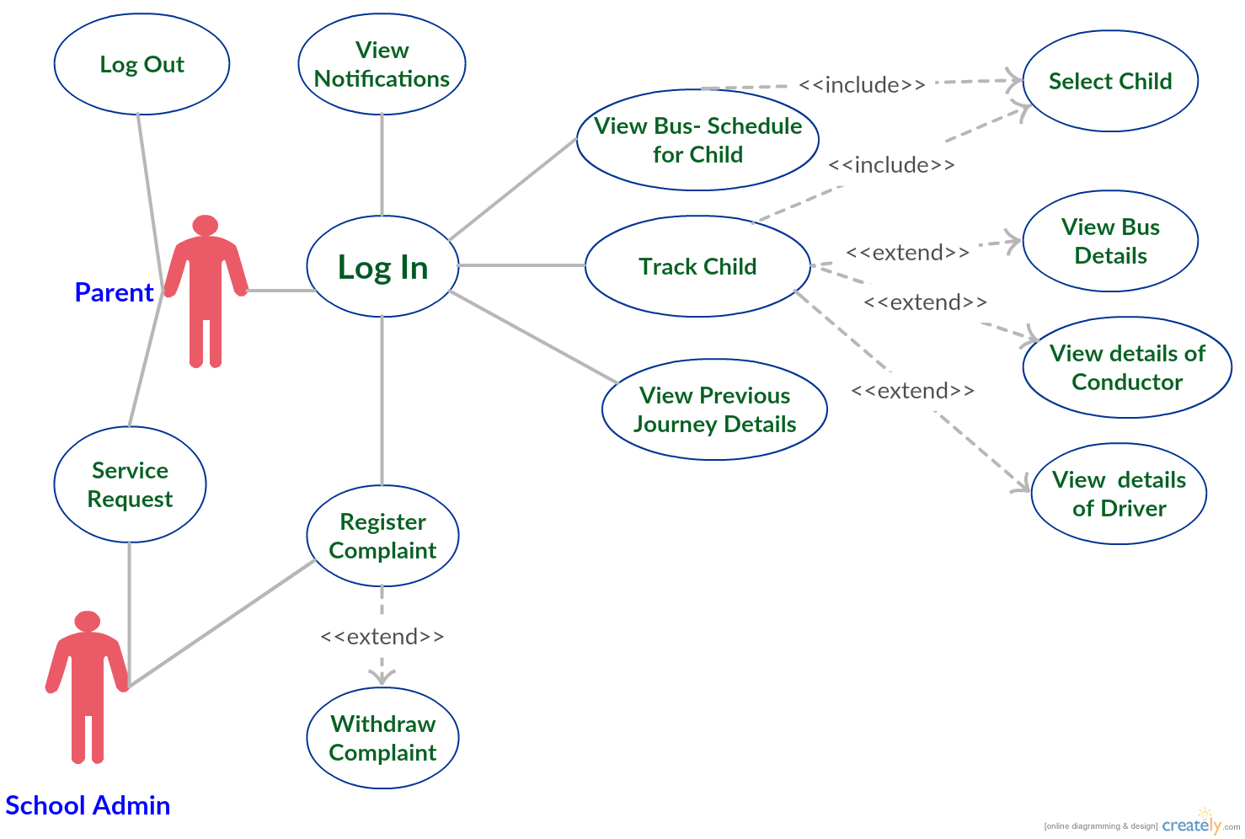
Figure 1 – Use cases for parent

2.2.1 Description of use cases for parent
 | USE CASE | DESCRIPTION
Log In |  | The parent can avail the functionalities offered by the application only after logging in to the application
View profile |  | Every registered patient has his/her own profile containing personal details.
Update profile |  | The patient has the option to update his/her own profile.
Create health record |  | The patient can create his/her own health record.
Update health record |  | The patient can update his/her health record.
Select doctor |  | The patient can select doctor based on various criteria.
Take an appointment |  | The patient can request for an appointment to a particular doctor.
Interact with doctor |  | The patient can interact with doctor .
File complaint |  | The patient can file complaint on doctor to admin.
Withdraw complaint |  | The patient has option to withdraw his/her complaint .
View thread |  | The patient can view already created thread in a discussion forum.
Create thread |  | The patient can create a new thread in a discussion forum.
Create new post |  | The patient can create a new post in a newly created or already present thread.
Send Message |  | The patient can send private message to doctors and admin.
Receive mail |  | The patient can receive mail.
Search |  | The patient can search for a particular item in website by entering the keyword.

3.3 Detailed Non-Functional Requirements

3.3.1 Logical Structure of the Data

The logical structure of the data to be stored in the internal Article Manager database is given below.

Review
Reviewer
Article
Author
writes
sent to
writes
has
Figure 2 - Logical Structure of the Article Manager Data

The data descriptions of each of these data entities is as follows:

Author Data Entity
Data Item | Type | Description | Comment
Name | Text | Name of principle author
Email Address | Text | Internet address
Article | Pointer | Article entity | May be several

Reviewer Data Entity
Data Item | Type | Description | Comment
Name | Text | Name of principle author
ID | Integer | ID number of Historical Society member | Used as key in Historical Society Database
Email Address | Text | Internet address
Article | Pointer | Article entity of | May be several
Num Review | Integer | Review entity | Number of not returned reviews
History | Text | Comments on past performance
Specialty | Category | Area of expertise | May be several

Review Data Entity
Data Item | Type | Description | Comment
Article | Pointer | Article entity
Reviewer | Pointer | Reviewer entity | Single reviewer
Date Sent | Date | Date sent to reviewer
Returned | Date | Date returned; null if not returned
Contents | Text | Text of review

Article Data Entity
Data Item | Type | Description | Comment
Name | Text | Name of Article
Author | Pointer | Author entity | Name of principle author
Other Authors | Text | Other authors is any; else null | Not a pointer to an Author entity
Reviewer | Pointer | Reviewer entity | Will be several
Review | Pointer | Review entity | Set up when reviewer is set up
Contents | Text | Body of article | Contains Abstract as first paragraph.
Category | Text | Area of content | May be several
Accepted | Boolean | Article has been accepted for publication | Needs Copyright form returned
Copyright | Boolean | Copyright form has been returned | Not relevant unless Accepted is True.
Published | Boolean | Sent to Online Journal | Not relevant unless Accepted is True. Article is no longer active and does not appear in status checks.

The Logical Structure of the data to be stored in the Online Journal database on the server is as follows:

Published Article Entity
Data Item | Type | Description | Comment
Name | Text | Name of Article
Author | Text | Name of one Author | May be several
Abstract | Text | Abstract of article | Used for keyword search
Content | Text | Body of article
Category | Text | Area of content | May be several

3.3.2 Security

The server on which the Online Journal resides will have its own security to prevent unauthorized write/delete access. There is no restriction on read access. The use of email by an Author or Reviewer is on the client systems and thus is external to the system.
The PC on which the Article Manager resides will have its own security. Only the Editor will have physical access to the machine and the program on it. There is no special protection built into this system other than to provide the editor with write access to the Online Journal to publish an article.

Index

Abstract, 6, 17, 27
add, 9, 11, 19, 20, 21
Add, 8, 9, 19
Article, 1, 5, 6, 7, 8, 9, 10, 11, 12, 13, 14, 15, 16, 17, 18, 19, 20, 21, 22, 23, 24, 25, 26, 27, 28
Article Manager, 5, 8, 9, 10, 11, 12, 13, 14, 15, 16, 19, 20, 21, 22, 23, 24, 25, 28
Author, 1, 4, 5, 6, 7, 8, 9, 13, 14, 16, 17, 19, 20, 22, 23, 25, 26, 27
Category, 5, 14, 17, 18, 20, 21, 23, 26, 27
Database, 2, 9, 11, 14, 15, 16, 17, 18, 19, 20, 21, 22, 24, 25, 26, 27
Editor, 1, 4, 5, 6, 7, 8, 9, 10, 11, 12, 13, 14, 15, 16, 17, 19, 20, 21, 22, 23, 24, 25, 28
Field, 17, 19, 20
Form, 1, 6, 9, 10, 11, 12, 14, 19, 20, 21, 23, 24, 27
Grid, 9, 11, 12, 19, 20, 21
Historical Society, 1, 5, 9, 11, 16, 17, 19, 20, 26
Online Journal, 4, 5, 6, 7, 15, 16, 17, 18, 24, 27, 28
Reader, 4, 5, 6, 16, 17, 18
Review, 1, 7, 11, 12, 18, 21, 23, 26, 27
Reviewer, 1, 4, 5, 6, 7, 9, 11, 16, 17, 19, 20, 21, 22, 23, 26, 27
Security, 27, 28
Status, 11, 12, 13, 14, 17, 21, 22, 23, 27
update, 9, 11, 20, 21
Update, 8, 9, 10, 11, 12, 13, 14, 15, 17, 19, 20, 21, 22
User, 7, 16, 18
Web Publishing System, 1, 4, 5, 17

