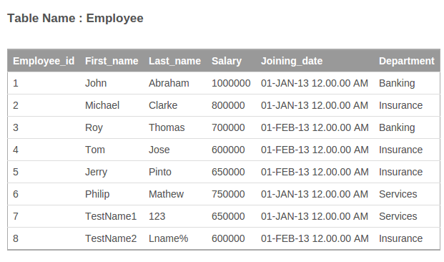
1. Create a table called Employee with schema as above. Please add EmployeeId as primary key, use appropriate data types to store data and add other constraints as required.

Create table Employee
(
Employee_id int,
First_name varchar(255),
Last_name var char(255),
salary int,
Joining_date datetime,
Department varchar(255),
PRIMARY KEY(Employee_id)
);

2. Insert records into the Employee table with records as shown above.

3. Fetch all employees with all information.

Select * from EMPLOYEE

4. Get firstName and last name of all employees.

Sol: SELECT First_name,Last_name FROM Employee

5. Get firstName of all employees in upper case.

SELECT Upper(First_name) FROM Employee

6. Print out all departments in table but each should be printed only once.

SELECT distinct department FROM Employee

7. Select all employees belonging to Insurance department.

SELECT First_name,Department
from Employee
where Department = "Insurance";

8. Select employee name who have salary more than 700000

SELECT First_name,salary
from Employee
where Salary > 7000000;

9. Select employee firstname,lastname who have Date of Joining between 15-Jan-2013 till 15-Feb-2013.

No answer found

10. Find all employees who have firstname or last name starting with the letter 'T'.

select First_name,Last_name
from Employee
where First_name LIKE "T%" OR Last_name LIKE "T%";

11. List all employees sorted by their salary in ascending order.

select * FROM Employee
ORDER BY Salary asc ;

12. List all employees sorted by their salary in descending order.

select * FROM Employee
ORDER BY Salary desc ;

13. Now add a new column called Date of Birth in table.

ALTER TABLE Employee
ADD Birth_date date

14. Update Date of Birth for each employee. Note DOB should be different for each employee.

UPDATE Employee
SET Birth_date = "12-Apr-1992"
WHERE Employee_id = 1;
UPDATE Employee
SET Birth_date = "2-Mar-1996"
WHERE Employee_id = 2;
UPDATE Employee
SET Birth_date = "2-Aug-1990"
WHERE Employee_id = 3;
UPDATE Employee
SET Birth_date = "24-Feb-1989"
WHERE Employee_id = 4;
UPDATE Employee
SET Birth_date = "23-Apr-1994"
WHERE Employee_id = 5;
UPDATE Employee
SET Birth_date = "14-Jul-1990"
WHERE Employee_id = 6;
UPDATE Employee
SET Birth_date = "22-Jun-1986"
WHERE Employee_id = 7;
UPDATE Employee
SET Birth_date = "5-Sep-1988"
WHERE Employee_id = 8;

15. Add an bonus of 10000 USD to all employees belonging to the Insurance department. It seems insurance department is doing very well !!

update Employee
set salary = salary+10000
where department = “Insurance”;

16. Delete only the last 2 records. Where First name starts with test.

delete from Employee
where First_name LIKE "Test%";

17. Now create new table called department with the following columns :
DepartmentId
DepartmentName
Make DepartmentId as a primary key.

create table Department
(
Department_id int,
Department_name varchar(255),
PRIMARY KEY(Department_id)
);

18. Insert 3 records for Banking,Insurance and Services in the department table.

insert into Department(Department_id,Department_name) values
(1,"Banking"),(2,"Insurance"),(3,"Services");

19. Remove the column department Name in the Employee table and add a new column called Department Id. Make this as a foreign key referring to the department id in the department table.

20. Update the DepartmentId in Employee table so that they point to the appropriate department in department table.

