Physics-informed Surrogate Modelling of Temperature Rise for Exposure at 10-90 GHz
A surrogate is an approximation model that is able to capture the behavior and dynamics of a computationally expensive simulation of the interest. In the case of computational dosimetry at 10-90 GHz, it is important to solve for the abosrbed electromagnetic (EM) field within a tissue, and compute associated maximal surface temperature rise. This usually requires using a costly high fidelity numerical solver. Once the exposure setup configuration is changed, the corresponding dosimetric value of interest has to be computed from the scratch.
Surrogate model, once it is trained and optimized, allows us to approximate this aforementioned dosimetric value of interest with orders of magnitude faster functional evaluation as it is built upon reusable building blocks. If the surrogate is neural-based, i.e., if the underlying approximating function is a neural network, it is also possible to alleviate the curse of dimensionalty. Moreover, it allows seamless (automatic) differentiation and direct uncertainty quantification.
The only bottleneck is – surrogate models are only as good as the data which are used for the training and optimization purposes. The data are usually scarce as it is required to run high fidelity numerical solvers in many instances which is both computationally heavy burden and time consuming. Some efficient sampling methods are developed over the years that are able to overcome this issue, but in many cases, with just enough data, a surrogate model could still work sufficiently well if the model itself is well suited for the problem of interest and/or is enriched with a priori known underlying physics.
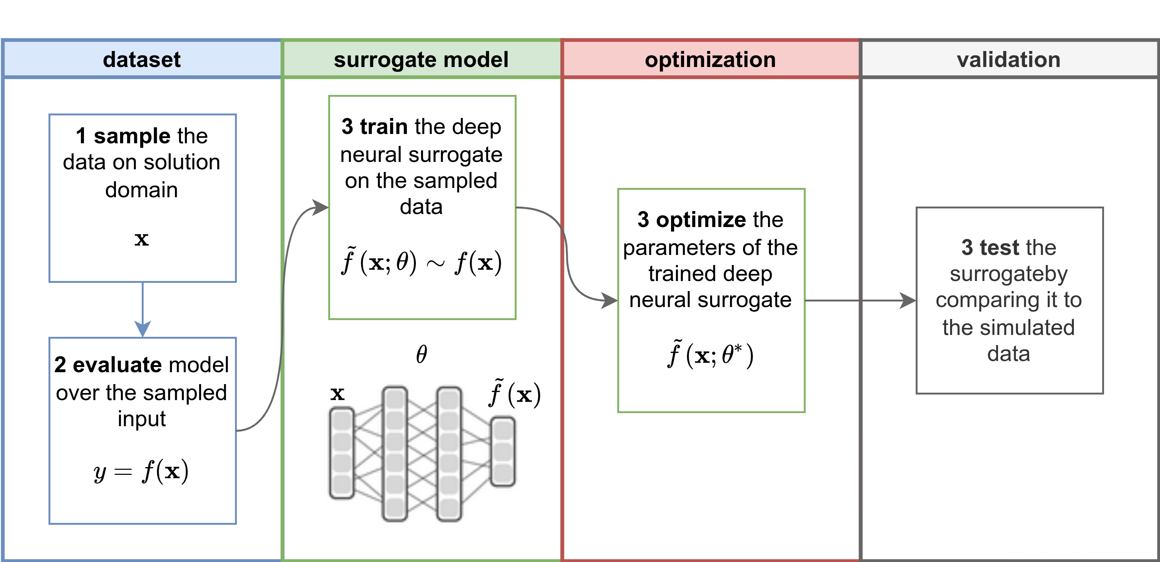
Figure: Overview of the workflow for the surrogate modelling

Dataset
If the dataset is yet to be defined, it would be best to use optimized sampling methods associated with the chosen surrogate model. Then, the target values, y, have to be evaluated over the sampled set of input points, x, by using the expensive function, f, which can be, for example, 3-D FEM or FDTD EM simulation.
Otherwise, if the dataset already exists, it should be sufficiently large to be divided into separate 3 subsets. The first subset is the largest and is to be used for the creation of the surrogate model, the second one is used for the optimization of the model’s parameters (by adjusting its hyperparameters), and the last one is intended for evaluation of the overall performance of the model.
In our case, the input data of interest are the antenna type, and the electric characteristics of an antenna, operating frequency of an antenna, antenna-to-tissue separation distance, tissue depth, thermal conductivity, blood perfusion coefficients, blood temperature, incident power density, EM penetration depth, air temperature, body core temperature, thermal diffusion constant, etc., while the target is the maximal surface temperature rise.

Surrogate Model
Feed-forward deep neural network (FNN) takes N inputs and returns 1 output. The learning process is performed in completely supervised manner given the dataset consisted of (x, ΔT) pairs and it represents the simplest step-up compared to multivariate polynomial regression.:
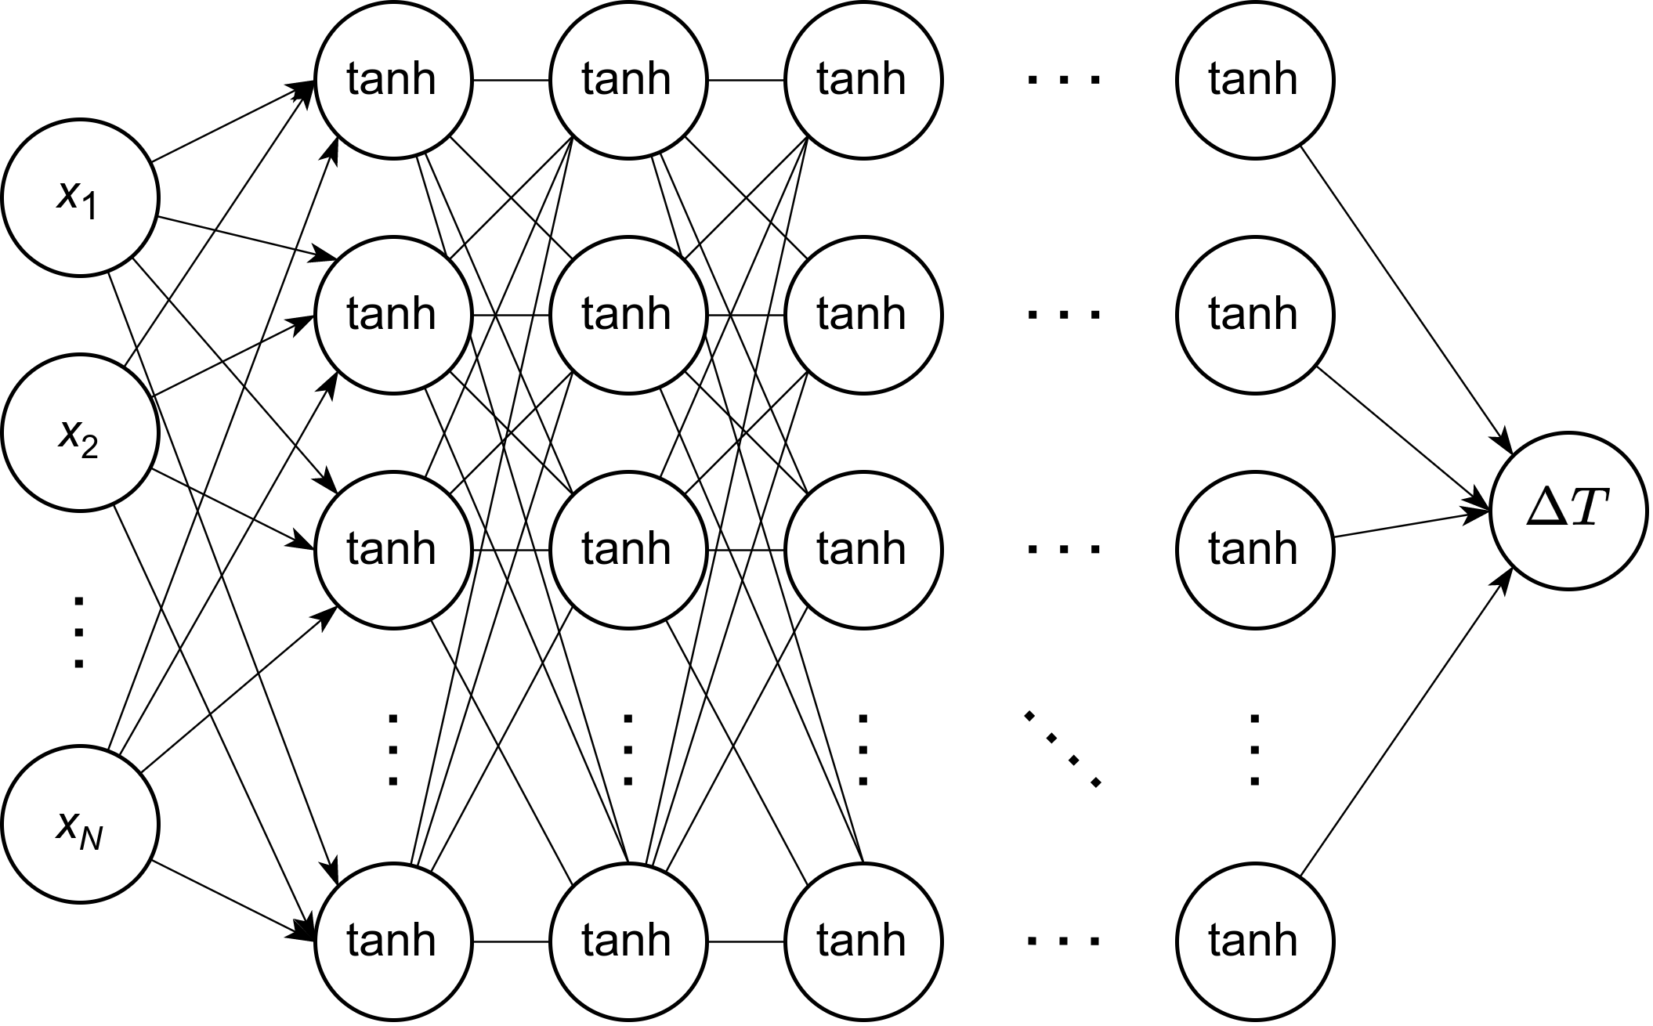
Figure: FNN for regression problem.
More complex architecures could also be used, such as residual neural networks (ResNet):
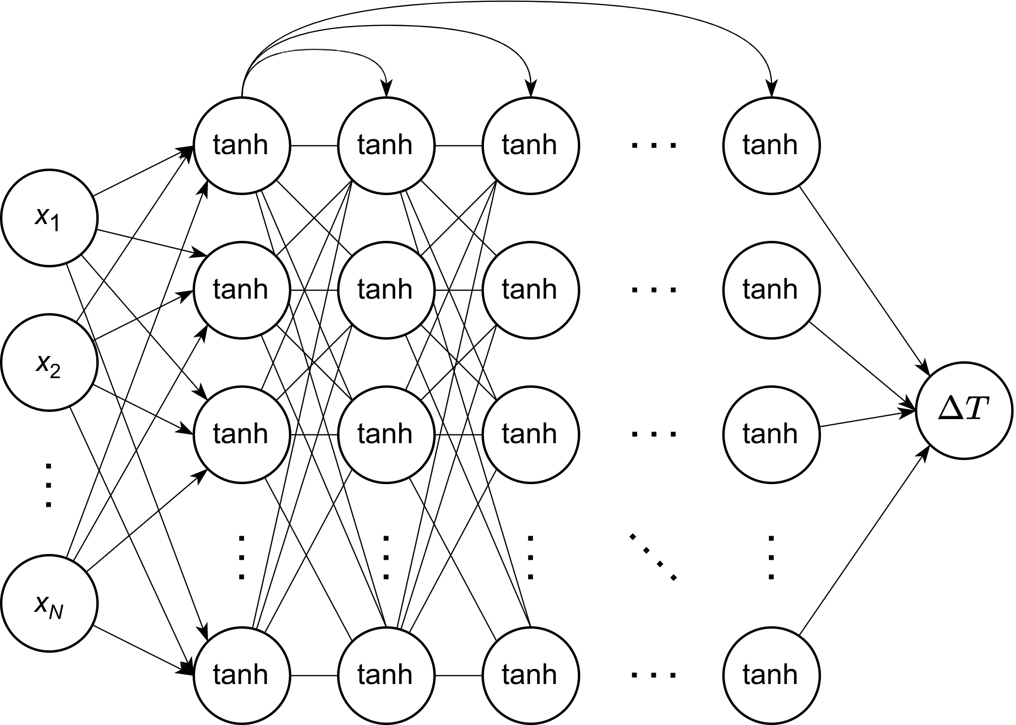
Figure: FNN with “skip” connections – ResNet.
Currently, sequence-to-sequence learning and more advanced architectures are discussed in literature where the neural operator learning seems as a viable solution to completely data-driven problems.
However, in our case, we are aware of underlying physics in terms of conservation of energy through its first principles. Namely, the first part of our problem is the assessment of the power density within irradiated tissue, while the second part of the problem is the evaluation of the heat distribution and extraction of the maximal temperature rise on the surface of tissue.
The first part of the problem could be seen as a completely data-driven problem because there are too many variables to embed any physical knowledge into the surrogate model – from the type of the antenna, to its electrical properties. The second part, however, always involve solving the bio-heat transfer equation, and the equation itself could be integrated into the loss function of the surrogate that is to be optimized (see work by Karniadakis lab at Brown University, especially the paper by Raissi, Perdikaris and Karniadakis, Physics-informed neural networks: A deep learning framework for solving forward and inverse problems involving nonlinear partial differential equations, Journal of Computational Physics 378:686-707, 2019).

Proposed model
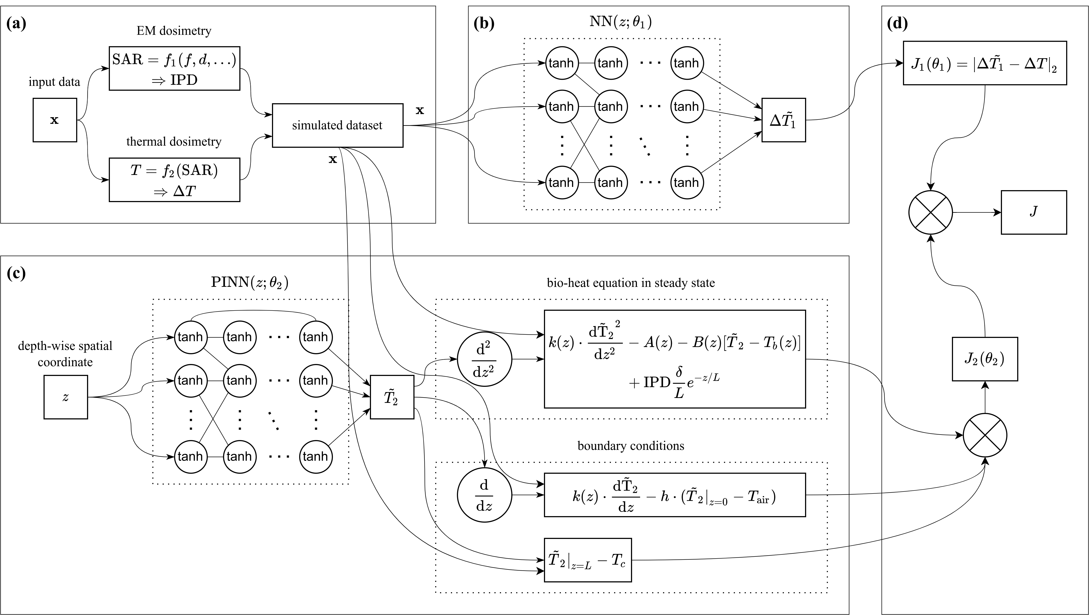
Figure: Surrogate model: FNN + physics-informed neural network (PINN)
- Assemble dataset where x stands for the input data vector and the target value is the maximal surface temperature rise, ΔT. Input data are the frequency, antenna-to-tissue separation distance, tissue depth, thermal conductivity, blood perfusion coefficients, blood temperature, incident power density, EM penetration depth, air temperature, body core temperature, thermal diffusion constant, …
- Perform supervised training using (x, ΔT) and create functional approximation for ΔT directly from the data.
- Learn PINN in unsupervised manner where the underlying physics are represented through the 1-D bio-heat equation in steady-state and its corresponding boundary conditions. Depth-wise spatial coordinate z is sampled within range z₀ to L, where z₀ is corresponding to the surface of tissue, and L stands for the depth of the tissue model.
- Create the loss function, J, which should be minimized with respect to both FNN and PINN parameters.

Analysis
- Evaluate performance of FNN using plain supervised learning.
- Evaluate performance of FNN+PINN and compare it to the approach in 1.
- FNN+PINN should result in faster convergence rate to more accurate solutions.

