


Team : SFC-Flexboxed

Project : BudgetBasics
NextGen BudgetBee - Student Financial Awareness
Project Documentation Report

Problem Definition
Ask most college students what happens to their allowance by the third week of the month, and you'll get the same answer: it's just gone. Nobody sits students down and teaches them how to handle money before they're suddenly responsible for rent, food, transport, textbooks, and everything in between on a fixed, limited amount. So they learn the hard way, usually by running out.
The everyday mistakes are almost always the same ones, an impulse purchase during a flash sale, a free trial that quietly turns into a paid subscription nobody remembers signing up for, a 200 rupees coffee that never feels like a big deal in the moment but adds up to over a thousands of Rupees a month. None of this is a lack of intelligence, it's a lack of awareness and a lack of tools built for how students actually live and spend.
Spreadsheets exist, but nobody opens one voluntarily. They're tedious, they don't explain anything, and they certainly don't tell a nineteen-year-old why their boba tea habit is quietly costing them $150 a month. What's missing is something a student would actually want to use: quick, visual, a little bit fun, and genuinely useful in the moment a spending decision is being made.
BudgetBasics was built to fill exactly that gap. It's a browser-based Single Page Application a student can open in seconds, no sign-up, no learning curve, that helps them:
Build a simple monthly budget and see where their money is actually going.
- Practice telling Needs apart from Wants through a hands-on classification exercise.
- Recognise the common money mistakes before they become habits.
- See their spending as a visual, not a wall of numbers.
- Ask a quick question and get an instant, judgement-free answer from an in-app AI assistant.
It isn't trying to replace a financial advisor. It's trying to catch students at the point where a small nudge, a tip, a quiz question, a “wait 48 hours before you buy that” reminder can quietly build a habit that sticks.

Design Specifications

Project Objectives
- Give students a free, no-login tool that makes budgeting feel approachable rather than like homework.
- Teach core financial concepts (income, fixed vs. variable expenses, needs vs. wants, savings) through interactive content instead of static text.
- Use realistic, relatable scenarios, flash sales, boba tea, forgotten subscriptions, so the lessons actually stick.
- Keep the interface simple, colourful, and mobile-friendly using a flexbox-based responsive layout.
- Deliver everything instantly and client-side, consistent with a Single Page Application (SPA), with no page reloads between tools.

Target Users
- College and university students managing an allowance, stipend, or part-time income.
- Personal finance beginners with little to no prior budgeting experience.
- Anyone seeking a quick, judgement-free way to understand their monthly spending pattern.

Functional Modules
The application is organised into the following functional modules:
# | Module | Description
1 | Landing / Home | Introduces BudgetBasics, shows a rotating ticker of quick money tips, and navigates into the main tools.
2 | Basic Concepts | Explains the five core budgeting building blocks, Income, Fixed Expenses, Variable Expenses, Needs vs. Wants, and Savings. Each with a plain language description and a worked example.
3 | Budget Calculator | Lets a student enter income and expenses and see how it splits across Fixed Needs, Variable Needs, Wants, and Savings.
4 | Needs vs. Wants Classifier | An interactive exercise where the user sorts everyday items into “Need” or “Want,” with an explanation revealed for each.
5 | Money Mistakes | Walks through five common student money mistakes with a real-world scenario, its cost impact, and a corrective action for each.
6 | Financial Literacy Quiz | A short multiple-choice quiz testing what the student has learned, with instant right/wrong feedback and an explanation for each answer.
7 | Visual Infographics | Presents four themed infographics (the 50-30-20 rule, a Needs-vs-Wants decision matrix, the monthly budget cycle, and a 30-day savings challenge).
8 | AI Chatbot Assistant | A keyword-matched assistant that answers common budgeting questions (e.g., “What is the 50-30-20 rule?”) instantly, with a friendly fallback message for unrecognised queries.
9 | Contact / FAQ | Answers common questions about the platform, e.g., that it's free and that all data stays client-side.
10 | Visitor Counter | Displays a live count of site visitors, powered by the Abacus API, as a small social-proof/engagement touch.

Non-Functional Requirements
Requirement | Description
Usability | Minimal, distraction-free UI; no account/login required to begin using core tools.
Responsiveness | Layout adapts to desktop, tablet, and mobile viewports using a flexbox-based CSS layout.
Performance | As a client-side SPA, navigation between tools is instant with no full-page reloads.
Feedback | Actions (adding an expense, answering a quiz question, etc.) are confirmed instantly via on-screen toast notifications.
Availability | Publicly reachable at all times via a hosted URL (Vercel), requiring no local installation to try.
Data Handling | All entries, goals, and calculations run entirely client-side in the browser; nothing is sent to a remote server for storage.

Technology Stack
BudgetBasics is a React-based Single Page Application, deployed and hosted on Vercel. The table below lists the actual libraries and services used, as confirmed by the project team.
Package / Service | Purpose in the Project
React Router DOM | Handles client side routing/navigation between pages (Home, Concepts, Calculator, Classifier, Quiz, etc.) without full page reloads.
Redux | Global state management. e.g., the running budget figures, quiz progress, and expense/classification data shared across components.
Context API | Lightweight state sharing for the theme filter (e.g., light/dark or category-based visual filtering).
React Hot Toast | Displays pop-up notification messages for user actions (e.g., confirming an entry was saved or a quiz answer was submitted).
Flickity | Powers the slideshow/carousel components used for the ticker tips and infographics.
Regex (Regular Expressions) | Used for form validation. e.g., ensuring budget and expense fields contain valid numeric input.
Abacus API | Supplies the live visitor counter shown on the site.
CSS Custom Properties (root variables) | Centralises the colour palette and theme values so styling stays consistent and easy to update across the app.

The colour palette itself was curated using ColorHunt, a resource for pre-tested colour-scheme combinations.

AI & Design Tools Used During Development
Two AI-assisted tools were used while building the project, though they are not runtime dependencies of the live application itself:
Tool | Used For
Google Gemini | Generating illustrative images and banner graphics used throughout the site.
Napkin AI | Generating flowchart diagrams during the planning/documentation stage of the project.

High-Level Architecture
The application follows a client only architecture typical of a modern React SPA:
- Presentation layer: Reusable React components for the concept cards, calculator, classifier, quiz, infographics, and chatbot panel, routed via React Router DOM.
- State layer: Redux for shared application state (budget figures, quiz/classification progress) and Context API for smaller, localised state such as the theme filter.
- Logic layer: Client-side functions for budget calculations, needs/wants classification checks, quiz scoring, and Regex-based input validation.
- Content layer: Structured data (tips, concepts, quiz questions, classification items, money-mistake scenarios, infographic content, and the chatbot's keyword-response knowledge base) that drives what each module displays.
- Feedback layer: React Hot Toast for instant confirmation messages, and the keyword-matched chatbot for answering student questions on demand.
- External integration: The Abacus API for the live visitor counter, the only outbound call to a third party service in the core experience.

Application Content & Data Model
Every module in BudgetBasics is driven by a structured content set rather than hard-coded text, which makes the app easy to extend with new tips, quiz questions, or scenarios. The main data groups are:
- Ticker Tips : short rotating money tips shown on the homepage banner (e.g., the 48-hour rule, the true cost of a daily coffee habit).
- Basic Concepts : five core definitions (Income, Fixed Expenses, Variable Expenses, Needs vs. Wants, Savings), each with a description and a worked dollar example.
- Sample Student Budget : a worked $500/month example budget split across Fixed Needs, Variable Needs, Wants, and Savings, used to demonstrate the calculator.
- Quiz Questions : a bank of multiple-choice questions with a correct answer index and an explanation shown after answering.
- Classification Items : everyday purchases (textbooks, gaming console, transport pass, coffee, etc.) each tagged as a Need or a Want with a short explanation.
- Money Mistakes : five common student money mistakes, each with a relatable scenario, its financial impact, and a corrective action.
- Infographics Data : four themed visual explainers (50-30-20 rule, decision matrix, budget cycle, savings challenge), each with a title, caption, colour, and supporting detail points.
- Chatbot Knowledge Base : a keyword-to-response map the AI assistant uses to answer common questions, plus a friendly fallback message for anything it doesn't recognise.
- Contact FAQs : short answers to common questions about the platform (cost, data privacy, and whether the 50-30-20 ratio can be adjusted).

Diagrams
The diagrams in this section illustrate the overall user flow through the application, the detailed activity flow for the expense-tracking feature, and the data flow through the system at two levels of detail, as required for the project documentation.

Overall Application Flowchart
Figure 1 traces a typical session: the user starts at the landing page, arrives at the dashboard, chooses one of the four core tools, interacts with it, and sees the results reflected in the visual infographics before returning to the dashboard.
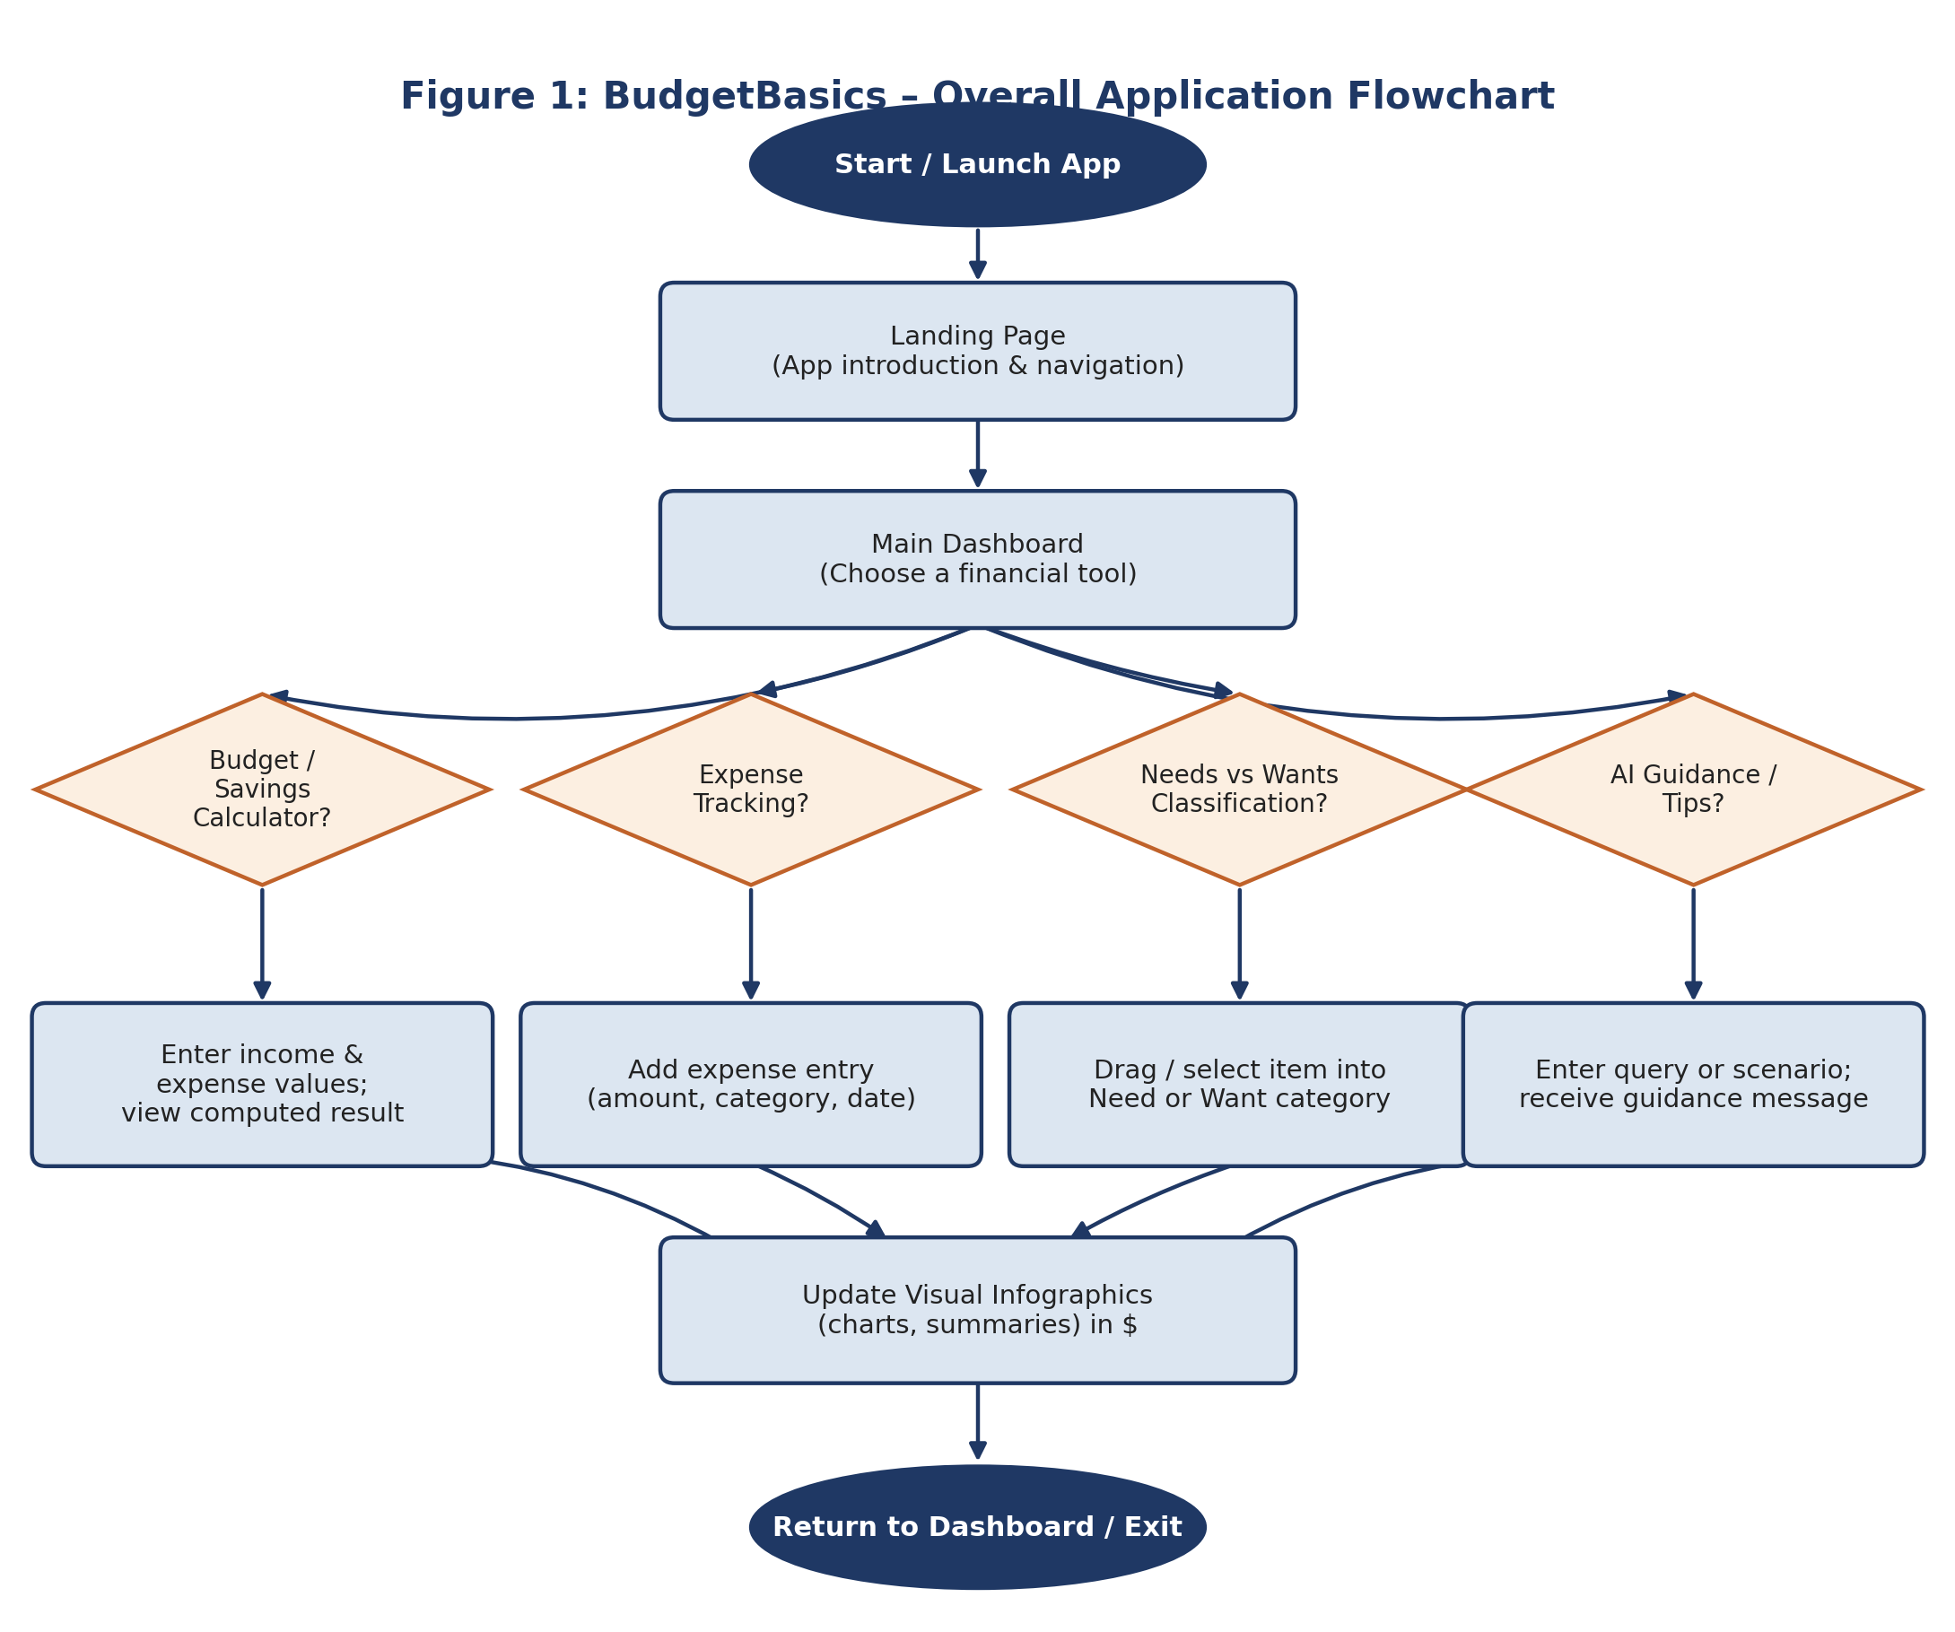

Expense Tracking & Classification Flowchart
Figure 2 details the activity flow specific to the Expense Tracker module, including field validation and the needs-vs-wants classification step for each entry.
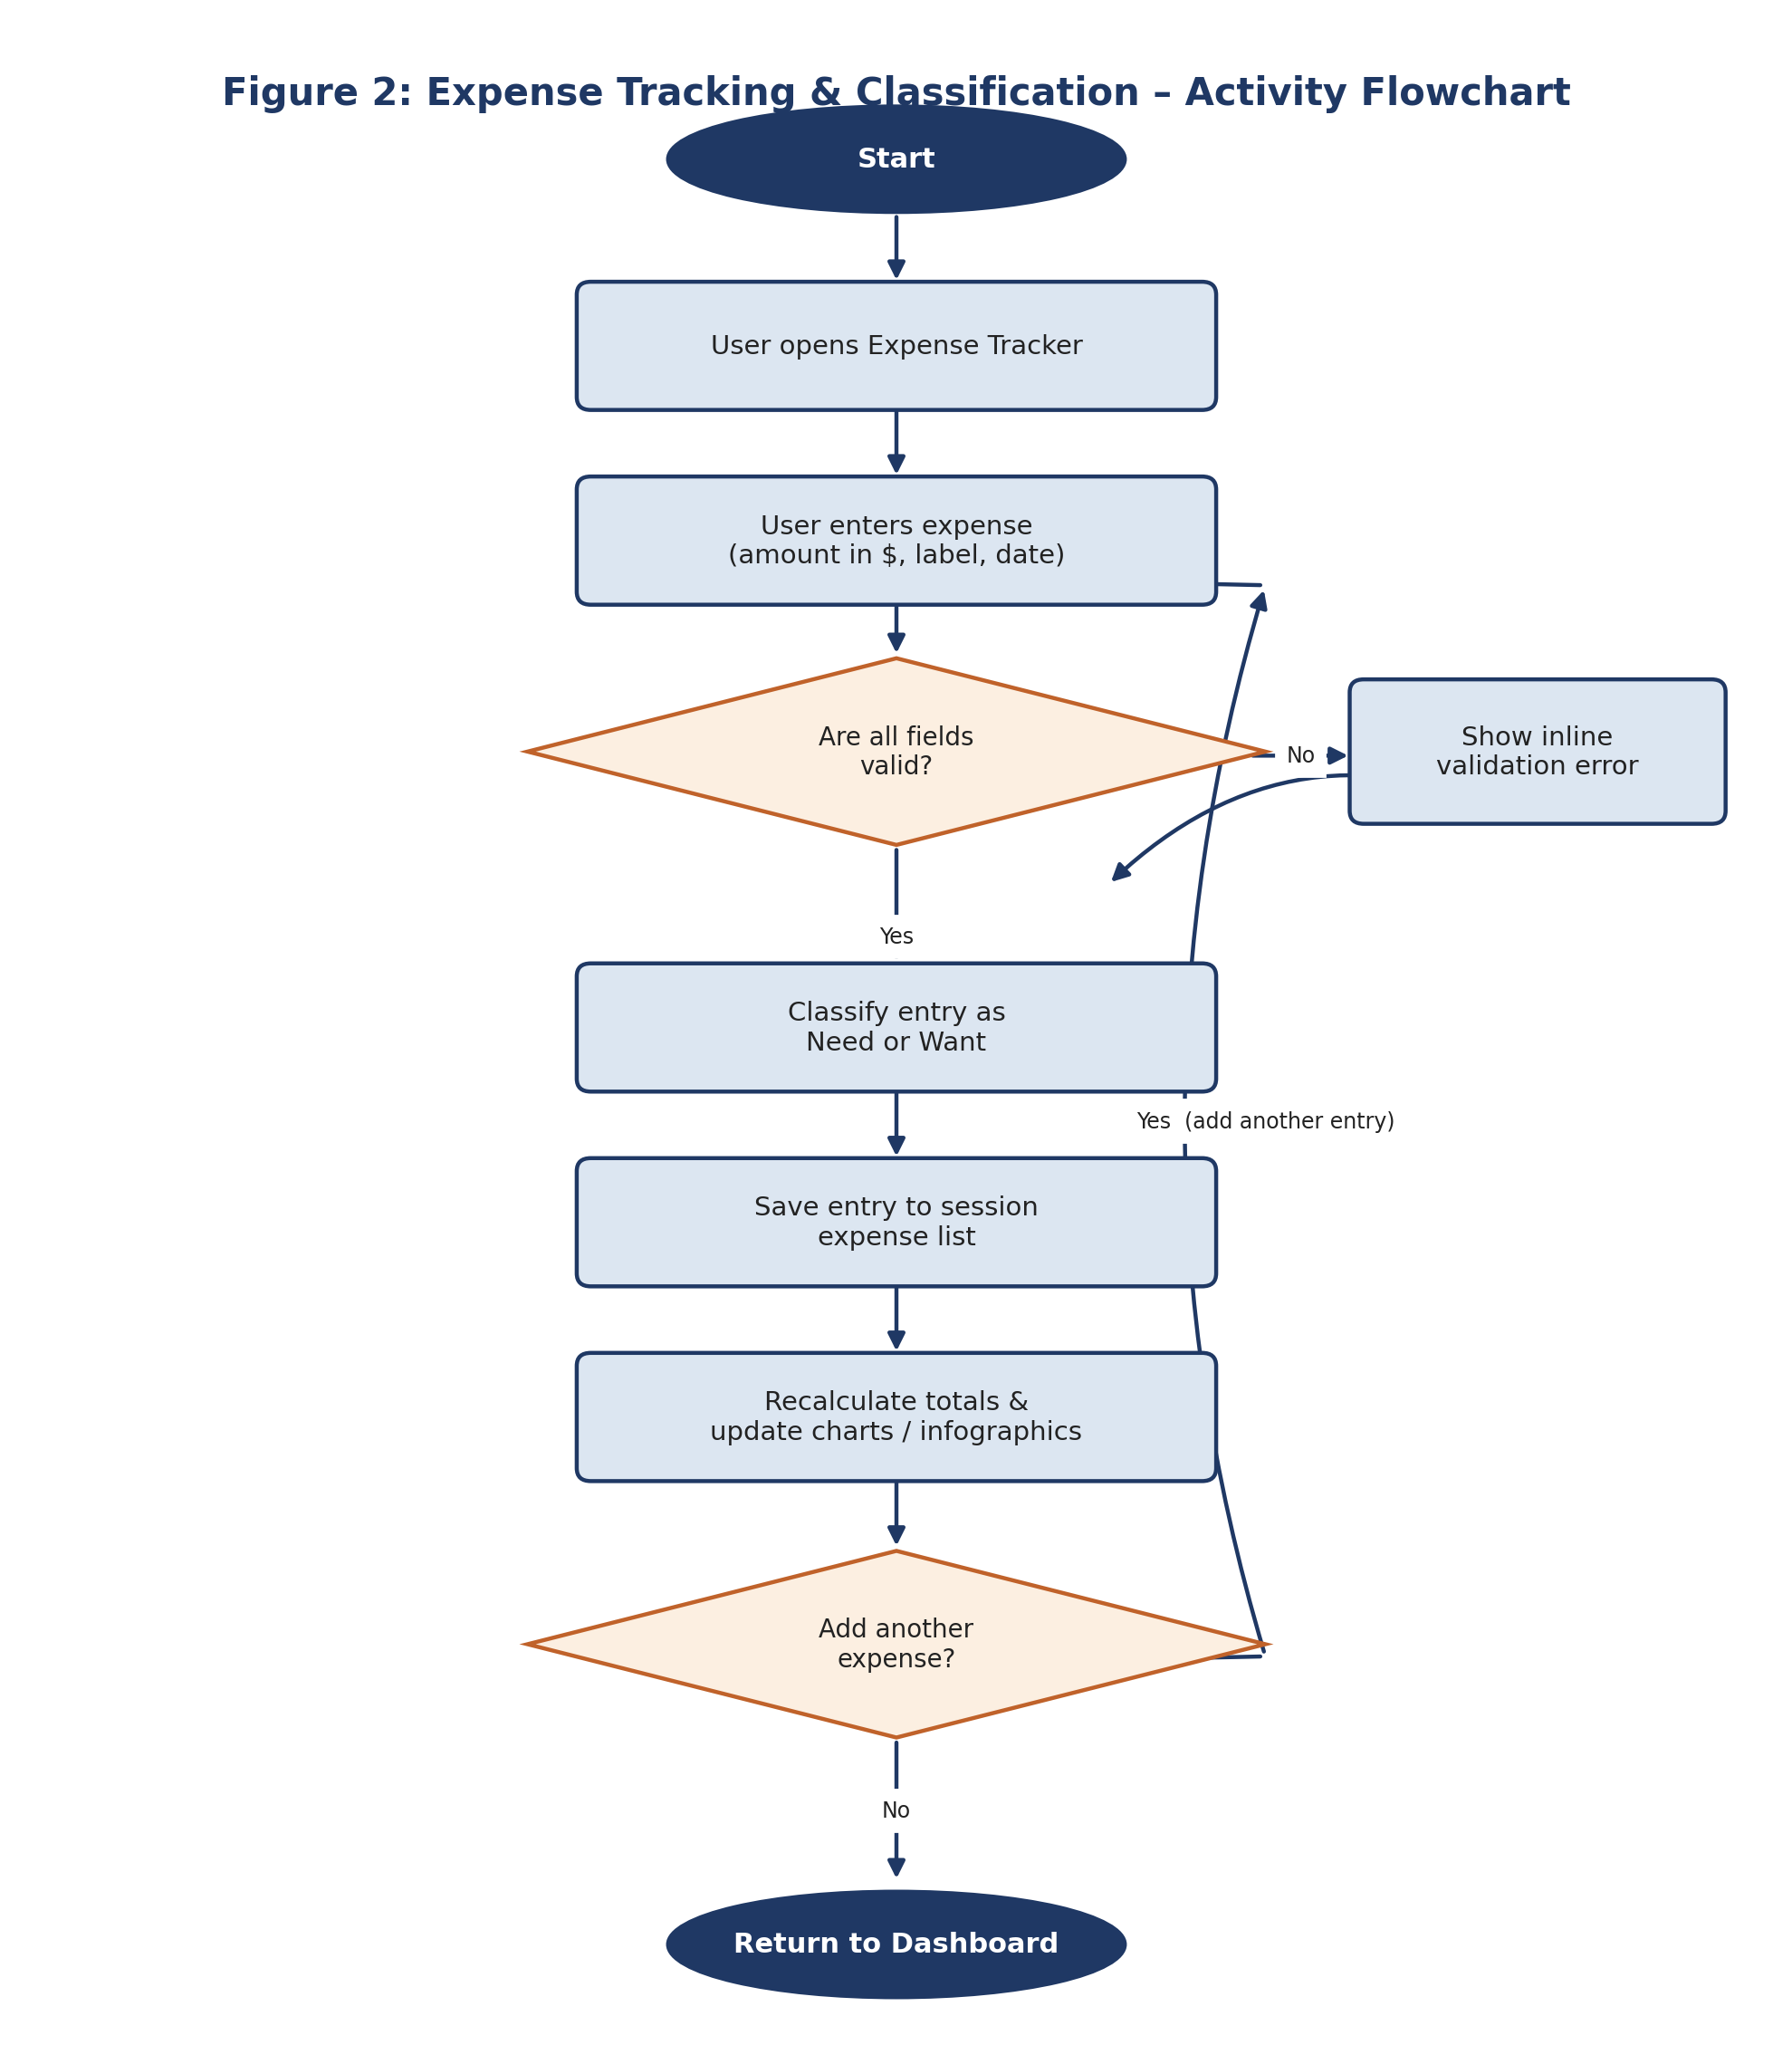

Data Flow Diagram – Level 0 (Context Diagram)
Figure 3 shows BudgetBasics as a single process exchanging data with two external entities: the student user, who supplies inputs and receives budgets/guidance, and the client browser's local storage, which persists session data between visits.
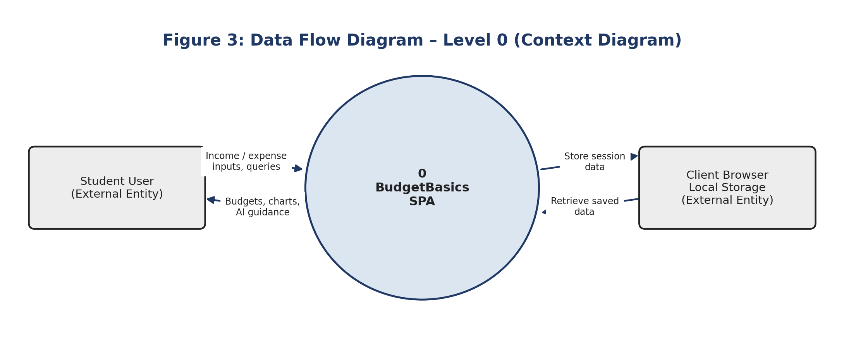

Data Flow Diagram – Level 1
Figure 4 decomposes the system into its four core processes and shows how data moves between the user, each process, the two internal data stores (expense/category data and budget/goal parameters), and the AI guidance service.
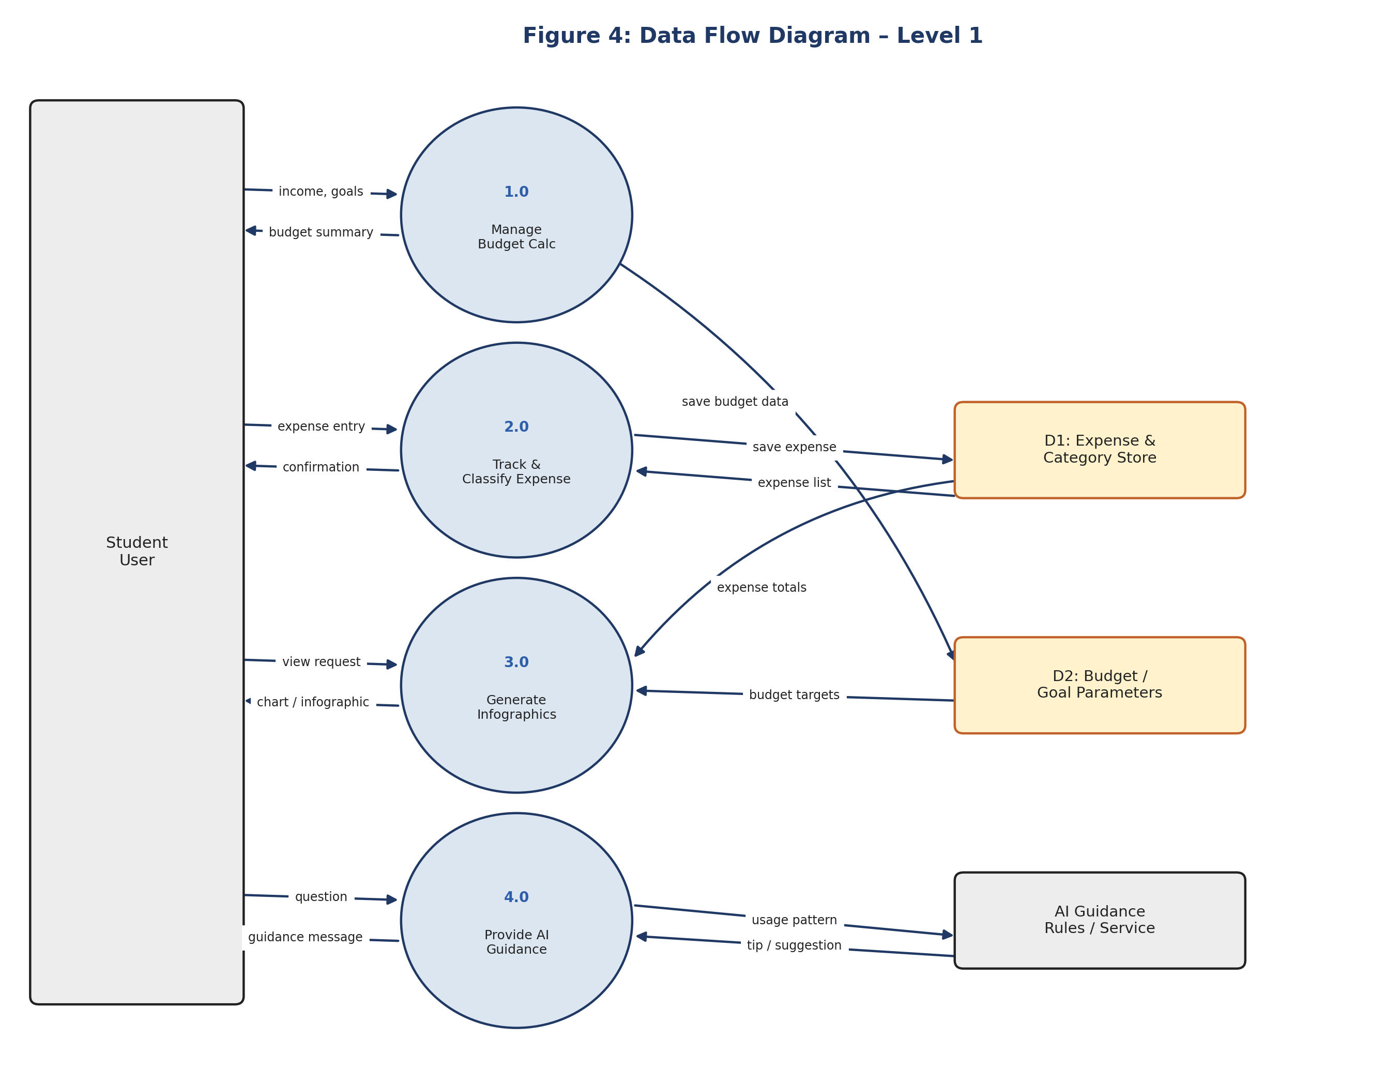

Test Data Used in the Project
The test data below is the actual content data used to build and exercise BudgetBasics, supplied by the project team. It is provided in full as machine-readable JSON alongside this document. A summary of each set is given below.

Sample Student Budget (Budget Calculator Test Case)
A worked $500/month student budget is used to demonstrate and test the Budget Calculator module:
Category | Description | Amount
Fixed Need | Hostel / Room Rent | $200
Fixed Need | Transportation Pass | $40
Variable Need | College Groceries & Food | $110
Variable Need | Books & Study Supplies | $35
Want | Weekend Hangouts & Snacks | $45
Want | Music & Video Streaming | $15
Savings | Emergency & Laptop Savings Goal | $55
Expected check: the seven line items sum exactly to the $500 total monthly income, confirming the calculator balances correctly against a real-world example.

Needs vs. Wants Classification Test Items
Item | Expected Category
College Course Textbooks | Need
Latest Gaming Console | Want
Monthly Public Transport Pass | Need
Gourmet Coffee & Boba Tea | Want
Healthy Daily Meals | Need
Multiple Streaming Subscriptions | Want
Prescription Medicine / Hygiene | Need
Designer Brand Sneakers | Want

Financial Literacy Quiz Test Cases
# | Question | Correct Answer
Q1 | Which of the following is a Fixed Expense for a college student? | Monthly room rent fee
Q2 | Under the 50-30-20 rule, what percentage of income goes to Savings? | 20%
Q3 | A $5 daily Boba tea costs how much over a 30-day month? | $150
Q4 | What is an Emergency Fund meant to cover? | Unplanned medical bills or urgent laptop repair

AI Chatbot Test Queries
The chatbot matches keywords in a user's question against a small knowledge base and returns a relevant, pre-written response; unmatched input falls back to a default assistant message.
Sample Prompt | Expected Response Topic
“What is the 50-30-20 rule?” | Explains the 50/30/20 income split
“What is a need vs a want?” | Explains the Needs vs. Wants distinction
“How much should a student save monthly?” | Suggests saving 15-20% of income
“How can I stop impulse buying?” | Suggests the 48-Hour Rule and related tips
“How do I create a simple student budget?” | Walks through the 4-step budgeting process
(unrecognised / off-topic input) | Falls back to the default assistant greeting/help message

Money Mistakes Content Set
Used to populate and test the Money Mistakes module, each entry pairs a relatable scenario with its financial impact and a corrective habit:
Mistake | Example Impact
Impulse Buying & Flash Sales | An unplanned $60 purchase eats into the grocery budget
Unused & Forgotten Subscriptions | $45/month lost to unused free trials
Ignoring Small Daily Expenses | $210/month lost to untracked snacks and drinks
Spending First, Saving “Whatever Is Left” | $0 left for savings by month end
Paying Bills Late | $15/month in avoidable late fees

Project Installation Instructions
BudgetBasics can be accessed in either of the two ways below. Option A requires no installation and is the fastest way to review the working application; Option B describes the general steps to run the project from its source files locally.

Option A - Access the Live Hosted Application (Recommended)
The project is already deployed and publicly accessible. No installation, sign-up, or configuration is required.
- Open a modern web browser (Chrome, Edge, Firefox, or Safari).
- Navigate to the following URL:
https://sfc-flexboxed.vercel.app/
- The application loads directly in the browser, begin using the calculators, expense tracker, classifier, and AI guidance tool immediately.

Option B - Run the Project Locally from Source
If the project source files are provided separately (outside this documentation, per the “no source code in documentation” requirement), it can be run locally using the general steps below for a standard Node.js-based front-end project:
- Ensure Node.js (v18 or later) and npm are installed on the machine. Verify with: node -v and npm -v in a terminal.
- Extract the project archive (.zip) to a folder on the local machine.
- Open a terminal / command prompt and navigate into the extracted project folder.
- Install project dependencies by running the package installation command for the project (e.g., npm install).
- Start the local development server using the project's start command (e.g., npm run dev or npm start).
- Open the local address shown in the terminal (typically http://localhost:3000 or http://localhost:5173) in a web browser.
- To stop the local server, return to the terminal and press Ctrl + C.
Note: Because this documentation intentionally excludes source code, the exact package/start commands above are given in their standard, generic form. The authoritative commands are defined in the project's own configuration files (e.g., package.json) included in the submitted project archive.

System Requirements
Requirement | Details
Browser (to view live app) | Any modern browser with JavaScript enabled (Chrome, Edge, Firefox, Safari)
Internet connection | Required to reach the hosted URL; not required once loaded locally
Node.js (local run only) | v18 or later, with npm
Screen size | Responsive from mobile widths up to desktop; no minimum resolution enforced

Assumptions
This documentation was prepared without directly reviewing the project's source code, in line with the guideline that documentation must not contain source code. The technology stack, package list, and content data in Sections 2 and 4 were supplied directly by the project team and are treated as authoritative. The following points, however, were assumed or inferred rather than confirmed:
- Currency: the content data supplied (ticker tips, sample budget, quiz questions) consistently uses US Dollar ($) figures, so this documentation follows that convention throughout. If the deployed application actually displays a different currency symbol, that is a presentation-layer detail not reflected in the underlying content data reviewed here.
- Exact UI layout and screen flow (e.g., how many clicks separate the dashboard from the quiz, precise wording of on-screen labels) could not be verified visually, since this documentation was prepared without app or code screenshots; the flowcharts in Section 3 represent the logical flow implied by the modules and data rather than a pixel-accurate walkthrough.
- The AI Chatbot is documented as a keyword-matched knowledge base (per the supplied chatbotKnowledge data) rather than a generative AI model; this reflects the actual mechanism provided and is not an assumption, but is called out here since it differs from a full conversational AI.
- Local installation commands (Section 5.2) are given in their standard, generic Node.js/React form (npm install, npm run dev), since exact scripts are defined in the project's own package.json, which is not reproduced here in keeping with the “no source code” requirement.
- Napkin AI and Google Gemini are documented as development-time tools (used to prepare diagrams and imagery while building the project) rather than runtime dependencies of the deployed application, based on how they were described by the project team.

Conclusion
BudgetBasics takes a subject students usually avoid budgeting and makes it something they might actually open more than once. The mix of a real worked budget, a hands-on needs-vs-wants exercise, a quiz that checks what stuck, honest examples of common money mistakes, and a chatbot that answers questions on the spot gives students more than a tracking tool. it gives them a reason to think about their spending before the month runs out, not after.

