Description of the Game:
The game engine used for the tournament is the Sauerbraten engine strlen.com . It was modified by Paul Ohanian to support the requirements of the competition. All .dlls located in Game/AIBots will be automatically loaded by the engine and set up with an entity to control.

Contents:
Contest Rules.doc – description of the rules and application for the contest.
Setup.doc – currently reading it.
Bot Source/ – Directory containing sample source code for an AI bot.
Bot Source/AIBotExample.sln – Visual Studio solution file.
Game/ – Directory containing modified Sauerbraten engine.
Game/AIBots – a few sample compiled bots available for testing.
Game/run.bat – bat file used to start the game

Commands in Game:
- “Space” will break out of the automatic camera and allow the user to move in fps mode (wasd keys for movement). The user can also fire a weapon for testing. Press space to return to automatic camera mode.
- “tab” at any time to view current score.
- “Esc” brings up the in-game menu.
- “-t” for command option to run the game in window mode.
- “`” to bring up the console. “infiniteammo 1” for infinite ammo

Compiling the provided source code to a .dll with Visual Studio 2010 express:
We recommend using Visual Studio 2010 express which is free from Microsoft. (Any other VS product will work).
- Download Visual Studio 2010 express http://www.microsoft.com/express/
- Select Visual c++ 2010 Express Edition and install.
- Open AIBotExample.sln with VS 2010 express.
- Open the project properties:
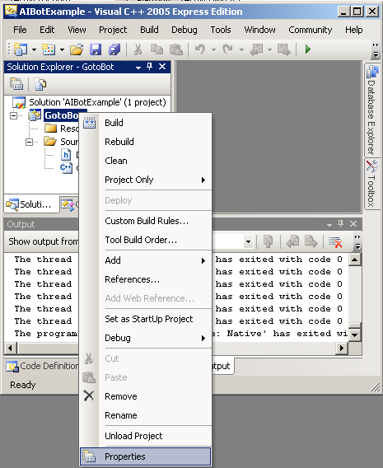

- In general settings, set the output directory to point towards Game\AIBots:
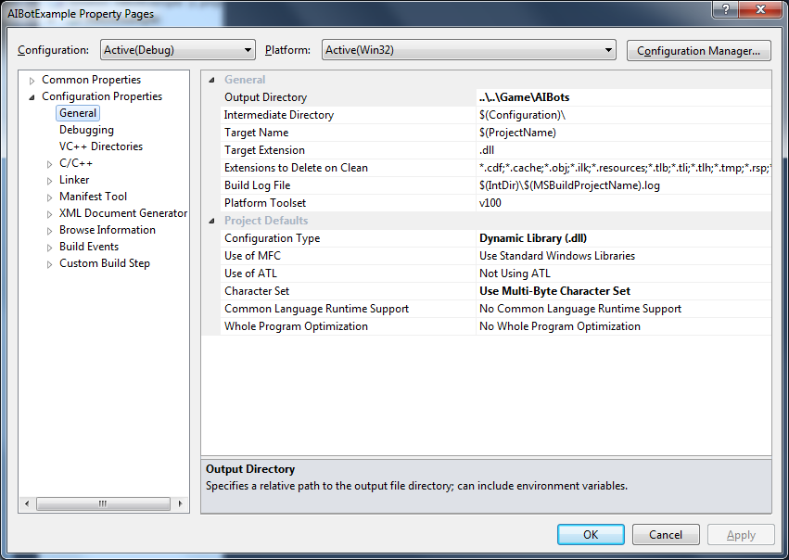

- In Debugging set a three fields. (NOTE: -t runs the game in window mode)
Command: ..\..\Game\bin\sauerbraten.exe
Command Arguments: -t
Working directory: point towards game directory

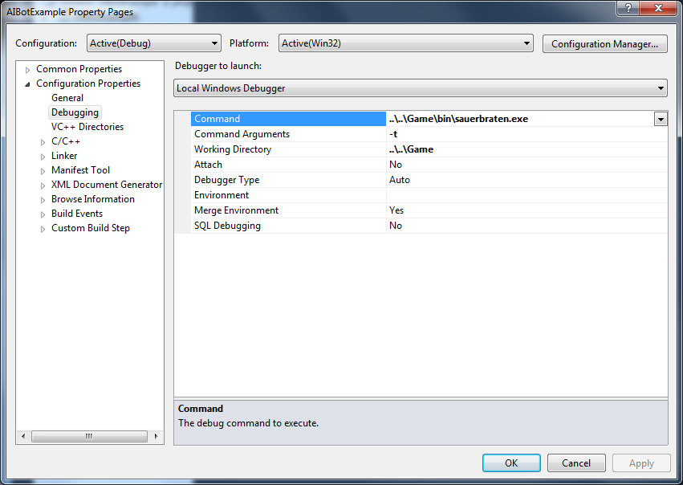
- Press OK to save options.
- Select profile you would like to compile:
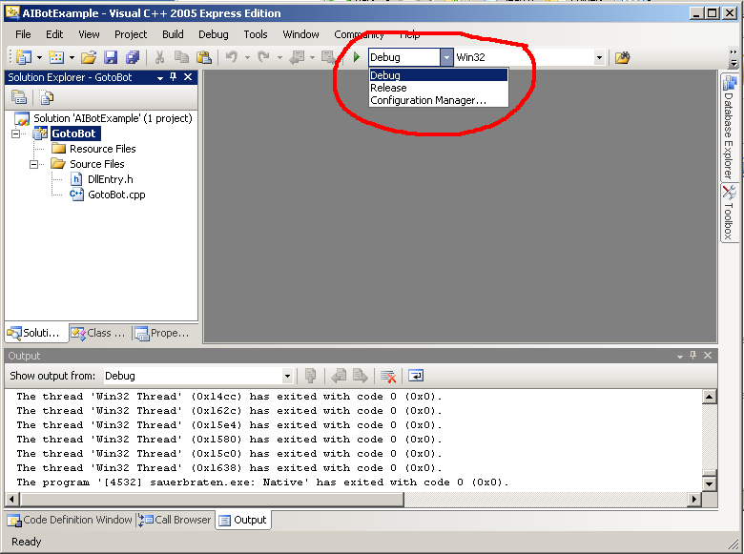
- Select Build->Build Solution to compile or press.
- Select Debug->Start Debugging to run the game.

