Question 1

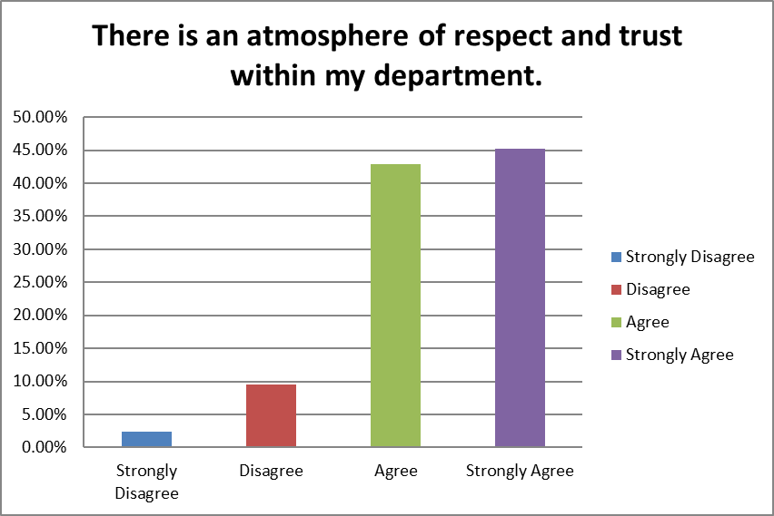

Question 2

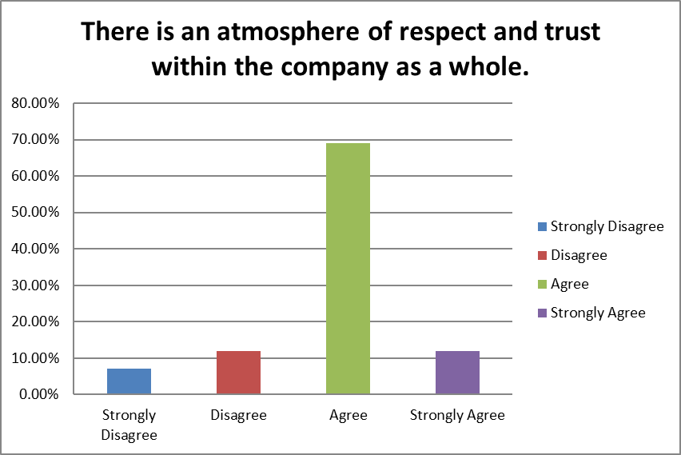

Question 3

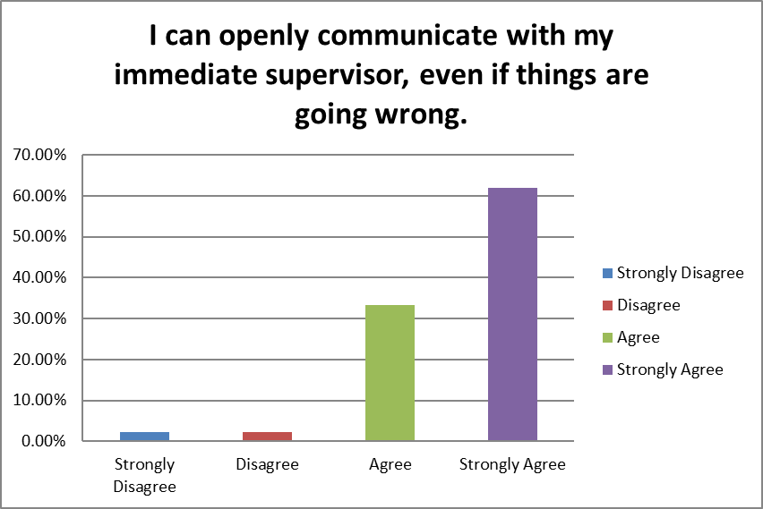

Question 4

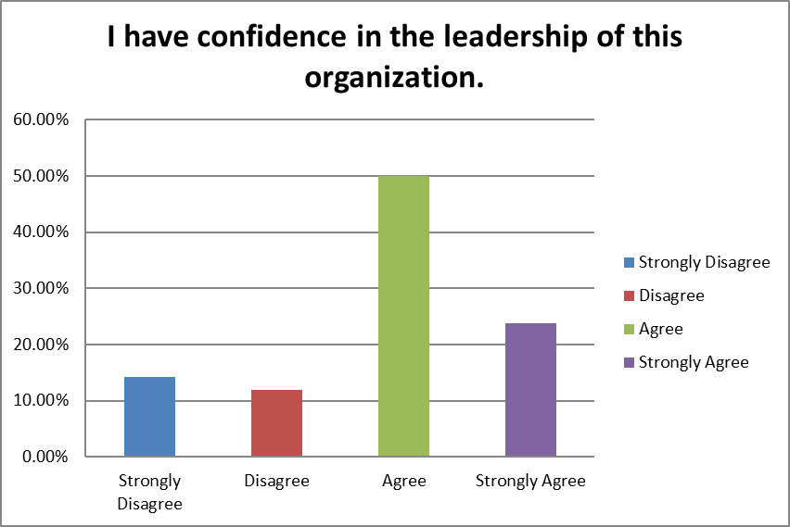

Question 5

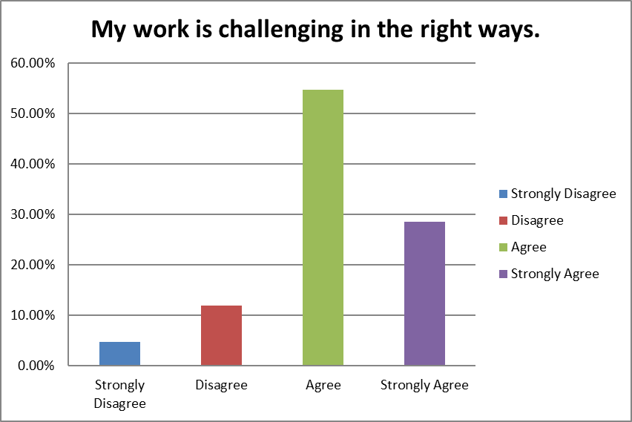

Question 6

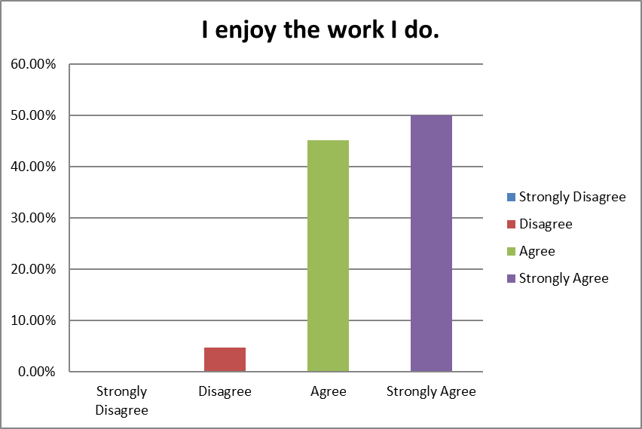

Question 7

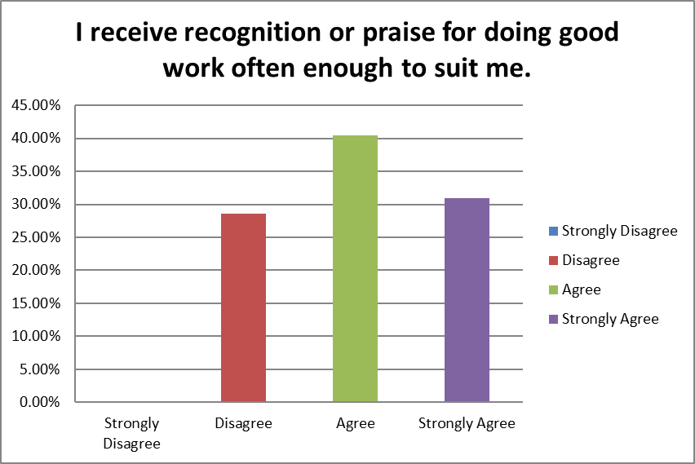

Question 8

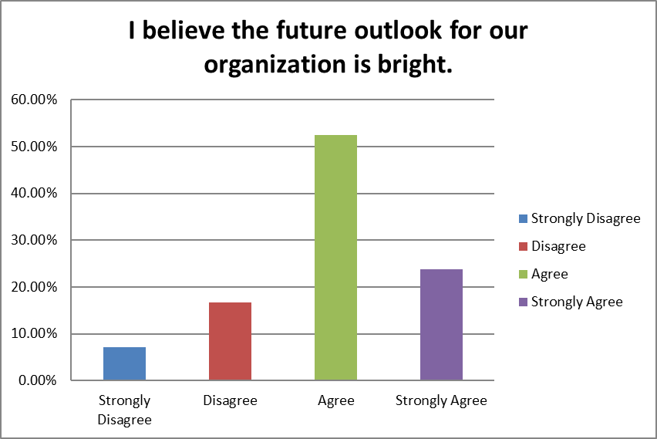

Question 9

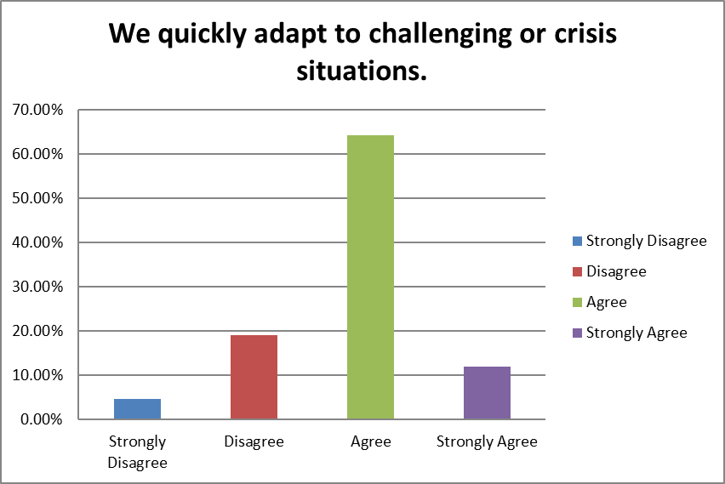

Question 10

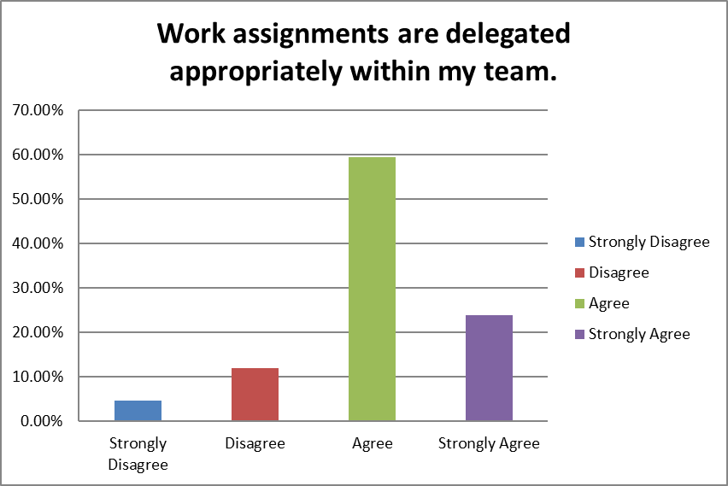

Question 11

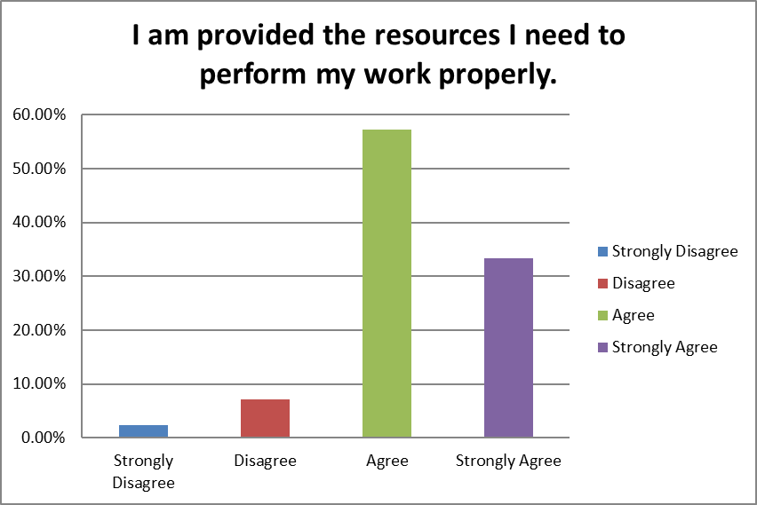

Question 12

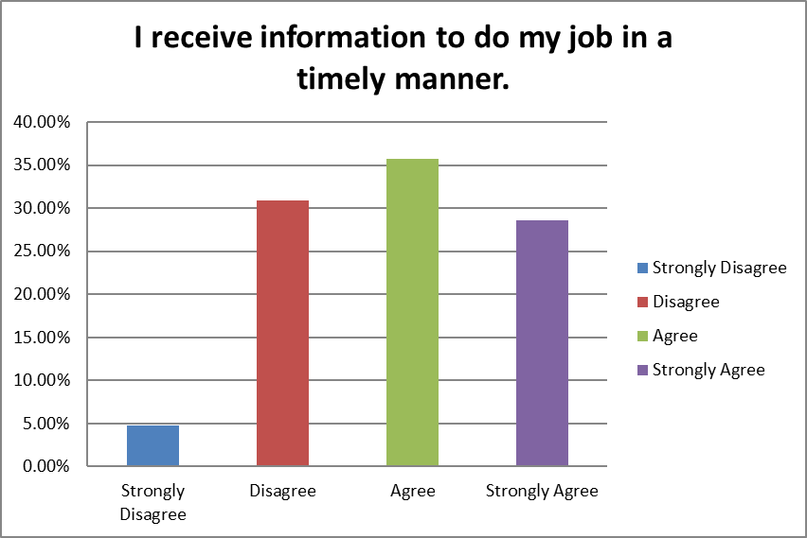

Question 13

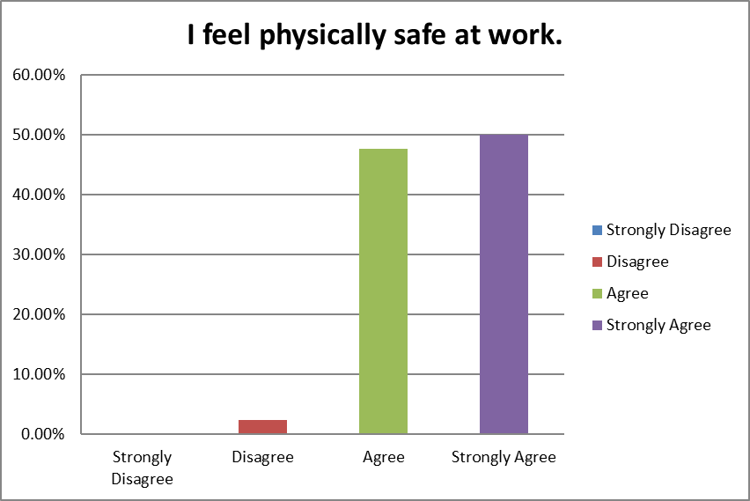

Question 14

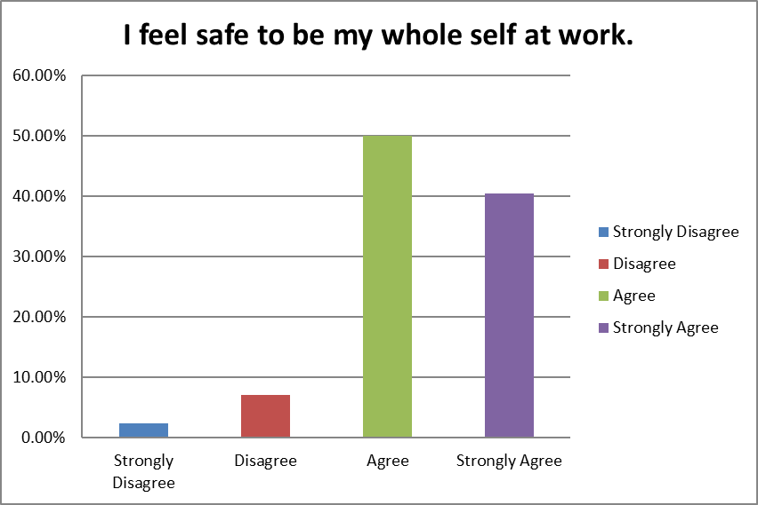

Question 15

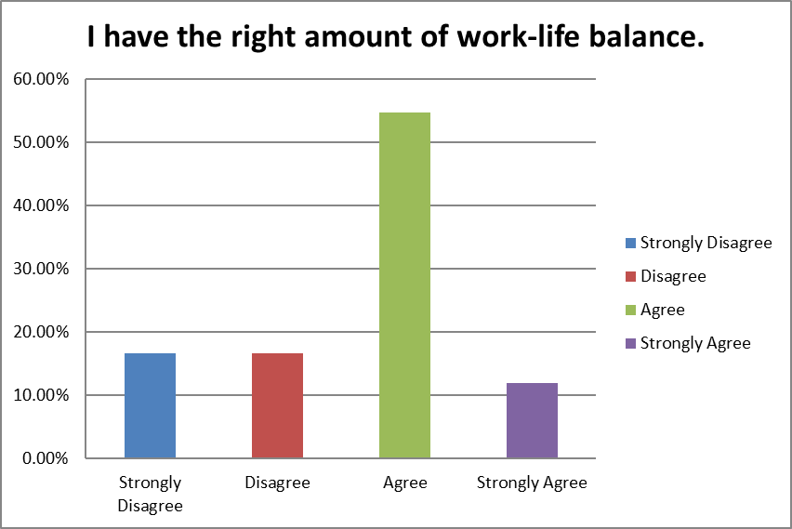

Question 16

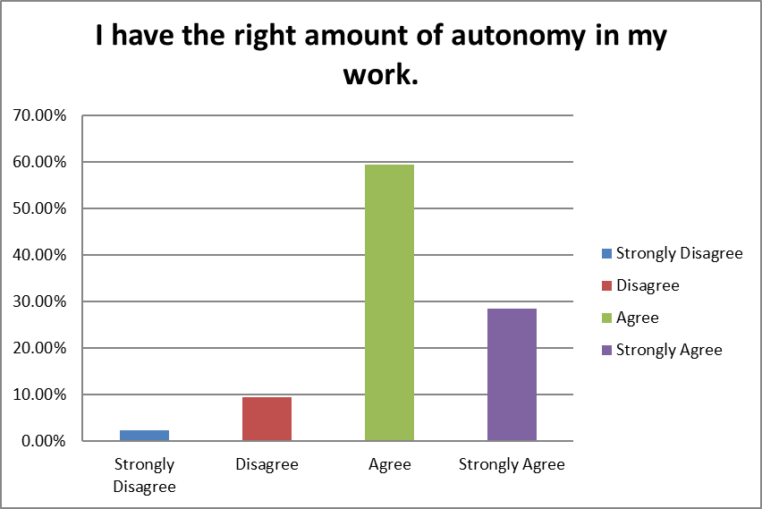

Question 17

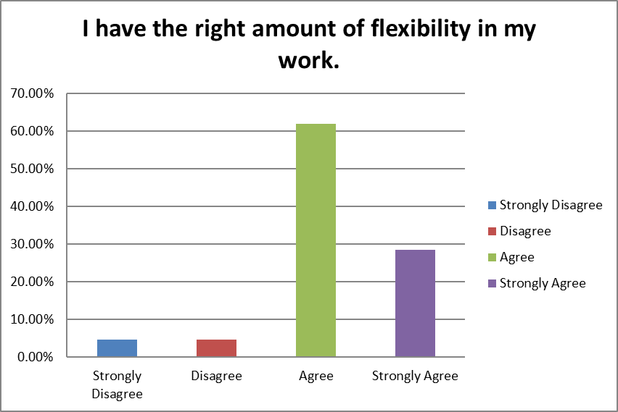

Question 18

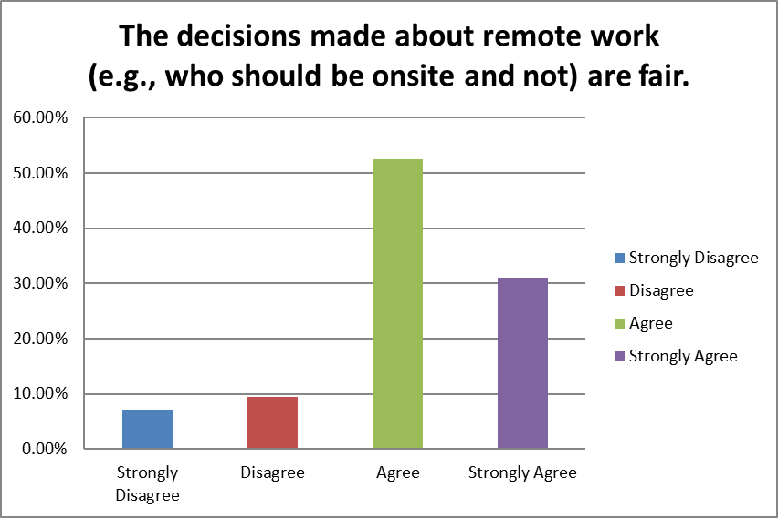

Question 19

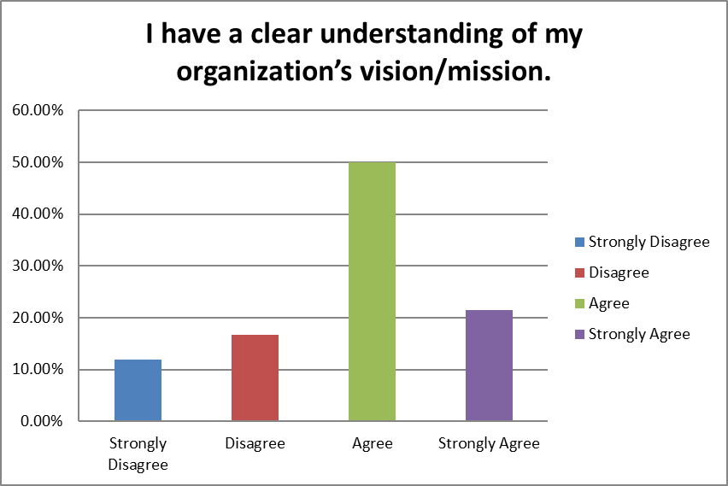

Question 20

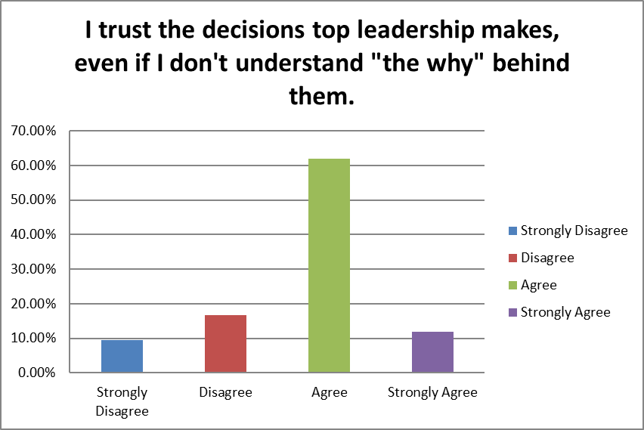

Question 21

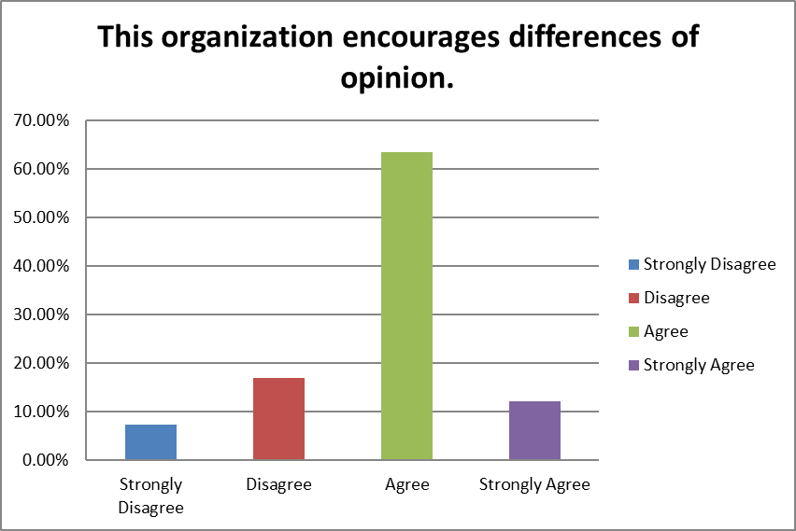

Question 22

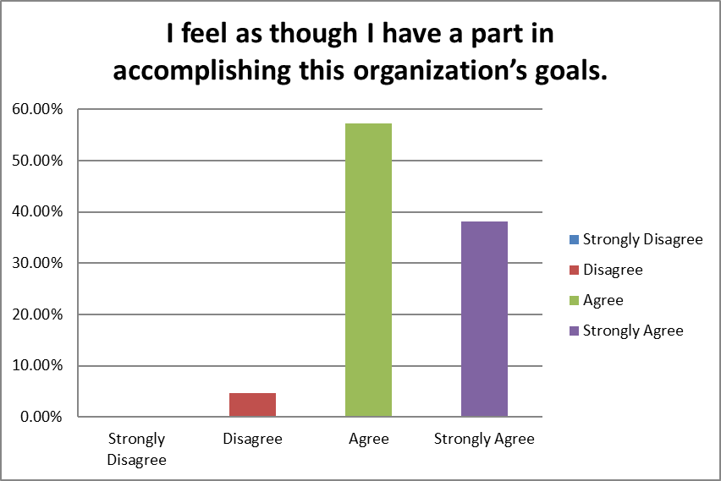

Question 23

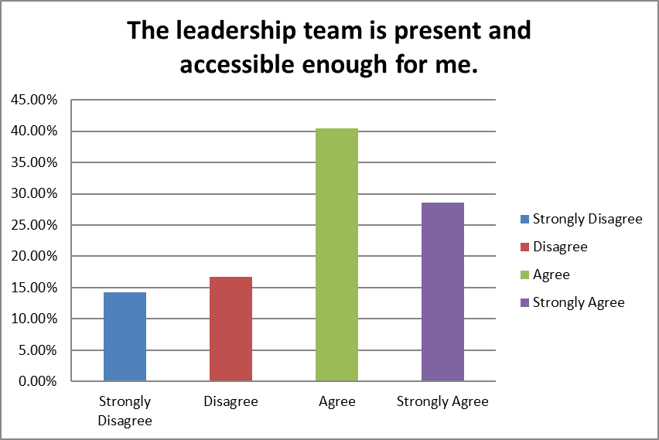

Question 24

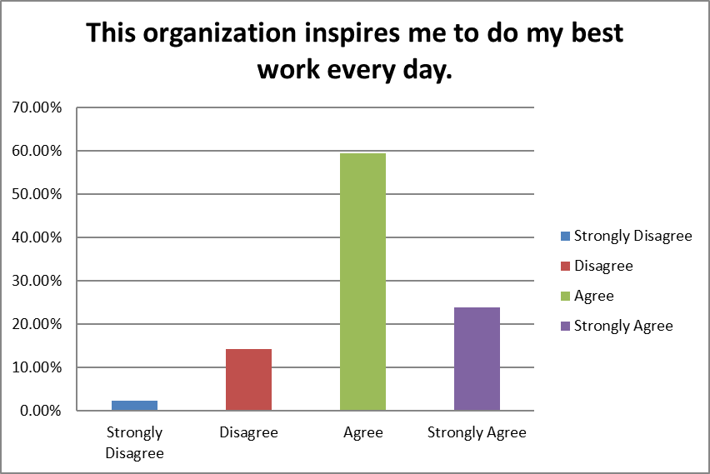

Question 25

* I think management does not do a good job of outlining the plans for the year or quarter to leaders of different teams in each department. I feel like every week, there is a special "rush" request because someone did not tell me or my team far in advanced the work that needed to be completed. I also feel like leadership members are very far removed from the internal issues that we have as a company and gloss over these issues during our "all hands meetings". Instead, they boast about 100% bonuses for upper management when in fact, everyone else who is not in upper management get far less of a bonus. I think
* The culture of the company should reflect positive communication, collaboration, and motivation fostered by strong leadership team.
* Interdepartmental and often intradepartmental communication has always been an issue at VXRT and I worry this will amplify as we rapidly grow.
* I strongly agree with my choices
* The work from home policy should be reevaluated.
* I am excited about where the company can go and enjoy what I do.
* It feels like the departments aren't working together for the same goal. All employees should be given the option to work at least 1-2 days from home. Employee onboarding is too quick, employee orientation is rushed and too much information. The employee's manager should have a 30-60-90 schedule and go over basic company procedures.
* I do not believe upper management has a clear vision for Vaxart (or if they do it is not common knowledge). I feel that R&D is not given enough credit for the contributions they have made since the start of the pandemic, it makes it hard to feel motivated to work hard when contributions are seemingly ignored or rewarded.
* Vaxart is growing, which is a good thing. Through this growth the company is understandably implementing larger company procedures. Unfortunately, without needed resources, the same workforce is having to add even more work to be able to complete bigger company tasks but taking advantage of the workforce to continue to keep small company perks (ex.. less personnel, working around the clock 7 days a week).
* The new management and diverse group of people in the workplace has been very helpful in promoting the growth and development of the company, however there is some notable tension around between individuals and teams at times. The rapid growth of the company definitely comes with its difficulties and adaptability is an ongoing challenge when it comes to ensuring the growing population onsite can better cooperate and respect one another.  
    
    
    
  Similarly, ensuring that all teams and individuals are well equipped in both materials, equipment and personnel is still a prevalent issue despite the rapid growth.
* covid protocols have not been adhered to or enforced. vaccination should be mandatory and weekly testing should be offered.
* Vaxart E-Team appears to be disorganized (questions 4, 19, 20). We keep beating the drum on Covid even though we are years away from having any kind of Covid product. While it's good to see the continued interest in Noro I feel we have lost our way in positioning ourselves as a vaccine platform company.   
    
    
    
  With a lack of a clearly communicated vision our teams do not know what to position themselves for in that time - are we focused on Phase 2 data? Or do we want a BLA? Focus on the former would push out the latter but it would provide our MFG, QC, and QA teams a focus for what is most important now.  
    
    
    
  Almost all of the E-team is off-site except for monthly appearances (question 23) which makes them less accessible for questions/concerns.  
    
    
    
  Our work/life balance consists of: "here is a mountain of problems that we need to solve, now." (questions 15, 18) This pressure-cooker environment is not sustainable for key employee retention in the long term.
* Need a "neutral" check box
* The company has a very compelling mission to change the landscape of vaccines and save the world from future pandemics that it is inspiring to work for the organization.
* I think upper management should be more transparent about the company’s timelines and any changes that are made in the timeline. They should also notify groups of any deadlines far in advance to allow those groups to complete those projects in a timely manner.

Question 26

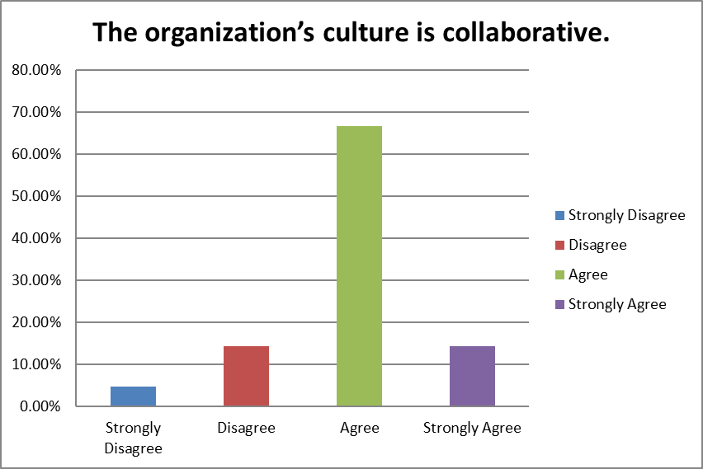

Question 27

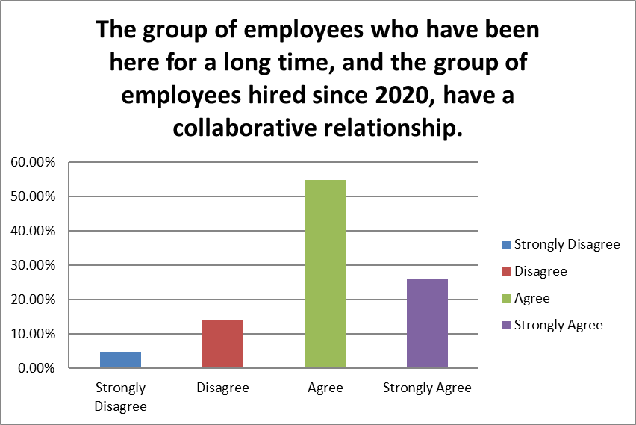

Question 28

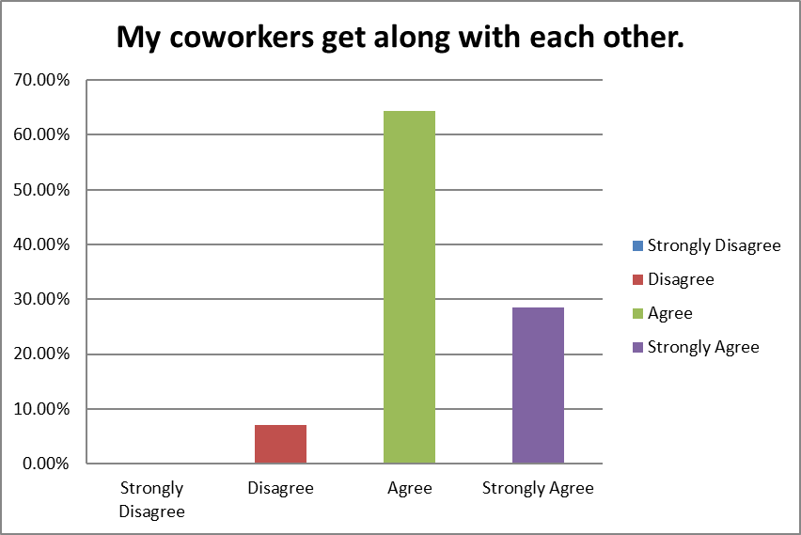

Question 29

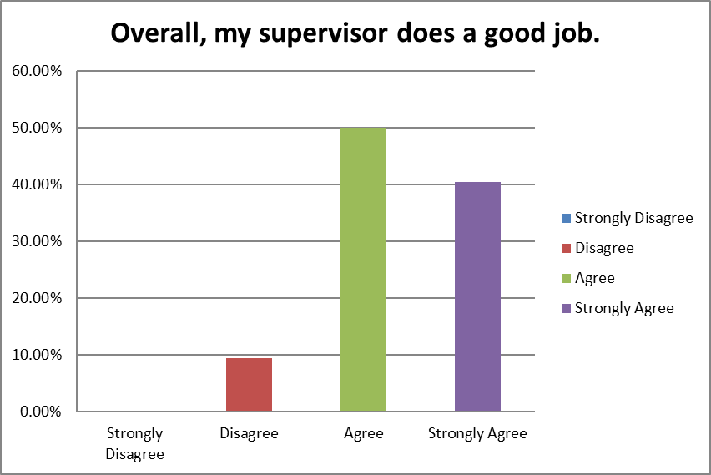

Question 30

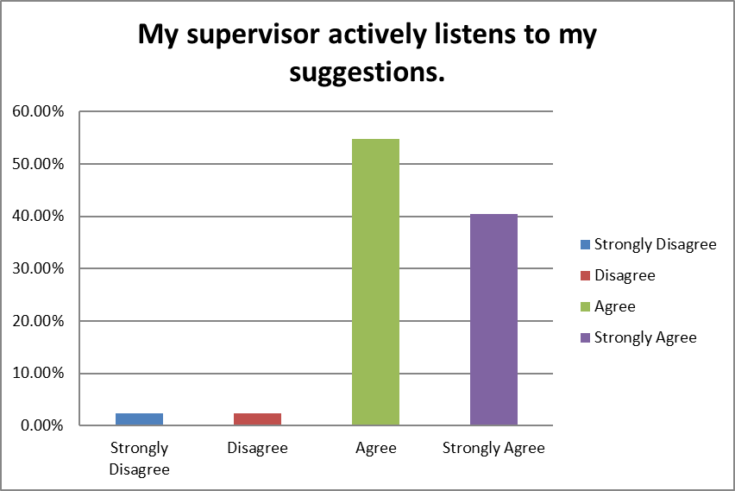

Question 31

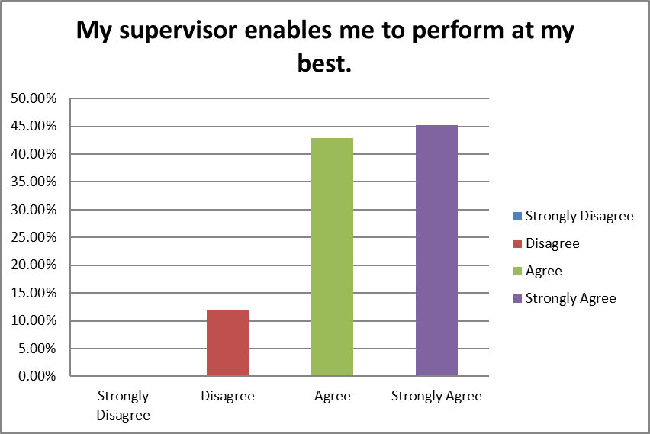

Question 32

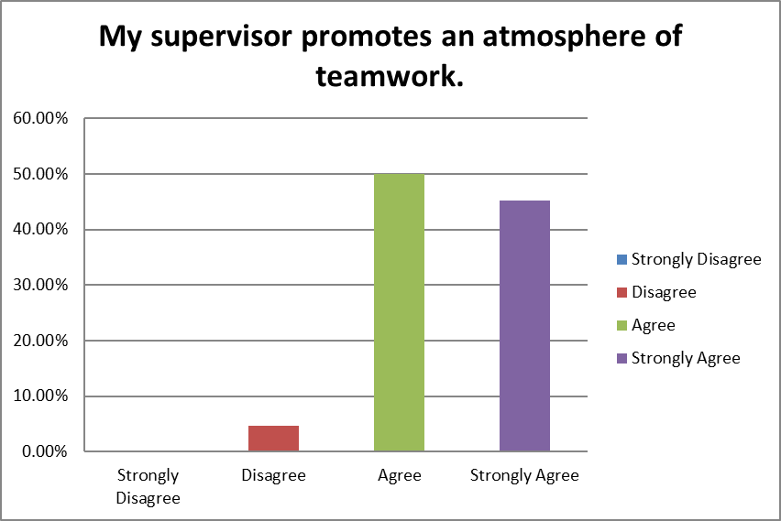

Question 33

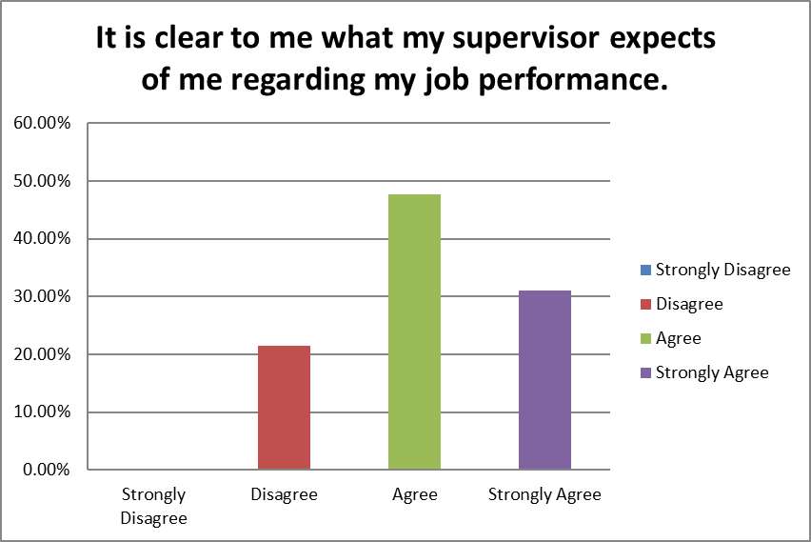

Question 34

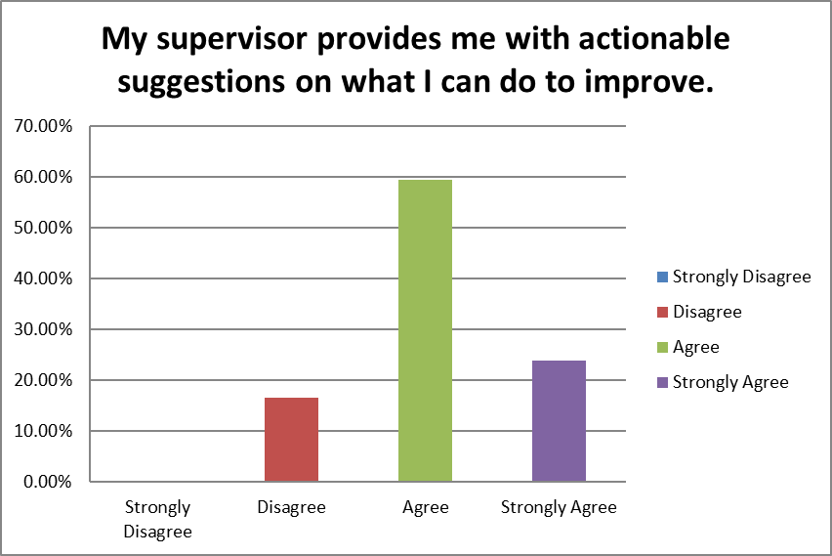

Question 35

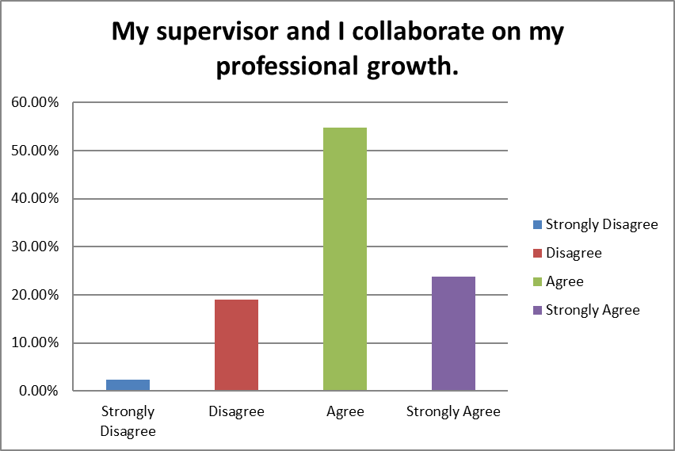

Question 36

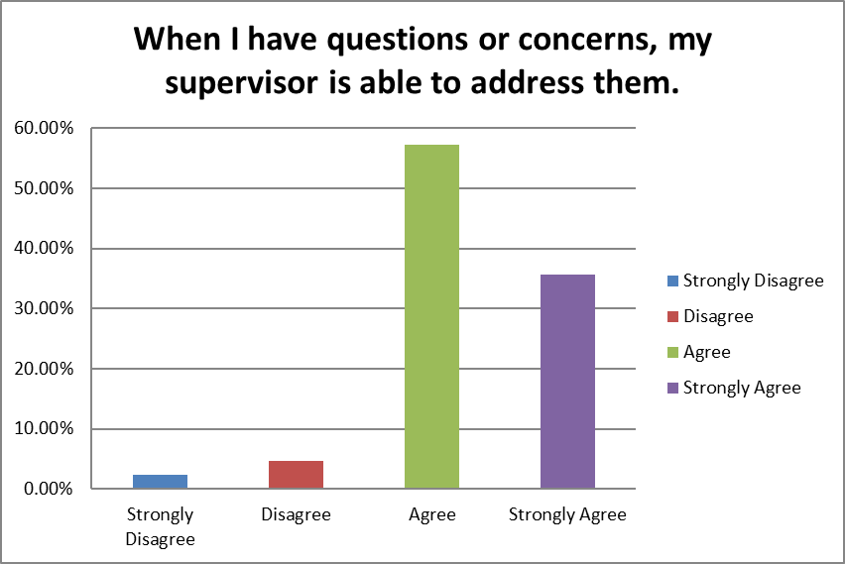

Question 37

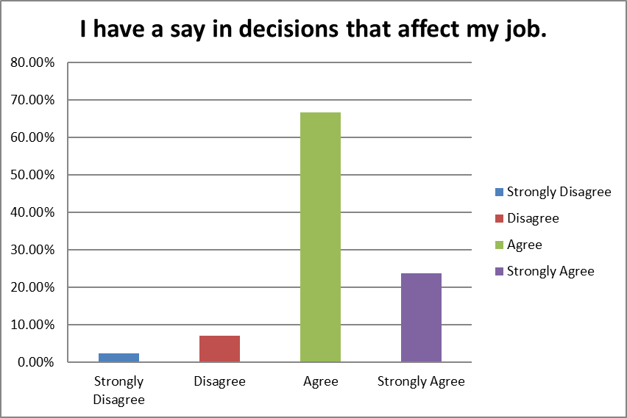

Question 38

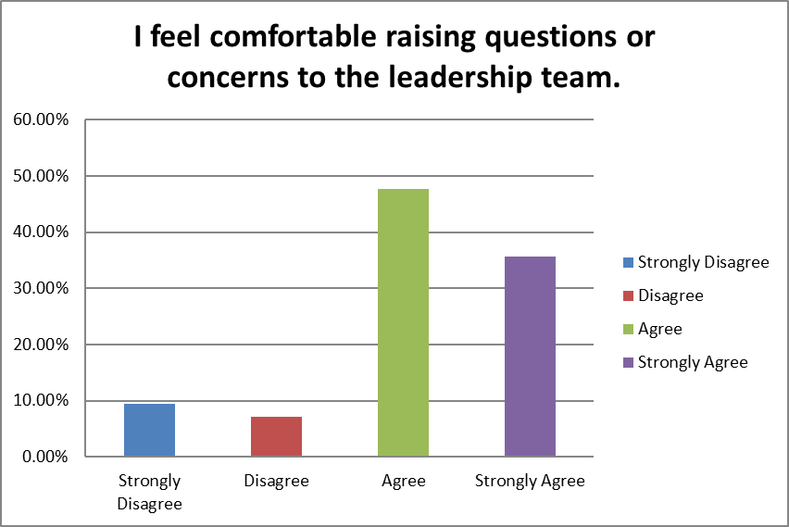

Question 39

* I have seen other coworkers raise issues with regards to raises or work harassment to members of the leadership team and I have seen them being shut down or told not to go to HR. I feel that this behavior strongly discourages me to speak with leadership when I feel uncomfortable.
* Empty offices should be immediately reassigned to onsite managers with direct reports to avoid negative moral. Clearly defined spaces will foster better communication and manager engagement with their direct reports.
* I feel like my supervisor does not have a clear picture of how I can progress within the department and this has me worried about long term career growth.
* My supervisors and I work very closely and agree very well!
* I do feel comfortable to speak freely with certain members of the team
* There are some tensions noted between the prior generation and the one hired after 2020. As for the motivation between these tensions, I'm not sure if it was motivated simply by the fact that one views themselves as above the other based on the origin of their time with Vaxart.  
    
    
    
  When communicating with my direct supervisor, timing and distance are more of the direct challenges present with regard to having the ability to convey everything to be addressed. It also introduces the ability to easily overlook or misinterpret subjects brought up, taking time to thoroughly process the subject being discussed. This is not to say that these issues happen every time a discussion is had, though it is one of the major challenges to be noted.
* Satisfying the requests of finance requires a significant quantity of time (question 26).
* There are other people at my supervisor’s level who do not promote a collaborative work environment. These supervisors tend to gossip and make negative comments about those at a lower level and those who are their equals.

Question 40

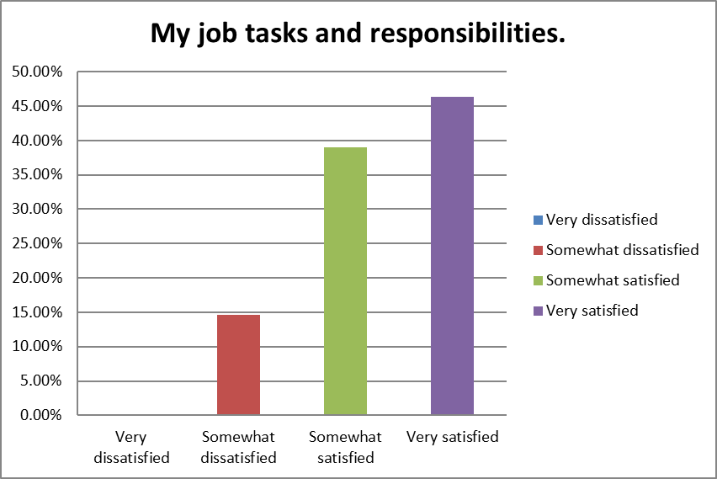

Question 41

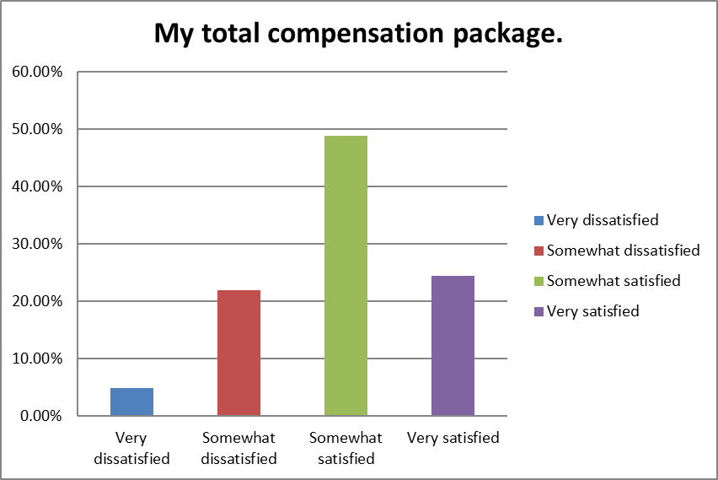

Question 42

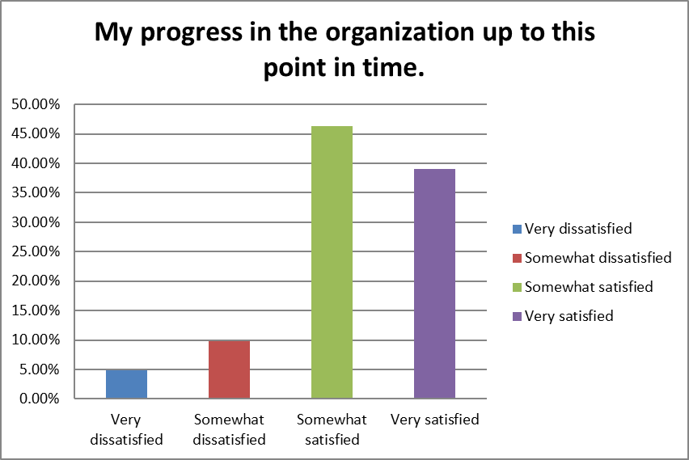

Question 43

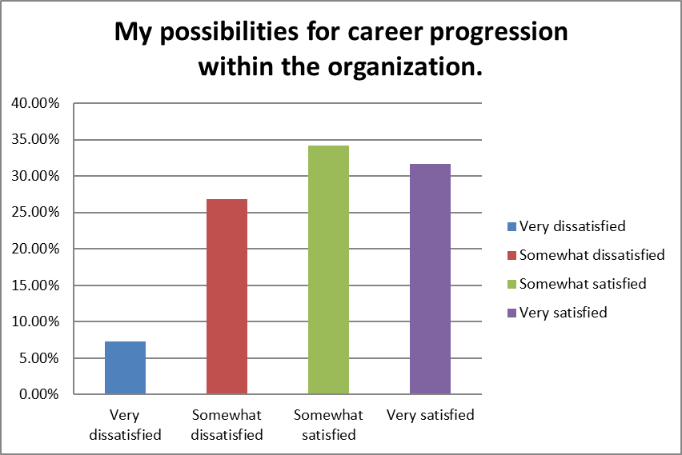

Question 44

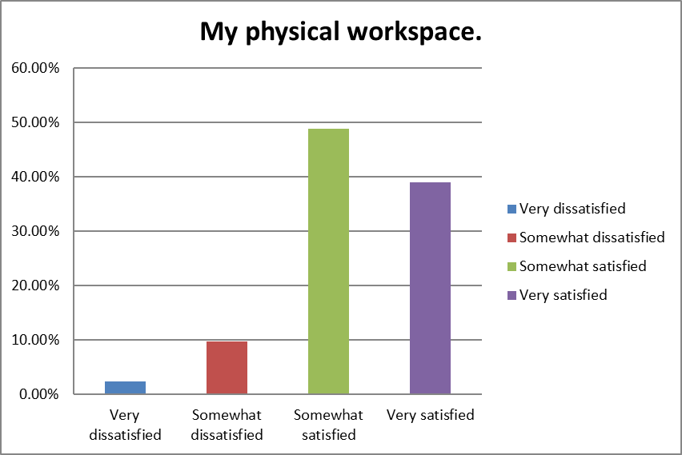

Question 45

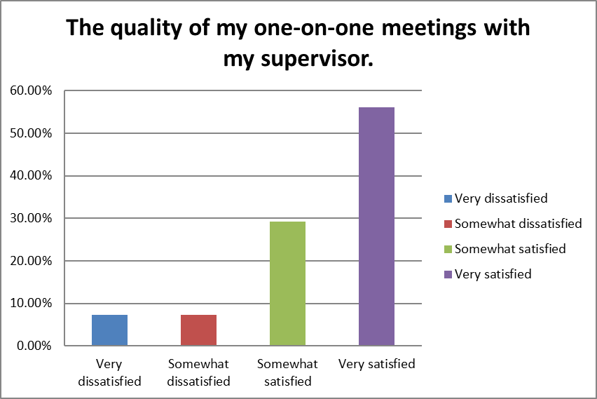

Question 46

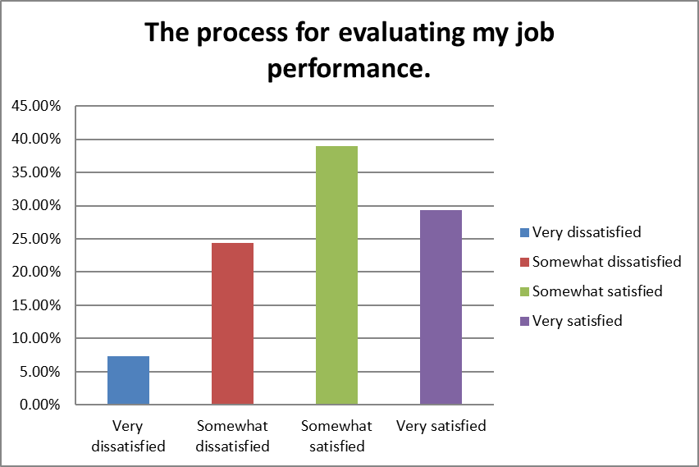

Question 47

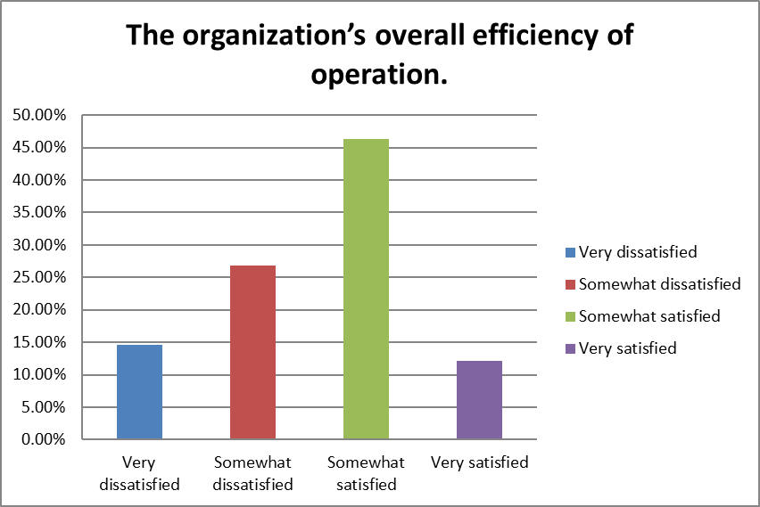

Question 48

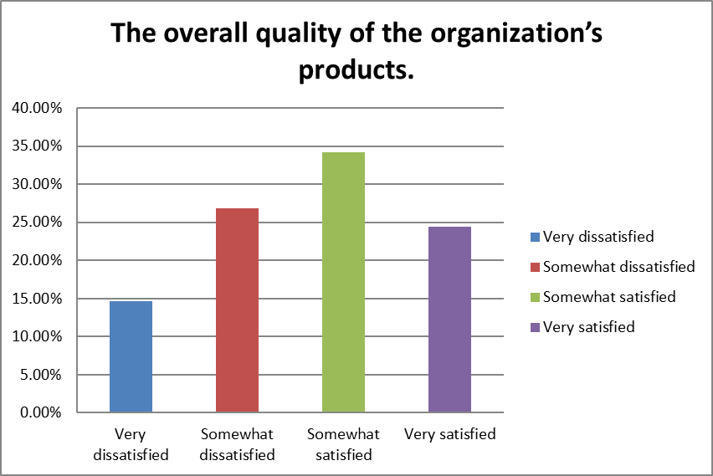

Question 49

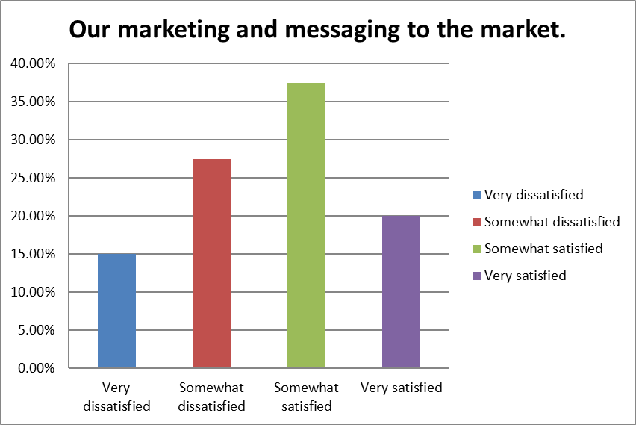

Question 50

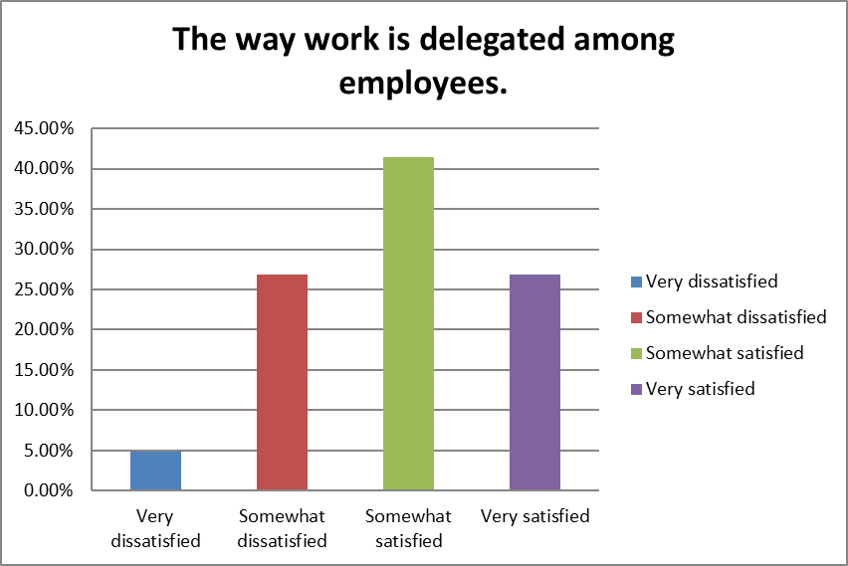

Question 51

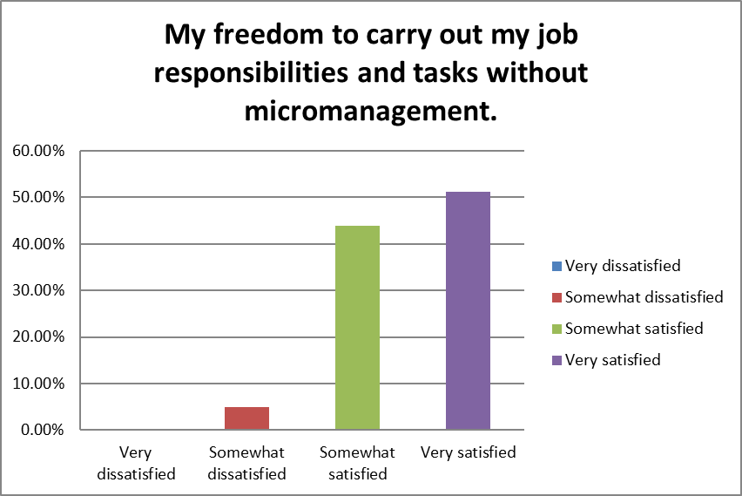

Question 52

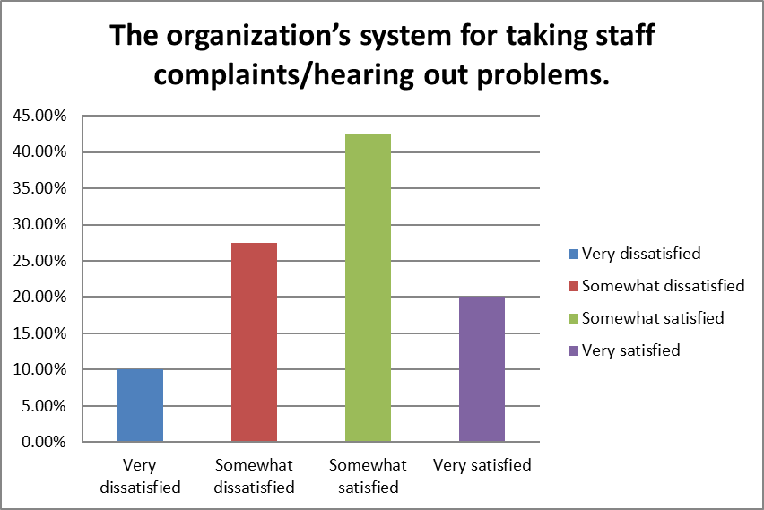

Question 53

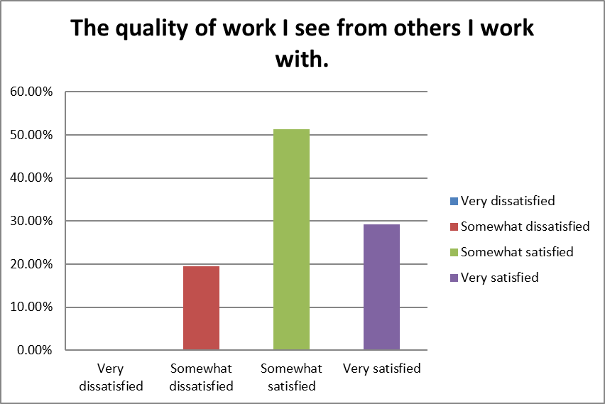

Question 54

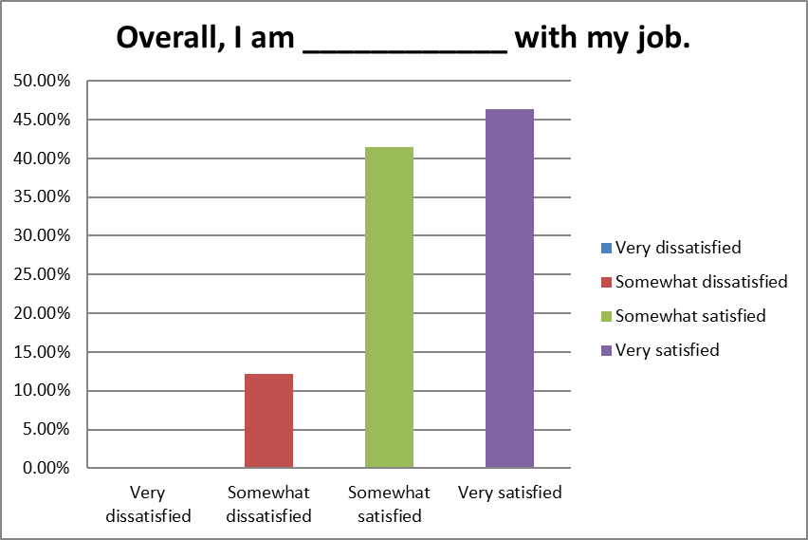

Question 55

* I'd suggest these questions to be asked after annual performance review.
* I have been told by others who have worked here longer than I have that being promoted is very difficult in my department. Thus, I do not see possibilities for me to grow within the company. I was also given a much lower compensation package than what I had originally asked for. Not too long after I joined, another member of the team was hired with the same amount of experience as I have and that person was given a higher base salary. I feel as though I am being discriminated for being of opposite gender.
* Company activities should be scheduled to celebrate milestones.
* Our marketing and overall public visibility is very poor. We should engage with a partner(s) that can increase VXRT’s visibility in strategic public coverage in a general as well as specifically targeted manner.
* Really enjoy working here and with my staff and superiors!
* Upward progression within the R&D department is seemingly impossible. I feel as if I am stagnant in my position and wonder if moving laterally to another department would help my career progression. I feel that we are underpaid given what I have seen from other similar job postings and recent interviews I have had. The CEO said during recent all-hands meeting that upper management received 100% bonuses while the rest of the company was ~10%. This disregard for lower level employees makes me seriously consider leaving this company. I very much enjoy my specific team within Vaxart, but we do not work in a bubble so the lack of career progression is of growing concern. For problematic senior employees there is no accountability or path forward for improvement. Lower level employees endure the brunt of working with a difficult senior scientist
* I like my work, I do not like the amount of work which is expected from some of us compared to others. If you are more diligent and good at your work, more work is expected of you. While others which do not do quality work end up having less work as they are not relied upon.
* Regarding my personal position within the Vaxart it is a bit confusing and sometimes overwhelming regarding some of the impromptu task and assignment being delegated to me. Though I am open and willing to take on just about any task, I'm unsure if that will be appropriately reflected on my evaluation and compensation in the future.
* HR has bound compensation to the Radfords. The Radfords are at least 1-3 years behind the compensation packages of similar companies. This insistence on base-lining to the Radfords may cause us to lose employees to better compensation packages or to not recruit qualified candidates. (Question 42)  
    
    
    
  There is no defined path for career progression. (Question 43)  
    
    
    
  The organization of the company is not well defined. Finance is a time sink, requiring up to 20% of time from other departments in order to support them. QA likes to insert themselves in problems that they do not directly need to solve. I appreciate their work and support, but they can slow down our processes by needing to solve problems "right now" and "for this batch" as opposed to recognizing the deficiency, adding it to a list, adding a priority, and working all of the solutions over time. (Question 47)  
    
    
    
  We have products? Are we a covid company or noro? Or a platform? (Question 48)  
    
    
    
  Andrei's responses to problems or complaints seems to be "go and fix it." That's hardly a management style, let alone one that builds any kind of culture. He needs to own up to his responsibilities. (Question 52)  
    
    
    
  Our marketing is laughable. This video just produced included no interviews outside of Andrei and Research. Our insistence on using the word "disrupt" is very 2010 era marketing and could be thrown into the pile of dead tech companies in the Silicon Valley that have used that term over the past decade. We are not Elon Musk, nor should we hitch our wagon to anything that resembles his style. (Question 49)
* manufacturing issues have caused many problems with trying to push forward

Question 56

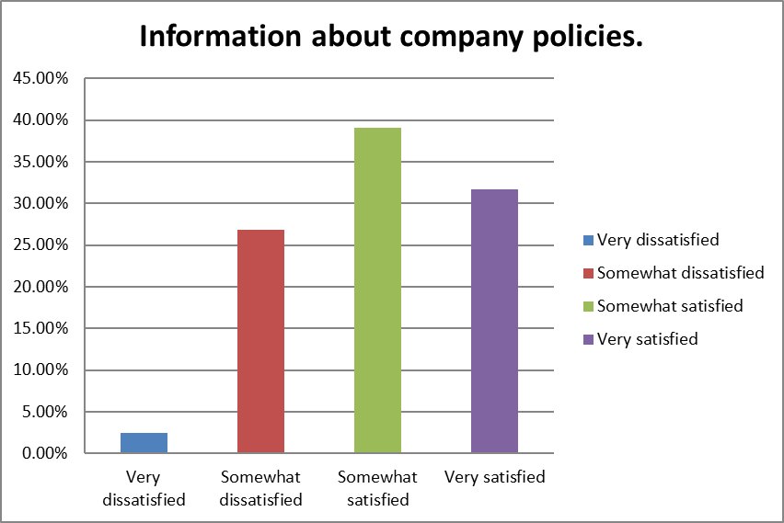

Question 57

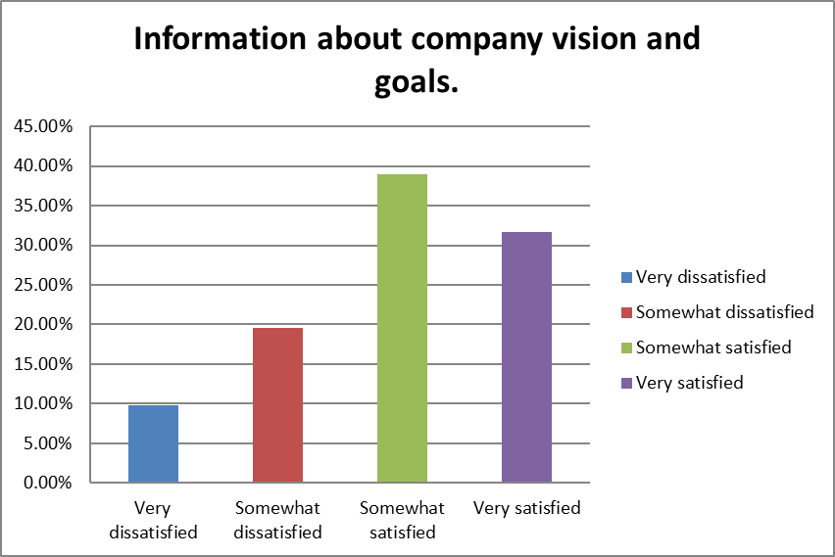

Question 58

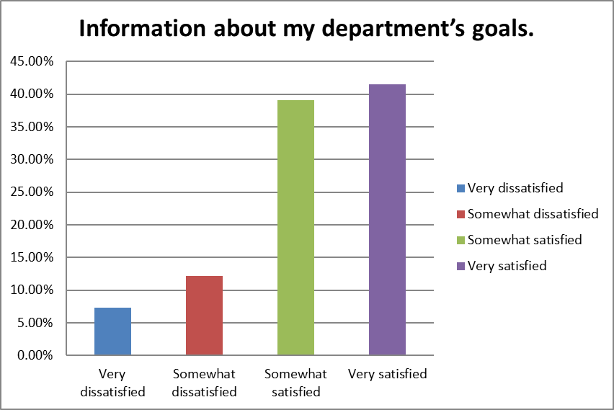

Question 59

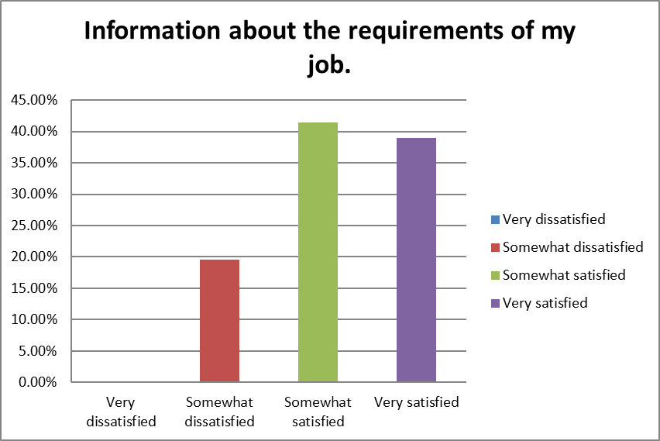

Question 60

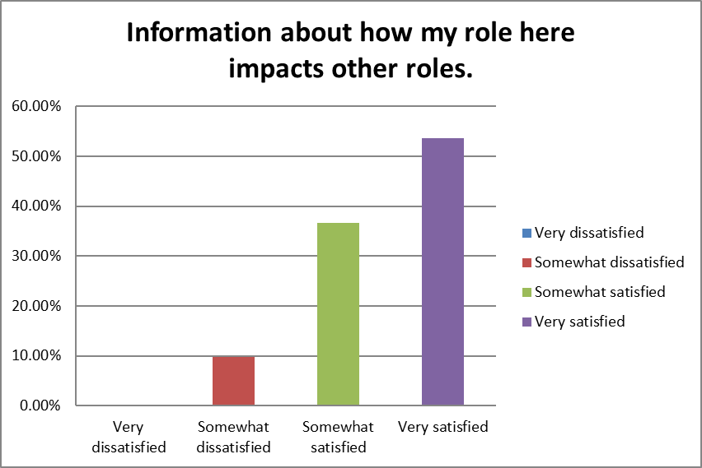

Question 61

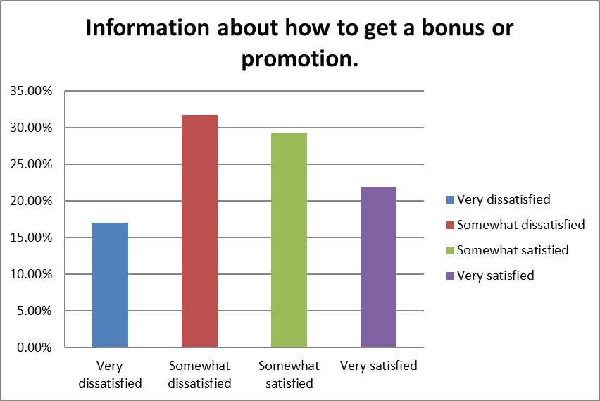

Question 62

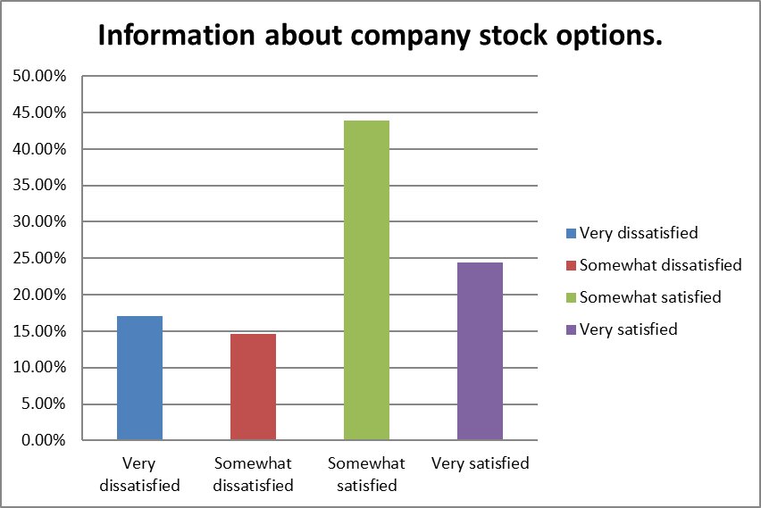

Question 63

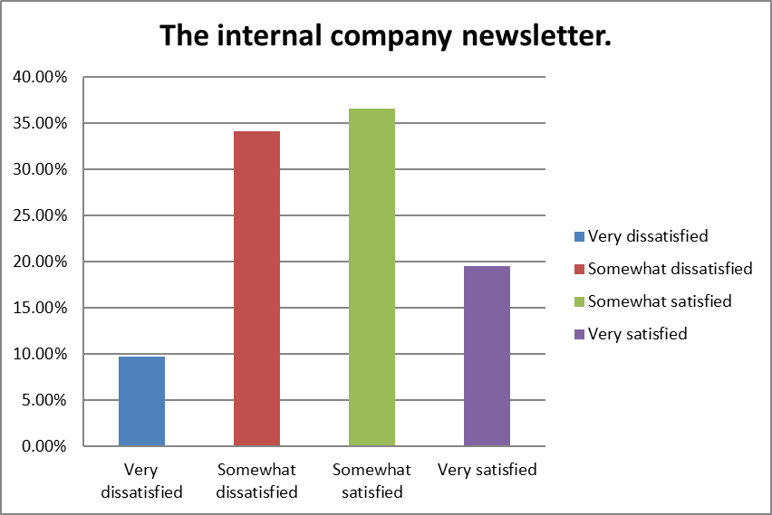

Question 64

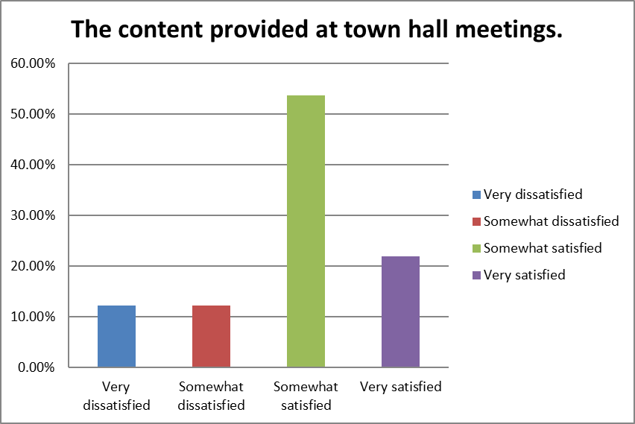

Question 65

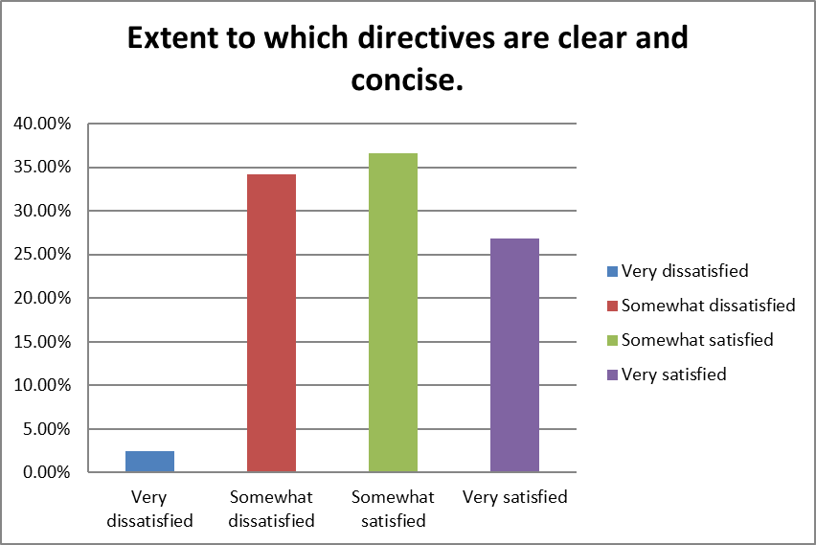

Question 66

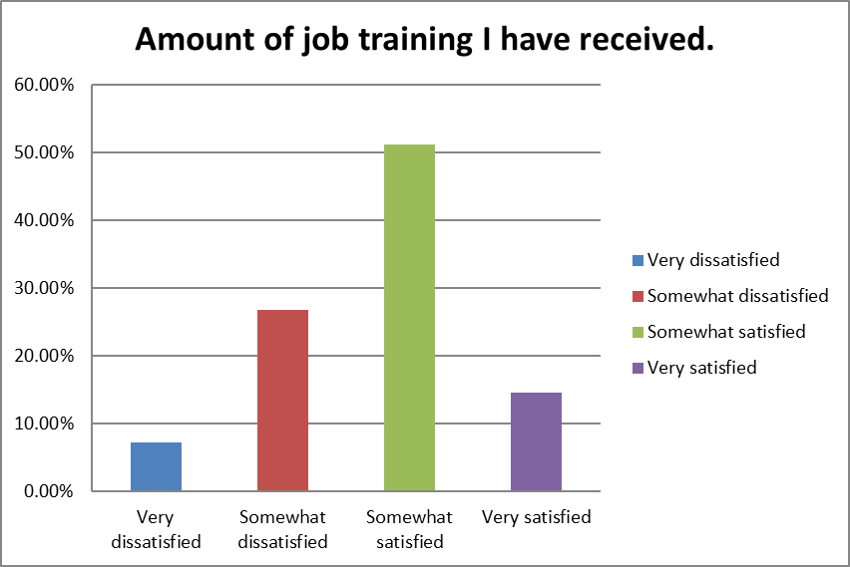

Question 67

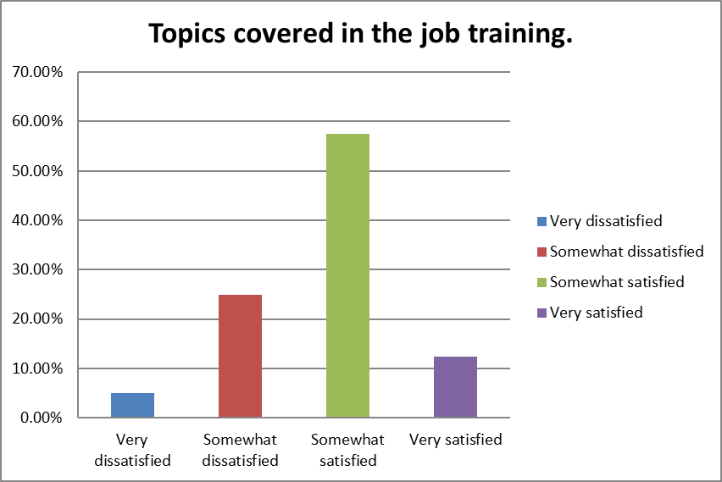

Question 68

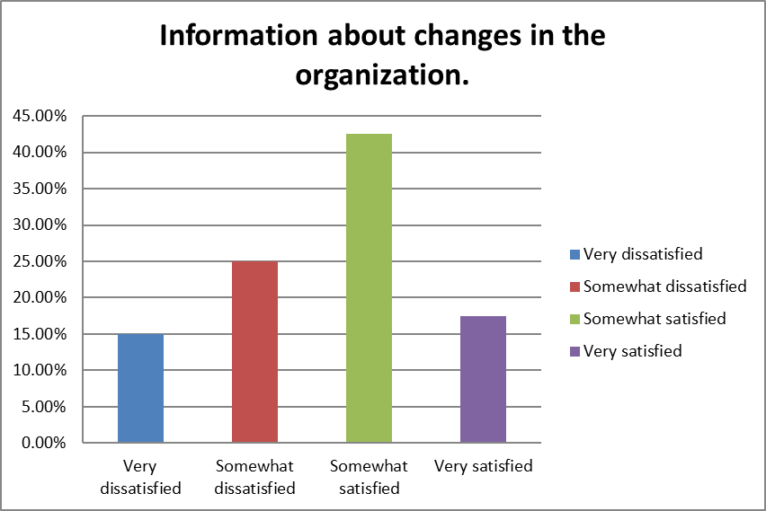

Question 69

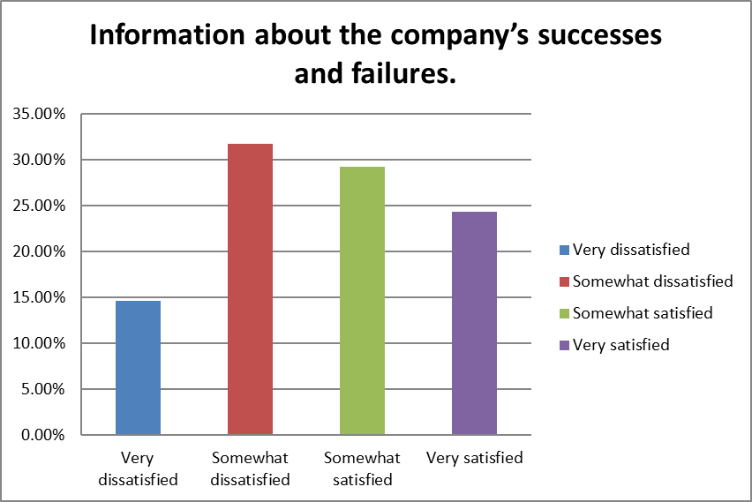

Question 70

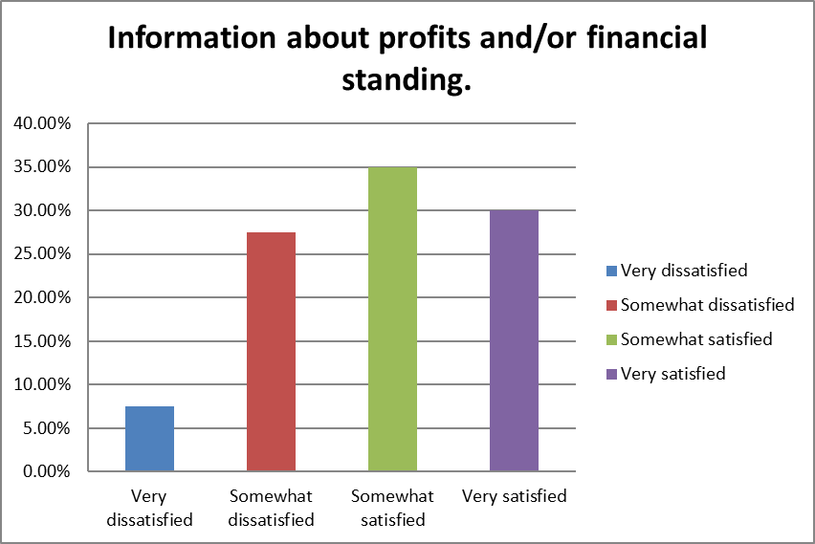

Question 71

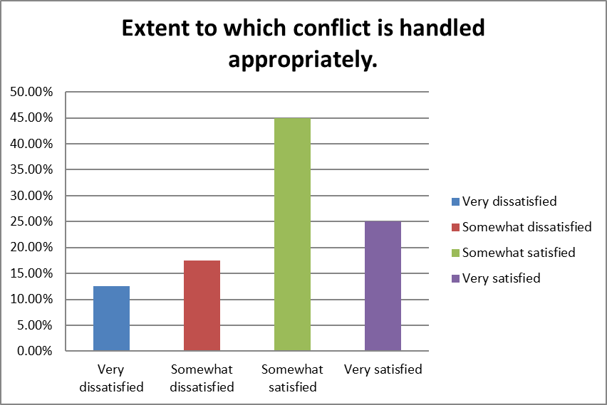

Question 72

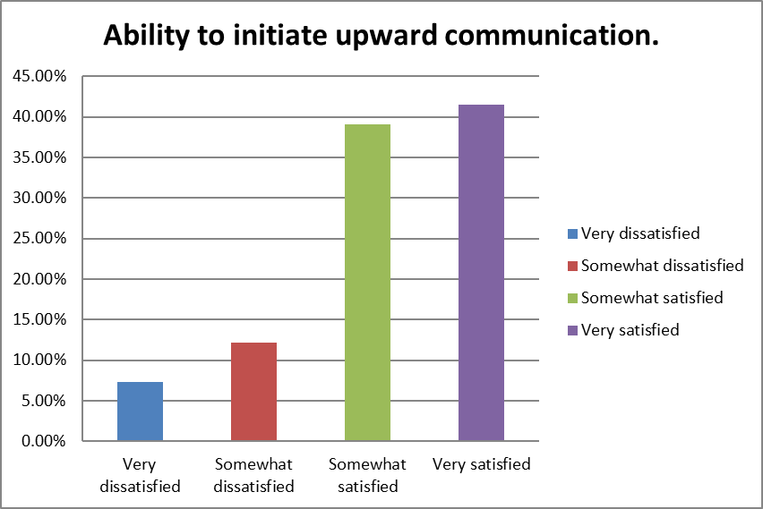

Question 73

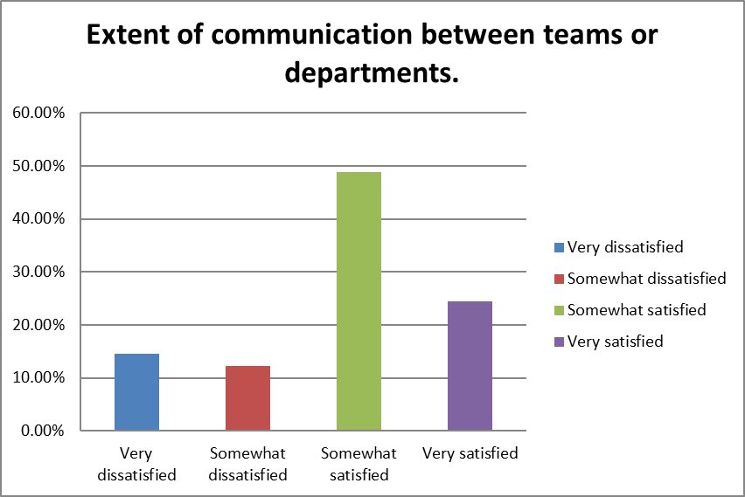

Question 74

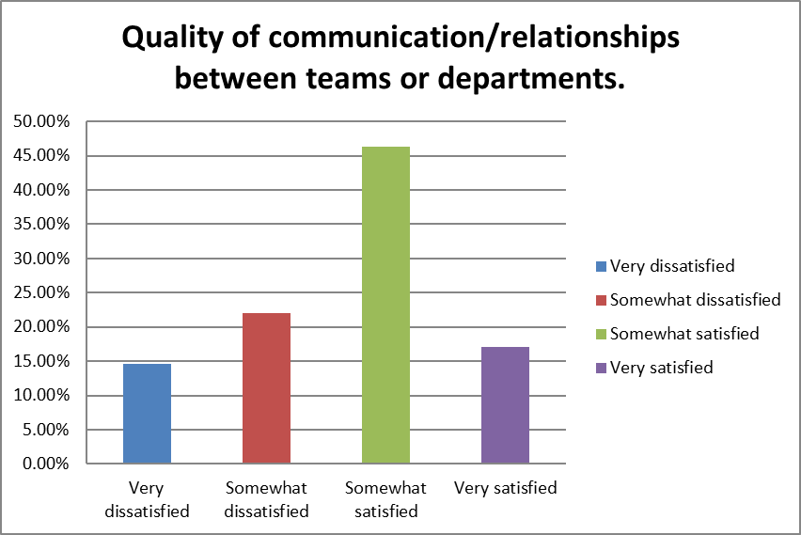

Question 75

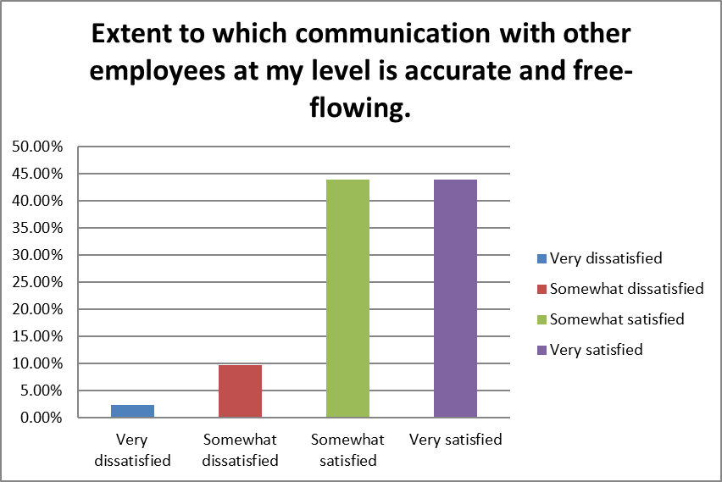

Question 76

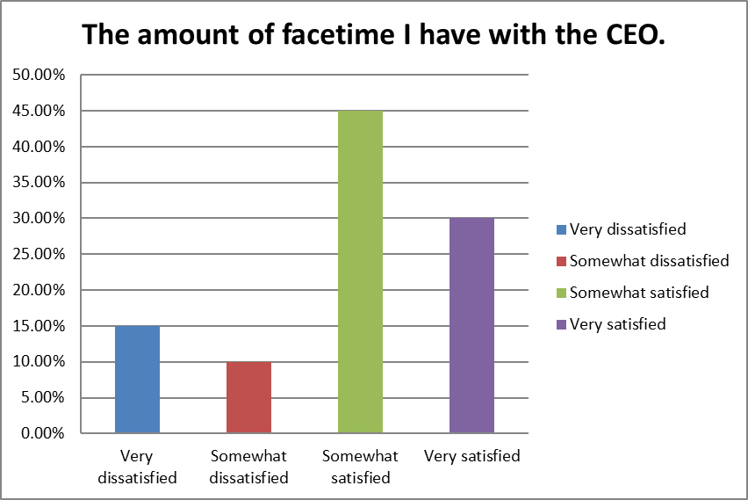

Question 77

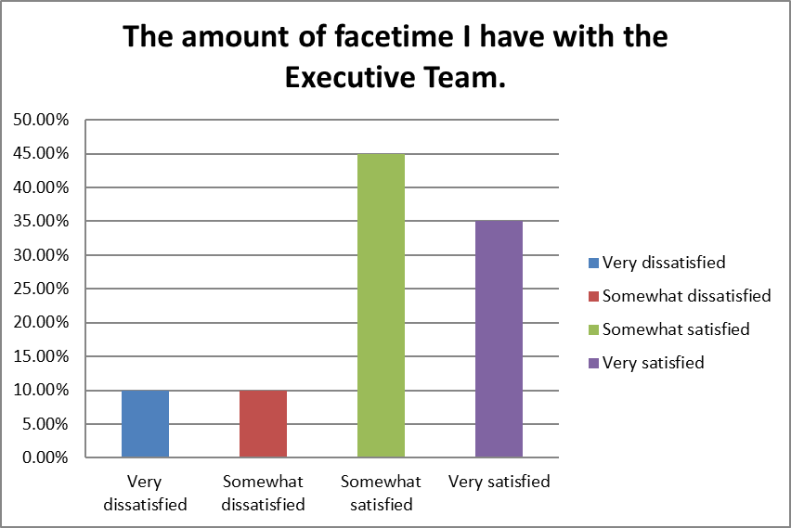

Question 78

* As the company has started growing and expanding recently, it's hard to answer these questions precisely.
* I feel as though upper management tends to hide the failures and mistakes we make as a company. As a result, we cannot grow and learn from our mistakes. In addition, the town hall meetings are not productive. At these town hall meetings, management does not do a good job of outlining the goals and expectations for the year/quarter. Because of this, leadership from subgroups are not able to plan accordingly. Conflicts are also handled poorly within the company. I see members of leadership constantly gossiping about one another. There have been instances in the past where leaders have lashed out at others when they are experiencing stress. Members from different departments do not talk often enough to coordinate deadlines for projects with one another.
* During ‘All hands’ management should define company objective and reinforce the vision. Company activities should be scheduled to celebrate milestones.
* We have not been granted equity packages at all in 2021 even though this has been approved by shareholder vote. We do not have an Employee Stock Purchase Plan in place even though VXRT has been public for over three years. This is a failure.
* The overall flow of information, company finances, messages from CEO about company progression are great!
* No annual stock options yet, Wouter looked after everyone, not just officers
* All employees should work at the corporate office not other states. They should be visible for all their employees.
* As my boss is also very busy. Our 1 on 1 are constantly missed.
* Communication between departments has improved but it could always be better. Especially as R&D ends up assisting other departments regularly and can easily be stretched out thinly. I wish there was more transparency with how manufacturing runs go, especially the never-ending failures. I am losing faith that this company will ever successfully make drug product much less complete a significant clinical trial.
* There are employees who have been here since before January of 2020 that have not seen an options grant since Wouter was CEO. (Question 62).  
    
    
    
  Quality and Tech Ops were not represented in the newsletter. That's over 50% of the company. (Question 63)  
    
    
    
  Andrei proceeded to talk about wanting to develop an "ownership culture" while simultaneously stating the bonuses he gave to management in 2020 - this when juxtaposed to a lack of stock options to existing employees here since prior to 2020 is insulting. (Question 64) Further, when talking about company culture Andrei talks about his shirts and socks and basically other topics about himself for 10 minutes. I've never cringed more in an all-hands meeting.  
    
    
    
  We talk about our successes, we do not talk about our failures. There are things to learn from both results. (Question 69)  
    
    
    
  A $5M burn per month (a guess of mine) with $200M in the bank is a time horizon of 3.33 years. That's not a lot and without a better time horizon from management, others may come to worse (or better) estimates. (Question 70)  
    
    
    
  Andrei has shown no interest in meeting with anyone other than the E-Team. He is also rarely on site. (Question 76)  
    
    
    
  As addressed previously, the E-Team is only on site about once a month (save for Sean). The E-team is also extremely busy so hopefully as they off-load some of their duties they can interface with the rest of the teams more often. (Question 77)
* The goals for 2021 were just announced in July. It seem it would be best to announce the goals early in the year.
* Regarding communication between teams and departments, all communication could be improved upon in order to allow for better crosstalk and clearer communication when conveying the needs between both parties.
* manufacturing and research teams need to communicate more

Question 79

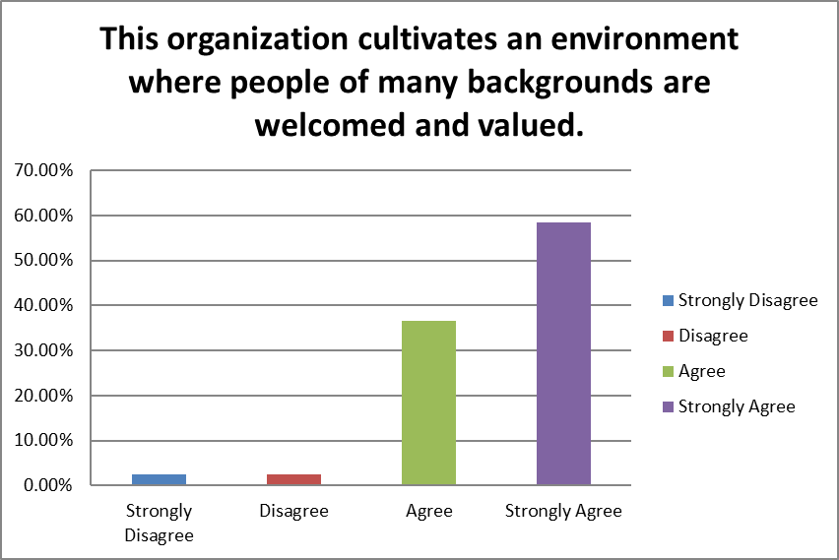

Question 80

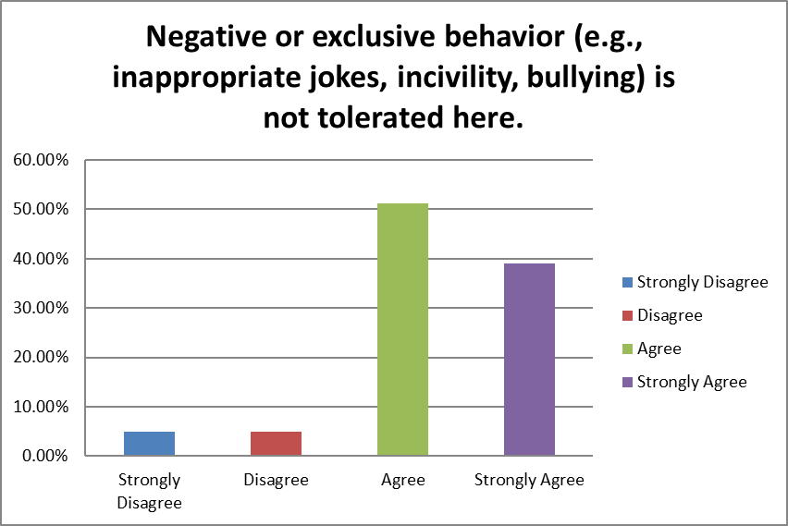

Question 81

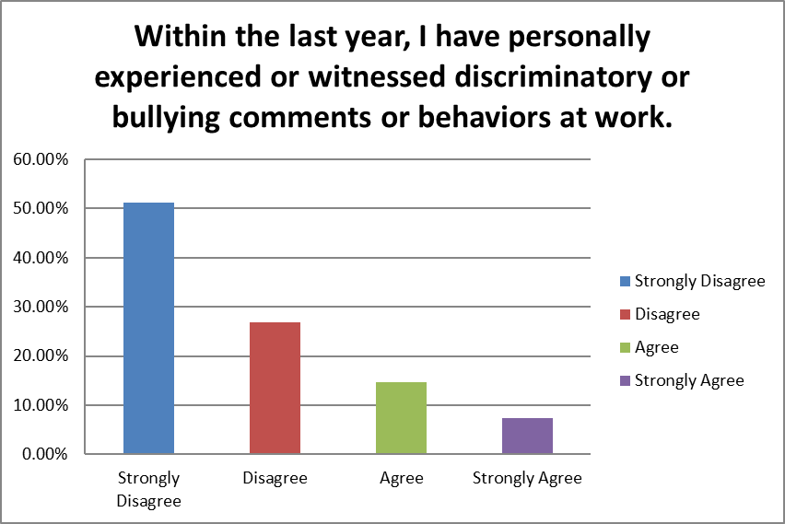

Question 82

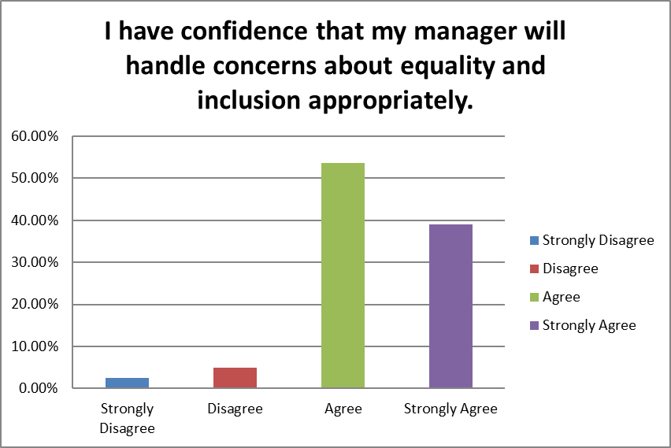

Question 83

* A very well rounded company of diversity, we all enjoy with each other easily!
* I was yelled at by a senior scientist earlier this year and when I talked about the event to upper management I was persuaded to not go to HR. Another senior scientist constantly brings my department morale down and does not treat his/her RA well. The senior scientist has unnecessarily blamed the RA for the loss of $1million preclinical study and made the RA feel unvalued. I hope this RA does not decide to leave Vaxart as they are a valuable asset to the team and are wonderful to work with.
* There has definitely been some tension and conflicting interactions, though it has not escalated to the point of doing more than causing social strain at times.

Question 84

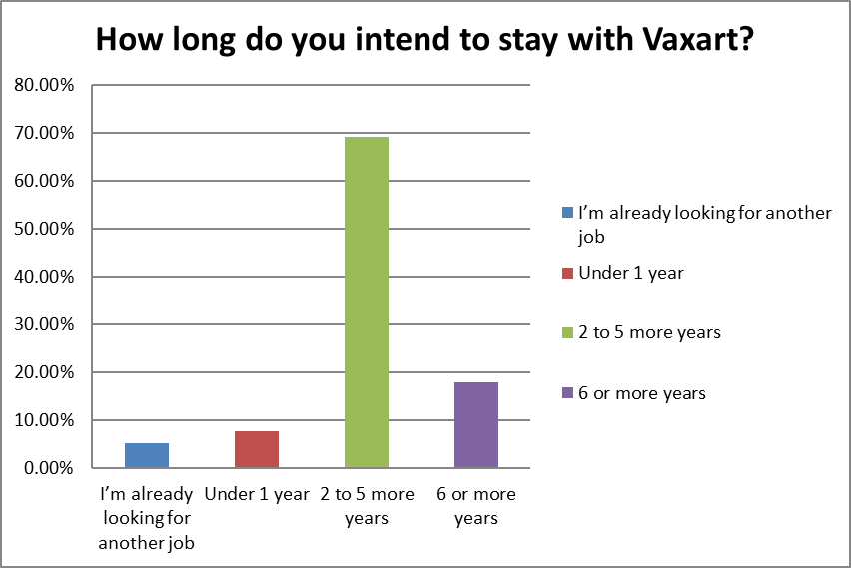

Question 85

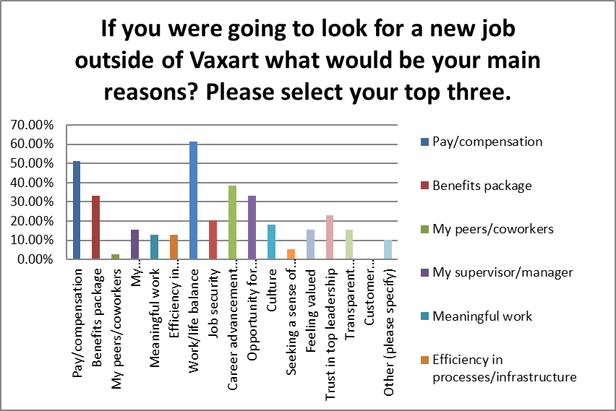

* Some where with higher pay and better future (both personal and the company)
* Had plans to relocate to be with immediate family about 100 miles away, plus retiring!, (70+)
* I believe in the companies technical platform and I am excited about the technical platform of the company. This is the reason I am here and will continue to do my best because: the compensation is enough and the comradery is enough, and I enjoy the science. However, when it come to the business it honestly feels more like "Sorry, it's just business". I don't know if Andree will be the same. He seems interested in building something.   
    
  A nice gesture from the management (CEO) would be if the company is sold all employee stocks would instantly vest.
* Belief that the product will be efficacious and result in an approval vaccine

Question 86

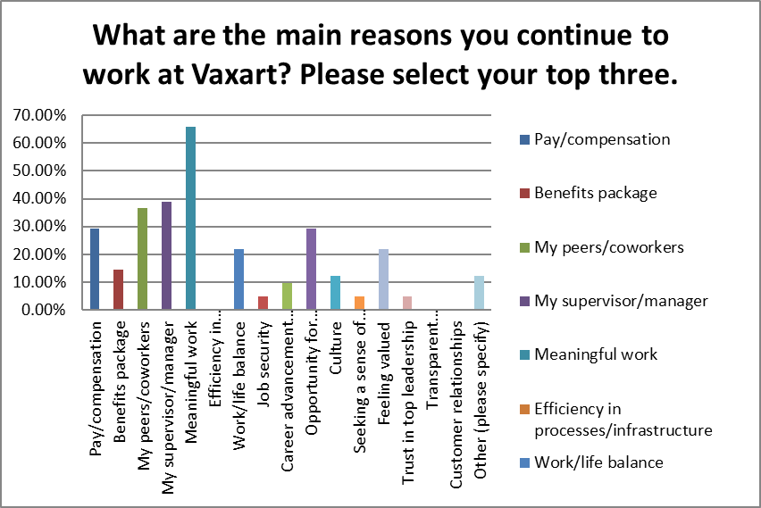

* Getting a product approved is my ultimate goal
* As a legacy employee I have a very lucrative options package granted in 2020 that is in place through 2022.
* The integrity of the company, the transparency and cohesiveness of everyone here is commendable!
* My stock options are good and I really enjoy most of my coworkers. Usually I feel that my work is meaningful
* Belief that the product could greatly benefit society

Question 87

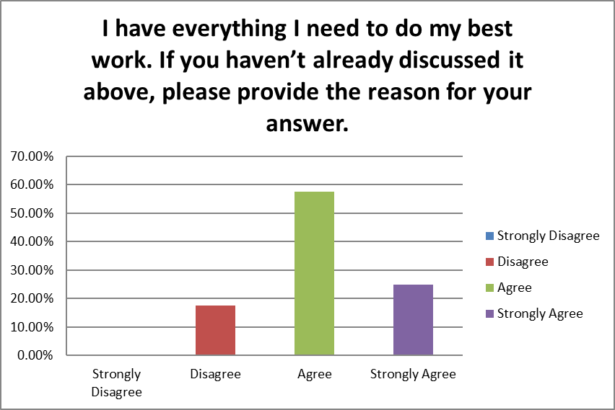

* I have a great relationship with my group and other teams that I interact with. In addition, I am empowered to implement new/better processes. It is challenging though to create new processes all the time because you first have create the process and then do your work. I think I would prefer more formalized 1:1 with manager so I can get performance about my performance.
* My manager takes the time to teach me valuable skills that I need to complete assignments for the company. My manager also teaches me valuable skills for me to grow professionally.
* Vaxart also needs to collaborate with the hiring agency to select, interview and hire qualified and highly skilled professionals.
* Everything is accessible, good culture prevails from CEO to the regular employees. The desire to make vaccines for the betterment of people is in everyone's ideology! It is a great place to work!
* I am new to the company but my manager is always there to answer any questions I have.
* I need more hours in the day to be able to properly write, review and really understand my work. I am constantly on a time crunch and given very unrealistic timelines to be able to properly do the best job I can.
* I have received great training and feel proficient at a variety of scientific techniques. However I do not feel motivated to work especially hard as I do not believe my work is rewarded or recognized.
* No formal options (or the time) for professional advancement.
* The company is still growing and developing in regards to resources from equipment to personnel, with more attention need to certain groups that are straining.
* If I need additional resources I just need to ask.
* Slow recruitment has hindered my ability to get the job done on time
* We need more people to get everything on our to do lists completed

Question 88

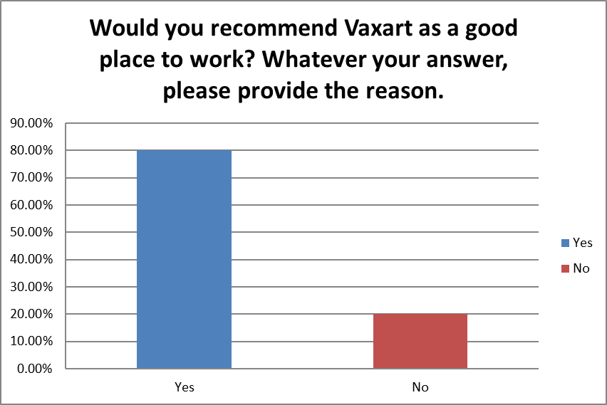

* Overall yes good balance and rewarding to know you’re working on a project that will change lives
* Great energy, intimate size, great product possibilities.
* Under paid, no promotions, some unhealthy competition between senior scientists and company still doesn't have any product or revenue after all these years
* The pay and stock option
* Depends on the department
* question 86
* I believe that this company needs to work on being more transparent with its employees and that those in upper management need to take accountability for the mistakes made. Instead of blaming those below them for making mistakes, upper management needs to address the mistake and come up with a plan to move forward. Upper management also needs to hire more people so that their employees are not underworked. In addition, compensation for current employees, especially at more junior levels, should be adjusted to meet the industry standard.
* The culture of the company should reflect positive communication, collaboration, and motivation fostered by strong leadership team. Management should be present at the offices to encourage personnel development, implement company culture, advocate for improvement, and share the on-going vision for the organization.
* I don’t think VXRT has a sustainable or replicable manufacturing process in place and there is no transparency surrounding failure of vaccine manufacturing lots. Until I have confidence that there is improvement in these processes, I cannot recommend VXRT as a stable long term prospect to potential employees.
* Yes, they treat employees very well! I was rehired! Great teamwork and the idea of making oral vaccine tablets , is unique and great for people!
* It's a good place to work
* Culture of collaboration with highly creative people.
* Great people and great peoduct
* As a growing company, Vaxart needs improvement in regards to leadership and communication roles within each department. However, I think the company's overall mission is what really allows everybody to easily collaborate, strive towards the same goal and ultimately create a good working environment.
* Management is too busy to properly give instructions. Unrealistic expectations for amount of work.
* It depends on department and what an individual is looking for. I think working with vaccines is very exciting but career progression is stagnant here so for a long-term position I would not recommend it. For short term at lower level or as upper management I think Vaxart is a great option as one can learn a lot.
* I'm a hard "maybe" and do not see this question as binary. It's a significantly more complicated question than yes/no. Yes in that the work could be very meaningful and there are good people here. No in that it is a pressure cooker and there is a ton of work to do. I've rounded down.
* There is a lot of potential despite the growing pains and the opportunity to help people on a global scale should we succeed in accomplishing our goal of generating vaccines as a solid-dose is amazing.
* I like the atmosphere and the employees in my group. I enjoying coming to work every day!
* interesting and meaningful work, exposure to a lot of things.
* It would depend on what the person is looking for in a company. I would only recommend to someone that fits in with the company.
* It is a typical small biotech. Lot's of technical challenges and low staffing issues.
* Work is very meaningful and rewarding. Please are generally nice.

Question 89

* Acceptance, supportive, respectful and appreciative
* Very friendly place to work
* It allows flexibility
* Professionals bringing their skills to bear together to work toward a tangible common goal.
* N/A
* Open communication; innovative; fun; team oriented; supportive; clear development path
* Current culture: Collaborative and work together as a team. Approachable and friendly executive leadership team. Flexible working environment.
* I like positive workplace culture here at Vaxart
* People are open an honest about their work and how they are doing. It is refreshing.
* I like that the cultured is very relaxed.
* what you like about the current culture? - None  
    
    
    
  The culture of the company should reflect positive communication, collaboration, and motivation fostered by strong leadership team.
* Inter- and intradepartmental communication needs to be greatly improved.
* I am very happy to be working for Vaxart and always try to give back 110%. The company embraces diversity, and everyone works and helps as a team!
* Good boss, good people to work with, good pay, challenging work, important work, the ability to make a difference in the world with my work.
* I enjoy coming to work. I like to work at the desk/bench. I would feel better if there was a real incentive like...  
    
  A nice gesture from the management (CEO) would be if the company is sold all employee stocks would instantly fully vest.
* It's hard to determine the current culture with so many working from home and most of the company being new hires. Comradery, things to show that the company cares.
* I like my team although I think the majority of people feel that upper management could care less about them.
* I am not sure what the current culture is? I think a good culture is where we are all working together as.one team and not as departments. Everyone should be treated as equal and not higher or lower than the other person. We are colleagues.
* what i like: friendly, collaborative, casual
* The culture changes daily, some days are more toxic than others.
* Ideal culture would be everyone working together for the same goal by having clear expectations on reasonable timelines.
* Current culture:  
    
  Nonexistent. Pressure cooker. Disorganized. A vehicle to make our Andrei, our E-team, directors, and major shareholders rich on the backs of everyone else that are actually doing the work.  
    
    
    
  Ideal culture:  
    
  Ownership, which brings with it a commitment to our goals. Well defined goals. Praise of success, lessons learned (not finger pointing) from failures.
* Work/life balance is really good, information on stock options is good/available, collaborative culture between departments, improve career advancement options
* Dynamic
* The culture is not completely defined. There is an "old school" culture and a "new school" culture. I would like management to figure out a way to meld the 2 schools together.
* cutting edge, dynamic, inclusive. we need to keep that as we grow.
* I like my manager
* Teams work together, collaboration. Need more company TGIF or other activities to build teamwork and interactions between groups. We are too small to not know almost everyone
* Casual, open, respectful, meaningful work gives purpose to our actions
* open flow of information, fun and open work environment

Question 90

* Less hours. Plus, regular Company meetings from Sean Tucker covering the scientific goals of the Company that drives the basis of our Company, to bring the Company focus together.
* On-site gym
* If we had an approved product and stable financed
* Product success, and growth that augments rather than dilutes the current comradery.
* N/A
* work life balance
* work and life balance improvement.
* to have work/life balance
* Having work/personal life balance.
* I think compensation should be adjusted to be more competitive for employees at a junior level. I believe that Vaxart should offer more benefits such as commuter stipends and health/gym stipends. I also think that Vaxart should hold more company bonding events.
* Company activities should be scheduled to celebrate milestones.
* Communication, confidence in timely equity grants, implementation of an Employee Stock Purchase Plan, confidence in improvements in manufacturing and lyophilization/tableting, confidence in consistent dose of tablets.
* Full able to manufacture a lot of Covid-19 tablets and cure the world of illnesses! Everything else here is great!
* We need to fix some things that are a function of our size and our lack of a marketed products. We need to focus now on supply chain and manufacturing issues that should be eliminated when we get some success.
* It will take time for this to happen. Start with a good gesture. And I will promises to work hard and be a productive loyal employee.
* Better work/life balance. Commuter benefits.
* Daily lunches and gym memberships!
* A great leadership team that communicates well and makes us feel like one team.
* better opportunity for professional growth
* Yearly Bay Area cost of living wage increase and a significant bonus.
* Work life balance. Coming back to work on a Monday being rested.
* Ownership. Better compensation Stock options (ISOs, NQs, or shares). Feedback. Team building.
* Increase in salary, recognition for hard work/progress, increase opportunities for career advancement more transparency with the progress of drug products
* Harmony and improved communication between all teams and individuals.
* More communication internally about where we are going and our achievements. I don't want to read about them in a press release... I would like to see the info from with in the org. I know we are growing but we can do a better job at internal communication.
* impactful work, good compensation, good work/life balance
* Intranet showing website where I can see company info and discounts
* A clear defined path to BLA so we can all be rowing in the same direction
* If the company could develop and bring the COVID vaccine to the public and wipe out the epidemic that would be an amazing achievement that would be historic and something to tell the grandkids. I would be very proud to say I was a part of that effort.
* better work life balance, more perks such as lunch a few times a week. More training opertunities

Question 91

* N/A
* none
* no
* None at this time.
* Empty offices should be immediately reassigned to onsite managers with direct reports to avoid negative moral. Clearly defined spaces will foster better communication and manager engagement with their direct reports.
* A few more socials for employees to know one another!
* I think it is very important that the company gain greater, maybe complete, control of our supply chain. CMOs are never going to be as effective as in-house organizations.
* 2020 was a tough year for everyone emotionally and financially. It was especially tough for young families with children in grade school and day care. Help the families out if you can.
* No.
* n/a
* Company should promote more social events to bring the departments closer together.
* Question 81 gives no option for times greater than 1 but less than 2 years which I would have otherwise selected - I've rounded down.
* I hope to see issues addressed on both the personal and team level while keeping to a sense of reason regarding evaluations and transparent communication of expectations.
* I believe in this company! Lets make this happen!
* communication needs to be improved. Research doesn't get informed about things happening, even when it affects them such as moving people into workspaces or manufacturing delays.

Question 92

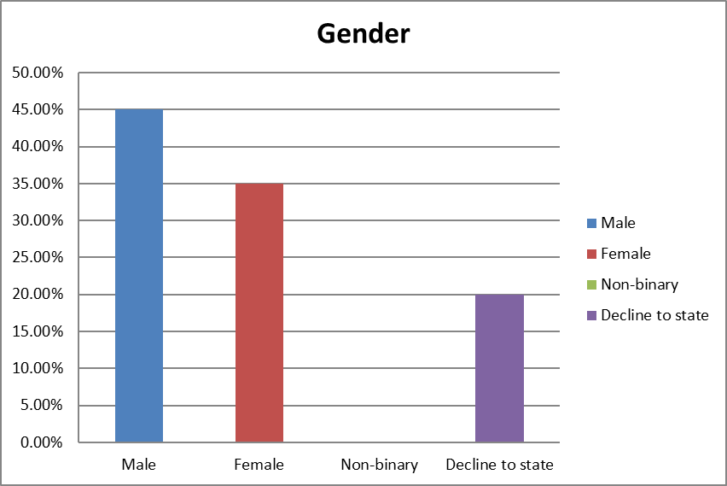

Question 93

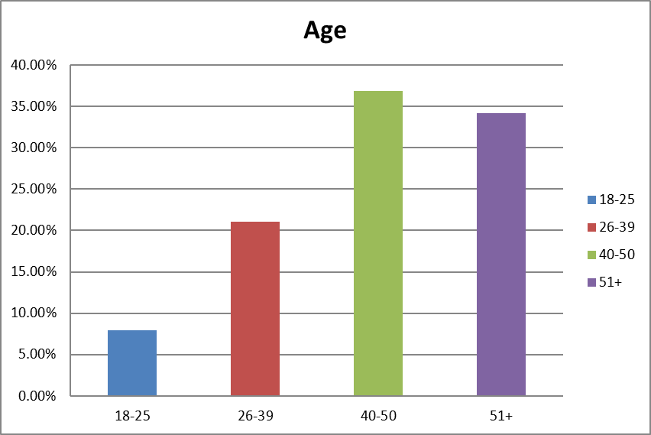

Question 94

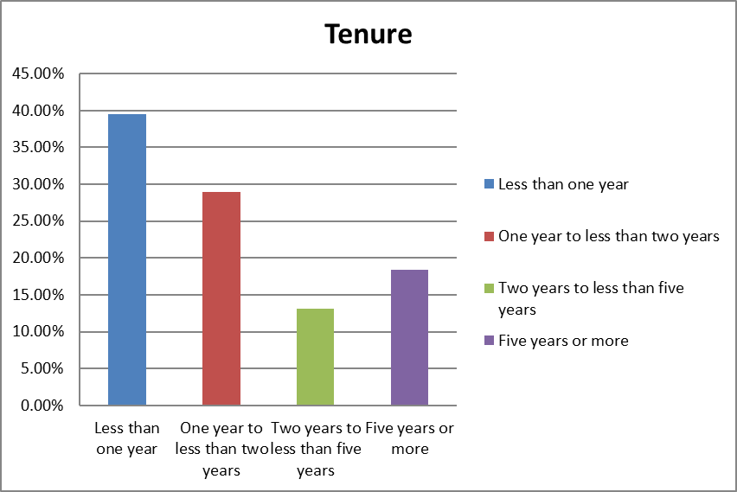

Question 95

