EXPERIMENT

Develop Multithreaded Programs Using Parallel Programming Libraries to Understand Thread Creation, Management, and Coordination

1. AIM
To develop multithreaded programs using Pthreads and OpenMP and understand:
- Thread creation
- Thread management
- Work distribution
- Race conditions
- Synchronization
- Thread coordination
- Performance improvement using multiple threads

2. BASIC IDEA OF THE EXPERIMENT
A thread is an execution path inside a program.
Think of a thread as a worker.

Sequential Program
One worker
|
|---- Task 1
|---- Task 2
|---- Task 3
|---- Task 4
|---- ...
One thread performs all the work.

Multithreaded Program
Program
|
---------------------
| | | |
Thread1 Thread2 Thread3 Thread4
| | | |
Work Work Work Work
Several threads can work on different parts of the problem.
That is the basic idea of parallel programming.
This experiment uses two technologies:
- Pthreads
- OpenMP
The final part measures whether increasing the number of threads reduces execution time.

3. SOFTWARE ENVIRONMENT
The experiment is performed using:
- Windows
- WSL Ubuntu
- GCC compiler
- Pthreads
- OpenMP
- Nano editor

4. STARTING WSL

Step 1 — Open PowerShell
On Windows:
- Press the Windows key.
- Search for PowerShell.
- Click Windows PowerShell.
You should see:
PS C:\WINDOWS\system32>

Step 2 — Start WSL
Type:
wsl
Press Enter.
Expected:
powerx@DESKTOP-5MP543G:~$
Your username and computer name may be different.

What are we doing?
We are leaving Windows PowerShell and entering the Linux environment where the C programs will be created and executed.

5. CREATE THE LAB DIRECTORY
Type:
mkdir -p ~/parallel_lab
Then:
cd ~/parallel_lab
Check the current location:
pwd
Expected:
/home/powerx/parallel_lab

What are we doing?
parallel_lab is the folder where all the C programs for this experiment are stored.

6. CHECK GCC
Type:
gcc --version
Expected output will show the installed GCC version.
For example:
gcc (Ubuntu ...) ...

What are we doing?
We are checking that the C compiler is installed and available.

7. CHECK OPENMP SUPPORT
Type:
gcc -fopenmp --version
Expected:
gcc (Ubuntu ...) ...

What are we doing?
The -fopenmp option enables OpenMP support when compiling C programs.

PART A — PTHREADS
Pthreads stands for POSIX Threads.
With Pthreads, threads are explicitly created and managed.
The main functions used are:
pthread_create()
pthread_join()
pthread_mutex_lock()
pthread_mutex_unlock()

STEP 1 — CREATE ONE THREAD

Objective
Learn:
- How to create a thread
- How the new thread executes a function
- How the main thread waits for the new thread

Step 1.1 — Create the C file
In the WSL terminal, type:
nano thread1.c
Press Enter.
A text editor called Nano will open.

Step 1.2 — Paste the program
Copy and paste this entire program into Nano:
#include <stdio.h>
#include <pthread.h>
void *thread_function(void *arg)
{
printf("Hello from the thread!\n");
return NULL;
}
int main()
{
pthread_t thread;
pthread_create(&thread, NULL, thread_function, NULL);
pthread_join(thread, NULL);
printf("Main thread finished.\n");
return 0;
}

Step 1.3 — Save the file
Inside Nano:
Ctrl + O
Press Enter.
Then:
Ctrl + X
You will return to the terminal.

Step 1.4 — Compile
Type:
gcc thread1.c -o thread1 -pthread
Press Enter.
If there is no error message, compilation was successful.

Step 1.5 — Run
Type:
./thread1
Expected:
Hello from the thread!
Main thread finished.

What did we just do?

pthread_t thread
pthread_t thread;
This creates a variable that stores the thread identifier.
It does not create the thread by itself.

pthread_create()
pthread_create(&thread, NULL, thread_function, NULL);
This actually creates the additional thread.
When the program starts, the main thread already exists.
Before pthread_create():
Main Thread
|
main()
After pthread_create():
Program
/ \
/ \
Main Thread New Thread
| |
main() thread_function()
One execution of pthread_create() creates one additional thread.

Why is it called an additional thread?
Because the main thread already exists.
We are adding another thread.
1 main thread
+
1 additional thread
=
2 threads

How did the new thread know what to execute?
We gave pthread_create() this function:
thread_function
Therefore the new thread starts executing:
void *thread_function(void *arg)
{
printf("Hello from the thread!\n");
return NULL;
}
So:
pthread_create()
|
v
New thread created
|
v
thread_function()
|
v
Hello from the thread!

pthread_join()
pthread_join(thread, NULL);
This tells the main thread:
Wait until the created thread finishes.
So:
pthread_create() -> CREATE
pthread_join() -> WAIT

STEP 2 — CREATE MULTIPLE THREADS
Now that one thread can be created, multiple threads can be created.

Step 2.1 — Create the file
Type:
nano thread2.c

Step 2.2 — Paste
#include <stdio.h>
#include <pthread.h>
void *thread_function(void *arg)
{
int thread_id = *(int *)arg;
printf("Hello from Thread %d\n", thread_id);
return NULL;
}
int main()
{
pthread_t threads[4];
int thread_ids[4];
for (int i = 0; i < 4; i++)
{
thread_ids[i] = i + 1;
pthread_create(
&threads[i],
NULL,
thread_function,
&thread_ids[i]
);
}
for (int i = 0; i < 4; i++)
{
pthread_join(threads[i], NULL);
}
printf("All threads have finished.\n");
return 0;
}
Save:
Ctrl + O
Enter
Ctrl + X

Step 2.3 — Compile
gcc thread2.c -o thread2 -pthread

Step 2.4 — Run
./thread2
Expected output may look like:
Hello from Thread 1
Hello from Thread 2
Hello from Thread 4
Hello from Thread 3
All threads have finished.
Your order may be different.
For example:
Hello from Thread 3
Hello from Thread 1
Hello from Thread 4
Hello from Thread 2
All threads have finished.
Both are acceptable.

What are we learning?
This loop:
for (int i = 0; i < 4; i++)
{
pthread_create(...);
}
calls pthread_create() four times.
Therefore:
1st execution -> Thread 1
2nd execution -> Thread 2
3rd execution -> Thread 3
4th execution -> Thread 4
So we create 4 additional threads.
There is also the original main thread.

Why is the output order different?
The operating system schedules the threads.
We cannot assume:
1 -> 2 -> 3 -> 4
The operating system may run them in another order.
Therefore:
Thread execution order is not guaranteed.

STEP 3 — DIVIDE WORK AMONG THREADS
Now we use threads to perform actual useful work.
We create:
thread_sum.c
The array is:
10 20 30 40 50 60 70 80
The work is divided into four parts.

Step 3.1 — Create the file
nano thread_sum.c

Step 3.2 — Paste
#include <stdio.h>
#include <pthread.h>
#define NUM_THREADS 4
#define ARRAY_SIZE 8
int array[ARRAY_SIZE] = {10, 20, 30, 40, 50, 60, 70, 80};
int partial_sum[NUM_THREADS];
void *calculate_sum(void *arg)
{
int thread_id = *(int *)arg;
int start = thread_id * (ARRAY_SIZE / NUM_THREADS);
int end = start + (ARRAY_SIZE / NUM_THREADS);
partial_sum[thread_id] = 0;
for (int i = start; i < end; i++)
{
partial_sum[thread_id] += array[i];
}
printf("Thread %d calculated sum = %d\n",
thread_id + 1,
partial_sum[thread_id]);
return NULL;
}
int main()
{
pthread_t threads[NUM_THREADS];
int thread_ids[NUM_THREADS];
for (int i = 0; i < NUM_THREADS; i++)
{
thread_ids[i] = i;
pthread_create(
&threads[i],
NULL,
calculate_sum,
&thread_ids[i]
);
}
for (int i = 0; i < NUM_THREADS; i++)
{
pthread_join(threads[i], NULL);
}
int total_sum = 0;
for (int i = 0; i < NUM_THREADS; i++)
{
total_sum += partial_sum[i];
}
printf("Total sum = %d\n", total_sum);
return 0;
}
Save:
Ctrl + O
Enter
Ctrl + X

Step 3.3 — Compile
gcc thread_sum.c -o thread_sum -pthread

Step 3.4 — Run
./thread_sum
Expected:
Thread 1 calculated sum = 30
Thread 2 calculated sum = 70
Thread 3 calculated sum = 110
Thread 4 calculated sum = 150
Total sum = 360
The order of the four thread messages may change.
The important values are:
30
70
110
150
360

What are we doing here?
Instead of one thread calculating:
10 + 20 + 30 + 40 + 50 + 60 + 70 + 80
we divide the work:
Thread 1 -> 10 + 20 = 30
Thread 2 -> 30 + 40 = 70
Thread 3 -> 50 + 60 = 110
Thread 4 -> 70 + 80 = 150
Then:
30 + 70 + 110 + 150 = 360
This is called:
Work distribution
The large problem is divided into smaller pieces.

STEP 4 — DEMONSTRATE A RACE CONDITION
Now we deliberately create a problem.
Several threads will modify the same variable:
counter++;

Step 4.1 — Create the file
nano race.c

Step 4.2 — Paste
#include <stdio.h>
#include <pthread.h>
#define NUM_THREADS 4
#define INCREMENTS 100000
int counter = 0;
void *increment_counter(void *arg)
{
for (int i = 0; i < INCREMENTS; i++)
{
counter++;
}
return NULL;
}
int main()
{
pthread_t threads[NUM_THREADS];
for (int i = 0; i < NUM_THREADS; i++)
{
pthread_create(
&threads[i],
NULL,
increment_counter,
NULL
);
}
for (int i = 0; i < NUM_THREADS; i++)
{
pthread_join(threads[i], NULL);
}
printf("Expected counter = %d\n",
NUM_THREADS * INCREMENTS);
printf("Actual counter = %d\n",
counter);
return 0;
}
Save:
Ctrl + O
Enter
Ctrl + X

Step 4.3 — Compile
gcc race.c -o race -pthread

Step 4.4 — Run
./race
You may get:
Expected counter = 400000
Actual counter = 167739
Run it again:
./race
You may get a different value.
For example:
Expected counter = 400000
Actual counter = 131342

Why is the result wrong?
We have four threads.
Each performs:
100000 increments
So theoretically:
4 x 100000 = 400000
But all four threads modify the same variable.
Imagine:
counter = 10
Two threads can do:
Thread 1 -> reads 10
Thread 2 -> reads 10
Thread 1 -> writes 11
Thread 2 -> writes 11
We wanted:
12
but got:
11
One update was lost.
This is a:
Race condition
The problem is that multiple threads are trying to access and modify the same shared data at the same time.

STEP 5 — FIX THE RACE CONDITION USING MUTEX
We now protect the shared variable using a mutex.

Step 5.1 — Create the file
nano mutex.c

Step 5.2 — Paste
#include <stdio.h>
#include <pthread.h>
#define NUM_THREADS 4
#define INCREMENTS 100000
int counter = 0;
pthread_mutex_t mutex;
void *increment_counter(void *arg)
{
for (int i = 0; i < INCREMENTS; i++)
{
pthread_mutex_lock(&mutex);
counter++;
pthread_mutex_unlock(&mutex);
}
return NULL;
}
int main()
{
pthread_t threads[NUM_THREADS];
pthread_mutex_init(&mutex, NULL);
for (int i = 0; i < NUM_THREADS; i++)
{
pthread_create(
&threads[i],
NULL,
increment_counter,
NULL
);
}
for (int i = 0; i < NUM_THREADS; i++)
{
pthread_join(threads[i], NULL);
}
pthread_mutex_destroy(&mutex);
printf("Expected counter = %d\n",
NUM_THREADS * INCREMENTS);
printf("Actual counter = %d\n",
counter);
return 0;
}
Save:
Ctrl + O
Enter
Ctrl + X

Step 5.3 — Compile
gcc mutex.c -o mutex -pthread

Step 5.4 — Run
./mutex
Expected:
Expected counter = 400000
Actual counter = 400000

What are we doing here?
The important part is:
pthread_mutex_lock(&mutex);
counter++;
pthread_mutex_unlock(&mutex);
Think of a mutex as a key.
Only one thread can enter the protected section at a time.
Thread 1 -> lock -> counter++ -> unlock
Thread 2 -> lock -> counter++ -> unlock
Thread 3 -> lock -> counter++ -> unlock
Thread 4 -> lock -> counter++ -> unlock
Therefore the shared counter is protected.

PART B — OPENMP
After Pthreads, we move to OpenMP.
Pthreads gives more manual control.
OpenMP provides a higher-level approach where directives such as:
#pragma omp parallel
#pragma omp parallel for
#pragma omp critical
#pragma omp barrier
are used for parallel execution and coordination.

STEP 6 — OPENMP BASIC PARALLEL REGION

Objective
Learn:
- How OpenMP creates a group of threads
- How to identify the current thread
- How to determine the total number of threads

Step 6.1 — Create file
nano omp1.c

Step 6.2 — Paste
#include <stdio.h>
#include <omp.h>
int main()
{
#pragma omp parallel
{
int thread_id = omp_get_thread_num();
int total_threads = omp_get_num_threads();
printf("Hello from Thread %d of %d\n",
thread_id,
total_threads);
}
return 0;
}
Save:
Ctrl + O
Enter
Ctrl + X

Step 6.3 — Compile
gcc omp1.c -o omp1 -fopenmp

Step 6.4 — Run
./omp1
Your output may contain many lines such as:
Hello from Thread 18 of 32
Hello from Thread 13 of 32
Hello from Thread 19 of 32
...
Hello from Thread 0 of 32
On the system used for this experiment, OpenMP used 32 threads for this program.
The exact order may change.

What are we learning?
This line:
#pragma omp parallel
means:
Execute the following block using multiple OpenMP threads.
We also use:
omp_get_thread_num()
to ask:
Which thread am I?
and:
omp_get_num_threads()
to ask:
How many threads are in this parallel team?
So OpenMP lets us create a parallel region without explicitly calling pthread_create() ourselves.

STEP 7 — OPENMP WORK SHARING
Now we want OpenMP to divide work automatically.
We create:
omp_sum.c

Step 7.1 — Create file
nano omp_sum.c

Step 7.2 — Paste
#include <stdio.h>
#include <omp.h>
#define ARRAY_SIZE 8
int array[ARRAY_SIZE] = {10, 20, 30, 40, 50, 60, 70, 80};
int main()
{
int total_sum = 0;
#pragma omp parallel for reduction(+:total_sum)
for (int i = 0; i < ARRAY_SIZE; i++)
{
int thread_id = omp_get_thread_num();
printf("Thread %d processing array[%d] = %d\n",
thread_id,
i,
array[i]);
total_sum += array[i];
}
printf("Total sum = %d\n", total_sum);
return 0;
}
Save:
Ctrl + O
Enter
Ctrl + X

Step 7.3 — Compile
gcc omp_sum.c -o omp_sum -fopenmp

Step 7.4 — Run
./omp_sum
Expected output will contain lines such as:
Thread 5 processing array[5] = 60
Thread 7 processing array[7] = 80
Thread 0 processing array[0] = 10
...
Total sum = 360
The order can vary.

What does parallel for mean?
This:
#pragma omp parallel for
tells OpenMP:
Divide the loop iterations among the available threads.
Instead of:
One thread:
0 -> 1 -> 2 -> 3 -> 4 -> 5 -> 6 -> 7
OpenMP can distribute them:
Thread 0 -> some iterations
Thread 1 -> some iterations
Thread 2 -> some iterations
...

What does reduction(+:total_sum) mean?
Each thread calculates a partial result.
Conceptually:
Thread 1 -> partial sum
Thread 2 -> partial sum
Thread 3 -> partial sum
Thread 4 -> partial sum
|
v
OpenMP combines
|
v
total_sum
This provides a safe way to combine the partial results.

STEP 8 — OPENMP RACE CONDITION
Now we deliberately create the same race condition in OpenMP.

Step 8.1 — Create file
nano omp_race.c

Step 8.2 — Paste
#include <stdio.h>
#include <omp.h>
#define NUM_THREADS 4
#define INCREMENTS 100000
int counter = 0;
int main()
{
omp_set_num_threads(NUM_THREADS);
#pragma omp parallel
{
for (int i = 0; i < INCREMENTS; i++)
{
counter++;
}
}
printf("Expected counter = %d\n",
NUM_THREADS * INCREMENTS);
printf("Actual counter = %d\n",
counter);
return 0;
}
Save:
Ctrl + O
Enter
Ctrl + X

Step 8.3 — Compile
gcc omp_race.c -o omp_race -fopenmp

Step 8.4 — Run
./omp_race
Expected:
Expected counter = 400000
Actual counter = 100000
The exact incorrect result can depend on execution timing.

What did we learn?
OpenMP creates and manages the threads, but it does not automatically make every shared-data operation safe.
Multiple threads are still modifying:
counter++;
Therefore a race condition can occur.

STEP 9 — OPENMP critical
Now we fix the race condition using:
#pragma omp critical
This allows only one thread at a time to execute the protected section.

Step 9.1 — Create file
nano omp_critical.c

Step 9.2 — Paste
#include <stdio.h>
#include <omp.h>
#define NUM_THREADS 4
#define INCREMENTS 100000
int counter = 0;
int main()
{
omp_set_num_threads(NUM_THREADS);
#pragma omp parallel
{
for (int i = 0; i < INCREMENTS; i++)
{
#pragma omp critical
{
counter++;
}
}
}
printf("Expected counter = %d\n",
NUM_THREADS * INCREMENTS);
printf("Actual counter = %d\n",
counter);
return 0;
}
Save:
Ctrl + O
Enter
Ctrl + X

Step 9.3 — Compile
gcc omp_critical.c -o omp_critical -fopenmp

Step 9.4 — Run
./omp_critical
Expected:
Expected counter = 400000
Actual counter = 400000

What is a critical section?
This:
#pragma omp critical
{
counter++;
}
means:
Only one OpenMP thread can execute this block at a time.
Conceptually:
Thread 1 -> enters
Thread 2 -> waits
Thread 3 -> waits
Thread 4 -> waits
Thread 1 -> exits
Thread 2 -> enters
This protects the shared operation.

STEP 10 — OPENMP BARRIER
Now we learn coordination.
We use:
#pragma omp barrier
A barrier means:
Every thread must reach the barrier before any thread continues beyond it.

Step 10.1 — Create file
nano omp_barrier.c

Step 10.2 — Paste
#include <stdio.h>
#include <omp.h>
int main()
{
omp_set_num_threads(4);
#pragma omp parallel
{
int thread_id = omp_get_thread_num();
printf("Thread %d completed Stage 1\n", thread_id);
#pragma omp barrier
printf("Thread %d started Stage 2\n", thread_id);
}
return 0;
}
Save:
Ctrl + O
Enter
Ctrl + X

Step 10.3 — Compile
gcc omp_barrier.c -o omp_barrier -fopenmp

Step 10.4 — Run
./omp_barrier
Expected pattern:
Thread 0 completed Stage 1
Thread 3 completed Stage 1
Thread 1 completed Stage 1
Thread 2 completed Stage 1
Thread 3 started Stage 2
Thread 2 started Stage 2
Thread 0 started Stage 2
Thread 1 started Stage 2
The order may differ.
But all completed Stage 1 messages appear before any started Stage 2 message.

What did we learn?
The barrier is a meeting point.
Thread 1 -- Stage 1 --|
Thread 2 -- Stage 1 --|
Thread 3 -- Stage 1 --|-- Barrier
Thread 4 -- Stage 1 --|
|
v
Stage 2
This is thread coordination.

PART C — PERFORMANCE ANALYSIS
Now that thread creation, management, synchronization, and coordination have been demonstrated, the next question is:
Does using multiple threads actually make the program faster?
A large computational workload is used to compare sequential, Pthreads, and OpenMP execution.

STEP 11 — SEQUENTIAL BASELINE

Step 11.1 — Create file
nano sequential.c

Step 11.2 — Paste
#include <stdio.h>
#include <time.h>
#define N 1000000000L
double get_time()
{
struct timespec ts;
clock_gettime(CLOCK_MONOTONIC, &ts);
return ts.tv_sec + ts.tv_nsec / 1e9;
}
int main()
{
double sum = 0.0;
double start = get_time();
for (long i = 0; i < N; i++)
{
sum += (double)i * 0.000001;
}
double end = get_time();
printf("Result = %.2f\n", sum);
printf("Execution time = %.6f seconds\n",
end - start);
return 0;
}
Save:
Ctrl + O
Enter
Ctrl + X

Step 11.3 — Compile
gcc sequential.c -o sequential

Step 11.4 — Run
./sequential
Expected:
Result = 499999999500.00
Execution time = ... seconds
Measured runs:

1.353895
1.355794
1.349621
1.353422
1.353365
Average:

1.353219 seconds
This value is used as the sequential baseline.

What is a baseline?
Baseline means the reference value against which the parallel versions are compared.

STEP 12 — PTHREADS PERFORMANCE
We now perform the same large calculation using Pthreads.

Step 12.1 — Create file
nano pthread_perf.c

Step 12.2 — Paste
#include <stdio.h>
#include <pthread.h>
#include <time.h>
#define N 1000000000L
double partial_sum[32];
typedef struct
{
int thread_id;
long start;
long end;
} ThreadData;
double get_time()
{
struct timespec ts;
clock_gettime(CLOCK_MONOTONIC, &ts);
return ts.tv_sec + ts.tv_nsec / 1e9;
}
void *calculate(void *arg)
{
ThreadData *data = (ThreadData *)arg;
double sum = 0.0;
for (long i = data->start; i < data->end; i++)
{
sum += (double)i * 0.000001;
}
partial_sum[data->thread_id] = sum;
return NULL;
}
int main()
{
int num_threads;
printf("Enter number of threads: ");
scanf("%d", &num_threads);
if (num_threads < 1 || num_threads > 32)
{
printf("Please enter a value between 1 and 32.\n");
return 1;
}
pthread_t threads[num_threads];
ThreadData data[num_threads];
long chunk = N / num_threads;
double start_time = get_time();
for (int i = 0; i < num_threads; i++)
{
data[i].thread_id = i;
data[i].start = i * chunk;
if (i == num_threads - 1)
data[i].end = N;
else
data[i].end = (i + 1) * chunk;
pthread_create(
&threads[i],
NULL,
calculate,
&data[i]
);
}
for (int i = 0; i < num_threads; i++)
{
pthread_join(threads[i], NULL);
}
double total_sum = 0.0;
for (int i = 0; i < num_threads; i++)
{
total_sum += partial_sum[i];
}
double end_time = get_time();
printf("Result = %.2f\n", total_sum);
printf("Execution time = %.6f seconds\n",
end_time - start_time);
return 0;
}
Save:
Ctrl + O
Enter
Ctrl + X

Step 12.3 — Compile
gcc pthread_perf.c -o pthread_perf -pthread

Step 12.4 — Test with 1 thread
./pthread_perf
Enter:
1
Measured:
Result = 499999999500.00
Execution time = 1.348142 seconds

Step 12.5 — Test with 2 threads
./pthread_perf
Enter:
2
Measured:
Execution time = 0.680737 seconds

Step 12.6 — Test with 4 threads
./pthread_perf
Enter:
4
Measured:
Execution time = 0.358872 seconds

Step 12.7 — Test with 6 threads
./pthread_perf
Enter:
6
Measured:
Execution time = 0.241345 seconds

Step 12.8 — Test with 16 threads
./pthread_perf
Enter:
16
Measured:
Execution time = 0.144812 seconds

13. PTHREADS PERFORMANCE RESULTS
Threads | Pthreads Time
1 | 1.348142 s
2 | 0.680737 s
4 | 0.358872 s
6 | 0.241345 s
16 | 0.144812 s

What are we learning?
The computational problem remains the same.
Only the number of threads changes.
1 -> 2 -> 4 -> 6 -> 16
The execution time generally decreases.
This demonstrates the benefit of parallelism for this workload.

STEP 14 — OPENMP PERFORMANCE
Now we perform the same performance experiment using OpenMP.

Step 14.1 — Create file
nano omp_perf.c

Step 14.2 — Paste
#include <stdio.h>
#include <omp.h>
#include <time.h>
#define N 1000000000L
double get_time()
{
struct timespec ts;
clock_gettime(CLOCK_MONOTONIC, &ts);
return ts.tv_sec + ts.tv_nsec / 1e9;
}
int main()
{
double sum = 0.0;
int num_threads;
printf("Enter number of threads: ");
scanf("%d", &num_threads);
if (num_threads < 1 || num_threads > 32)
{
printf("Please enter a value between 1 and 32.\n");
return 1;
}
omp_set_num_threads(num_threads);
double start_time = get_time();
#pragma omp parallel for reduction(+:sum)
for (long i = 0; i < N; i++)
{
sum += (double)i * 0.000001;
}
double end_time = get_time();
printf("Result = %.2f\n", sum);
printf("Execution time = %.6f seconds\n",
end_time - start_time);
return 0;
}
Save:
Ctrl + O
Enter
Ctrl + X

Step 14.3 — Compile
gcc omp_perf.c -o omp_perf -fopenmp

Step 14.4 — Run with 1 thread
./omp_perf
Enter:
1
Measured:
Result = 499999999500.00
Execution time = 1.409294 seconds

Step 14.5 — Run with 2 threads
./omp_perf
Enter:
2
Measured:
Execution time = 0.715560 seconds

Step 14.6 — Run with 4 threads
./omp_perf
Enter:
4
Measured:
Execution time = 0.360803 seconds

Step 14.7 — Run with 6 threads
./omp_perf
Enter:
6
Measured:
Execution time = 0.241608 seconds

Step 14.8 — Run with 16 threads
./omp_perf
Enter:
16
Measured:
Result = 499999999500.00
Execution time = 0.140692 seconds

15. FINAL PERFORMANCE RESULTS

Sequential Baseline

1.353219 seconds

Pthreads and OpenMP Comparison
Threads | Pthreads Time (s) | OpenMP Time (s)
1 | 1.348142 | 1.409294
2 | 0.680737 | 0.715560
4 | 0.358872 | 0.360803
6 | 0.241345 | 0.241608
16 | 0.144812 | 0.140692
Figure 1 — Execution Time vs Number of Threads
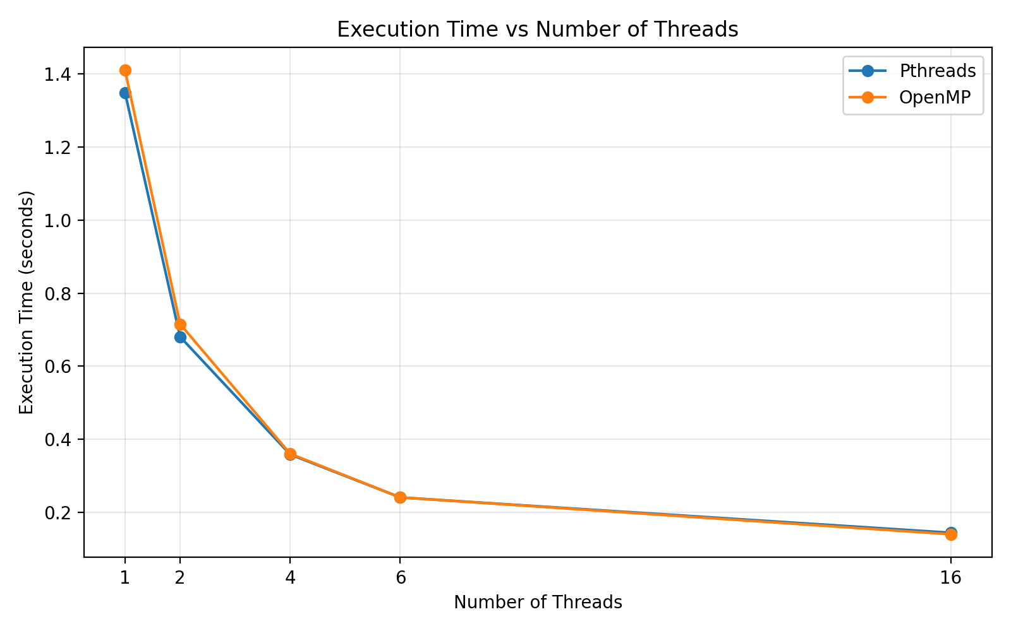

Observation
As the number of threads increases, the execution time generally decreases for both Pthreads and OpenMP.
The execution time becomes much smaller with 16 threads compared with 1 thread.

16. SPEEDUP
Now we ask:
How much faster did the parallel program become compared with the sequential program?
Formula:
$$Speedup=\frac{Sequential Time}{Parallel Time}$$
For example, OpenMP with 16 threads:
Sequential = 1.353219 s
OpenMP = 0.140692 s
Therefore:
Speedup ≈ 9.62
This means the measured 16-thread OpenMP execution completed the workload in roughly 1/9.62 of the sequential time.

Speedup Results
Threads | Pthreads Speedup | OpenMP Speedup
1 | 1.004x | 0.960x
2 | 1.988x | 1.891x
4 | 3.771x | 3.751x
6 | 5.608x | 5.601x
16 | 9.345x | 9.618x
Figure 2 — Speedup vs Number of Threads
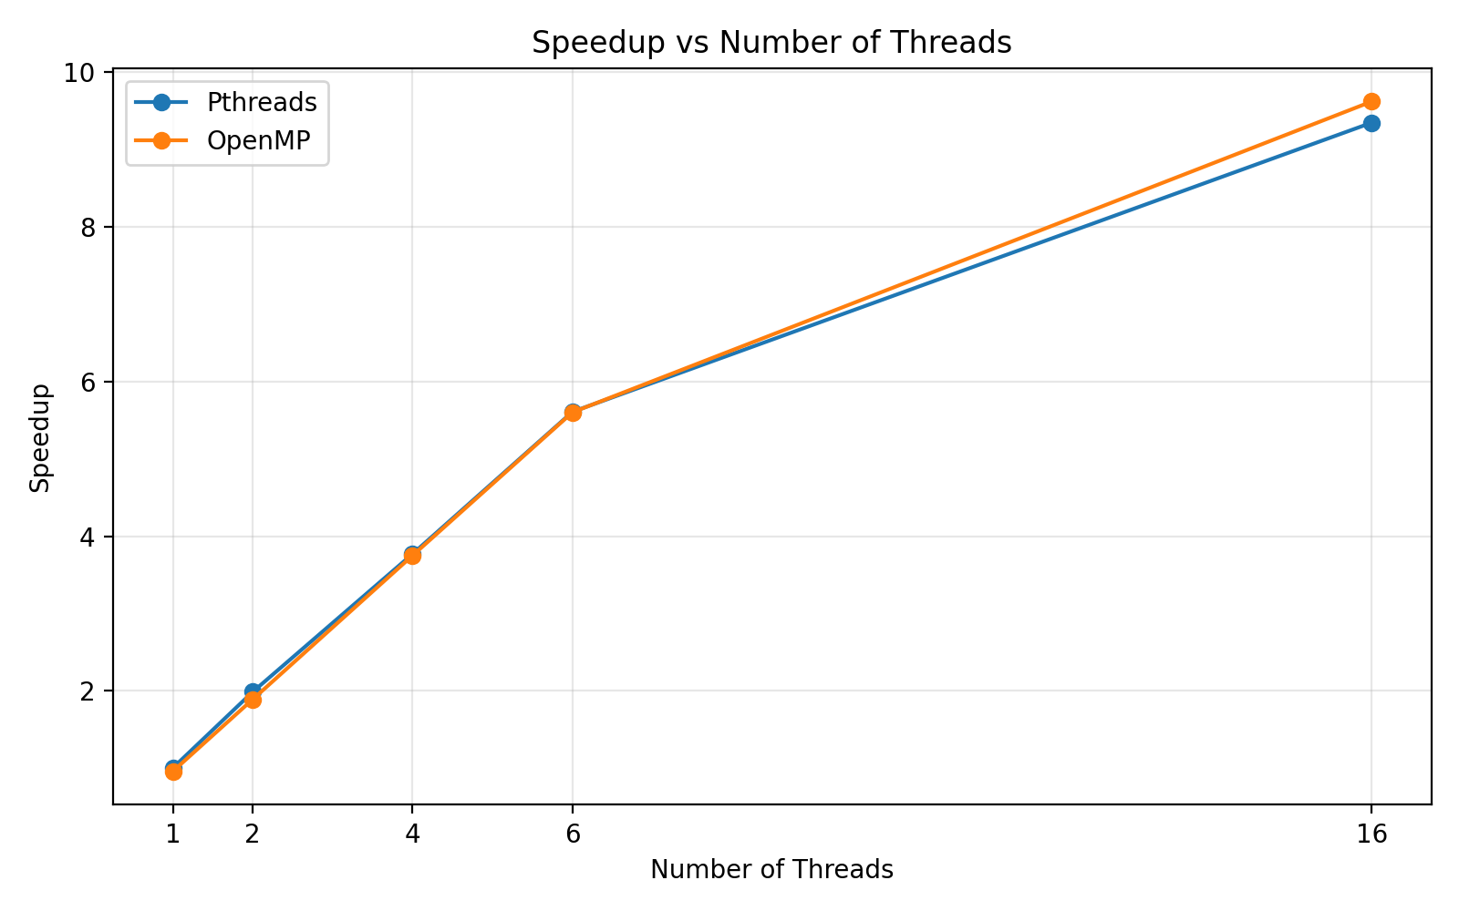

Observation
Speedup increases as the number of threads increases.
With 16 threads:
- Pthreads achieved approximately 9.35x speedup
- OpenMP achieved approximately 9.62x speedup
These values represent the measured results for this execution environment and workload.

17. EFFICIENCY
Efficiency tells us how effectively the available threads contribute to the speedup.
Formula:
$$Efficiency=\frac{Speedup}{Number of Threads}×100$$
For 16-thread OpenMP:
Speedup = 9.62
Threads = 16
Therefore:
Efficiency ≈ 60.1%

Efficiency Results
Threads | Pthreads Efficiency | OpenMP Efficiency
1 | 100.38% | 96.02%
2 | 99.39% | 94.56%
4 | 94.27% | 93.76%
6 | 93.45% | 93.35%
16 | 58.40% | 60.11%
Figure 3 — Efficiency vs Number of Threads
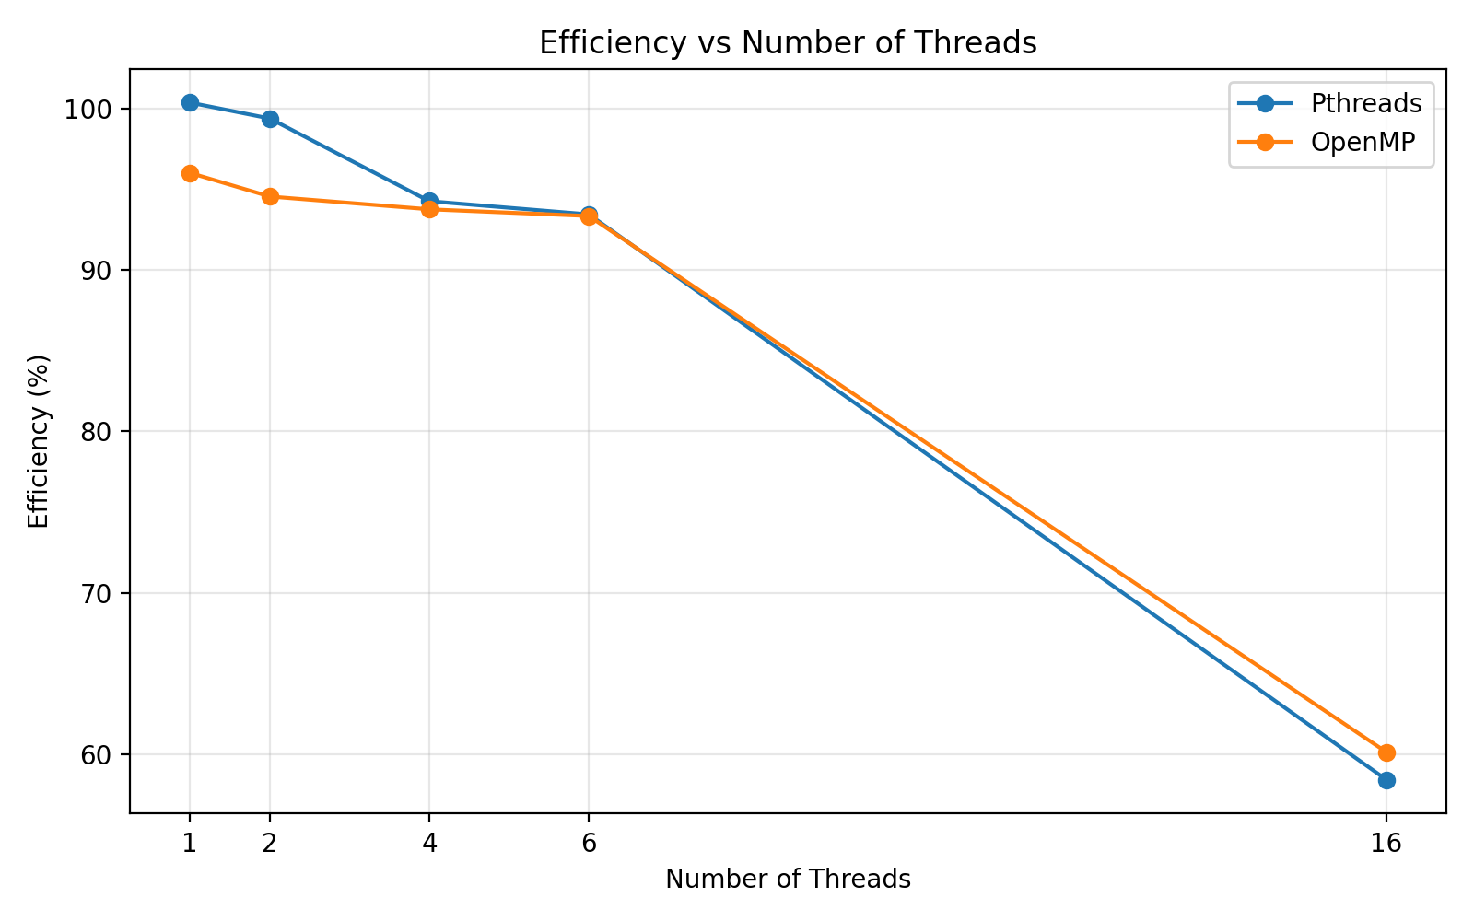

Observation
Efficiency remains relatively high at lower thread counts but decreases at 16 threads.
This shows that adding more threads does not automatically provide proportional speedup.

18. WHY DOES 16 THREADS NOT GIVE 16x SPEEDUP?
We might expect:

1.35 / 16
≈ 0.084 seconds
But the measured OpenMP time was:

0.140692 seconds
The reason is that real parallel programs have overhead.
Examples include:
Thread management
Scheduling
Synchronization
Memory access
Operating-system activity
Non-parallel work
Therefore:
More threads can reduce execution time, but the speedup is not perfectly linear.

19. QUICK DIFFERENCE — PTHREADS VS OPENMP
Concept | Pthreads | OpenMP
Create threads | pthread_create() | #pragma omp parallel
Wait for threads | pthread_join() | OpenMP runtime handles team completion at region end
Work distribution | Programmer explicitly divides work | parallel for can distribute loop iterations
Protect shared data | Mutex | critical
Coordination | Join / synchronization mechanisms | barrier
Combine partial results | Programmer-managed | reduction

20. IMPORTANT TERMS

Thread
A path of execution inside a program.

Main thread
The thread that starts executing the main() function when the program begins.

Additional thread
A new thread created by the program using a thread-creation mechanism such as pthread_create().

Multithreading
Using multiple threads within one program.

Parallel programming
Dividing work so that multiple execution units can perform parts of the work concurrently.

Work distribution
Dividing one large task into smaller tasks and assigning them to different threads.

Race condition
A situation where multiple threads access or modify shared data without proper coordination and the result can become incorrect.

Mutex
A locking mechanism used in Pthreads to protect a critical section.

Critical section
A section of code where simultaneous execution by multiple threads must be restricted.

Barrier
A synchronization point where threads wait until all required threads reach the same point.

Speedup
How much faster the parallel program is compared with the sequential baseline.

Efficiency
How effectively the available threads produce the measured speedup.

21. IMPLEMENTED PROGRAMS

Part A — Pthreads
- thread1.c — Create one thread
- thread2.c — Create multiple threads
- thread_sum.c — Divide work among threads
- race.c — Demonstrate race condition
- mutex.c — Fix race condition using mutex
- pthread_perf.c — Measure performance

Part B — OpenMP
- omp1.c — Parallel region and thread identification
- omp_sum.c — Work sharing and reduction
- omp_race.c — Demonstrate race condition
- omp_critical.c — Synchronization using critical
- omp_barrier.c — Thread coordination
- omp_perf.c — Measure performance

Part C — Performance Analysis
- Sequential execution
- Pthreads execution
- OpenMP execution
- Execution-time comparison
- Speedup calculation
- Efficiency calculation
- Graphical analysis
- Performance interpretation

22. COMPLETE LEARNING FLOW
START
|
v
Understand Threads
|
v
Create One Thread
|
v
Create Multiple Threads
|
v
Divide Work
|
v
Shared Data
|
v
Race Condition
|
v
Synchronization
|
v
OpenMP Parallel Region
|
v
OpenMP Work Sharing
|
v
OpenMP Race Condition
|
v
OpenMP Critical Section
|
v
OpenMP Barrier
|
v
Sequential Performance
|
v
Pthreads Performance
|
v
OpenMP Performance
|
v
Execution-Time Graph
|
v
Speedup
|
v
Speedup Graph
|
v
Efficiency
|
v
Efficiency Graph
|
v
Final Analysis

23. CONCLUSION
The experiment demonstrates how multithreaded programs can be developed using Pthreads and OpenMP.
Pthreads provides explicit control over thread creation, joining, and mutex-based synchronization. OpenMP provides a higher-level programming model using parallel regions, work-sharing directives, critical sections, barriers, and reductions.
The experiments also demonstrate that multiple threads can introduce race conditions when shared data is not protected. Synchronization mechanisms such as mutexes and critical sections are therefore necessary.
The performance experiment demonstrates that increasing the number of threads can reduce execution time for a suitable workload. Both Pthreads and OpenMP showed substantial reductions in execution time as the thread count increased.
The graphs provide three complementary views of the results:
- Execution time shows how long the computation takes.
- Speedup shows how much faster the parallel execution is relative to the sequential baseline.
- Efficiency shows how effectively the available threads contribute to the measured speedup.
The measured results also show that speedup is not perfectly proportional to the number of threads because parallel execution introduces overhead such as scheduling, synchronization, memory access, thread management, and non-parallel work.
The complete learning flow is:
Create -> Manage -> Divide Work -> Share Data -> Handle Race Conditions -> Synchronize -> Coordinate -> Measure Performance -> Analyze Results

