# Credit Rating Data Flow, Mapping Issues & Proxy Curves

This document outlines the current data flow for credit ratings between Creditmate, Bloomberg, Asset Control (AC), the Market Data Store (MDS), and risk models such as SRVAR, GMV, and MRA. It highlights the mapping issues observed, current workarounds, agreed next steps, and the role of proxy curves in ensuring data completeness for risk calculations.

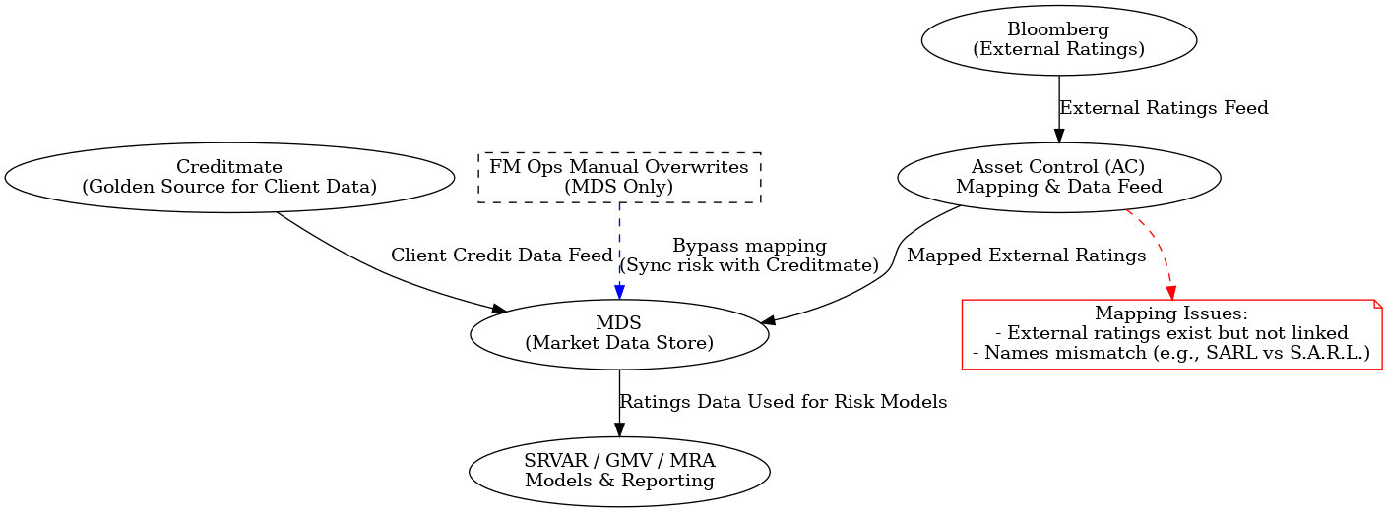

Figure 1: Credit Rating Data Flow and Mapping Issues

## 1. Standard Data Flow

1. Creditmate is the golden source for client credit data (internal ratings, onboarding info).  
2. Bloomberg provides external ratings (Moody’s, S&P, Fitch).  
3. Asset Control (AC) receives Bloomberg data, performs mapping, and feeds it into MDS.  
4. MDS aggregates both internal and external ratings.  
5. SRVAR, GMV, and MRA models consume ratings from MDS for risk calculations.

## 2. Current Issues

- External ratings exist in Bloomberg but are not linked correctly to counterparties in MDS.  
- Mapping mismatches (e.g., “SARL” vs. “S.A.R.L.”) cause ratings to be missing in MDS.  
- SRVAR prioritizes external ratings; missing mappings lead to fallback on internal ratings.  
- The Bloomberg → AC → MDS mapping fix (MDS AC Project) is planned for end of September.

## 3. Current Workarounds

- FM Ops manually overwrites ratings in MDS for critical cases.  
- This bypasses mapping but risks desynchronizing Creditmate and MDS.  
- Overwrites were meant for exceptional use but have become common due to slow Creditmate → MDS updates.

## 4. Risks

- Permanent data misalignment between Creditmate and MDS if overwrites are not mirrored in Creditmate.  
- Regulatory reporting inconsistencies if external vs. internal ratings diverge.  
- Duplicated work after project completion if sync is not maintained.

## 5. Proxy Curves in Context

In cases where a counterparty or instrument lacks a direct market curve (credit spread, discount curve, etc.), risk and valuation models often rely on a proxy curve. This ensures that SRVAR, GMV, and MRA calculations remain complete and consistent despite missing or illiquid data.  
  
Typical use cases:  
• Credit risk: If a counterparty has no CDS curve or it is illiquid, a proxy from a similar sector, rating, and region is used.  
• XVA & CVA: Proxies provide spread term structures for names with limited data.  
• Market risk / VaR: Proxies allow shocking illiquid risk factors using correlated liquid curves.  
• Funding & collateral: A minor currency curve may be proxied from a major currency curve plus a basis adjustment.  
  
Selection criteria:  
1. Match currency, credit rating, industry sector, and region.  
2. Use historical correlation between the candidate proxy and the target.  
3. Apply scaling or shifting to align with any available observed points.  
  
Risks of proxy use:  
• Divergence from the target curve in stressed markets.  
• Regulatory scrutiny requiring documentation and back-testing.  
  
In the MDS–AC context, proxy curves may be required if Bloomberg data exists but is unmapped, allowing model runs to continue while mapping issues are resolved. Governance processes should ensure that proxies are documented, justified, and replaced with actual mappings once available.

## 6. Agreed Next Steps

1. Confirm with Chandra and Hemant how Creditmate fits into Bloomberg → AC → MDS flow.  
2. Clarify governance and approval for bulk MDS overwrites.  
3. Ensure interim fixes are also reflected in Creditmate to avoid misalignment.  
4. Involve architecture team to design a process that keeps Creditmate and MDS synchronized post-project.  
5. Document a formal proxy curve policy for use during mapping gaps, including selection criteria and replacement rules.