# Credit Rating Data Flow & Mapping Issues

This document outlines the current data flow for credit ratings between Creditmate, Bloomberg, Asset Control (AC), the Market Data Store (MDS), and risk models such as SRVAR, GMV, and MRA. It highlights the mapping issues observed, current workarounds, and agreed next steps to ensure data integrity.

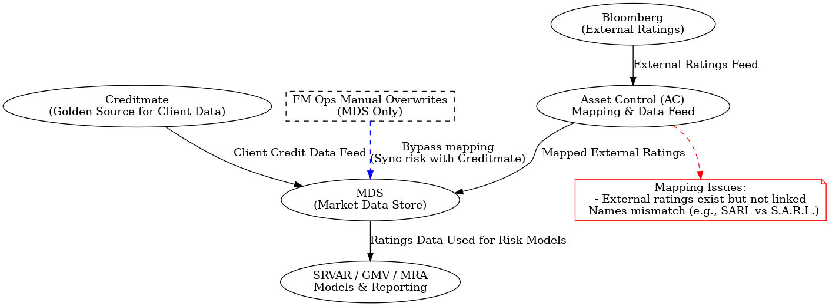

Figure 1: Credit Rating Data Flow and Mapping Issues

## 1. Standard Data Flow

1. Creditmate is the golden source for client credit data (internal ratings, onboarding info).  
2. Bloomberg provides external ratings (Moody’s, S&P, Fitch).  
3. Asset Control (AC) receives Bloomberg data, performs mapping, and feeds it into MDS.  
4. MDS aggregates both internal and external ratings.  
5. SRVAR, GMV, and MRA models consume ratings from MDS for risk calculations.

## 2. Current Issues

- External ratings exist in Bloomberg but are not linked correctly to counterparties in MDS.  
- Mapping mismatches (e.g., “SARL” vs. “S.A.R.L.”) cause ratings to be missing in MDS.  
- SRVAR prioritizes external ratings; missing mappings lead to fallback on internal ratings.  
- The Bloomberg → AC → MDS mapping fix (MDS AC Project) is planned for end of September.

## 3. Current Workarounds

- FM Ops manually overwrites ratings in MDS for critical cases.  
- This bypasses mapping but risks desynchronizing Creditmate and MDS.  
- Overwrites were meant for exceptional use but have become common due to slow Creditmate → MDS updates.

## 4. Risks

- Permanent data misalignment between Creditmate and MDS if overwrites are not mirrored in Creditmate.  
- Regulatory reporting inconsistencies if external vs. internal ratings diverge.  
- Duplicated work after project completion if sync is not maintained.

## 5. Agreed Next Steps

1. Confirm with Chandra and Hemant how Creditmate fits into Bloomberg → AC → MDS flow.  
2. Clarify governance and approval for bulk MDS overwrites.  
3. Ensure interim fixes are also reflected in Creditmate to avoid misalignment.  
4. Involve architecture team to design a process that keeps Creditmate and MDS synchronized post-project.