1. Assigning Values to Variables
counter = 100 # An integer assignment
miles = 1000.0 # A floating point
name = "John" # A string
print (counter)
print (miles)
print (name)
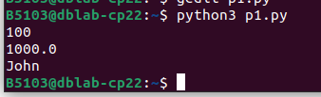

2.Python numbers
a = 5 # integer assignment
b= 4.56 #floating point assignment
#mathematical operations with scalar variables
print (5*a)
print (a/2)

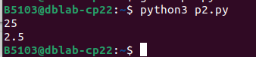

3.
var1 = 'Hello World!'
print ("Updated String :", var1[:6] + 'Python')

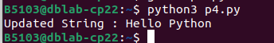

4.str = "this is string example wow!!!";
print (str.capitalize())
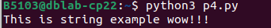

5.
str = "this is string example ... wow!!!";
ans = str.count(‘s’)
print(ans)
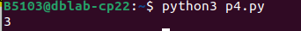

6. ans = str.find(‘example’)
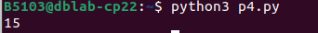

7.str = "THIS IS STRING EXAMPLE ... WOW!!!";
print (str.lower())
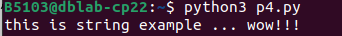

8.str = "this is string example ... wow!!! this is really string";
print (str.replace("is", "was"))

9.
list = [ 'abcd', 786 , 2.23, 'john', 70.2 ]
tinylist = [123, 'john']
print (list) # Prints complete list
print (list[0]) # Prints first element of the list
print (list[1:3]) # Prints elements starting from 2nd till 3rd
print (list[2:]) # Prints elements starting from 3rd element
print (tinylist * 2) # Prints list two times
print (list + tinylist) # Prints concatenated lists

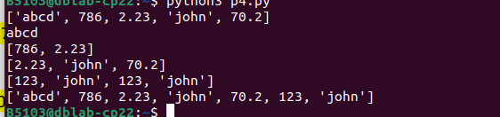
10.
list = ['physics', 'chemistry', 1997, 2000];
list.append(‘maths’)
print(list)
11.
list = ['physics', 'chemistry', 1997, 2000];
del list[2]
print('physics' in list)
print('1997' in list)
len(list)
print(list.count('physics'))

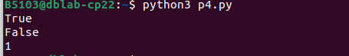

12.
list = ['physics', 'chemistry', 1997, 2000];
list.pop()
print(list)
list.insert (2, ‘maths’)
print(list)
list.remove(‘chemistry’)
print(list)
list.reverse()
print(list)
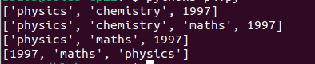

The main differences between lists and tuples are: Lists are enclosed in brackets ( [ ] ) and
their elements and size can be changed, while tuples are enclosed in parentheses ( ( ) ) and
cannot be updated.

13.
num = float(input(‘Enter a number’));
if num>0:
print(‘pos number’)
elif num ==0:
print(‘zero’)
else:
print(‘Neg number’)

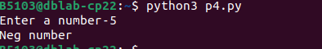

14.

x=42
if x>1:
print(‘above one’)
if x<100:
print(‘less than 100’)
print(‘All done’)

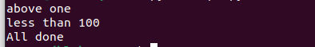

15.

age=15
b=(‘kid’ if age<18 else ‘adult’)
print(b)

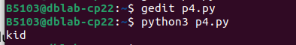

16.
stud=[‘Ram’,’Vijay’,’Nithya’]
for k in stud:
print(‘Hello:’, k)

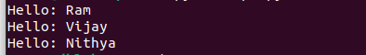

17.
x=int(input(‘Enter a number:’))
for i in range(1,x+1):
if x%i ==0:
print(i)

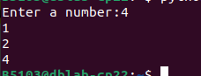

18.
x= [9, 41, 12, 3, 74, 15]
res=[]
for i in x:
if i>20:
res.append(i)
print(res);
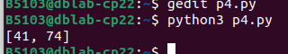

19.
import numpy as np
x= [20,50,60,15,10]
y=np.zeros(len(x))
for i in range(len(x)):
if x[i]>20:
y[i]=x[i]
print(y)

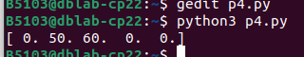

21.

total = 0
number = int(input('Enter a number: '))

while number != 0:
total += number # total = total + number
number = int(input('Enter a number: '))
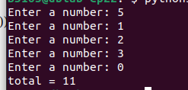
print('total =', total)

