**SIGNIFICANCE OF**

**ANTAGONIST**

**INDEX**

1. Introduction
2. Case Study
3. Some villains in real life
4. Some villains in fiction
5. Discussion
6. Anti-hero
7. Why is antagonist required in fiction?
8. Should villain win?
9. Goals of a villain
10. Abstract
11. Conclusion
12. References

**INTRODUCTION**

*An antagonist ("opponent, competitor, enemy, rival", from anti- "against" + agonizesthai "to contend for a prize,") is a character, group of characters, or*[*institution*](http://en.wikipedia.org/wiki/Institution)*that represents the opposition against which the*[*protagonist*](http://en.wikipedia.org/wiki/Protagonist) *(one who plays the first part, chief actor, supposedly the good guy) must contend. In other words, an antagonist is a person or a group of people who oppose the main character. In the classic style of stories wherein the action consists of a*[*hero*](http://en.wikipedia.org/wiki/Hero)*fighting a*[*villain*](http://en.wikipedia.org/wiki/Villain)*/*[*enemy*](http://en.wikipedia.org/wiki/Enemy)*, the two can be regarded as protagonist and antagonist, respectively.*

*The antagonist may also represent a major threat or obstacle to the main character by their very existence, without necessarily deliberately targeting him or her.*

*Examples in film include*[*Sauron*](http://en.wikipedia.org/wiki/Sauron)*, the main antagonist in*[*The Lord of the Rings*](http://en.wikipedia.org/wiki/The_Lord_of_the_Rings)*, who constantly battles the series' protagonists, in drama include Iago who hates Otello and devises a plan to destroy him and in literature Voldemort who obsessed with idea of immortality and invincibility.*

*A convention of the antagonist in a story is that their moral choices are less savoury than those of the protagonist.*

**CASE STUDY**

Some villains in Real life:

1. **Adolf Hitler:**

*"Hitler is among the 'terrible simplifiers' of history, the most systematic, the most historical, the most philosophical, and yet the coarsest, cruellest, least magnanimous conqueror the world has ever known".*

-By English historian [Hugh Trevor-Roper](http://en.wikipedia.org/wiki/Hugh_Trevor-Roper)

**Who was he?**

Adolf Hitler (20 April 1889 – 30 April 1945) was an [Austrian](http://en.wikipedia.org/wiki/Austria-Hungary)-born [German](http://en.wikipedia.org/wiki/Germans) politician and the leader of the [Nazi Party](http://en.wikipedia.org/wiki/Nazi_Party); National Socialist German Workers Party). He was [chancellor of Germany](http://en.wikipedia.org/wiki/Chancellor_of_Germany#Chancellor_of_the_Third_Reich_.281933.E2.80.931945.29) from 1933 to 1945 and [dictator](http://en.wikipedia.org/wiki/Dictator) of [Nazi Germany](http://en.wikipedia.org/wiki/Nazi_Germany) from 1934 to 1945. Hitler was at the centre of Nazi Germany, [World War II in Europe](http://en.wikipedia.org/wiki/European_theatre_of_World_War_II), and the [Holocaust](http://en.wikipedia.org/wiki/Holocaust).

**Motivation:**

Adolf Hitler was born on 20 April 1889 at the Gasthof zum Pommer, a town on the border with [Bavaria](http://en.wikipedia.org/wiki/Bavaria), Germany.  He became fixated on warfare after finding a picture book about the [Franco-Prussian War](http://en.wikipedia.org/wiki/Franco-Prussian_War) among his father's belongings.

The move to Hafeld coincided with the onset of intense father-son conflicts caused by Hitler's refusal to conform to the strict discipline of his school. The death of his younger brother, [Edmund](http://en.wikipedia.org/wiki/Edmund_Hitler), from measles on 2 February 1900 deeply affected Hitler. He changed from being confident and outgoing and an excellent student, to a morose, detached, and sullen boy who constantly fought with his father and teachers.

Hitler later dramatised an episode from this period when his father took him to visit a customs office, depicting it as an event that gave rise to an unforgiving antagonism between father and son, who were both strong-willed. Ignoring his son's desire to attend a classical high school and become an artist, in September 1900 Alois sent Hitler to the [*Realschule*](http://en.wikipedia.org/wiki/Realschule) in Linz. Hitler rebelled against this decision, and in *Mein Kampf* revealed that he intentionally did poorly in school, hoping that once his father saw "what little progress I was making at the technical school he would let me devote myself to my dream".

Like many Austrian Germans, Hitler began to develop [German nationalist](http://en.wikipedia.org/wiki/German_nationalism) ideas from a young age. He expressed loyalty only to [Germany](http://en.wikipedia.org/wiki/German_Empire), despising the declining [Habsburg Monarchy](http://en.wikipedia.org/wiki/Habsburg_Monarchy) and its rule over an ethnically variegated empire. After his father’s sudden death on 3 January 1903, Hitler's performance at school deteriorated and his mother allowed him to leave. Hitler left the school without any ambitions for further schooling or clear plans for a career.

 On 21 December 1907, his mother died aged 47. In 1909 he lived in a homeless shelter, and by 1910, he had settled into a [house for poor working men on Meldemannstrae](http://en.wikipedia.org/wiki/Meldemannstra%C3%9Fe_dormitory). At the time Hitler lived there, Vienna was a hotbed of religious prejudice and racism. Fears of being overrun by immigrants from the East were widespread, and the populist mayor, [Karl Lueger](http://en.wikipedia.org/wiki/Karl_Lueger), exploited [anti-Semitism](http://en.wikipedia.org/wiki/Antisemitism) (hatred towards Jews) for political effect. Anti-Semitism had a strong on him. Hitler read local newspapers that fanned prejudice and played on Christian fears of being swamped by an influx of eastern Jews.

At the outbreak of World War I, Hitler was a resident of Munich and volunteered to serve in the [Bavarian Army](http://en.wikipedia.org/wiki/Bavarian_Army) as an Austrian citizen.  On 15 October 1918, he was temporarily blinded by a [mustard gas](http://en.wikipedia.org/wiki/Mustard_gas) attack and was hospitalised. While there, Hitler learnt of Germany's defeat, and—by his own account—on receiving this news, he suffered a second bout of blindness.

Hitler described the war as "the greatest of all experiences", and was praised by his commanding officers for his bravery. His wartime experience reinforced his German patriotism. He was embittered over the collapse of the war effort, and his ideology began to take shape. The [Treaty of Versailles](http://en.wikipedia.org/wiki/Treaty_of_Versailles) stipulated that Germany must relinquish several of its territories and [demilitarise](http://en.wikipedia.org/wiki/Demilitarisation) the country. The treaty imposed economic sanctions and levied heavy reparations on the country. Many Germans perceived the treaty—especially [Article 231](http://en.wikipedia.org/wiki/Article_231_of_the_Treaty_of_Versailles), which declared Germany responsible for the war—as a humiliation. The Versailles Treaty and the economic, social, and political conditions in Germany after the war were later exploited by Hitler for political gains.

**Evil deeds:**

Hitler was a decorated veteran of [World War I](http://en.wikipedia.org/wiki/World_War_I). He joined the [German Workers' Party](http://en.wikipedia.org/wiki/German_Workers%27_Party) (precursor of the NSDAP) in 1919, and became leader of the NSDAP in 1921. In 1923, he attempted a [*coup d'état*](http://en.wikipedia.org/wiki/Coup_d%27%C3%A9tat) in Munich, known as the [Beer Hall Putsch](http://en.wikipedia.org/wiki/Beer_Hall_Putsch). The failed coup resulted in Hitler's imprisonment. After his release in 1924, Hitler gained popular support by attacking the [Treaty of Versailles](http://en.wikipedia.org/wiki/Treaty_of_Versailles) and promoting [Pan-Germanism](http://en.wikipedia.org/wiki/Pan-Germanism), [antisemitism](http://en.wikipedia.org/wiki/Antisemitism), and [anti-communism](http://en.wikipedia.org/wiki/Anti-communism) with charismatic oratory and [Nazi propaganda](http://en.wikipedia.org/wiki/Nazi_propaganda). After his appointment as chancellor in 1933, he formed [single-party](http://en.wikipedia.org/wiki/Single-party_state) dictatorship based on the [totalitarian](http://en.wikipedia.org/wiki/Totalitarianism) and [autocratic](http://en.wikipedia.org/wiki/Autocratic) ideology of Nazism.

Hitler's aim was to establish a [New Order](http://en.wikipedia.org/wiki/New_Order_(Nazism)) of absolute Nazi German [hegemony](http://en.wikipedia.org/wiki/Hegemony) in continental Europe. To this end, his foreign and domestic policies had the aim of seizing living space for the [Germanic people](http://en.wikipedia.org/wiki/Nazism_and_race). He directed the rearmament of Germany and the [invasion of Poland](http://en.wikipedia.org/wiki/Invasion_of_Poland) by the [Wehrmacht](http://en.wikipedia.org/wiki/Wehrmacht) in September 1939, resulting in the outbreak of [World War II in Europe](http://en.wikipedia.org/wiki/European_Theatre_of_World_War_II).

**How was he a Villain?**

Hitler's actions and [Nazi](http://en.wikipedia.org/wiki/Nazism) ideology are almost universally regarded as gravely immoral. Hitler's political programme brought about a world war, leaving behind a devastated and impoverished Eastern and Central Europe. Germany itself suffered wholesale destruction. Hitler's policies inflicted human suffering on an unprecedented scale. Hitler was solely responsible for the Holocaust, resulting in the mass murder of nearly 5.5 to six million Jews. Hitler's policies also resulted in the killing of nearly two million [Poles](http://en.wikipedia.org/wiki/Nazi_crimes_against_ethnic_Poles), over 3 million [Soviet prisoners of war](http://en.wikipedia.org/wiki/Nazi_crimes_against_Soviet_POWs), estimated 19.3 million civilians and prisoners of war, communists and other political opponents, homosexuals, the physically and mentally disabled.

In addition, 29 million soldiers and civilians died as a result of military action in the World War. Historians, philosophers, and politicians often use the word "[evil](http://en.wikipedia.org/wiki/Evil)" to describe the Nazi regime.

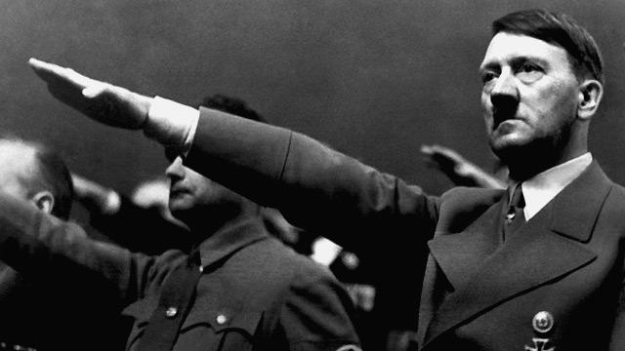

1. Osama Bin Laden:

*"God knows it did not cross our minds to attack*[*the Towers*](http://en.wikipedia.org/wiki/World_Trade_Center)*, but after the situation became unbearable—and we witnessed the injustice and tyranny of the American-Israeli alliance against our people in*[*Palestine*](http://en.wikipedia.org/wiki/Palestine)*and*[*Lebanon*](http://en.wikipedia.org/wiki/Lebanon)*—I thought about it. And the events that affected me directly were*[*that of 1982*](http://en.wikipedia.org/wiki/1982_Lebanon_War)*and the events that followed—when America allowed the Israelis to invade Lebanon, helped by the*[*U.S. Sixth Fleet*](http://en.wikipedia.org/wiki/U.S._Sixth_Fleet)*. As I watched*[*the destroyed towers in Lebanon*](http://en.wikipedia.org/wiki/Siege_of_Beirut)*, it occurred to me punish the unjust the same way: to destroy towers in America so it could taste some of what we taste and to stop killing our children and women."*

*— Osama bin Laden, 2004*

**Who was he?**

Osama bin Mohammed bin Awad bin Laden (March 10, 1957 – May 2, 2011) was the founder of [al-Qaeda](http://en.wikipedia.org/wiki/Al-Qaeda), the [Sunni](http://en.wikipedia.org/wiki/Sunni) [militant Islamist](http://en.wikipedia.org/wiki/Militant_Islamist) organization that claimed responsibility for the [September 11 attacks](http://en.wikipedia.org/wiki/September_11_attacks) on the United States, along with numerous other [mass-casualty attacks](http://en.wikipedia.org/wiki/Timeline_of_al-Qaeda_attacks) against civilian and military targets. He helped to fund the mujahideen by funnelling arms, money and fighters from the Arab world into Afghanistan, also gaining popularity from many Arabs. In 1988, he formed al-Qaeda.

**Motivation:**

Osama bin Laden was born in [Jeddah](http://en.wikipedia.org/wiki/Jeddah), Saudi Arabia, a son of [Mohammed bin Awad bin Laden](http://en.wikipedia.org/wiki/Mohammed_bin_Awad_bin_Laden), a billionaire construction magnate with close ties to the [Saudi royal family](http://en.wikipedia.org/wiki/Saudi_royal_family).

Bin Laden was raised as a devout [Wahhabi](http://en.wikipedia.org/wiki/Wahhabi) Muslim. At university, bin Laden's main interest was religion, where he was involved in both "interpreting the [Quran](http://en.wikipedia.org/wiki/Quran) and [jihad](http://en.wikipedia.org/wiki/Jihad)" and charitable work.

Osama bin Laden, the al-Qaeda leader was motivated by a belief that [U.S. foreign policy](http://en.wikipedia.org/wiki/Foreign_policy_of_the_United_States) has oppressed, killed, or otherwise harmed Muslims in the Middle East, condensed in the phrase, "They hate us for what we do, not who we are." He opposed such alternatives as "[pan-Arabism](http://en.wikipedia.org/wiki/Pan-Arabism), socialism, communism, democracy."[[47]](http://en.wikipedia.org/wiki/Osama#cite_note-47)

This belief, in conjunction with violent [*jihad*](http://en.wikipedia.org/wiki/Jihad) shaped his entire life.  Bin Laden believed that Afghanistan, under the rule of [Mullah Omar](http://en.wikipedia.org/wiki/Mohammed_Omar)'s [Taliban](http://en.wikipedia.org/wiki/Taliban), was "the only Islamic country" in the Muslim world.  Bin Laden consistently dwelt on the need for violent jihad to right what he believed were injustices against Muslims perpetrated by the United States and sometimes by other non-Muslim states.  He called on Americans to "reject the immoral acts of [fornication](http://en.wiktionary.org/wiki/fornication), homosexuality, intoxicants, gambling, and [usury](http://en.wikipedia.org/wiki/Usury)", in an October 2002 letter.

Bin Laden's ideology included the concept that civilians, including women and children, are legitimate targets of jihad. Bin Laden was [anti-Semitic](http://en.wikipedia.org/wiki/Antisemitism), and delivered warnings against alleged Jewish conspiracies: "These Jews are masters of usury and leaders in treachery. They will leave you nothing, either in this world or the next." Bin Laden opposed music on religious grounds, and his attitude towards technology was mixed.

His viewpoints and methods of achieving them had led to him being designated as a terrorist by scholars. Bin Laden's overall strategy against much larger enemies such as the [Soviet Union](http://en.wikipedia.org/wiki/Soviet_Union) and United States was to lure them into a long [war of attrition](http://en.wikipedia.org/wiki/Attrition_warfare) in Muslim countries, attracting large numbers of jihadists who would never surrender. He believed this would lead to economic collapse of the enemy nations.

**Evil deeds:**

After leaving college in 1979, bin Laden went to Pakistan and used money and machinery from his own construction company to help the [mujahideen](http://en.wikipedia.org/wiki/Mujahideen) resistance in the [Soviet war in Afghanistan](http://en.wikipedia.org/wiki/Soviet_war_in_Afghanistan).

By 1984, bin Laden funnelled money, arms and fighters from around the Arab world into Afghanistan. Bin Laden established camps in Pakistan and trained volunteers from across the Muslim world to fight against the Soviet puppet regime, the [Democratic Republic of Afghanistan](http://en.wikipedia.org/wiki/Democratic_Republic_of_Afghanistan).

He formed al-Qaeda was on August 11, 1988, at meeting between "several senior leaders" of [Egyptian Islamic Jihad](http://en.wikipedia.org/wiki/Egyptian_Islamic_Jihad) and bin Laden, where it was agreed to join bin Laden's money with the expertise of the Islamic Jihad organization and take up the jihadist cause elsewhere after the Soviets withdrew from Afghanistan.

Bin Laden organized an al-Qaeda congress on June 24, 1998. The [1998 U.S. Embassy bombings](http://en.wikipedia.org/wiki/1998_U.S._Embassy_bombings) were a series of attacks that occurred on August 7, 1998, in which hundreds of people were killed in simultaneous [truck bomb](http://en.wikipedia.org/wiki/Truck_bomb) explosions at the United States [embassies](http://en.wikipedia.org/wiki/Embassy) in the major East African cities. The attacks were linked to local members of the Egyptian Islamic Jihad, brought Osama bin Laden to the attention of the United States public for the first time, and resulted in the U.S. Federal Bureau of Investigation placing bin Laden on its [Ten Most Wanted](http://en.wikipedia.org/wiki/FBI_ten_most_wanted_fugitives) list.

In 2004 Osama bin Laden finally claimed responsibility for the September 11, 2001 attacks in the United States. The attacks involved the hijacking of four commercial passenger aircraft and flying them into the Twin Towers of the [World Trade Center](http://en.wikipedia.org/wiki/World_Trade_Center) in New York City, New York and [The Pentagon](http://en.wikipedia.org/wiki/The_Pentagon) in [Arlington, Virginia](http://en.wikipedia.org/wiki/Arlington,_Virginia), destroying the former, and severely damaging the latter. It resulted in the deaths of 2,973 people. In response to the attacks, the United States launched the [War on Terror](http://en.wikipedia.org/wiki/War_on_Terror) to depose the Taliban regime in Afghanistan and capture al-Qaeda operatives.

Osama bin Laden was killed in Pakistan on May 2, 2011, shortly after 1:00 am local [time](http://en.wikipedia.org/wiki/Pakistan_Standard_Time) by a United States [Special Forces](http://en.wikipedia.org/wiki/Special_forces) military unit. The operation, code-named Operation Neptune Spear, was ordered by United States [President](http://en.wikipedia.org/wiki/President_of_the_United_States) [Barack Obama](http://en.wikipedia.org/wiki/Barack_Obama) and carried out in a U.S. Central Intelligence Agency (CIA) operation by a team of United States Navy SEALs. The raid on bin Laden's compound in Abbottabad, Pakistan was launched from Afghanistan.After the raid, U.S. forces took bin Laden's body to Afghanistan for identification, then buried it at sea within 24 hours after his death.

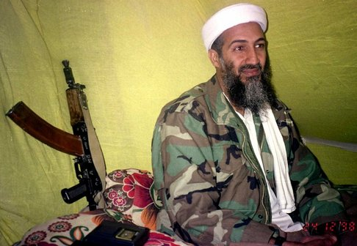

1. Bashar al-Assad:

**Who is he?**

Bashar Hafez al-Assad is the [President of Syria](http://en.wikipedia.org/wiki/President_of_Syria), General Secretary of the [Ba'ath Party](http://en.wikipedia.org/wiki/Ba%27ath_Party_(Syrian-led_faction)) and Regional Secretary of [the party's branch](http://en.wikipedia.org/wiki/Arab_Socialist_Ba%27ath_Party_%E2%80%93_Syria_Region) in Syria. He has served as President since 2000, when he succeeded his father, [Hafez al-Assad](http://en.wikipedia.org/wiki/Hafez_al-Assad), who led Syria for 30 years until his death.

Initially seen by the domestic and international community as a potential reformer, this expectation ceased when he ordered a mass crackdown and military sieges on pro-rebel protesters amid recent [civil war](http://en.wikipedia.org/wiki/Syrian_civil_war), described by some commentators as related to the wider "[Arab Spring](http://en.wikipedia.org/wiki/Arab_Spring)" movement. The domestic [Syrian opposition](http://en.wikipedia.org/wiki/Syrian_opposition), the [United States](http://en.wikipedia.org/wiki/United_States), [Canada](http://en.wikipedia.org/wiki/Canada), the European Union states and the members of the [Arab League](http://en.wikipedia.org/wiki/Arab_League) have subsequently called for al-Assad's resignation from the presidency.

**Evil deeds:**

Bashar's government and [secret police](http://en.wikipedia.org/wiki/Secret_police) routinely tortured, imprisoned, and killed political opponents, and those who spoke against the government. The military, ruling elite and ruthless secret police are so intertwined in Syria that it is now impossible to separate the Assad government from the security establishment. The government and its loyal forces have been able to deter all but the most resolute and fearless oppositional activists.

**How is he a villain?**

Following anti-government demonstrations in some other Middle Eastern countries, protests in Syria started on 26 January 2011. Protesters called for political reforms and the re-instatement of civil rights, as well as an end to the state of emergency which had been in place since 1963. To stops such protests Bashar took up violence and ordered his armed forces to kill those who protested against his rule. By the end of January 2012, it was reported that over 5,000 civilians and protesters (including armed militants) had been killed by the Syrian army, militia ([Shabeeha](http://en.wikipedia.org/wiki/Shabeeha)) and security agents, while 1,100 people had been killed by the anti-government forces. On 15 July, the [International Committee of the Red Cross](http://en.wikipedia.org/wiki/International_Committee_of_the_Red_Cross) had officially declared Syria to be in a state of civil war,[[85]](http://en.wikipedia.org/wiki/Bashar_al-Assad#cite_note-85) as the nationwide death toll for all sides was reported to have neared 20,000.In August 2013 his armed forces made use of chemical weapons which led to mass destruction and death of many Syrians. This has got wide criticism from the whole world as the use of such weapons is inhuman and oppressive.

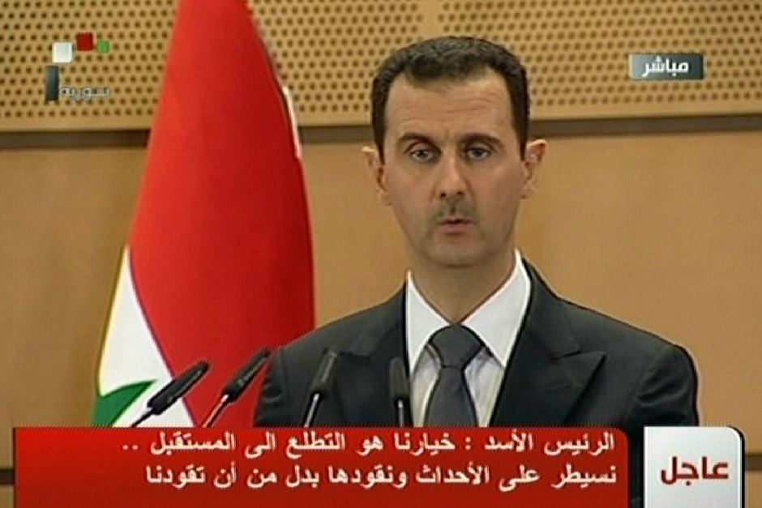

Some other peoples and organisations who show traits of a villain are East India Company ,Silvio Berlusconi, Saddam Hussain etc.

Some Villains in Fiction**:**

1. Joker:

*“I don’t want to kill you! What would I do without you? Go back to ripping off mob dealers? No, no, No! No.***You… you… complete me.”**

-Joker to Batman in The Dark Knight

*"When super-villains want to scare each other, they tell Joker stories."*

*-*[*Trickster*](http://en.wikipedia.org/wiki/Trickster_(comics)) *(villain)*

**Who is he?**

The **Joker** is a [fictional character](http://en.wikipedia.org/wiki/Character_(arts)), a comic book super villain appearing in publications by [DC Comics](http://en.wikipedia.org/wiki/DC_Comics). The character was created by [Jerry Robinson](http://en.wikipedia.org/wiki/Jerry_Robinson), [Bill Finger](http://en.wikipedia.org/wiki/Bill_Finger) and [Bob Kane](http://en.wikipedia.org/wiki/Bob_Kane), and first appeared in [*Batman*](http://en.wikipedia.org/wiki/Batman_(comic)) #1 (Spring 1940). He is the archenemy of the superhero [Batman](http://en.wikipedia.org/wiki/Batman).

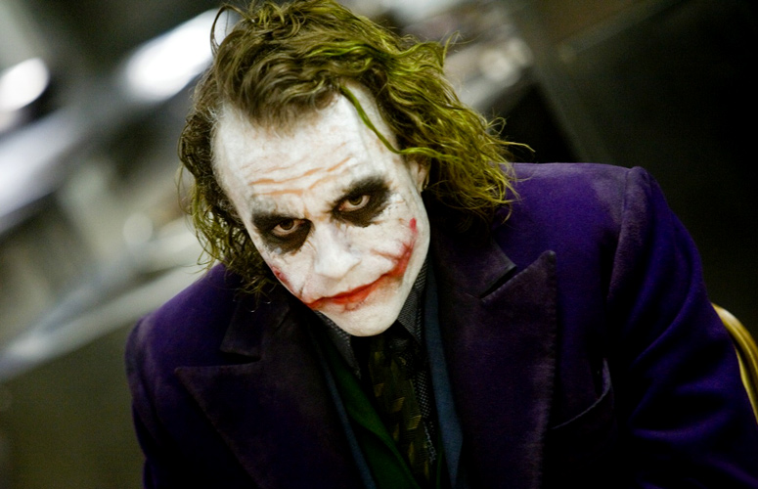

Throughout his comic book appearances, the Joker is portrayed as a highly intelligent, master criminal. He is originally introduced as a [psychopath](http://en.wikipedia.org/wiki/Psychopathy) with a warped, [sadistic](http://en.wikipedia.org/wiki/Sadomasochism) sense of humour. As Batman's nemesis, Joker has been a part of many of the defining stories of that character, including the paralysis of Batman's ally [Batgirl](http://en.wikipedia.org/wiki/Batgirl), and the murder of [Jason Todd](http://en.wikipedia.org/wiki/Jason_Todd), Batman's ward and the second [Robin](http://en.wikipedia.org/wiki/Robin_(comics)). He has been repeatedly analysed by critics as the perfect adversary for Batman; their long, dynamic relationship often parallels the concept of [yin and yang](http://en.wikipedia.org/wiki/Yin_and_yang).

As one of the most iconic and recognized villains in popular media, the Joker was ranked #1 on [*Wizard*](http://en.wikipedia.org/wiki/Wizard_(magazine))*'*s list of the 100 Greatest Villains of All Time.

**Origins:**

Though many have been related, a definitive [back-story](http://en.wikipedia.org/wiki/Back-story) has never been established for the Joker in the comics, and his real name has never been confirmed. He himself is confused as to what actually happened; as he says in *The Killing Joke*, "Sometimes I remember it one way, sometimes another... if I'm going to have a past, I prefer it to be multiple choice!"

The most widely cited backstory depicts him as originally being an engineer at a chemical plant who quits his job to become a stand-up comedian, only to fail miserably. To support his pregnant wife, he agrees to help two criminals in a crime that goes wrong and sees him leap into a chemical vat when confronted by Batman. When he surfaces in a nearby reservoir and removes the hood, the chemicals are shown to have given him bleached chalk-white skin, ruby-red lips, and bright green hair. Coupled with the earlier accidental death of his wife and unborn child, the engineer goes insane and becomes the Joker.

Although many Joker origins conform to the notion of his physical transformation being the result of chemical bleaching, some portrayals suggest that his red lips are purely the result of wearing lipstick. Others have inconsistently depicted the Joker's trademark smile as resulting from some form of additional disfigurement.

**Character:**

The Joker has been referred to as the Clown Prince of Crime (or Chaos), the Harlequin of Hate (Havoc), and the Ace of Knaves. Throughout the evolution of the [DC Universe](http://en.wikipedia.org/wiki/DC_Universe), interpretations and incarnations of the Joker have taken two forms. The original and currently dominant image is of a highly intelligent [psychopath](http://en.wikipedia.org/wiki/Psychopathy) with a warped, [sadistic](http://en.wikipedia.org/wiki/Sadomasochism) sense of humour. The Joker's victims have included men, women, children, and even his own henchmen and other villains. In the graphic novel *The Joker: Devil's Advocate*, the Joker is reported to have killed well over 2,000 people. Despite having murdered enough people to get the [death penalty](http://en.wikipedia.org/wiki/Death_penalty) thousands of times over, he is always found [not guilty by reason of insanity](http://en.wikipedia.org/wiki/Insanity_defense). Batman has had numerous opportunities to put the Joker down once and for all, but has relented at the last minute. As an example, in one story line, Batman threatens to kill the Joker, but stops himself upon realizing that such an act would make him "a killer like him!" Conversely, the Joker has given up many chances to kill the Batman because the Joker defines himself by his struggle with his arch nemesis. However, after a man dressed as Batman shot the Joker, Joker became enraged that his old enemy tried to end his life. Additionally, in a confrontation with a resurrected Jason Todd, Batman admits that he often fantasizes about killing the Joker, but that he will not allow himself the pleasure because he knows that there would be no turning back, thus resulting in a seemingly never-ending battle between him and the Joker.

His methods are unpredictable and incalculable. He does things according to his own twisted sense of logic, and does not desire money. If there was one thing that he did desire, it would be the power to instil anarchy into Gotham by any means necessary, proving that organization is meaningless and futile. He is an exceptionally intelligent man, and this tends to be his greatest weapon against Batman.

The Joker is renowned as Batman's greatest enemy. His unpredictable, homicidal nature makes him one of the most feared super villains in the [DC Universe](http://en.wikipedia.org/wiki/DC_Universe); in the [*Villains United*](http://en.wikipedia.org/wiki/Villains_United) and *Infinite Crisis* mini-series, the members of the villains' Secret Society refuse to induct the Joker for this reason.

**What he does?**

The Joker commits crimes with weaponized comic props such as a deck of bladed playing cards, an acid-squirting flower, [cyanide](http://en.wikipedia.org/wiki/Cyanide)-stuffed pies, exploding cigars filled with [nitroglycerin](http://en.wikipedia.org/wiki/Nitroglycerin), harpoon guns that utilize razor-sharp BANG!-flags, and a lethally electric [joy buzzer](http://en.wikipedia.org/wiki/Joy_buzzer). His most prominent weapon is his Joker venom, a deadly poison that infects his victims with a ghoulish [rictus grin](http://en.wikipedia.org/wiki/Risus_sardonicus) as they die while laughing uncontrollably.

**His relationship with the protagonist:**

Though he may be Batman's undisputed arch-nemesis, The Joker has always held some kind of respect for Batman, saying in "The Dark Knight", "Why would I kill you? What would I do without you?” He also acknowledges that Batman will never kill him, as that is Batman's only rule, and since The Joker will not kill Batman, they are truly destined to fight forever. As The Joker says, "This is what happens when an unstoppable force meets an immovable object."

Joker and Batman are the two sides of a magnet. One is good and one is bad. While the incorruptible Batman fights believing that everyone has good inside them, the Joker tries to prove that when confronted with an inescapable situation everyone can turn into a vile character like himself. Both of them refuse to kill each other. Batman because of his morals while Joker because he thinks that “Batman is too much fun.” If one loses to another, then it shows that their ideal is correct, but one can never win, as Joker puts it, it's like an immovable object clashing with an unstoppable force. Neither will ever stop because of how much they believe in what they are doing.

1. Iago

**Who was he?**

**Iago** is a fictional character in [Shakespeare](http://en.wikipedia.org/wiki/Shakespeare)'s [*Othello*](http://en.wikipedia.org/wiki/Othello) (c. 1601–04). The play's main [antagonist](http://en.wikipedia.org/wiki/Antagonist), Iago is the 'Ancient' (standard bearer) of General Othello as well as being husband of [Emilia](http://en.wikipedia.org/wiki/Emilia_(Othello)), who is in turn the attendant of [Othello](http://en.wikipedia.org/wiki/Othello_(character))'s wife [Desdemona](http://en.wikipedia.org/wiki/Desdemona). Iago hates Othello (who is also known as "The [Moor](http://en.wikipedia.org/wiki/Moorish)") and devises a plan to destroy him by making him believe that his wife is having an affair with his lieutenant, [Michael Cassio](http://en.wikipedia.org/wiki/Michael_Cassio).

**What he did?**

Iago is a soldier who has fought beside Othello for several years, and has become his trusted advisor. At the beginning of the play, Iago claims to have been unfairly passed over for promotion to the rank of Othello's lieutenant in favour of [Michael Cassio](http://en.wikipedia.org/wiki/Michael_Cassio). Iago plots to manipulate Othello into demoting Cassio, and thereafter to bring about the downfall of Othello himself. He has an ally, [Roderigo](http://en.wikipedia.org/wiki/Roderigo), who assists him in his plans in the mistaken belief that after Othello is gone, Iago will help Roderigo earn the affection of Othello's wife, [Desdemona](http://en.wikipedia.org/wiki/Desdemona). After Iago engineers a drunken brawl to ensure Cassio’s demotion , he sets to work on his second scheme: leading Othello to believe that Desdemona is having an affair with Cassio.

Iago only reveals his true nature in his soliloquies, and in occasional [asides](http://en.wikipedia.org/wiki/Asides). Elsewhere, he is charismatic and friendly, and the advice he offers to both Cassio and Othello is superficially sound; as Iago himself remarks: "And what's he then, that says I play the villain, when this advice is free I give, and honest...?" It is this [dramatic irony](http://en.wikipedia.org/wiki/Dramatic_irony) that drives the play.

**Character:**

Iago is one of Shakespeare's most sinister [villains](http://en.wikipedia.org/wiki/Villain), often considered such because of the unique trust that Othello places in him, which he betrays while maintaining his reputation of honesty and dedication. Shakespeare contrasts Iago with Othello's nobility and integrity. Iago is a [Machiavellian](http://en.wikipedia.org/wiki/Machiavellian) schemer and manipulator, as he is often referred to as "honest Iago", displaying his skill at deceiving other characters so that not only do they not suspect him, but they count on him as the person most likely to be truthful.

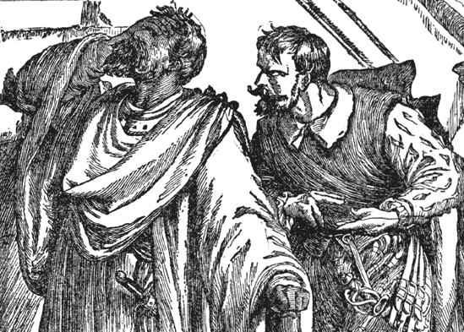

1. GABBAR SINGH:

**Who is he?**

**Gabbar Singh** is a [fictional character](http://en.wikipedia.org/wiki/Fictional_character) and the antagonist in the 1975 [Hindi film](http://en.wikipedia.org/wiki/Bollywood) [*Sholay*](http://en.wikipedia.org/wiki/Sholay)*.* Played by [Amjad Khan](http://en.wikipedia.org/wiki/Amjad_Khan), he is shown in the movie *Sholay* as a [dacoit](http://en.wikipedia.org/wiki/Dacoit) who leads a group in looting and plundering the villages in the region of Ramgarh. He has a sadistic personality and insists on killing whenever required to continue his status and to take revenge on his enemies. His sadism lies in his choice of words like "Khurach, khurach (scratch)" when he talks to [Hema Malini](http://en.wikipedia.org/wiki/Hema_Malini). The character of Gabbar is one of the most popular in [Indian films](http://en.wikipedia.org/wiki/Hindi_film).

**Character:**

Gabbar Singh is considered by many to be the first depiction of pure evil on the screen in Hindi Cinema; a totally evil character who doesn't make excuses for its evil. His mannerisms and dialogues have become an integral part of Bollywood lexicon.Although the movie boasted an ensemble cast of superstars including Dharmendra and Amitabh Bachchan, he stole the thunder with his unorthodox and eerie dialogue delivery that was perfectly apposite to the total lack of empathy his character was supposed to convey. Even after thirty five years people fondly remember his dialogues and mannerisms. *Sholay* went on to become a blockbuster, and is the highest grossing movie in India. The role of Gabbar singh was so deep-rooted in people's mind those days that Amjad Khan was known rest of his life by this role alone.

One of the famous dialogue of Gabbar singh was:

Gabbar- Hmmmm.... Kitane aadmi the?  
Kaliya- sardar.. do aadmi the.

Gabbar- hmmm.. Do aadmi ? .... SOOWAR KE BACHCHO..

woh do the aur tum teen .. phir bhi waapas aagayeye . khaali haath..

kya samaz kar aaye the?.. sardar bahot khus hoga sabasi dega kyoon?

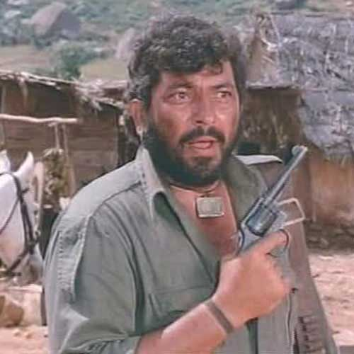

**DISCUSSION**

Anti-hero. Can the antagonist be the protagonist?

*If we look up a dictionary both antagonist and protagonist are listed as antonyms. Although it is not necessary that meanings of both these words have to really oppose each other. The traditional approach takes the main character as the good guy or the so called protagonist and his opponent, the guy who causing problems as the antagonist.*

*Most fictions tend to feature the perfect hero – handsome, muscular, charming (if somewhat shy), and always willing to do the right thing, even at the cost of self. This perfect vision of a hero is not the way the world works, though – the line between heroism and villainy is often pretty thin. Enter the anti-hero.*

*In fiction, an anti-hero (feminine: anti-heroine) is generally considered to be a protagonist whose character is at least in some regards conspicuously contrary to that of the archetypal hero, and is in some instances its antithesis. One common error people seem to make is to confuse the anti-hero with the villain. In fact, they play different roles. Generally, the motives of the anti-hero are impure, yet at the same time, sympathetic. The usual motivating drive would be revenge; thus the anti-hero will commit all manner of atrocities to achieve revenge.*

*A villain, on the other hand, is usually driven by the thirst for unabated power – an unsympathetic motive. Anti-heroes are often portrayed as underdogs and who doesn’t like to root for the underdog. So even if the anti-hero breaks commits crimes to accomplish a means, we often still root for him by virtue of the underdog quality; basically, the anti-hero has the odds stacked against him and must use any means possible to overcome them. Some examples of anti-heroes in fiction include:*

*In movies-*

* [*1. Travis Bickle in Taxi Driver (1976)*](http://thescriptlab.com/features/the-lists/1948-top-10-antiheroes?q=%2Ffeatures%2Fthe-lists%2F1948-top-10-antiheroes&start=10)
* [*2. Michael Corleone in The Godfather Trilogy (1972-90)*](http://thescriptlab.com/features/the-lists/1948-top-10-antiheroes?q=%2Ffeatures%2Fthe-lists%2F1948-top-10-antiheroes&start=9)
* [*3. Tyler Durden in Fight Club (1999)*](http://thescriptlab.com/features/the-lists/1948-top-10-antiheroes?q=%2Ffeatures%2Fthe-lists%2F1948-top-10-antiheroes&start=7)

*In novels-*

* *1. Shylock in Merchant of Venice.*
* *2. Severus Snape in Harry Potter Series.*
* *3. Jay Gatsby in The Great Gatsby.*

Why is antagonist required in a fiction ?

An antagonist is required in a story as he  makes the story more interesting.  He or she serves as a foil to the main character, or hero.  That means the villain gives the hero someone to act off of and oppose.  The villain increases the suspense and conflict. Without the villain, conflict does not exist. Without conflict, nothing is learned, nothing is gained, nothing really happens. In 'Othello', the villain, Iago, is probably the most memorable and evil of all villains in literature. We are fascinated as an audience with regard to the intricate planning with which he executes the destruction of those around him. We continue to be repelled, intrigued and compelled by him as a character as his motivations have various evil interpretations.

Besides without the villain, we couldn't have a "good guy." Any hero needs a nemesis.  Heroes are nothing without their villains.  They are simply all wonderful people who fight for the right, etc.  What really makes them shine is their villains.  These are the people who are "bad" in various ways that allow the characteristics of the good guys to really shine.  Infact, a villian is absolutely necessary in any aspect of life- textual, situational, and in life. For example in real life we worship gods like shiva, ram and krishna because they were the ones who freed the world from the oppression and inhumanity of demons like ravan who were engulfing the world with their evil deeds.

Should villain win?

Why should always the hero win? Some people think that it is the law of nature that good should always triumph over the evil. But is this neccesary in fiction as well? Nowadays in some stories it is shown that the villain also has a sympathetic side. This is when the plot becomes really interesting and gripping. This happens because we can't decide whether we are angry with the villain for what evil stuff he is doing and dead bent on defeating him or whether we are silently rooting for him to win against the hero.

Sometimes the villain may do many atrocities on people and then also win in some way or the other directly or indirectly. This is to give a tragic ending to the story or to just refrain from taking the beaten path of depicting the hero as victorious. Some example of this in movies include seven, usual suspects and saw series where the evil side of human takes the upper hand. Some of the novels which show this is watchmen, animal farm and the darka trilogy.

Goals of a Villain:

*Without a protagonist a story or fiction is meaningless. Every literature, drama or movie consists of a villain. In real life, emotions such as hatred, jealousy, anger etc. in an individual level can be considered a villain. If taken globally, terrorists, criminals and dictators can be considered villains. The villain is the guy who opposes good but that doesn’t mean that he is necessary evil (in some cases). After the defeat of the World War I, the pathetic plight of Germany was greatly improved by Hitler, though his anti-Semitic and racist thoughts made him inhumane in the end. In the mind of Osama, the rule of Americans has oppressed the Muslims in the Middle East. Thus, he wanted to punish USA. A villain maybe right or wrong to the society but in their head they do it for a purpose. But some criminals commit crime for money and power. In this context villains like Hitler and Osama are unlike these criminals because they abuse their power and money to a certain goal. But many a times we come across villains from fiction who doesn’t want money and power. Like, Joker who just commits crimes because he wants to play with Batman(comics). Thus, a villain can have many or no reasons to commit evil. Revenge is a very powerful factor that can convert a person to the dark side. Murders, robbery, rape etc. and many of such hideous crimes are mainly committed because of revenge.*

**Abstract**

*“I like not fair terms and a villain’s mind.”*

*-William Shakespeare*

*Like an electron which opposes a proton and thus stabilizes the whole atom, good and bad characters co-exist in our society. However, we cannot eradicate evil totally; we can in a limited sense control it, to make this world a better place. On one hand we see villains such as Hitler who tried to change history with a single thought in his mind and on other hand there are criminals who commit crimes for personal gains and vendetta. Particularly these kinds of villains make our society a rotten place.*

*In fiction the antagonist opposes the protagonist. We all know what a hero will do with his good qualities but if you observe closely an antagonist makes a fiction popular or mundane. The unpredictable and scary qualities of the Joker or the Voldemort or Iago, only themselves make that particular fiction more interesting. As quoted by Marilyn Manson;*

*“In any story the villains is the catalyst. The hero is not a person who will bend the rules or show the cracks in his armour. He is one-dimensional intentionally. But the villain is the person who owns up to what he is and stands by it.”*

*And on an entirely different plane we have anti-heroes; the characters who can be seen as both protagonist and antagonist. Anti-heroes don’t always do the right thing; they may be selfish and do the wrong thing – if not always, then occasionally. In extreme cases, anti-heroes might even qualify as the villain. Look at the character Don from the Bollywood movie ‘Don’! Thus, without a doubt we can say that villains may not be an ideal character to follow but they are definitely interesting than heroes.*

***Keywords:***

1. *Evil*
2. *Villain*
3. *Protagonist*
4. *Antagonist*
5. *Anti-hero*

**CONCLUSION**

We were able to conclude from the project that the antagonist is as important as the hero of the fiction and sometimes he could also take the upper-hand in a story by being the dominant character in the whole story. Sometimes he could also be the person who drives plot forward. So an antagonist could take up any trait from human nature make it of his own.

**REFERENCES**

Websites :

1. Wikipedia.org
2. Telegraph-files.com
3. Wikihow.com
4. Yahooanswers.com
5. Google.com

Books :

1. Fantasy world
2. Fiction Encyclopedia
3. All about villains