|  |
| --- |
|  |
| **MULTI CHANNEL QUEUING SYSTEM IN SUPERMARKET** |

**Table of Contents**

|  |  |
| --- | --- |
| ***SNo.*** | ***TITLE*** |
| 1. | Abstract |
| 2. | Methodology |
| 3. | Literature Survey (CASE STUDY) |
| 4. | Program Code |
| 5. | Output |
| 6. | Conclusion |
| 7. | Pragmatic Application |
| 8. | References |

**ABSTRACT**

* A queuing system is used to control queues. Queues of people form in various situations and locations in a queue area. The process of queue formation and propagation is defined as ***Queuing Theory***.
* Multi-channel queuing theory treats the condition in which there is more than one service station in parallel and each customer in the waiting line can be served by more than one station.
* Each server is prepared to deliver the same type of service. The new arrival selects one station without any external pressure (i.e. it depends on the customer).
* When a waiting line is formed, a single line usually breaks down into several shorter lines in front of each service station in order to reduce the waiting time.
* The arrival rate represented by λ and service rate represented by μ is mean values from Poisson distribution and exponential distribution respectively. Since discipline is first come, first served (FIFO) and customers are taken from a single queue i.e., any empty channel is filled by the next customer in line. There is no server left empty in case of rush.
* Here, the variables used to denote the multi-channel queuing system and their descriptions are given below-

n = number of customers in system

po = probability of 0 customers in the system

pn = probability of n customers in the system

c = number of parallel service channels(c>1)

λ = arrival rate of customers

μ = service rate of individual channel

**METHODOLOGY**

The three main inputs are arrival rate, service rate and number of service channels. A list of formulas is given below which help in the computation of the desired value. The queuing model is of the type:

(M/M/C): (∞/FCFS) Here,

* FCFS stands for first come first served.
* C refers to the number of servers who work in parallel.
* ∞ refers to the population.
* Since the model is based on Poisson and exponential distribution which are related to each other, both are denoted by 'M' due to Markovian property of exponential distribution.

1. **Ls –** Expected (average) number of customers in the system, including those being served.

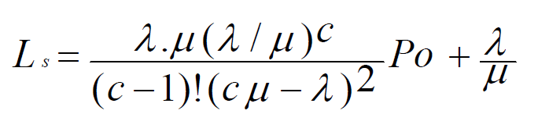

1. **Lq** - Expected (average) number of customers in the queue, which excludes those being served.

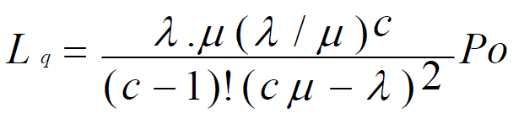

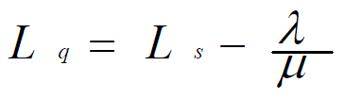

1. **Ws –** Expected (average) waiting time in the system, including service time, for an individual.

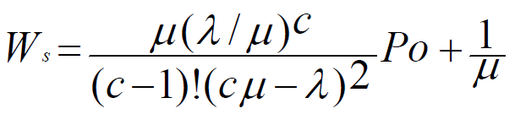

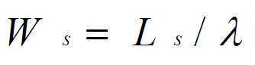

1. **Wq -** Expected (average) waiting time in the queue, which excludes service time for an individual customer.

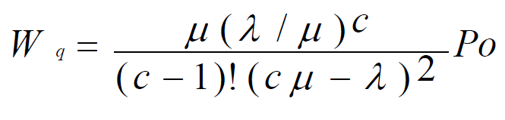

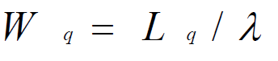

1. **P(n>c)** – Probability that a customer has to wait.

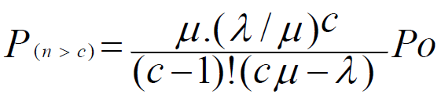

1. Probability that a customer enters the service without waiting

= **1- P(n>c)**

1. **Po** – Probability of having no customer in the system

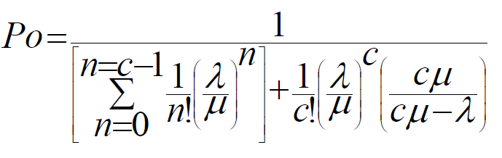

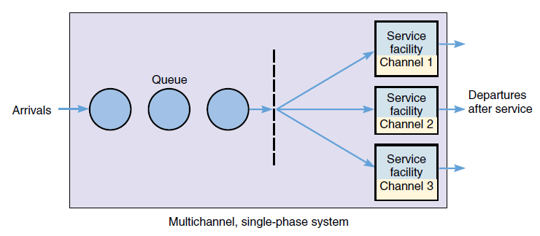

**CASE STUDY**

We conducted a case study on this subject in order to collect data. We visited Allmart(Supermarket) on 5 different days at different timings to record the arrival and the service time . According to that we calculated the average service time of the two servers (Multi queuing system)

The following table represents the data recorded:

|  |  |  |  |
| --- | --- | --- | --- |
|  | **Arrival Rate** | **SERVER 1** | **SERVER 2** |
| **Service rate** | **Service rate** |
| **DAY 1 (9am - 10am)** | 67 | 30 | 32 |
| **DAY 2 (12pm - 1pm)** | 65 | 33 | 30 |
| **DAY 3 (1pm – 2pm)** | 60 | 25 | 33 |
| **DAY 4 (5pm – 6pm)** | 85 | 45 | 40 |
| **DAY 5 (7pm – 8pm)** | 61 | 38 | 30 |
| **TOTAL** |  | **171** | **175** |

Mean arrival rate: 67.6

Mean service rate for server 1: 34.20

Mean service rate for server 2: 35.00

Mean service rate: 34.6

**Example of a case study similar to our multi channel queuing system**

QUEUING THEORY AND ITS APPLICATION:

ANALYSIS OF THE SALES CHECKOUT

OPERATION IN ICA SUPERMARKET

By

Azmat Nafees

**ABSTRACT**

This paper contains the analysis of Queuing systems for the empirical data of supermarket checkout service unit as an example. One of the expected gains from studying queuing systems is to review the efficiency of the models in terms of utilization and waiting length, hence increasing the number of queues so customers will not have to wait longer when servers are too busy. In other words, trying to estimate the waiting time and length of queue(s), is the aim of this research paper. We may use queuing simulation to obtain a sample performance result and we are more interested in obtaining estimated solutions for multiple queuing models.

**CONCLUSION**

This paper reviews a queuing model for multiple servers. The average queue length can be estimated simply from raw data from questionnaires by using the collected number of customers waiting in a queue each minute. We can compare this average with that of queuing model. Three different models are used to estimate a queue length: a single-queue multi-server model, single-queue single-server and multiple queue multi-server model. In case of more than one queue (multiple queue), customers in any queue switch to shorter queue (jockey behavior of queue). Therefore, there are no analytical solutions available for multiple queues and hence queuing simulation is run to find the estimates for queue length and waiting time.

**PROGRAM CODE**

#include<stdio.h>

#include<conio.h>

#include<math.h>

int rfact(int n)

{

if (n<=1)

return(1);

else

n=n*rfact(n-1);

return n;

}

int main()

{

Float a,s,u,temp,fact,div,sum,p,temp2,power,div1,fact1,sq,Ls,Lq,Ws,Wq,Pn,Pl;

int c,choice;

printf("\n\nMULTI CHANNEL QUEUING MODEL");

printf("\n\nEnter the arrival rate :");

scanf("%f" ,&a);

printf("\n Enter the service rate (µ) :");

scanf("%f" ,&s);

printf("\n Enter the no of channels :");

scanf("%d" ,&c);

for(int i=0;i<c;i++)

{

temp = pow((a/s),i);

fact = rfact(i);

div = temp/fact;

sum = sum+div;

}

temp = pow((a/s),c);

fact = rfact(c);

div = temp/fact;

temp2 = div*((c*s)/((c*s)-a));

p = 1/(sum+temp2);

div1 = a/s;

power = pow(div1,c);

fact1 = rfact(c-1);

sq = pow(((c*s) - a),2);

Ls = ((power*s*a*p)/(fact1*sq)) + div1;

Lq= (Ls-(a/s));

do {

printf(": \n\n"

"1) Utilisation rate \n"

"2) Probabability of having no customer in the system (Po) \n"

"3) Expected (average) no of customers in the system (Ls) \n"

"4) Expected (average) no of customers waiting in the queue (Lq) \n"

"5) Average time a customer spends in a system (Ws) \n"

"6) Average waiting time of a customer in the queue (Wq)\n"

"7) Probability that a customer has to wait P(n>=c) \n"

"8) Probability that a customer enters the service without waiting \n"

"9) Exit \n\n\n");

scanf("%d", &choice);

if (choice == 1)

{

u=(a/(c*s));

printf("\n\n The utilisation factor is : %f" , u);

}

else if (choice == 2)

{

printf("\n The probability of having no customer in the system (Po) is : %f" ,p);

}

else if (choice == 3)

{

printf("Expected (average) no of customers in the system (Ls) is : %f" , Ls);

}

else if (choice == 4)

{

printf("Expected (average) no of customers waiting in the queue (Lq) is %f", Lq);

}

else if (choice == 5)

{

Ws=(Ls/a);

printf("Average time a customer spends in a system (Ws) is %f" , Ws);

}

else if (choice == 6)

{

Wq=(Lq/a);

printf("Average waiting time of a customer in the queue (Wq) is %f" , Wq);

}

else if (choice == 7)

{

Pn= (Lq*((c*s)-a))/a;

printf("Probability that a customer has to wait P(n>=c) is %f",Pn);

}

else if (choice == 8)

{

Pn= (Lq*((c*s)-a))/a;

Pl=1-Pn;

printf("Probability that a customer enters the service without waiting is %f",Pl);

}

else {

printf("Invalid Choice");

}

} while (choice != 9);}

**OUTPUT**

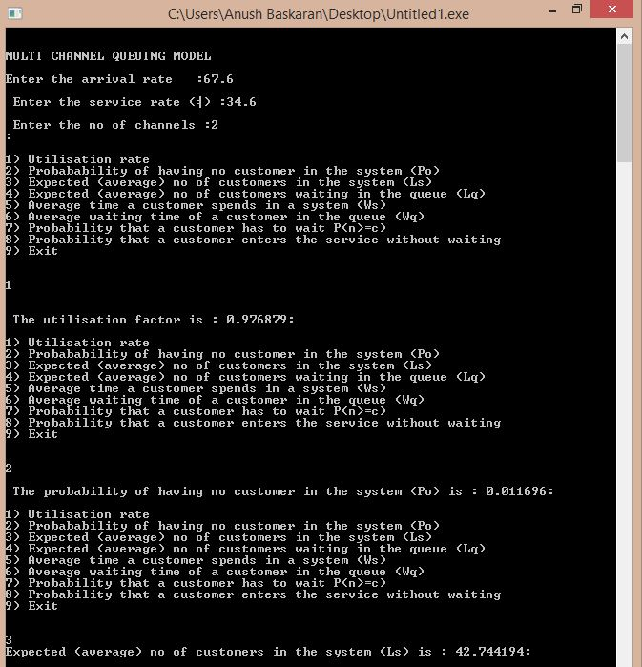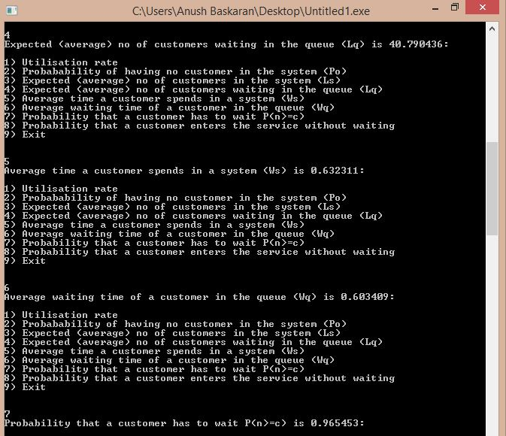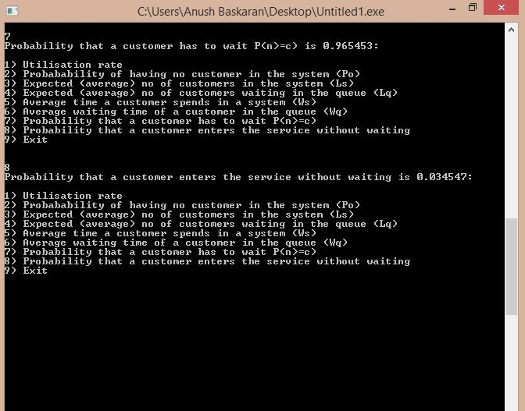

**PRAGMATIC APPLICATION**

**The Cost of Waiting in Line:**

The problem in virtually every queuing situation is a trade-off decision. The manager must weigh the added cost of providing more rapid service (i.e., more checkout counters, more production staff) against the inherent cost of waiting. For example, if employees are spending their time manually entering data, a business manager or process improvement expert could compare the cost of investing in bar-code scanners against the benefits of increased productivity. Likewise, if customers are walking away disgusted because of insufficient customer support personnel, the business could compare the cost of hiring more staff to the value of increased revenues and maintaining customer loyalty.

The relationship between service capacity and queuing cost can be expressed graphically (Figure 1). Initially, the cost of waiting in line is at a maximum when the organization is at minimal service capacity. As service capacity increases, there is a reduction in the number of customers in the line and in their wait times, which decreases queuing cost. The optimal total cost is found at the intersection between the service capacity and waiting line curves.

Figure 1: Service Capacity vs. Cost

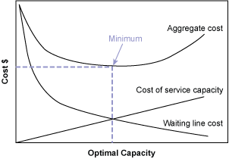

*Source: Richard B. Chase and Nicholas J. Aquilano,* Production and Operations Management, *1973, page 131.*

**Queuing Theory**

Queuing theory, the mathematical study of waiting in lines, is a branch of operations research because the results often are used when making business decisions about the resources needed to provide service. At its most basic level, queuing theory involves arrivals at a facility (i.e., computer store, pharmacy, bank) and service requirements of that facility (i.e., technicians, pharmacists, tellers). The number of arrivals generally fluctuates over the course of the hours that the facility is available for business (Figure 2).

Figure 2: Number of Arrivals at Facility

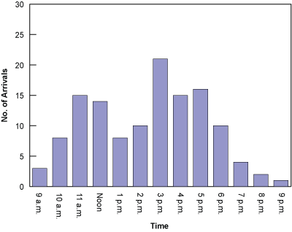

Customers demand varying degrees of service, some of which can exceed normal capacity (Figure 3). The store manager or business owner can exercise some control over arrivals. For example, the simplest arrival-control mechanism is the posting of business hours. Other common techniques include lowering prices on typically slow days to balance customer traffic throughout the week and establishing appointments with specific times for customers. The point is that queues are within the control of the system management and design.

Figure 3: Service Requirements

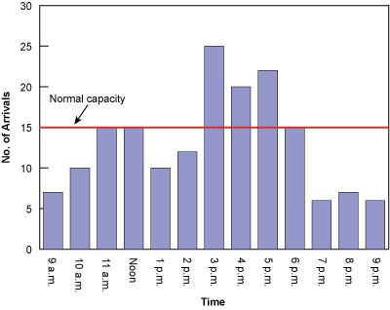

Queuing management consists of three major components:

1. How customers arrive
2. How customers are serviced
3. The condition of the customer exiting the system

**Arrivals:** Arrivals are divided into two types:

1. *Constant*  exactly the same time period between successive arrivals (i.e., machine controlled).
2. *Variable*  random arrival distributions, which is a much more common form of arrival.

A good rule of thumb to remember the two distributions is that time between arrivals is exponentially distributed and the numbers of arrivals per unit of time is Poisson distributed.

**The Servicing or Queuing System:** The *servicing* or *queuing system* consists of the line(s) and the available number of servers. Factors to consider include the line length, number of lines and the queue discipline. Queue discipline is the priority rule, or rules, for determining the order of service to customers in a waiting line. One of the most common used priority rules is first come, first served (FCFS). Others include a reservations first, treatment via triage (i.e., emergency rooms of hospitals), highest-profit customer first, largest orders first, best customers first and longest wait-time first. An important feature of the waiting structure is the time the customer spends with the server once the service has started. This is referred to as the *service rate*: the capacity of the server in numbers of units per time period (i.e., 15 orders per hour).

Another important aspect of the servicing system is the line structure. There are four types: single-channel/single-phase; single-channel/multi-phase; multi-channel/single-phase; and multi-channel/multi-phase. The simplest type of waiting line structure is the single-channel, single-phase. Here, there is only one channel for arriving customers and one phase of the service system. An example is the drive-through window of a dry-cleaning store or bank.

**Exit:** There are two possible outcomes after a customer is served. The customer is either satisfied or not satisfied and requires re-service.

**CONCLUSION**

The above developed program can be used to calculate values of the attributes associated with multi queuing system e.g.: Ls, Lq when the arrival and service rates are given as input. Multi queuing system is more efficient because the number of service channels is more than one and thus the main queue splits into smaller ones.

**References**

* http://www.nhai.org/projectmap.htm
* http://www.theijes.com/papers/v2-i1/Y02101540159.pdf
* http://www.cedc.ro/media/MSD/Papers/Volume%204%20no%201%2020 12/MSD_11.pdf
* www.ccsenet.org/journal/index.php/ijbm/article/download/10851/7704
* http://www.isixsigma.com/industries/retail
* classes.bus.oregonstate.edu/ba302/reitsma/queuing.html
* books.google.co.in/books?isbn=0486439143
* hal.archives-ouvertes.fr/docs/00/26/90/41
* home.snc.edu/eliotelfner/333/Team%204%20Queuing%20Analysis
* isites.harvard.edu/fs/docs/icb.../Queuing%20Theory%20