

Abdul Rasheed Feroz Khan

Technical Evangelist

Fb.com/Abdulrasheed92

© 2015 Microsoft Corporation. All rights reserved.

Table of Contents

Introduction 3

Overview of the lab 3

Scenario 3

Prerequisites 3

Exercise 1 : 4

Migrate on-premise database as-is and find out features not supported in Azure SQL Database. 4

Summary 11

SQL Database Migration Wizard 12

Scenario 2: 13

Migrate database using SQL Database Migration Wizard. 13

Summary 21

Scenario 3: 22

Migrate database to a Premium P3 database and compare performance. 22

Azure Database editions’ comparison 22

Best practices 22

Tell us what you think 24

References 25

Azure Support 26

# Introduction

Estimated time to complete this lab - 45 minutes

Objectives After completing this lab, you will be able to:

- Understand different Azure SQL editions.

- Migrate On-Premise SQL databases to Azure SQL.

- learn Azure SQL Database Migration best practices

# Overview of the lab

In this lab you will be migrating On-Premise SQL Server database to Azure SQL database using different tools available, like – SQL Database Migration Wizard, SSMS – Deploy database to SQL Azure, Import and Export Wizard.

While migrating, you will also learn the best practices. The lab also focuses on features that are not supported in Azure SQL database and ways to identify such features/syntax.

# Scenario

1. Migrate on-premise database as-is and find out features not supported in Azure SQL Database. Rectify the problems and migrate again.
2. Migrate database using [SQL Database Migration Wizard](https://sqlazuremw.codeplex.com/releases/view/32334).
3. Migrate database to a Premium P3 database and compare performance.

# Prerequisites

1. Microsoft Azure subscription.
2. OS - Microsoft Windows 8.1 Enterprise
3. SQL Server 2012 Enterprise Edition.

Microsoft SQL Server 2012 - 11.0.2218.0 (X64)

Enterprise Edition (64-bit) on Windows NT 6.2 <X64> (Build 9200: ) (Hypervisor)

4. The following in C:\Contents folder of the machine -

a. SQL Database migration Assistant(SQLAzureMW v4.15.4 Release Binary for SQL Server 2012.zip) - can be downloaded from <https://sqlazuremw.codeplex.com/releases/view/32334>

b. AdventureWorksFull.bak - can be downloaded from <http://1drv.ms/1aXfz5v>

# Exercise 1:

## Migrate on premise database as-is and find out features not supported in Azure SQL Database.

1. Open SQL Server Management Studio and restore AdventureWorksFull.bak placed under c:\contents. This will be the database that we will try to migrate.

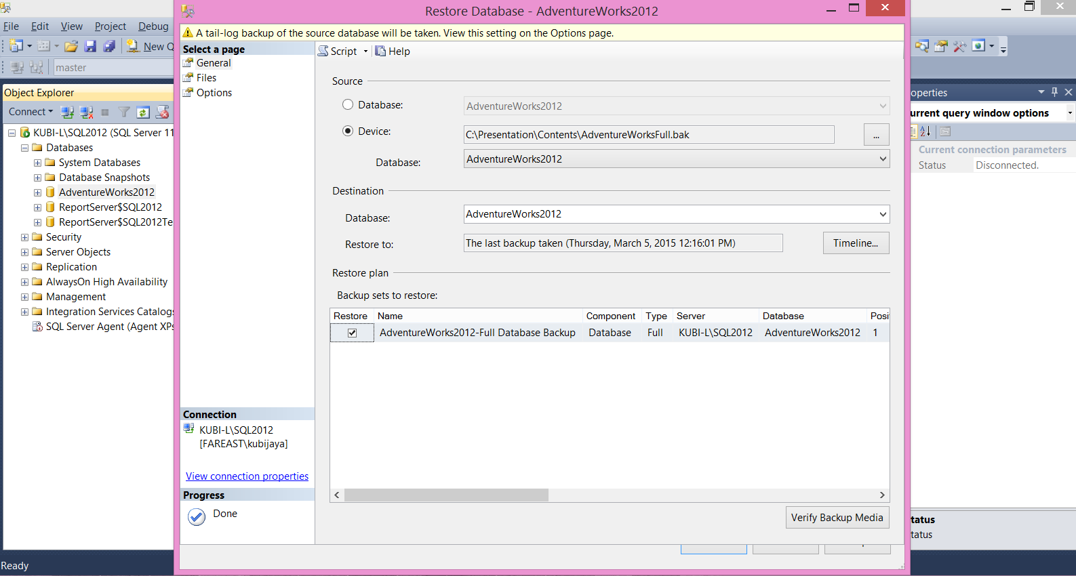

1. Log on to Azure portal at <https://manage.windowsazure.com/> .
2. Create a new Azure SQL Database. Click on “NEW” at the left bottom of the screen.



1. Click on “Data Services” -> SQL Database -> Quick Create -> Fill in the database details - 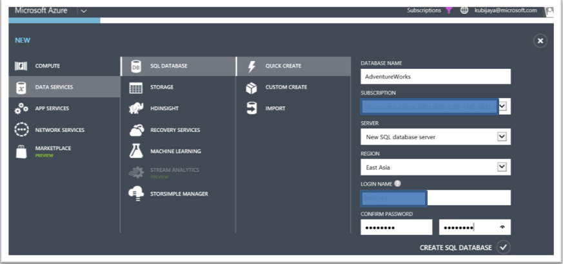

NOTE: The login name that you give is sort of sa account on Azure SQL Database.

1. This should create your database on a new server –

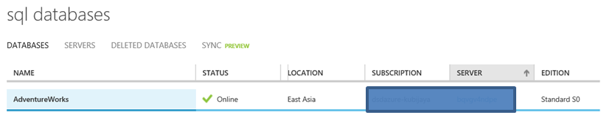

1. Click on Server -> Configure and add the “current client IP address” to the allowed IP addresses.

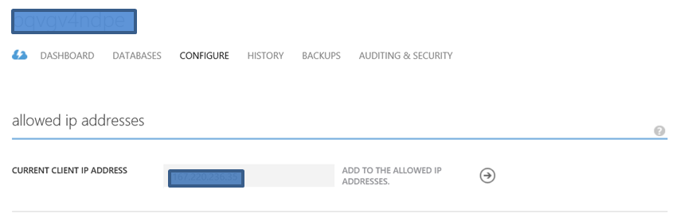

1. Following the steps above will have your Azure environment ready for data migration. Follow the steps below on the on-premise server.
2. On SSMS -> Right click on the database(AdventureWorks2012) -> tasks -> Export Data tier Application. Select “Save to local disk” and specify a location where the bacpac flie will be created. 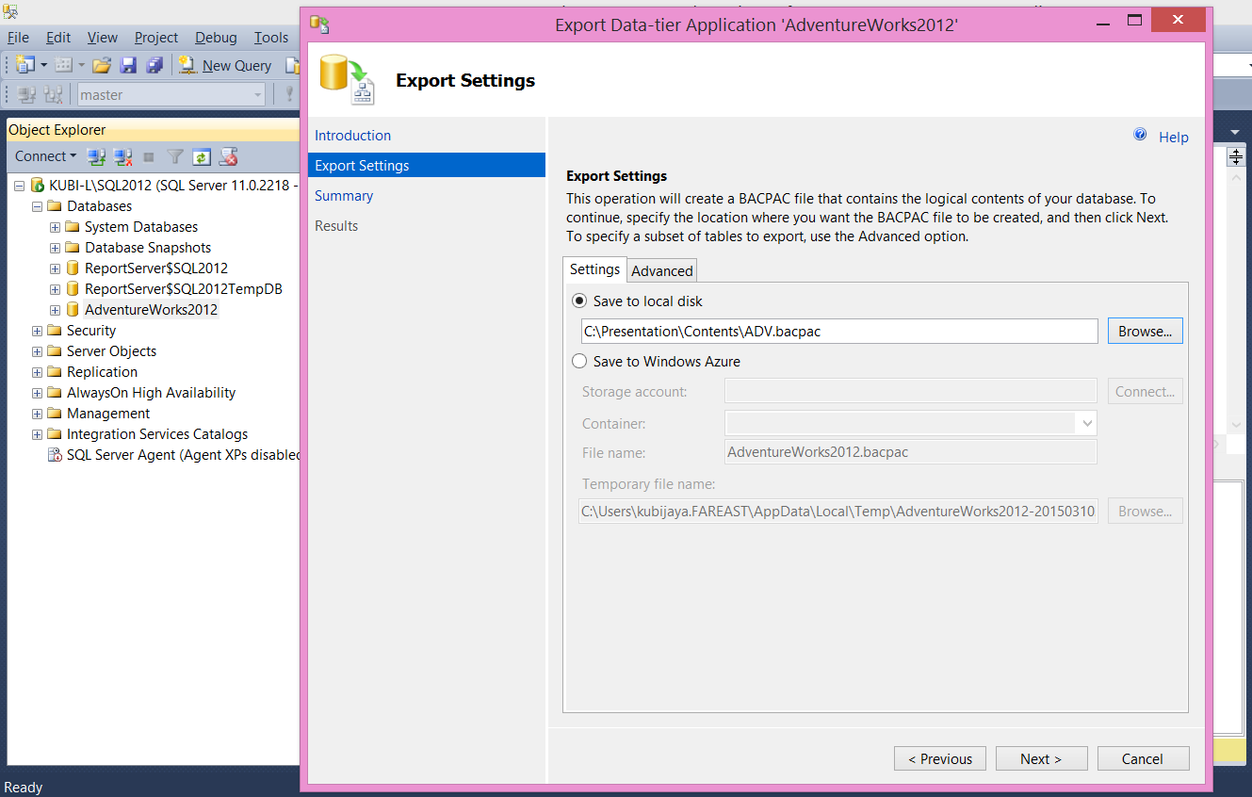

NOTE: A BACPAC contains both schema and data, but does not support being imported to a database project for schema modification. The primary use of a BACPAC is to move a database from one database service to another (either instances of the Database Engine or Azure SQL Database. A BACPAC can also be used to archive an existing database in an open format. These uses make it a good tool for migrations where the database requires no schema changes. Refer <https://msdn.microsoft.com/en-us/library/azure/jj156148.aspx> for details.

1. Run through the rest of the tabs and click “Finish”.
2. The export would fail as there are objects in the database which are not supported –

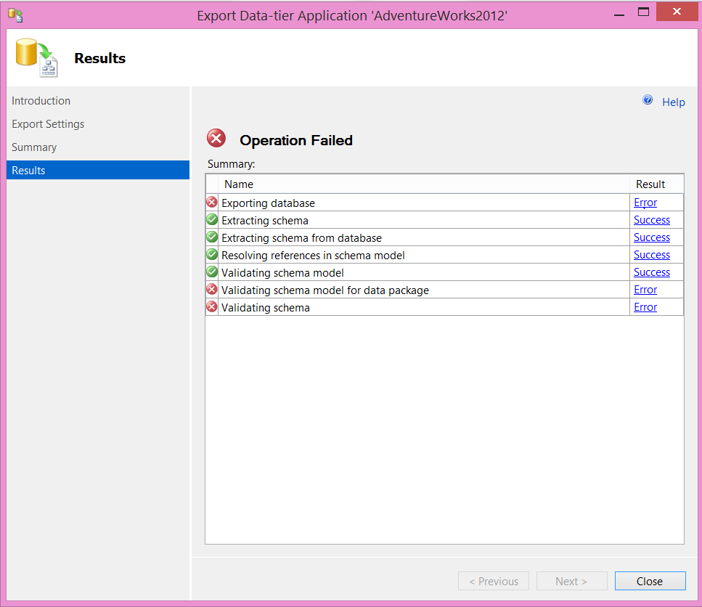

1. Click on the error message above, and it displays the following message –

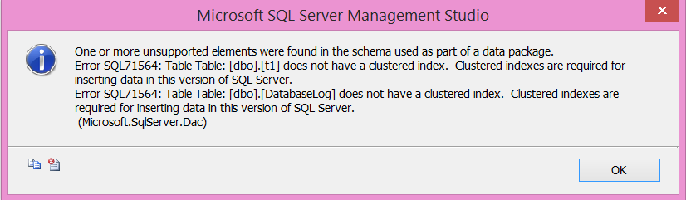

The error message tells us that the two tables(t1 and DatabaseLog) do not have clustered indexes, which is a requirement for the Azure SQL database.

1. To fix the error, connect to your on-premise database and run the following queries –

CREATE CLUSTERED INDEX ind_t1 ON t1 (name)

CREATE CLUSTERED INDEX ind_DatabaseLog ON DatabaseLog(DatabaseLogID)

1. We have fixed a problem and we do not know if there are other problems with the database or not. Let’s use “Deploy database to SQL Azure” wizard this time. Even “Deploy database to SQL Azure” wizard creates a bacpac and then imports it into Azure SQL database.

To use the wizard, right click on the database -> tasks -> Deploy database to SQL Azure. This will open up a window. Skip the introduction page and the window will look like this –

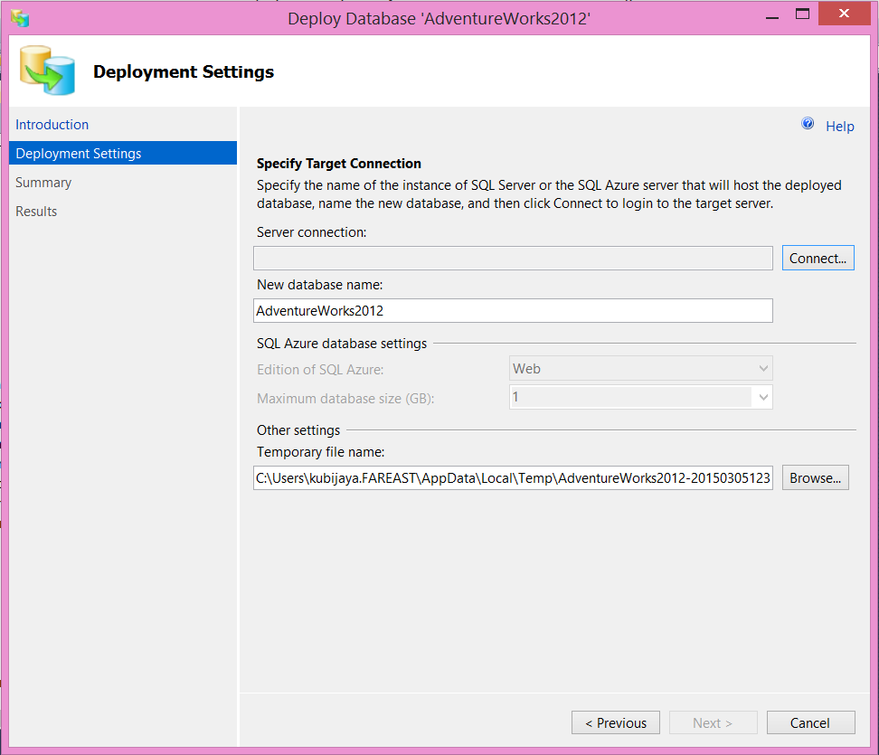

1. Click on “Connect” and specify the Azure Database Server that you want your on-premise database to be migrated to –

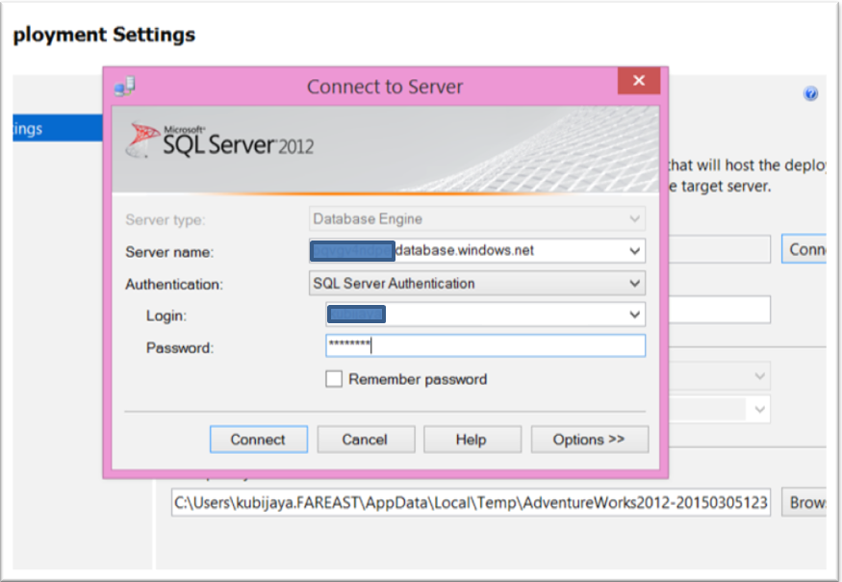

1. Run through the rest of the steps and click “finish” This will initiate data export.
2. Export then moves forward, but fails (in about 5 minutes) - 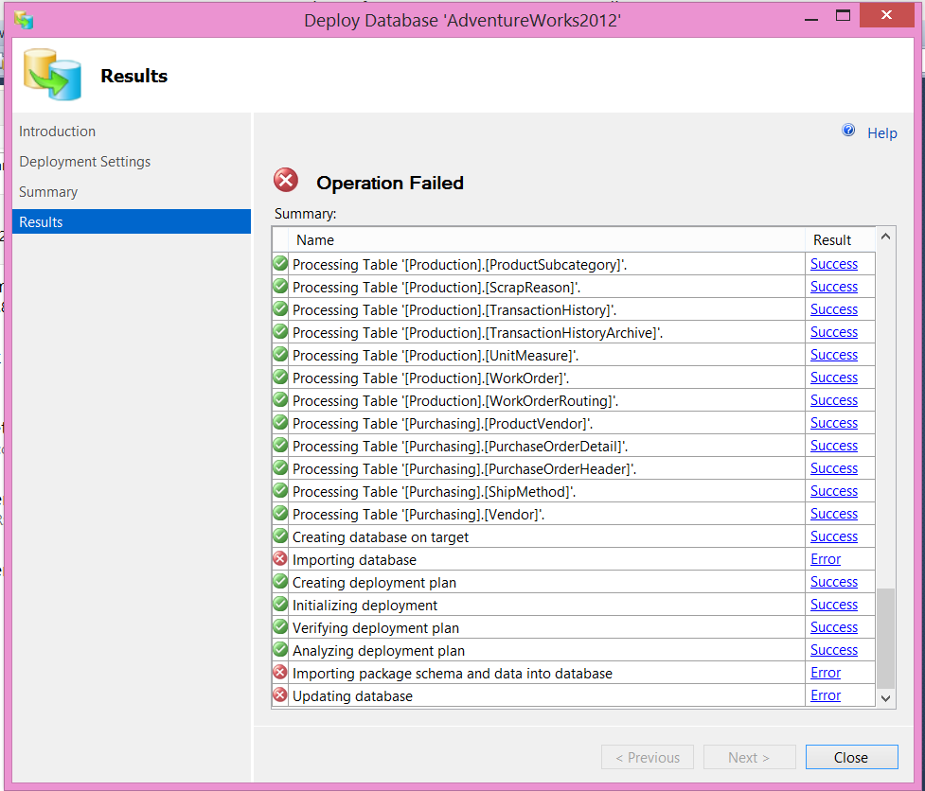
3. Click on the error message, and it reports following –

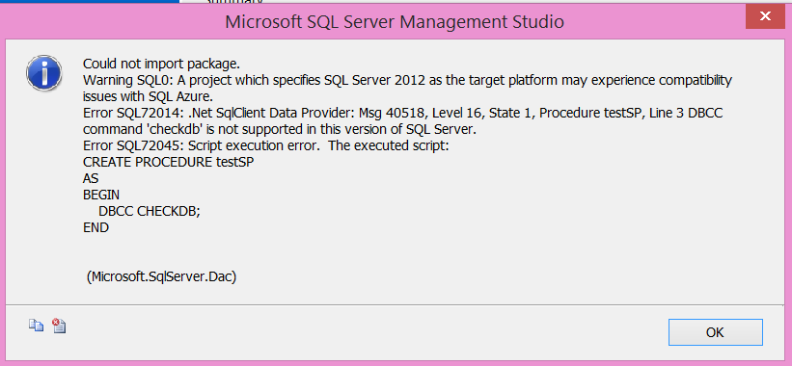

1. From the above error – we understand that there is a Stored Procedure within the on-premise database that is running “DBCC CHECKDB” , which isn’t supported in Azure SQL databases.

### Summary

We discovered that the import/export wizard just fails when it finds an object/feature that isn’t supported in Azure SQL Databases. We will use “[SQL Database Migration Wizard](https://sqlazuremw.codeplex.com/releases/view/32334)” to avoid such failures. This new wizard can read through the schema definition/trace file and report the features not supported in Azure SQL Databases. You can then make necessary changes and move the database to Azure.

# SQL Database Migration Wizard

The SQL Database Migration Wizard (SQLAzureMW) gives you the options to analyze, generates scripts, and migrate data (via BCP) from:

1.SQL Server to Microsoft Azure SQL Database

2.Microsoft Azure SQL Database to SQL Server

3.Microsoft Azure SQL Database to Microsoft Azure SQL Database

It will also analyze SQL Profiler trace files and TSQL script for compatibility issues with Microsoft Azure SQL Database.

1.If your source is a SQL Server database, SQLAzureMW will list all of the object types (i.e. Tables, Stored Procedures, Views, etc.) and let you decide which ones you want analyzed / scripted. Using the “Advanced” options you can tell SQLAzureMW which compatibility checks to perform and if the data should be migrated.

2.If your source is a file containing TSQL, then you will be given the option to have SQLAzureMW check the TSQL for incompatibilities and fix where possible or just run the script without any compatibility checking.

3.You can specify a SQL Profiler trace file for analysis.

Read more at <https://sqlazuremw.codeplex.com/>.

# Scenario 2:

## Migrate database using SQL Database Migration Wizard.

1. Download SQL Database Migration Wizard(SQLAzureMW v4.15.4 Release Binary for SQL Server 2012) from <https://sqlazuremw.codeplex.com/releases/view/32334>.
2. Extract the downloaded zip file - SQLAzureMW v4.15.4 Release Binary for SQL Server 2012.zip
3. Open the folder where the file was extracted and open SQLAzureMW.exe. This will open the migration wizard –

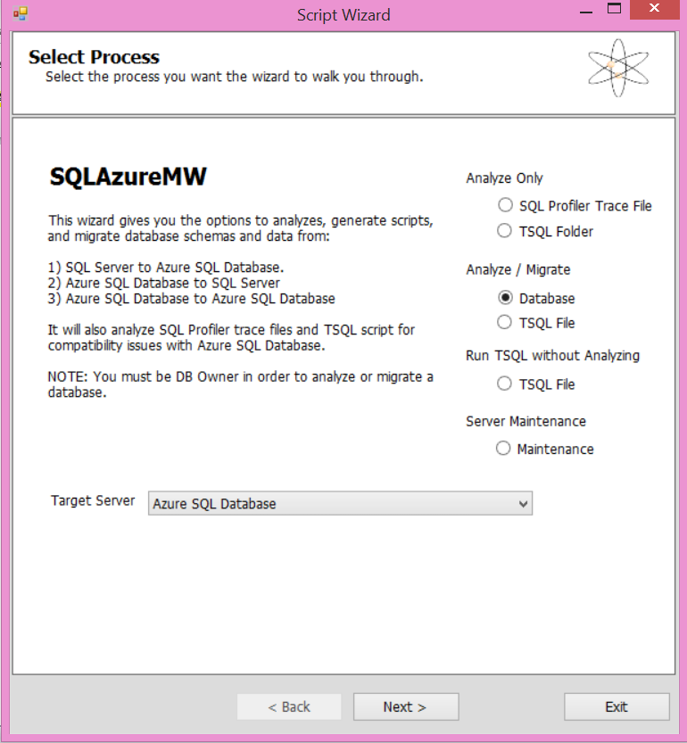

1. Select “Database” under “Analyze/Migrate”. Select “Azure SQL Database as the target server, and click next.
2. Enter the source server details, which is your on-premise database.

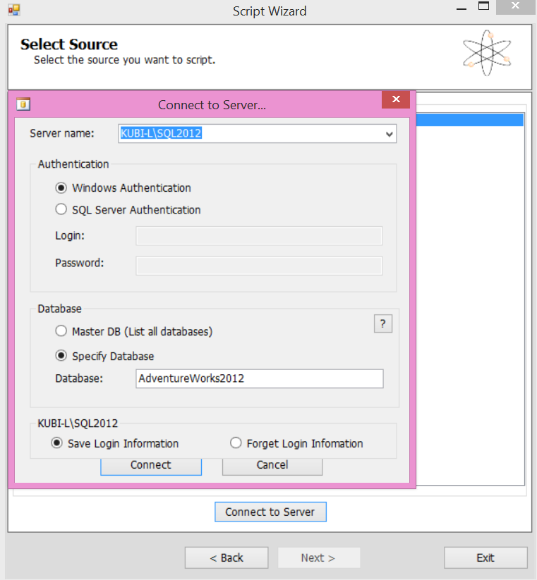

1. The databases hosted on the server will be displayed on the next page –

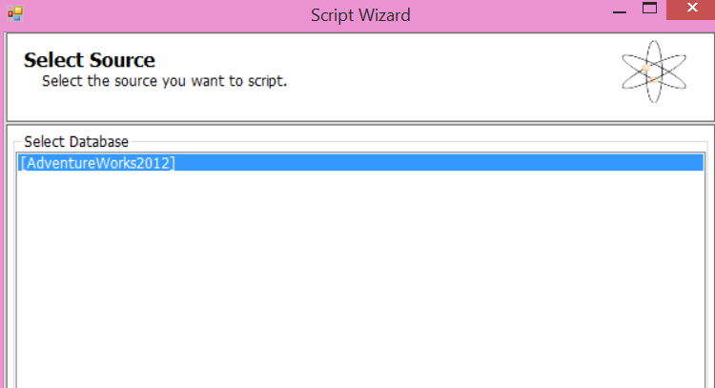

1. Select the database that you want to migrate and click next.
2. Select the objects that you want to migrate. We will select only a few tables considering the network bandwidth.
3. Click “Advanced”. Select “table schema with data” for “script table / data” under Table/View Options and click ok and then click next.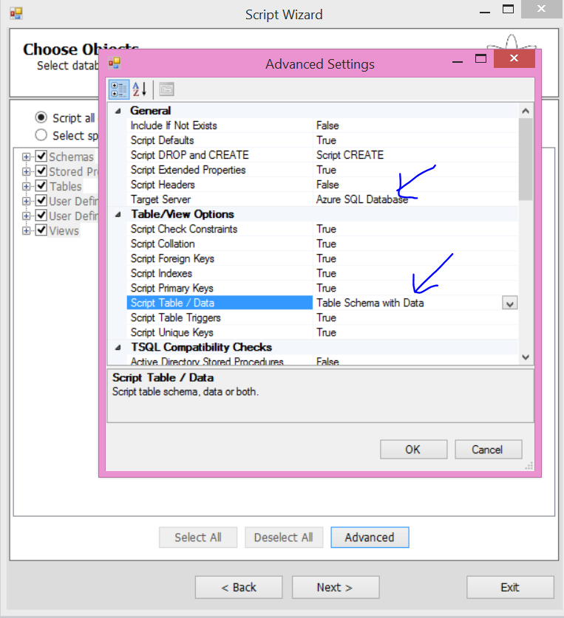
4. The next page displays summarizes your selection. Click next on the page.
5. The Migration Wizard now does its work – creates a SQL Script for migration and displays Result

Results Summary –

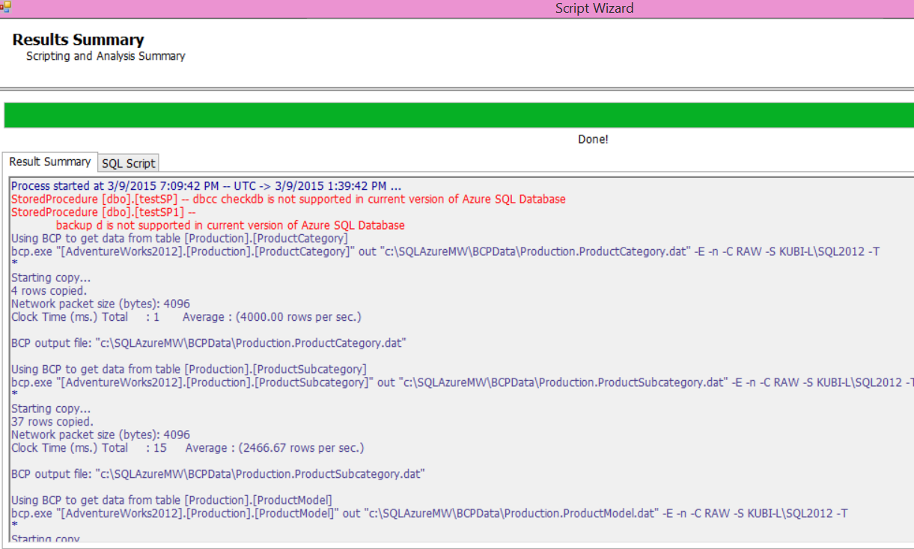

You can see in the results that the problems are identified. The wizard reports the problems in red and also displays the message about the bcp files created. Review the results and then click on the “SQL Script” tab. You should see the following screen –

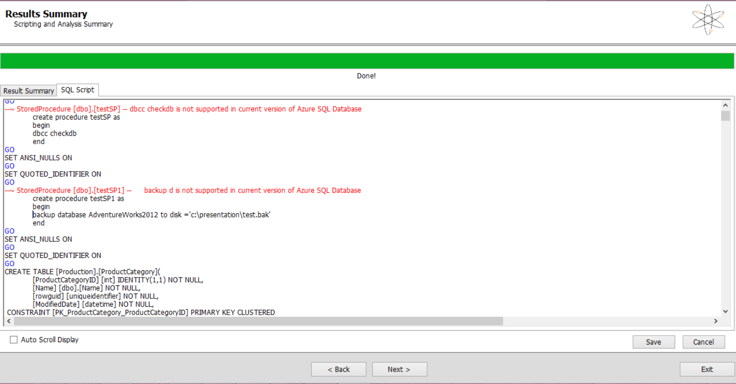

1. This is the script that’s going to run to migrate your database schema and data. You could modify the script here. For this session, we will just delete the SQL Commands that are in red and not supported. Also, the wizard adds a clustered index if it’s missing –

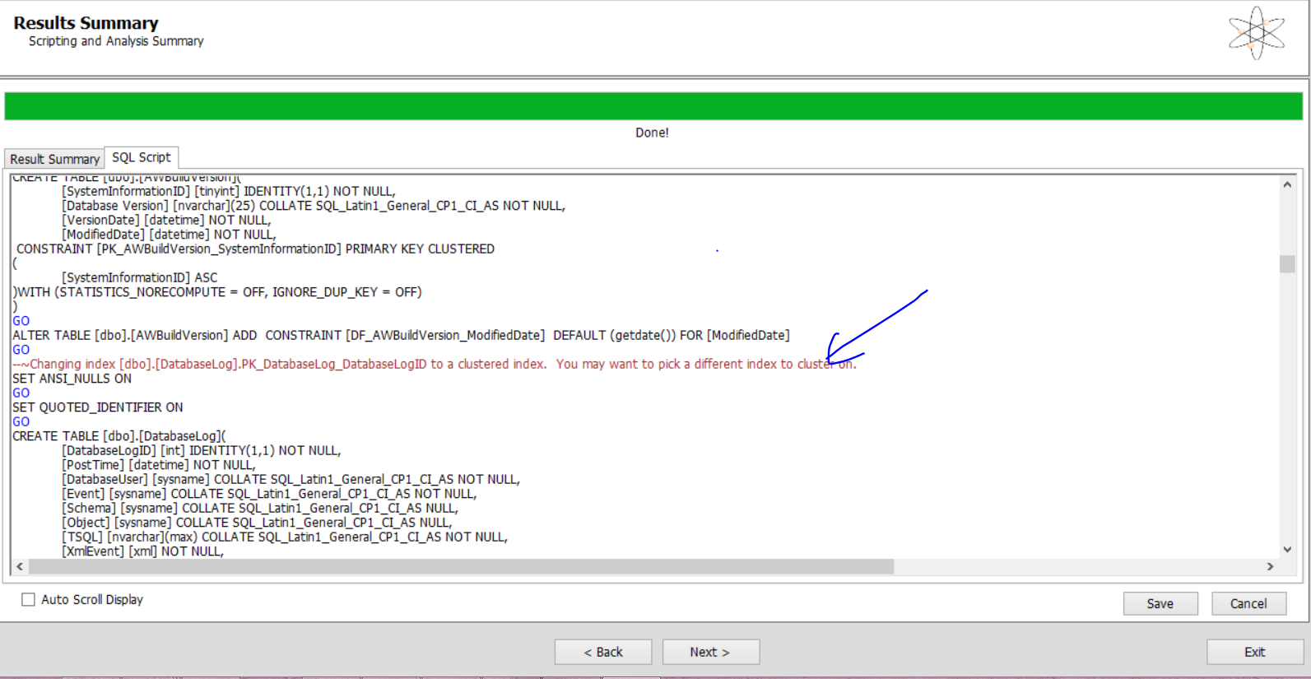

1. Click next and then enter the details of the target Azure SQL Database –

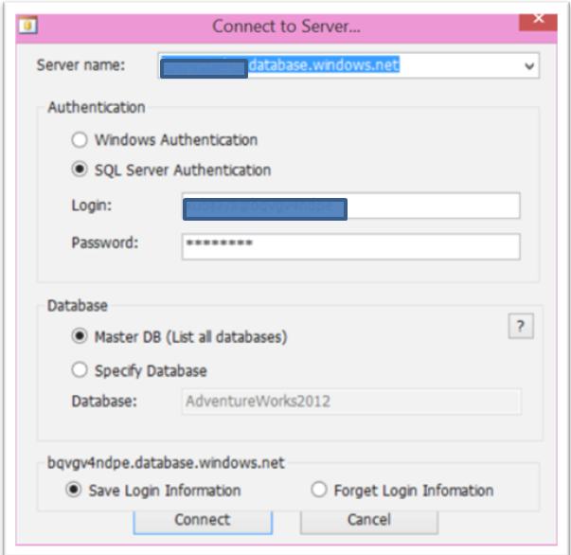

1. Click connect and then click “create database”. Enter the name of the database and the target edition. By default wizard creates a Standard S2 database. You could pick a Premium DB for just the migration time as it helps migrating quicker.

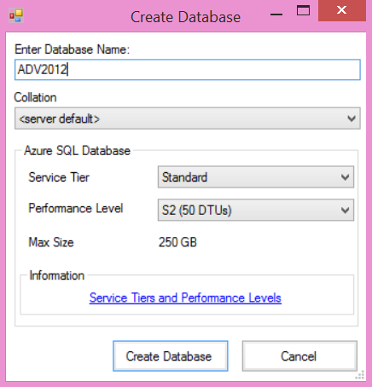

1. Click next and click yes on the message box that says “Execute script against destination server”.

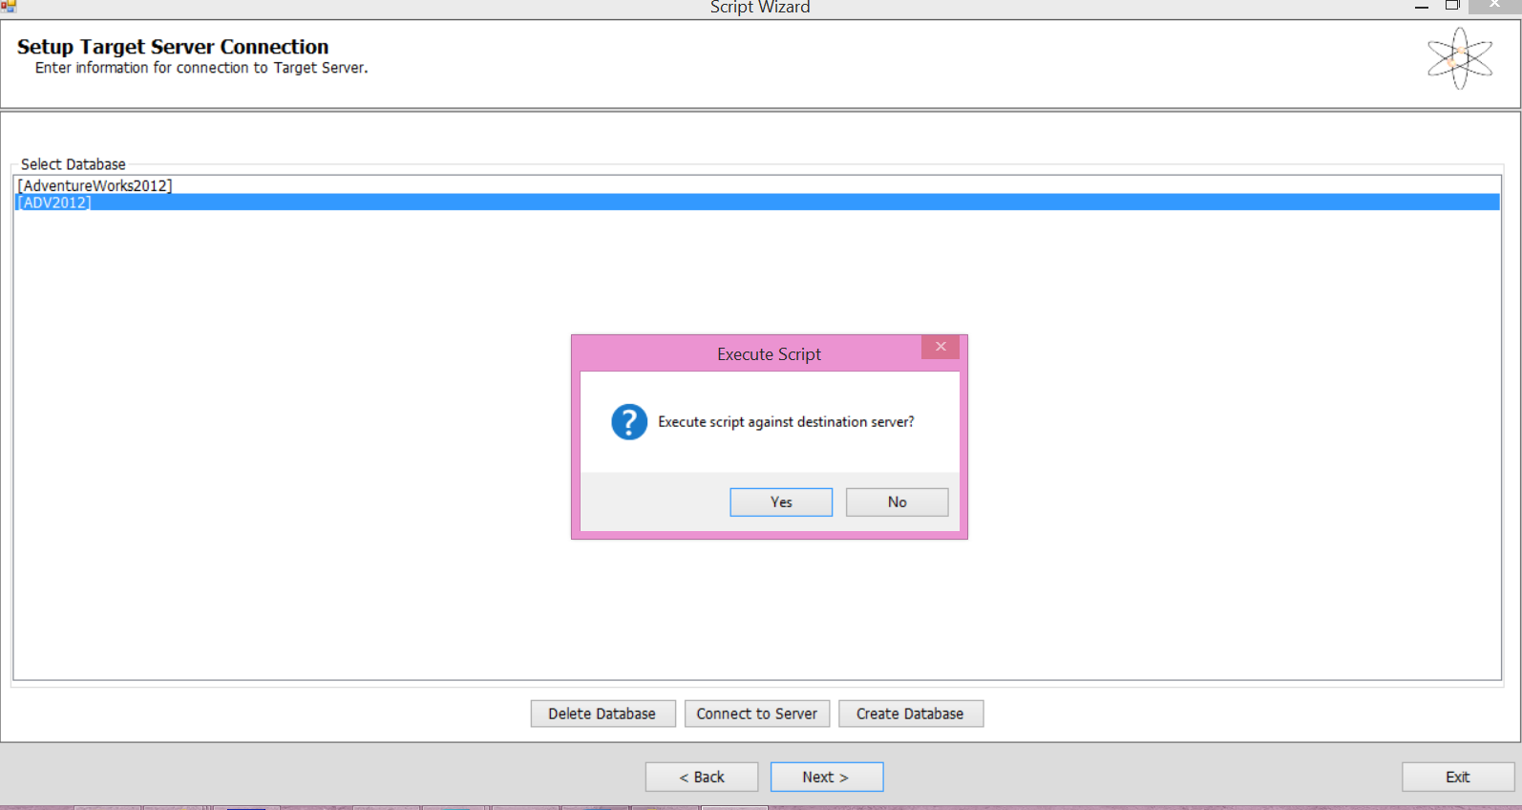

1. The script starts running and the database is successfully migrated to the Azure SQL database on the target server.

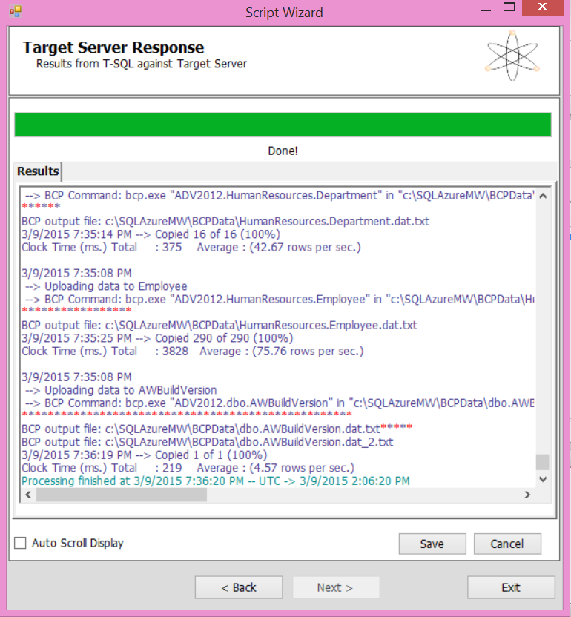

### Summary

In this exercise, we have learnt migrating a database to Azure SQL database using migration wizard. We have also seen that the objects/features that are not supported on Azure SQL Database are reported so you could take necessary action before initiating the migration. The SQL Script that will run against the target Azure database can be modified for a successful migration. It is a good idea to run the wizard before any Azure database migration.

# Scenario 3:

## Migrate database to a Premium P3 database and compare performance.

Run through the steps as mentioned in Scenario 2 and select Premium P3 for the target database edition. Compare the amount of time it takes to migrate the database to Standard S2 vs Premium P3.

It’s a good idea to migrate the database to a Premium P3, as it improves the migration performance drastically. The time to migrate reduces. You could reduce the database performance level at the end of migration.

# Azure Database editions’ comparison

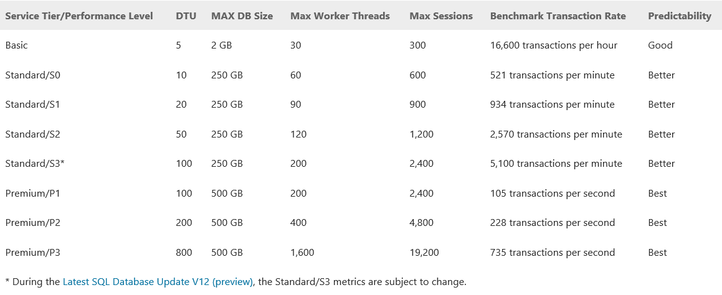

# Best practices

1. Scale the target Azure SQL database to Premium edition while migrating.
2. If the database is huge –
3. create a bacpac and copy it to one of the VMs in the same data center as the database.
4. Copy the bacpac file to Azure VM using AzCopy tool.
5. Initiate importing data into Azure SQL Database using from this VM.
6. Configure SQL Data Sync if you want the downtime to the tunes of a few minutes.

# Recommended/related sessions

1. Session Name - Track, Hall, Time
2. Session Name - Track, Hall, Time
3. Session Name - Track, Hall, Time

# Tell us what you think

Help us shape future events by sharing your valuable feedback.



Scan the QR code to evaluate *this* session or click the link: __________

< QR Code will be given 2 days before the Conference >

# References

Related references for you to expand your knowledge on the subject:

|  |  |
| --- | --- |
| Azure Portal: | <http://azure.microsoft.com> |
| Azure Updates: | <http://azure.microsoft.com/blog/> |
| Microsoft Virtual Academy: | <http://aka.ms/mva/> |
| Developer Network: | <http://msdn.microsoft.com/> |
| Migrating Databases to Azure SQL Database | <https://msdn.microsoft.com/en-us/library/azure/ee730904.aspx> |
| How to use SQL Database Migration Wizard | <https://msdn.microsoft.com/en-us/library/azure/jj156144.aspx> |
| MASD Service tiers and performance levels | <https://msdn.microsoft.com/en-us/library/azure/dn741336.aspx> |
| MASD Performance Guidance | <https://msdn.microsoft.com/en-us/library/azure/dn369873.aspx> |
| MASD throttling | <https://msdn.microsoft.com/en-us/library/azure/dn338079.aspx> |
| MASD Resource Management | <https://msdn.microsoft.com/en-us/library/azure/dn338083.aspx> |

# Azure Support

Must know resources to get online help for Azure:

1. **Azure Support Options** <http://azure.microsoft.com/en-us/support/options/>
2. **Azure Support Plans** <http://azure.microsoft.com/en-us/support/plans/>
3. **Ask questions, & get answers** ****Post questions in the Azure forums Tag questions with the keyword Azure.