Windows Store App submission process

**Create App Package**

1. Make sure you have no errors in “Visual Assets” Tab of Package.AppxManifest File.

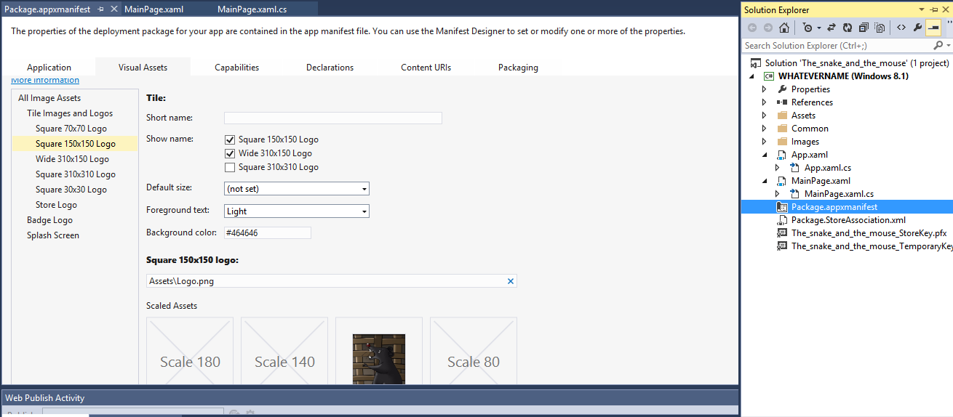

1. Make sure you have all proper visual assets in Assets Folder:
   1. Logo
   2. StoreLogo
   3. SmallLogo
   4. SplashScreen
2. Right click on your project in Solution Explorer, go to Store >> Create App Package

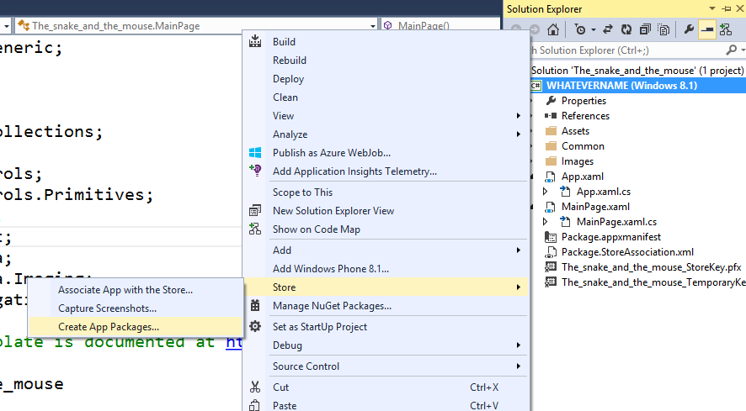

1. Click on “Yes”
2. Sign in to Windows Store using your Store Developer Account
3. Reserve your App name so others can’t use the same name
4. Select Neutral and don’t change anything else then click Create

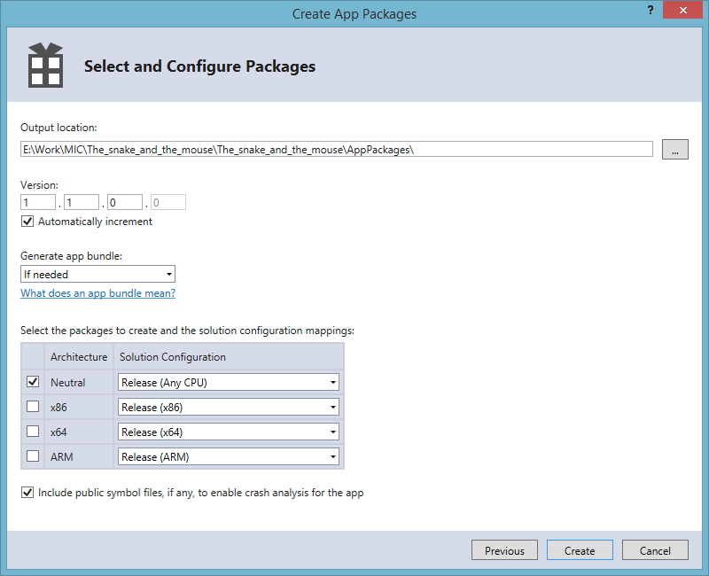

1. Click “Launch Windows App Certification Kit”
2. Select only two of the test options

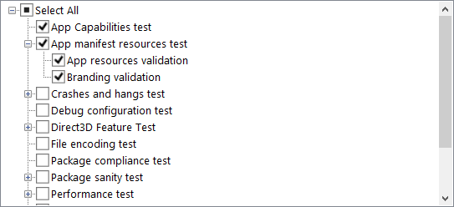

1. You should see the following screen

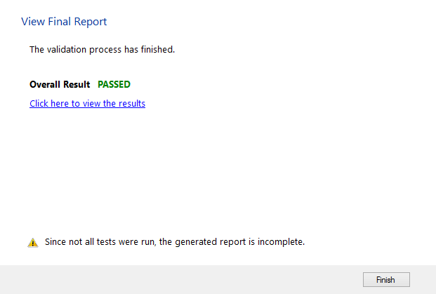

To submit an app, you'll need to sign in to your Windows Store Dashboard. (You can get there by clicking the "Dashboard" link near the top of any page in the [Windows Store apps Developer Center](http://go.microsoft.com/fwlink/p/?LinkId=223974).)

<http://dev.windows.com>

1. In your Windows Store Dashboard and click **Submit an app**. This takes you to the Release summary page, which lists the steps that get your app ready for Windows Store certification.

**Note**  If you've already reserved an app name, you will see a tile on the Dashboard for that app. If that's the case, click the app tile instead of **Submit an app**.

1. Click **App Name** to enter and reserve the [name of your app](http://msdn.microsoft.com/en-in/library/windows/apps/hh694077.aspx), if you haven't already done so.

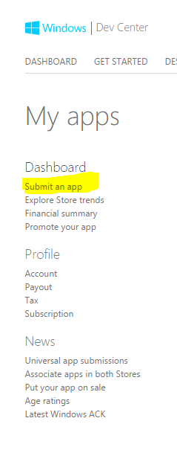

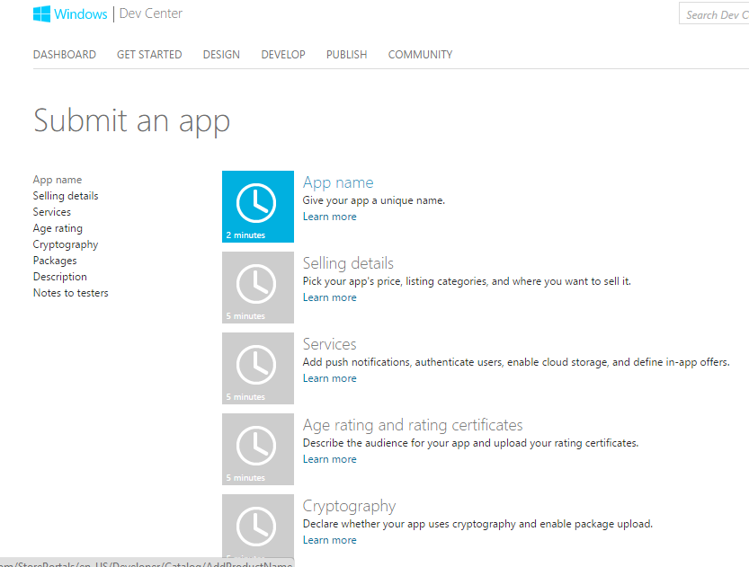

**Select New App by reserving a unique name**

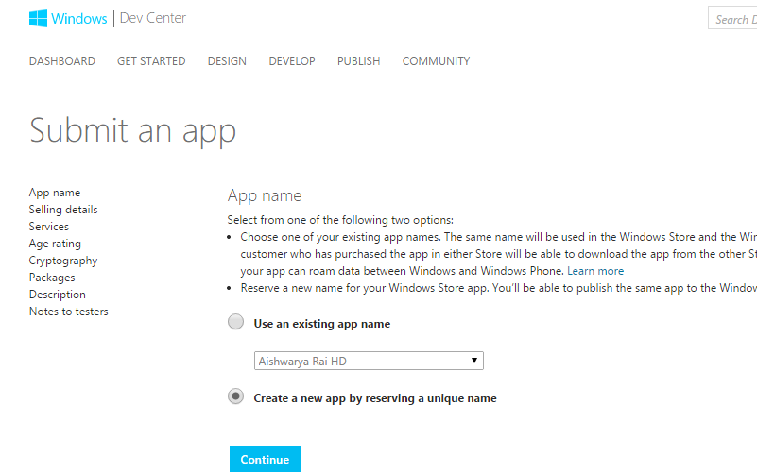

**Reserve app name for your application.**

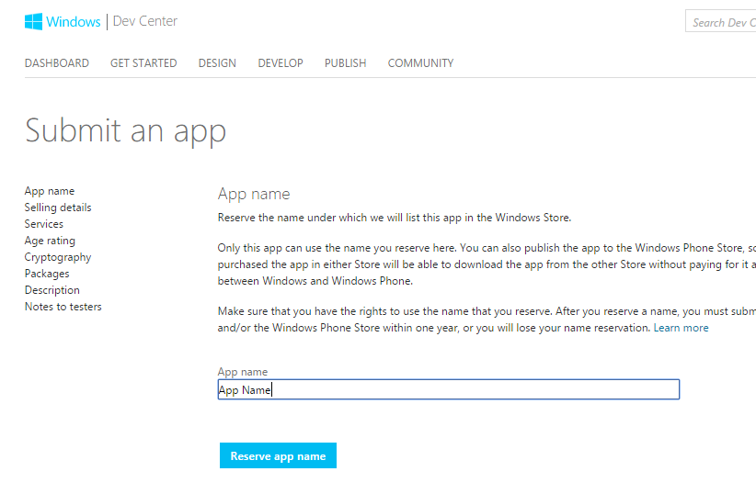

**Then Click on “Save” Button**

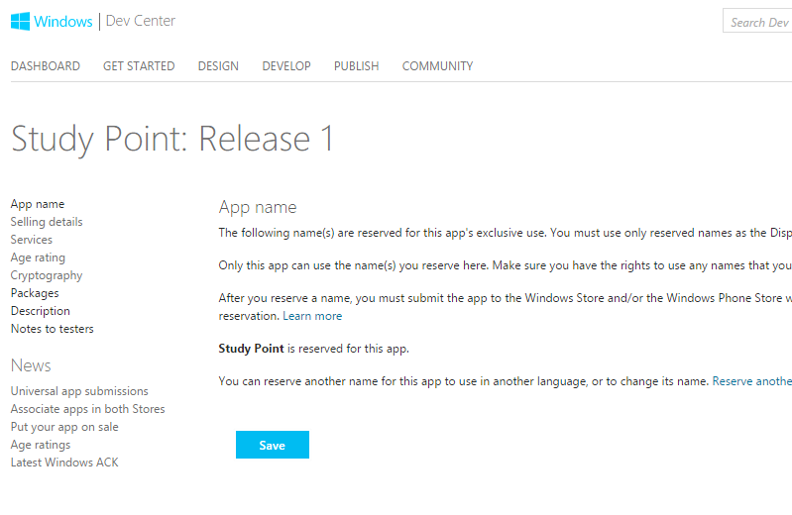

1. Click **Selling details** to supply info such as your app's price, [category and subcategory](http://msdn.microsoft.com/en-in/library/windows/apps/hh694073.aspx), and [markets](http://msdn.microsoft.com/en-in/library/windows/apps/hh694064.aspx).

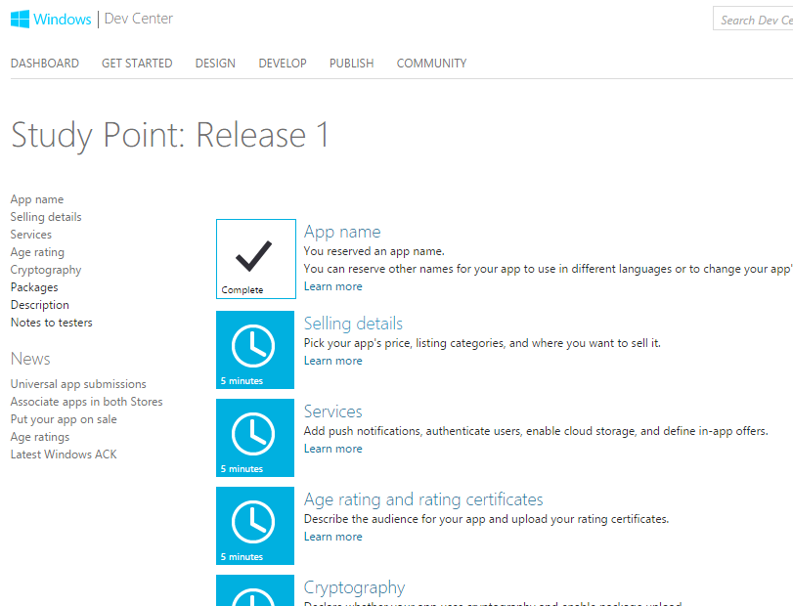

**Select Price of Application – Select “Free”**

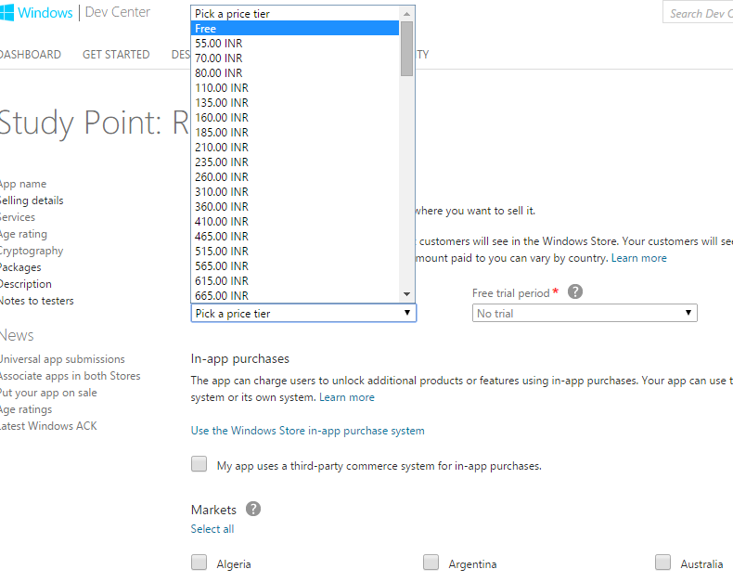

**Click on “Select All “for selecting all the Market for the app publish**

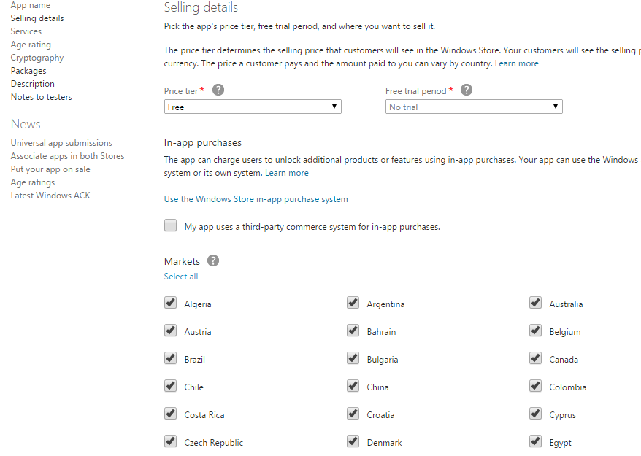

**Select Category and Subcategory for the App**

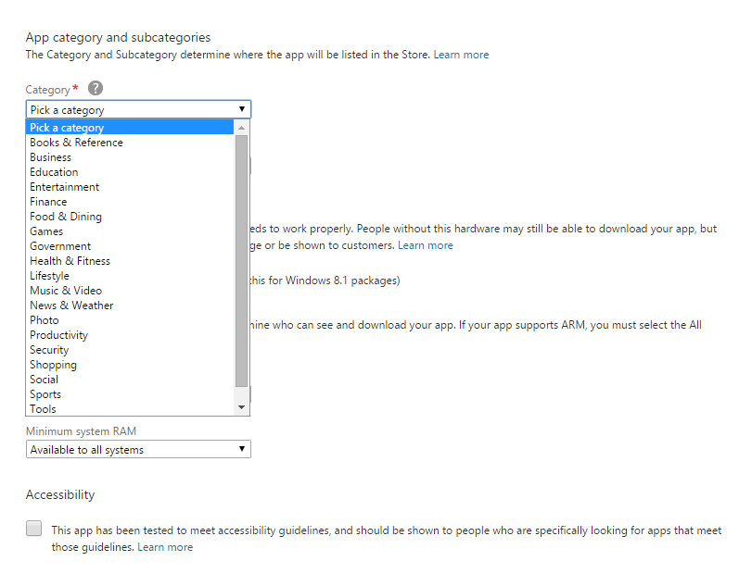

1. Click **Services** to configure features such as [push notifications](http://msdn.microsoft.com/en-in/library/windows/apps/hh913756.aspx) and [in-app purchases](http://msdn.microsoft.com/en-in/library/windows/apps/hh694067.aspx).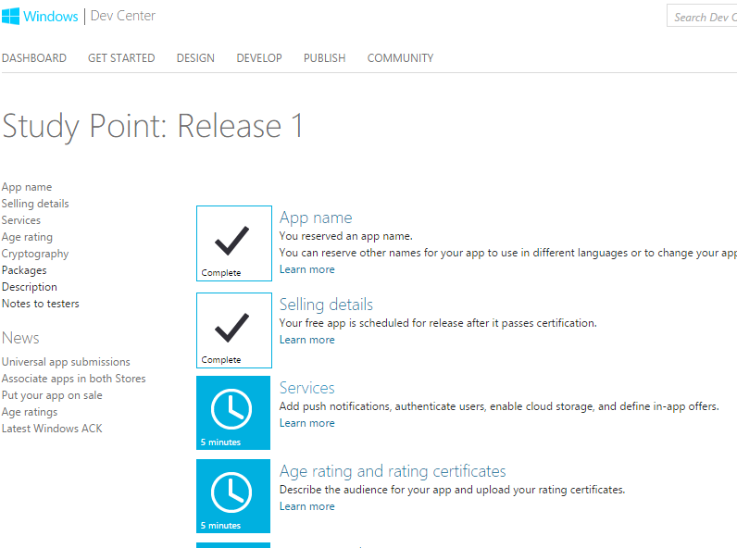

**Keep Product ID Blank and Click on Save Button**

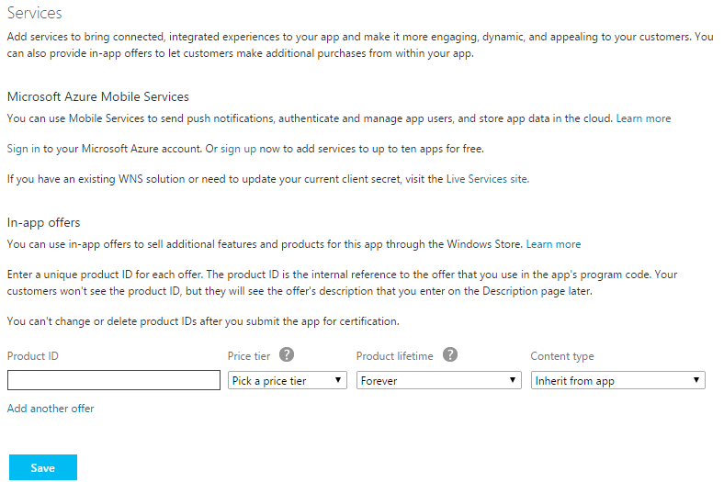

1. Click **Age rating and ratings certificates** to select the [age rating](http://msdn.microsoft.com/en-in/library/windows/apps/hh694080.aspx) for your app and upload any ratings certificates.

**Select suitable option for your application and Save.**

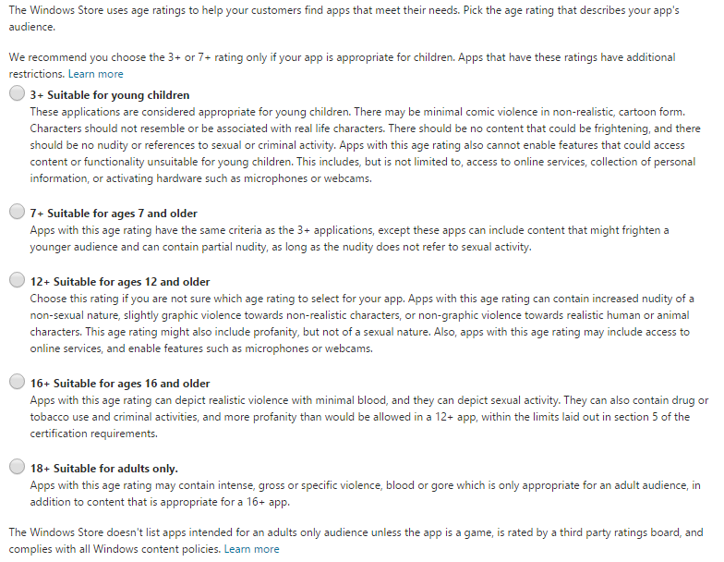

1. Click **Cryptography** to declare whether [your app uses any cryptography](http://msdn.microsoft.com/en-in/library/windows/apps/hh694069.aspx).

**If your app call, support, contain, or use cryptography or encryption then select “Yes” otherwise select “No”**

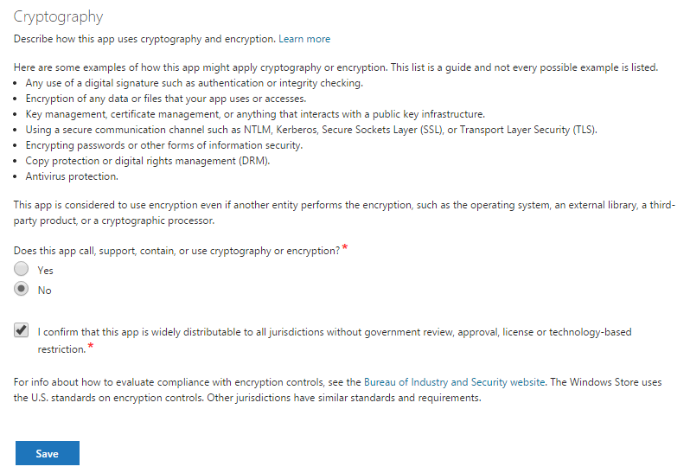

1. Click **Packages** to [upload your app's packages](http://msdn.microsoft.com/en-in/library/windows/apps/hh694075.aspx).

**Click on “browse to files” to upload App’s package**

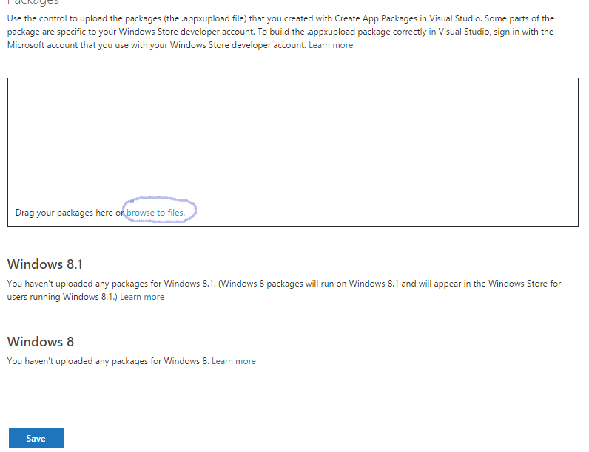

**Your App Package is in your project folder(select .appxupload file)**

|  |  |
| --- | --- |
|  |  |

1. Click **Description** to [enter your app's description](http://msdn.microsoft.com/en-in/library/windows/apps/hh694076.aspx).

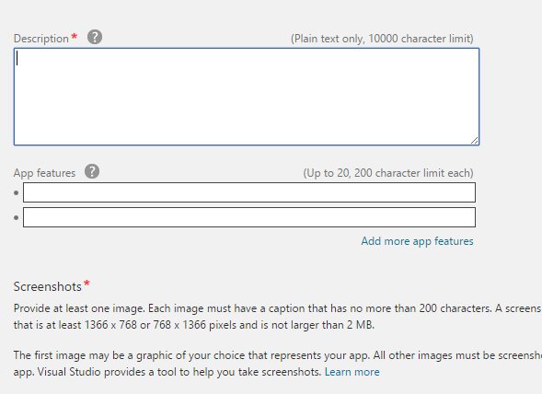

**Add Screenshots of Application**

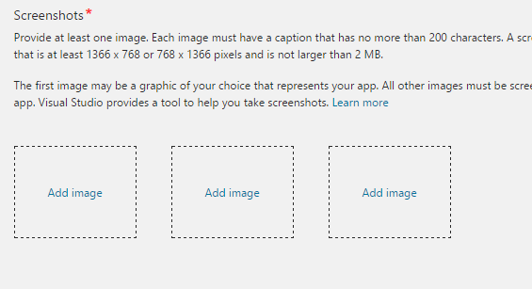

**Add Keywords for your app**

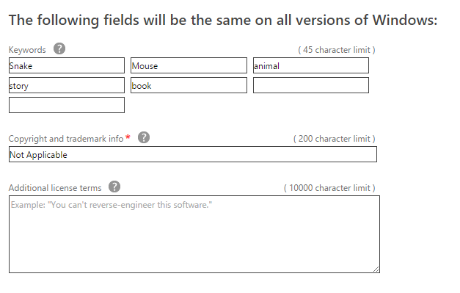

**If your app doesn’t contain ay copyright and trademark information then just write “No Copyright and trademark info” or “Not Applicable”**

1. Click **Notes to testers** to [provide the certification testers with info](http://msdn.microsoft.com/en-in/library/windows/apps/hh694071.aspx) that will help them test your app. **If you don’t have any instruction for tester then keep it blank and Save it**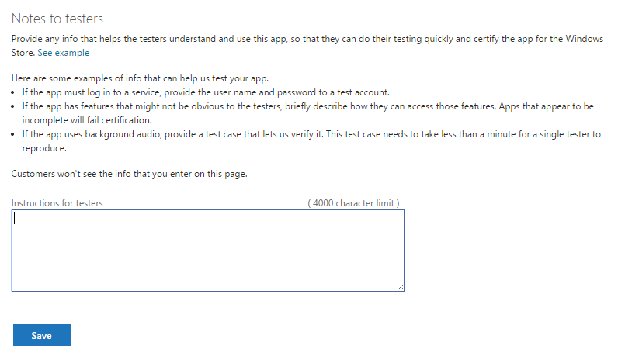
2. Click **Submit for certification** to submit your app.

We'll send you an email when the [certification process](http://msdn.microsoft.com/en-in/library/windows/apps/hh694079.aspx) is complete. You can also [check on your app's certification status](http://msdn.microsoft.com/en-in/library/windows/apps/hh757605.aspx) at any time.