
CMN 224 – Software Engineering
Task 4: Assembly Checklist.

Student Name: Russell Aka
ID: 00200
Lecturer: Mr. Solomon Hombiku
Date: 09/10/26

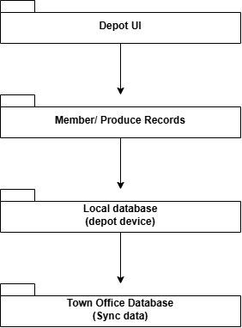
Figure 1 – Layered Architecture
This diagram illustrates a sequential data flow architecture for an application system, moving downward from the user interface down to a centralized storage server. It begins at the Depot UI layer, where user interactions prompt the application to capture or process Member/ Produce Records. These active records are immediately written and stored locally within the Local database (depot device) to ensure operational continuity on-site. Finally, the information flows from the localized device storage to a centralized Town Office Database via a synchronization mechanism (Sync data) to consolidate the records.
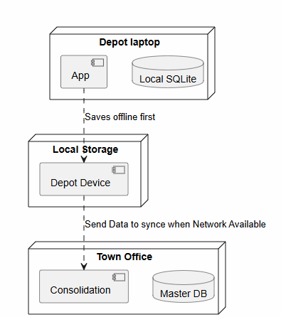
Figure 2 - Deployment Diagram
This UML deployment diagram expands on the previous concept by illustrating an offline-first data architecture split across three distinct operational layers. At the top tier, a Depot laptop runs a localized application instance (App) that immediately commits structural records into an integrated Local SQLite database to ensure continuous field operations when disconnected from the internet. Once saved, this data persists within the intermediate Local Storage (Depot Device) layer, waiting for connectivity. When an active network link is established, a synchronization routine is triggered (Send Data to sync when Network Available) to securely push the localized changes downstream to the central Town Office tier, where a Consolidation service processes and integrates the incoming data streams into a centralized Master DB.
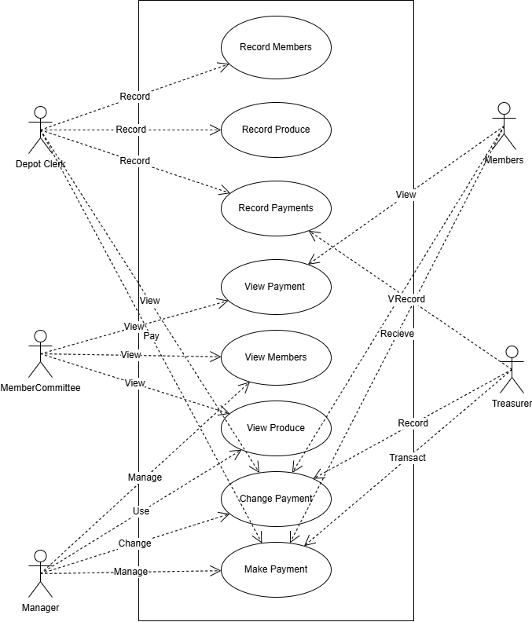
Figure 3 - Use Case Diagram
This UML Use Case Diagram maps out the functional interactions between five specific system roles (Actors) and the software boundaries of a member management and payment ecosystem. The Depot Clerk acts as the primary operations ledger handler, responsible for executing the Record Members, Record Produce, and Record Payments functions. For administrative oversight, the Member Committee holds read-only privileges across data fields via View Payment, View Members, and View Produce, whereas the Manager possesses administrative override capabilities to manage membership datasets, change transaction structures, and execute cash dispatches. On the receiving end, Members can view their discrete payment histories and receive disbursements, which are explicitly authorized, tracked, and verified by the Treasurer through the Make Payment, Change Payment, and transaction ledger updates.
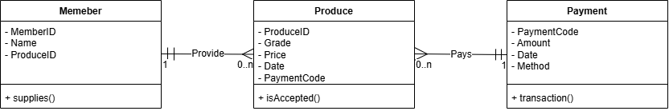
Figure 4 - Class Diagram
This UML Class Diagram illustrates a data structure model composed of three entities—Member (Member), Produce, and Payment—that handle supply inventory and financial tracking. The system establishes a one-to-many (1 to 0..n) relationship between Member and Produce, indicating that an individual member can log multiple inventory contributions through the supplies() function using attributes such as MemberID and Name. The Produce entity functions as a central transactional hub, tracking operational fields like ProduceID, Grade, Price, and Date, while validating inventory via the isAccepted() mechanism. Finally, the Produce entity connects to the Payment entity through a many-to-one (0..n to 1) relationship managed by a shared PaymentCode field, which means multiple produce deliveries can be consolidated into or resolved by a single financial record that captures Amount, Date, and Method attributes inside the transaction() processing sequence.

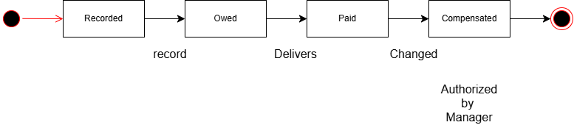
Figure 5 – State diagram
This UML State Machine Diagram illustrates the lifecycle of a transaction or produce order as it moves through four distinct operational statuses. The process originates at an initial start state (the solid black circle) and immediately shifts into the Recorded status when a new entry is initialized. Once the item or member profile is processed via the record trigger, the entity transitions to an Owed state, signaling an active outstanding balance. Upon physical delivery or system resolution triggered by Delivers, the lifecycle updates to Paid to confirm the initial financial settlement. Finally, if structural parameters are Changed and subsequently Authorized by Manager, the status enters its terminal state of Compensated before concluding at the final end state (the targeted double circle).
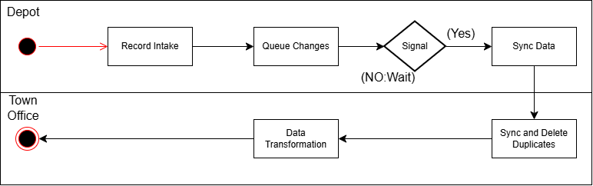
Figure 6 - Activity Diagram

This UML Activity Diagram illustrates a partitioned data synchronization process split across two distinct operational areas using horizontal swimlanes: Depot and Town Office. The workflow originates in the Depot swimlane at an initial start state, moving directly to Record Intake to capture incoming raw transactional information before routing it to Queue Changes to prepare the entries for staging. The system then encounters a Signal decision diamond that acts as a gatekeeper; if network connectivity or a transmission signal is unavailable (NO: Wait), the process pauses in a holding state, but once a valid connection is established (Yes), it executes Sync Data to push the staged local data downstream. Control then crosses the swimlane boundary into the Town Office environment, where the system runs Sync and Delete Duplicates to filter out redundant records, routes the cleaned entries through a final Data Transformation phase to format the records, and safely terminates at the final end state.

