HERE-to-care   
(DYNAMIC WEBSITE)

**Introduction:**

A common problem that we have seen come up time and again is, the people who have the means and wish to contribute back to the society feel apprehensive about lack of authentic mediums to do so. If you begin to count the number of such popular platforms where people can contribute in a hassle free manner with monetary help or voluntary service, there aren't many.

This gave rise to the idea of this project, a dynamic website (one which updates its content regularly and responds to real time needs of users).

**Objectives:**

* Primary objective for this project is to provide a medium between people who wish to provide any sort of help to those in need.
* To achieve this we promote collaboration among various users providing different kinds of help. For example, a person donating some books and another person transporting it to the needy, work in collaboration to achieve a particular task.
* NGO's who are already working for the underprivileged would get a chance to represent themselves so that more and more people can know about them.
* Their credibility would also be approved by the people who gave them donations through our platform, by giving them rating.
* Some trusted users will verify whether the donation is received or not. In case of any anomaly we would re-verify, and after that suitable action may be taken.
* Since the success of this project depends on people’s initiative to help, we will also provide certain incentives to helpers like coupons and services which would be facilitated by other helpers.

**Context Level DFD:**

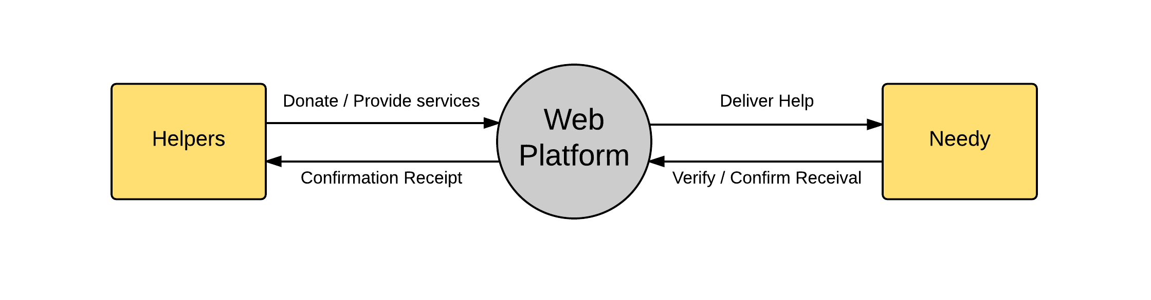

**Zero Level DFD:**

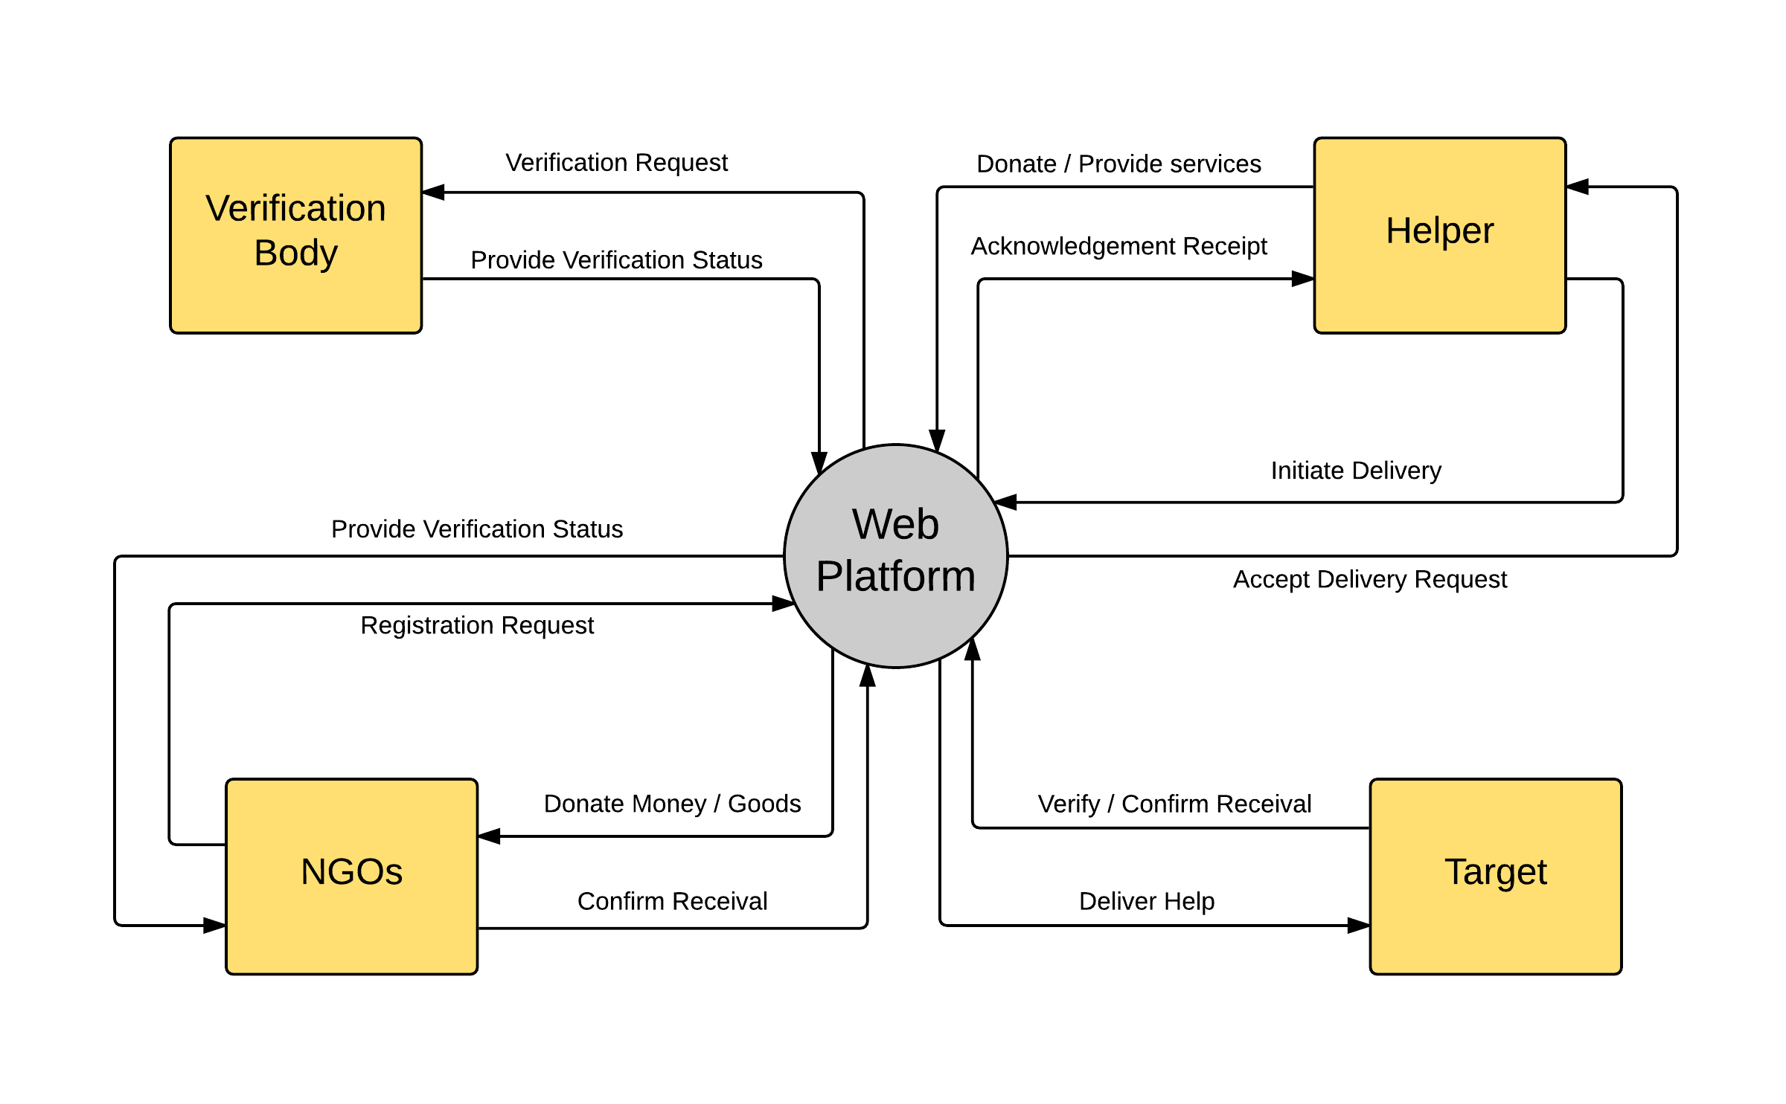

**System Domain:**

* Front End: HTML5, CSS, JavaScript
* Back End: Python (Django Framework), MySQL
* Tools Used: LucidChart Diagram Creator (for DFD & ER diagram)