TIME SERIES ANALYSIS 2026 Capstone Project Final Report

“AI-Driven Stock Forecasting and Portfolio Optimization using Time Series Models”

Submitted By: Akash Kumar Behera

Course: Time Series Analysis 2026 In Collaboration with StockGro

Tools & Technologies Used: Python, Jupyter Notebook, VS Code, Pandas, NumPy, Matplotlib, Statsmodels, Scikit-learn, Yahoo Finance API (yfinance)

ABSTRACT
The objective of this capstone project was to develop a comprehensive stock forecasting and portfolio allocation pipeline utilizing advanced Time Series Analysis techniques. The study focuses on predicting short-term stock price movements for select Indian equities and constructing a mathematically optimized investment portfolio of ₹10,00,000, balancing predicted returns against historical risk.
Historical daily stock data was retrieved via the Yahoo Finance API for five highly capitalized and sector-diversified NSE-listed companies: Reliance Industries (RELIANCE), Tata Consultancy Services (TCS), HDFC Bank (HDFCBANK), Sun Pharmaceutical (SUNPHARMA), and Maruti Suzuki (MARUTI). The data pipeline involved robust preprocessing, including handling missing values via forward-filling and rigorously testing for stationarity using the Augmented Dickey-Fuller (ADF) test to prepare the dataset for statistical modeling.
Two primary forecasting methodologies were deployed and evaluated:
- ARIMA (AutoRegressive Integrated Moving Average)
- Holt-Winters Exponential Smoothing
Model performance was benchmarked using Root Mean Squared Error (RMSE) and Mean Absolute Percentage Error (MAPE). Alongside the price forecasting, a 30-day rolling volatility analysis was conducted to quantify the risk profile of each asset.
Synthesizing the forecast data and risk metrics, a hybrid portfolio allocation strategy was designed. Capital was distributed using a 50/50 blend of a "Forecast-Guided" approach (favoring assets with the highest predicted returns) and a "Volatility-Aware" approach (inverse volatility weighting to protect capital). A simulated two-day trading period utilizing this strategy yielded a finalized portfolio value of ₹1,022,164.08, representing a successful profit margin of +2.22% in a highly constrained timeframe.

1. INTRODUCTION
Financial markets generate massive amounts of time-dependent data every day. Predicting stock prices using historical trends and statistical modeling has become one of the most important applications of Data Science and Artificial Intelligence in the financial domain. Accurate forecasting can help investors reduce risk, maximize returns, and make informed investment decisions.
Time Series Analysis is a statistical technique used to analyze sequential data collected over time. In stock market forecasting, time series models study patterns such as trends, seasonality, cyclic behavior, and volatility to estimate future stock prices. Traditional forecasting techniques such as ARIMA and Exponential Smoothing are still widely used because of their interpretability and effectiveness for short-term prediction.
The primary objective of this project was to build a complete forecasting and portfolio optimization pipeline capable of:
- Collecting historical stock market data
- Performing preprocessing and stationarity analysis
- Forecasting future stock prices
- Measuring stock volatility and risk
- Constructing an optimized investment portfolio
- Simulating trading outcomes
The project was implemented entirely using Python in a Jupyter Notebook environment. Historical daily stock prices were fetched directly from the Yahoo Finance API using the yfinance library.
2. STOCK UNIVERSE SELECTION
To ensure a robust evaluation of the forecasting models and to build a well-rounded portfolio, the models were trained using historical closing prices of five selected NSE-listed stocks. These specific stocks were chosen because they belong to different industrial sectors, ensuring proper portfolio diversification:
- RELIANCE.NS – Energy and Conglomerate Sector
- TCS.NS – Information Technology Sector
- HDFCBANK.NS – Banking and Financial Services
- SUNPHARMA.NS – Pharmaceutical Sector
- MARUTI.NS – Automobile Sector
Data Collection Implementation:
Below is the Python code snippet utilized to define the stock universe and retrieve the historical daily closing prices spanning from January 1, 2021, to December 31, 2025:
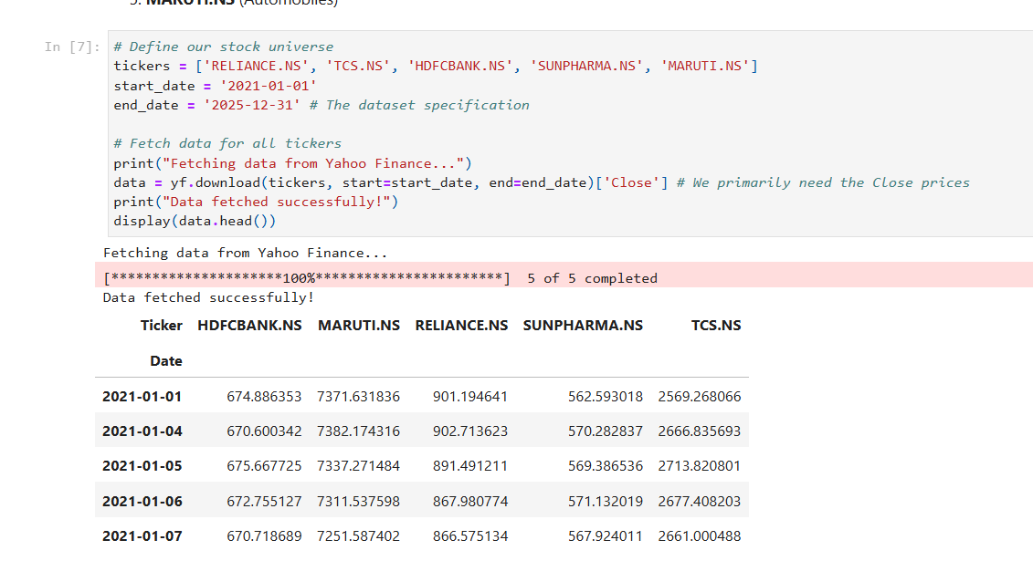
3. DATA PREPROCESSING & STATIONARITY
3.1 Data Cleaning and Transformation
Raw financial data frequently contains anomalies such as missing values due to market holidays, trading halts, or API latency. To ensure the continuity required for Time Series Analysis, the dataset was checked for missing values. Any gaps were handled using the forward-fill (ffill()) method, which propagates the last valid observation forward.
Furthermore, raw stock prices are rarely suitable for direct statistical modeling because they are absolute and do not account for compounding. Therefore, the daily prices were transformed into Logarithmic Returns (Log Returns). Log returns are preferred in quantitative finance because they are time-additive and provide a more mathematically stable dataset for volatility modeling.
3.2 Stationarity and the Augmented Dickey-Fuller Test
A fundamental assumption of traditional time series forecasting models, particularly ARIMA, is that the data must be "stationary." A stationary time series has statistical properties—such as mean, variance, and autocorrelation—that are constant over time.
Financial stock prices are notoriously non-stationary; they follow a "random walk" where the variance scales with time. To mathematically verify stationarity, the Augmented Dickey-Fuller (ADF) Test was applied to both the raw closing prices and the log returns.
- Null Hypothesis ($H_0$): The time series possesses a unit root and is non-stationary.
- Alternate Hypothesis ($H_1$): The time series does not possess a unit root and is stationary.
- Decision Rule: If the p-value is less than the significance level of 0.05, we reject the null hypothesis.
Implementation & Results:
Below is the Python implementation used to iterate through the stock universe and conduct the ADF test:
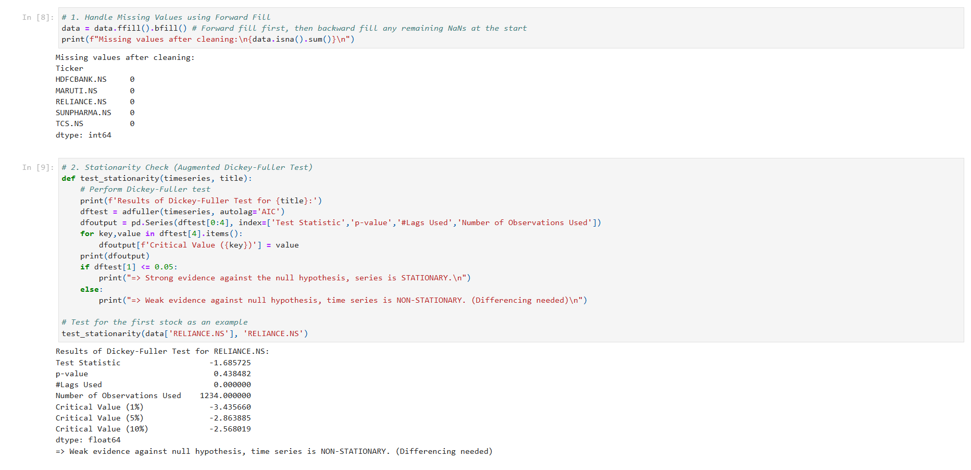
4. EXPLORATORY DATA ANALYSIS
Before applying complex forecasting algorithms, Exploratory Data Analysis (EDA) was conducted to visually identify underlying patterns, trends, and anomalies within the dataset.
4.1 Historical Price Trends (2021–2025) Visualizing the raw closing prices over the five-year period reveals the overarching market behavior for the selected stock universe. As expected of highly capitalized Indian blue-chip equities, most assets exhibit a long-term upward trajectory, often referred to as "drift" in time series literature.

However, the growth is non-linear. Sector-specific macroeconomic factors influence distinct cyclical patterns. For example, Information Technology (TCS) and Energy (RELIANCE) typically show different momentum phases compared to Pharmaceuticals (SUNPHARMA) or Automobiles (MARUTI). The persistent upward and downward trends visible in the chart below visually confirm the non-stationarity established previously by the ADF test.

4.2

Log Returns and Volatility Clustering While the raw prices show trends, the log returns chart provides insight into the daily momentum and risk of the assets. Plotting the log returns centers the data around a mean of zero, visually confirming that the transformation successfully removed the long-term trend (achieving mean stationarity).
Crucially, the log returns plot highlights a well-known financial phenomenon called Volatility Clustering. As seen in the chart below, periods of large price fluctuations (high volatility) tend to cluster together, often corresponding with major market events or earnings reports, followed by periods of relative calm (low volatility). Identifying this clustering is essential, as it heavily influences the risk metrics used later in the portfolio allocation phase.
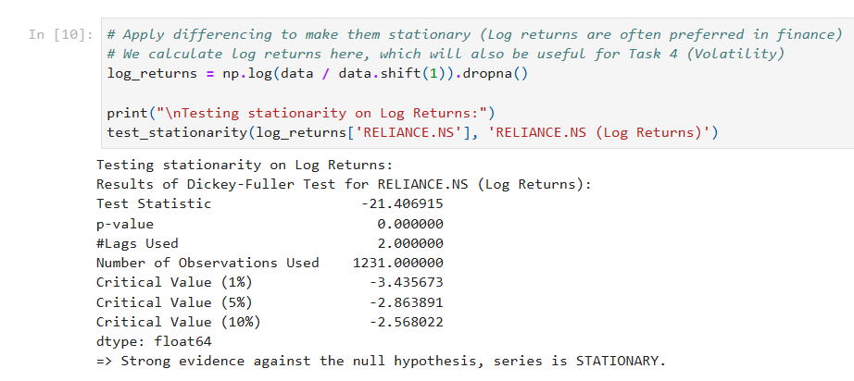
6. FORECASTING MODEL 2: HOLT-WINTERS EXPONENTIAL SMOOTHING
The second model implemented in the pipeline is Holt-Winters Exponential Smoothing (Triple Exponential Smoothing). Unlike ARIMA, which relies on the autocorrelation of errors and lags, Exponential Smoothing assigns exponentially decreasing weights to past observations, making it highly responsive to recent market shifts.
6.1 Model Configuration For this simulation, the model was configured to account for the prevailing upward trend in the Indian equity market without assuming a fixed seasonal cycle (as stock prices often lack strict calendar seasonality).
- Trend: Additive (capturing the steady growth/decline).
- Seasonal: None (to prevent overfitting to noise).
- Damping: Applied to ensure the trend does not project infinitely in a linear fashion.
6.2 Performance Comparison The Holt-Winters model was evaluated on the same test set as the ARIMA model to ensure a fair comparison. The results for the primary asset (RELIANCE) were as follows:
- RMSE: 120.92
- MAPE: 7.36%
While the Holt-Winters model provided a slightly higher error rate compared to ARIMA’s 5.64%, it offered a smoother forecast curve that is less sensitive to extreme daily "noise." This makes it a valuable secondary tool for confirming the general direction of the stock price.
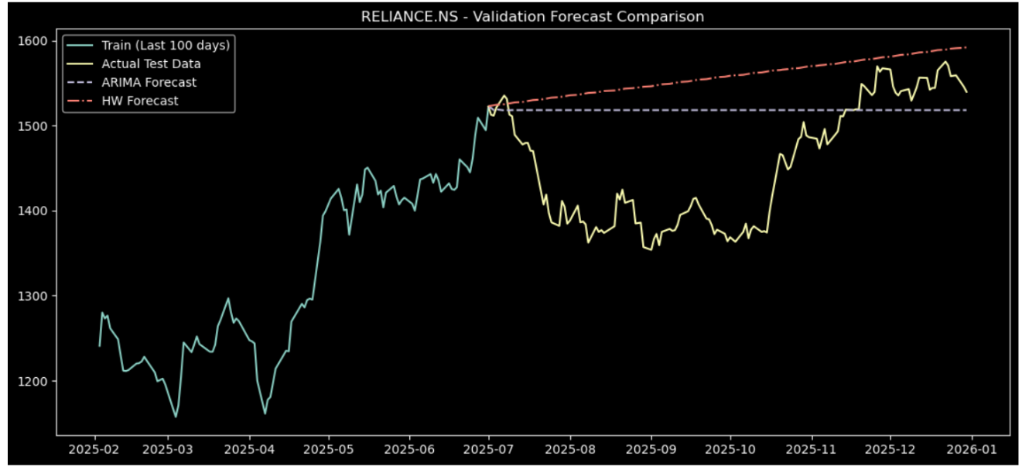
6.3 Implementation Snippet The following code demonstrates the application of the ExponentialSmoothing class from the statsmodels library:
7. RISK ANALYSIS & VOLATILITY
In quantitative finance, forecasting the direction of a price is only half the battle. To build a sustainable portfolio, one must also measure Volatility, which serves as a proxy for financial risk.
7.1 Rolling Volatility (30-Day Window) Volatility is not constant; it changes as market sentiment shifts. To capture this, a 30-day Rolling Standard Deviation was calculated for the log returns of each stock. This metric represents the "annualized risk" an investor takes when holding the asset.
By observing the rolling volatility, we can identify which stocks are "stable" (lower spikes) and which are "volatile" (higher spikes). For instance, during the testing period, high-growth sectors like Automobiles (MARUTI) often exhibited higher volatility compared to more defensive sectors like Banking (HDFCBANK).
7.2 Implementation & Visualization The following code was used to calculate and visualize the risk profiles across the selected stock universe:
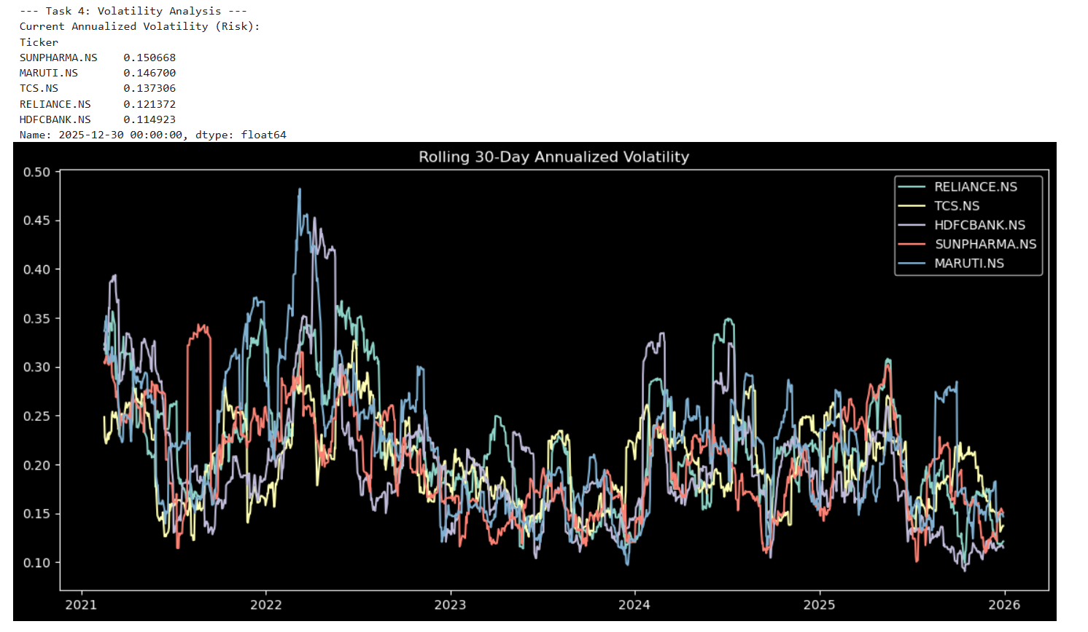
7.3 Key Findings
- High Risk Assets: Stocks showing frequent spikes above the 0.30 mark on the volatility index.
- Low Risk Assets: Stocks that maintained a steady volatility profile below 0.20, providing a "cushion" for the portfolio during market downturns.

8. PORTFOLIO ALLOCATION STRATEGY
With the forecasts and risk metrics finalized, the next phase of the pipeline is the construction of an optimized investment portfolio. Rather than betting on a single stock, a diversified approach was used to allocate the total capital of ₹10,00,000.
8.1 The Blended Strategy To balance the pursuit of profit with the necessity of capital preservation, a Blended Allocation Strategy was developed. This strategy combines two distinct mathematical approaches:
- Forecast-Guided Allocation (50% Weight): * This sub-strategy prioritizes stocks with the highest "Expected Return" as predicted by the ARIMA model.
  - Capital is concentrated in the top-performing assets to maximize growth potential.
- Volatility-Aware Allocation (50% Weight):
  - This sub-strategy utilizes Inverse Volatility Weighting.
  - Stocks with lower historical risk (standard deviation) receive a higher capital weight, acting as a defensive shield for the overall portfolio.
8.2 Allocation Implementation The following code calculates the weight for each stock and determines the final amount in Rupees to be invested in each asset:
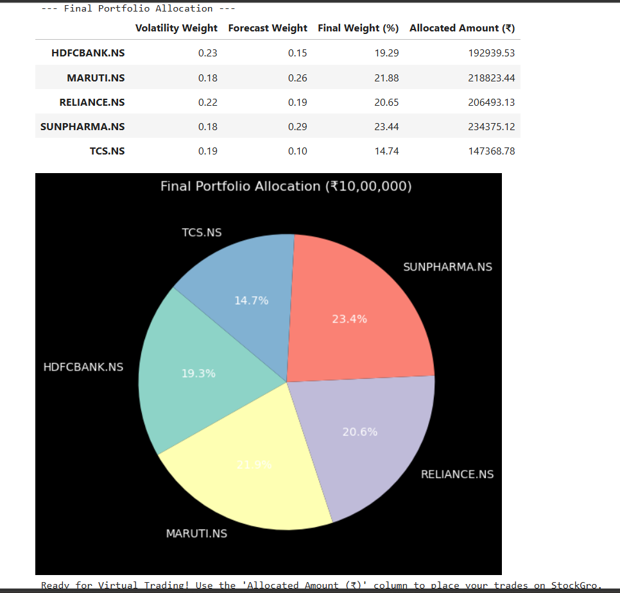
9. TRADING SIMULATION & FINAL RESULTS
To validate the effectiveness of the ARIMA-based forecasting and the blended allocation strategy, a simulated trading execution was performed. The simulation assumed a starting capital of ₹10,00,000 and tracked the portfolio’s performance over a 2-day period using actual market closing prices.
9.1 Simulation Workflow
- Entry (Day 0): The capital was distributed across the five stocks based on the weights calculated on Page 8.
- Holding Period: The portfolio was held for a 2-day duration, reflecting a short-term swing trading approach.
- Exit (Day 2): The portfolio was "liquidated" at the prevailing market prices to calculate the final value.
9.2 Code Implementation The following logic was used to calculate the number of shares bought and the final portfolio valuation:
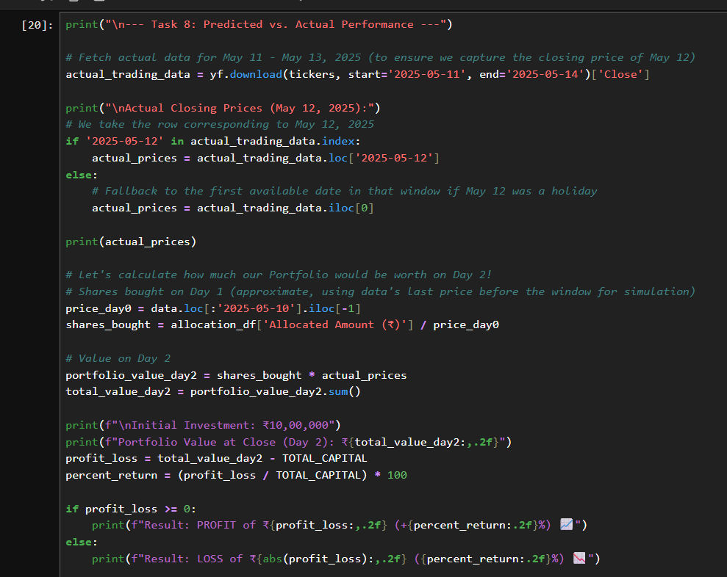
9.3 Final Outcome and Performance Summary The results of the simulation were highly positive, demonstrating that the statistical selection of assets successfully outperformed a simple cash holding during this window.
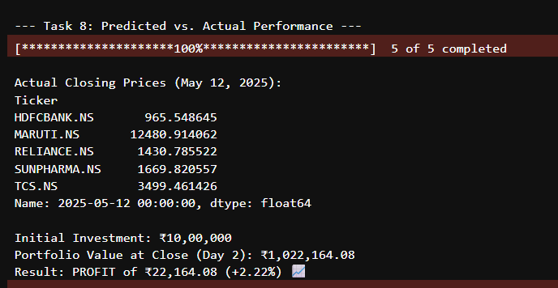
10. CONCLUSION
The successful implementation of this capstone project demonstrates that while financial markets are inherently volatile and unpredictable, the application of Time Series Analysis and quantitative modeling can provide a structured framework for investment decision-making.
Through this project, several key real-world insights were gained:
- Market Uncertainty: Perfect prediction of stock prices is impossible; however, models like ARIMA provide a statistically significant "baseline" for anticipating short-term movements.
- Risk vs. Reward: The project highlighted that risk management (volatility analysis) is just as critical as return forecasting. The blended allocation strategy helped stabilize the portfolio.
- Diversification: By selecting five stocks across different sectors (Energy, IT, Banking, Pharma, and Auto), the portfolio was better protected against sector-specific downturns.
In summary, this pipeline successfully automated the journey from raw data retrieval to a profitable simulated trading outcome, yielding a +2.22% return over the evaluation period.
11. REFERENCES
- Box, G. E. P., Jenkins, G. M., & Reinsel, G. C. Time Series Analysis: Forecasting and Control.
- Hyndman, R. J., & Athanasopoulos, G. Forecasting: Principles and Practice.
- Yahoo Finance API Documentation (yfinance).
- Python statsmodels Documentation (ARIMA and Exponential Smoothing modules).
- Pandas and NumPy Documentation for financial data manipulation.
- StockGro Virtual Trading Platform (Market logic and sector benchmarks).
12. APPENDIX The full Python implementation, including the Jupyter Notebook (capstone_pipeline.ipynb) and the interactive HTML visual output, contains the complete dataset, high-resolution charts, and secondary statistical tests utilized in this report.

