**Aim : Weather Analysis using MapReduce.**

Step 1 : Open terminal > Add the weather.txt file and create mapper.py and reducer.py.

[cloudera@quickstart Desktop]$ mkdir weather

[cloudera@quickstart Desktop]$ cd weather

[cloudera@quickstart weather]$ touch weather.txt

[cloudera@quickstart weather]$ ls

weather.txt

[cloudera@quickstart weather]$ touch mapper.py

[cloudera@quickstart weather]$ touch reducer.py

Step 2 : Open mapper.py and write the code.

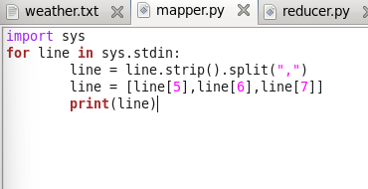

Step 3 : Open reducer.py and write the code.

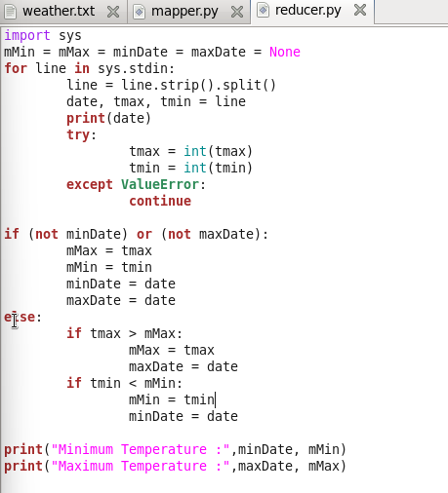

Step 4 : Running the mapper function with weather.txt file to check the output.

[cloudera@quickstart weather]$ cat weather.txt | python mapper.py

**Output:**

20100101 -178 -311

20100102 -244 -322

20100103 -194 -289

20100104 -167 -200

20100105 -133 -167

20100106 -133 -172

20100107 -150 -278

20100108 -233 -328

20100109 -233 -322

20100110 -117 -244

20100111 -67 -128

20100112 -78 -122

20100113 -17 -89

20100114 39 -72

20100115 -67 -72

20100116 22 -50

20100117 33 -44

20100118 6 -172

20100119 -56 -183

20100120 -67 -139

20100121 -67 -94

20100122 -44 -67

20100123 -6 -44

20100124 0 -11

20100125 -11 -161

20100126 -161 -233

20100127 -167 -222

20100128 -167 -283

20100129 -189 -283

20100130 -156 -267

20100131 -150 -272

Step 5: The mapper function will put these values in the stream which will be used by the reducer function and give the output

[cloudera@quickstart weather]$ cat weather.txt | python mapper.py |python reducer.py

**Output:**

['20100101', '-178', '-311']

20100101

('Minimum Temperature:', '20100101', -311)

('Maximum Temperature:', '20100101', -178)

['20100102', '-244', '-322']

20100102

('Minimum Temperature:', '20100102', -322)

('Maximum Temperature:', '20100101', -178)

['20100103', '-194', '-289']

20100103

('Minimum Temperature:', '20100102', -322)

('Maximum Temperature:', '20100101', -178)

['20100104', '-167', '-200']

20100104

('Minimum Temperature:', '20100102', -322)

('Maximum Temperature:', '20100104', -167)

['20100105', '-133', '-167']

20100105

('Minimum Temperature:', '20100102', -322)

('Maximum Temperature:', '20100105', -133)

['20100106', '-133', '-172']

20100106

('Minimum Temperature:', '20100102', -322)

('Maximum Temperature:', '20100105', -133)

['20100107', '-150', '-278']

20100107

('Minimum Temperature:', '20100102', -322)

('Maximum Temperature:', '20100105', -133)

['20100108', '-233', '-328']

20100108

('Minimum Temperature:', '20100108', -328)

('Maximum Temperature:', '20100105', -133)

['20100109', '-233', '-322']

20100109

('Minimum Temperature:', '20100108', -328)

('Maximum Temperature:', '20100105', -133)

['20100110', '-117', '-244']

20100110

('Minimum Temperature:', '20100108', -328)

('Maximum Temperature:', '20100110', -117)

['20100111', '-67', '-128']

20100111

('Minimum Temperature:', '20100108', -328)

('Maximum Temperature:', '20100111', -67)

['20100112', '-78', '-122']

20100112

('Minimum Temperature:', '20100108', -328)

('Maximum Temperature:', '20100111', -67)

['20100113', '-17', '-89']

20100113

('Minimum Temperature:', '20100108', -328)

('Maximum Temperature:', '20100113', -17)

['20100114', '39', '-72']

20100114

('Minimum Temperature:', '20100108', -328)

('Maximum Temperature:', '20100114', 39)

['20100115', '-67', '-72']

20100115

('Minimum Temperature:', '20100108', -328)

('Maximum Temperature:', '20100114', 39)

['20100116', '22', '-50']

20100116

('Minimum Temperature:', '20100108', -328)

('Maximum Temperature:', '20100114', 39)

['20100117', '33', '-44']

20100117

('Minimum Temperature:', '20100108', -328)

('Maximum Temperature:', '20100114', 39)

['20100118', '6', '-172']

20100118

('Minimum Temperature:', '20100108', -328)

('Maximum Temperature:', '20100114', 39)

['20100119', '-56', '-183']

20100119

('Minimum Temperature:', '20100108', -328)

('Maximum Temperature:', '20100114', 39)

['20100120', '-67', '-139']

20100120

('Minimum Temperature:', '20100108', -328)

('Maximum Temperature:', '20100114', 39)

['20100121', '-67', '-94']

20100121

('Minimum Temperature:', '20100108', -328)

('Maximum Temperature:', '20100114', 39)

['20100122', '-44', '-67']

20100122

('Minimum Temperature:', '20100108', -328)

('Maximum Temperature:', '20100114', 39)

['20100123', '-6', '-44']

20100123

('Minimum Temperature:', '20100108', -328)

('Maximum Temperature:', '20100114', 39)

['20100124', '0', '-11']

20100124

('Minimum Temperature:', '20100108', -328)

('Maximum Temperature:', '20100114', 39)

['20100125', '-11', '-161']

20100125

('Minimum Temperature:', '20100108', -328)

('Maximum Temperature:', '20100114', 39)

['20100126', '-161', '-233']

20100126

('Minimum Temperature:', '20100108', -328)

('Maximum Temperature:', '20100114', 39)

['20100127', '-167', '-222']

20100127

('Minimum Temperature:', '20100108', -328)

('Maximum Temperature:', '20100114', 39)

['20100128', '-167', '-283']

20100128

('Minimum Temperature:', '20100108', -328)

('Maximum Temperature:', '20100114', 39)

['20100129', '-189', '-283']

20100129

('Minimum Temperature:', '20100108', -328)

('Maximum Temperature:', '20100114', 39)

['20100130', '-156', '-267']

20100130

('Minimum Temperature:', '20100108', -328)

('Maximum Temperature:', '20100114', 39)

['20100131', '-150', '-272']

20100131

('Minimum Temperature:', '20100108', -328)

('Maximum Temperature:', '20100114', 39)

[cloudera@quickstart weather]$ ^C

[cloudera@quickstart weather]$