CSS Selectors:
Universal selector *
element selectors
Class Selectors .
Id selectors #
Attribute selectors []

FONT:
color:red;
font-family:
background-color:
googlefont:
font-weight:

CSS box model:
width:
height:
padding:
border:
margin:

size: px, em, rem, percentage

Display:
1)block: full length, can set width and height
2)inline: cant set width and height, margin and padding respected horizontally only
3)inline-block: can do every thing
4)None: hides the element

https://appbrewery.github.io/css-display/

Float: wrap text around an element
applied on img. img{float:left;}
But text floats around img.
For footer to clear float --> footer{float:clear;}

Position:
absolute
relative:

Border:
10px solid black;
border-style: solid dashed wavy ,,,,
border shorthand
border-width: 10px 20px --- top-bottom left-right
: 10px 20px 30px 40px (top right bottom left (clockwise))

hints:
You horizontally center a div by giving it a width of 50% and a margin-left of 25%.

Hint: Set the image to have a width of 100% so it fills the div.

Specificity:
1)Position : later one will win
2)specificity : element < class < attribute < id
3)Type : external < internal < inline
4)Importance

Combining CSS selectors:
Group Rule:
h1, h2 {color:red} applies to borh h1 and h2

Child Rule:
.outer-box > p { color:red} ( direct child)

Descendant Rule:
.box p { color:red} (no need for direct descendant)

Chaining Rule:
h1#title.big.heading (not parent, child , or sibling but the same element should have these properties )

Combining Combiners: h1#title.big.heading > p{ color : red} (combination of various methods)
-----------------------------------------------------------------------------------------

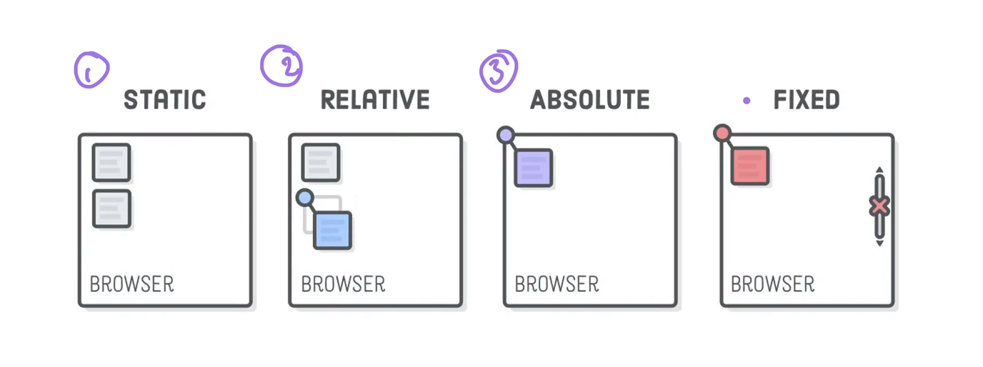
CSS Positioning:
1)static: default position

2)relative(relative to its default position)

3)absolute(relative to its nearest ancestor which has position property set else top left corner of the page)

4)fixed : fixed realtive to browser

Z index:

note: to make a element relative to parent , we have to make parent position as relative type and child position type as absolute.

https://appbrewery.github.io/css-positioning/

