GIT is a version control system

gitbash vs bash:
linux and macos have bash but in windows there is no bash so window user install gitbash

configuration :
git config user.name (to check whether name already set)
git config user.email ( to check whether email already set)

git config –global user.name “akash”
git config –global user.email “ akash@gmail.com”

git init
git status
git add filename (for staging or tracing a file)
git add . (for staging all the file )
git commit -m “message for commit”

git log
git log –abbrev-commit
git log –oneline (shows only one line of each commit even if very long msg)

amending commit which is just the previous one...
case1) if we want to change the commit message .. then simply :
git commit –amend (this will open up editor to edit the comment or message)

case2) if we also want to add a file to stage with the previous comit ..
git add filename
git commit – amend (this will open up editor to edit the comment or message as well as add/merge the file in the previous commit)

git remote add origin <REMOTE_URL> (Add the URL for the remote repository where your local repository will be pushed.)

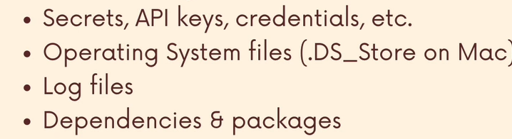
.gitignore

you may get common file name to be ignored using gitignore.io website or googling it...

Git Branch:
git branch (list all the branch)
git branch new_branch_name (creates new branch but not switch)
git switch branch_name (switch to another branch)

