Javascript notes-

Three ways to include JS in web pages :
1) inline
2internal
3) External
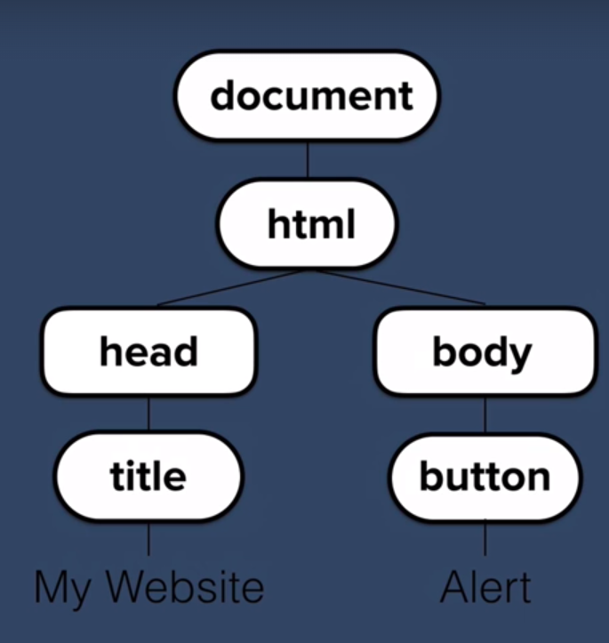
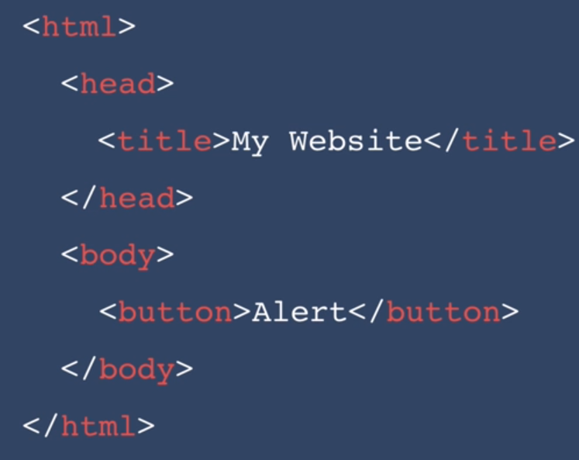
DOM (Document Object Model) :

our HTML page is changed in form of a tree by the BROWSER.

Each element is converted into objects and associated with other object in tree form.
We may use an chrome extension HTML Tree Generator
to visualise this tree structure of any webpage.

Html object is the first child .
Head is the firstChild of the html
Body is the last child of the html.

How to select Head => document.firstElementChild

Example:
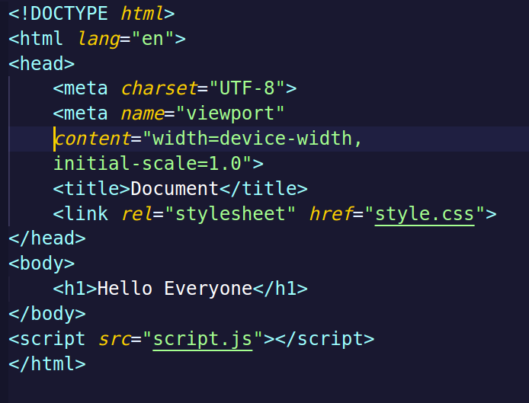



How the website looked before any DOM manipulation :

DOM manipulation :

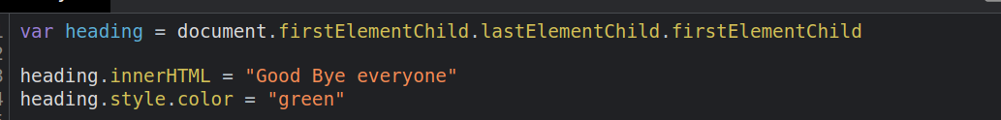


using query selector

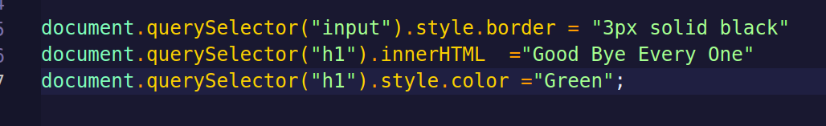

=======================================================================

inerHTML vs textContent

====================================================================
ATTRIBUTES

attributes
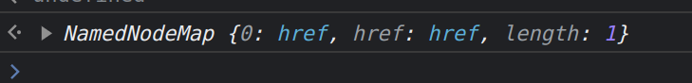

------------------------------------------------------------------------------------------------------------------------


.getAttribute

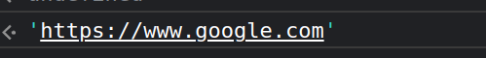

------------------------------------------------------------------------------------------------------------------------

.setAttribute
---------------------------------------------------------------------------------------------------------------------

