CSS Selectors:
Universal selector *
element selectors
Class Selectors .
Id selectors #
Attribute selectors []

FONT:
color:red;
font-family:
background-color:
googlefont:
font-weight:

CSS box model:
width:
height:
padding:
border:
margin:

size: px, em, rem, percentage

Display:
1)block: full length, can set width and height
2)inline: cant set width and height, margin and padding respected horizontally only
3)inline-block: can do every thing
4)None: hides the element

https://appbrewery.github.io/css-display/

Float: wrap text around an element
can be applied to any element. img{float:left;}
But what actually floats is text.

For footer to clear float --> footer{clear:both;}

Note: usually we dont use it for complex box layout for that we use flexbox , grid, bootstrap.
So this float is only used to wrap a text around an image.

Border:
10px solid black;
border-style: solid dashed wavy ,,,,
border shorthand
border-width: 10px 20px --- top-bottom left-right
: 10px 20px 30px 40px (top right bottom left (clockwise))

hints:
You horizontally center a div by giving it a width of 50% and a margin-left of 25%.

Hint: Set the image to have a width of 100% so it fills the div.

Specificity:
1)Position : later one will win
2)specificity : element < class < attribute < id
3)Type : external < internal < inline
4)Importance

Combining CSS selectors:
Group Rule:
h1, h2 {color:red} applies to borh h1 and h2

Child Rule:
.outer-box > p { color:red} ( direct child)

Descendant Rule:
.box p { color:red} (no need for direct descendant)

Chaining Rule:
h1#title.big.heading (not parent, child , or sibling but the same element should have these properties )

Combining Combiners: h1#title.big.heading > p{ color : red} (combination of various methods)
-----------------------------------------------------------------------------------------

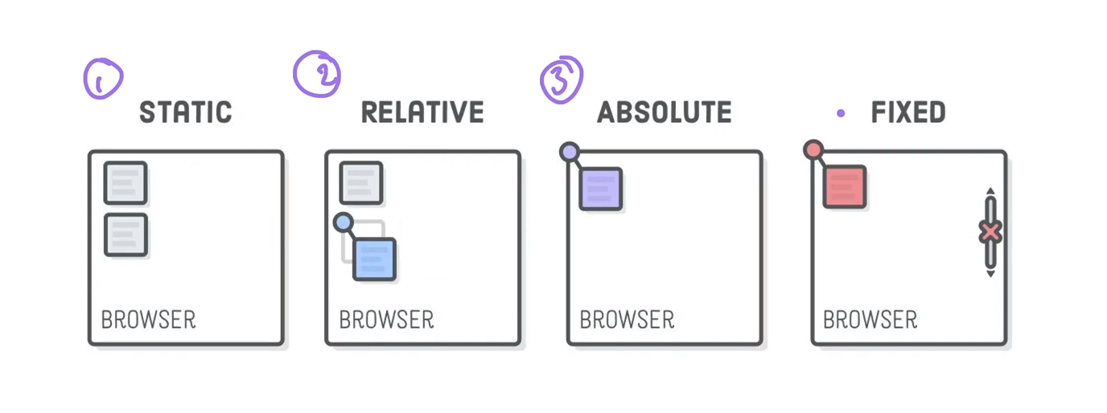
CSS Positioning:
1)static: default position

2)relative(relative to its default position)

3)absolute(relative to its nearest ancestor which has position property set else top left corner of the page)

4)fixed : fixed realtive to browser

Z index:

note: to make a element relative to parent , we have to make parent position as relative type and child position type as absolute.

https://appbrewery.github.io/css-positioning/

Responsive webpage:
there are 4 ways :

1)Media querry : @media(max-width:600px){
h1{
font-size:15px;}}
2)CSS grid : for 2d division

3)CSS flexbox : for 1D division

4)External frameworks – eg Bootstrap (12 division system)

CSS Flexbox:
https://css-tricks.com/snippets/css/a-guide-to-flexbox/

for one – dimensional division, Uses ratio.
Enclose every thing in a div, and give that div class of container and

Below property set on container (not items)
.container{display:flex} for block

or {display : inline-flex} (content area)

flex-direction :row (for horizontal )
flex-direction : column; (for vertical)

for distribution space between items along main axis :
{justify-content:flex-start or flex-end or center or space-between or space-around or space-evenly}

for positioning items along cross axis: but first need to set height of the container to observe its effect:
{align-items : flex-start or flex-end or center or space-between or space-around or space-evenly}
{align-self : to individually move an item up or down }

align-content{ }

below Property set on individual items inside the container:

.container > div { flex-basis: 100px;}
odoror
flex-basis: 10em;
flex-basis: 3px;
flex-basis: 50%;
flex-basis: auto;

for setting relative width of each items :
.firstBox{flex:1;}
.secondBox{flex:2;}

{flex-wrap: wrap or nowrap}

https://appbrewery.github.io/flex-layout/

https://appbrewery.github.io/flexboxfroggy/

flex-sizing priority :
content-width < width / height < flex-basis < min-width / max-width

flex-shrink:0 (no shrink) 1(then shrink)
flex-grow : 0 (no growth) 1(then shrink)

https://www.appbrewery.github.io/flexbox-sizing-exercise/

-----------------------------------------------------------------------------------------

Grid:
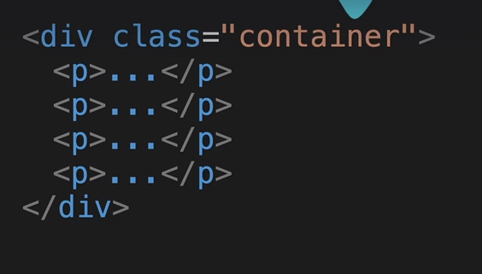
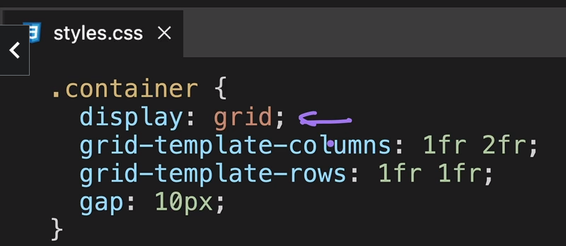
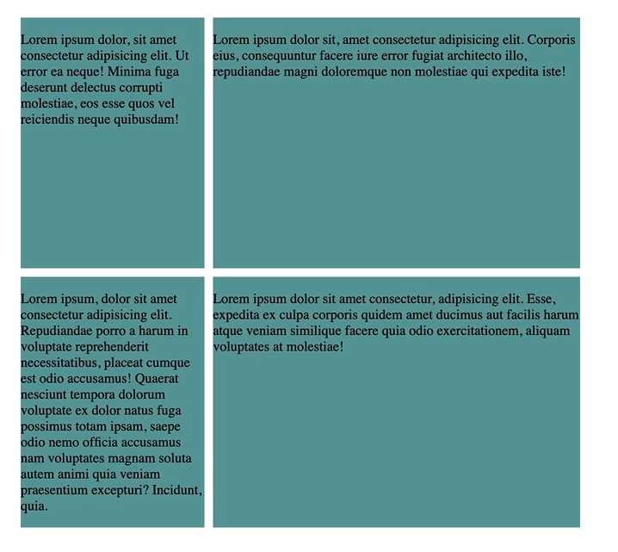
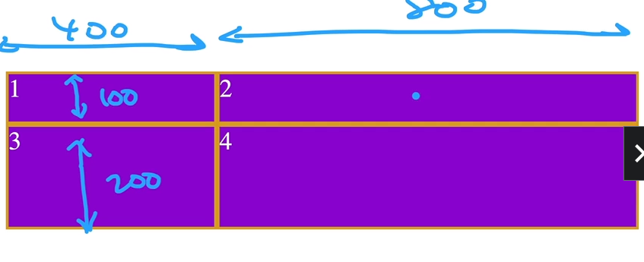
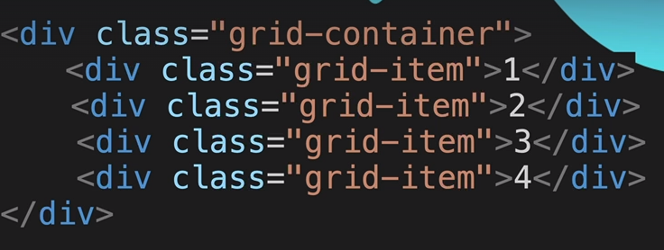
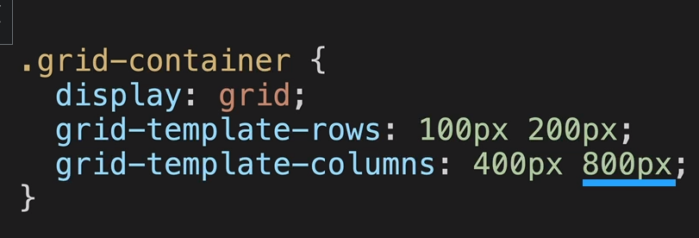
for 2d layout

https://appbrewery.github.io/grid-sizing/

ways to difine size: fixed (100 px 200 px)
fractional(1fr 2fr)
auto
minmax(400px , 800px)

grid-auto-rows: 50px;

https://appbrewery.github.io/grid-sizing/test

Grid and flex mixed together :

Grid cell merged using grid items span : {grid-column : span 2}

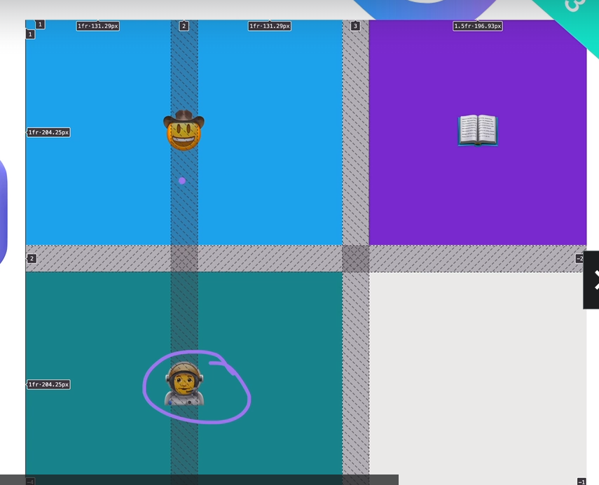
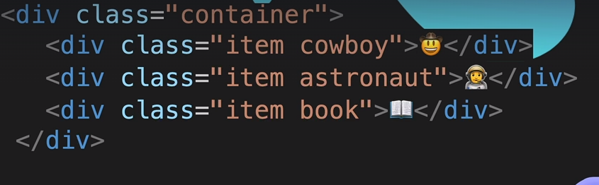
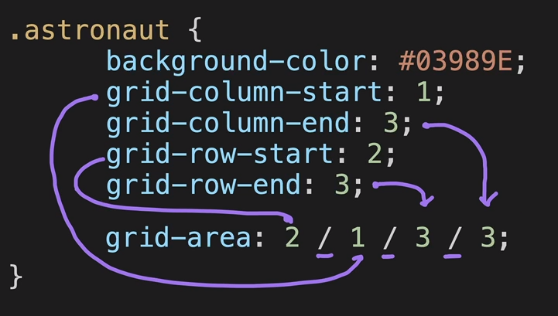
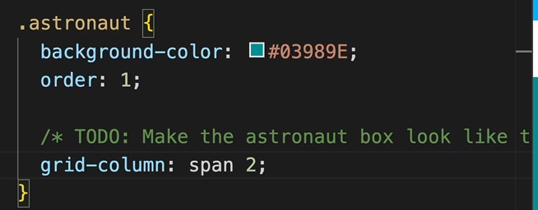

or
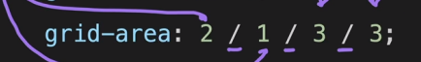

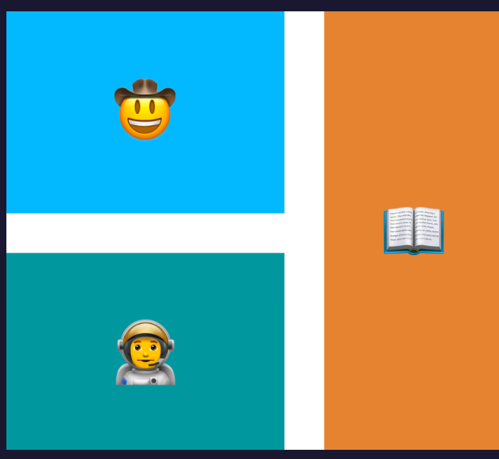
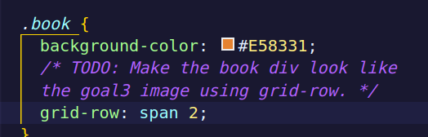
or shorthandd

-----------------------------------------------------------------------

Overlaying items on each other:
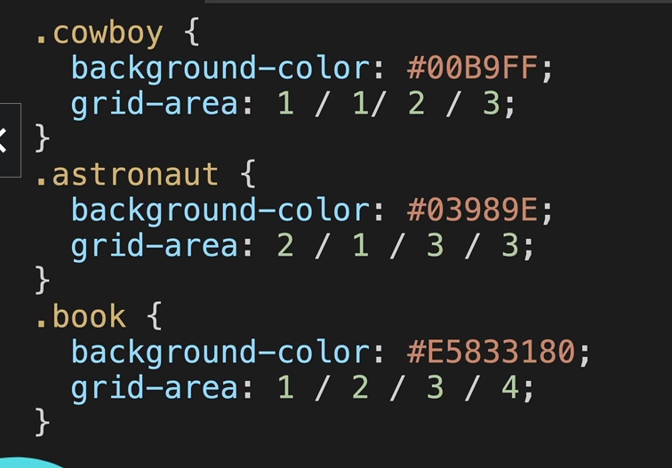
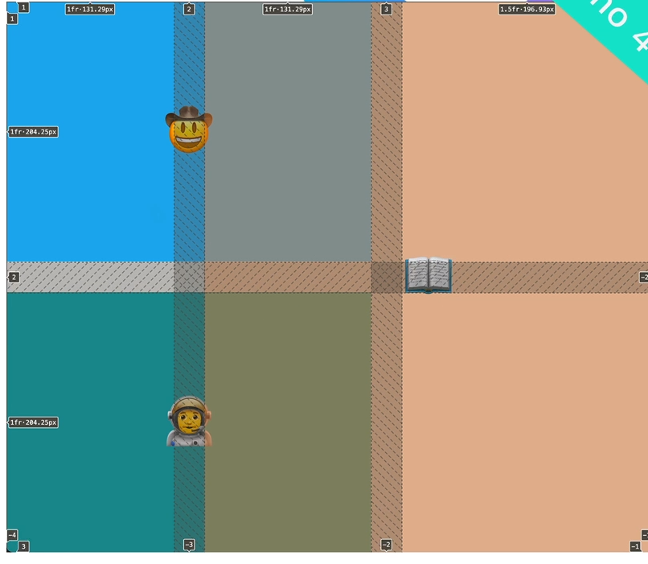
we can also overlay grid items over each other by defing the area method and giving starting row and column such values so that they overlap on each other and also give color of div such that there is transparency of let say 50 %.

practice grid: https://appbrewery.github.io/gridgarden/

Bootstrap:
it is a css framework ( an external css library) built upon flexbox.
We have to include cdn link for css and js in the head and the end of body section.
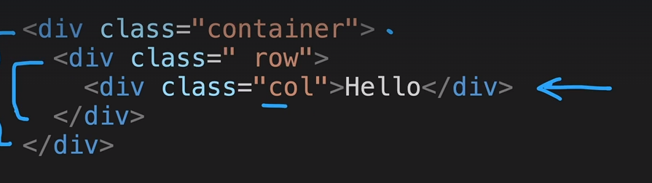
12 Column-system :

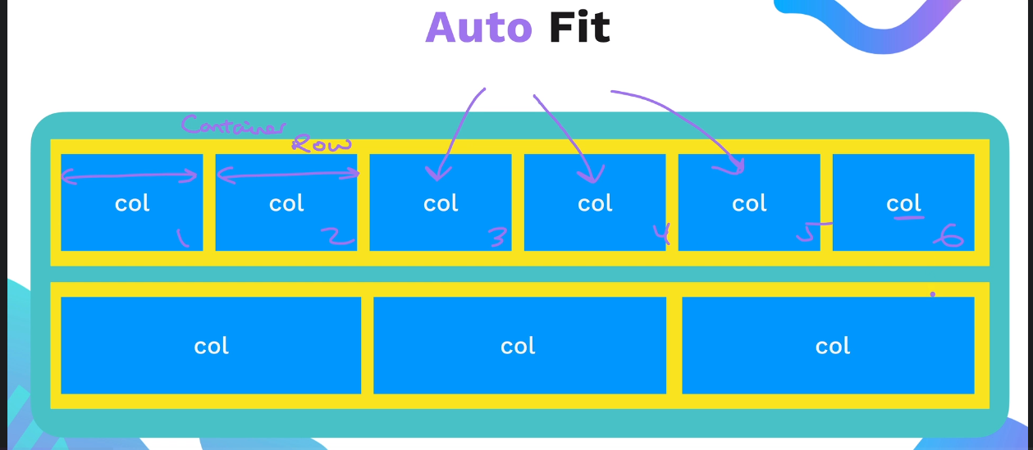

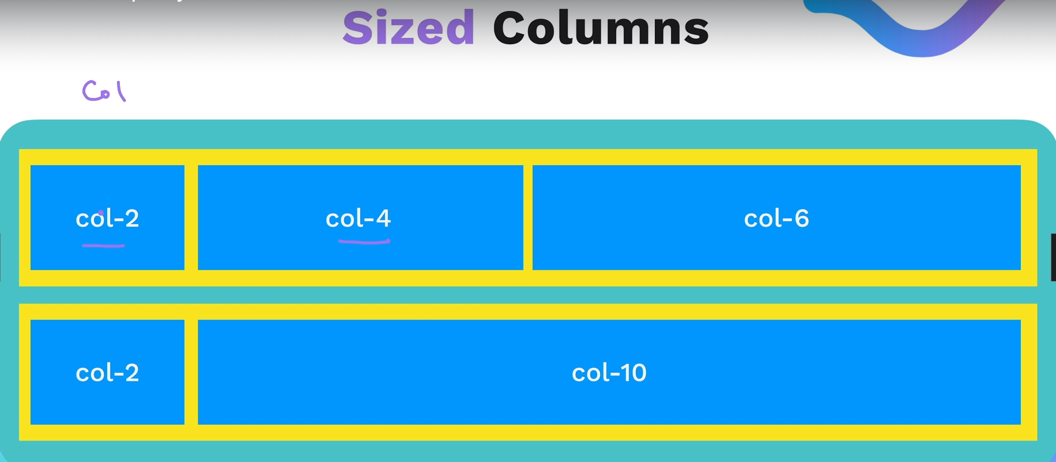
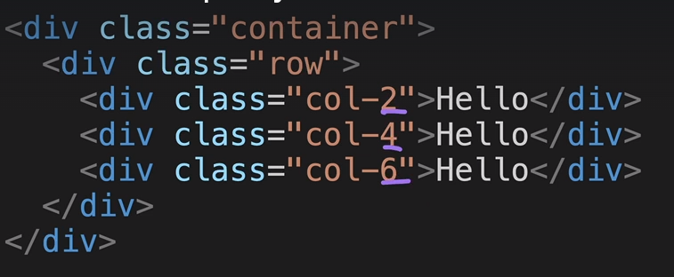

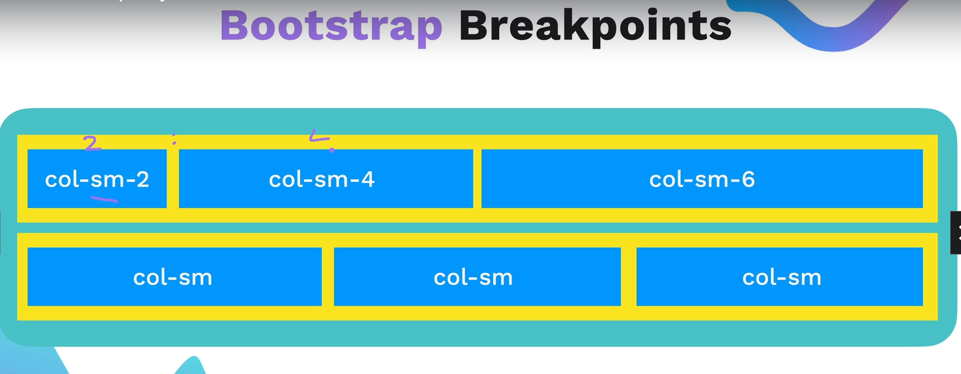

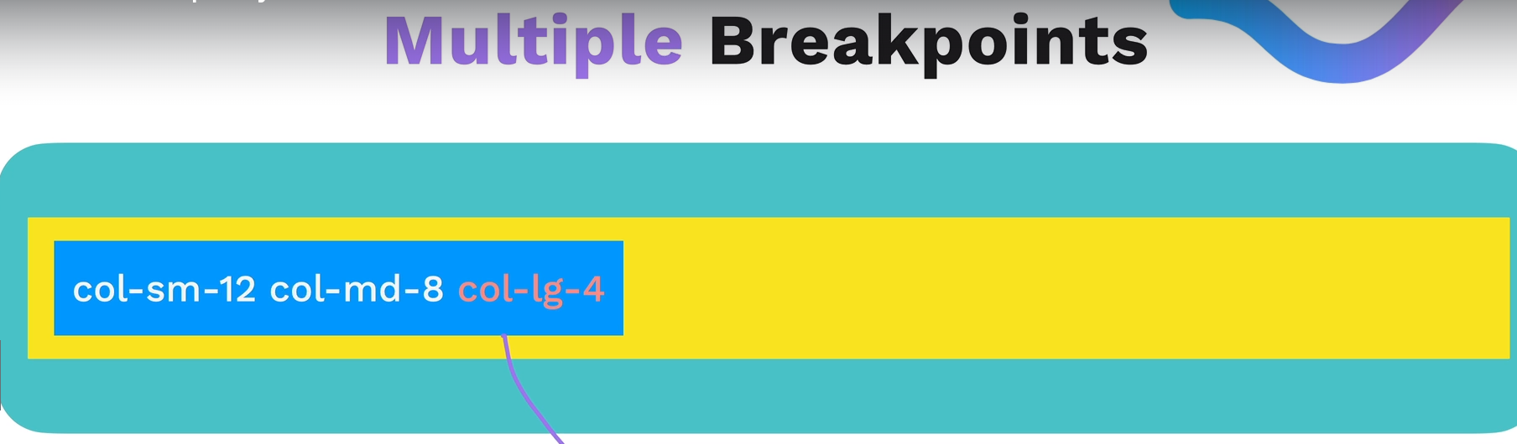

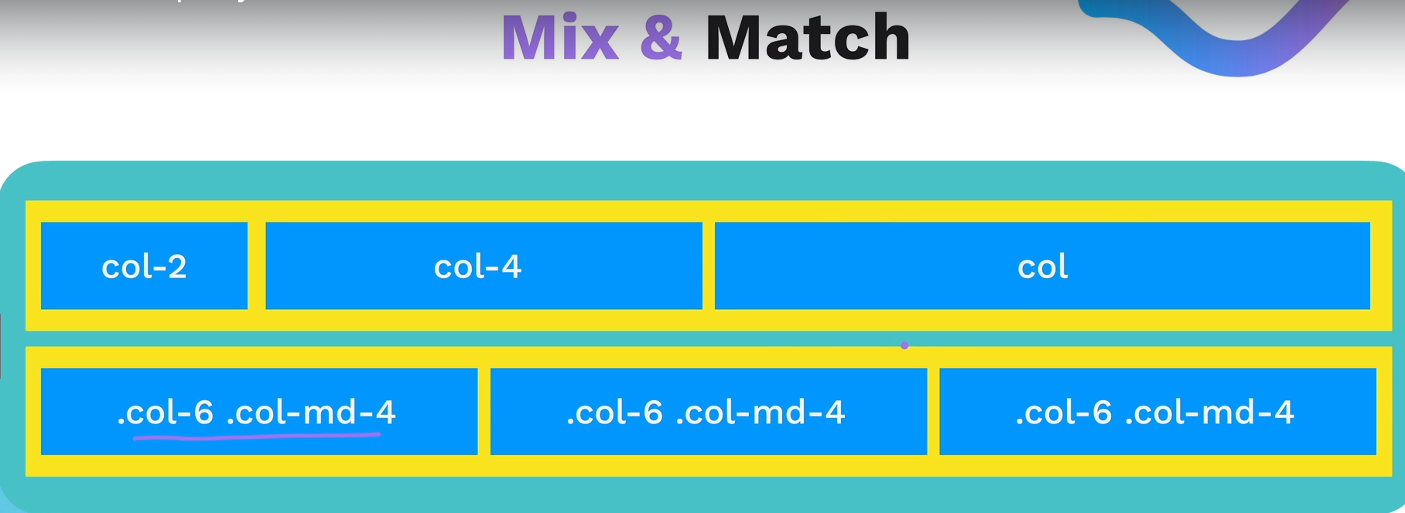

practice https://appbrewery.github.io/bootstrap-layout/

(first check ki koi bhi layout kis screen size se start ho rha hai.. and kis screen size par end.. so set the rule for starting screen size and then new rule for ending screen size..)
eg

practice project:
https://appbrewery.github.io/tindog/

