**LAB REPORT - 6**

Aim of the Experiment:

1. Introduction to Network Simulator Tool (Cisco Packet Tracer) and its application in Research Work.

2. Demonstration of how routing works using Cisco Packet Tracer.

Assignments:

1. Simulate routing of packets in a LAN within the same subnet.

2. Simulate routing of packets in a LAN with different subnets.

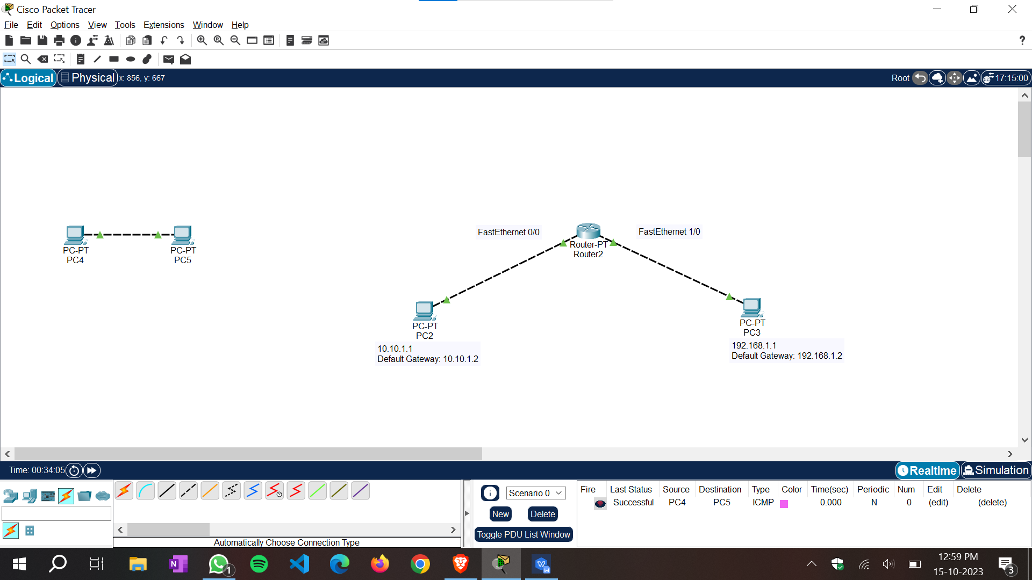

Akash Duttachowdhury | 21052386

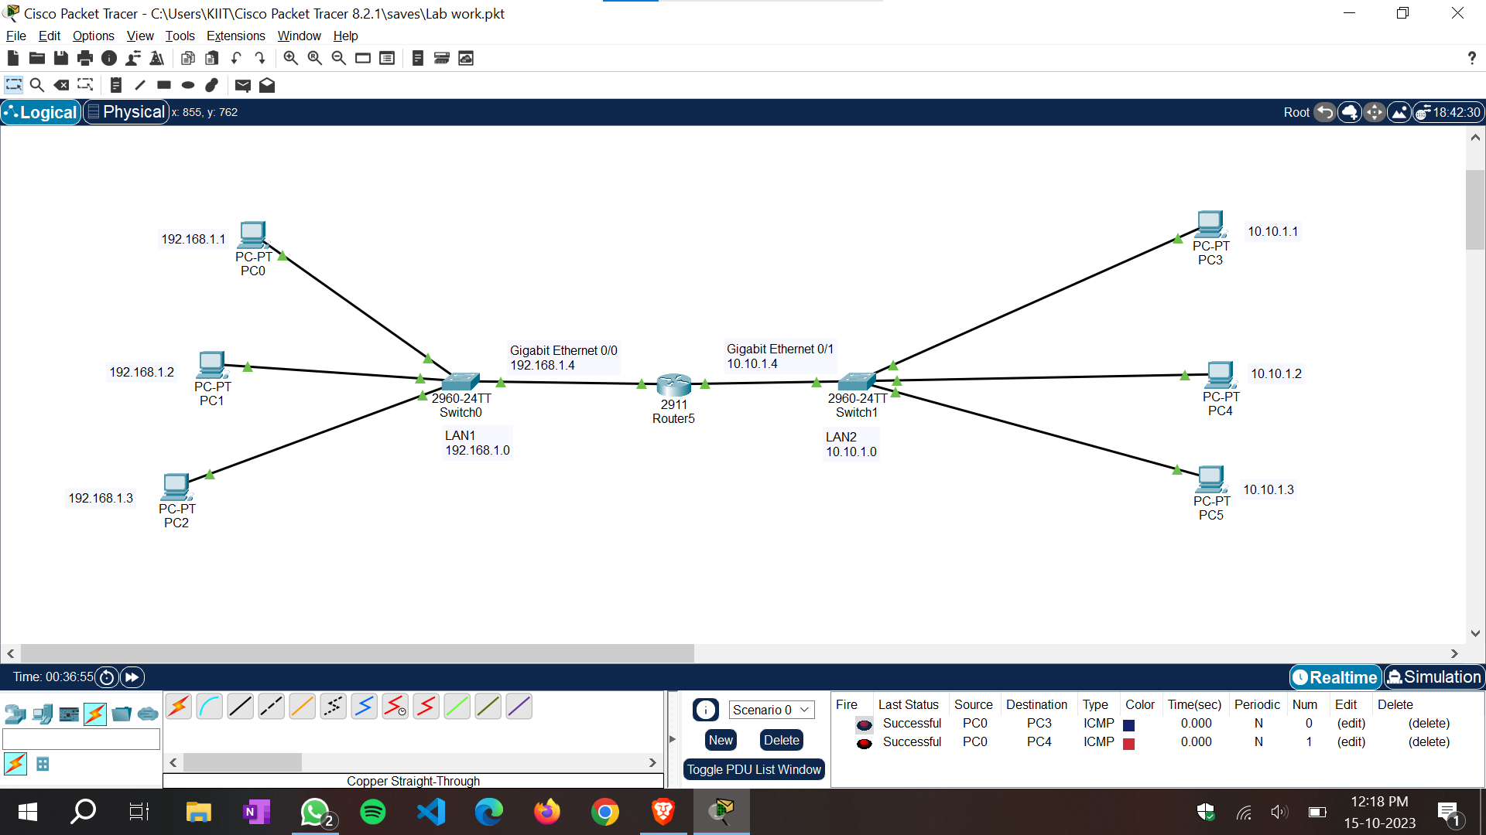

Akash Duttachowdhury | 21052386