EPIGROTIVE
HOMEPAGE STRUCTURE BLUEPRINT
Section-by-section information architecture + visual wireframes

PRIMARY GOAL  Turn the current premium visual identity into a clearer, higher-converting business homepage. | DESIGN DIRECTION  Keep the existing dark / neon / gaming-native language, but strengthen hierarchy, proof and conversion.

Prepared as a handoff document for design + development. The wireframes are structural references, not final UI screens.

1. Executive Recommendation
The current interface already has a strong visual identity: dark premium surfaces, electric blue/pink accents, distinctive typography and a clear gaming-native personality. The homepage should now be reorganized around a simple conversion story:
- Who are we?
- What can we do for you?
- Why should you trust us?
- What have we done?
- Which side of Epigrotive is relevant to you?
- What should you do next?
Recommended homepage narrative
Hero → Trust → One House / Two Engines → Services → Why Us → Portfolio → Epigrotive Gaming → Who We Work With → Process → Testimonials → Final CTA.
Three principles
- Clarity over decoration: every section needs one job.
- Proof over claims: replace generic statements with real logos, numbers and case-study outcomes wherever possible.
- Two clear journeys: brand/client visitors should find Epigro Media quickly; esports/community visitors should find Epigrotive Gaming quickly.

2. Section 01 — Hero / First Impression
The hero is the most important change. Keep the existing visual style, but make the business proposition immediately understandable. The two business paths should be visible without opening the menu.
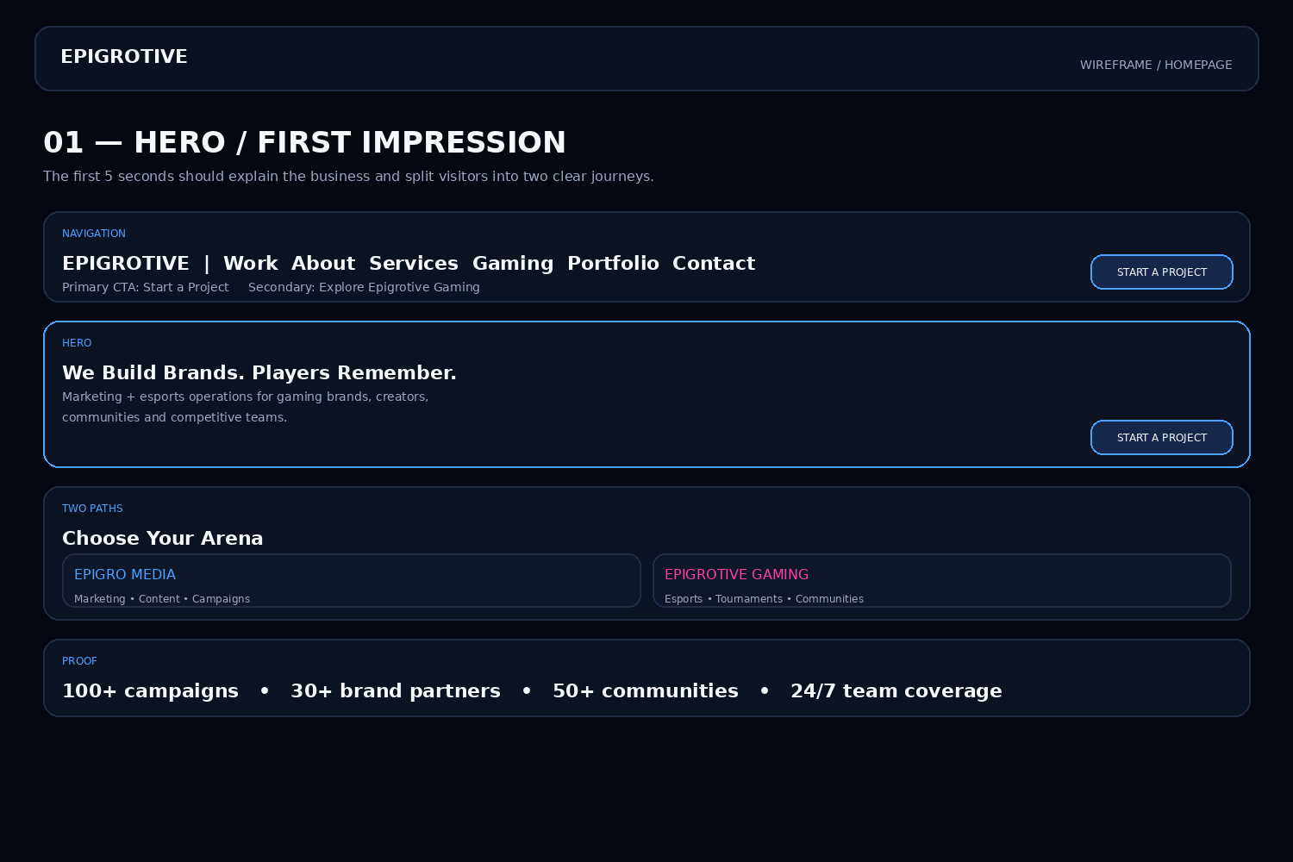
Implementation notes
- Desktop: use a wide hero with the two pathways visible above the fold.
- Mobile: stack the two pathways vertically; do not hide one behind a hamburger menu.
- Primary CTA should open a short project form or contact route.

3. Section 02 — Trust / Proof Strip
Move evidence closer to the top. Numbers should be verified and logos should be real. If a metric cannot be substantiated, do not display it.
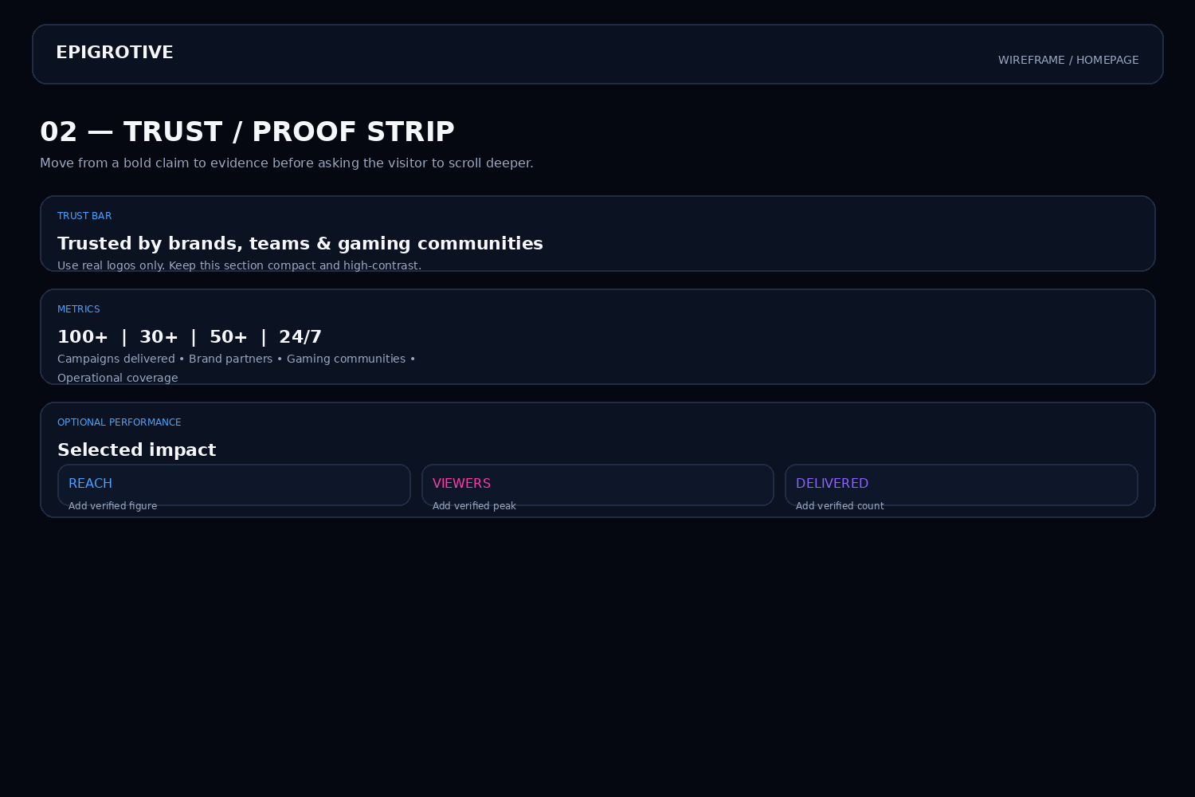

4. Section 03 — One House. Two Engines.
This is the clearest way to explain the relationship between Epigro Media and Epigrotive Gaming without forcing visitors through a long About section.
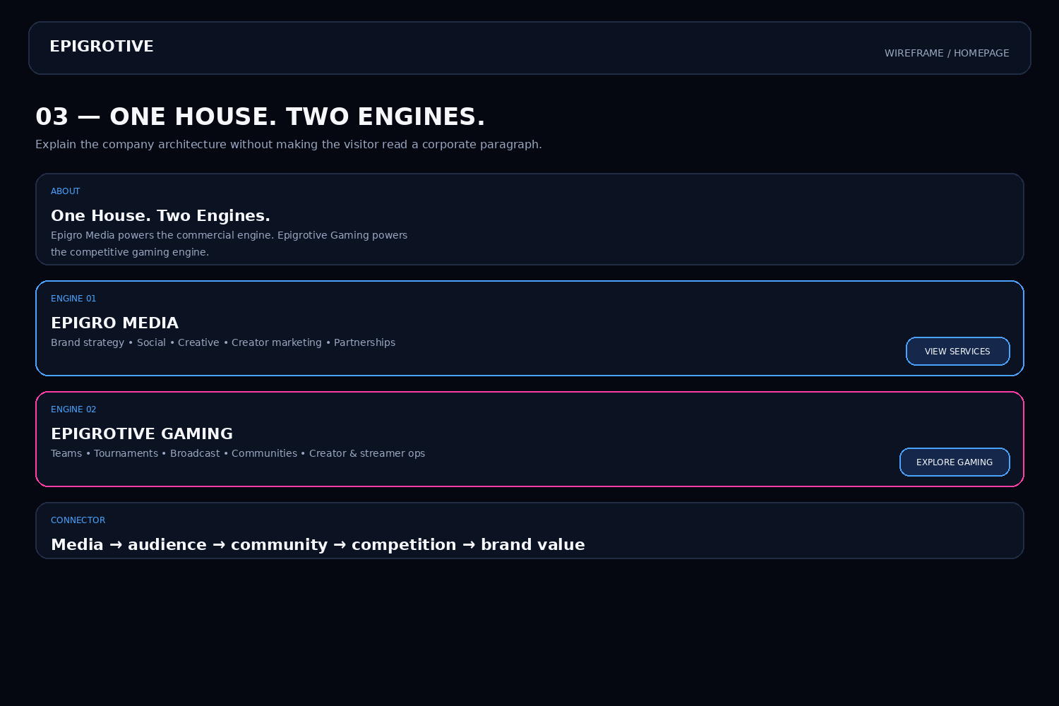

5. Section 04 — Services
The existing 10-item service list is visually clean but feels like a catalogue. Group services into outcome-led pillars and let visitors drill down.
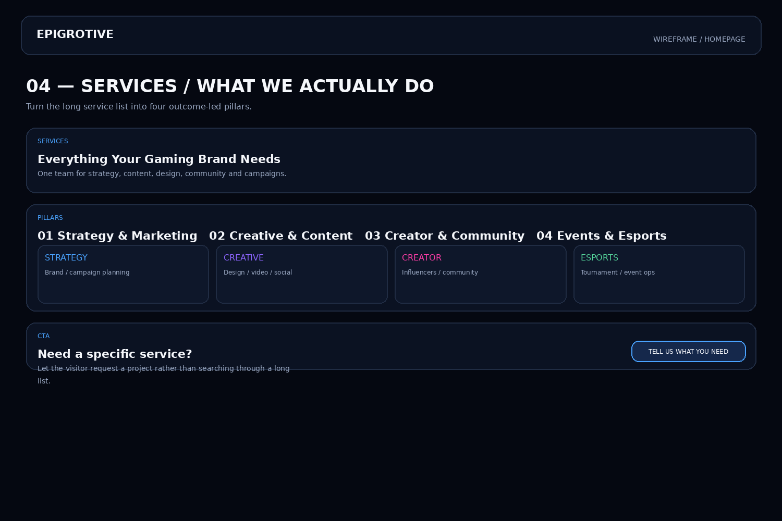
Suggested service grouping
- Strategy & Marketing — brand strategy, campaign strategy, digital marketing.
- Creative & Content — graphic design, video editing, social content.
- Creator & Community — creator marketing, community management, Discord.
- Events & Esports — tournament promotion, event marketing, esports operations.

6. Section 05 — Why Epigrotive
This section should answer the client's silent question: “Why you instead of a normal marketing agency or tournament organizer?”
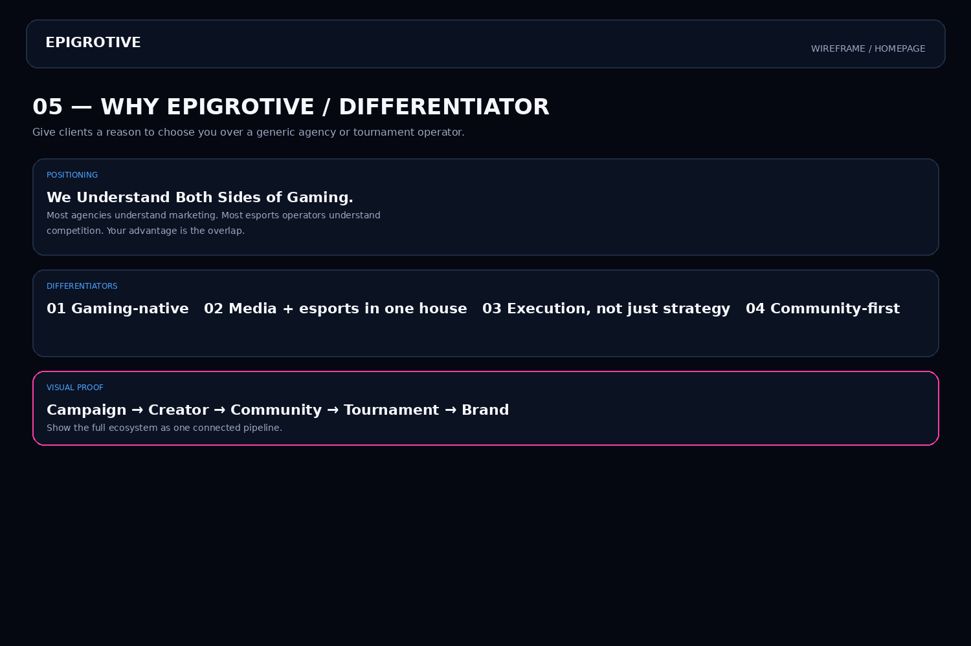

7. Section 06 — Portfolio / Case Studies
The current portfolio direction is good. Upgrade it from image-first to proof-first: objective, execution and measurable result.
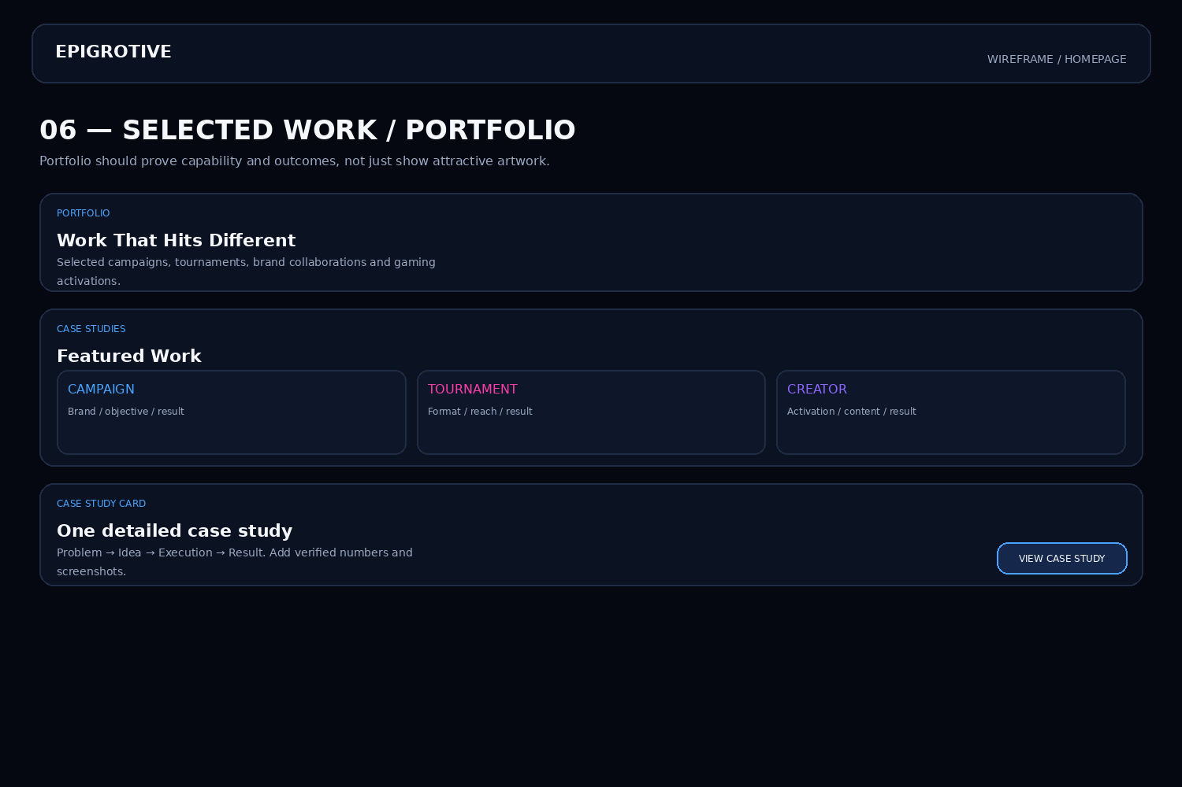
Case-study card template
- Client / campaign name
- Objective
- What Epigrotive delivered
- Verified result
- View case study

8. Section 07 — Epigrotive Gaming
Give the esports arm its own strong visual moment. Keep the pink accent to create a clear distinction from the media/agency side.
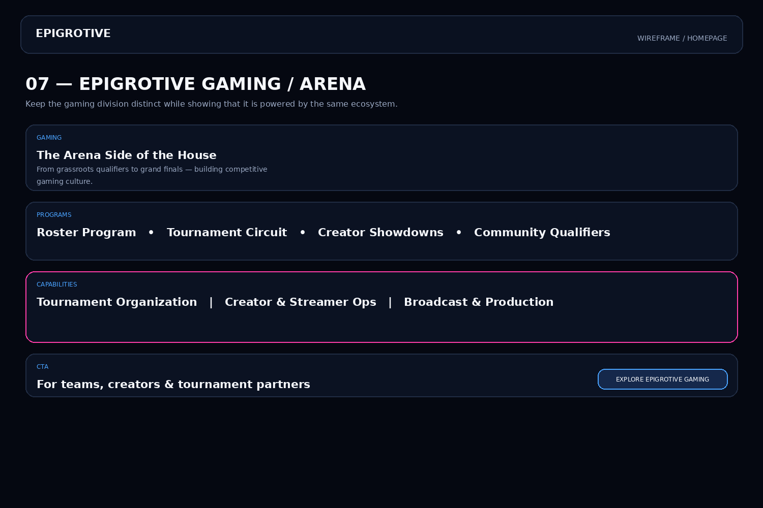

9. Section 08 — Who We Work With
This can become a routing system. A brand, team, creator or tournament organizer should immediately know which path is meant for them.
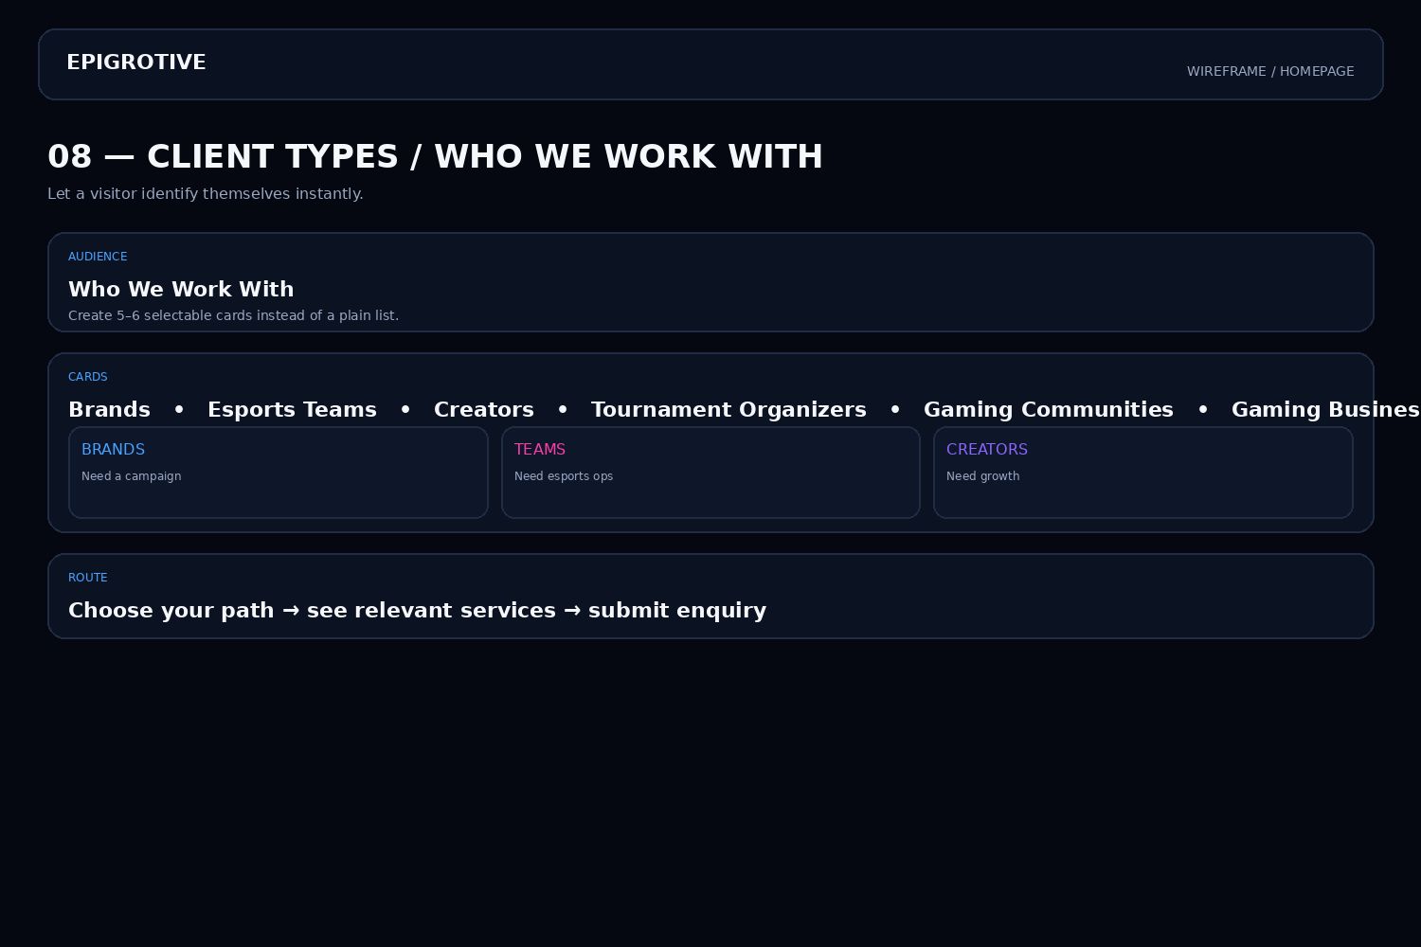

10. Section 09 — How We Work
A simple three-step process makes the agency feel easier to work with and reduces uncertainty before the enquiry.
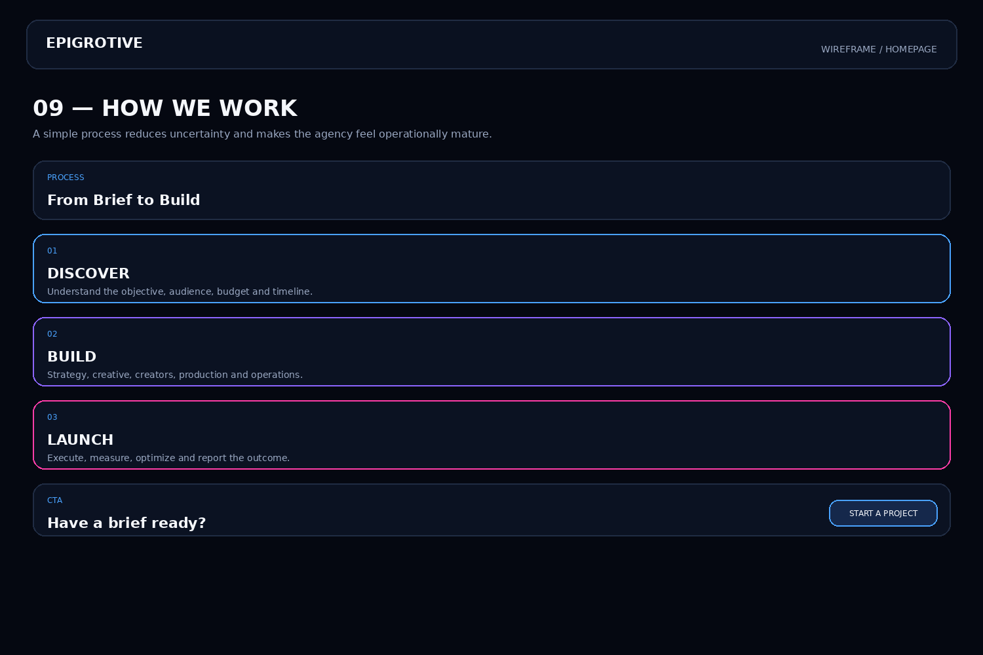

11. Section 10 — Testimonials / Social Proof
Use real names, roles and companies. Short, specific quotes are stronger than long generic praise.
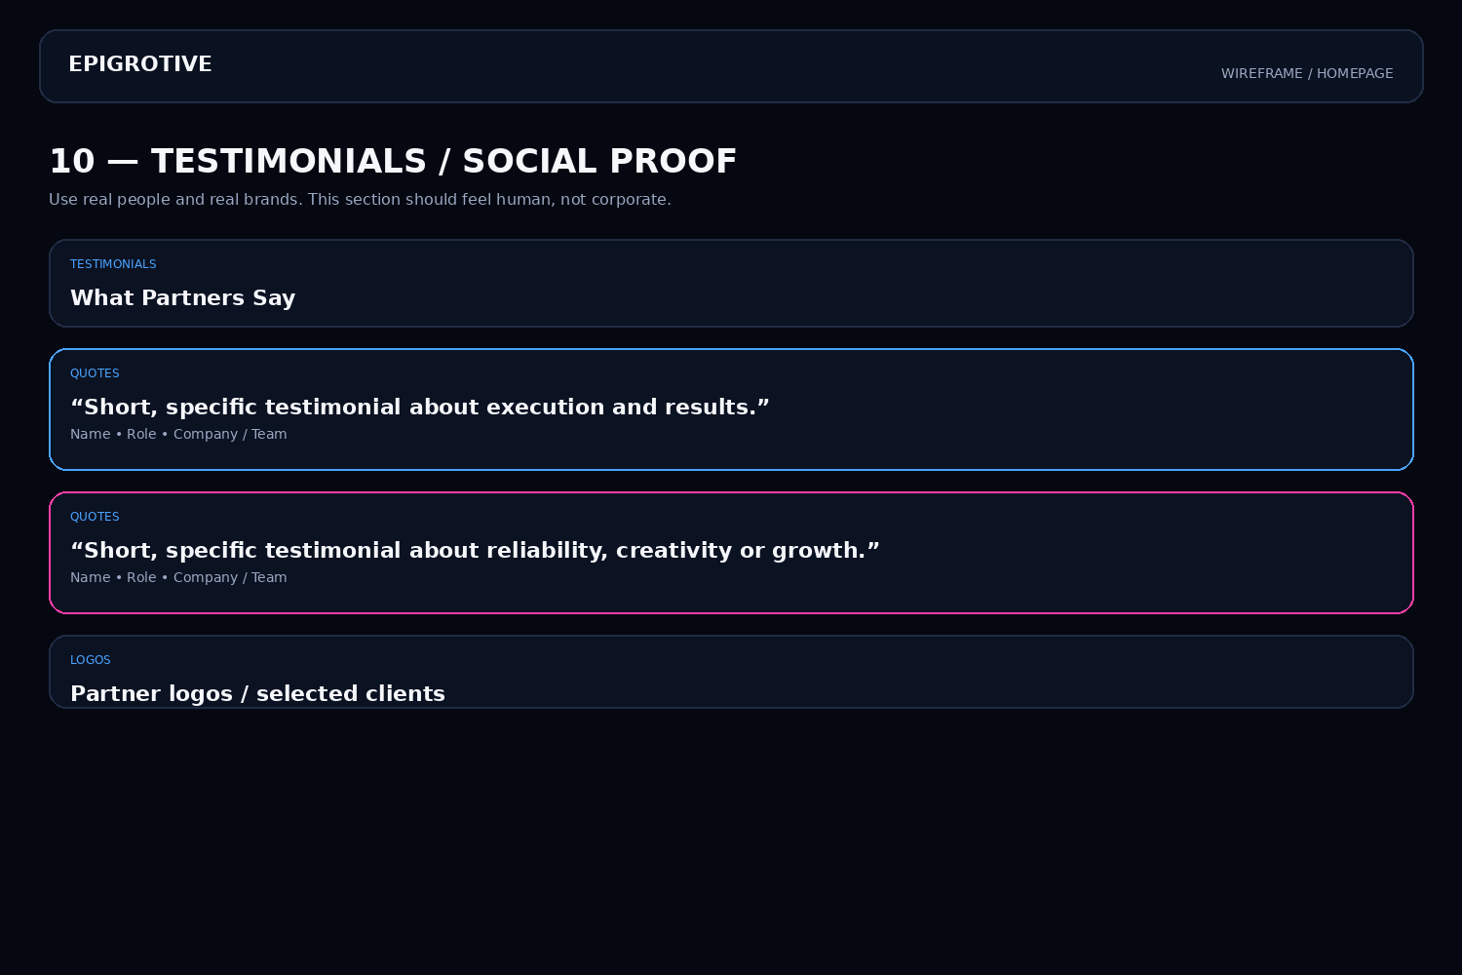

12. Section 11 — Final CTA / Contact
End the page with a strong action. The final CTA should not be another vague “contact us”; it should start a project conversation.
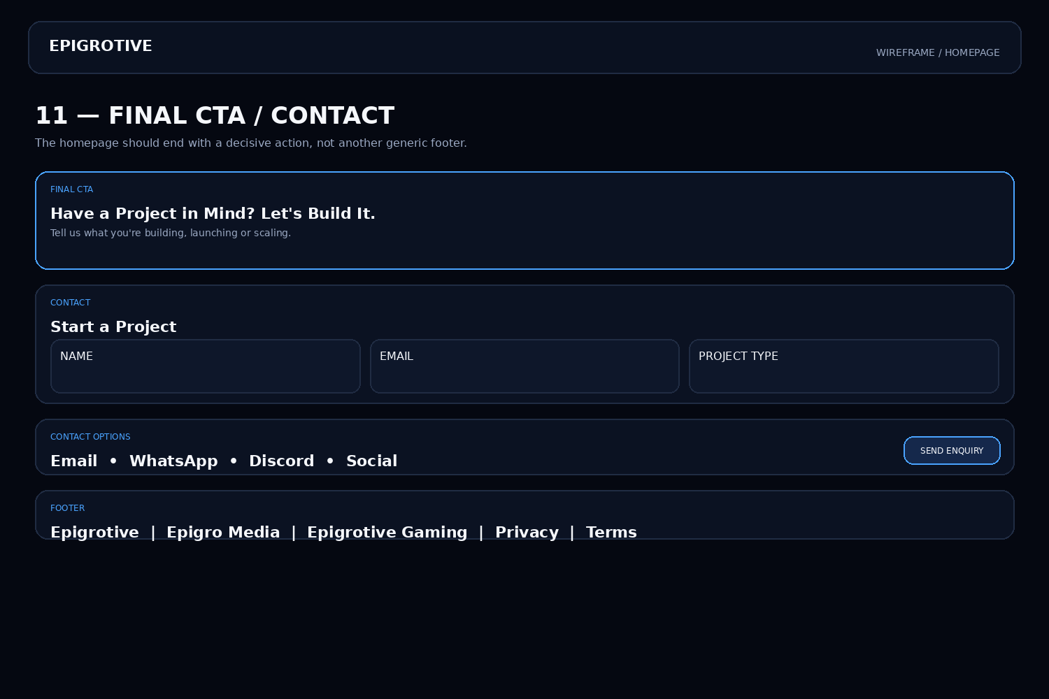
Contact form fields
- Name + work email
- Company / team
- What are you looking to build?
- Approximate timeline
- Optional budget range
- Submit enquiry

13. Full Homepage Flow — Developer Handoff
This is the recommended final scroll order. Treat it as the homepage's information architecture.
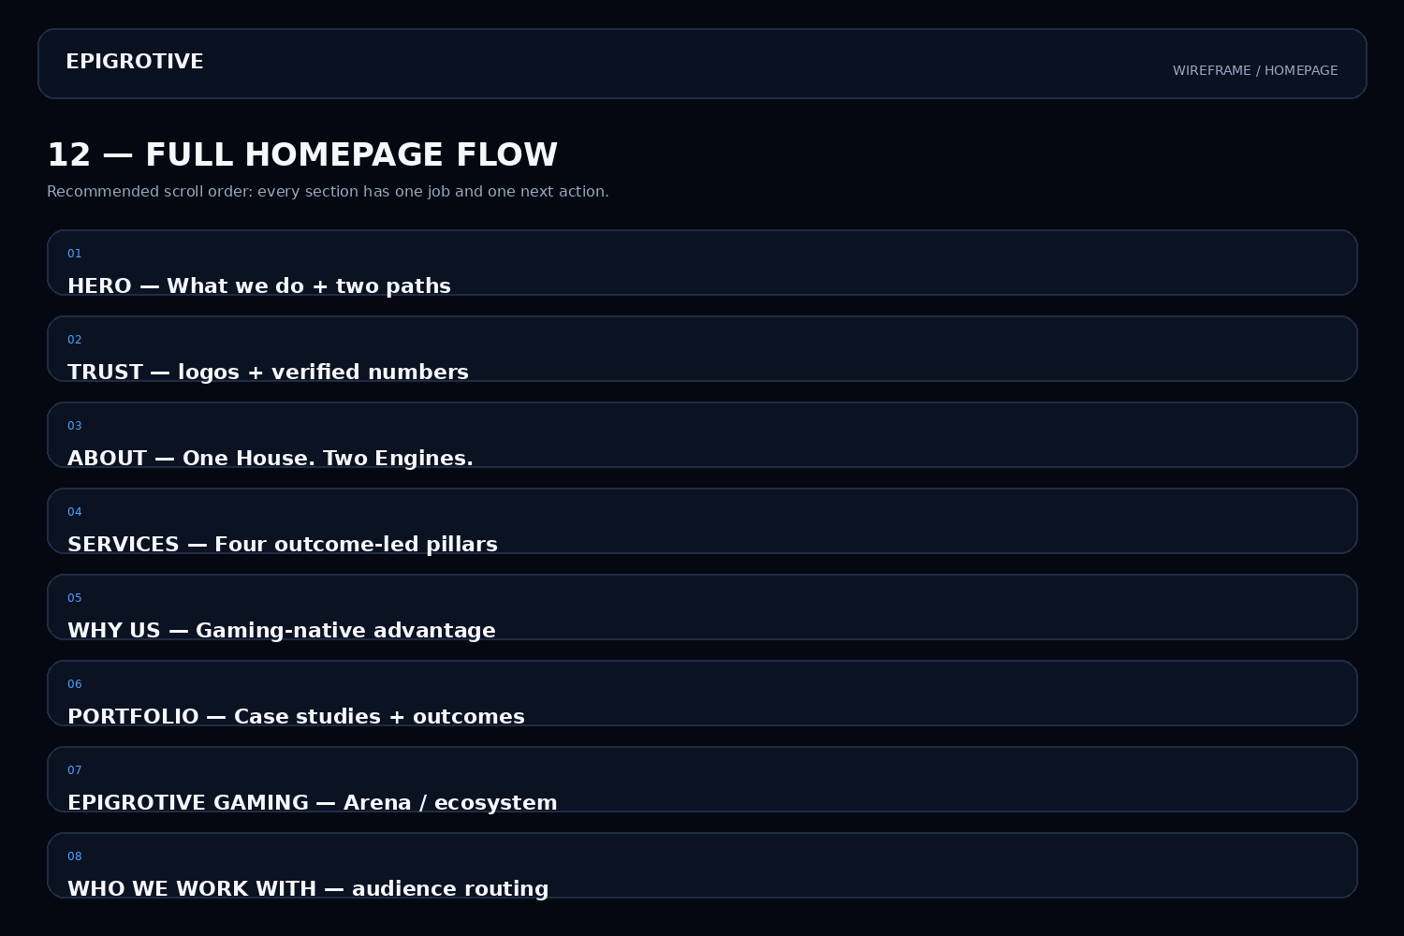

14. Recommended Copy Bank
Use these as working copy. Keep the tone confident, modern and gaming-native, but avoid exaggerated claims unless they are backed by data.
Hero
Headline: We Build Brands. Players Remember.
Subheadline: Marketing + esports operations for gaming brands, creators, communities and competitive teams.
Primary CTA: Start a Project
Secondary CTA: Explore Epigrotive Gaming
Positioning
One House. Two Engines.
Epigro Media builds the commercial side — strategy, creative, content, creators and campaigns. Epigrotive Gaming builds the competitive side — teams, tournaments, broadcasts and communities.
Differentiator
We Understand Both Sides of Gaming.
Final CTA
Have a Project in Mind? Let's Build It.
Tell us what you're building, launching or scaling.

15. Developer / Designer Checklist
- Keep the current dark visual language; do not redesign the brand from scratch.
- Use one consistent grid, border radius and spacing system across cards.
- Make blue the primary business/agency accent and pink the gaming/esports accent.
- Keep body copy shorter than the current long paragraphs; prioritize scanability.
- Use real client logos and verified metrics only.
- Add subtle motion: section reveal, hover glow, animated counters and soft background movement.
- Make all CTA buttons visually consistent and trackable.
- Ensure mobile is treated as a first-class layout, not just a scaled desktop.
- Compress imagery and lazy-load portfolio assets for fast initial load.
- Add accessible labels, keyboard focus states and sufficient contrast.
- Track CTA clicks, contact-form starts, form submissions and Gaming-section clicks.
- Keep the navigation simple: Work, Services, Gaming, About, Contact + Start a Project.
Final design direction
Do not add more visual effects just for the sake of making the site look futuristic. The current aesthetic is already distinctive. The next level is making the same aesthetic communicate business value, proof and action much faster.
EPIGROTIVE • Homepage Structure Blueprint

