EPIGROTIVE
HOMEPAGE STRUCTURE BLUEPRINT
Professional information architecture • wireframes • content direction • developer handoff
Reference direction: NODWIN's company/IP-led positioning and Upthrust's service, IP, workflow, team and contact architecture. The goal is to take those strategic cues without copying their visual identity.

1. Executive Direction
The current Epigrotive interface already has a strong visual language. The next version should feel less like a landing-page template and more like a serious gaming, esports and youth-culture company.
- Sharper corporate positioning
- Clear separation between Epigro Media and Epigrotive Gaming
- Case-study and IP-led storytelling
- Real proof and partner credibility
- Shorter path from visitor → relevant service → enquiry
2. Recommended Homepage Flow
Hero → Trust → One House / Two Engines → Services → Why Us → Work / IPs → Epigrotive Gaming → Who We Work With → Process → Testimonials → Final CTA.

01 — HERO / FIRST IMPRESSION
The hero should establish the company, not merely the aesthetic. The two business journeys must be visible immediately.
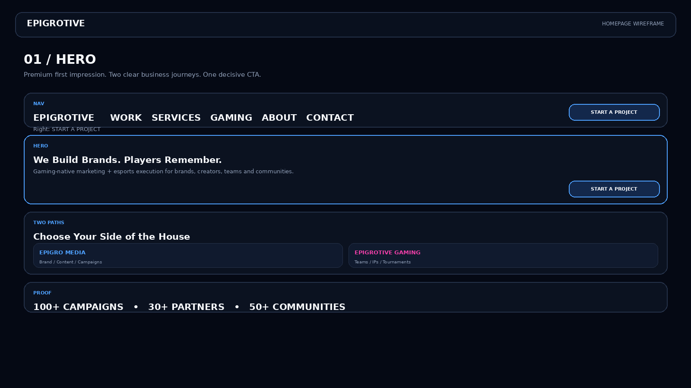

02 — ONE HOUSE. TWO ENGINES
Make the Epigro Media + Epigrotive Gaming relationship a core brand architecture.
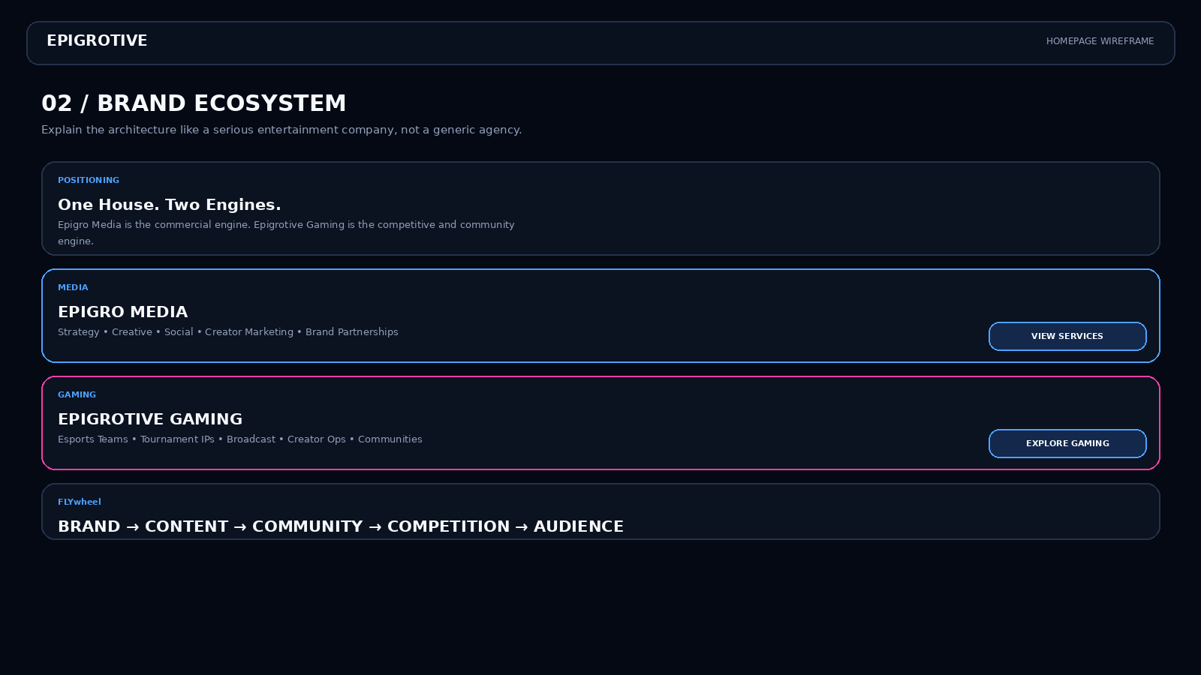

03 — SERVICES
Replace the long list with four capability pillars that can be expanded into detail pages.
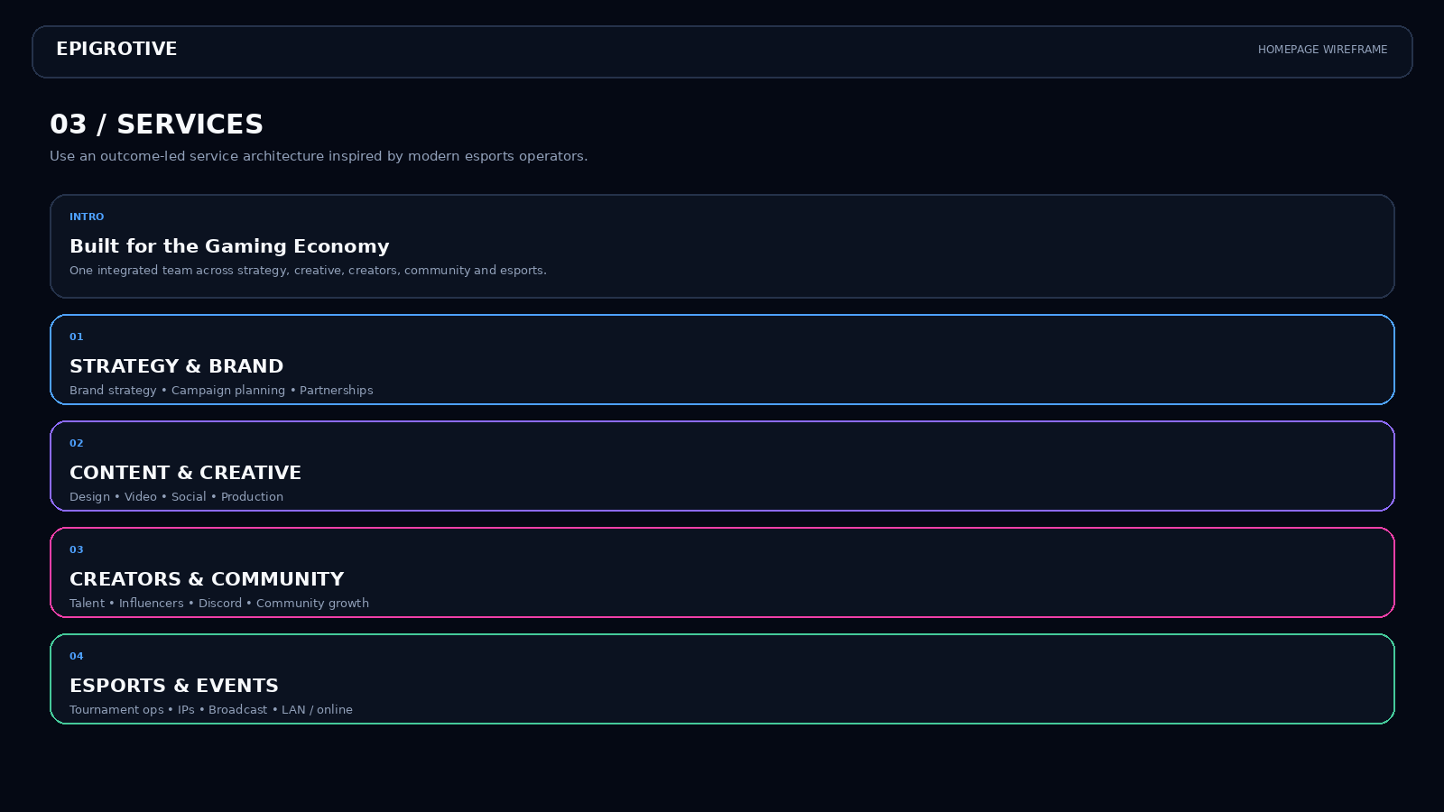

04 — WORK + IPs
Treat work as a case-study and IP library. Add objective, delivery and verified result.
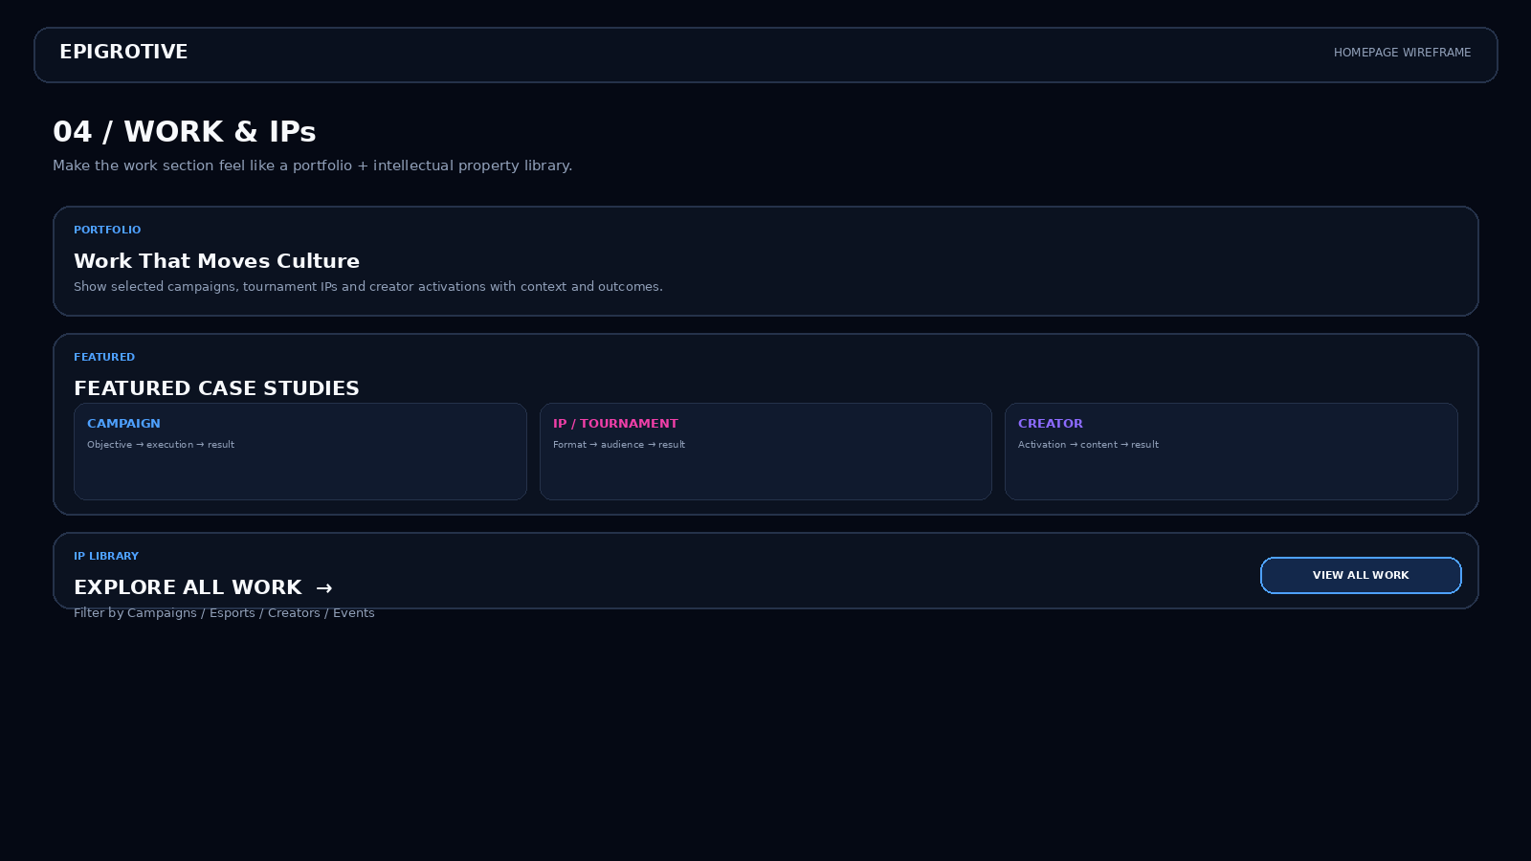

05 — EPIGROTIVE GAMING
Create a distinct gaming chapter with pink as an accent, while retaining the master brand system.
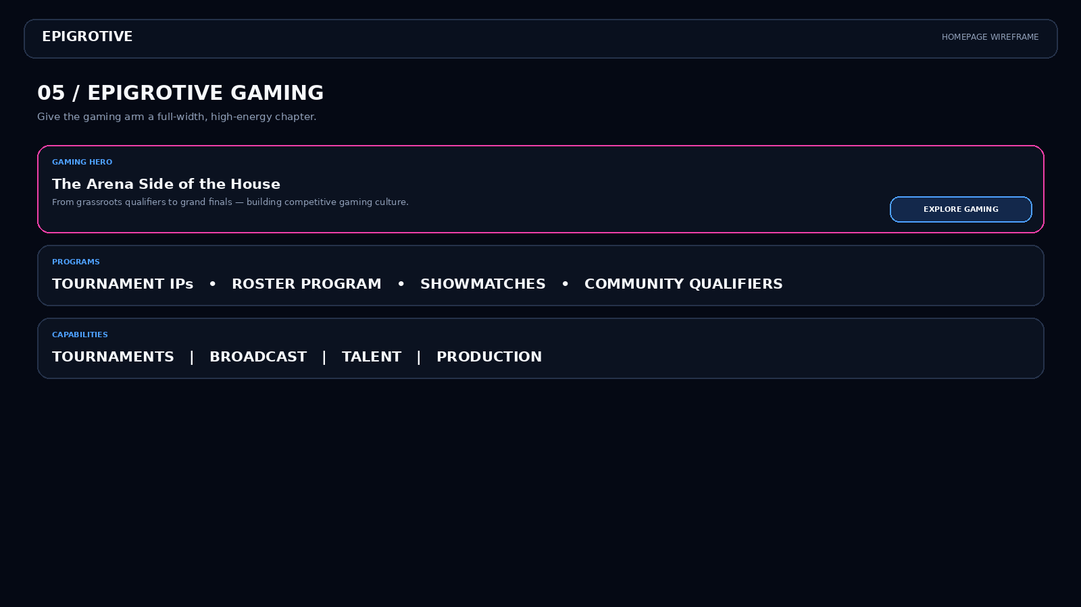

06 — PROOF
Bring partner logos, metrics and testimonials together into one credible proof layer.
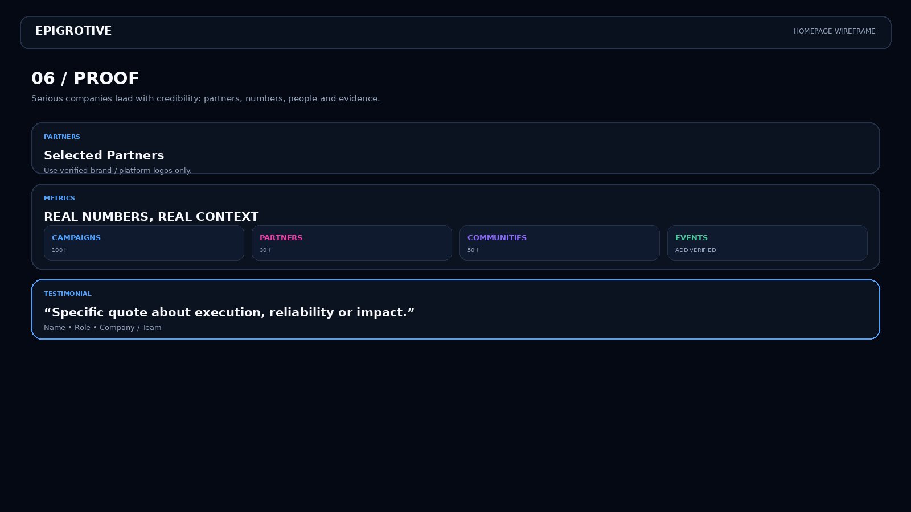

07 — PROCESS + CTA
Show a simple Discover → Build → Launch process and end with a strong Start a Project CTA.
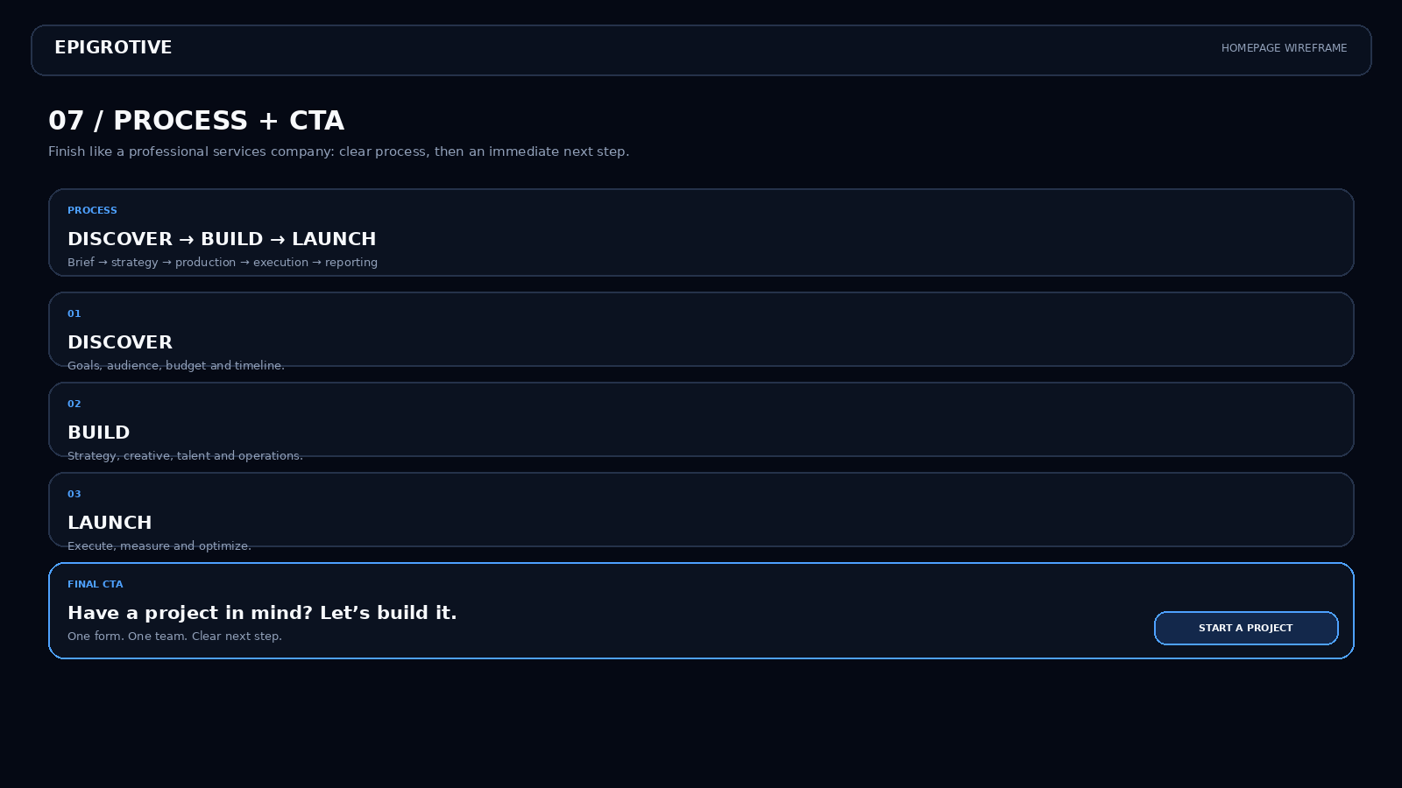

08 — FULL HOMEPAGE ARCHITECTURE
This is the final recommended information architecture for development.
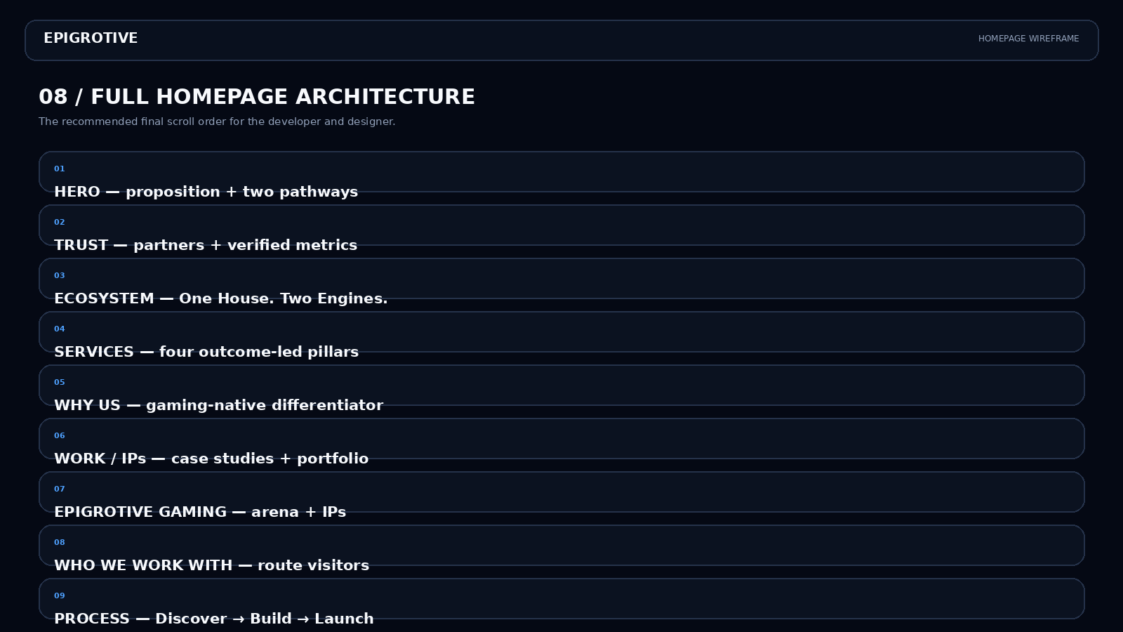

9. Content Architecture
- Hero: one sentence describing the business + two clear routes + one primary CTA.
- Services: Strategy & Brand / Content & Creative / Creators & Community / Esports & Events.
- Portfolio: Client → Objective → Execution → Result → Case Study.
- Gaming: Tournament IPs / Roster Program / Creator Showdowns / Community Qualifiers.
- Proof: real partner logos, verified metrics and named testimonials.
- Contact: Name, Email, Company/Team, Project Type, Timeline, optional Budget.
10. UX / Development Rules
- Persistent Start a Project CTA on desktop; accessible CTA in mobile navigation.
- Mobile-first spacing and typography; avoid excessively tall empty sections.
- Lazy-load portfolio media and compress all images.
- Use subtle motion only where it improves hierarchy or feedback.
- Track CTA clicks, form starts, submissions, case-study views and Gaming CTA clicks.
- Use real claims only; remove placeholder metrics before launch.
11. Final Design Target
Think NODWIN-level company positioning and Upthrust-level operational clarity — but keep Epigrotive's own identity. The result should look capable of handling a national esports IP, a major brand campaign, a creator activation or a competitive gaming ecosystem without feeling like a generic agency website.

