**AI ASSISTED CODING LAB**

**ASSIGNMENT 14.4**

**ENROLLMENT NO :**2503A51L47

**BATCH NO:** 20

**NAME:** N.AKASH

**TASK1**

TASK1 DESCRIPTION:- **AI-Assisted Portfolio Website**  
**Scenario**:  
A student wants to showcase their projects, skills, and contact details in a portfolio website. Instead of writing all code manually, they want to speed up the process using GitHub Copilot.

**PROMPT**:- Create a simple and responsive student portfolio website with HTML and CSS. Include a navigation menu (Home, About, Projects, Contact), a projects grid with hover effects, and a contact form.

CODE:-

HTML:-

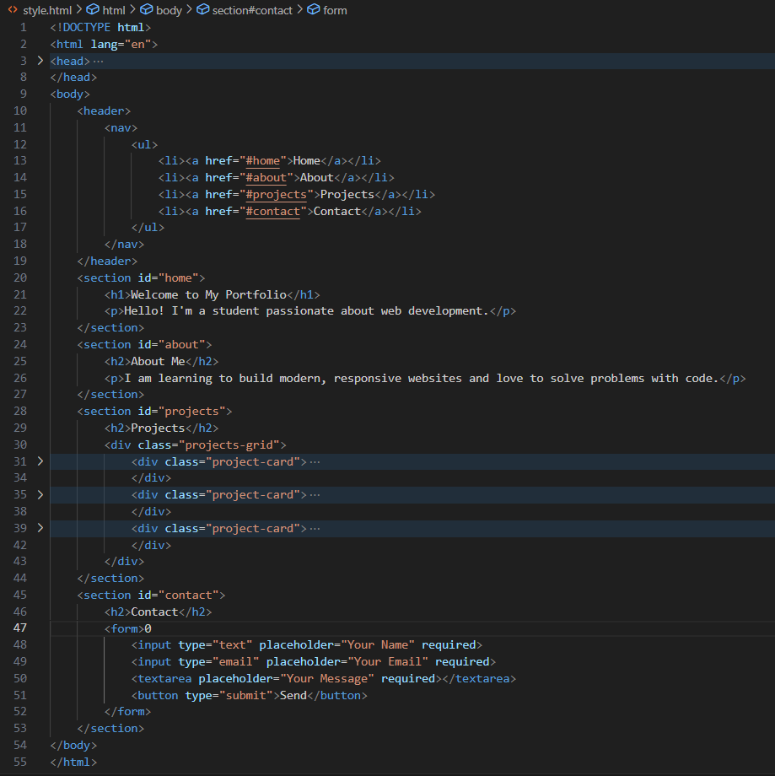

CSS:-

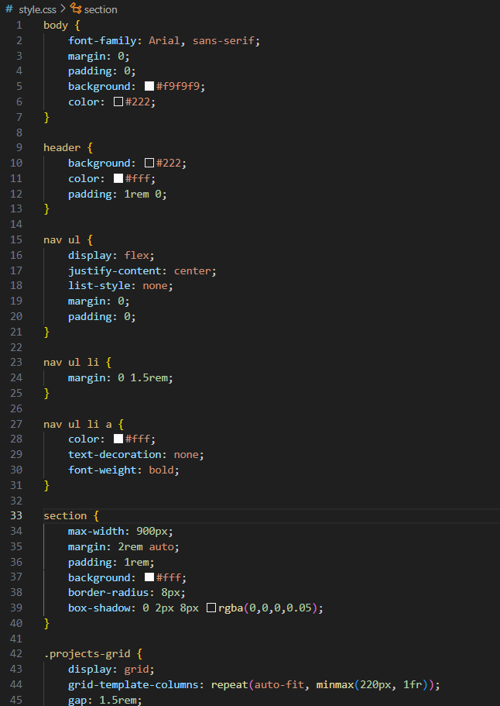

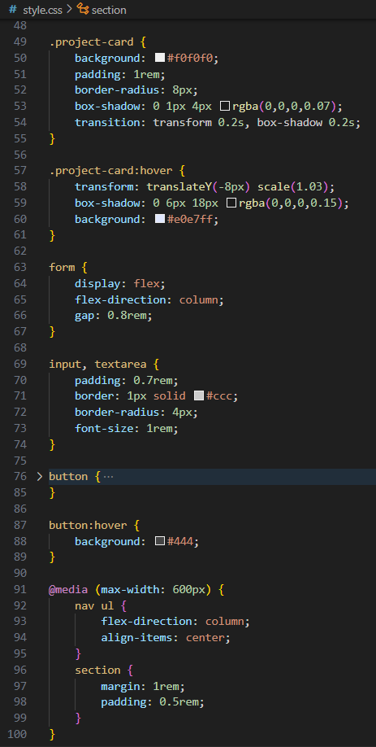

OUTPUT:-

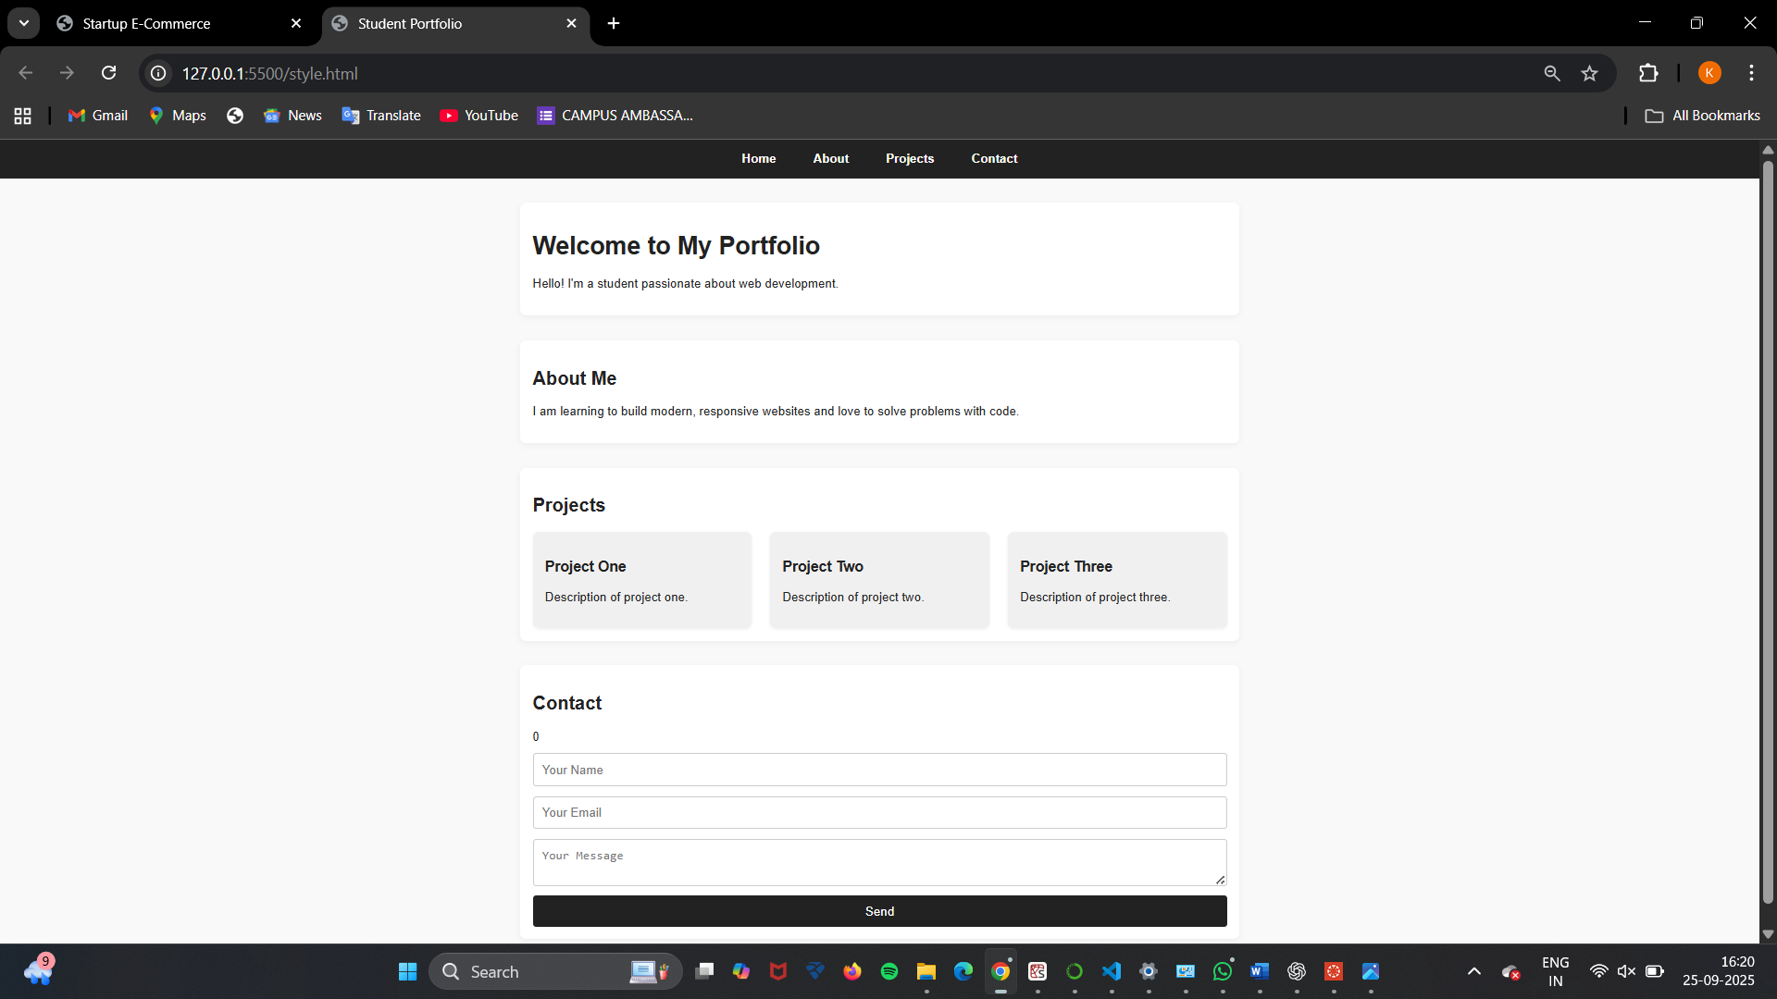

**OBSERVATION**:- I observed that using AI tools like GitHub Copilot significantly reduces the time required to create a portfolio website. The AI suggested responsive HTML and CSS code for navigation, project grids, and contact forms. This task demonstrated how AI can speed up the development process while still requiring human review for customization and styling.

TASK2

**TASK2 DESCRIPTION**:- AI-Generated Restaurant Landing Page  
**Scenario:**  
A local restaurant needs a simple landing page with a navigation bar, menu highlights, and an image gallery. The developer wants to quickly generate it using AI assistance.

**PROMPT**:- Generate a responsive restaurant website with navigation, menu cards, image slider, contact info, and hover effects using HTML, CSS, and JavaScript.

CODE:-

HTML:-



CSS:-

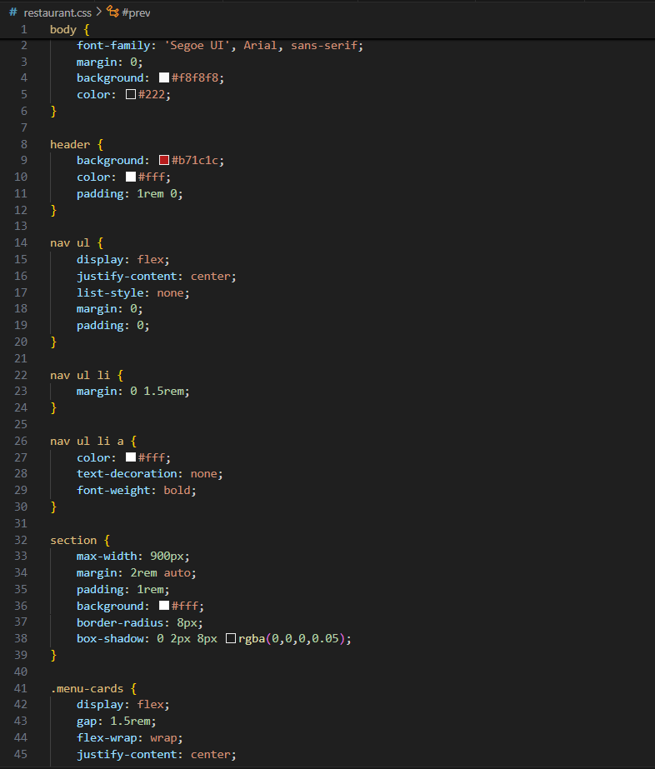

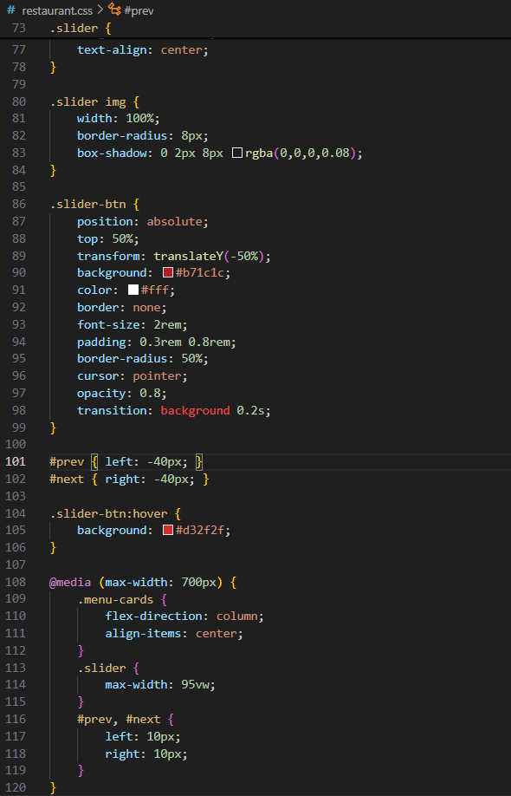

**OBSERVATION**:- I learned how AI can assist in generating a restaurant landing page with a navigation bar, menu highlights, and an image gallery. The code produced by AI was responsive and included hover effects. However, I observed that while AI provided the basic structure, additional manual refinements were needed to match the design expectations.

TASK3

**TASK3 DESCRIPTION**:- **AI-Powered Event Registration Form**  
**Scenario:**  
SR University is hosting a tech fest. They need a web-based registration  
form for students. The form must validate user input in real-time.

**PROMPT**:- Create a restaurant landing page with a navigation bar, menu highlights styled as cards, and a JavaScript image slider for the gallery section.

**CODE**:-

HTML:-

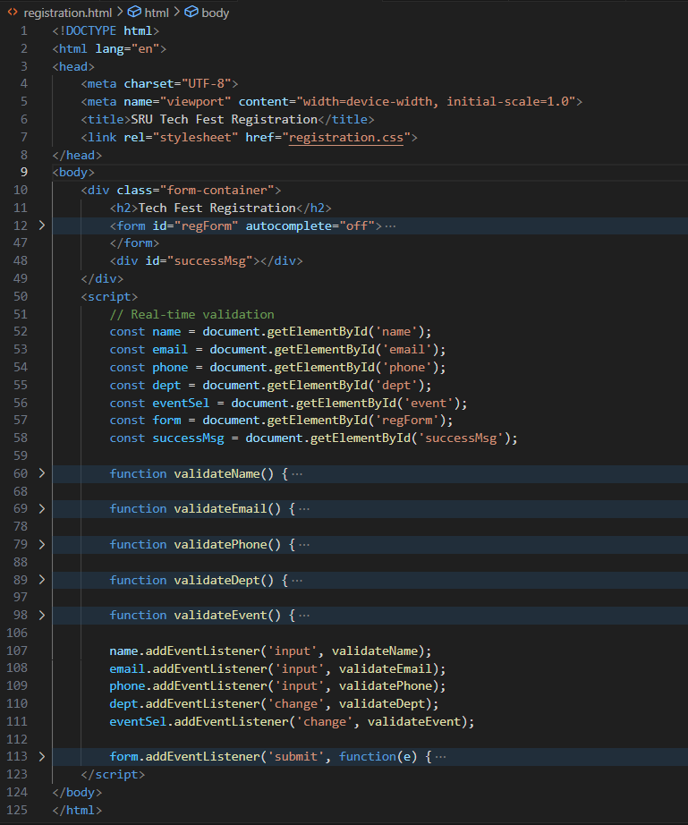

CSS:-

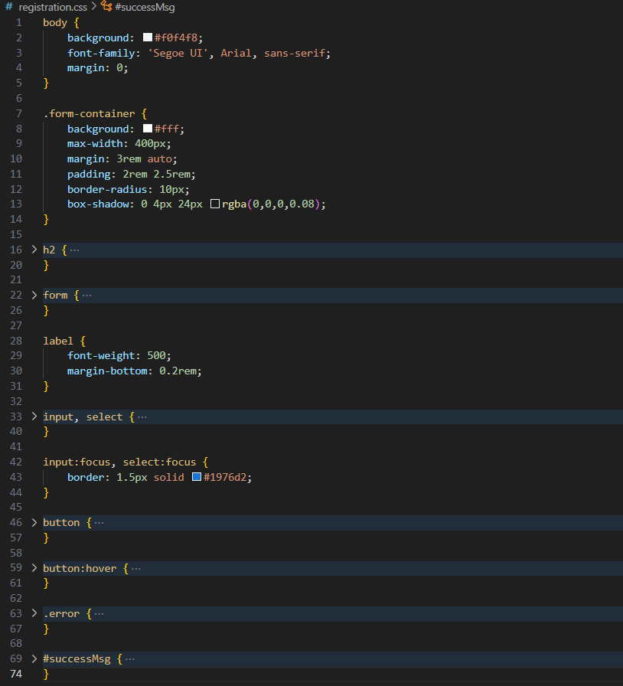

**OBSERVATION**:- This task highlighted the use of AI in generating a registration form with real-time input validation. I observed that AI-generated JavaScript handled input checks effectively, reducing coding effort. The task also showed that AI assistance can improve form usability by suggesting features like error messages and validation prompts, which enhance user experience.

TASK4

**TASK4 DESCRIPTION**:- **AI-Assisted E-Commerce Product Page  
Scenario:**  
A startup wants a basic e-commerce product page to display products  
with prices and an “Add to Cart” button.

**PROMPT**:- Generate a restaurant landing page with a navigation bar, menu highlights as styled cards, and a JavaScript image slider for the gallery section.

CODE:-

HTML:-

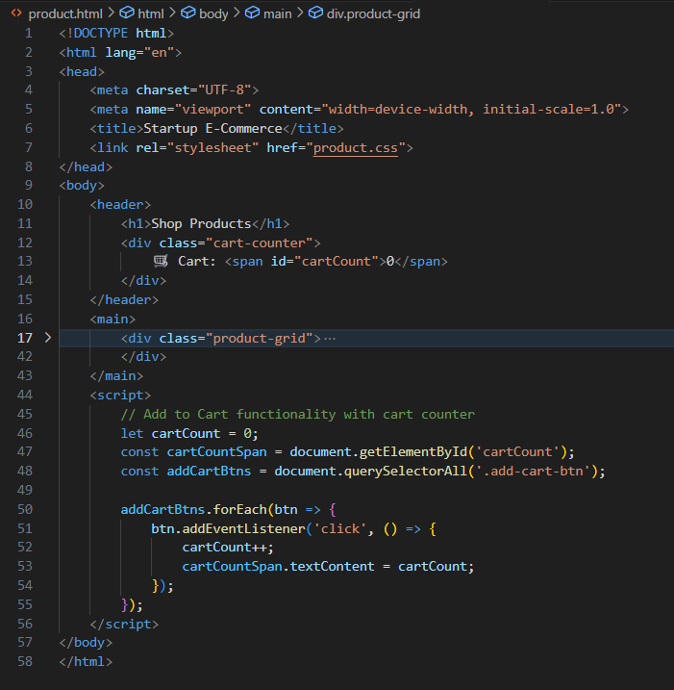

CSS:-

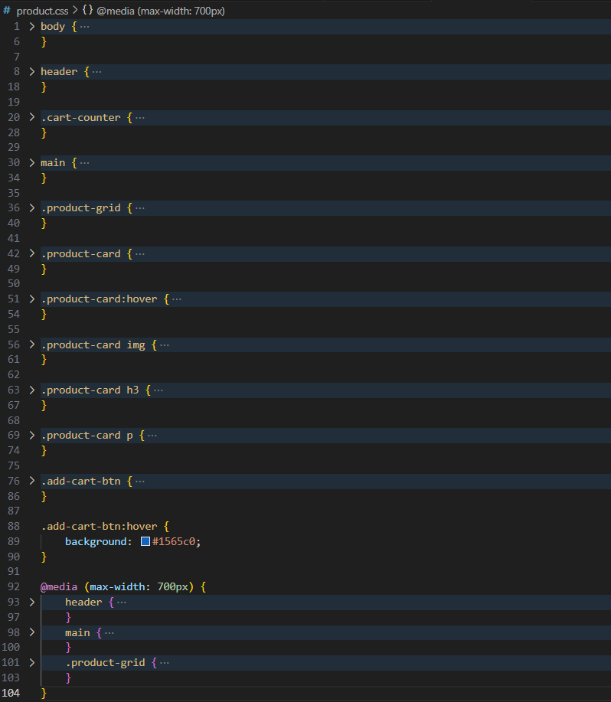

**OBSERVATION:-** I observed that AI-generated code provided a quick way to design a product display page with prices and “Add to Cart” functionality. The structure was simple yet functional. However, I noticed that while AI generated the HTML and CSS effectively, integrating dynamic cart functionality would still require additional logic and backend support.