import pandas as pd  
  
# Load the dataset  
df = pd.read_csv("covid_19_india.csv")  
  
# Display the columns in the DataFrame  
print(df.columns)

Index(['Sno', 'Date', 'Time', 'State', 'Cured', 'Deaths', 'Confirmed'], dtype='object')

import pandas as pd  
import matplotlib.pyplot as plt  
from statsmodels.tsa.arima.model import ARIMA  
from statsmodels.tsa.stattools import adfuller  
from statsmodels.graphics.tsaplots import plot_acf, plot_pacf  
  
# Load the dataset  
df = pd.read_csv("covid_19_india.csv")  
  
# Extract data for Kerala  
kerala_data = df[df['State'] == 'Kerala']  
  
# Convert 'Date' column to datetime object  
kerala_data['Date'] = pd.to_datetime(kerala_data['Date'])  
  
# Set 'Date' as index  
kerala_data.set_index('Date', inplace=True)  
  
# Plot the time series  
plt.figure(figsize=(10, 6))  
plt.plot(kerala_data['Deaths'], label='Deaths')  
plt.xlabel('Date')  
plt.ylabel('Deaths')  
plt.title('Daily Deaths in Kerala')  
plt.legend()  
plt.show()

C:\Users\nikhi\AppData\Local\Temp\ipykernel_36412\3164192458.py:14: UserWarning: Parsing dates in %d/%m/%Y format when dayfirst=False (the default) was specified. Pass `dayfirst=True` or specify a format to silence this warning.  
 kerala_data['Date'] = pd.to_datetime(kerala_data['Date'])  
C:\Users\nikhi\AppData\Local\Temp\ipykernel_36412\3164192458.py:14: SettingWithCopyWarning:   
A value is trying to be set on a copy of a slice from a DataFrame.  
Try using .loc[row_indexer,col_indexer] = value instead  
  
See the caveats in the documentation: https://pandas.pydata.org/pandas-docs/stable/user_guide/indexing.html#returning-a-view-versus-a-copy  
 kerala_data['Date'] = pd.to_datetime(kerala_data['Date'])

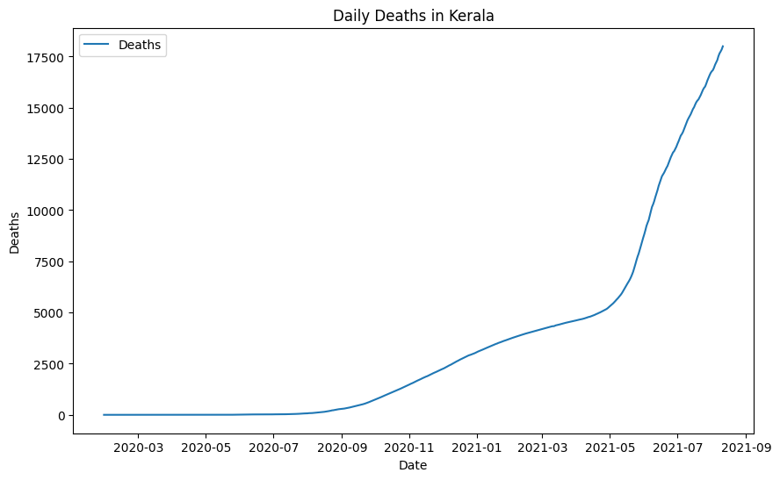

# Stationarity check  
result = adfuller(kerala_data['Deaths'])  
print('ADF Statistic:', result[0])  
print('p-value:', result[1])  
  
  
# In[22]:  
  
  
# Differencing  
kerala_data_diff = kerala_data['Deaths'].diff().dropna()  
  
# ACF and PACF plots  
fig, axes = plt.subplots(1, 2, figsize=(12, 4))  
plot_acf(kerala_data_diff, ax=axes[0])  
plot_pacf(kerala_data_diff, ax=axes[1])  
plt.show()

ADF Statistic: 3.136414888505709  
p-value: 1.0

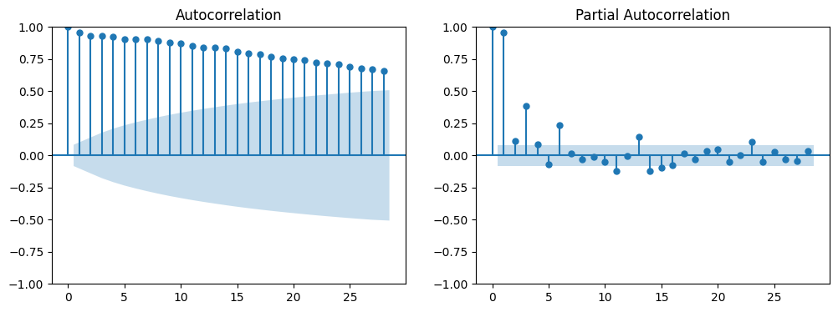

#Fit ARIMA model  
model = ARIMA(kerala_data['Deaths'], order=(7, 0, 25))  
results = model.fit()  
  
# Forecast  
forecast = results.forecast(steps=10)

C:\Users\nikhi\AppData\Local\Programs\Python\Python311\Lib\site-packages\statsmodels\tsa\base\tsa_model.py:473: ValueWarning: No frequency information was provided, so inferred frequency D will be used.  
 self._init_dates(dates, freq)  
C:\Users\nikhi\AppData\Local\Programs\Python\Python311\Lib\site-packages\statsmodels\tsa\base\tsa_model.py:473: ValueWarning: No frequency information was provided, so inferred frequency D will be used.  
 self._init_dates(dates, freq)  
C:\Users\nikhi\AppData\Local\Programs\Python\Python311\Lib\site-packages\statsmodels\tsa\base\tsa_model.py:473: ValueWarning: No frequency information was provided, so inferred frequency D will be used.  
 self._init_dates(dates, freq)  
C:\Users\nikhi\AppData\Local\Programs\Python\Python311\Lib\site-packages\statsmodels\tsa\statespace\sarimax.py:966: UserWarning: Non-stationary starting autoregressive parameters found. Using zeros as starting parameters.  
 warn('Non-stationary starting autoregressive parameters'  
C:\Users\nikhi\AppData\Local\Programs\Python\Python311\Lib\site-packages\statsmodels\base\model.py:607: ConvergenceWarning: Maximum Likelihood optimization failed to converge. Check mle_retvals  
 warnings.warn("Maximum Likelihood optimization failed to "

# Plot forecast  
plt.figure(figsize=(10, 6))  
plt.plot(kerala_data['Deaths'], label='Actual')  
plt.plot(forecast, label='Forecast')  
plt.xlabel('Date')  
plt.ylabel('Deaths')  
plt.title('Forecasted Deaths in Kerala')  
plt.legend()  
plt.show()

