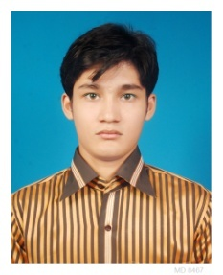Curriculum Vitae of Akash kumar basak

**Akash Kumar basak**

***Present Address: 125 darogabari, jurain, dhaka 1204***

***Permanent Address: 10no atulchakrabarty road mymensingh 2200***

***Email: akash4116@gmail.com***

***Contact Number: 01937053338***

***Linkedin: www.linkedin.com/in/akash-kumar-basak-029a8992?trk=nav_responsive_tab_profile.***

**Skills:**

**Programming Language: object oriented java, c++, php and c**

**Framework: codeigniter**

**Development: Mobile app development(android), web development**

**Personal/Team Project List:**

**Project 1 Title:** *Current weather update*

**Description:** *This is a android application for update city's weather.*

**Tools and Technologies used: Android application, android studio**

**Other Contributors*:*** *Nipun sarkaer, Satu bisswas, tanvir hasan*

**Project 2 Title:** *ToureMate*

**Description:** *TourMate is the data centre of user travel information.This app sorts user travel information in a manner,which will give user a good experience.*

**Tools and Technologies used: Android studio, java programming language**

**Other Contributors*:***  *Nipun sarker, Satu bisswas, tanbir hasan*

**Academic Information:**

|  |  |  |  |  |
| --- | --- | --- | --- | --- |
| **Degree/Certificate**  **Name** | **Result** | **Institute Name** | **Start Year** | **End Year** |
| S.S.C. | 4.06 out of 5.00 | Jurain Ashraf Master Adarsha High School | 2000 | 2008 |
| Diploma-in-Computer Engineering | Appeared | Ahsanullah institute of technical and vocationa education and training(AITVET) | 2012 | 2016 |

**Academic Project/Thesis/Training Summary:**

**Title**: *Mobile app development (Govt SEIP Project )*

**Description:** *Using object oriented java programming, activity life cycle,layout, intent,service,broadcast receiver, content provider, SQLite databse, shared preference, fragment, file system, web service(JSON, API),google location with( lat & long, notification.*

**Supervisor: Nazmul Hasan**

**Interest: planting, adventure, walking at night**