#1 Query is to create a database and a table named books.

Create database library;

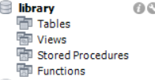

use library;

create table books(

id int Primary key Auto_increment,

title varchar(250),

author varchar(100),

year year,

genre varchar(100)

);



#2 Query is to insert values in the table books.

insert into books(title,author,year,genre)

values("The Great Gatsby","F.Scott Fitzgerald",1925,"Fiction"),

("Pride and Prejudice","Jane Austen",1913,"Romance"),

("To kill a Mockingbird","Harper lee",1960,"Fiction"),

("1984","Georrge Orwell",1949,"Dystopian"),

("Moby Dick","Herman Melville",1951,"Adventure");

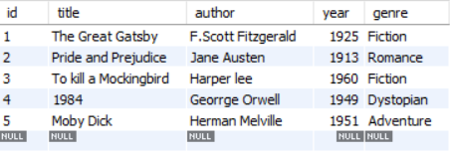

#3 Query is to select all the books starts with letter T by using like operator.

select *from books where title like "T%";

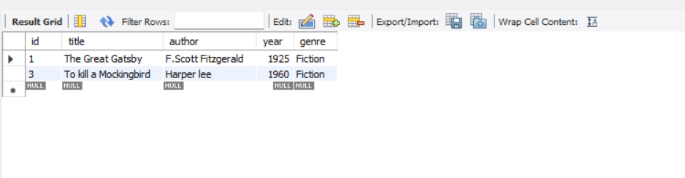

#4 Query is to find all the books where author's last name ends with son by using like operator.

select* from books where author like "%son";



#5 Query is to find all the books in which title contains the word end by using like operator.

select * from books where title like"%and%";

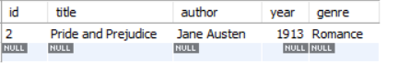

#6 Query is to retrieve all the books where title ends with the word bird by using like operator.

select *from books where title like "%bird";

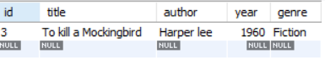

#7 Query is to find all the books where title has exactly 3 characters by using regexp operator.

select *from books where title regexp"[A-Z]e | [A-Z]e | [A-Z]e ";

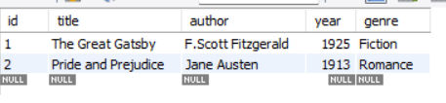

#8 Query is to find all the books where title contains a number by using regexp operator.

select *from books where title regexp"[0-9]";

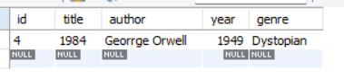

#9 Query is to find all the books where author name start between A and J by using regexp operator.

select *from books where author regexp"^[A-J]";

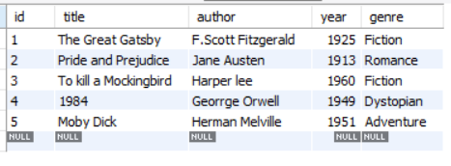

#10 Query is to find all the books where genre is either fiction or Adventure by using regexp operator.

select*from books where genre regexp"Fiction|Adventure";

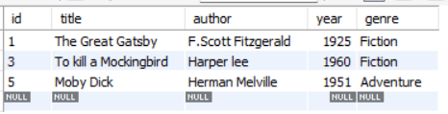

#11 Query is to find all the books where title contains at least one uppercase letter by using regexp operator.

select *from books where title regexp"[A-Z]";

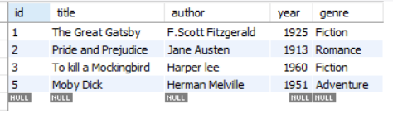

#12 Query is to find all the books where year is between 1800 and 1950 by using like operator.

select *from books where year like "19%" and year<1951 ;



#13 Query is to find all the books where author's name contains exactly two words by using regexp operator.

select *from books where author regexp "[A-Z]e |[A-Z]e";

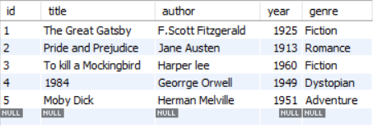

#14 Query is to find all the books where title starts with P and contains exactly two words by using regexp operator.

select*from books where title regexp"^P" and title regexp "[A-Z]e |[A-Z]e";

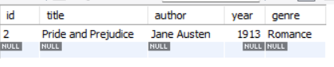

#15 Query is to find all the books where title contains any special characters by using regexp operator.

select*from books where title regexp"[^a-zA-Z0-9 ]";

